Year 2 Home Learning
Week Commencing: 27th April 2020
Year 2 teachers: Mrs Nicholson and Mrs Tomordy
Year 2 TAs: Mrs Rowland and Ms Shaista
Message from staff: Hello to all of you from all of us. I hope you have had chance to enjoy some of the sunshine. We are all keeping busy and trying to ensure that you have tasks to do that will help you keep your brains whirring and your learning continuing in these strange times. Mrs Tomordy has been busy in the Easter holidays sowing some seeds. Have you managed to plant yours yet? She has planted some pea seeds and they are just poking through the soil. She has also been looking at the learning you will be doing when we all get back together again and creating some interesting things for you to do each week.
Mrs Rowland has been looking after Holly and her cat Puss. The weather has been lovely so she has been enjoying the sunshine in the garden while doing her school work. She has also been doing PE with Joe every morning to wake her up. Have you been doing it too? She can’t wait to see you when we get back to school!
Mrs Nicholson has been gardening and finding a path through the jungle in her garden! She has been walking her dog although her dog has had a poorly leg so cannot walk very far.
Mrs Shaista has been busy cooking and trying and experimenting new dishes most of the time successful! The weather has been so beautiful so she has been enjoying the sunshine while walking every morning with her mum. Every day in the evening she is catching up with reading her favourite books. Are you reading as well?

Your Home Learning this Week:
Every day (Monday to Friday), make sure you choose a *reading, *writing, *spelling/handwriting, *maths and *theme learning activity. There are also further activities to choose from should you wish to.

Reading Home Learning
Task 1  Read this text  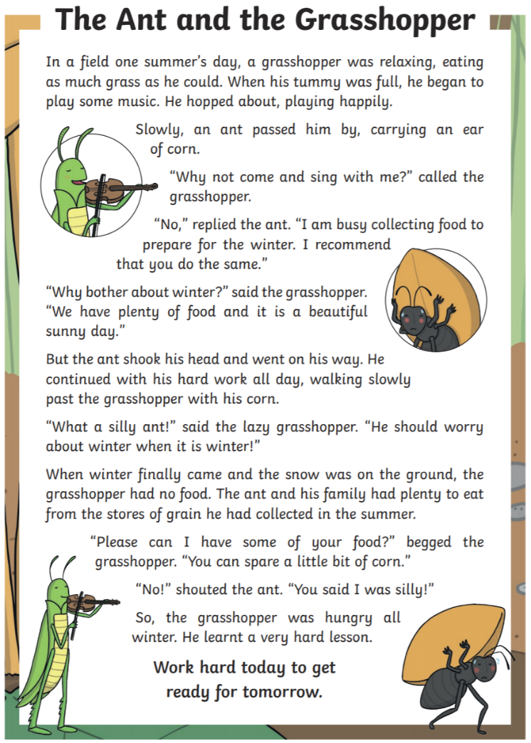  What are the meanings of these words?  • an ear of corn  • prepare  • plenty  • spare | Task 2  Make your own text map to go with the story. Remember, this is where you retell the story using pictures instead of words.  Add some actions to your story and tell it to someone in your family 🙂. | Task 3  Answer these questions about the story.  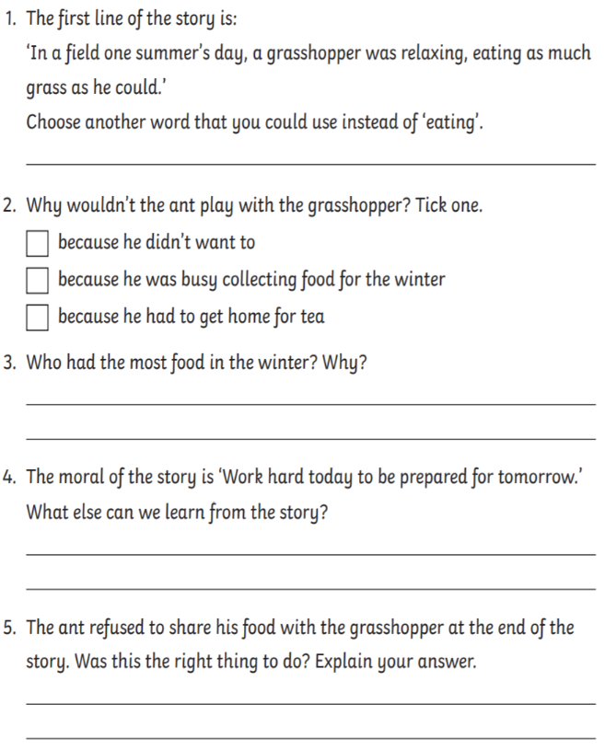
Task 4  Can you read this text in 60 seconds? Get somebody to time you and keep practising until you can!  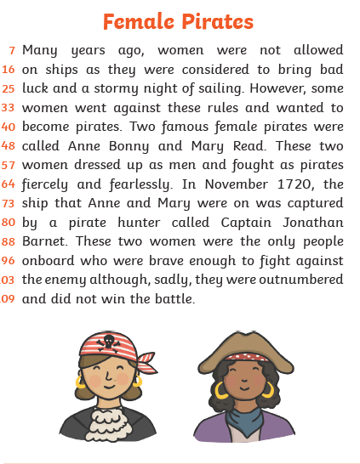 | Task 5  Answer these questions about the text  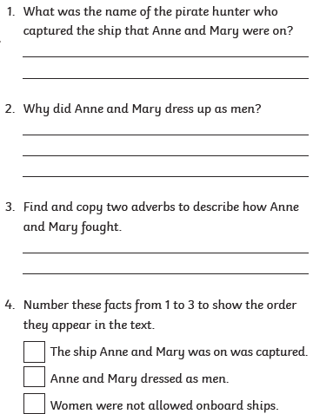

Writing Home Learning
Task 1  How many amazing adjectives can you write down to describe this picture? | Task 2  Use those adjectives to put into your own writing to describe what you can see. | Task 3  Draw a picture of a character that you might find living in the place you see in the picture. Give your picture some labels to describe your character. | Task 4  What happens here? Add to your writing from Task 2 to tell me what your character does here and what happens. | Task 5  Answer these questions: Would you like to live here and why/why not?  Who would you want to live here with you?  How would it make you feel?

Spelling/Handwriting Home Learning
Task 1  Practise these spellings and put them into sentences  • believe  • bicycle  • breath  • breathe  • build | Task 2  Write these words to practise your joined handwriting. Remember the o joins at the top!  • look  • pole  • bone  • join  • food | Task 3  Rainbow write the months of the year  January  February  March  April  May  June  July  August  September  October  November  December | Task 4  Can you write these spellings 10 times in the shape of your name?  • calendar  • caught  • consider  • complete  • continue | Task 5  Write these words using joined handwriting. Pay attention to your ascenders and descenders!  • flag  • black  • climb  • school  • dogs
Maths Home Learning
Task 1  Mixed addition and subtraction using column method  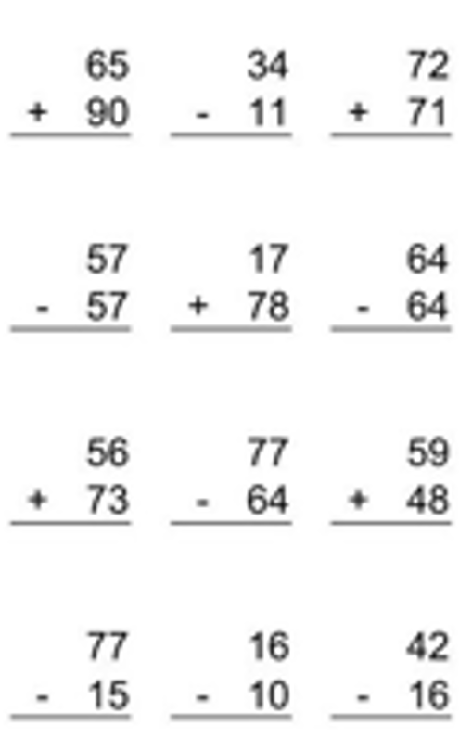 | Task 2  Word problems. Remember to read them carefully!  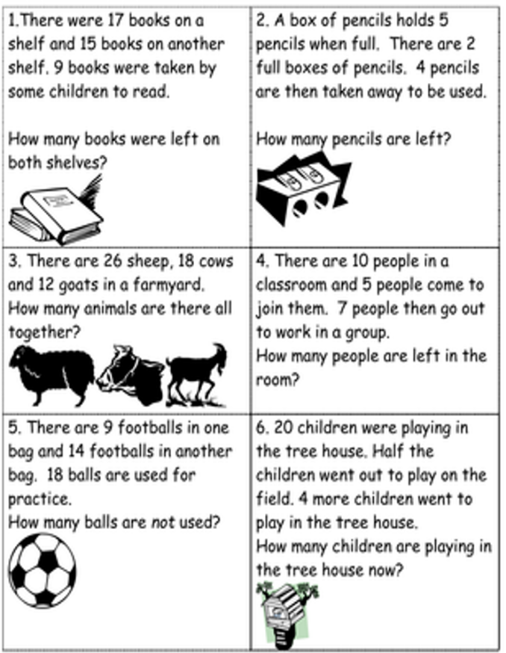 | Task 3  Fractions  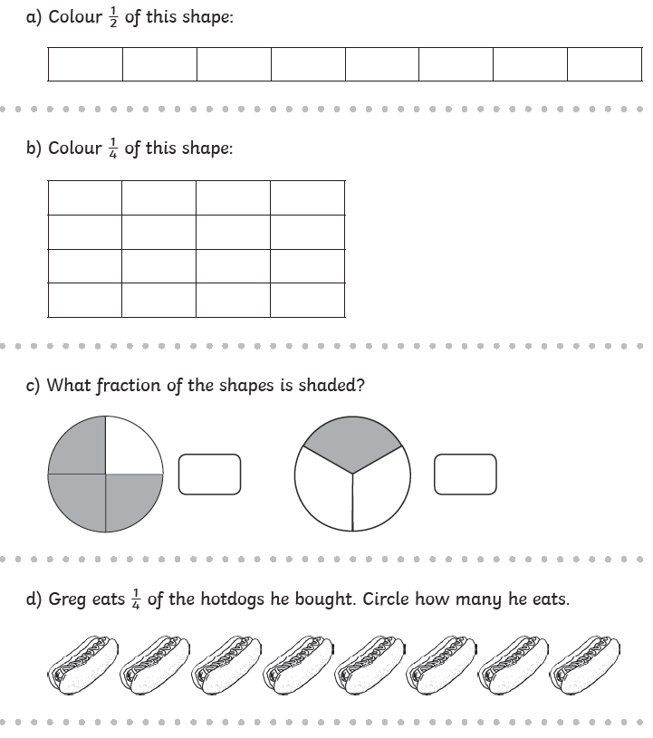
Task 4  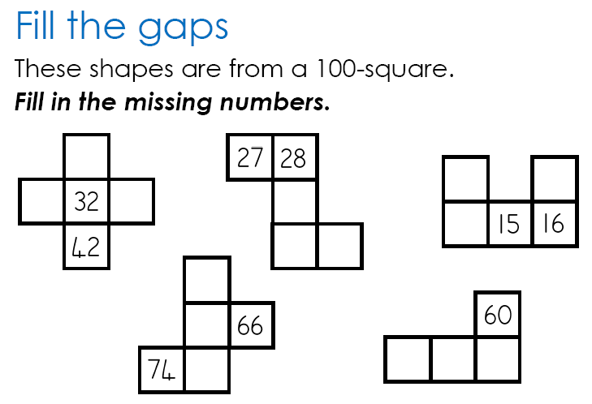 | Task 5  Ask your adults if you can count the money they have.  Draw the money they have and add it up. Get them to check to see if you have got it right. Remember to look carefully at the shape and of the coins and the numbers on them 🙂

Theme Home Learning
Art  Create a viewfinder with a piece of paper where the middle is cut out and then draw whatever you can see in the middle. Try this with something in your house or a plant in your garden. Try to notice the lines and shapes you can see. 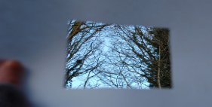 | Computing  Create a poster to tell others how to stay safe online. Remember the most important parts are to tell someone if you are not sure and never share personal information on line, including photographs. | Science  What different things do plants need to survive? Name 4 different things and then explain in a sentence why they need each thing. | Geography  Compare the school playground and your back garden Create a Venn diagram to show what you have found out. Remember the middle is where it is found in both places. | Art/PSHE  Create a poster that you can put up in your window to make people smile. So you could say thank you to someone or just have lots of rainbows, smiles etc.

Other Activities
On your daily walk see if you can add the numbers on the doors in your head. | Write a diary or draw a picture each day of something you have done and how you felt. | Do a rubbing of things around you by placing a thin sheet of paper over something and then carefully rubbing over with a crayon or chalk. How many different patterns can you make? | Create some salt dough and make some models of things. | Create a song or poem about flowers and things that grow. Keep practising it until you can do it in a performance to your family.

Key skills to continue practicing weekly:
Times table rock stars
Reading with Oxford Owl
Read, read and read again.
Telling the time to the 5 minutes
Practise reading and spelling your common exception words.
Handwriting out a passage from a book

Useful websites:
https://www.bbc.co.uk/bitesize This is a very useful website. It is run by the BBC and they are running daily lessons for children so why not have a look and see what they have.
On Youtube every morning at 9am, if you type in Joe Wicks, he is running an exercise session for children and adults to join in with.

If you or your child has any further queries regarding their learning projects, please contact admin@hardwick.derby.sch.uk, clearly stating your child’s name and class teacher, and the staff will be in touch to support you and your child.

Thank you and stay safe.

