Year 6 Home Learning
Week Commencing: 22nd June 2020
Year 6 teachers: Mrs Haider, Miss Qayoom, Mr Nowak
Year 6 TAs: Mrs Yar-Khan
Message from staff: We understand that this is a particularly difficult time for year 6 as this is your final term as primary pupils. To support you we are here, so if you have any concerns please let us know either when we ring you or leave a message with the office and we will get back to you.
To support with transition, please work through the transition booklet, this includes activities that you can complete with your parents as well as useful websites.
Don’t worry, we the year 6 team are thinking of ways about how we can have a final goodbye. Rest assured that we will not let you go unnoticed!

Reading Home Learning
Monday | Tuesday | Wednesday |  | Thursday | Friday
Read the title “Earthquakes” and predict what the text is going to be about.  Write your explanation then read the text to see if you were right. Underline any words and phrases you are unsure about. | Summarise the main points of the text (VIPs) and write them down using bullet points. | Visualise the text and draw a seismograph. |  | Answer the first 4 questions and highlight the evidence in the text to support your answers. | Reading for pleasure  Read any book of your choice for 45 minutes.
Easier:  Do as many of the above activities as you can. If you are finding some of the activities challenging, try these as they are a little easier:  - Draw a picture of the Earth.  - Find words you don’t understand and look them up in a dictionary  - Summarise the text in one sentence. |  |  | Challenge:  If you feel you need a further challenge, try these:  - Answer Q5 and Q6 and highlight the evidence in the text.  - Write everything you know about earthquakes. Find some information about earthquakes that occurred in the past and their consequences.  - Read a book of your choice for 1 hour
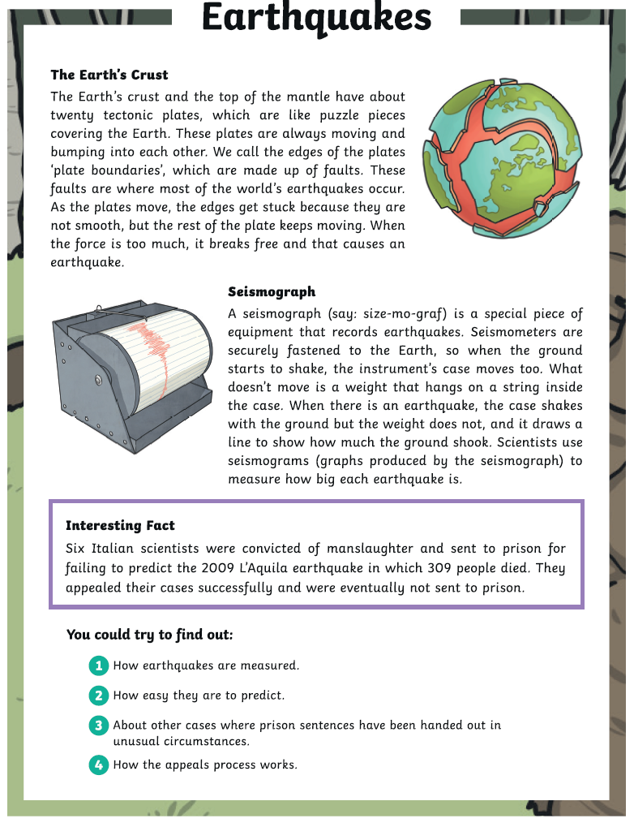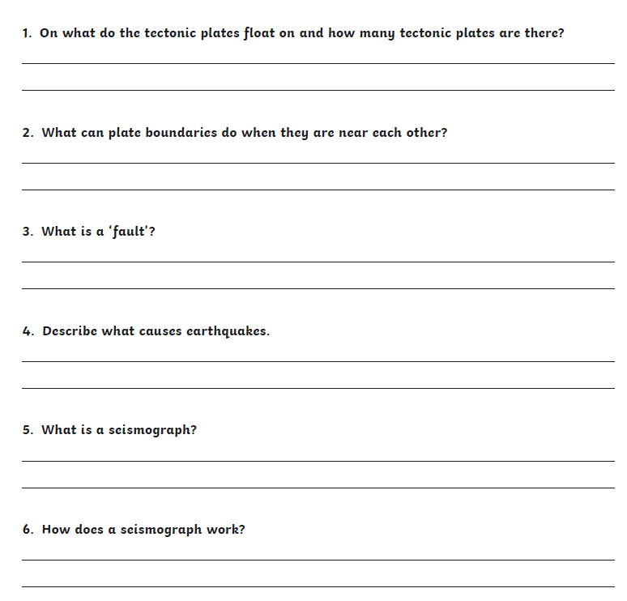
Writing Home Learning
Monday | Tuesday | Wednesday |  | Thursday | Friday
Oh dear. This pupil hasn’t understood how to use different prefixes or suffixes! Can you help? If prefixes and suffixes are a bit of a struggle for you too, stick to the first activity. If you’re pretty confident, then go straight to the second one. And if you’re raring to go, try the challenge too! | This pupil has had a homophone horror! Can you help? First, decide which of the sentences are correct by placing a tick or a cross in the column next to it. Then use the third column to correct any homophones that are wrong. | This (very formal!) note has been left on a car windscreen. Read it carefully and answer the questions below. If you’re anxious about this task, try questions 1-8. If you’re confident do questions 1-11 and if you’re raring to go, do the challenge too! |  | Look at the image of the two people below. What could they be talking about?  Your task is to write a dialogue to go with this picture. You will need to consider: the nature of the people’s relationship and whether the conversation is formal or informal. Don’t forget to use the correct punctuation! (At least 250 words) | Edit your work from yesterday and read it to your parents/carers/siblings.
Easier:  Do as many of the above activities as you can. If you are finding some of the activities challenging, try these as they are a little easier:  - If you find homophones difficult, stick to the first set of sentences. If you’re feeling confident, do set two as well. |  |  | Challenge:  If you feel you need a further challenge, try these:  Try the challenges included in each section.

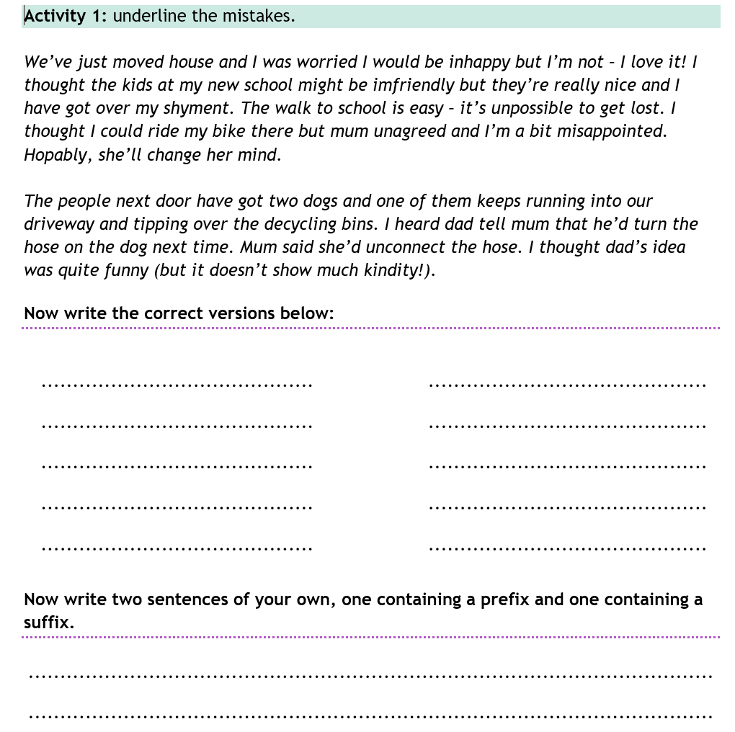
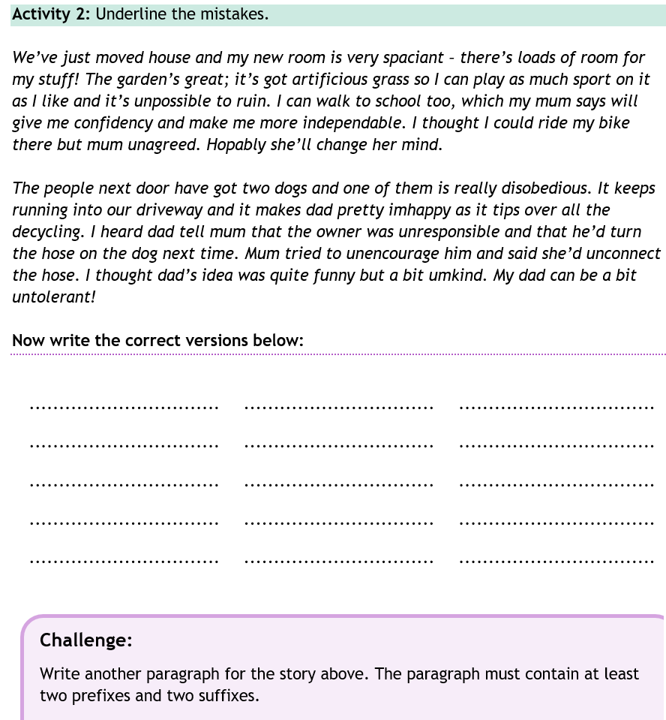
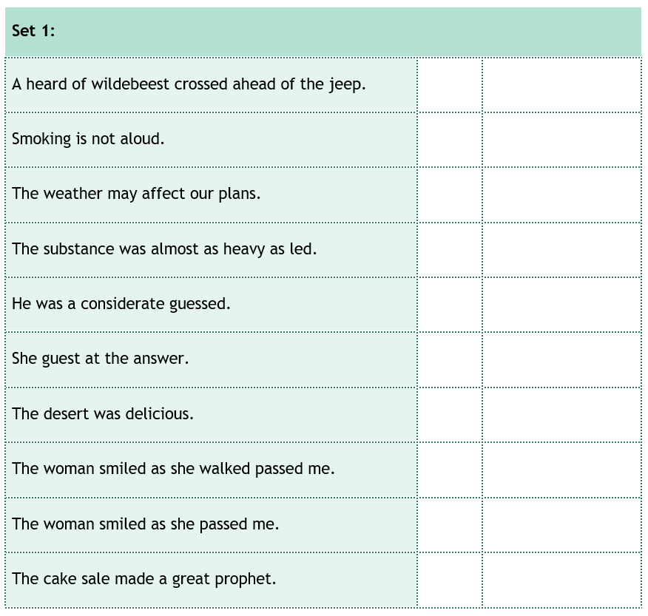
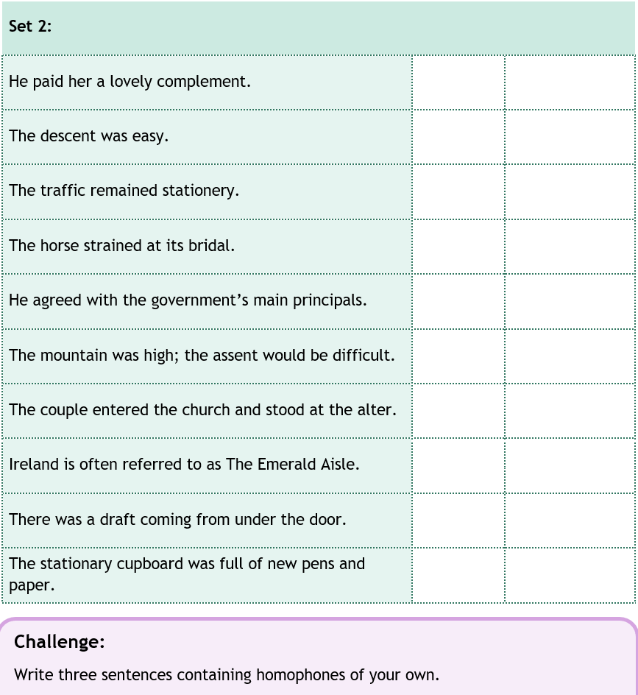
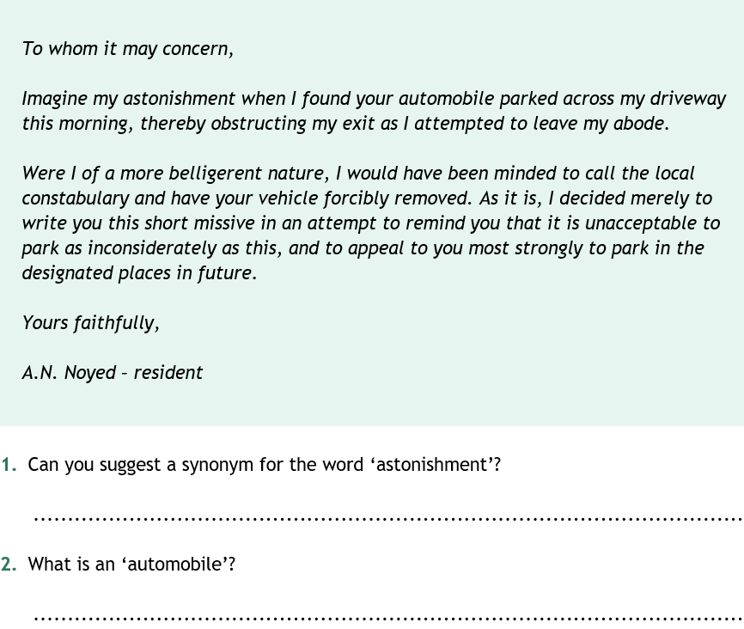
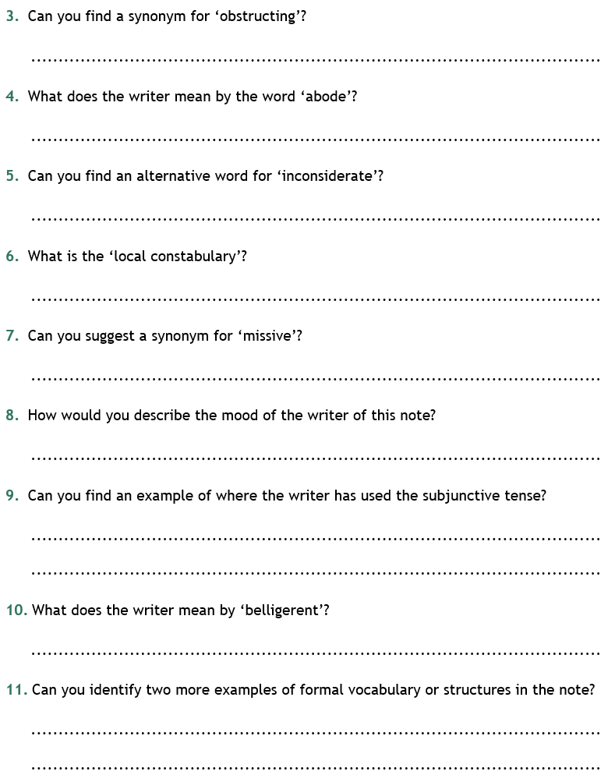
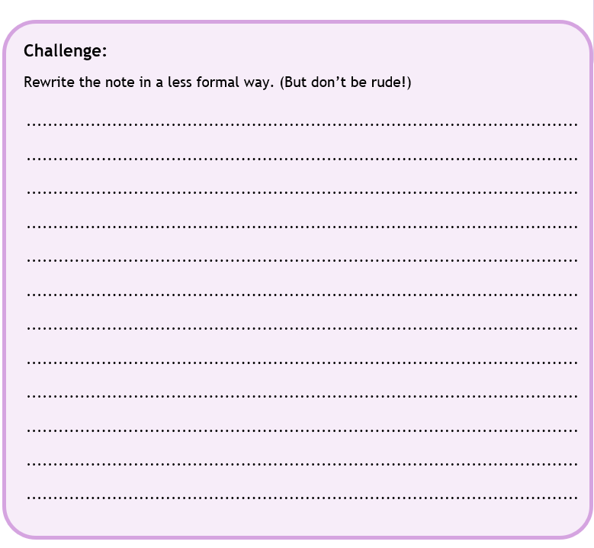

Spelling/Handwriting Home Learning Keep revising the same words this half term.
Monday | Tuesday | Wednesday |  | Thursday | Friday
suspicious  artificial  confidential  commercial  innocence  independent  recommend  significance  appearance  ferocious | Abstract nouns  disappointment  determination  enthusiasm  graciousness  apprehension  consideration  opportunity  speculation  enhancement  disturbance | Hyphens can be used to  join a prefix to a root  word. Words beginning  with the prefix co- can be  written with or without  prefixes.  co-ordinate  re-enter  co-operate  co-own  de-ice  co-author  re-examine  re-educate  re-form  co-pilot |  | Morphology - Provides  opportunity to find links  from previously taught  spelling/structure of  words and parts of words  (Stems, roots, prefixes, suffixes etc.)  opportunity  parliament  programme  privilege  explanation  disastrous  exaggerate  frequently  necessary  appreciate | ASSESSMENT  Ask someone in your family to test you. 10 random words.
Easier:  Do as many of the above activities as you can. If you are finding some of the activities challenging, try these as they are a little easier:  - Use a dictionary to make sure you understand each word  - Try the following words:  chef  chalet  machine  brochure  chute  parachute  moustache  quiche  chauffeur  chandelier |  |  | Challenge:  If you feel you need a further challenge, try these:  - Write a story and try to include as many words from your spelling list as possible.  - Write a poem using some of the words above  - Learn the words with double consonants:  accommodate  accommodation  aggressive  embarrass  apparatus  success  successfully  willingness  worthlessness  happiness

Maths Home Learning
Monday | Tuesday | Wednesday |  | Thursday | Friday
Look at the calendar in learning activity 1a and answer the questions in 1c. | Revise the facts in learning activity 2.  Complete task 2b | Revise over learning activity facts 3a.  Complete 3c and 3d. |  | Choose a challenge from Learning activity 4. | Choose a challenge from Learning activity 4.
Easier:  Do as many of the above activities as you can. If you are finding some of the activities challenging, try these as they are a little easier:  - Use picture 1b to help you remember how many days there are in each of the months. Ask your family to test you. E.g: How many months have 31 days?  - Learn facts in 2a and ask an adult to test you- make up some questions to answer too.  - Learn facts in 3a and complete task 3b  - Draw a poster of the key facts you know to help somebody else. |  |  | Challenge:  If you feel you need a further challenge, try these:  - Complete learning activity 1d  - Complete learning activity 2c  - Make up your own challenges

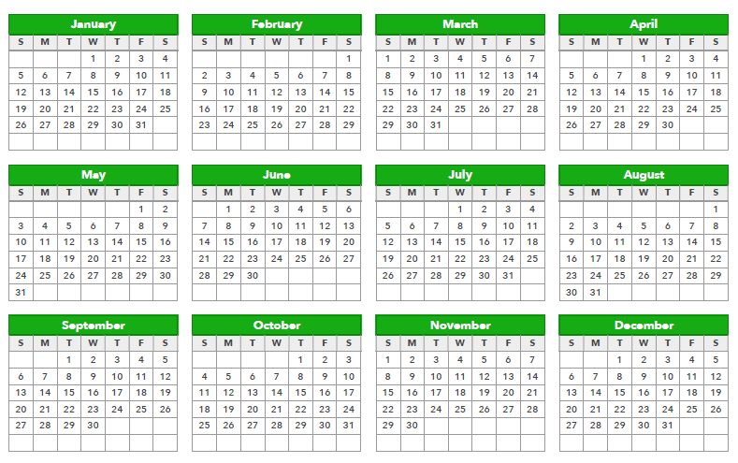
Learning activity 1a: Facts 1b.Facts and learning tip

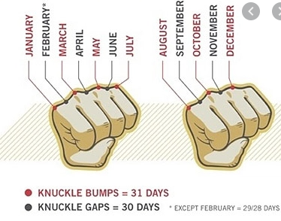
1c: task
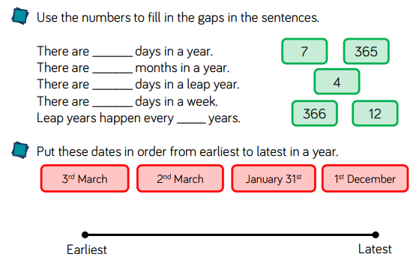
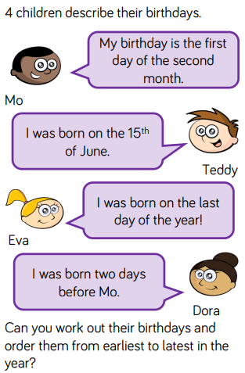
1d: Task Learning activity 2a: facts
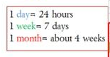
2b: Task
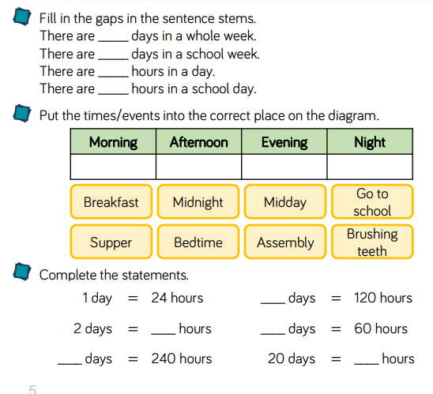
2c: Task:
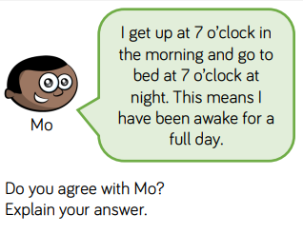
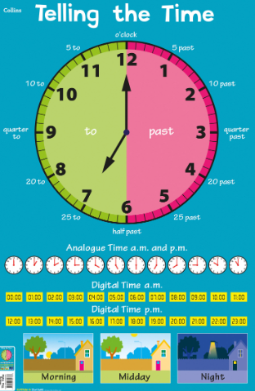
Learning activity 3a: Facts 3b: Task
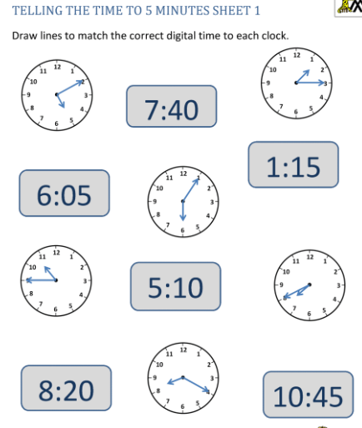
What time is it?
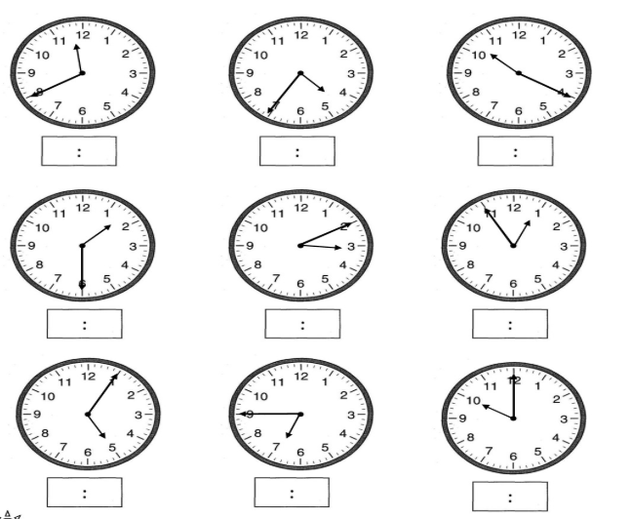
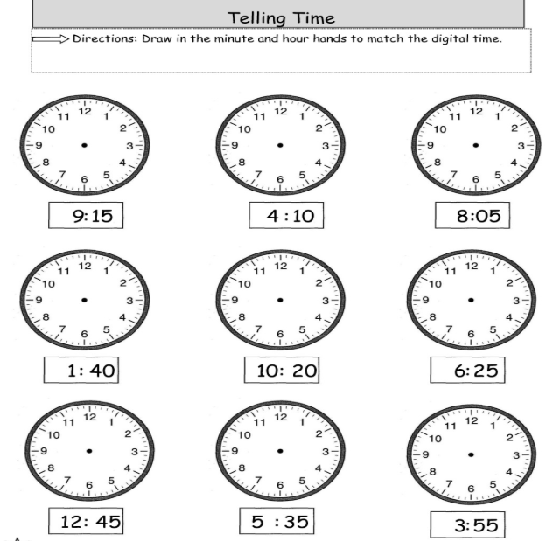
3c: Task 3d: Task
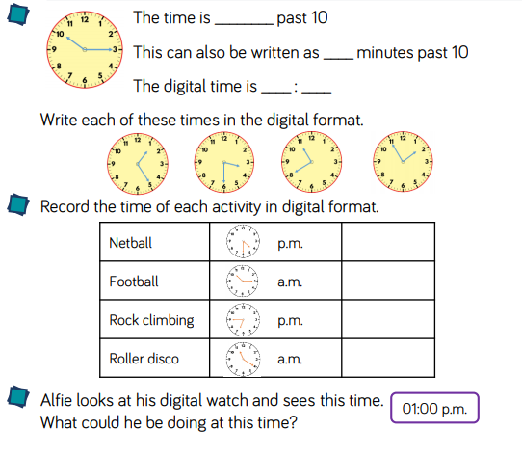

Learning activty 4: Challenge
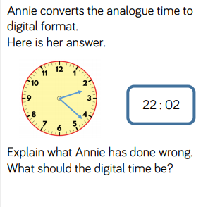
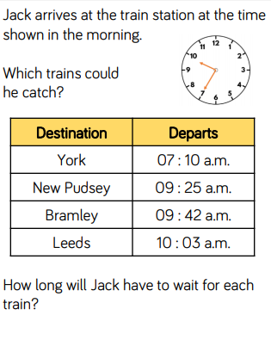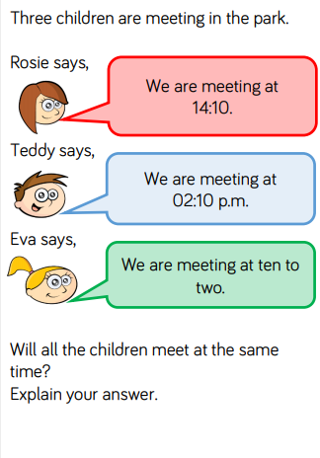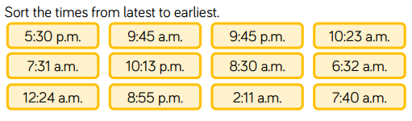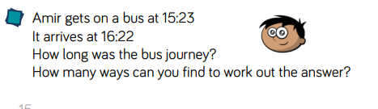

Theme Home Learning
Monday | Tuesday | Wednesday | Thursday |  | Friday
Science  From last week’s experiment (tomato plant and sunflower seeds planted), record what happened (growth).  Make a drawing of what you see each day for both of the plants. | Science  Learn scientific vocabulary seen on the sheets.  Complete all 3 sheets: Living things and their habitats.  Ask an adult to test you on the definitions. | RE  Read the text ‘The Prophet Muhammad (PBUH) and the revelation of the Quran’  Answer the comprehension questions in complete sentences. Remember, to check your punctuation. | PSHE  - Would you rather?  Complete any 3 activity. Choose any. Write a detailed explanation for each. |  | PE  See PE sheet  Start from Easier (throwing and catching skills).  Complete Year 6 PE section.
Easier:  Do as many of the above activities as you can. If you are finding some of the activities challenging, try these as they are a little easier:  - Science learn all the scientific vocabulary on the sheet and learn how water moves through the plants. Revise what plants need in order to grow healthy.  - RE complete easier comprehension sheets.  - PSHCE choose any two activities. Ask an adult to help you think of a reason if you are stuck.  - PE Complete all throwing and catching skills with an adult. |  |  |  | Challenge:  If you feel you need a further challenge, try these:  - Science learn the vocabulary from both sheets.  Complete the sheet living things and their habitats.  - RE complete all comprehension sheets.  - PSHCE give detailed answers using paragraph and a range of punctuation.  - PE Design your own 10 minutes warm up activities

Science Easier
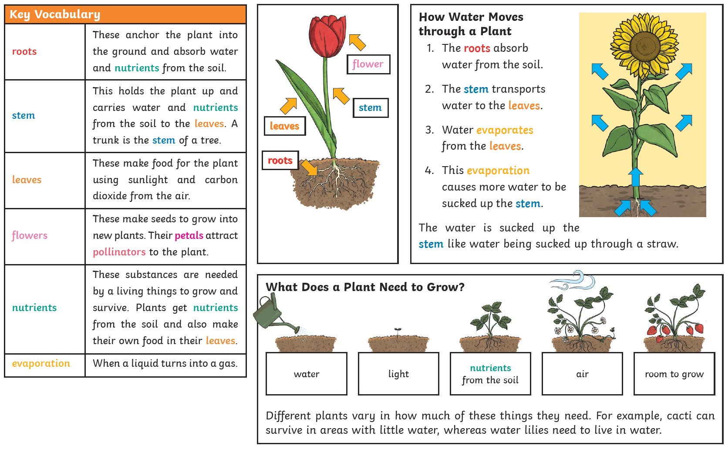

Science Year 6 and Challenge
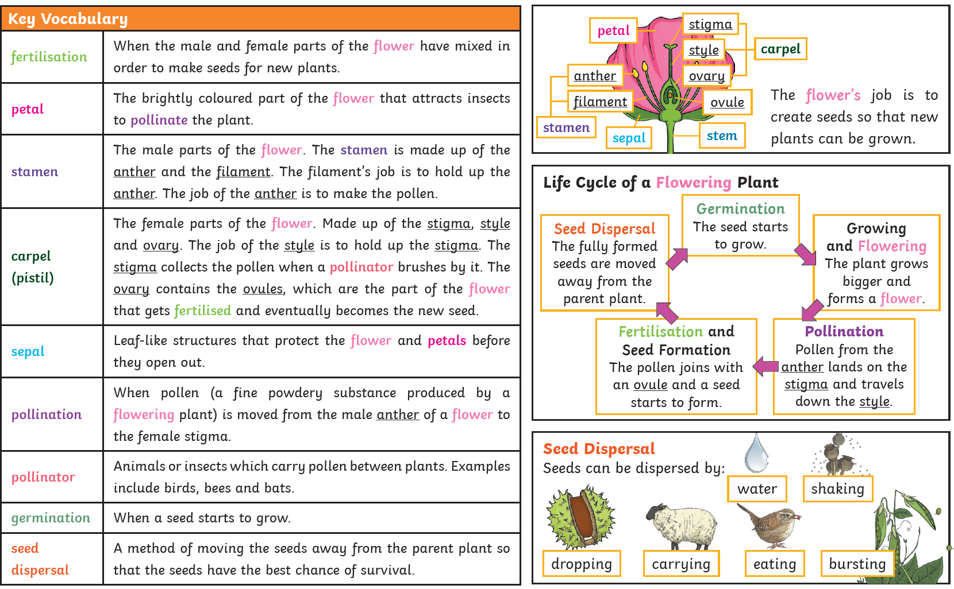

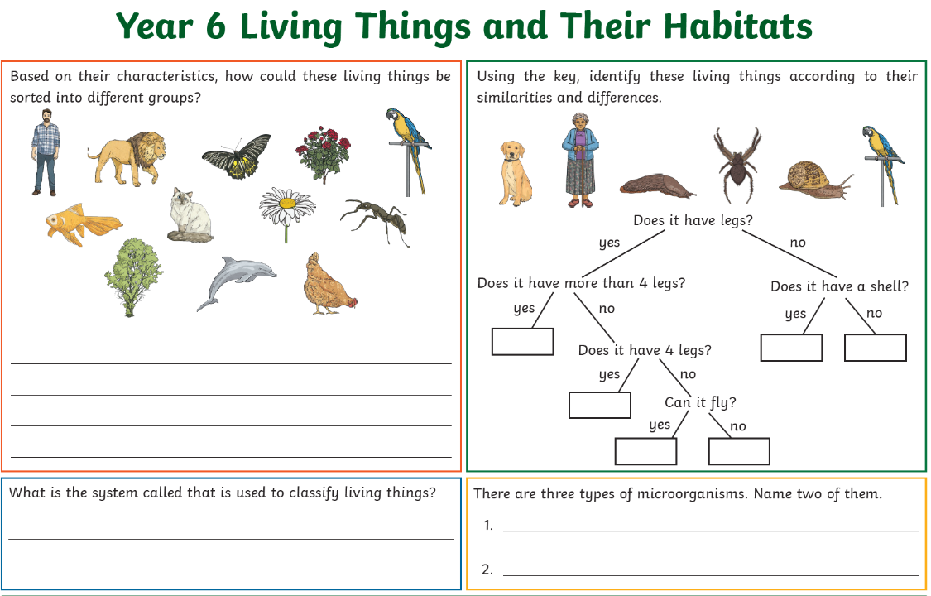
Science Year 6 and Challenge
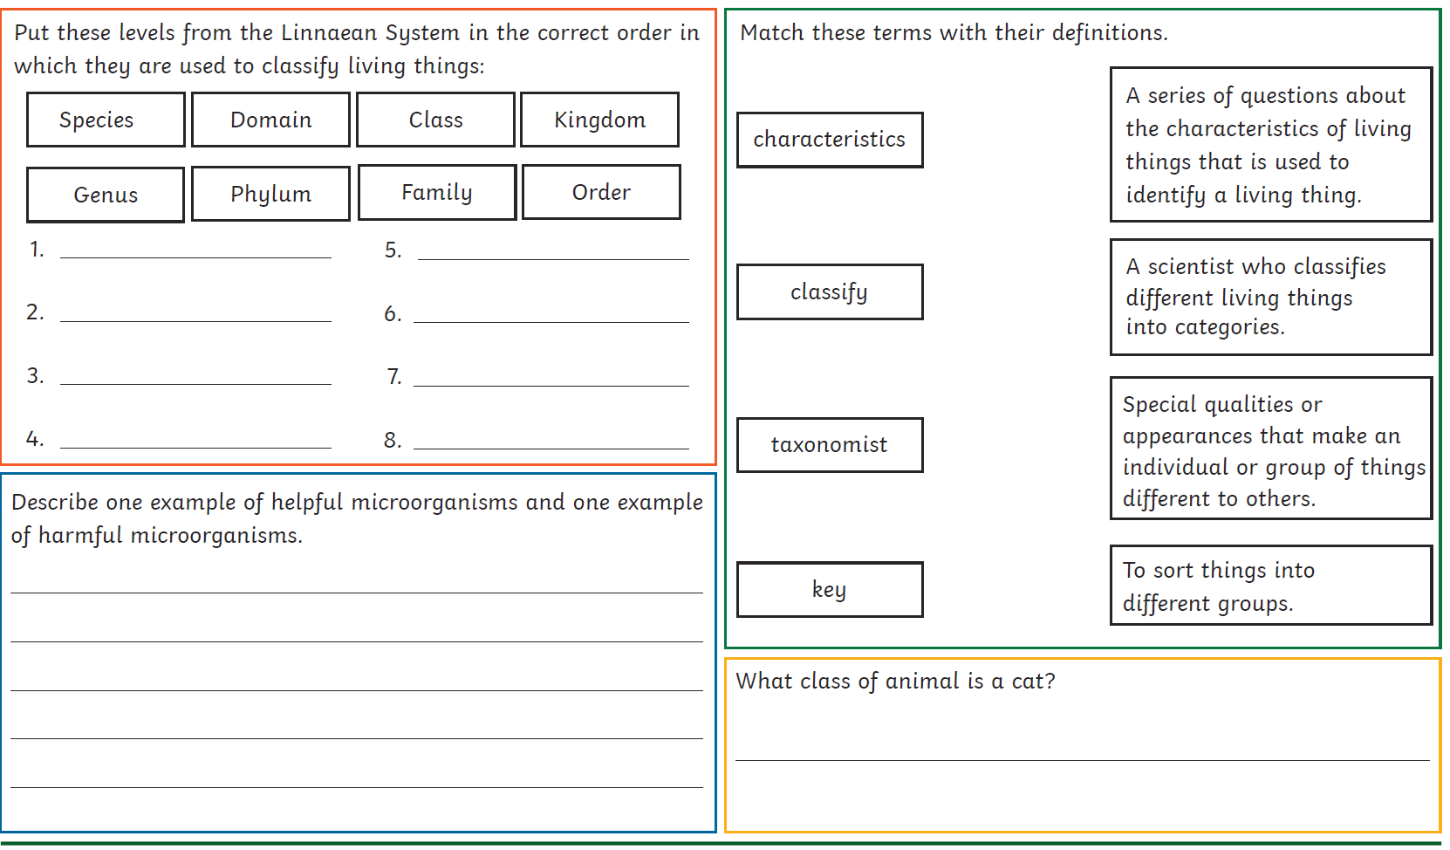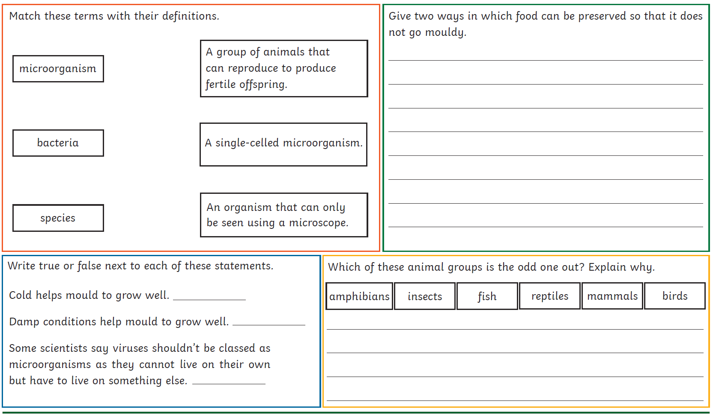
RE Easier
RE Year 6
RE Challenge

Oracy: Choose and discuss with your family. Find out what their opinions are.
PSHE: Complete any 3 activity. Choose any. Write a detailed explanation for each..

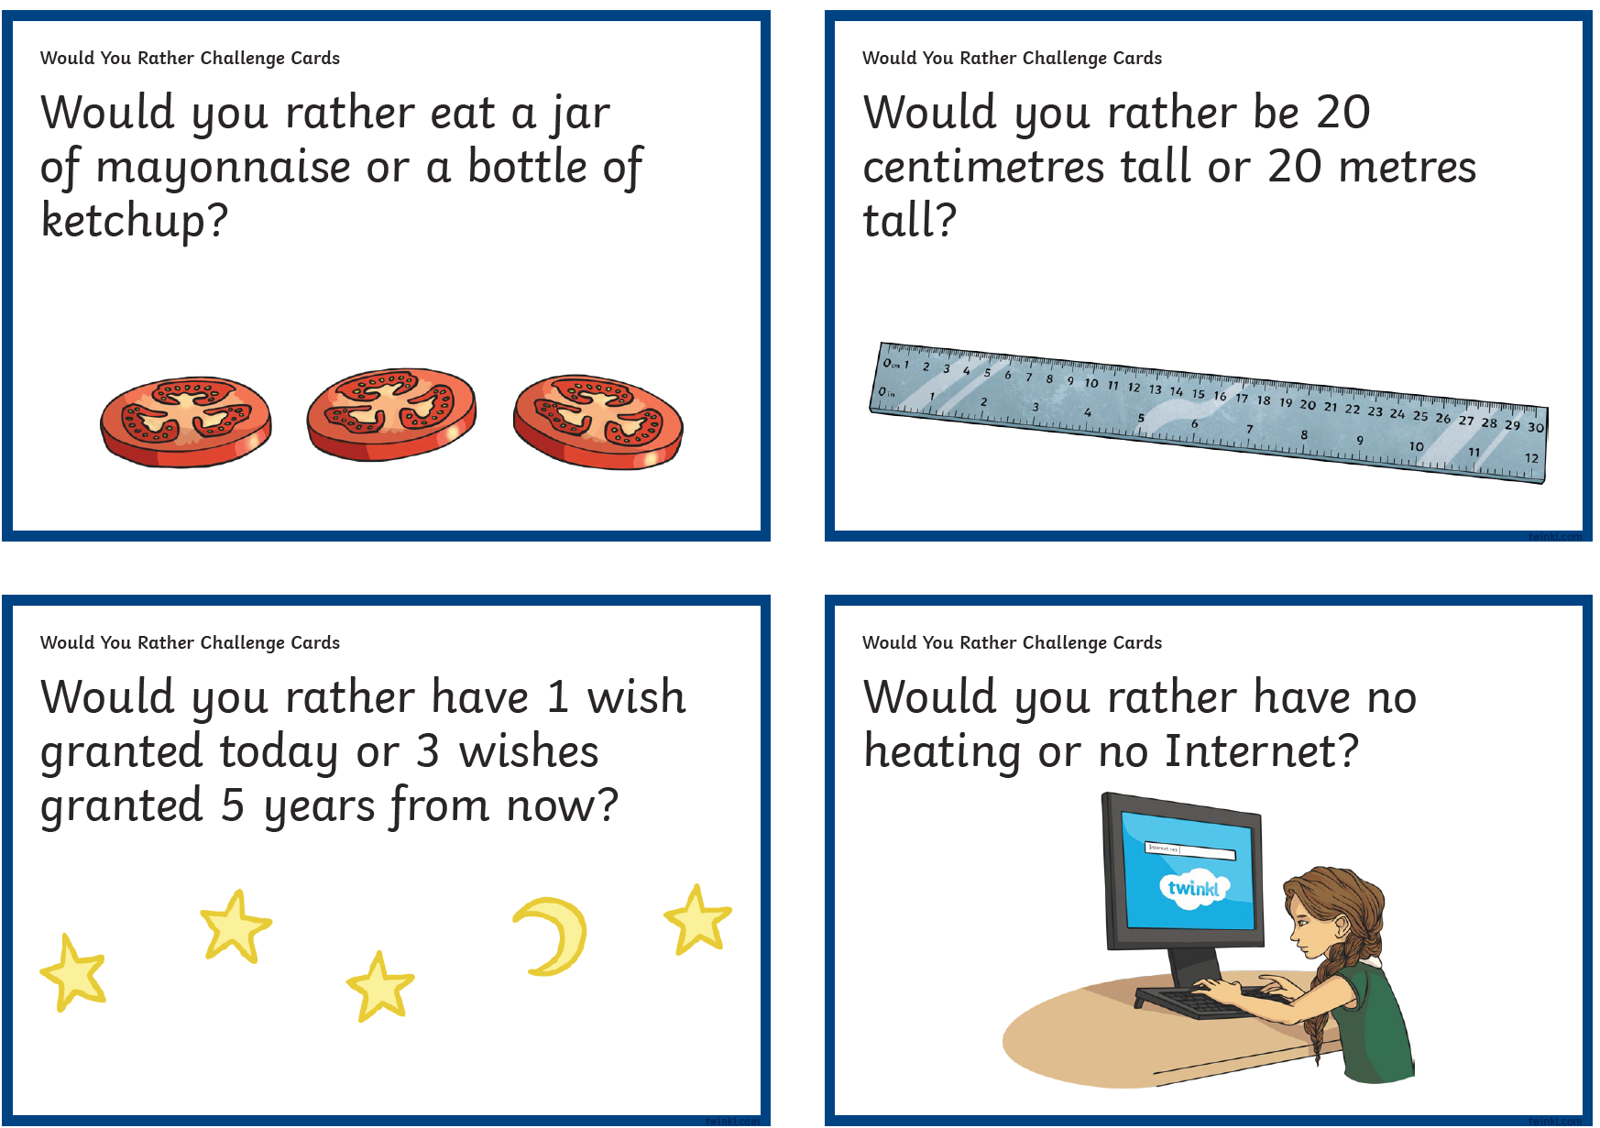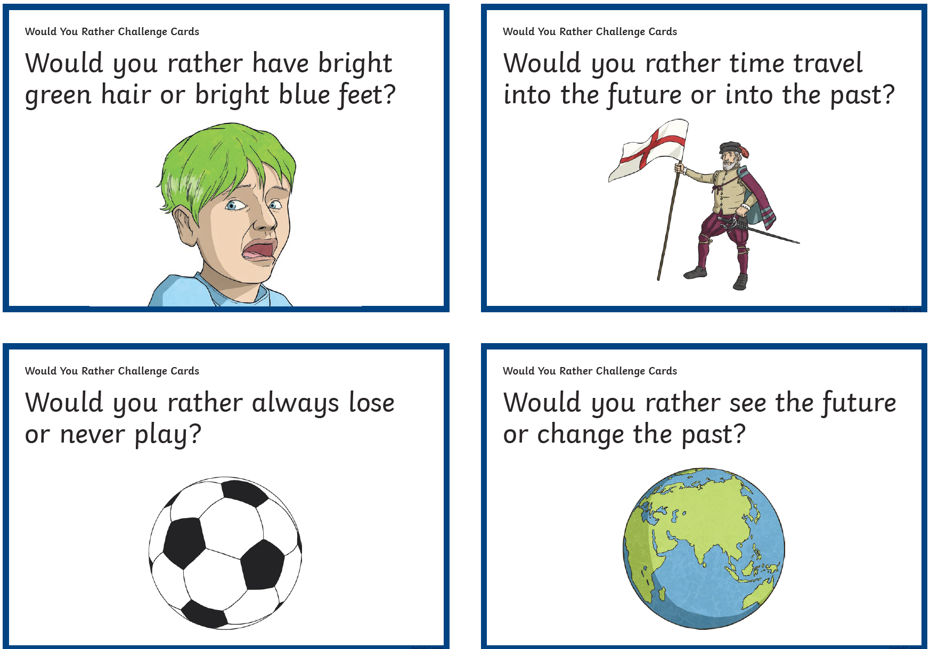
PE Easier
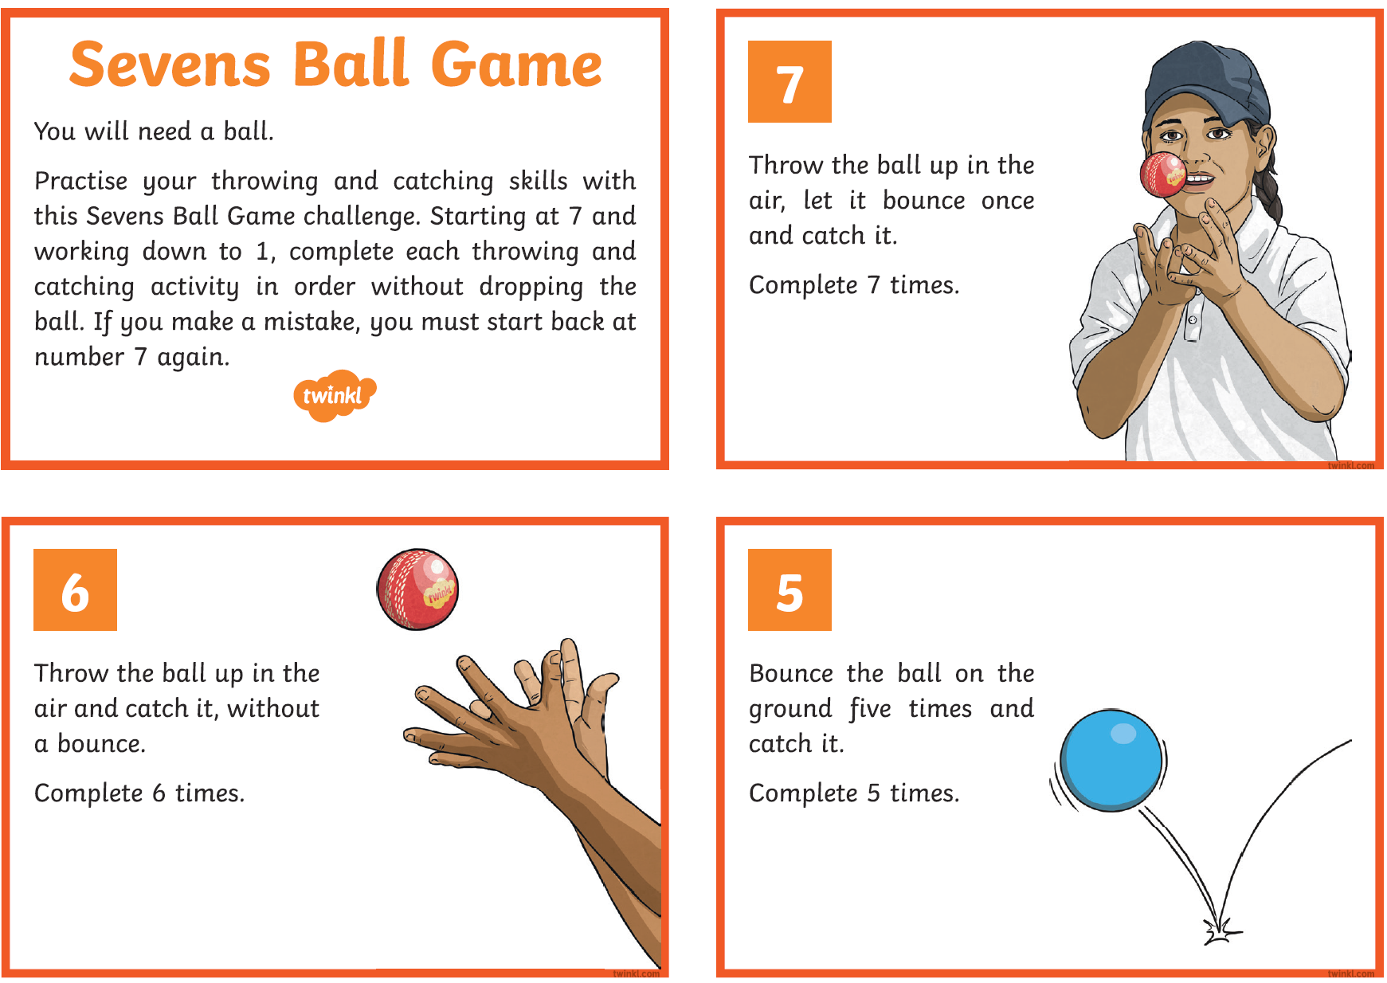
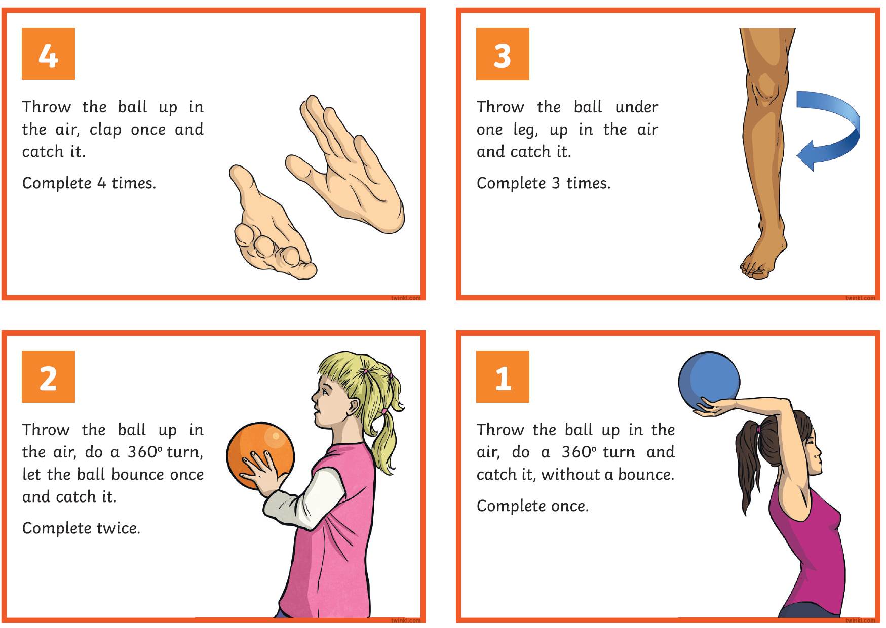

PE Year 6
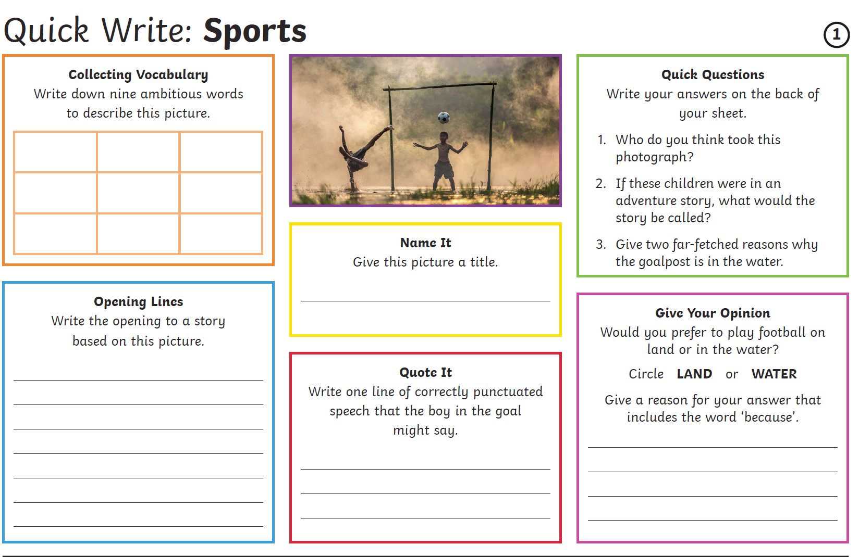
Other Activities
Times tables  Build up speed. Time yourself how long it takes you to answer 0 to 12 x tables in mixed order (work with an adult). | Get active.  With an adult, think of at least two different exercises you can do at home e.g. in the garden. You must exercise for at least half an hour a day. | Use Purple Mash and play online learning games.  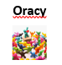  Choose from would you rather activities. | Watch the news and choose any 3 stories to summarise. | Mindfulness  Try out some of the activities attached to help you relax.  How many different mindful techniques can you think of?  Which is your favourite?

Key skills to continue practicing weekly:
-spellings
-grammar (go through revision booklets)
-speed reading
-speed writing (count the number of words you can write in one minute)
-neat and joined up handwriting
-timetables (build up speed)

If you or your child has any further queries regarding their learning projects, please contact admin@hardwick.derby.sch.uk, clearly stating your child’s name and class teacher, and the staff will be in touch to support you and your child.

Thank you and stay safe.

