B LO - To know how to use decimal notation when recording measures

Can you now write mass in three ways and convert between them?

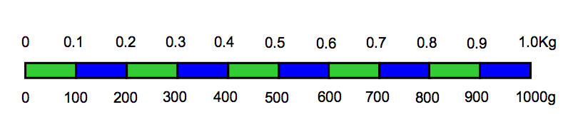

Kg and g | g
1kg 250g

 | 1700g
 | 1450g
2Kg 400g

 | 2800g
5Kg 300g

3Kg 700g

 | 800g
1kg 900g

 | 3750g
 | 4800g

