Home Learning
Week Commencing: 15th June 2020
Teachers: Mrs Bletcher
TAs: Mrs White
Message from staff:
Hello! We hope you have had a lovely week enjoying the windy and wet weather! It has been a bit cold, but hopefully the weather will cheer up soon! We are so pleased to hear that you and your families are all well, and that you have been having lots of fun at home. We can’t believe we are in our final half term of Nursery: The year has gone by so quickly! As ever, we are SO proud of our kind, funny, and clever nursery children. All our love, Mrs Bletcher and Mrs White xx
If you have any queries over home learning please don’t hesitate to get in touch via admin@hardwick.derby.sch.uk and we will get back to you quickly!

Your Home Learning this Week:
Every day (Monday to Friday), make sure you choose a *physical, *communication, *reading/phonics, *writing and *maths learning activity. There are also further activities to choose from should you wish to.
Physical Home Learning
Monday | Tuesday | Wednesday |  | Thursday | Friday
Develop your fine motor skills by using a soapy sponge to scrub your grown-ups car or your bike or scooter!  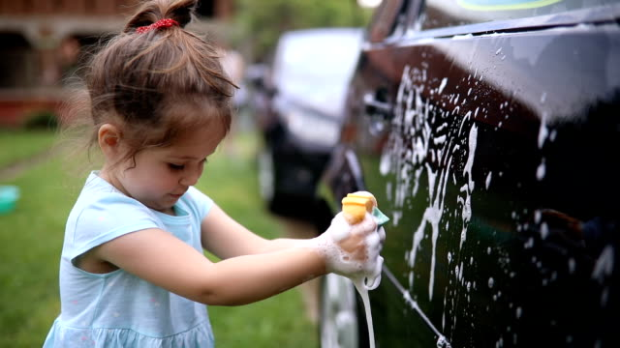 | Develop your fine motor skills by using a soapy sponge to scrub your front or back door! | Develop your fine motor skills by using a soapy sponge to help scrub clean your plate and cutlery from lunch time! |  | Develop your fine motor skills by fastening the buttons on your cardigan, or zip on your hoody, by yourself. | Develop your fine motor skills by dressing yourself in the morning, and putting your pyjamas on at night.
Easier:  Do as many of the above activities as you can. If you are finding some of the activities challenging, try these as they are a little easier:  - Practise your toileting by not wearing a nappy and using the toilet with a grown-up.  - Explore squeezing a soapy sponge with your hands to squeeze the water out.  - Try taking your socks off by yourself and putting them back on again.  - Try taking your jumper off by yourself. |  |  | Challenge:  If you feel you need a further challenge, try these:  - Try juicing oranges and lemons by squeezing the fruits until the juice comes out.  - Use scissors to cut out a zigzag or spiral.  - Help your grown-up make food by chopping and mixing ingredients.  - Make a sandwich independently for lunch, using a knife to spread filling and cut the bread.
Communication Home Learning
Monday | Tuesday | Wednesday |  | Thursday | Friday
Have a go at retelling the story of ‘Naughty Bus’ to your grown-up. | Tell your grown up what you can see in the picture below. What do you think is happening? Why? | Tell your grown up what you can see in the picture below. What do you think is happening? Why? |  | How do you think the Naughty Bus feels when he is sent out into the garden? Why do you think this? | Would you like to be friends with the Naughty Bus? Why?
Easier:  Do as many of the above activities as you can. If you are finding some of the activities challenging, try these as they are a little easier:  - Can you find a picture of a toy you have at home in the story? Use your words to say what you can see.  - Can you sing ‘The Wheels on the Bus’ and join in with the actions?  - What sound does a bus make? Example: Beep Beep |  |  | Challenge:  If you feel you need a further challenge, try these:  - How does the girl feel when she can’t find the Naughty Bus? Why?  - How does the Naughty Bus feel after he has had a shower? Why do you think this?
Reading/Phonics Home Learning
Monday | Tuesday | Wednesday |  | Thursday | Friday
Can you think of a word that starts with the sounds:  -S (Examples: Snake)  -A (Example: Apple)  -T (Example:  Tiger)  -P (Example: Penny)  -I (Example: Igloo)  -N (Example: Nugget)  See link below to pronounce each phoneme (unit of sound) correctly)  Remember, alliteration is when words start with the same sound. | Practise making the following letter sounds in the mirror. What shape does your mouth make? What does your tongue do?  -S  -A  -T  -P  -I  -N  -C  -M  -R  -B  -F  -L  -K  -SH  -Z | Listening carefully to your grown up, have a go at sounding out the following CVC words we looked at last week:  a-t (at)  s-a-t (sat)  c-a-t (cat)  m-a-t (mat)  r-a-t (rat)  b-a-t (bat)  i-t (it)  s-i-t (sit)  i-p (ip)  t-i-p (tip)  sh-i-p (ship)  a-p (ap)  s-a-p (sap)  m-a-p (map) |  | Listening carefully to your grown up, have a go at sounding out the following CVC words:  a-n (an)  s-a-n (san)  t-a-n (tan)  p-a-n (pan)  n-a-n (nan)  Listen carefully to the words you are blending. Do they rhyme? How do you know? | Listening carefully to your grown up, have a go at sounding out the following CVC words:  m-a-n (man)  c-a-n (can)  r-a-n (ran)  f-a-n (fan)  b-a-n (ban)  Listen carefully to the words you are blending. Do they rhyme? How do you know?
Easier:  Do as many of the above activities as you can. If you are finding some of the activities challenging, try these as they are a little easier:  - Explore making sounds with your body (Example: Clapping, stomping, tapping)  - Develop your listening skills by joining in with the actions for ‘The Wheels on the Bus’  - Fill a bottle with rice or pasta to make a musical shaker. Explore making quiet and loud sounds. |  |  | Challenge:  If you feel you need a further challenge, try these:  - Have a go at matching a sound to its corresponding letter in the alphabet.  - Have a go at writing the letters of any words you have sounded out. (Example: c-a-t to cat)  - Can you find any objects in your home that start with the sounds s, a, t, p, i, n? Can you write their names down, matching sounds to letters correctly?  - Have a go at breaking words down into individual phonemes (Example: Cat to c-a-t). Can your grown up guess what you are trying to say?

Writing Home Learning
Monday | Tuesday | Wednesday |  | Thursday | Friday
Practise writing the first letter in your name. | Draw your own story map about a vehicle of your own choosing: It could be a digger, a motorbike, or a hot air balloon!  Below is an example of a previous story map.  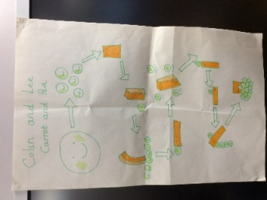 | Practise writing your full name by yourself. Can you write how old you are underneath?  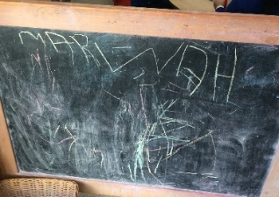 |  | Draw or paint a picture of the Naughty bus’s garden. | Have a go at retelling the Naughty Bus story by writing it down. You may need your grown up to help you!
Easier:  Do as many of the above activities as you can. If you are finding some of the activities challenging, try these as they are a little easier:  Explore drawing circles and lines when shown by a familiar adult.  - Explore drawing circles and lines in the air with your finger.  - Explore drawing zigzags, spirals, and crosses in the air with your finger.  - Practise forming zigzags, crosses, spirals and circles when shown by a familiar adult. |  |  | Challenge:  If you feel you need a further challenge, try these:  - Can you identify the initial sound and write the initial grapheme of bike? (b)  - When you write your story, can you sound out any familiar words or letters to add to your story map?

Maths Home Learning
Monday | Tuesday | Wednesday |  | Thursday | Friday
Where is teddy?  Model: Teddy is in the box. | Find a teddy in your home.  Can you put teddy on the chair?  Can you put teddy under the chair? | Where is the Naughty Bus?  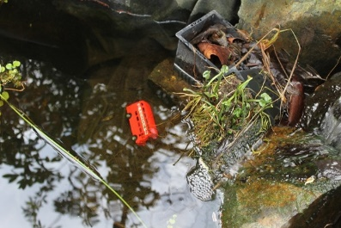  The Naughty Bus is in the water. |  | Where is the Naughty Bus?  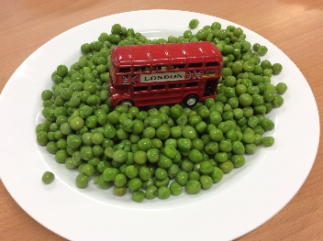  The Naughty Bus is in the peas.  Or…  The Naughty Bus is on the plate. | How many?  Remember to count the holes of Numicon!
Easier:  Do as many of the above activities as you can. If you are finding some of the activities challenging, try these as they are a little easier:  - Have a go at showing 0, 1, 2, 3 and 4 on your fingers.  - Sing ‘1 potato, 2 potato, 3 potato, 4, joining in with actions and vocalisations.  - Count 0-10 as rockets.  - Have a go at counting three toys by yourself. |  |  | Challenge:  If you feel you need a further challenge, try these:  - Have a go at drawing arrows to lead to one of your toys. Can your grown-up or sibling follow your arrows?  - Using a teddy from your home, can you place him on a chair, under a chair, next to the chair, and behind a chair.

Other Activities
Sing one of your favourite Nursery Rhymes every day.  Examples include:  -Wind the bobbin up  -Miss Polly had a Dolly  -Two little Dickey birds  -5 little Peas | Ask your grown-up to put on your favourite songs to dance to and join in with. | Draw a picture of what you have done at home every day. | Develop your fine motor skills by helping your grown- up make breakfast, lunch, and dinner. | Think about what your favourite thing to do at Nursery is. Draw a picture of it, tell your grown up, and then email us so we can make sure we do it when we get back!

Key skills to continue practising weekly:
- Children should be practising being independent with their toileting at home.
- Children should be starting to be more independent in dressing/removing clothes themselves. Examples include: Taking their jumper off when hot, putting on shoes on, and starting to do zips and buttons
- Encouraging children to use at least four words in their sentences (Example: ‘I ate toast for breakfast’. This can be supported through modelling.

If you are able to access the internet, try these useful websites:
- Alphablocks: Alphablocks is excellent for blending CVC words!
- Letters and Sounds overview: This is what we follow in Phonics!
- Singing Hands: Singing hands are fantastic at providing Makaton actions for familiar Nursery Rhymes!
- Youtube ‘The Naughty Bus’ to watch a great animated version of our quality text.

If you or your child has any further queries regarding their learning projects, please contact admin@hardwick.derby.sch.uk, clearly stating your child’s name and class teacher, and the staff will be in touch to support you and your child.

Thank you and stay safe.

