FS2 Home Learning
Week Commencing: 4th May 2020
FS2 teachers: Mrs Connelly-Haywood and Miss Ralph
FS2 TAs: Miss Hayat
Message from staff:
Miss Ralph: Hello, I am really looking forward to meeting you all when we return back to school. I hope you and your families are all well and you have been enjoying your time at home. I look forward to hearing about what you have been up to and getting to know you all. Take care, from Miss Ralph.
Mrs Connelly-Haywood: Hello everyone, I hope that you have had another good week at home. It has been another busy week for us. In my spare time this week, I have been doing lots of running and cooking. I cannot wait to hear about what you have been up to at home. Take care everyone!
Your Home Learning this Week:
Every day (Monday to Friday), make sure you choose a *physical, *communication, *reading/phonics, *writing and *maths learning activity. There are also further activities to choose from should you wish to.
Physical Home Learning
Practice your movements by moving like insects e.g. fly like a butterfly, crawl like a caterpillar. Can you create your own movements for other minibeasts and insects? | With an adults supervision, use a knife to cut up pieces of fruit and make a yummy fruit salad | Continue to practice your scissor skills – cut out your own wings with different shapes to stick onto them. | Join in with a Cosmic Kids session. How many animal poses can you learn?  Follow the link at the end. | In the garden or an outside space, see how many times you can throw and catch a ball. Use different sized balls

Communication Home Learning
Listen to ‘The Very Hungry Caterpillar’ story. Discuss what happened in the story. If you have a copy of the book, you could follow the story.  Follow the link at the end. | Can you remember the fruit in the story? Draw the pieces of fruit and retell the story using your pictures. The text map will also help you to remember the story. | Discuss your favourite fruit. What fruit do you not like and why?  I like ___ because ___.  I do not like ___ because ___. | Have a look at the minibeast PowerPoint. Which minibeasts can you see? Have you ever seen these minibeasts/insects in real life?  Powerpoint link at the end. | Can you describe different minibeasts using these words?  Fast, slow, hard, soft, slimy, tickly, delicate, long, short.  What does the word symmetrical mean? Can you use it to describe a minibeast?

Reading/Phonics Home Learning
Focus on the digraph ‘ai’. Read and write the words:  wait hail pain aim sail main tail rain bait | Focus on the digraph ‘ee’. Read and write the words:  see feel weep feet meet deep seep | Focus on the digraph ‘igh’. Read and write the words:  high light night fight sigh tonight might tight | Focus on the digraph ‘oa’. Read and write the words:  coat load toast moat boat soap goat | Focus on reading and writing these key words in a sentence.  was my

Writing Home Learning
Draw a picture of the fruit and food that the caterpillar ate each day and label each picture. | Discuss different minibeasts and write names of them E.g. caterpillar, butterfly, moth, spider, ant, fly. | Using your list of minibeasts/insects, can you write a sentence to describe each of them?  The ant had ___  The spider is ___  The caterpillar has ___ | Write sentences for a different bug and what they eat. You can make these up or you can research what each bug really eats.  The butterfly eats ___ | The caterpillar eats something different on each day of the week. Write each of the days of the week in order. Remember to use capital letters for each day.  Challenge – What did you eat on each day?

Maths Home Learning
What is a pattern? Can you create a  pattern using 2 colours? 3 colours? | Can you create a pattern by drawing different 2d shapes?  Triangle, square, rectangle, circle, hexagon, oval | Play a pattern game online using the link below. There are different levels of the games to challenge yourself. | Go on a shape hunt at home. Stick 2d shapes around the house and find real life objects that are 3d shapes e.g. a tin is a cylinder  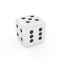  Sphere, cylinder, cube, cuboid, pyramid, cone  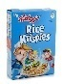  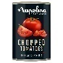 | Discuss what symmetrical patterns are. Can you create your own pattern symmetrical patter? You can paint on one side of paper and fold it in half to create a symmetrical pattern.  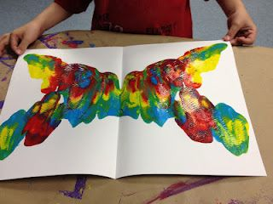

Other Activities
Make a caterpillar out of an egg box  Link to different ideas below | Find minibeats in the garden/outside and make a list of the minibeasts you find. | Sort minibeasts in different ways, e.g. how many legs they have, what colour they are. | Ask everyone in your house their favourite fruit record your findings in a graph or draw a picture to share what you found out. | Watch ‘Come outside – Butterflies’  Link below.

Key skills to continue practicing weekly:
Write your name.
Practice handwriting – try to form the letters on the line correctly.
Form numbers correctly.
Getting changed on your own.
Zip your coat up on your own.
Useful websites:
The Very Hungry Caterpillar - https://www.youtube.com/watch?v=75NQK-Sm1YY

Ladybird spot counting - https://www.topmarks.co.uk/learning-to-count/ladybird-spots

Caterpillar to butterfly time lapse - https://www.youtube.com/watch?v=63B1lnqPa8k

Come outside Butterflies - https://www.youtube.com/watch?v=7l6nnv9ijBQ

What is the minibest power point - https://www.twinkl.co.uk/resource/t-t-10417-minibeast-what-can-you-see-powerpoint

Cosmic Kids Yoga - https://www.youtube.com/watch?v=xhWDiQRrC1Y
Egg box caterpillar - https://www.wikihow.com/Make-an-Egg-Carton-Caterpillar

Shape pattern game - https://www.topmarks.co.uk/Search.aspx?q=FINISH%20THE%20PATTERN

If you or your child has any further queries regarding their learning projects, please contact admin@hardwick.derby.sch.uk, clearly stating your child’s name and class teacher, and the staff will be in touch to support you and your child.

Thank you and stay safe.

*Hungry Caterpillar Below:

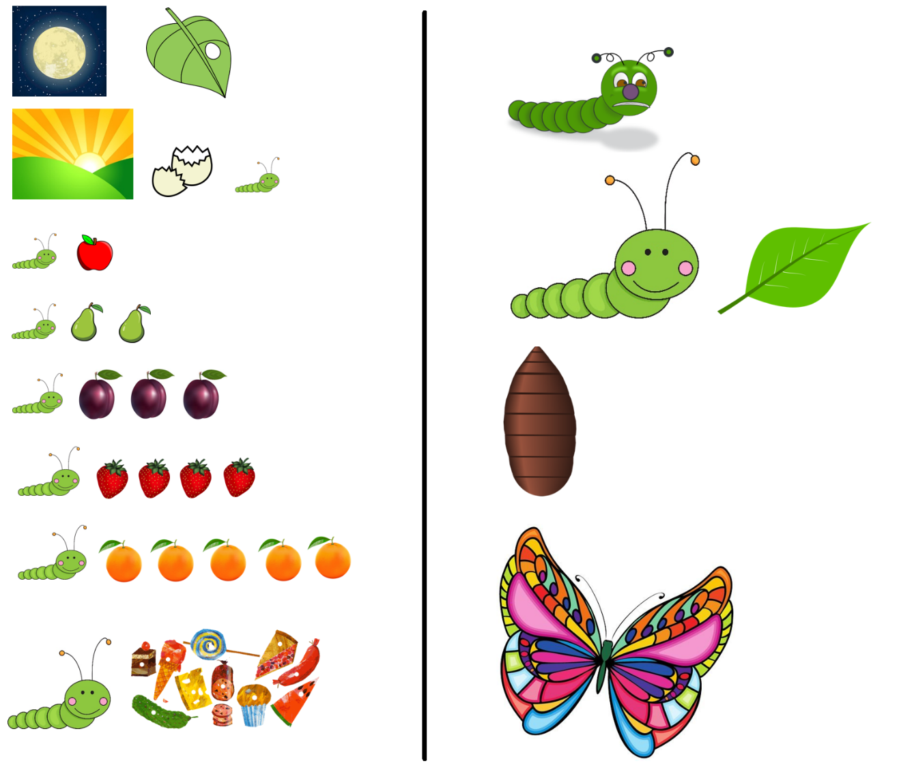
The Very Hungry Caterpillar

By Eric Carle

