Phonics and Key Words

Key Words

Practise reading these key words:

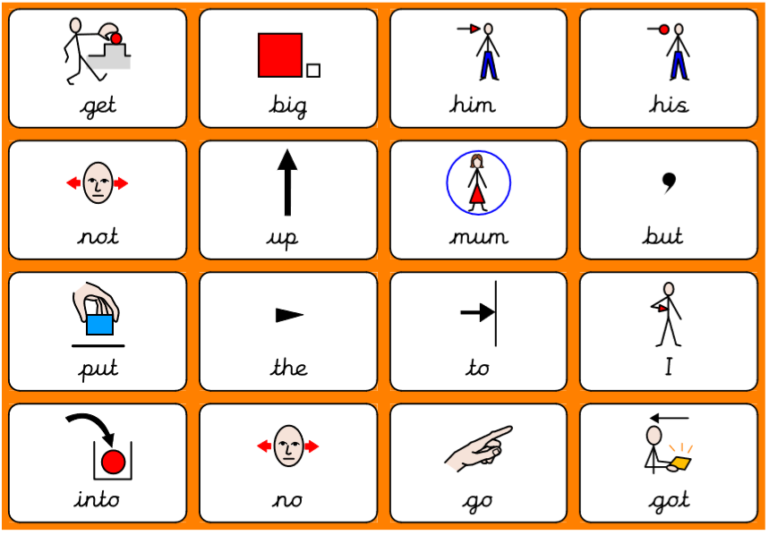

Practise writing these key words. The first two you can look to make sure you are spelling it right. Next, give it a go without looking. Lastly, check is you spelled it right!

Key word | Practise 1  (copy into space) | Practise 2  (copy again) | Practise 3  (fold and hide) | Can spell word  (check and correct)
get
big
him
his
not

Key word | Practise 1  (copy into space) | Practise 2  (copy again) | Practise 3  (fold and hide) | Can spell word  (check and correct)
up
mum
but
put
the

Key word | Practise 1  (copy into space) | Practise 2  (copy again) | Practise 3  (fold and hide) | Can spell word  (check and correct)
to
I
into
no
go

Phonics:

Read and write the following words. First segment the words e.g. cat – c – a – t. Then, try and read the words without segmenting them!

Focus GPCs = ‘J V W X’

y | z/zz | qu
yap | zip | quit
yes | zot | quick
yet | Zak | quack
yell | zat | liquid
yem | buzz | quiz
yun | jazz | queep
yin | lizz | quag
yum-yum | zigzag | quot

Give it a go reading the following questions. Remember to try and not segment the key words in RED.

Can a rabbit yell at a man?
Is a zebra a pet?
Can a web buzz?
Can a duck quack?
Which sentence do you think goes with which picture?
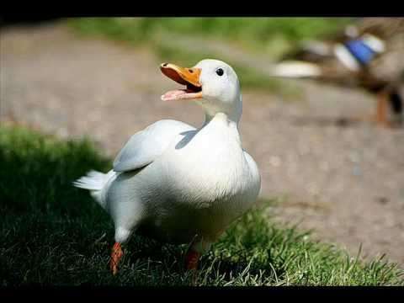

Handwriting:

Keep practising your handwriting – remember to write on the line! You can practise on any paper! If your paper does not have line – draw some!
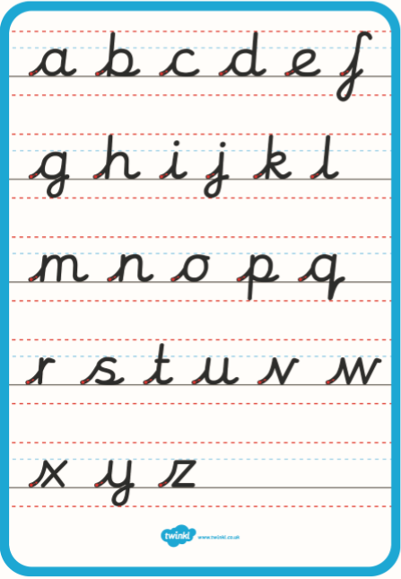

Practise your handwriting with the following words:

yes
yell
jazz
zip
quit
liquid
Everyday English:

Look at the following picture. What can you see? What are they doing? See if you can get someone to read you the questions.
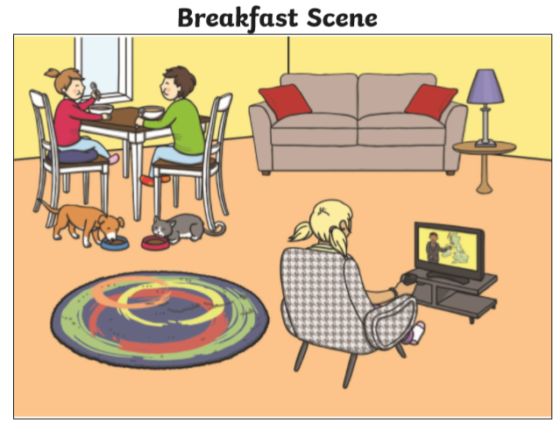

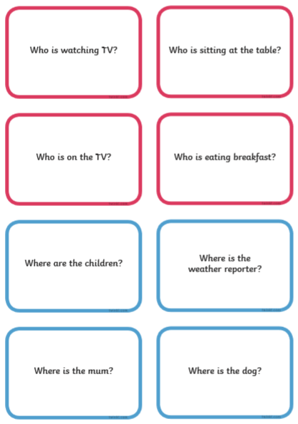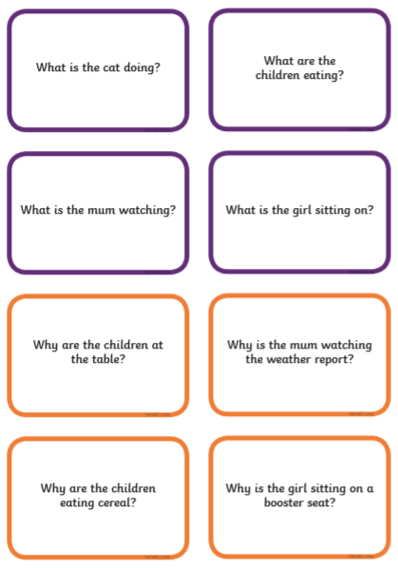

Try and use the following words:

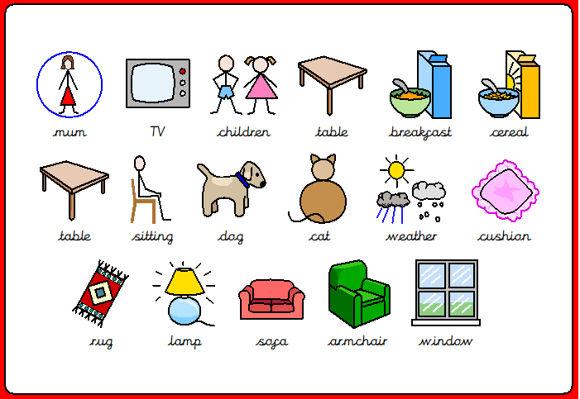

I-spy game!

Play I-spy with someone in your house. Then, complete the sheet. You can write the answers on any piece of paper.
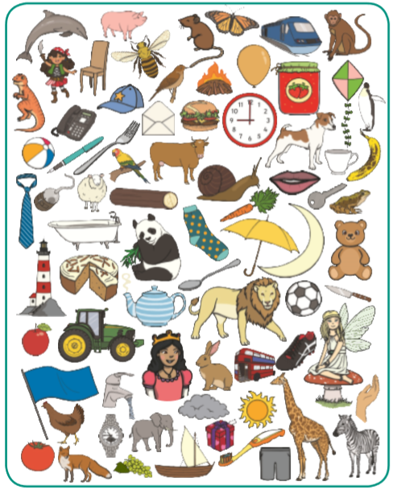

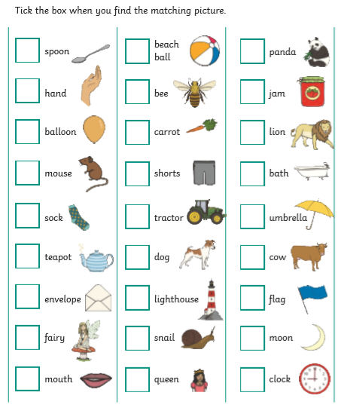

Talk!

Discussion of the week!
Look at the following question and discuss it with someone. Tell them WHY!
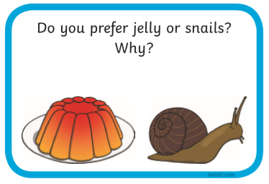

Useful websites:

Have a look at the following websites

- https://www.bbc.co.uk/cbeebies/shows/alphablocks - great phonics videos!
- https://www.bbc.co.uk/cbeebies/shows/numberblocks - great number videos!
- https://www.phonicsplay.co.uk/# - free to sign up!

I hope you enjoy the work and have a great week!

