Home Learning
Week Commencing: 1st June 2020
Teachers: Mrs Bletcher
TAs: Mrs White

Message from staff:
Hello, and Eid Mubarak! We hope those of you celebrating had a lovely Eid, and have had lots of fun with your families at home. We can’t believe we are now in our final half term of Nursery. So many of you will be going to Reception in September! We know the last couple of months have been so strange for everybody, but we are so proud of all of you. We feel very lucky to be your teachers. Enjoy the sunshine and spending time with your lovely families, and we can’t wait to see you soon! Big big hugs as always, Mrs Bletcher and Mrs White x
If you have any queries over home learning please don’t hesitate to get in touch via admin@hardwick.derby.sch.uk and we will get back to you quickly!

Your Home Learning this Week:
Every day (Monday to Friday), make sure you choose a *physical, *communication, *reading/phonics, *writing and *maths learning activity. There are also further activities to choose from should you wish to.

Physical Home Learning
Monday | Tuesday | Wednesday |  | Thursday | Friday
Using the playdough recipe we provided, use your hands to roll, fold and pat samosas and roti for Eid. | Develop your fine motor skills by using your hands to roll balls of playdough sweets for Eid. | Develop your fine motor skills by using a knife and fork by yourself to eat your dinner this week! |  | Develop your fine motor skills by cutting or peeling pieces of fruit to make a fruit salad for snack.  Try a piece of fruit you haven’t eaten before! | Develop your fine motor skills by dressing yourself in the morning, and putting your pyjamas on at night.
Easier:  Do as many of the above activities as you can. If you are finding some of the activities challenging, try these as they are a little easier:  - Practise your toileting by not wearing a nappy, and using the toilet with a grown-up.  - Explore making marks with your fingers in the playdough.  - Try taking your socks off by yourself, and putting them back on again.  - Try taking your jumper off by yourself. |  |  | Challenge:  If you feel you need a further challenge, try these:  - Try forming the letters of your name with playdough.  - Try forming a spiral independently with playdough.  - Help your grown-up make food for a celebration by chopping and mixing ingredients.  - Make a sandwich independently for lunch, using a knife to spread filling and cut the bread.
Communication Home Learning
Monday | Tuesday |  | Wednesday | Thursday | Friday
If you have access to the internet, develop your listening skills by following the link to our new quality text ‘The Lion who wanted to Love.’ Can you remember what happened in the story?  https://www.youtube.com/watch?v=o3hU_aR71M0 | Tell a grown up what you can see in the picture from the story.  What do you think is happening? Why?  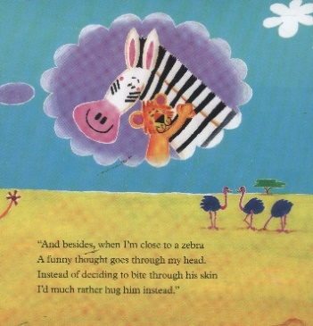 |  | Why do you think Leo wants to help all the animals in the jungle?  Example: Leo wants to help the animals because he is kind. | How do you think Leo feels when he sees his Mummy again?  Example: Leo feels happy when he sees his Mummy. | How would you feel if you met Leo in the jungle? Why?  Example: I would feel happy if I met Leo in the jungle because he is kind.
Easier:  Do as many of the above activities as you can. If you are finding some of the activities challenging, try these as they are a little easier:  - What sound does a snake make? Sssssssss  - Can you find a picture of an elephant in the story? Use your words to say what you can see.  - Is Leo a big or a small lion? Example: Small lion cub |  | Challenge:  If you feel you need a further challenge, try these:  - How does Leo look after his friends in the jungle? Why?  - How does Leo feel when he can’t get out of the water? Why?  - How does Leo feel when he is saved by the animals? Why?

Reading/Phonics Home Learning
Monday | Tuesday | Wednesday |  | Thursday | Friday
Can you think of a word that starts with the sounds:  -S (Examples: Snake)  -A (Example: Apple)  -T (Example: Tiger)  -P (Example: Penny)  -I (Example: Igloo)  -N (Example: Nugget)  If you have the internet, see link below to pronounce each phoneme (unit of sound) correctly)  Remember, alliteration is when words start with the same sound. | Practise making the following letter sounds in the mirror. What shape does your mouth make? What does your tongue do?  -S  -A  -T  -P  -I  -N  -C  -M  -R  -B  -F  -L  -K  -SH  -Z | Listening carefully to your grown up, have a go at sounding out the following CVC words we looked at last week:  a-t (at)  s-a-t (sat)  c-a-t (cat)  m-a-t (mat)  r-a-t (rat)  b-a-t (bat)  i-t (it)  s-i-t (sit)  n-i-t (nit)  p-i-t (pit) |  | Listening carefully to your grown up, have a go at sounding out the following CVC words:  i-p (ip)  s-i-p (sip)  t-i-p (tip)  p-i-p (pip)  n-i-p (nip)  Listen carefully to the words you are blending. Do they rhyme? How do you know? | Listening carefully to your grown up, have a go at sounding out the following CVC words:  m-i-p (mip)  k-i-p (kip)  z-i-p (zip)  sh-i-p (ship)  l-i-p (lip)  Listen carefully to the words you are blending. Do they rhyme? How do you know?
Easier:  Do as many of the above activities as you can. If you are finding some of the activities challenging, try these as they are a little easier:  - Go into your garden and listen to the sounds. What can you hear? Can you draw what you heard?  - Explore making sounds with your body (Example: Clapping, stomping, tapping)  - If you have the internet, develop your listening skills by joining in with the Makaton actions for ‘Peter Rabbit had a fly upon his nose’ (Youtube Makaton Singing Hands Peter Rabbit had a fly upon his nose) |  |  | Challenge:  If you feel you need a further challenge, try these:  - Play ‘I Spy’ with your grown up or sibling, identifying sounds independently.  - Have a go at matching a sound to its corresponding letter in the alphabet.  - Have a go at writing the letters of any words you have sounded out. (Example: c-a-t to cat)  - Can you find any objects in your home that start with the sounds s, a, t, p, i, n?

Writing Home Learning
Monday | Tuesday | Wednesday |  | Thursday | Friday
Practise writing the first letter in your name. | 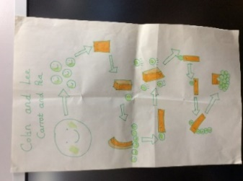  Retell the story of ‘The Lion who wanted to Love’ by drawing your own story map. Below is an example of a previous story map. | Practise writing your full name by yourself.  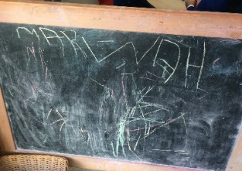 |  | Draw a mehndi pattern. Include lots of spirals, zigzags, and swirls!  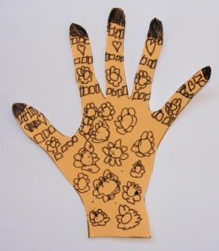 | Make an Eid card for your friends or family. Write your name inside the card so they know it’s from you!  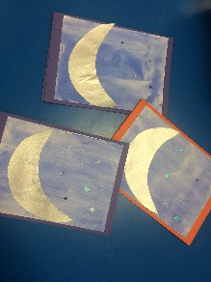
Easier:  Do as many of the above activities as you can. If you are finding some of the activities challenging, try these as they are a little easier:  - Explore drawing circles and lines when shown by a familiar adult.  - Explore drawing circles and lines in the air with your finger.  - Explore drawing zigzags, spirals, and crosses in the air with your finger.  - Practise forming zigzags, crosses, spirals and circles when shown by a familiar adult. |  |  | Challenge:  If you feel you need a further challenge, try these:  - Can you identify the initial sound and write the initial grapheme of snake? (S)  - Can you identify the initial sound and write the initial grapheme of elephant? (E)  - Can you identify the initial sound and write the initial grapheme of a friend at Nursery? Example: ‘B’ for Ben.

Maths Home Learning
Monday | Tuesday | Wednesday |  | Thursday | Friday
Where is the arrow pointing? Use your words to explain. | Where is the arrow pointing? Use your words to explain. | Who is the arrow pointing to? Use your words to explain.  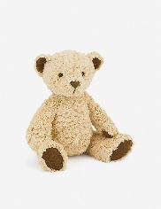 |  | Who is the arrow pointing to? Use your words to explain. | How many?  Remember to count the holes of Numicon!
Easier:  Do as many of the above activities as you can. If you are finding some of the activities challenging, try these as they are a little easier:  - Have a go at representing 0, 1, 2 and 3 on your fingers.  - Sing ‘1 potato, 2 potato, 3 potato, 4, joining in with actions and vocalisations.  - Count 0-10 as rockets. |  |  | Challenge:  If you feel you need a further challenge, try these:  - Have a go at drawing arrows. Tell a grown-up which direction they are facing.  - Draw two people who live in your house. Draw an arrow pointing in the direction of one of the people you have drawn.

Other Activities
Sing one of your favourite Nursery Rhymes every day.  Examples include:  -Wind the Bobbin Up  -Miss Polly had a Dolly  -Two Little Dickey Birds  -5 Little Peas | Ask your grown-up to put on your favourite songs to dance to and join in with. | Draw a picture of what you have done at home every day. | Develop your fine motor skills by helping your grown- up make breakfast, lunch, and dinner. | Think about what your favourite thing to do at Nursery is. Draw a picture of it, tell your grown up, and then email us so we can make sure we do it when we get back!

Key skills to continue practising weekly:
- Children should be practising being independent with their toileting at home.
- Children should be starting to be more independent in dressing/removing clothes themselves. Examples include: Taking their jumper off when hot, putting on shoes on, and starting to do zips and buttons
- Encouraging children to use at least four words in their sentences (Example: ‘I ate toast for breakfast’. This can be supported through modelling.

If you are able to access the internet, try these useful websites:
- Alphablocks: Alphablocks is excellent for blending CVC words!
- Letters and Sounds overview: This is what we follow in Phonics!
- Singing Hands: Singing hands are fantastic at providing Makaton actions for familiar Nursery Rhymes!

If you or your child has any further queries regarding their learning projects, please contact admin@hardwick.derby.sch.uk, clearly stating your child’s name and class teacher, and the staff will be in touch to support you and your child.

Thank you and stay safe.

