Year 3 Home Learning
Week Commencing: 6.7.20
Year 3 teachers: Mrs Begg, Mrs Lumsden, Mrs Priestland, Mr Rogers
Year 3 TAs: Miss Batool, Mrs Stringer
Message from staff:
Hello everyone. School is filling up with staff and pupils beginning to come back to school. This week your teachers will be ringing you up to say Goodbye from Year Three. Be ready to tell us about your best memory from Year 3 and what you are looking forward to in Year 4. Teachers have been planning the new learning for next year and thinking about how we can all stay safe and happy at school.

Your Home Learning this Week:
Every day (Monday to Friday), make sure you choose a *reading, *writing, *spelling/handwriting, *maths and *theme learning activity. There are also further activities to choose from should you wish to.

Reading Home Learning
Monday | Tuesday | Wednesday |  | Thursday | Friday
The text you will read is called “How to brush your teeth.”  BEFORE you read it, make a quick list of what you predict will be in this text. These might be key words, phrases or complete sentences.  Now read the text and you score one point for everything you guessed correctly! | Use the text to help you write instructions to tell people how to brush their teeth. Remember, instructions have a summary of the contents at the top, a list of things you will need (you could use commas in a list here!) and uses numbers to keep the instructions organised. | The main 3 reasons authors write is to:  Persuade (make the reader understand their opinion, and convince them to think the same as them)  Inform (to teach the reader about something new)  Entertain (to amuse the reader with a thrilling story or a funny poem)  Complete the page about the author’s purpose for writing. |  | Read the 2nd text “Tooth brush games”  This is about the same subject (brushing teeth) but it is very different.  Can you identify 5 differences between the 2 texts? (think about the author’s purpose, the text features for information texts)  Are there any similarities between these 2 texts? (for example topic specific vocabulary) | Read through the texts again and try to improve them! You could:  - cross out verbs and replace with ones you feel work better.  - Add in adjectives to help describe.  - Join 2 sentences using a conjunction.  - Insert other technical vocabulary (for example, use the word ‘plaque’ from the 2nd text correctly in the first)
Easier: Do as many of the above activities as you can. If you are finding some of the activities challenging, try these as they are a little easier:  - Get someone at home to help you read the text  - Write out some connections to the text (connections between the texts and your life, or the text and other stories you know)  - Write some questions that you would like to ask Tim and Tina. Remember to use question marks.  - As you read, write down any verbs from both ot the texts (remember, verbs are action words like dance or wash) |  |  | Challenge:  If you feel you need a further challenge, try these:  Some tricky questions! (these use inference…putting together what is read AND what you know)  - Where about could your ‘molars’ be in your mouth? Can you spot the clue in the text?  - What is the relationship between Tim and Tina? What make you think this?  - How did Tim feel at the end of the story? Can you really tell? Are there any clues?  - What might have happened next? Would they go straight to bed?
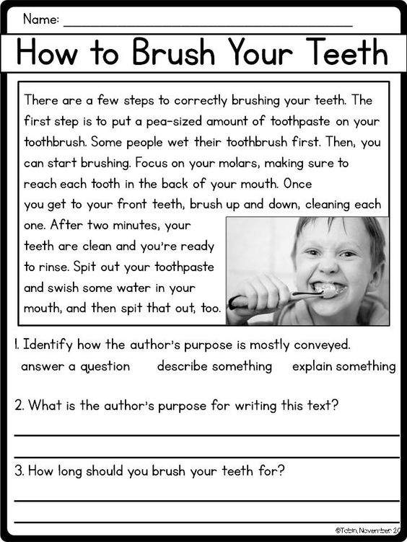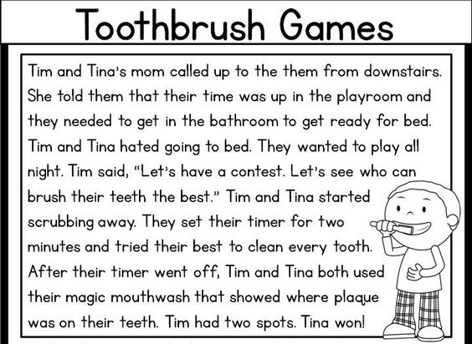
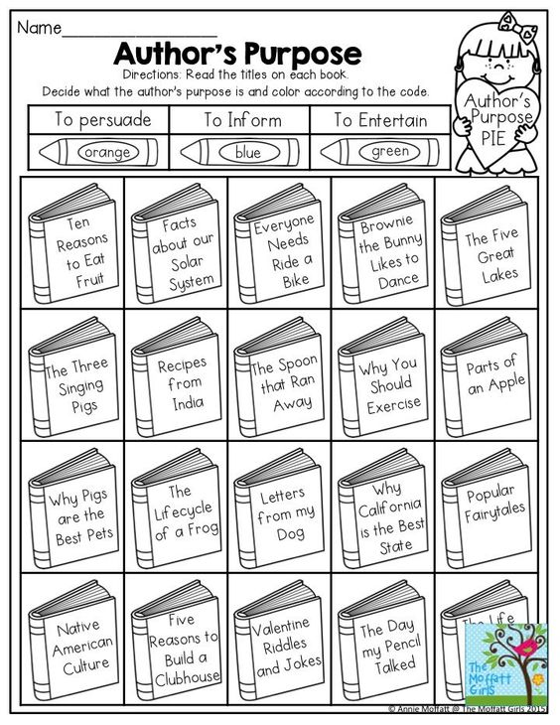
Writing Home Learning
Monday | Tuesday | Wednesday |  | Thursday | Friday
Read the text “Sun safety.”  This type of text is an infographic poster It displays information to try to excite people into reading it.  How do you think the layout of this text helps the reader to learn from it?  Write out the words in the text connected to the topic of ‘sun safety’ | This piece of writing has quite a friendly tone. It sounds like a clever, kind person chatting to you to help you understand.  Can you write some friendly warning sentences to advise using ‘while” like in the SHADE part? They can be about anything.  While is it exciting to…  While it is fun to….  While it is appealing to…  While it is thrilling to…  While it is wonderful to… | The first tip uses ‘but’ to join together two opposite ideas. (clothing could make you hot, BUT it helps protect your skin). Write out your own ‘but’ sentences.  They could be about foods, pets, hobbies… anything! Remember you need a positive point and a negative point about the same subject.  NOTE: the comma goes before the word but to make the reader pause before continuing. |  | Write some sentences that start using the conjunction ‘when’  These sentences have 2 events. When you do this, you do this.  For example,  When you are in the sun, (1st event) you should drink lots of water. (2nd event)  When you go shopping, it is a good idea to take a list.  NOTE: the comma comes in between the 2 events. | Try and write your own infographic about something you know a lot about. If could be about a computer game or about characters in a TV show.  Make sure your sentences teach the reader something new in each section. Draw symbols that catch the eye to make the reader want to learn more!
Easier:  Do as many of the above activities as you can. If you are finding some of the activities challenging, try these as they are a little easier:  - Write sentence using ‘when’ When I go to the park I will…..  - ‘ly’ words describe how something is done. For example, The cat stretched slowly. Write some sentences using ‘ly’ words. |  |  | Challenge:  If you feel you need a further challenge, try these:  - Write your own infographic about how to survive ‘lockdown’ What would be your 5 top tips? Copy the sentence starter ideas to make your infographic have a friendly, but helpful tone of voice.
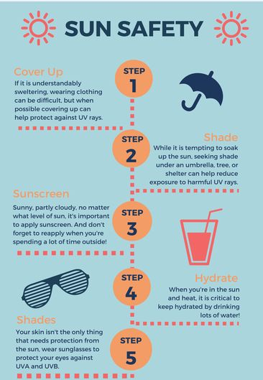
Spelling/Handwriting Home Learning
Monday | Tuesday | Wednesday | Thursday |  | Friday
Look at the meanings of root words ‘photo’ and ‘cycl’  You can see how these Greek words make up words in the English language.  Can you finish the definition part on each sheet? Use the ‘word parts’ bit to help you think of a good definition. | The prefix ‘de’ comes from Latin and means ‘undo’ or ‘do the opposite of’.  Can you write definitions for these words. Look at the word parts to help you.  Decrease Demist  Defrost Defuse  Decaffeinated  Decompose  Declaw Decode  Defog Degrease  Demystify | Draw pictures to help you remember the meaning of these homophones.  Root- route  Weave – we’ve  Rows – rose  Soul – sole  Real – reel  Red - read  Days – daze  Berry – bury  Patients – patience | Look at the list of words containing silent letters.  Practise writing the out suing pyramid writing, alternate colours or use bubble writing.  The choice is yours! |  | Write out the alphabet down a sheet of paper.  Now try and think of an animal that starts with each letter of the alphabet. Try to spell them correctly, and use your best hand writing! (you can’t use my ideas!!)  Ant  Beaver  Cow
Easier:  Do as many of the above activities as you can. If you are finding some of the activities challenging, try these as they are a little easier:  - When making the plural (more than one) of a word ending y, remove the y and ies. For example baby – babies, teddy-teddies. Now try city duty pony  - Silent ‘w’ is often followed by an ‘r’ then a vowel. For example wrap wreck wrist wrong write practise writing out these spellings. |  |  |  | Challenge:  If you feel you need a further challenge, try these:  Have a go at the word order sheet. Read it carefully and try to say the sentence correctly in your head before you start to write.
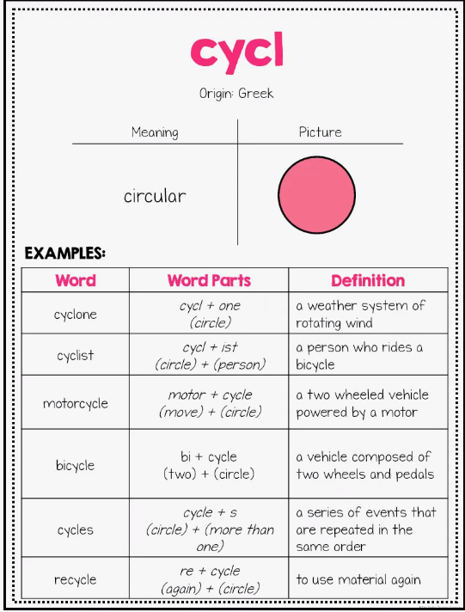
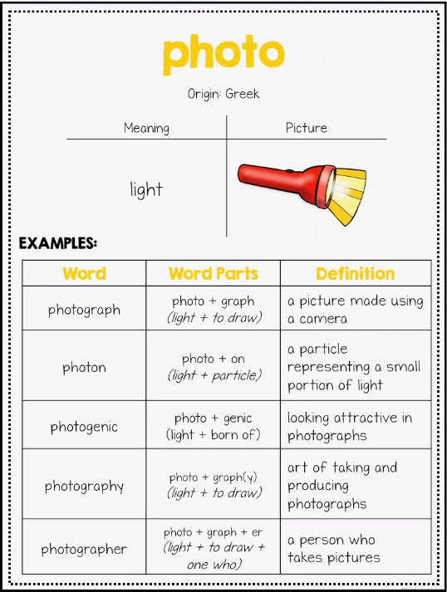
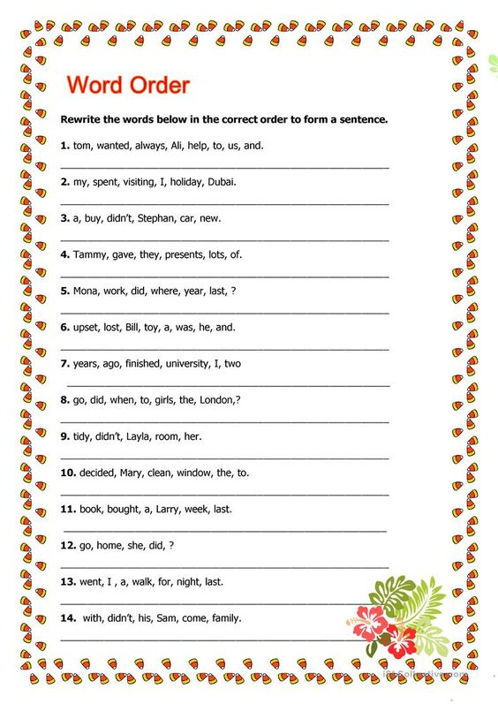
Maths Home Learning
Monday | Tuesday | Wednesday |  | Thursday | Friday
Read the sheet “identifying parallel lines”  Then complete the next sheet (worksheet 2) to circle pairs of parallel lines and name lines that are parallel to each other on the shapes. | Complete the shape patterns below where the shapes turn.  Now make up 3 of your own shape patterns. Remember to colour them in. | Read the information about “making angles”  Then complete the following worksheet (angles) to identify pairs of lines that make angles, and where there are angles in different capital letters. |  | Complete the problem solving below about Dora and the 12th shape in the pattern.  Remember to explain your thinking. | Complete the lollypop stick challenge below.  You can use pencils or strips of paper to test out our ideas.
Easier:  Do as many of the above activities as you can. If you are finding some of the activities challenging, try these as they are a little easier:  - A ‘right angle’ is a square corner. Can you find any square corners in your house? Make a list of the ones you can find. |  |  | 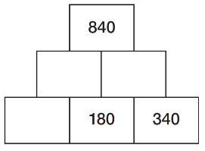  Challenge:  If you feel you need  a further challenge,  try this Can you work out  what numbers go on this  pyramid? (hint, use + and  - calculations)
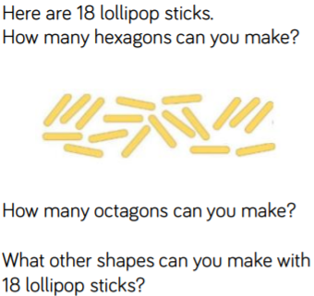
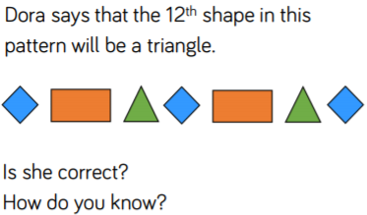
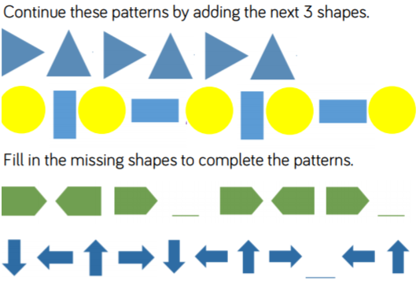

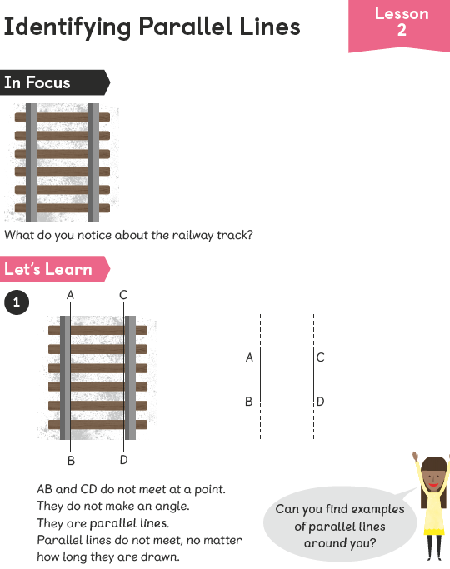
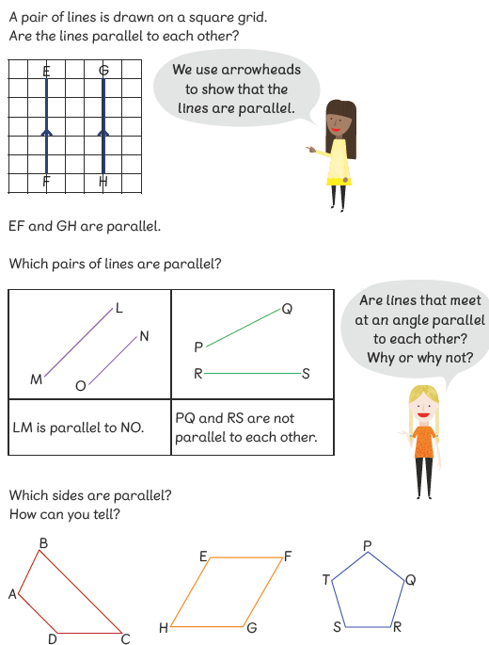
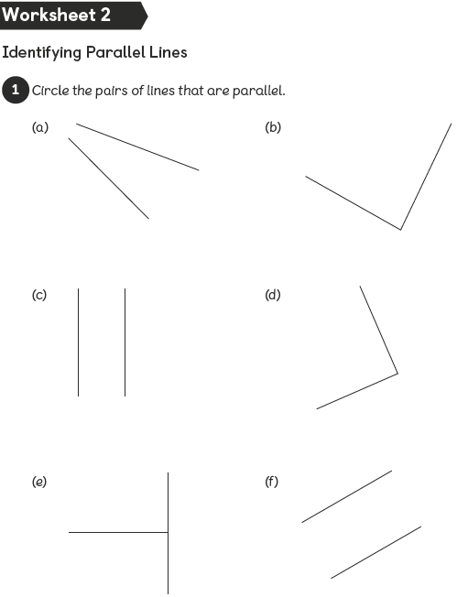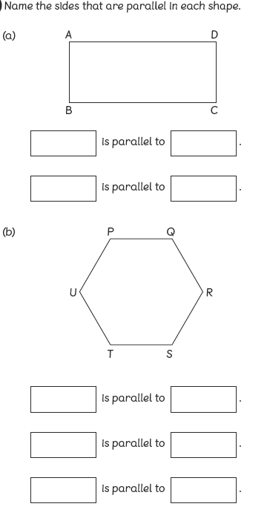
Remember: lines are names by the 2 letters at either end.
TU
UP
AB
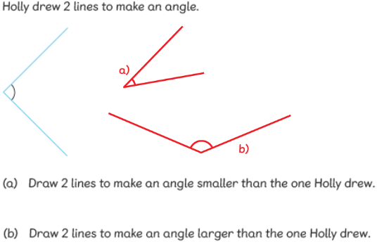
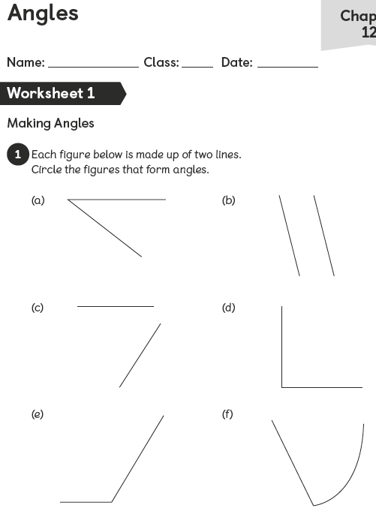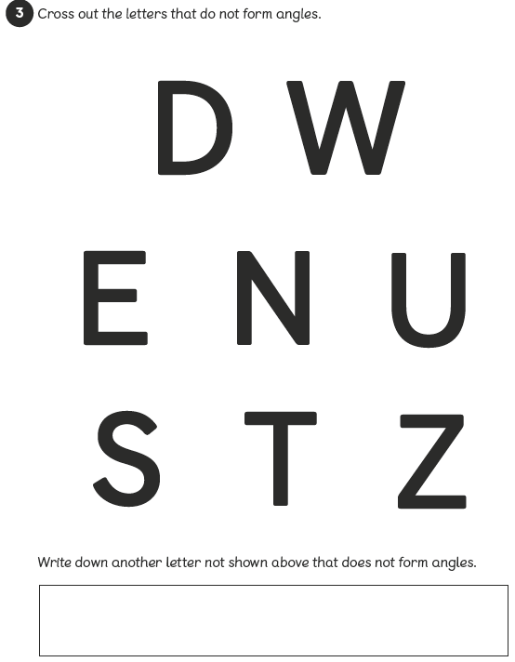
Theme Home Learning –
Monday | Tuesday | Wednesday | Thursday | Friday
Art: explore warm and cool colours.  Can you create a sun and moon picture which uses cold-feeling colours (like blue, purple and green) for the moon and warm-feeling colours for the sun?  Use different patterns to help decorate the picture. 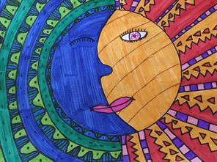  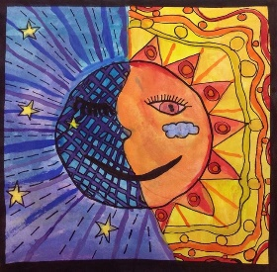 | Oracy:  Have a go at the “one breath” boxes. (there is an easy sheet and a harder sheet!)  Which is the longest list you do in one breath? Remember, the person listening must be able to hear each word clearly do don’t mumble to rush through them. | Philosophy:  Would you rather?  - Live in the countryside  - Live in a big city.  - Live by the seaside  - Live on a farm  Remember to give reasons why you have picked yours, and why not the others. Compare your answer with someone else in your family. Do you change their mind? Do you change your mind? | Oracy: choose a topic from the “talk about sports for 1 minute” and time yourself speaking about the question.  You can have 1 minute to think about the question before you have to talk.  Can you talk without lots of gaps?  Do you explain your answer clearly? | Philosophy:  The BIG question.  Could kindness change the world?  What do you think? Do your ideas match other’s in your family or not?  Think about how kindness makes you feel. Is it more important to be kind to yourself or to others, or is it of equal importance? Think about the effect of kindness and unkindness on the world.

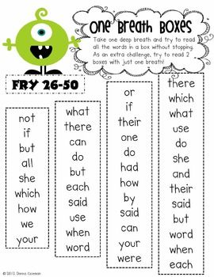
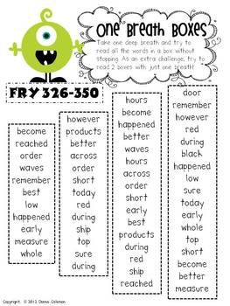
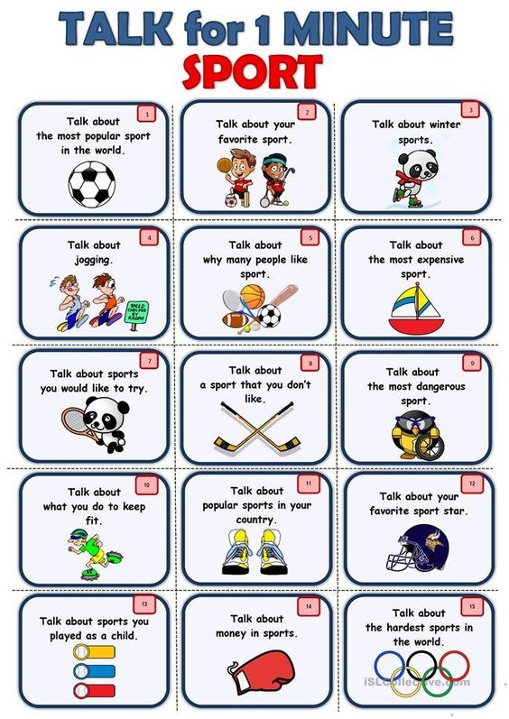
Other Activities This week we will look more closely at what make you, YOU!
Read all of the personal qualities and circle the ones you thin apply to you. Include the good and the bad ones.  Write your top 5 which best describe you at the bottom.  Remember to do some mindful breathing every day. | Complete the sheet about your strengths.  Include what you think as well as what others have said to you before.  Remember to do some mindful breathing every day. | Learn about the good and bad personal qualities.  Can you use the sheet to look at the upside and downside to each personality trait.  Remember to do some mindful breathing every day. | Write a build a friend sheet. Think carefully about what you’d like in a friend, not just when things are good, but also when you need help or someone is being treated unkindly. What you would you want your friend to do?  Remember to do some mindful breathing every day. | Complete the mindful breathing activities for the week.  Follow the sheet to do your mindful breathing, once you are nice and calm, read  ‘the tunnel’ and ‘The river’. Think about what they mean to you.

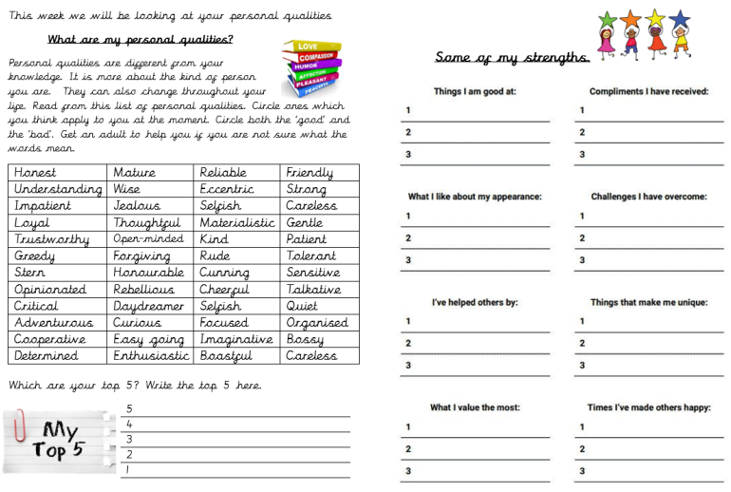

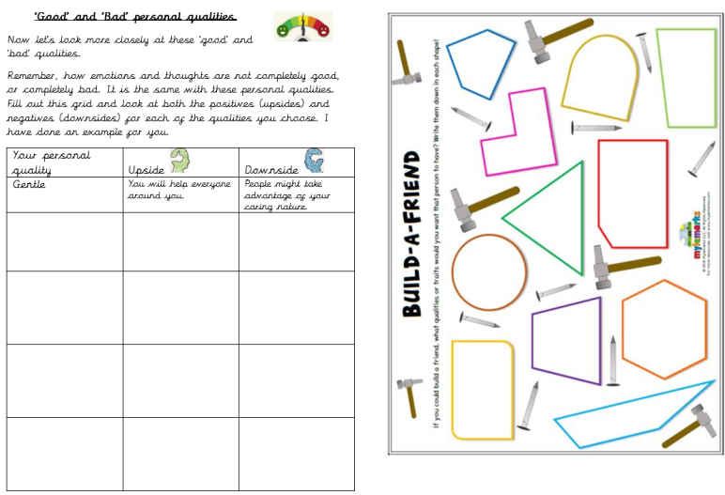

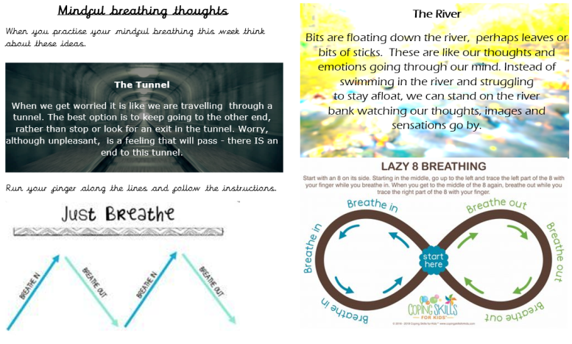

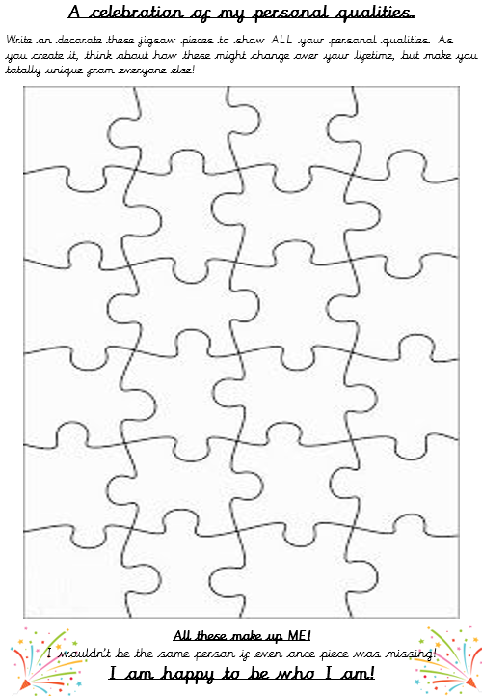

Key skills to continue practising weekly:
- 2, 3, 4, 5, 8, 10 times tables
- Quick addition and number facts 9+7 11 – 5

- Year One, two and three spelling sheets
- Reading any books, newspapers, cereal packets, websites you can find
If you are able to access the internet, try these useful websites:
- BBCbitesize/daily lessons
- https://www.youtube.com/user/CosmicKidsYoga- Cosmic Yoga is amazing. There are lots of yoga stories, mindfulness activities and active exercises for you to do.
- https://scratch.mit.edu/- we would be doing this if we were at school. Have an explore of Scratch and learn how to code. Make the cat move, speak and even dance. Create new characters, change the background and have some fun.

If you or your child has any further queries regarding their learning projects, please contact admin@hardwick.derby.sch.uk, clearly stating your child’s name and class teacher, and the staff will be in touch to support you and your child.

Thank you and stay safe.

