Year 6 Home Learning
Week Commencing: 8th June 2020
Year 6 teachers: Mrs Haider, Miss Qayoom, Mr Nowak
Year 6 TAs: Mrs Yar-Khan
Message from staff: It was lovely to catch up with you all again and speak to you. It is great to know that everybody is doing well.
Keep safe and don’t forget to complete an hour of physical activity daily.
Continue to work through Purple Mash using your logins.
Remember to collect your booklets from school. If you are still experiencing difficulties, please get in touch.

Reading Home Learning
Monday | Tuesday | Wednesday |  | Thursday | Friday
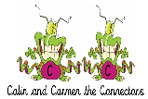  You will be reading a text about how Muslims celebrate Eid ul-Fitr and the purpose of the festival. Make connections with what you already know about Eid ul-Fitr. Are there any interesting facts you know? Have you heard anything about this from your friends/family on the television or elsewhere (e.g. newspapers)? Ask the people you live with if they know anything. | Read ‘The Islamic Celebration’ text, using reading skills to help you understand as you go through it. Highlight any words you do not understand and find the meaning of them. | Summarise what you have read in the text. Remember, a summary covers the very important parts of the text (VIP). Which parts in the text do you think are important? |  | Now try answering these questions:  See the differentiated sheets (Easier, year 6 and challenge).  Explain how Eid was different/might have been different for Muslims this year due to the Corona Virus. | After reading the text on ‘The Islamic Celebration’, think of any questions you may have. Is there anything you were left wondering that was not answered? Write these questions down. Reread the text again and this time, try to answer the questions you have. Can you answer them? If not, try to research the answers or, save the questions for when we come back to school so you can research at school.
Easier:  Do as many of the above activities as you can. If you are finding some of the activities challenging, try these as they are a little easier:  - Read the text ‘The Islamic Celebration’, using reading skills to help you understand as you go through it.  - Highlight any words you do not understand and find the meaning of them.  - What type of text is this and how do you know? What do you notice about how it is set out? Have you seen anything like this before?  - Can you think of any other festivals which Muslims celebrate? Why do they celebrate them? |  |  | Challenge:  If you feel you need a further challenge, try these:  - Test yourself! How many different Eid festivals are there?  - What is the purpose of the article?  - Who is the article written for? How did you decide on your answer?  - Why do you think the writer included ‘Did you know’ sections?  Go back to the text. Ask an adult to test you to see if you can explain the meaning of the new words you have learnt.  - Use the new words by writing sentences of your own.
Reading Easier
Reading Year 6
Reading Challenge

Writing Home Learning
Monday | Tuesday | Wednesday |  | Thursday | Friday
There has been a lot of disagreement regarding whether schools should open in June due to the Corona Virus.  You were asked to watch Newsround and daily updates from the government about the Corona Virus. This should have provided with you a detailed insight to the disagreement around the safety of children and staff should schools open.  Write all your ideas, facts and opinions so far about schools reopening in June. | Draw a table with 2 columns:  Yes schools should reopen in June No Schools should not reopen in June  1)  2)  3)  4)  5)  6)  7)  8)  9)  10)  Complete the table with at least 10 reasons for each section. | You will write a balanced argument for reopening of schools in June.  Write a title using a question.  In your first paragraph, explain why schools were closed in the first place. |  | You need to include your point which you have listed in the table (see Tuesday’s work).  You will need to write several paragraphs.  Remember, to write a balanced argument. | Edit your work. Check that you have written a balanced argument (both points of view with reasons).
Easier:  Do as many of the above activities as you can. If you are finding some of the activities challenging, try these as they are a little easier:  - When thinking of reasons for and against, you can think of 5 points for each (rather than the 10) |  |  | Challenge:  If you feel you need a further challenge, try these:  - Research using the internet what the British Medical Association have to say about safety for children to return to school.  - Watch the daily updates of news as well as the 6 0’clock news
Spelling/Handwriting Home Learning
Monday | Tuesday | Wednesday |  | Thursday | Friday
Homophones  Go through the homophone list and pick 15 homophones to learn for the week. Circle them.  Learn 3 homophones each day (learn the spellings and the meanings of the words).  Write each word into a sentence using the homophones | Ask an adult to test you on the spellings of the homophones and the definition of the homophones you have picked for the week.  Learn 3 homophones each day (learn the spellings and the meanings of the words).  Write each word into a sentence using the homophones | Ask an adult to test you on the spellings of the homophones and the definition of the homophones you have picked for the week.  Learn 3 homophones each day (learn the spellings and the meanings of the words).  Write each word into a sentence using the homophones |  | Ask an adult to test you on the spellings of the homophones and the definition of the homophones you have picked for the week.  Learn 3 homophones each day (learn the spellings and the meanings of the words).  Write each word into a sentence using the homophones | Handwriting  See handwriting sheets.  For further handwriting work see sheet on joining letter sets.
Easier:  Do as many of the above activities as you can. If you are finding some of the activities challenging, try these as they are a little easier:  - Ask an adult to help you find the definition  - Choose any two pairs of homophones to learn each day. |  |  | Challenge:  If you feel you need a further challenge, try these:  - Write 5 different types of sentences (compound or complex sentences) using the homophones each day  - Learn two extra homophones of your own choice.  - Write a poem using the homophones (topic of your own choice).
Homophones
Handwriting

brake
break
grate
great
eight
ate
weight
wait
son
sun
brake
break
grate
great
eight
Maths Home Learning
Monday | Tuesday | Wednesday |  | Thursday | Friday
Make 2 sets of digit cards from 0 to 9 (see examples) and a decimal point. Cut these out. (keep these as you will use them for other activities too). Mix the cards up and place them facing down. Make 10 sums with a range of digits, write these down and complete using addition. E.g. 345 +78904=  Repeat this with subtraction. | Using the digit cards you made yesterday, mix the cards up and place them facing down. Make 10 sums with a range of digits, write these down and complete using multiplication. E.g. 34×894=  Repeat this with division. | Read through the top tips for rounding.  Use the numbers in learning activity 1 to round to the nearest 10, 100 and 1000. Ext: Use the digits cards to make your own numbers and round to the nearest 10,100 and 1000. |  | Choose a challenge from learning activity 3 and have a go at solving it with your family. | Choose a challenge from learning activity 3 and have a go at solving it with your family.
Easier:  Do as many of the above activities as you can. If you are finding some of the activities challenging, try these as they are a little easier:  - Make a set of digit cards from 0 to 9 (see examples) Cut these out. (keep these as you will use them for other activities too.) Mix the cards up and place them facing down. Make 10 sums with a range of digits, write these down and complete using addition. E.g. 345 +7894=  - Repeat this with subtraction.  - Use the digit cards to make multiplication sums with 1 digit by 3 and 4 digit numbers.  E.g. 3 × 465  - Read through the top tips for rounding. Use the numbers in learning activity 1 to round to the nearest 10. |  |  | Challenge:  If you feel you need a further challenge, try these:  - Make sums with whole and decimal numbers, add and subtract these. e.g: 3.45 + 67 =  - Make sums with whole and decimal numbers, multiply and divide these. e.g: 3.45 × 67 =  - Read through top tips for rounding to the nearest whole and tenth. Use the numbers in learning activity 2 to round to the nearest whole and tenth.

Digit cards Top Tips
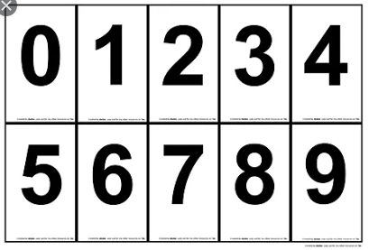
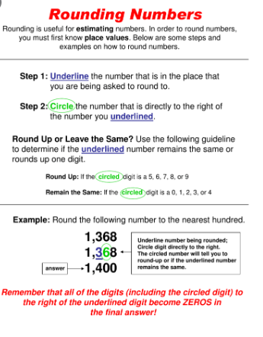

Top Tips
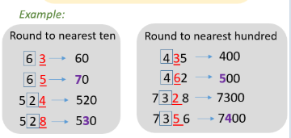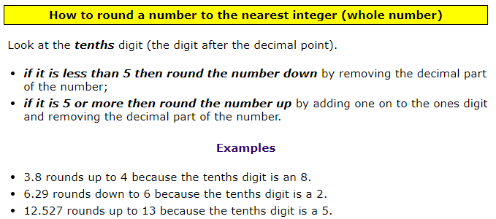
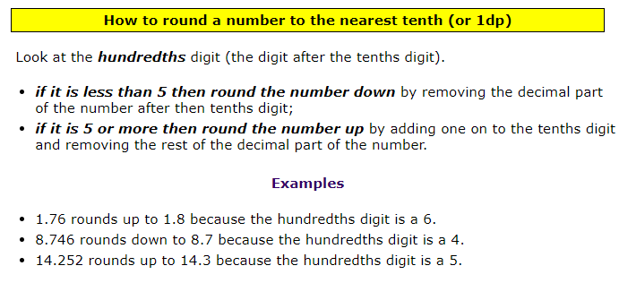

Learning activity 1 Learning activity 2
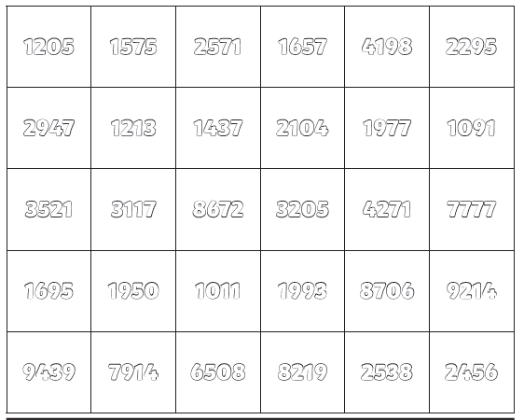
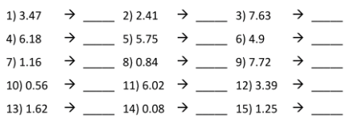

Learning activity 3- Challenge
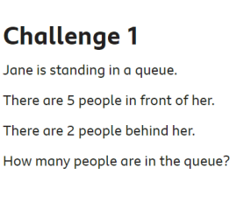
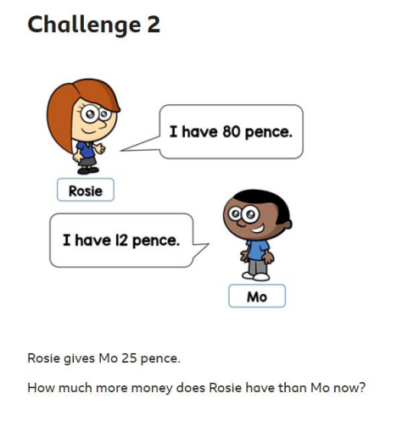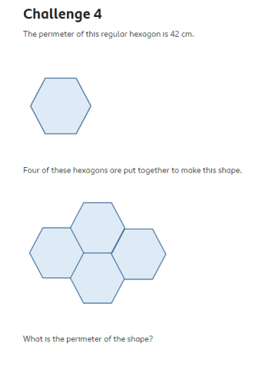
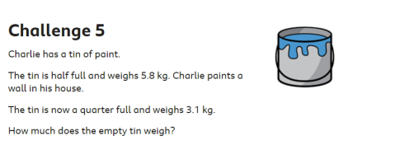
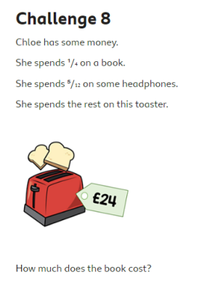

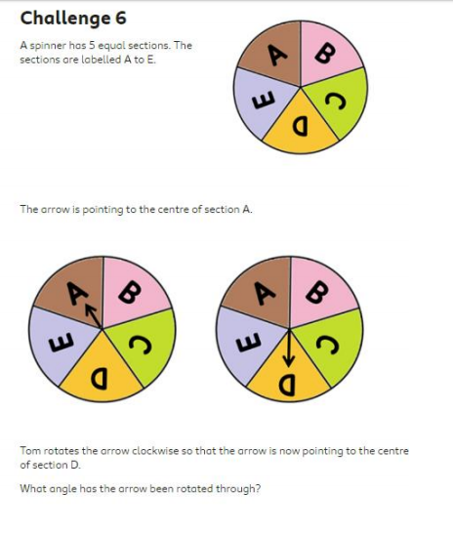
Theme Home Learning
Monday | Tuesday | Wednesday | Thursday |  | Friday
Science  Look at the Stem activities in the Science section of this booklet.  With an adult, complete the activities which you have not covered yet. Discuss with an adult how you will go about completing the activities. Have fun! | ICT  Create a poster from an adult’s point of view to tell parents what they can do to keep their child safe when they are online.  Talk it through with an adult. | ICT  See Snakes and ladder game.  Create your own board game which encourages learning to support what a child should do to stay safe online.  Make sure you have a look at the board game carefully to see the layout before your create your own game, | PSHCE  - Would you rather?  Complete 1 activity. Choose any. Write a detailed explanation. |  | PE  See PE sheet  Think of three warm up exercises you could do before playing a sport. Carry out these warm ups.  Complete any 4 activities to complete with a family member.
Easier:  Do as many of the above activities as you can. If you are finding some of the activities challenging, try these as they are a little easier:  - Science make sure you write a plan with an adult before you complete the activities  - ICT ask an adult to help you for ideas.  - PSHCE ask an adult to help you think of a reason if you are stuck.  - PE Complete any 3 activities to complete with a family member. |  |  |  | Challenge:  If you feel you need a further challenge, try these:  - Science after the activities, carrying out the activities, explain what happened and why.  - PSHCE give detailed answers using paragraphs.  - ICT create a poster to tell adults what they can do to support the safety of their child when they are online. Use features of a poster.  - PE Complete all 5 activities on the sheet with a family member.

Science

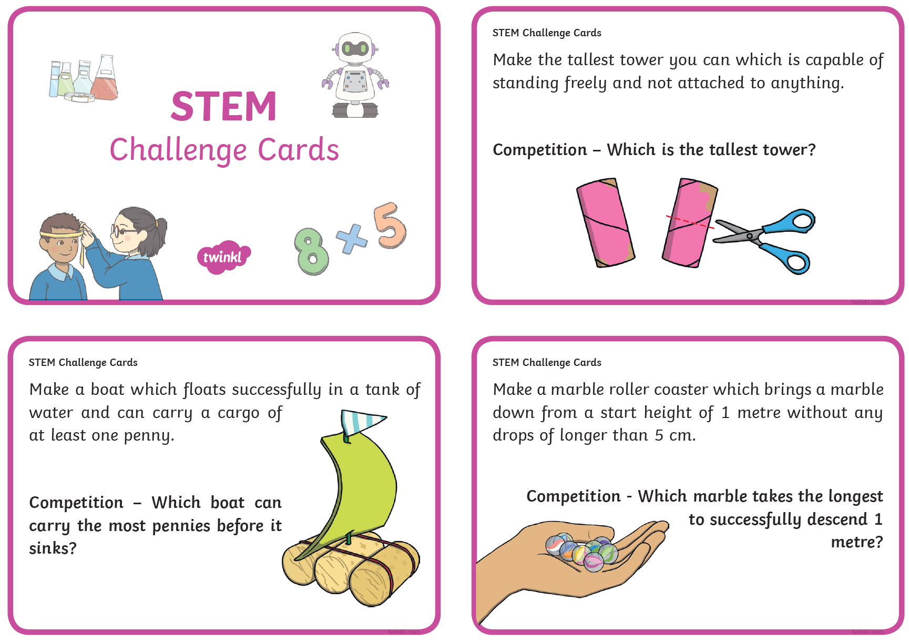
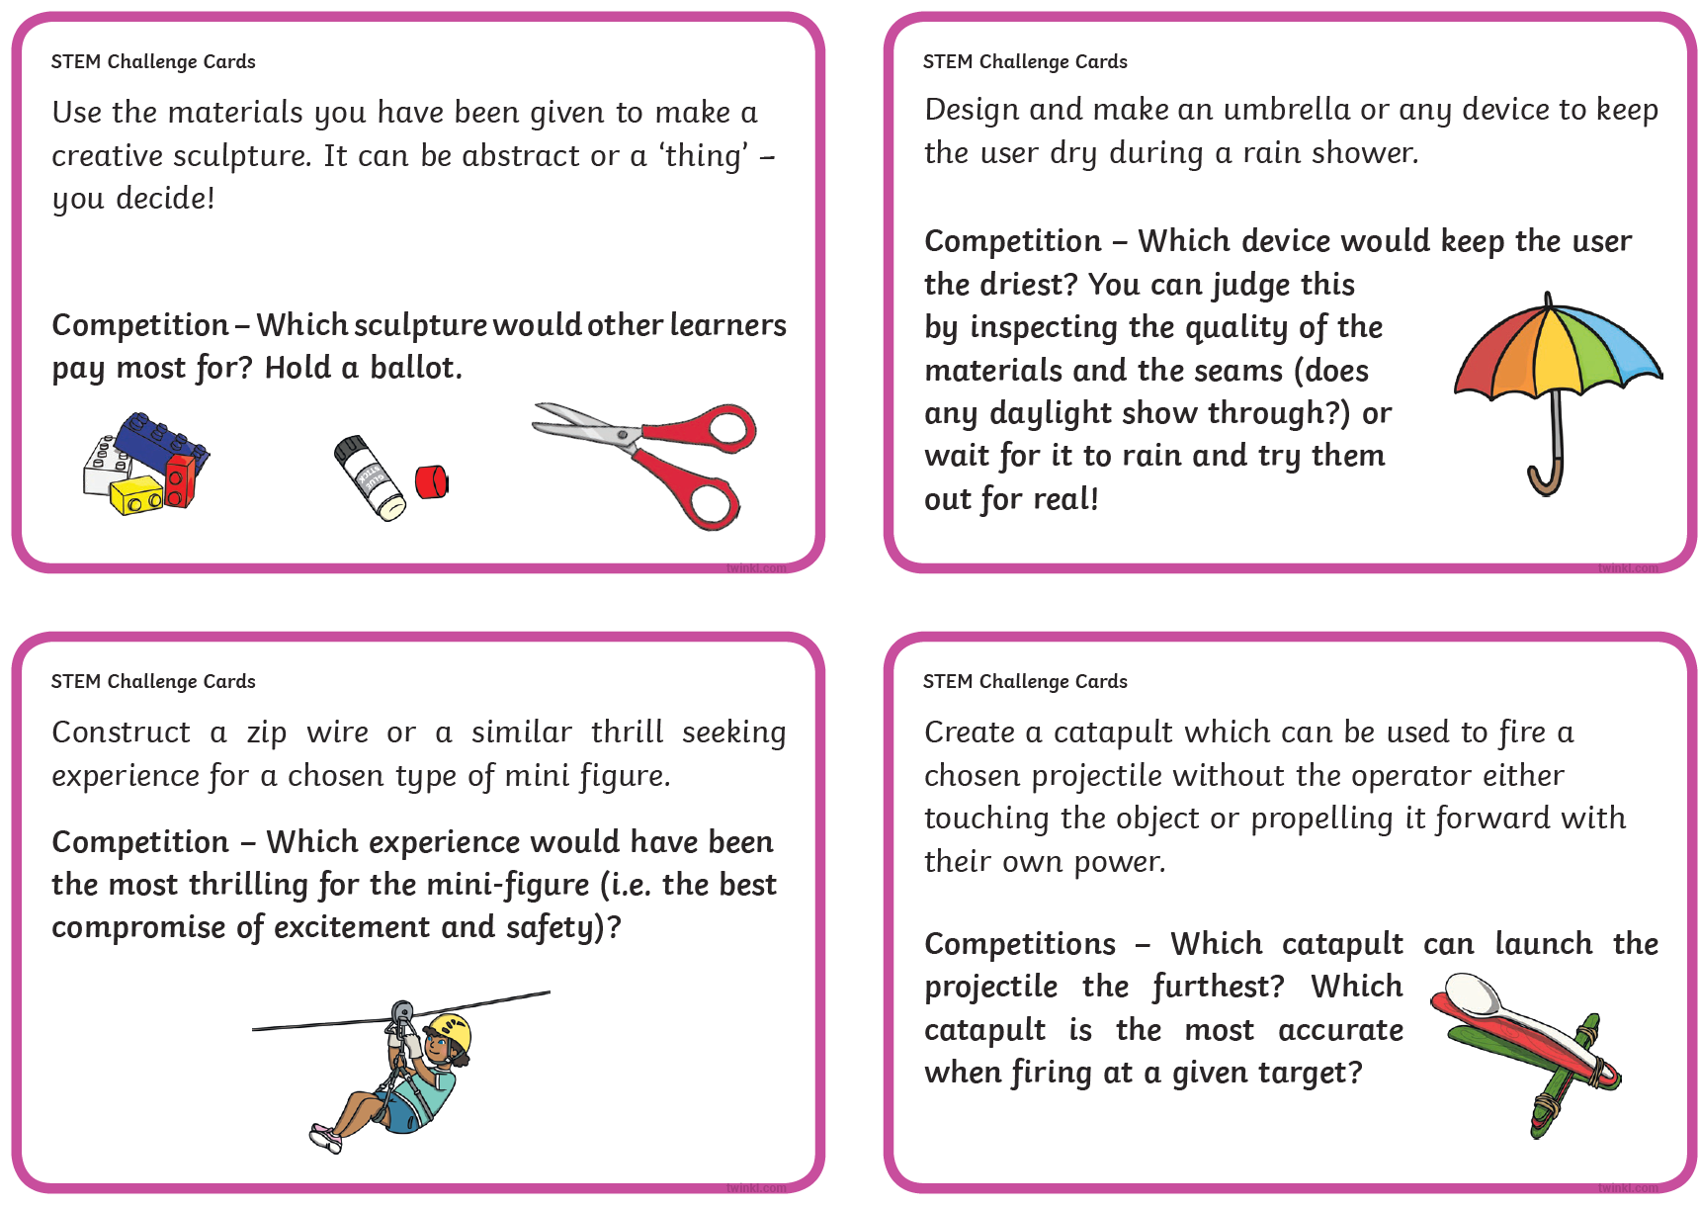

ICT
Internet safety
Example

Oracy
Would You Rather…
It is so important to talk and when we are at school, we have plenty of time to do so. However, that doesn’t mean you can’t talk even more when at home! So, to help you and give you an idea, here is an activity you can play with someone at home. For each box, make a choice; which would you rather? Remember, you can only choose one and explain why you would choose that. Don’t forget to have some fun with it!
PSHCE: Write your answer in detail (write one detailed paragraph which explains your reason).

ice – cream  or  chocolate | Bat-man  or  Wonder-woman | snowball fight  or  water balloon fight
fly  or  breathe under water | really cold  or  really hot | play inside  or  play outside
plane  or  ship | dragon  or  dinosaur | desert  or  forest

PE

Other Activities
Times tables  Build up speed. Time yourself how long it takes you to answer 0 to 12 x tables in mixed order (work with an adult). | Get active.  With an adult, think of at least two different exercises you can do at home e.g. in the garden. You must exercise for at least half an hour a day. | Use Purple Mash and play online learning games.  Choose a would you rather activity. | Watch the news and choose any 3 stories to summarise. | Mindfulness  Try out some of the activities attached to help you relax.  How many different mindful techniques can you think of?  Which is your favourite?

Key skills to continue practicing weekly:
-spellings
-grammar (go through revision booklets)
-speed reading
-speed writing (count the number of words you can write in one minute)
-neat and joined up handwriting
-timetables (build up speed)

If you or your child has any further queries regarding their learning projects, please contact admin@hardwick.derby.sch.uk, clearly stating your child’s name and class teacher, and the staff will be in touch to support you and your child.

Thank you and stay safe.

