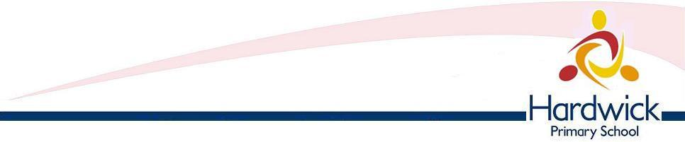

**APPLICATION FOR PUPIL PREMIUM & FREE SCHOOL MEALS FOR FULL-TIME PUPILS**

**1 - Applicant Details (Parent or Guardian claiming benefit)**

|  |
| --- |
|  |

Title: Mrs 🖵 Ms 🖵 Miss 🖵 Mr 🖵 Other 🖵🖵🖵🖵  
  
First Names:

|  |
| --- |
|  |

Surname:

Address:

|  |
| --- |
|  |
| Postcode: |

|  |
| --- |
|  |

Telephone:

National Insurance / Asylum Seeker Number: 🖵🖵🖵🖵🖵🖵🖵🖵🖵  
Date of Birth: 🖵🖵/🖵🖵/🖵🖵

**2 – Details of your Partner, if applicable.**

|  |  |  |  |
| --- | --- | --- | --- |
| First Name | Surname | Date of Birth | National Insurance / Asylum Seeker Number |
|  |  |  |  |

**3 – Children at Hardwick Primary School for whom you wish to claim Free School Meals.**

|  |  |  |  |  |
| --- | --- | --- | --- | --- |
| First Name | Surname | Date of Birth | Age | Boy/Girl |
|  |  |  |  |  |
|  |  |  |  |  |
|  |  |  |  |  |
|  |  |  |  |  |

**4 – Declaration**

* I understand that my child/ren’s entitlement to Free School Meals will only continue as long as I receive one of the relevant Support Payments (see notes over page).
* I will inform you immediately if my entitlement to any of the Support Payments is terminated.
* I understand that if I do not inform you of any change and my child/children continues to receive free meals I will have to repay the cost of any meals taken.
* I will inform you immediately if I change my address.
* I declare that I am legally responsible for the child/children I am claiming for.

I certify that the above statement and information given by me on this form is complete and true and I authorise Hardwick Primary School to take such steps as they consider necessary to verify the same.

I understand that this may involve Hardwick Primary School contacting the HMRC or the Department for Work and Pensions for confirmation of my/our entitlement.

**A DELIBERATE FALSE STATEMENT MAY LEAD TO PROSECUTION**

|  |  |
| --- | --- |
| **Signature:** | **Date:** |

**Notes**

1 – Free School Meals are only available to pupils whose parents/guardians are receiving one of the following Support Payments for the child/children named:

* Income Support
* Income Based Job Seekers Allowance
* Income Related Employment and Support Allowance
* Child Tax Credits (**provided you are NOT also entitled to Working Tax Credit**), and your annual gross income is no more than £16,190.
* Pension Credit (the Guaranteed Credit element only)
* Support under Part VI of the Immigration and Asylum Act 1999
* Universal Credit

This form must be completed by the person who claims the Support Payment in the household.

2 – If you are receiving one of these Support Payments, please let us see an up to date letter from the Department for Work and Pensions or Jobcentre confirming which Payment(s) you are receiving.

3 - All claims are checked on an online checking system provided by Link2ICT. This only confirms or denies your eligibility to claim Free School Meals: it does not give us any other information.

Please return completed form to:

Hardwick Primary School, Dover Street, Derby DE23 6QP

01332 272249

** All information provided will be treated in accordance with the Data Protection Act 1998.**

