FS2 Home Learning
Week Commencing: 11th May 2020
FS2 teachers: Mrs Connelly-Haywood and Miss Ralph
FS2 TAs: Miss Hayat
Message from staff:
Mrs Connelly-Haywood – Hello everyone! It was lovely to speak with most of you last week. I am so glad to hear that you are doing well. It has been another busy week. I have been taking my dog Winston on some lovely walks in the sun and I have been catching up with my family through video calls. I really enjoyed hearing about all of the lovely things you have been up to at home. I am looking forward to speaking to you all once again. Stay safe everyone.
Miss Ralph: Hello everyone, I hope you all had a lovely week. I am looking forward to speaking with you all this week to hear about what you have been up to and to get to know you. I have also been taking my dog Ace for lots of lovely walks in the sunshine and doing some baking in my spare time. Stay safe and I will speak to you soon!

Your Home Learning this Week:
Every day (Monday to Friday), make sure you choose a *physical, *communication, *reading/phonics, *writing and *maths learning activity. There are also further activities to choose from should you wish to.
Physical Home Learning
Monday | Tuesday | Wednesday |  | Thursday | Friday
Go for a local walk with your family. What can you see and hear? Can you spot any wildlife? | Can you move like different bugs?  If you have access to the internet, try Cosmic Kids Yoga.  All about bugs.  Can you copy the yoga positions?  Follow the link at the end. | Balancing. What is a balance? Can you practice different balances? Balance on 1 leg, 1 arm and 1 leg. How many different balances can you do? Can you balance with a partner? |  | Practice throwing a ball at a target. Can you hit the target?  Can you throw a ball into a bucket? | Can you colour in the rainbow by staying in the lines?  What colours do you need?
Easier:  Do as many of the above activities as you can. If you are finding some of the activities challenging, try these as they are a little easier:  - Practice holding a pencil and make lines and circles.  - Roll a ball to a partner.  - Make a mud pie by mixing mud and water. Stir with a stick. |  |  | Challenge:  If you feel you need a further challenge, try these:  - Draw your own rainbow and colour it in.  - Can you bounce a ball into a bucket?  - Can you balance whilst holding an object?

Communication Home Learning
Monday | Tuesday | Wednesday |  | Thursday | Friday
Play I spy outside. What can you see in your garden or on your daily walk?  Example  I spy with my little eye something beginning with… g  grass | Tell an adult a list of as many bugs you can think of.  If you have access to the internet, watch Minibeast Adventures with Jess. What are the new words you have learnt?  Link in the links section at the end. | Play guess the insect. Think of an insect and describe it to a partner. Can they guess the insect you are thinking of?  Vocabulary:  Wing, leg, eye, antennae, shell |  | Can you remember the nursery rhyme ‘Incy wincy spider?’  Rehearse the song and perform it with actions to your family. | Describe the butterfly using colours and shapes.  Example:  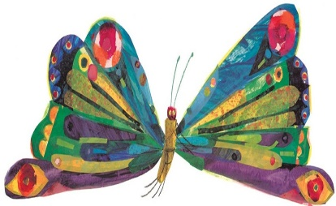  It has red circles on the wings.
Easier:  Do as many of the above activities as you can. If you are finding some of the activities challenging, try these as they are a little easier:  - Name the colours on the butterfly.  - Name the insects you know.  - If you have the internet, watch The Very Hungry Caterpillar again and retell the story using the story map. |  |  | Challenge:  If you feel you need a further challenge, try these:  - Explain where minibeasts live and why they live in certain areas.  - If you have the internet, ask a grown up to read you the story of The Hungriest Caterpillar. Find it on page 88 in The Book of Hopes. See the link below.

Reading/Phonics Home Learning
Monday | Tuesday | Wednesday |  | Thursday | Friday
Focus on the digraph ‘oo’  Read and write words.  look foot book good took too zoo boot hoof food  moon. | Focus on the digraph ‘ar’  Read and write words.  car bark hard zoom wool root lar tark pard noom goot  Which words are real? | Focus on the digrapgh ‘or’  Read and write words.  for fork sort born worn torn hard park cook boot |  | Focus on the digraph ‘ur’  Read and write words.  fur burn burp curl hurt surf turn turnip | Focus on reading and writing these key words in a sentence.  no, go
Easier:  Do as many of the above activities as you can. If you are finding some of the activities challenging, try these as they are a little easier: Swap the sounds for h b ff ll ss  - hat hug big bag bed bat hap huck bip bem bup hin  - huff puff tuff riff kiff  - less hiss fuss kiss mess niss dess tass goss  - mess fat bun boss back hop cuff dull sell |  |  | Challenge:  If you feel you need a further challenge, try these: Swap the sounds for er  - her hammer letter ladder supper dinner better summer farmer shorter longer powder  Two syllable words  - chicken tonight boatman rooftop farmyard market lightning bedroom

Writing Home Learning
Monday | Tuesday | Wednesday |  | Thursday | Friday
Write a list of where you might find minibeasts in the garden.  Example…  mud, sticks, grass, pond, leaf, plants, rock, webs etc… | Talk to an adult about the life-cycle of a butterfly. Can you stick the pictures in the correct order and label each section of the life-cycle?  (egg, caterpillar, cocoon, butterfly)  If you have the internet, follow the link at the end to watch the cycle. | Write a short sentence about the first part of the life-cycle of a butterfly. Example:  The egg is on the leaf. |  | Write a short sentence about the second stage of the life-cycle of a butterfly.  Example:  The egg turns into a caterpillar. | Write short sentences about the final stages of the life-cycle of a butterfly.  Example:  The caterpillar turns into a cocoon.  The cocoon turns into a butterfly.
Easier:  Do as many of the above activities as you can. If you are finding some of the activities challenging, try these as they are a little easier:  - Can you write the initial sounds to these words (mud, sticks, grass, pond, leaf)  - Write the initial sounds for these words (egg, caterpillar, cocoon, butterfly) |  |  | Challenge:  If you feel you need a further challenge, try these:  - Write sentences to explain what happens in each section of the life cycle of a butterfly.  First…  Then…  Next…  Finally…

Maths Home Learning
Monday | Tuesday | Wednesday |  | Thursday | Friday
Use the sheet to complete the addition equations. Can you find the answer by counting them altogether? | Create your own addition using the ten frames. Put objects in the ten frames and count on to find the answer.  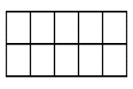  E.g. 5+3 = | Create your own addition equations and find the answer by counting on using the number line.  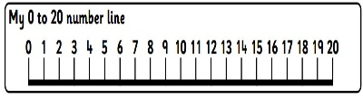 |  | Draw your own addition problems.  Example:  There are 5 caterpillars on a leaf and 3 more join them. How many are there altogether? | Draw pictures to help you solve these:  12+2=  5+6=  7+2=  15+3=  5+8=
Easier:  Do as many of the above activities as you can. If you are finding some of the activities challenging, try these as they are a little easier:  - Number bonds to 10. If you have the internet, follow the link at the end.  - Practice writing numbers to 20.  - Identify numbers to 20.  - Order numbers to 20. |  |  | Challenge:  If you feel you need a further challenge, try these:  - Roll two dice and write your own addition equation by adding the two numbers together.  - Can you add bigger numbers using the number line  Example:  17+2=  15+4=  12+5=

Other Activities
Imagine what happens to the butterfly once he comes out of the cocoon. Can you draw or write about the adventures of a butterfly? | Paint/draw a picture of your favourite insect. Can you label the insect? | If you have the internet, listen to another Eric Carle story. There are plenty to choose from on YouTube.  E.g. The Very Busy Spider.  Follow the link below. | 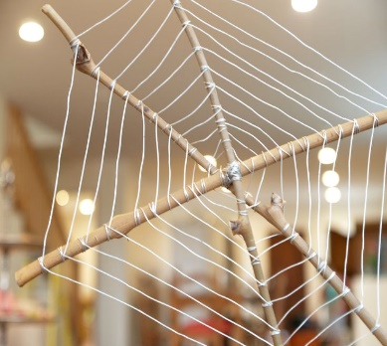  Create your own spider web using sticks and string. | 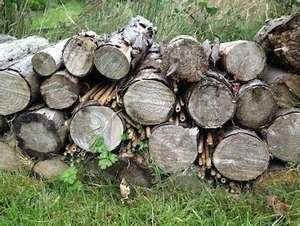  Can you create your own minibeast habitat? Find sticks and create your own bug hotel. Take photographs of what you find in your homemade minibeast hotel.

Key skills to continue practising weekly:
- Write your name.
- Practise handwriting – try to form the letters on the line correctly.
- Form numbers correctly.
- Getting changed on your own.
- Zip your coat up on your own.
- Match the capital letters with the lowercase letters e.g. A a B b
- Number bonds to 10.

If you are able to access the internet, try these useful websites:
- Minibeast Adventures with Jess https://www.youtube.com/watch?v=JuHg5oWF_mo
- Cosmic Kids https://www.youtube.com/watch?v=qIT-9Nnlvn0
- Eric Carle – The Very Busy Spider https://www.youtube.com/watch?v=TfL0g-XRxnA
- The book of hopes https://issuu.com/bloomsburypublishing/docs/thebookofhopes_interactivepdf/4?ff
- The Very Hungry Caterpillar https://www.youtube.com/watch?v=75NQK-Sm1YY
- The life cycle of a butterfly https://www.youtube.com/watch?v=3o_nE1X014U
- Number bonds to 10 https://www.youtube.com/watch?v=lD9tjBUiXs0

If you or your child has any further queries regarding their learning projects, please contact admin@hardwick.derby.sch.uk, clearly stating your child’s name and class teacher, and the staff will be in touch to support you and your child.

Thank you and stay safe.

