FS1 Home Learning
Week Commencing: 6th July 2020
Teachers: Mrs Bletcher
TAs: Mrs White

Hello! We can’t believe we are saying goodbye to some of our wonderful Nursery children this week! We are so SO proud of all of you and have had so much fun being your teachers this year. We feel very fortunate to have had such lovely children and families to work with. Thank you! We know that you are all so ready for Reception, and that your new teachers can’t wait to meet you: They are so lucky to have such kind, funny, and clever children in their classes. Have lots of fun over the summer and remember that we love you all so so much! Big, big cuddles, Mrs Bletcher and Mrs White xx

If you have any queries over home learning please don’t hesitate to get in touch via admin@hardwick.derby.sch.uk and we will get back to you quickly!

Your Home Learning this Week:
Every day (Monday to Friday), make sure you choose a *physical, *communication, *reading/phonics, *writing and *maths learning activity. There are also further activities to choose from should you wish to.
Physical Home Learning
Monday | Tuesday | Wednesday |  | Thursday | Friday
Develop your gross and fine motor skills by collecting sticks, leaves, and natural materials to create the woods from Little Red Riding Hood.  How can you make the objects stick together? | Develop your fine motor skills by cutting citrus fruits into slices, and then squeezing the juice out with your hands into a cup.  How much juice can you squeeze out?  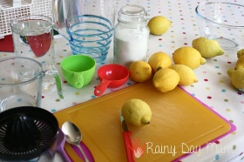 | Develop your fine motor skills by cutting citrus fruits into slices, and putting them into a jug or cup. Add water and sugar, then mix to make a drink.  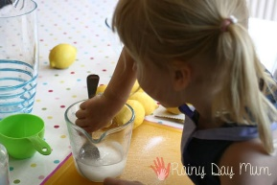 |  | Develop your fine motor skills by cutting citrus fruits into slices, and putting them in a bowl. Add water, and leave in your freezer for the day.  Later, develop your fine motor skills by using a spoon to scoop the citrus fruits out of the ice. | Develop your fine motor skills by dressing yourself in the morning, and putting your pyjamas on at night.
Easier:  Do as many of the above activities as you can. If you are finding some of the activities challenging, try these as they are a little easier:  - Practise your toileting by not wearing a nappy, and using the toilet with a grown-up.  - Explore rolling a ball out of playdough in the palm of your hands.  - Try taking your socks off by yourself, and putting them back on again.  - Try taking your jumper off by yourself. |  |  | Challenge:  If you feel you need a further challenge, try these:  - Link strips of paper together in circles to make a paper chain.  - Use scissors to cut out a picture that you have drawn.  - Use sharper utensils carefully (such as a blunt knife) to chisel the lemons out of the ice.
Communication Home Learning
Monday | Tuesday | Wednesday |  | Thursday | Friday
Retell the story of our quality text Little Red Riding Hood to a grown-up using the folllowing time connectives:  First  Next  Then  Last | Use your words to describe the characters of Little Red Riding Hood, Grandma, and the Wolf.  Try and extend your sentences using connectives.  Example: The Wolf is scary because he tries to eat LRRH and Grandma. | Use your words to describe what you can taste when you have made your fruity drink.  Example: My drink tastes sour! |  | Use your words to predict what will happen to the water when you put it in the freezer.  Example: The water will freeze and turn to ice! | Use your words to predict what could happen to the wolf after the woodcutter has chased him away.  Example: I think the wolf will run away and hide in a cave.
Easier:  Do as many of the above activities as you can. If you are finding some of the activities challenging, try these as they are a little easier:  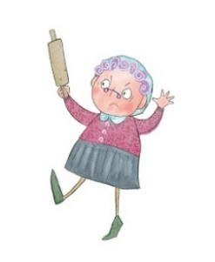  - Can you find the picture of Grandma from LRRH? Say what you can see. Example: I see Grandma.  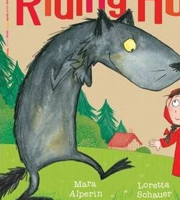 |  |  | Challenge:  If you feel you need a further challenge, try these:  - How does the wolf feel when LRRH tricks him? Why do you think this?  - How does Grandma feel when LRRH saves her? Why do you think this?
Reading/Phonics Home Learning
Monday | Tuesday | Wednesday |  | Thursday | Friday
Can you think of a different word to last week that starts with the following sounds:  -S (Examples: Snake)  -A (Example: Apple)  -T (Example: Tiger)  -P (Example: Penny)  -I (Example: Igloo)  -N (Example: Nugget)  See link below to pronounce each phoneme (unit of sound) correctly.  Remember, alliteration is when words start with the same sound. | Listening carefully to your grown up, have a go at sounding out the following CVC words we looked at last week:  a-t (at)  s-a-t (sat)  c-a-t (cat)  m-a-t (mat)  r-a-t (rat)  b-a-t (bat)  i-t (it)  s-i-t (sit)  i-p (ip)  t-i-p (tip)  sh-i-p (ship)  Can you use your fingers to count the phonemes (sounds) in the words?  Example: s-i-t (3) | Listening carefully to your grown up, have a go at sounding out the following CVC words we looked at last week:  a-p (ap)  s-a-p (sap)  m-a-p (map)  a-n (an)  p-a-n (pan)  m-a-n (man)  i-n (in)  p-i-n (pin)  b-i-n (bin)  sh-i-n (shin)  w-i-n (win)  Can you use your fingers to count the phonemes (sounds) in the words?  Example: sh-i-n (3) |  | See if you can blend words by yourself by listening carefully to the instructions!  You will need a grown-up to help read out the following instructions:  Touch your t-oe-s (toes)  j-u-m-p in the air (jump)  r-u-n on the spot (run)  Go to s-l-ee-p (sleep)  Can you use your fingers to count the phonemes (sounds) in the words? | See if you can blend words by yourself by listening carefully to the instructions!  You will need a teddy and a grown-up to help read out what teddy would like to eat!  Teddy would like to eat some…  ch-ee-se (cheese)  f-i-sh (fish)  p-ie (pie)  s-ou-p (soup)  e-g-g (egg)  Can you use your fingers to count the phonemes (sounds) in the words?
Easier:  Do as many of the above activities as you can. If you are finding some of the activities challenging, try these as they are a little easier:  - Explore making sounds with your body (Example: Clapping, stomping, tapping)  - Fill a bottle with rice or pasta to make a musical shaker. Explore making quiet and loud sounds.  - Have a go at singing your favourite Nursery Rhyme by yourself, using appropriate actions and vocalisations. |  |  | Challenge:  If you feel you need a further challenge, try these:  - Have a go at matching a sound to its corresponding letter in the alphabet.  - Have a go at breaking words down into individual phonemes (Example: Cat to c-a-t). Can your grown up guess what you are trying to say?  - Do you recognise the following letters s, a, t, p, i, n. Can you say each sound? Can you write them down?  - Do you recognise the following letters i, n, m, d. Can you say each sound? Can you write them down?

Writing Home Learning
Monday | Tuesday | Wednesday |  | Thursday | Friday
Retell your own story map on our quality text: Little Red Riding Hood  Below is an example of a previous story map.  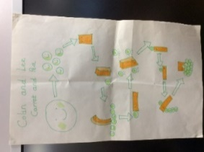 | Draw a picture of the items you think LRRH should put in her basket for Grandma. | Practise writing your full name by yourself. Can you write how old you are underneath?  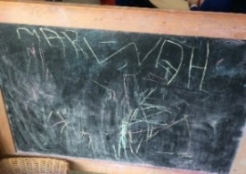 |  | Draw or paint a picture of the wolf. Can you identify and write the first grapheme in wolf? (W) | Create your own story map about a Grandma.  Below is an example of a previous story map.  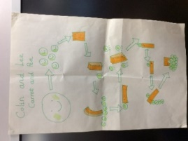
Easier:  Do as many of the above activities as you can. If you are finding some of the activities challenging, try these as they are a little easier:  - Explore drawing circles and lines when shown by a familiar adult.  - Explore drawing circles and lines in the air with your finger.  - Practise forming zigzags, crosses, spirals and circles when shown by a familiar adult.  - Have a go at forming the first letter in your name with playdough. |  |  | Challenge:  If you feel you need a further challenge, try these:  - Have a go at identifying and labelling the fruits by writing their initial sound next to them. Example: A for apple.  Have a go at writing the letters of any words you have sounded out. (Example: c-a-t to cat)  - Can you find any objects in your home that start with the sounds s, a, t, p, i, n? Can you write their names down, matching sounds to letters correctly?
Maths Home Learning
Monday | Tuesday | Wednesday |  | Thursday | Friday
Do you recognise the following shapes? Can you name them correctly? Talk to your grown up about what you can see!  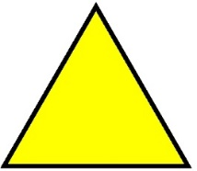 | Can you categorise these objects correctly? Tell a grown up what shape you think they are! | Draw a picture of your home. Can you use shapes appropriately to draw the frame, roof, windows and doors? Talk about the shapes that you are using. Example: The door is a rectangle.  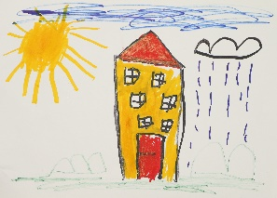 |  | Draw a picture of yourself. Can you use shapes appropriately to draw your head, eyes, nose, mouth, body, arms and legs? Talk about the shapes that you are using. Example: My head is a circle.  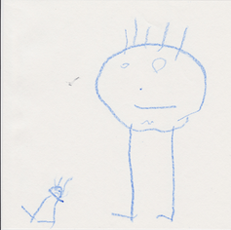 | Make a sandwich for your lunch, carefully using a knife to spread the filling. Have a go at cutting your sandwich into rectangles, squares, or triangles.  Talk to your grown up about the sandwich shapes that you are making.  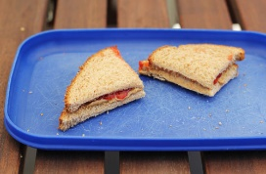
Easier:  Do as many of the above activities as you can. If you are finding some of the activities challenging, try these as they are a little easier:  - Have a go at representing 0, 1, 2, 3, 4 and 5 on your fingers.  - Sing ‘1 potato, 2 potato, 3 potato, 4, joining in with actions and vocalisations.  - Count 0-10 as rockets.  - Have a go at counting five toys by yourself.  - Have a go at recognising the numerals 0, 1, 2, and 3 by yourself.  - Have a go at drawing a circle by yourself. |  |  | Challenge:  If you feel you need a further challenge, try these:  - Do you recognise the following shape? Can you count the sides? Can you find anything in your house that is the same shape? Does it look similar to any shapes you have seen before?  Oval  Kite

Other Activities
Sing one of your favourite Nursery Rhymes every day.  Examples include:  -Wind the bobbin up  -Miss Polly had a Dolly  -Two little Dickey birds  -5 little Peas | Ask your grown-up to put on your favourite songs to dance to and join in with. | Draw a picture of what you have done at home every day. | Develop your fine motor skills by helping your grown- up make breakfast, lunch, and dinner. | Think about what your favourite thing to do at Nursery is. Draw a picture of it, tell your grown up, and then email us so we can make sure we do it when we get back!

Key skills to continue practising weekly:
- Children should be practising being independent with their toileting at home.
- Children should starting to be more independent in dressing/removing clothes themselves. Examples include: Taking their jumper off when hot, putting on shoes on, and starting to do zips and buttons
- Encouraging children to use at least four words in their sentences (Example: ‘I ate toast for breakfast’. This can be supported through modelling.

If you are able to access the internet, try these useful websites:
- Alphablocks: Alphablocks is excellent for blending CVC words!
- Letters and Sounds overview: This is what we follow in Phonics!
- Singing Hands: Singing hands are fantastic at providing Makaton actions for familiar Nursery Rhymes!
- Youtube ‘Little Red Riding Hood by Mara Alperin’ to watch a great animated version of our quality text.

If you or your child has any further queries regarding their learning projects, please contact admin@hardwick.derby.sch.uk, clearly stating your child’s name and class teacher, and the staff will be in touch to support you and your child.

Thank you and stay safe.

