Year 3 Home Learning
Week Commencing: 4th May 2020
Year 3 teachers: Mrs Begg, Mr Rogers, Mrs Priestland, Mrs Lumsden
Year 3 TAs: Miss Batool, Mrs Stringer
Message from staff: Last week your teachers all tried to ring you at home. It was great to talk to so many of you and to know that you are quite well and happy but missing school. We will try to speak to you again next week.
Last week all the year three teachers had a meeting to plan your learning. Don’t worry – we were not in the same room. We had a virtual meeting using our lap tops and the internet! We could all talk and every time a new speaker came on we saw them ‘live’ on the screen. It was great! Mr Rogers was in his garden. Mrs Lumsden had her son in the room with her and he kept looking to see what we were up to. Mrs Priestland’s little boy was having a nap but he came in to say ‘Hello!’ at the end of the call. Mrs Stringer took a break from teaching her daughter to join us. Miss Batool was having her Easter holiday because she was working at the Arboretum School during the holiday. You’ll be glad to know we are all fit and well.
Mr Rogers has been very busy cooking and has made cakes and pecan slice – YUM. I hope he remembers to do plenty of exercise to work off all those extra calories.
When you do your work, this week, please remember to do your best – remembering to write in sentences, use punctuation and check your spelling. You can always add pictures and there are lots and lots of extra activities on BBC Bitesize/daily lessons

Your Home Learning this Week:
Every day (Monday to Friday), make sure you choose a *reading, *writing, *spelling/handwriting, *maths and *theme learning activity. There are also further activities to choose from should you wish to.

Reading Home Learning
Read a book with your family and then tell them who the characters are, where it is set and tell them your favourite part of the story. | Find some of the key words or common exception words in a book and say or write them | Draw a picture and write some sentences about the book.

Writing Home Learning
Write some sentences about what you do every day.  Remember to include the word “and” in your sentences. | 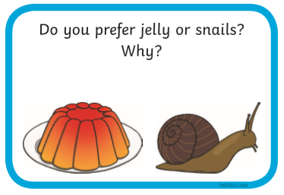  Write a sentence to answer the question. ‘I prefer_____ because____’ | Using some of your key words (he, she, him, her, they) write some interesting or funny sentences about your teachers.

Phonics /Handwriting Home Learning
Read and write these key words  the, to, his, has, I, no, go, put, push, pull, full  of, are, was, his, has, you, they, be, he, me, she, we, by, my | Practise writing the days of the week.  Monday Tuesday  Wednesday Thursday  Friday Saturday  Sunday | Read the following words with the ‘ay’ diagraph  stay, play, day, way, away  Can you use the words in sentences?

Maths Home Learning
Practise adding 2-digit number and 1-digit number together.  Can you write 10 sums where you add a 2-digit number to 1-digit number?  12+5=17 | Practise subtracting 2-digit number and 1-digit number together.  Can you write 10 sums where you subtract a 2-digit number to 1-digit number?  12-5=7 | Can you find objects around your garden that are the following 2D shapes?  Rectangle, square, triangle, circle

Theme Home Learning
If you could create 2 new Olympic events, what would they be?  (It could be anything!)  Mine would be how many grapes you can eat in 1 minute! | Design a healthy meal you and your family can eat.  Remember to include some fruit and vegetable and not too much sugar or fast food. | Go for a walk with your family and count how many different people you can see doing exercise.  They can be walking, running, riding a bike.
Other Activities
Get outside and make some shadows! There are some cool videos on Youtube showing you how to make shadow puppets with your hands! | Mr Rogers has done lots of baking! Why not have a go yourself?  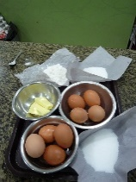  There are some very simple cake recipes on the internet, ask someone for help and have a go! | Mrs Priestland has been trying to do lots of building with her little boy including making a marble run. Can you make a marble run using  different items in your house.  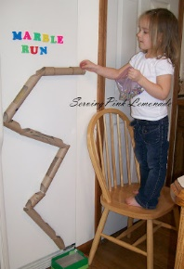
Key skills to continue practicing weekly:
joined-up handwriting, times tables – 2, 3, 5, 10 times tables. Key word spelling
Don’t forget to watch Newsround each day to see what is happening in the world.
Make sure you get your daily exercise.

Useful websites:
bbc.co.uk/bitesize/daily lessons - For the next few weeks the BBC have produced daily lessons for all age groups. The lessons include a short teaching clip, a follow up activity and a free downloadable resource to practise the skills taught.
https://oxfordowl.co.uk/for-home/find-a-book/library-page - You can access loads of reading books at the correct level for your child. You will need to create a log in with email address and a password. Go to free e books- click on levels and then book band. If you click on the colour band your child is reading at school lots of books will appear for you to choose from. Just click on the yellow circle with an e in it.
If you or your child has any further queries regarding their learning projects, please contact admin@hardwick.derby.sch.uk, clearly stating your child’s name and class teacher, and the staff will be in touch to support you and your child.

Thank you and stay safe.

