Year 4 Home Learning
Week Commencing: 8th June 2020

Year 4 teachers: Mrs Haslam, Mrs Tatla, Mrs Jogela and Miss Annable
Year 4 TAs: Miss Perry and Mrs Smith

Message from staff: Hello Year 4, we hope you are all well and keeping safe! The year 4 teachers have been working hard to prepare your work, we hope you give it your best shot, but don’t get stressed if there is anything you are unsure of. You can ask any questions about the home learning when we give you a call each week! Lockdown has been a strange time for everyone and all of us have a mixture of changing feelings, which is completely normal. Just remember to keep positive, try to do some daily physical activity and get some fresh air when you can!

Your Home Learning this Week:
Every day (Monday to Friday), make sure you choose a *reading, *writing, *spelling/handwriting, *maths and *theme learning activity. There are also further activities to choose from should you wish to.

Reading Home Learning – Reading Comprehension!
Monday | Tuesday | Wednesday |  | Thursday | Friday
Monica the Monitor  Read the text ‘Garden Birds’.  Highlight any words you do not understand and find out the meaning of them. | Stan the Summariser  Can you write a short summary of the Garden Birds text. Remember to pick out the VIP’s. | Colin and Carmen the Connectors  Text-to-self. Text-to-world  We have had some lovely weather recently, which means we have been able to spend more time outdoors. Have you noticed more birds around? Keep a diary of birds that you see in your garden or when out for a walk. |  | Questions:  Re-read the text and have a go at answering the questions.  Go through the answers with an adult to check how you have done! | Read for pleasure  Today choose a book, poem, magazine article or any reading that interests you.  Find a quiet place in the home and read for pleasure.
Easier:  Do as many of the above activities as you can. If you are finding some of the activities challenging, try these as they are a little easier:  - Listen to an adult read the text.  - Discuss together what the text is about and meaning of new words. |  |  | Challenge:  If you feel you need a further challenge, try these:  Write a paragraph that could be added to the text, all about how to care for birds in the garden.
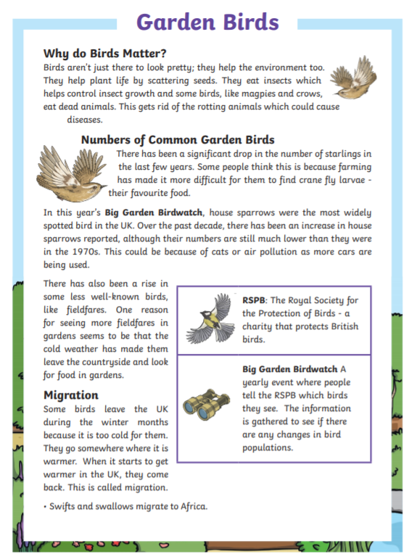
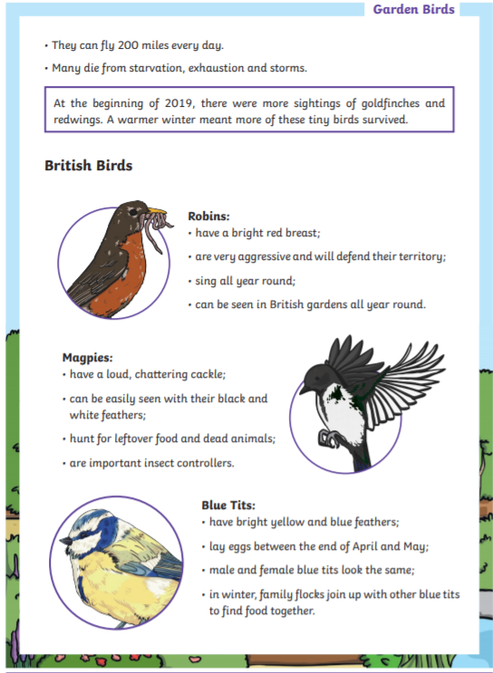
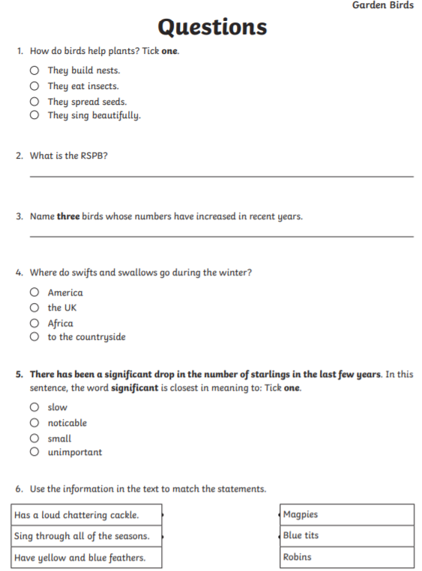
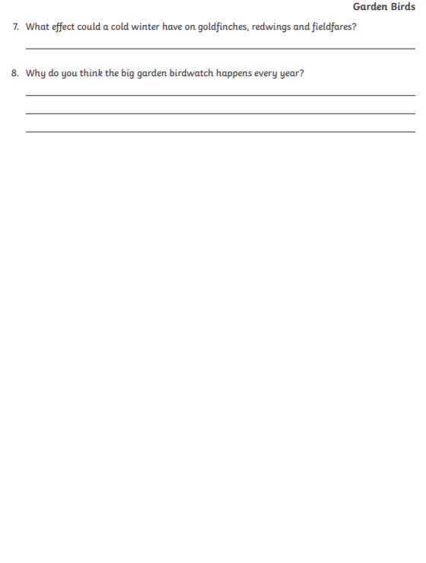
Writing Home Learning – WOW START!
Monday | Tuesday | Wednesday | Thursday |  | Friday
Diary Writing  A diary is a record of events and experiences. This can include thoughts and feelings too.  To make our diary writing more interesting we are going to imagine that we are a ‘classroom object’ and write from its point of view.  To help you understand, read the example diary entries on the next two pages. Look up any words you are unsure of. | Analyse the text  Look at the features of a diary (features checklist). Can you find the features in the diary entries you have read.  Highlight the features (using different colours if you have them and create a key – just like we do at school). | Plan  Think about what classroom object you would like to write about. You could choose anything at all.  Here are some ideas; pen, rubber, sharpner, book, bookshelf, bin, whiteboard, desk, chair, etc.  Now complete the planning sheet provided. | Writing your Diary  Now you can use your plan to start writing your diary.  Remember to refer back to the features of a diary and you can use the diary examples for ideas too! |  | Edit / check  Once you have completed writing your diary as a classroom object read over it to check that it all makes sense.  Edit your work to make it even better!  Check the following:  - Features of a diary  - Punctuation  - Neat handwriting
Easier:  Do as many of the above activities as you can. If you are finding some of the activities challenging, try these as they are a little easier:  - You could choose any household object, a favourite toy, something from the kitchen. Ask your adult for some ideas.  - Discuss with someone at home what it may feel like to be a specific object from the house. Think about all the things that the object does or is used for.  - Imagine that if the object was able to talk and feel, what would it say? |  |  |  | Challenge:  If you feel you need a further challenge, try these:  - Try keeping a diary of what you have been doing on a daily basis.  - Choose a character of your choice and write a diary for them.
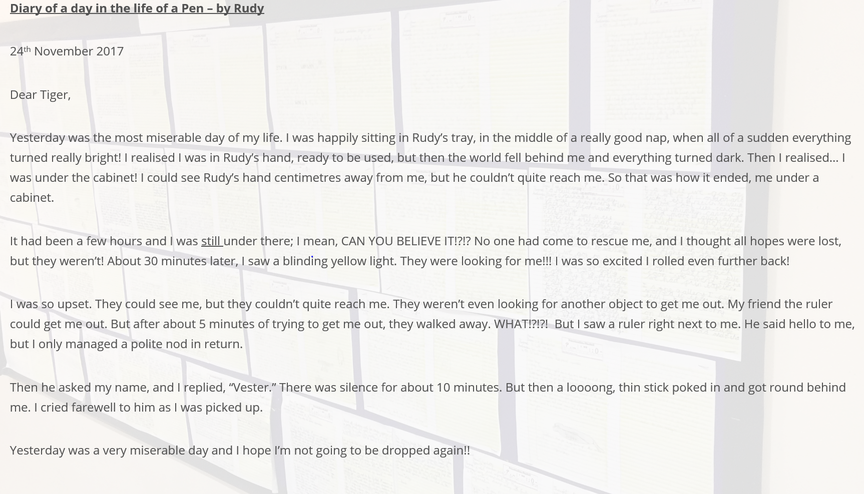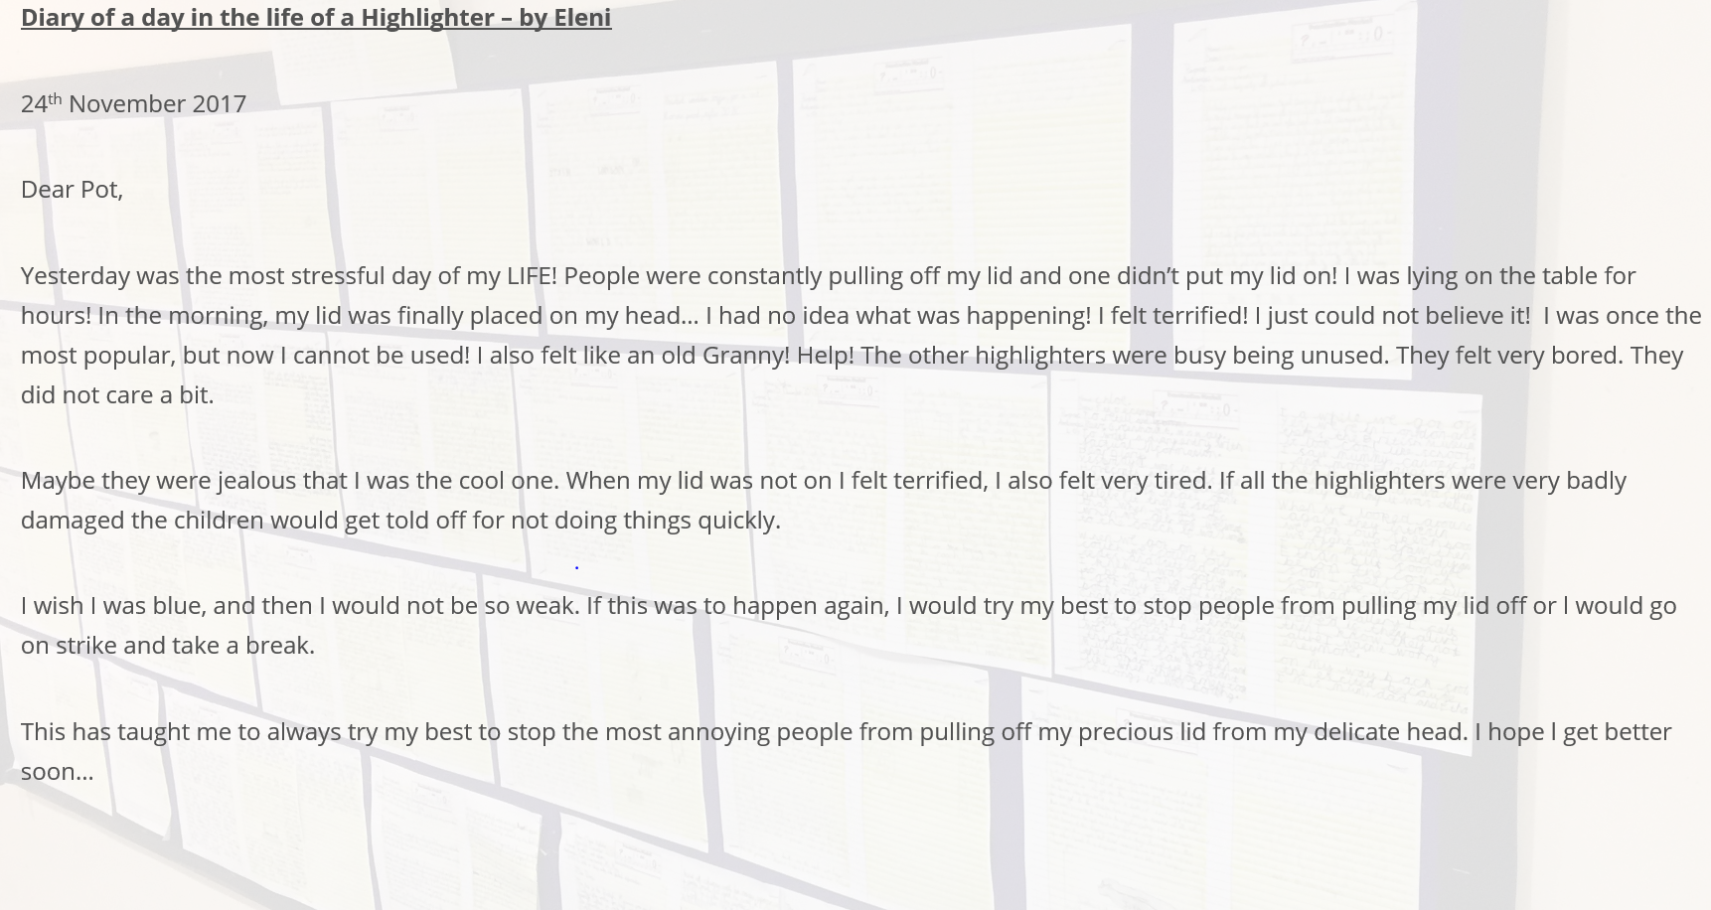
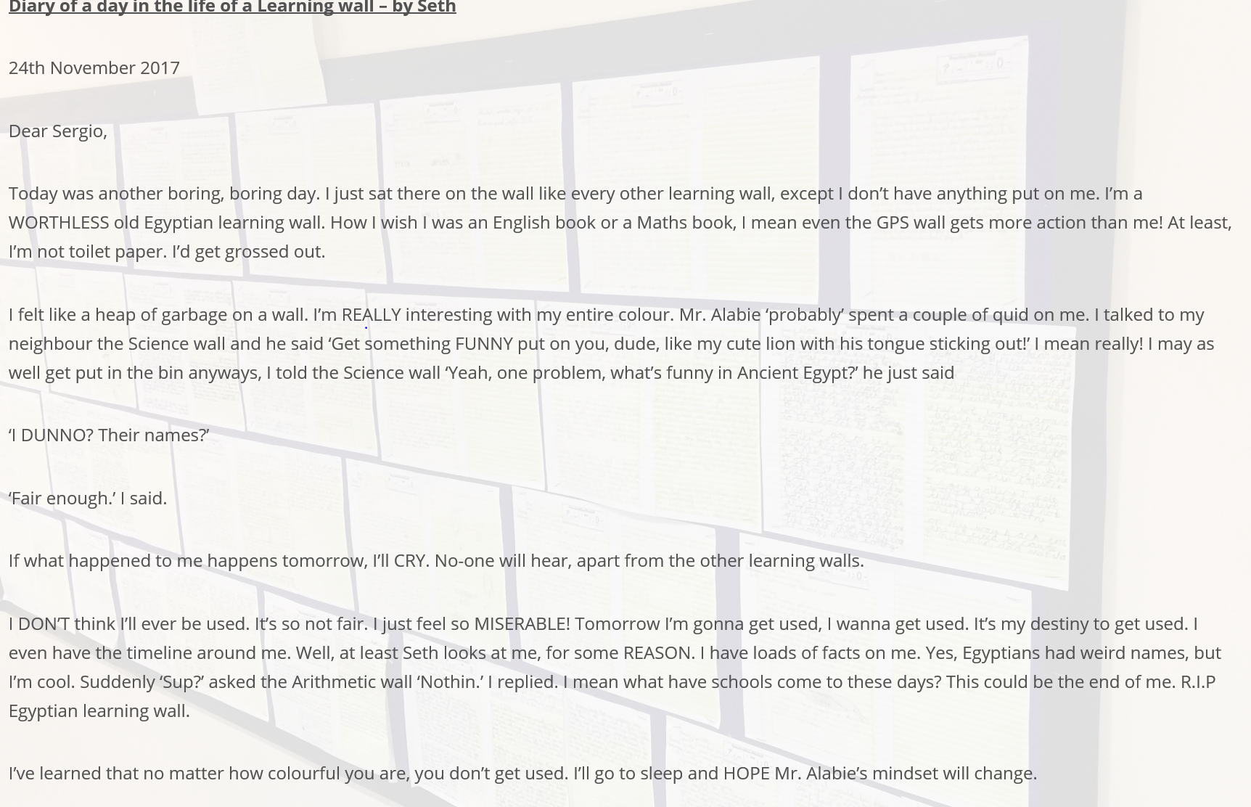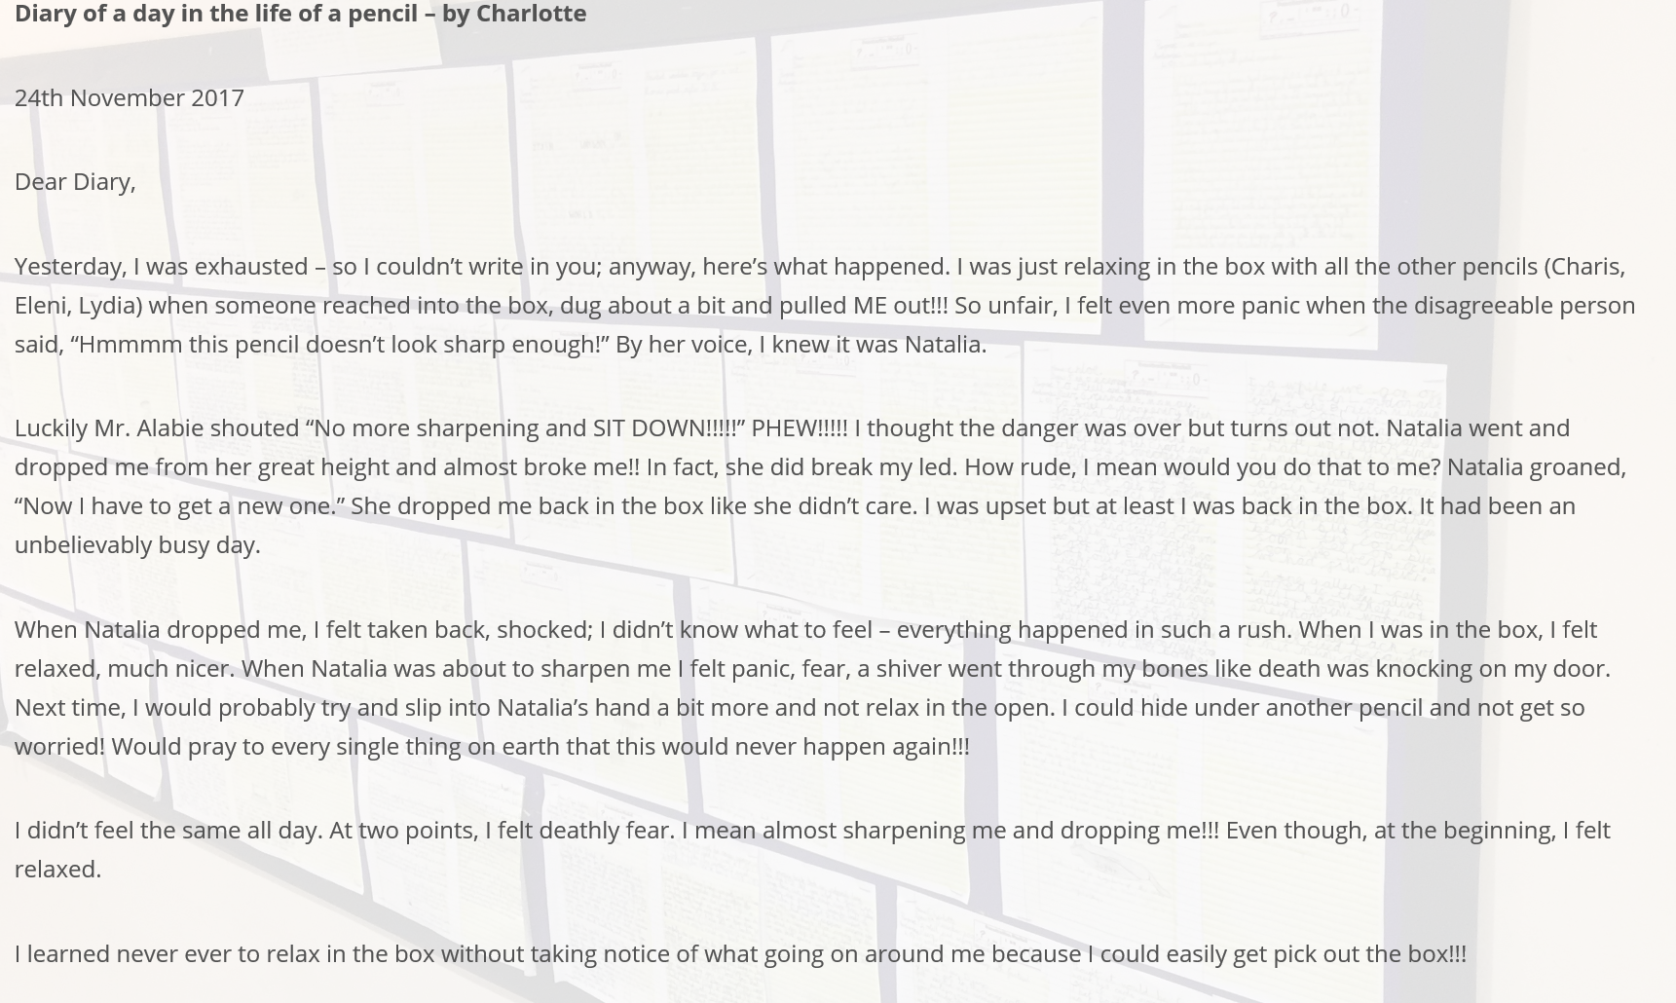
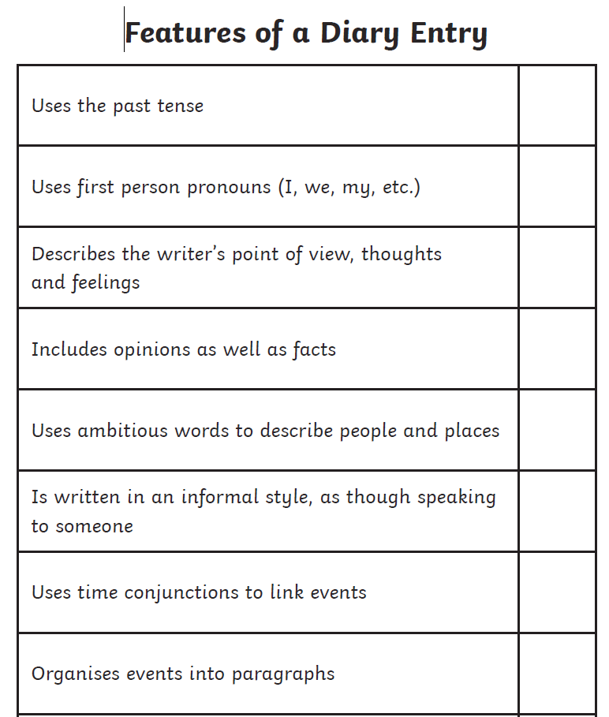
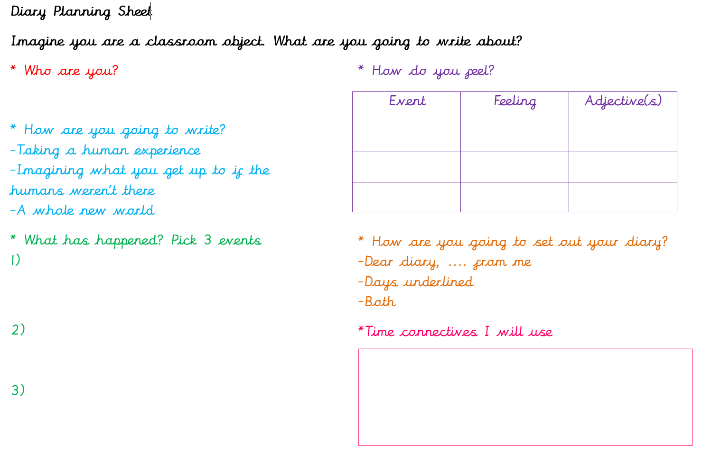
Spelling/Handwriting Home Learning
Monday | Tuesday | Wednesday |  | Thursday | Friday
Monday  Choose the next 10 spellings on your list that you struggle with.  Pyramid Write  Example:  S  St  Str  Stre  Stren  Streng  Strength | Tuesday  Riddles  Can you make up any riddles/poems to help you to remember how to spell the words. | Wednesday  Rainbow Write  Can you write out your spellings in rainbow colours. |  | Thursday  Using your finger, ‘write’ the word on a family member’s back and ask them to try and guess the word. | Friday  Spelling quiz!  Ask a family member to test you on your spellings.  You could also test yourself on the Top Marks website:  http://www.ictgames.com/mobilePage/lcwc/index.html
Easier:  Complete the same activities as above but choosing the next 10 spellings on the Year 1 and 2 statutory spelling list that you struggle with. |  |  | Challenge:  If you feel you need a further challenge, try these:  - Write a definition of each of the above words.  - Write a sentence using the words above to show that you understand the meaning.

Maths Home Learning
Monday | Tuesday | Wednesday | Thursday |  | Friday
Solving problems involving money: Lesson 5  Have a go at the guided practice then complete the worksheet. | Solving problems involving money: Lesson 6  Have a go at the guided practice then complete the worksheet. | Solving problems involving money: Lesson 7  Have a go at the guided practice then complete the worksheet. | Multiplication and Division  Can you write all the multiplication and division facts for the 4, 6 and 7 times tables.  Example:  4 x 3 =12  3 x 4 = 12  12 / 3 = 4  12 / 4 = 3 |  | Addition and Subtraction  Complete the following;  - 2346 +5632  - 4632 +3723  - 5213 +6397  - 3876 – 653  - 4274 – 853  - 7493 - 1298
Easier:  Do as many of the above activities as you can. If you are finding some of the activities challenging, try these as they are a little easier:  - Play shops together! Label objects in your house of differing prices, someone pretends to be the customer buying objects and someone pretends to be the shopkeeper. The customer either needs to pay with the correct amount of money or the shopkeeper needs to work out how much change to give. Swap roles.  - Ask an adult to give you some 3 digit addition and subtraction sums, rather than doing the 4 digit ones above. |  |  |  | Challenge:  If you feel you need a further challenge, try:  Complete the challenge activities on the last page of this booklet.
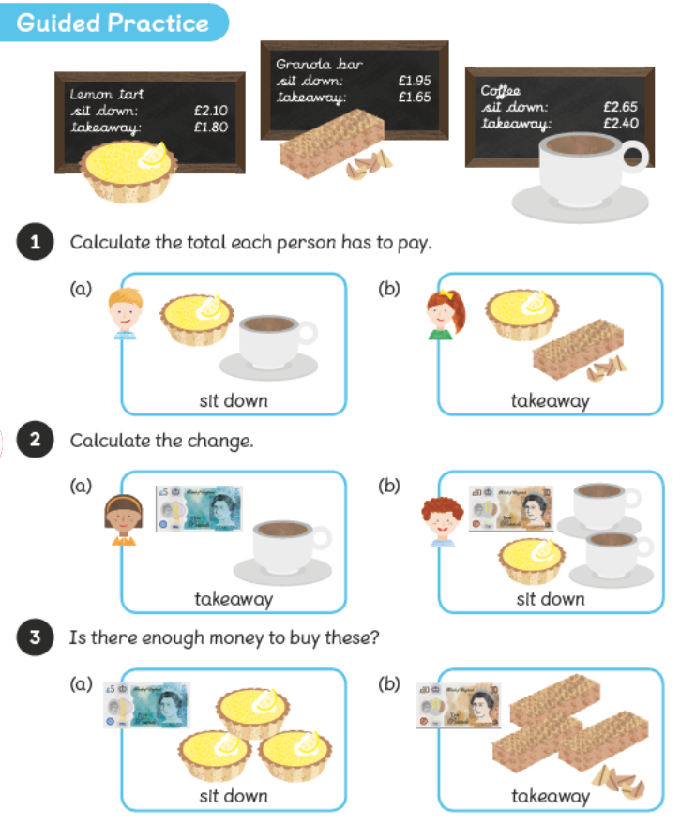
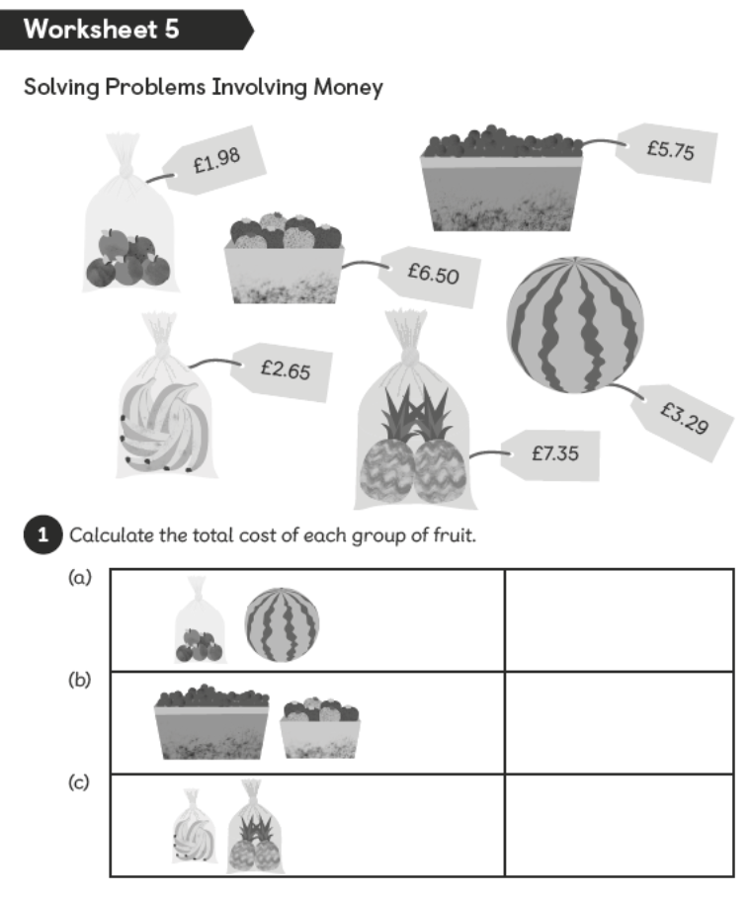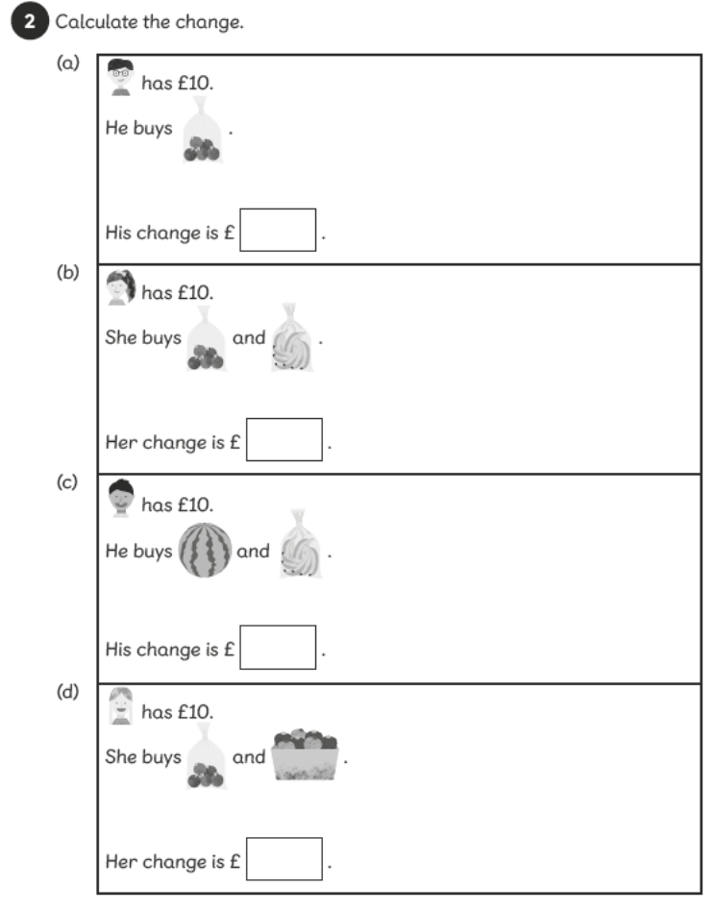
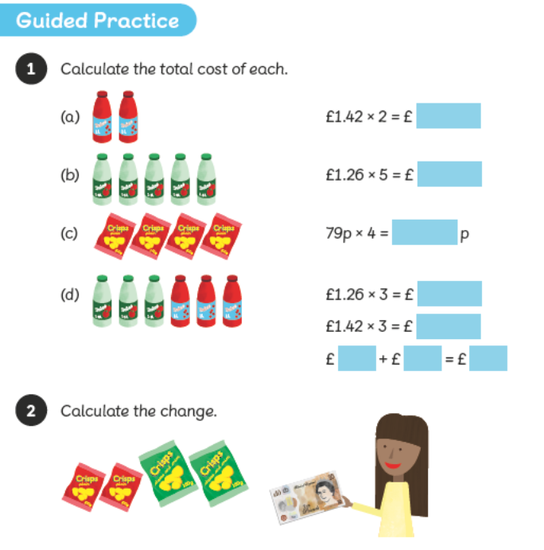
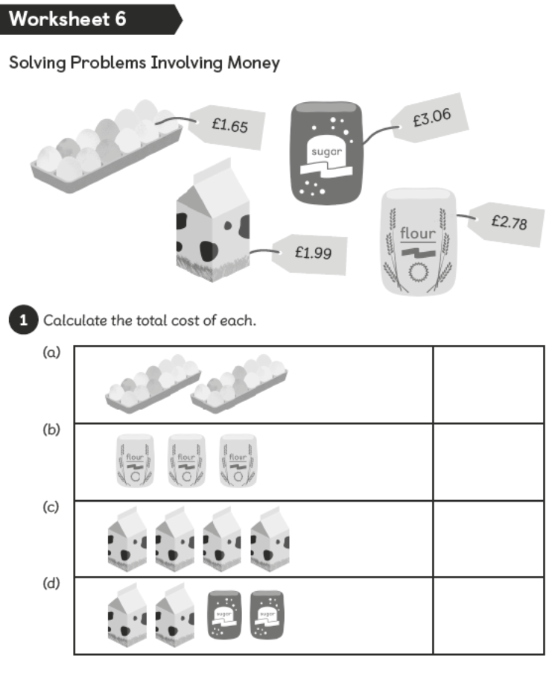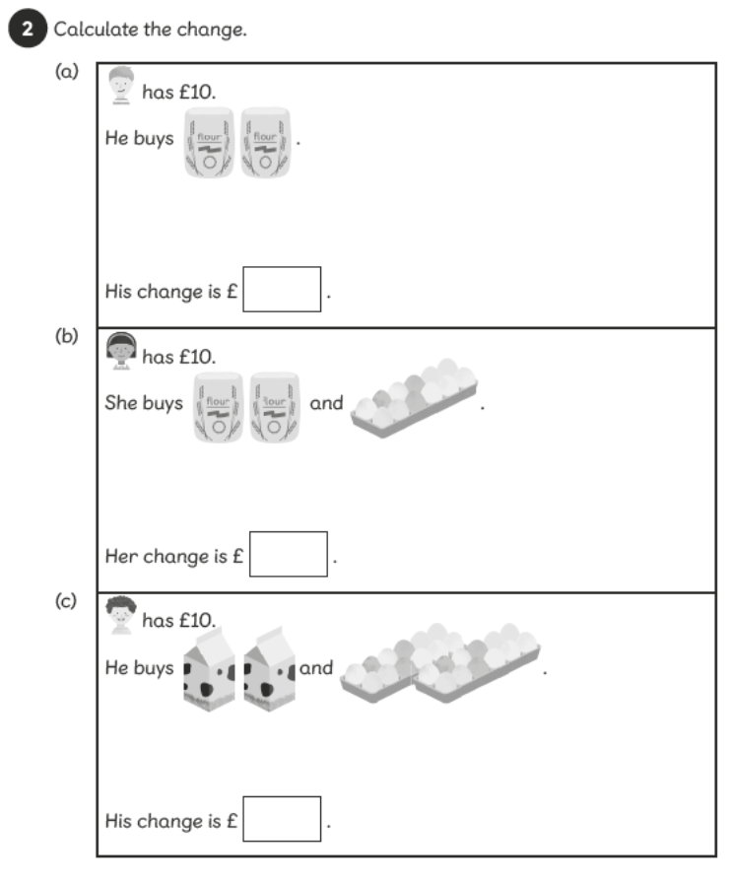
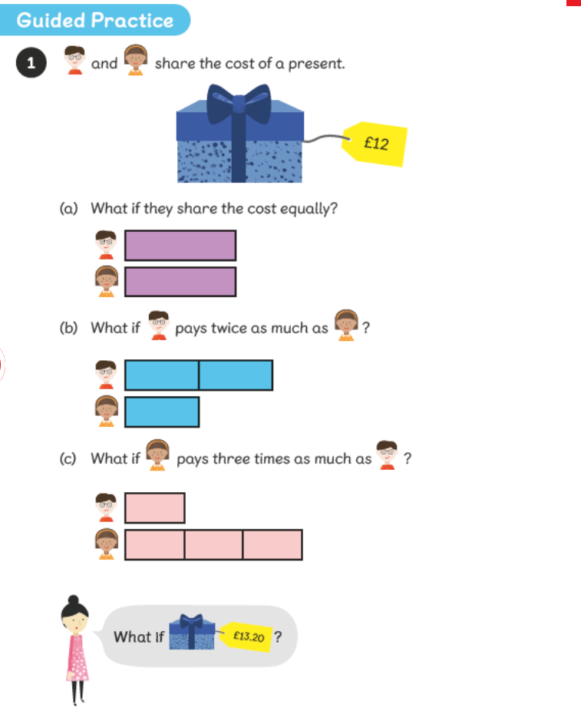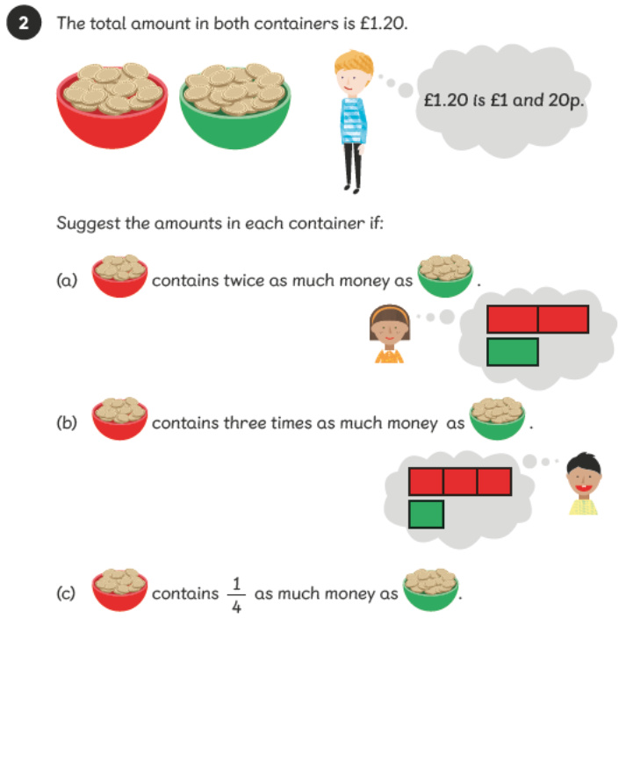
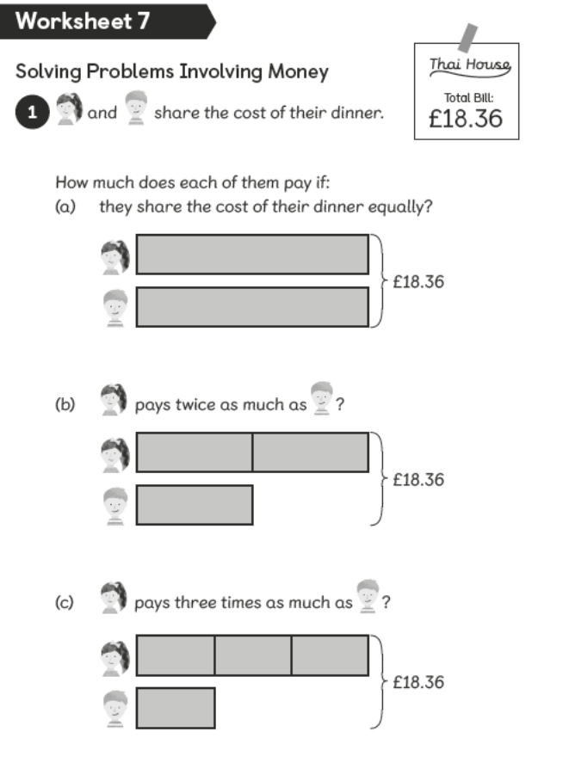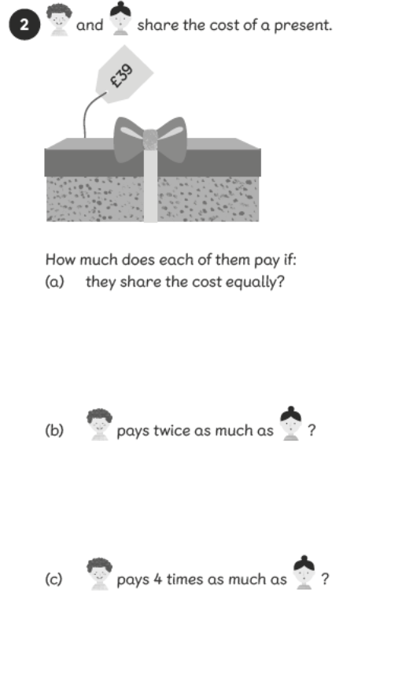

Theme Home Learning
Monday | Tuesday | Wednesday |  | Thursday | Friday
Geography  Can you make a list of at least 20 countries around the world and name their capital cities.  Can you research a landmark or place of interest for that city?  Example:  London – Big Ben  Paris – Eiffel Tower | Art  Using your reading from this week can you sketch a drawing of a bird.  Think about all the details on the bird, e.g. feathers, beak, any patterns etc. | R Time – Memory game  Can you work with one of you family members to complete an R time activity.  Firstly, explain to them what R Time is all about! (Remember it is about working well with others, suing our manners and being kind).  Next, ask your partner (family) to place 10 random objects into a bag (without you seeing them).  Then they will need to slowly remove them from the bag showing you them all, once you have seen them all, they will need to place them back into the bag.  Now, you have 1 minute to try and write down all 10 objects.  Change the objects and give your partner a turn. |  | History / D & T  This half term we would be learning about the Vikings at school.  Remember back to when we had our year 4 trip to Derby museum and we saw the Viking Longship!  Have a go at making your own Viking Longship following the instructions provided carefully. | Mindfulness  Make a list of the first five things that you would want to do when lockdown is over!  Think about the things you have missed the most!
Easier:  Do as many of the above activities as you can. If you are finding some of the activities challenging, try these as they are a little easier:  - Ask an adult to support you when cutting and making the model. |  |  | Challenge:  If you feel you need a further challenge, try these:  - Geography - Research the currency and climate for the 20 countries you found the capital cities for.  - R-Time - Try increasing the objects to 15, really test your memory.  - Mindfulness – write a letter to a friend or family member that you are missing or haven’t seen.

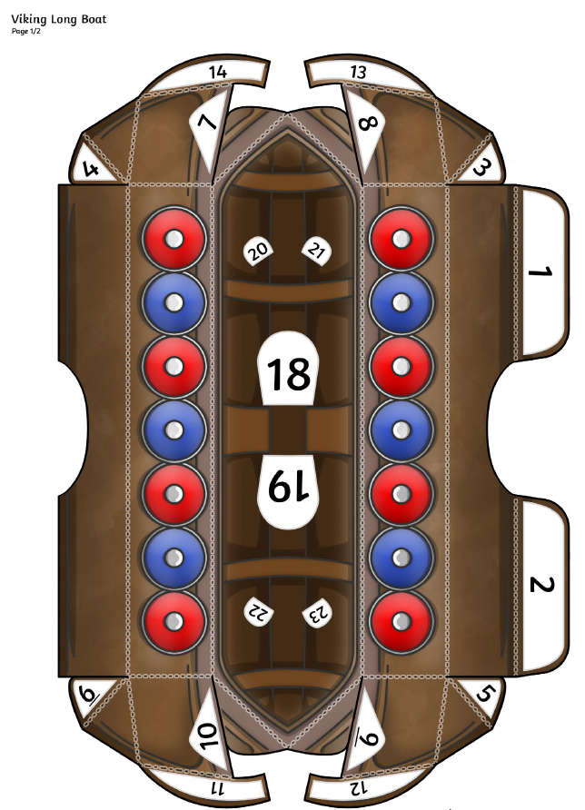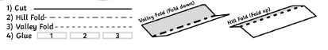
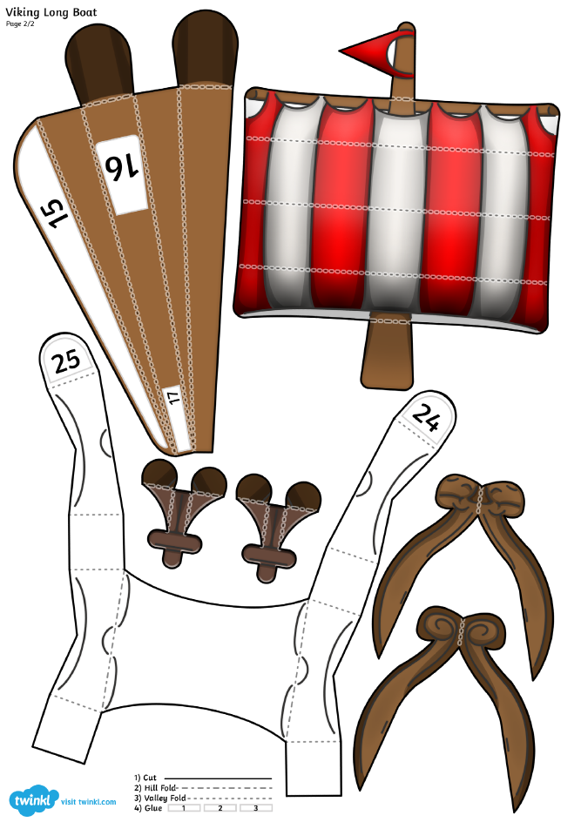
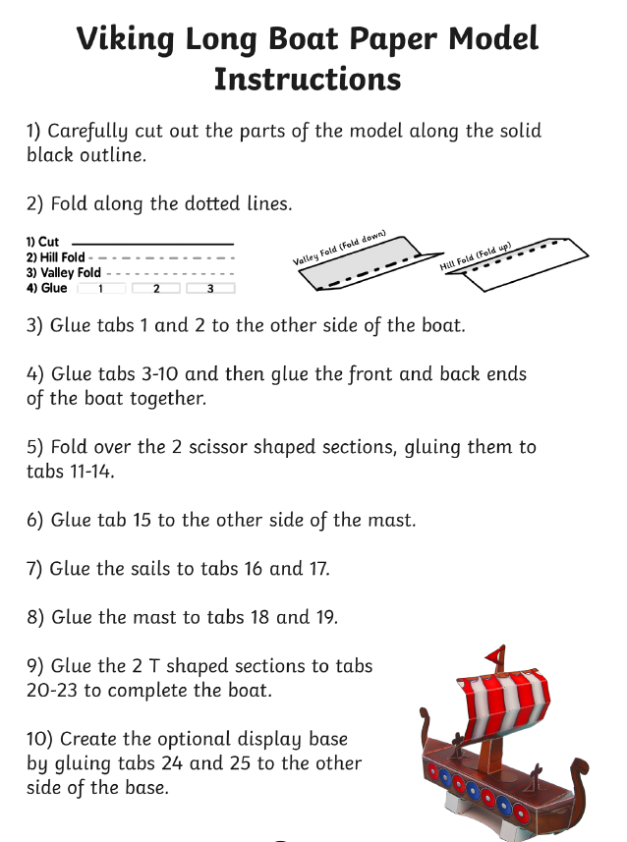
Other Activities
Start your day with Joe Wicks’ YouTube workout for kids live every morning at 9.00.  https://www.youtube.com /results?search_ query=joe+wicks | Write a book review for a book you have recently read. | Have a go at one of the puzzles on the next page. | Have a go at making your own wordsearch using the blank grid provided. | Year 4 Revision  BBC Bitesize daily lessons for Year 4  https://www.bbc.co.uk/ bitesize/dailylessons

Key skills to continue practising weekly:
- Times tables (including division facts)
- Reading (This can be anything! Reading your favourite book again, reading magazines, sub-titles on the TV etc.)
- Watch Newsround everyday so you are keeping up-to-date with what is going on in the world.

If you are able to access the internet, try these useful websites:
- Reading: There is an online book of short stories written during lockdown by 100 authors, including Michael Morpurgo. https://issuu.com/bloomsburypublishing/docs/thebookofhopes_interactivepdf/4?ff
- Timestable.co.uk
- Topmarks.co.uk

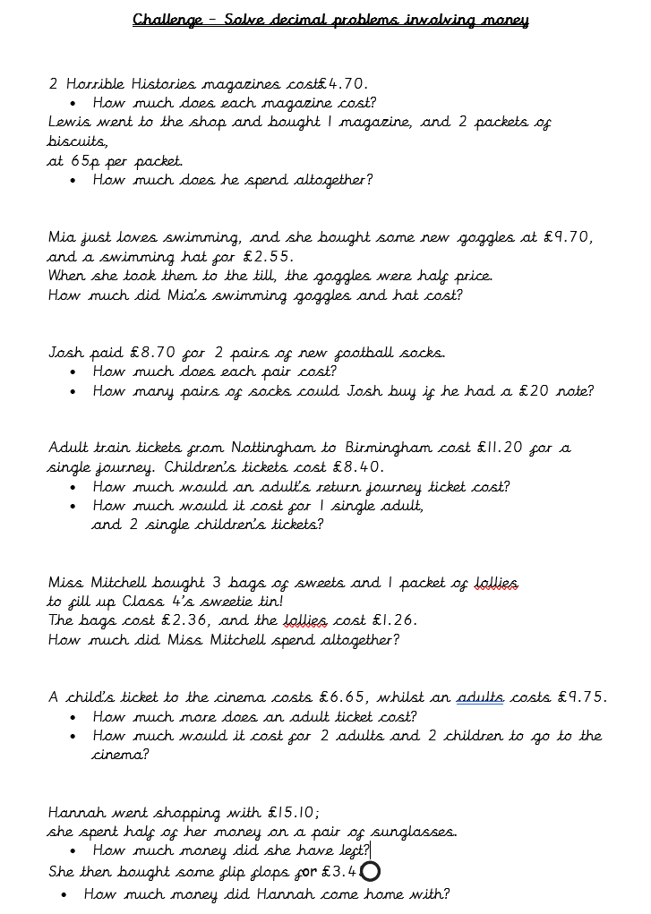
If you or your child has any further queries regarding their learning projects, please contact admin@hardwick.derby.sch.uk, clearly stating your child’s name and class teacher, and the staff will be in touch to support you and your child.

Thank you and stay safe.

