Nursery Home Learning
Week Commencing: 27th April 2020
Nursery Teacher: Mrs Bletcher
Nursery TA: Mrs White

Message from staff: We are both missing you all lots! We hope you are all well, and that you have had a lovely holiday at home with your grown-ups enjoying the sunshine. We are so proud of all of you, and can’t believe so many of you will be starting school in September. You are all so big now! We are SO proud of all of you and can’t wait to see you soon so we can have lots of fun together at Nursery! Whilst you are at home, we’ve out together lots of things you can be doing to have some fun and continue your learning. When you return to school, you can tell us all about it! Big BIG hugs, Mrs Bletcher and Mrs White x

Your Home Learning this Week:
Every day (Monday to Friday), make sure you choose a *physical, *communication, *reading/phonics, *writing and *maths learning activity. There are also further activities to choose from should you wish to.

Physical Home Learning
Develop your fine motor skills by using a knife and fork by yourself to eat your dinner this week!  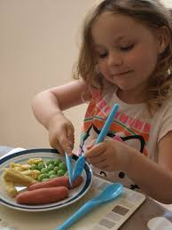 | Develop your fine motor skills by doing up the zip/buttons on your jacket by yourself. | Develop your fine motor skills by peeling your fruit by yourself (Examples: oranges and bananas). | Develop your fine motor skills by dressing yourself in the morning, and putting your pyjamas on at night! | Develop your fine motor skills by using a knife independently (supported by a grown up) to cut pieces of fruit.  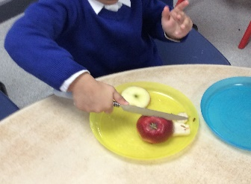

Communication Home Learning
Ask your child to retell you the story from our quality text: ‘I am a Tiger’  Follow the link to listen to the story again: https://www.youtube.com/watch?v=QE-ZeusK6bE | Apart from the tiger can the mouse, do you recognise any of the other characters in the story? What do you think they are? Why? | How do you think the tiger is feeling? Why?  Example: The Tiger is feeling sad because the mouse was mean to him. | Who is your favourite character in ‘I am a Tiger?’ Why?  Example: I like the mouse because he is brave. | How does the mouse feel when he’s talking to the tiger? Why do you think this?

Reading/Phonics Home Learning
Follow the link to listen to one of our favourite poems in Nursery:  https://www.youtube.com/watch?v=yD-yG2XnxpU  Can you complete the rhyming pairs? (Example: ‘Ning’ and ‘Ping’)  Which sound does ‘Ning, Nang, and Nong’ all start with? | Can you think of any objects that start with the sounds?  S  A  T  P  I | What object can you see? What sound does it start with? N  Remember, alliteration is when words start with the same sound. | What object can you see? What sound does it start with? N | What object can you see? What sound does it start with? N  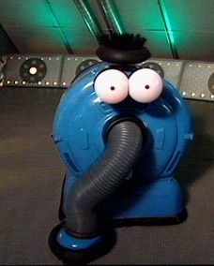

Writing Home Learning
Retell the story of ‘I am a Tiger’ by drawing your own story map. Below is an example of a previous story map.  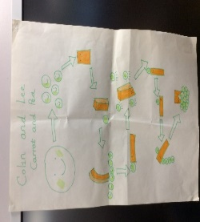 | Can you identify the initial sound and write the initial grapheme in any of your grown-ups names? Example: ‘D’ for Daddy. | Practise writing the first letter in your name. | Practise writing your whole name by yourself.  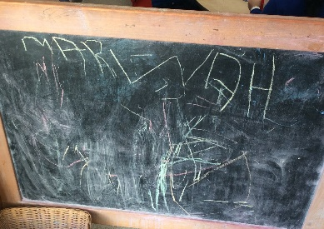 | Draw your favourite character from ‘I am a Tiger’.  Can you identify the initial sound and write the initial grapheme of your favourite animal?  Example: ‘M’ for ‘Mouse’
Maths Home Learning
Follow the link to join in counting numbers 1-20  https://www.youtube.com/watch?v=0VLxWIHRD4E  Have a go at counting 0-20 by yourself. How far can you get? | Have a go at representing 0-10 on your fingers. | Have a go at writing 0-10 by yourself. | Count how many people live in your house.  Can you recognise the matching numeral?  Can you show it on your fingers?  Can you write it down? | How many?  Remember to count the holes of Numicon!

Other Activities
Sing one of your favourite Nursery Rhymes every day.  Examples include:  -Wind the bobbin up  -Miss Polly had a Dolly  -Two Little Dickey Birds  -5 Little Peas  -Twinkle Twinkle Little Star | Ask your grown-up to put on your favourite songs to dance to. | Draw a picture of what you have done at home every day.  Write your name on it. | Develop your gross motor skills by helping your grown- up make dinner. Example: Rolling roti. | Think about what your favourite animal in the world is. Why? Draw a picture of your favourite animal.
Key skills to continue practicing weekly:
-Children should be practising being independent with their toileting at home.
-Encouraging children to extend sentences using connectives (Example: ‘I ate toast for breakfast because I was hungry’). This can be supported through modelling.
-Children should starting to be more independent in dressing/removing clothes themselves. Examples include: Taking their jumper off when hot, putting on shoes on, and starting to do zips and buttons.
-Children should be using knives and forks independently at meal times.

Useful websites: For link to ‘The Grand Old Duke of York’: https://www.youtube.com/watch?v=KGvEQTQaTbQ
For Phonics: https://www.youtube.com/watch?v=Y0ZILFubEdI
https://www.youtube.com/watch?v=VxBEmaaSh1c

If you or your child has any further queries regarding their learning projects, please contact admin@hardwick.derby.sch.uk, clearly stating your child’s name and class teacher, and the staff will be in touch to support you and your child.

Thank you and stay safe.

