Speech and Language Activity Ideas

Following 3-step instructions

Get three toys (animals of action figures) and 3 pairs of items different in colour or size (two coloured balls, two coloured blocks, two coloured pencils).
Tell your child, “(Name… good listening. Give cow green pencil” Repeat changing the keywords for 6 or 7 instructions.
You could try with other items:
- different types of food and big and small bowl/ coloured plates.
-coloured pencils and markers in different containers
- Cutlery and different size or colours mugs/cups

Positional language
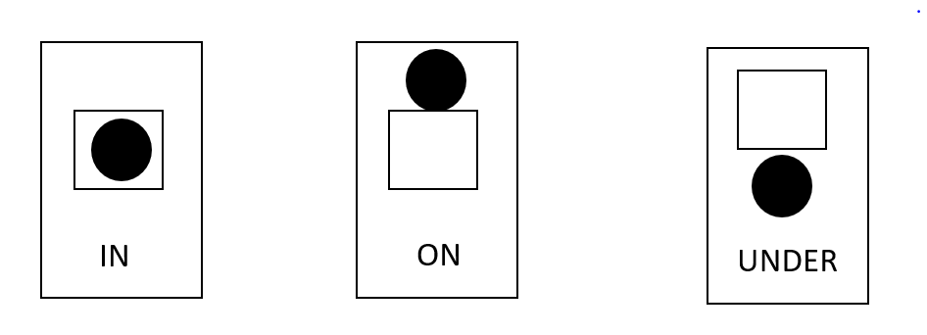

Use a ball and a pot (or a similar set of resources that you have at home). Model it first for your child: show them “IN” and put the ball in the pot. Reinforce the keyword “IN”. Do the same for the other two. Next, ask them to repeat it, showing them the flashcards: “(Child’s name), IN…Put the ball IN the pot”. Repeat with different sets of in, on, under instructions.

Colourful Semantics

You could use the Colourful Semantics powerpoint on the website. Practise the names of the people and the actions first, showing your child the pictures in the first slides.

Then show them a picture: Ask them: “WHO is in the picture?”. If you child can do this accurately, you can extend to asking “WHO is in the picture? And “WHAT are they doing?”. Model saying this in a full sentence e.g. “The lady is cutting.”

