Year 2 Home Learning
Week Commencing: 15th June 2020
Year 2 teachers: Mrs Nicholson and Mrs Tomordy
Year 2 TAs: Mrs Rowland and Ms Shaista
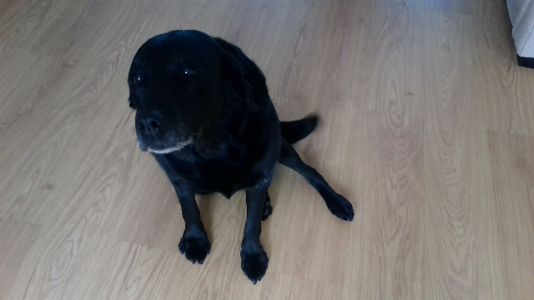
Message from staff: Hello everyone. It was lovely to speak to many of you and/or your parents last week. The weather is a bit cooler now so don’t forget your jumpers! Mrs Rowland is in school teaching some children but Mrs Nicholson, Mrs Tomordy and Ms Shaista are still at home, busily getting some learning ready for you! Here is a picture of Mrs Nicholson’s dog – she had a bath last week and is very happy now!
Mrs Tomordy has been out for a walk. These are some photos she took.
A bottlebrush plant A family of swans
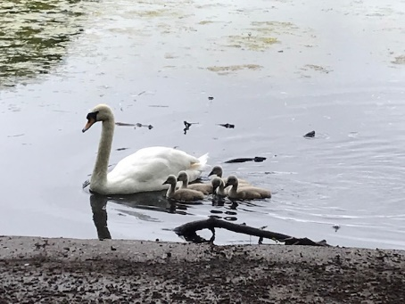
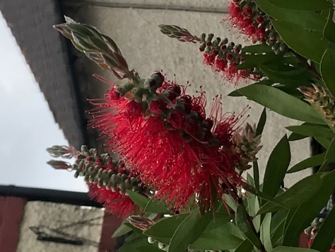

Your Home Learning this Week:
Every day (Monday to Friday), make sure you choose a *reading, *writing, *spelling/handwriting, *maths and *theme learning activity. There are also further activities to choose from should you wish to.
Reading Home Learning
Monday | Tuesday | Wednesday |  | Thursday | Friday
You will be reading the story Snow White and the Seven Dwarfs. Make connections with what you already know about fairy tales. Which other fairy tales do you know? What sort of characters are in fairy tales? How many fairy tales can you retell? Ask the people you live with if they know any fairy tales.  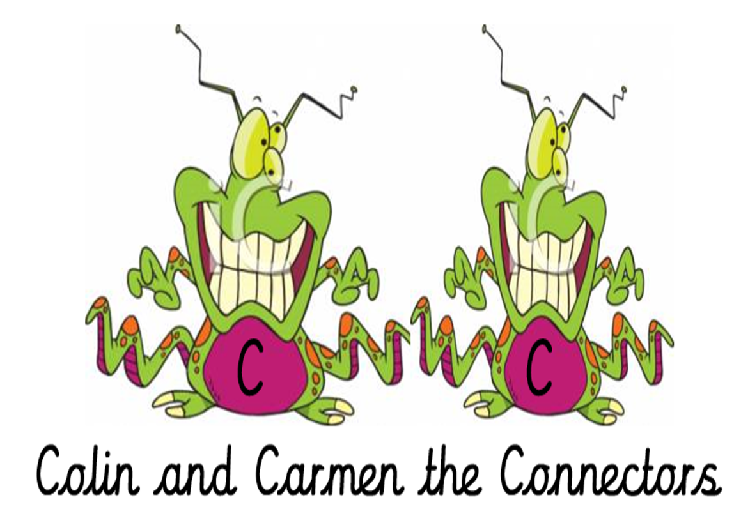 | Read ‘Snow White and the Seven Dwarfs’, using reading skills to help you understand as you go through it. Highlight any words you do not understand and find the meaning of them.  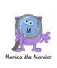 | Summarise what you have read in the text. A summary covers the very important parts of the text (VIP). Which parts in the text do you think are important?  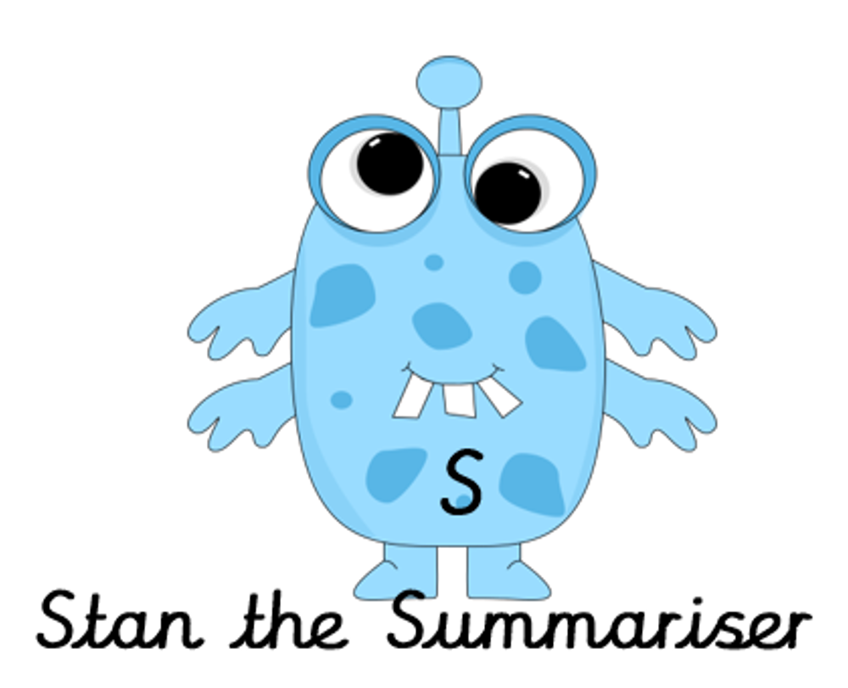 |  | Now try answering these questions:  - What did the queen ask the magic mirror every day?  - What word means the same as found?  - Why do you think the huntsman lied to the queen about removing Snow White?  - How did the queen turn into an old lady?  - What were the names of the dwarfs?  - Who rode into the forest and found Snow White? | After reading the text on ‘Snow White and the Seven Dwarfs’, think of any questions you may have. Is there anything you were left wondering that was not answered? Write these questions down. Reread the text again and this time, try to answer the questions you have. Can you answer them?  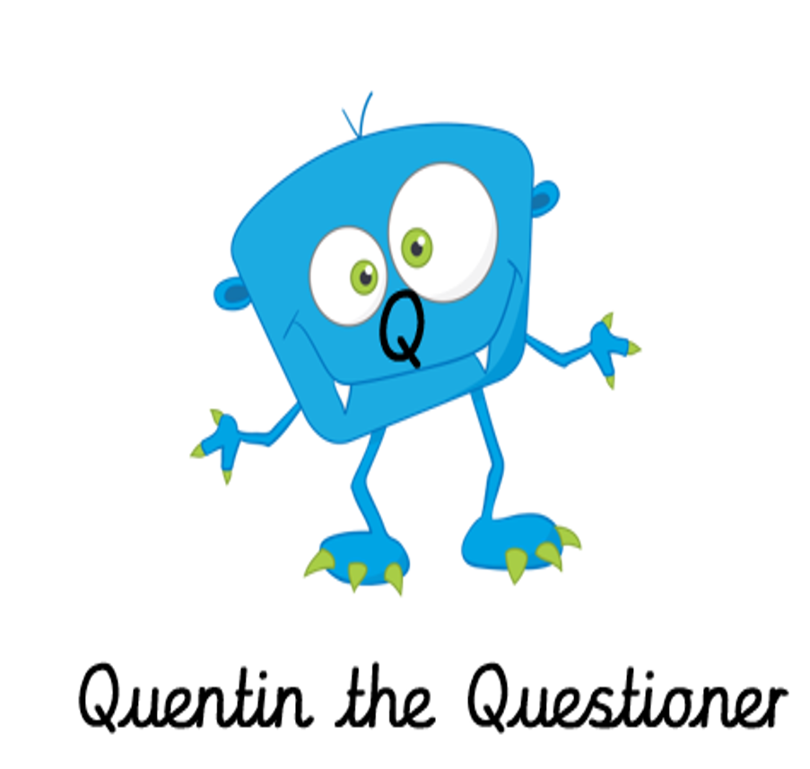
Easier:  Do as many of the above activities as you can. If you are finding some of the activities challenging, try these as they are a little easier:  - Read the text ‘Tim’s Van’ on the next page and answer the questions:  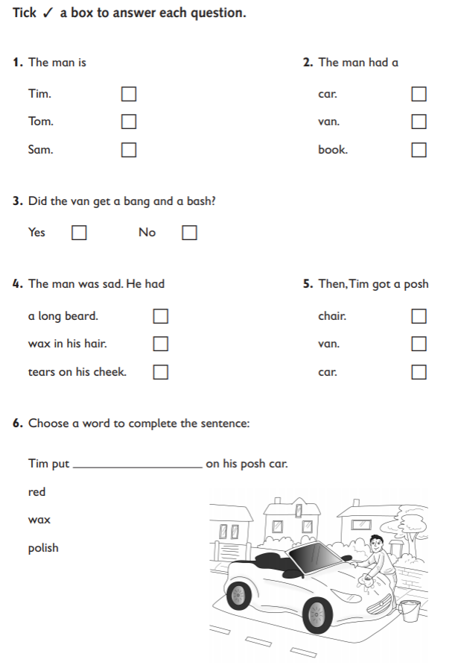 |  |  | Challenge:  If you feel you need a further challenge, try these:  - Test yourself! On a blank piece of paper, write down the names of all the fairy tales you know.  - Create a list of all the types of characters that you find in fairy tales.  - Predict what happens in the new fairy tale, ‘The Wicked King and the Dragon’. What could happen in this story? Who would the goody be? What would happen to the goody? How would it end?  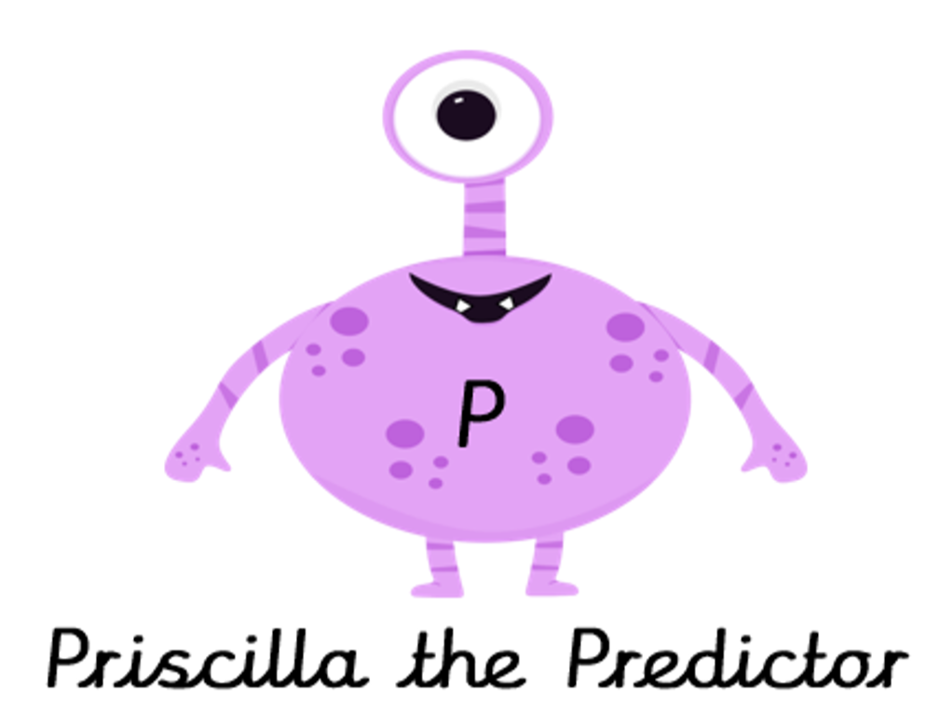
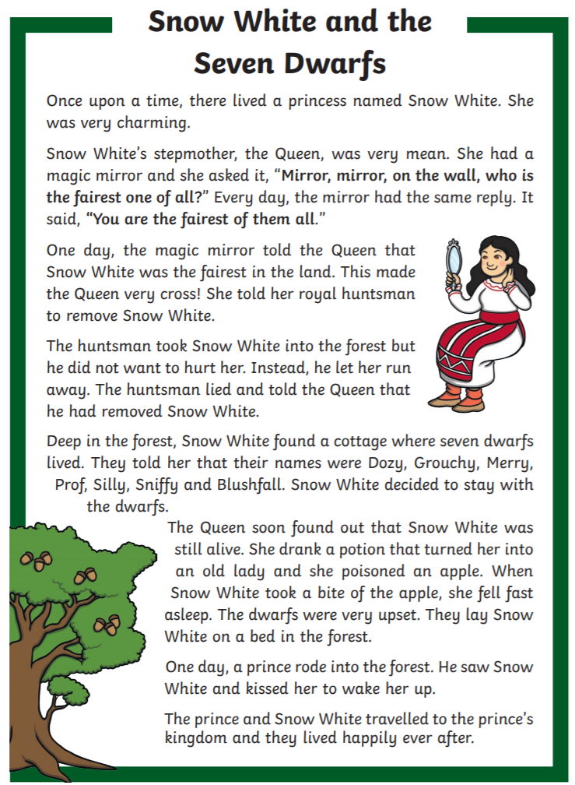
Tim’s Van
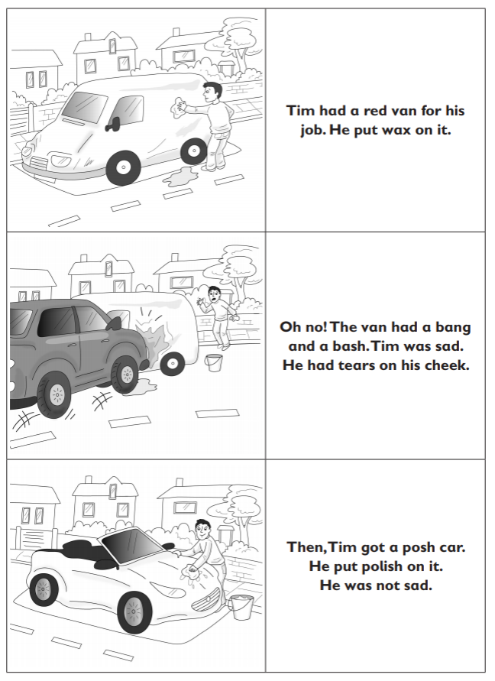

Writing Home Learning
Monday | Tuesday | Wednesday |  | Thursday | Friday
Using the pictures below, tell the story of the Enormous Turnip. | Can you write a sentence for each of the characters in the story and include noun phrases?  A brown-haired girl was skipping happily in the muddy field next to the farm. | Imagine the farmer plants a pumpkin. Tell a new story of him pulling it up. What new characters could be in the story? A friendly cow? A clucking chicken? |  | Retell your story from yesterday and draw a text map to remember your new story.  One day, a farmer and his wife planted a pumpkin seed… | Write the story that you told yesterday.  Draw an illustration for your story.
Easier:  Do as many of the above activities as you can. If you are finding some of the activities challenging, try these as they are a little easier:  - How many different animals can you see in the farm? Try writing them down using your sounds.  - Draw a picture for these words, and practise writing them:  cat  dog  rat  dig  mud  pull  boots |  |  | Challenge:  If you feel you need a further challenge, try these:  Task 1  Add some speech to your story… “Where are we going to do?” asked the farmer.  Task 2  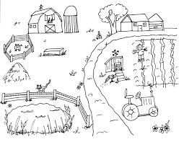  Draw the farmyard and  label it:  noisy, red tractor
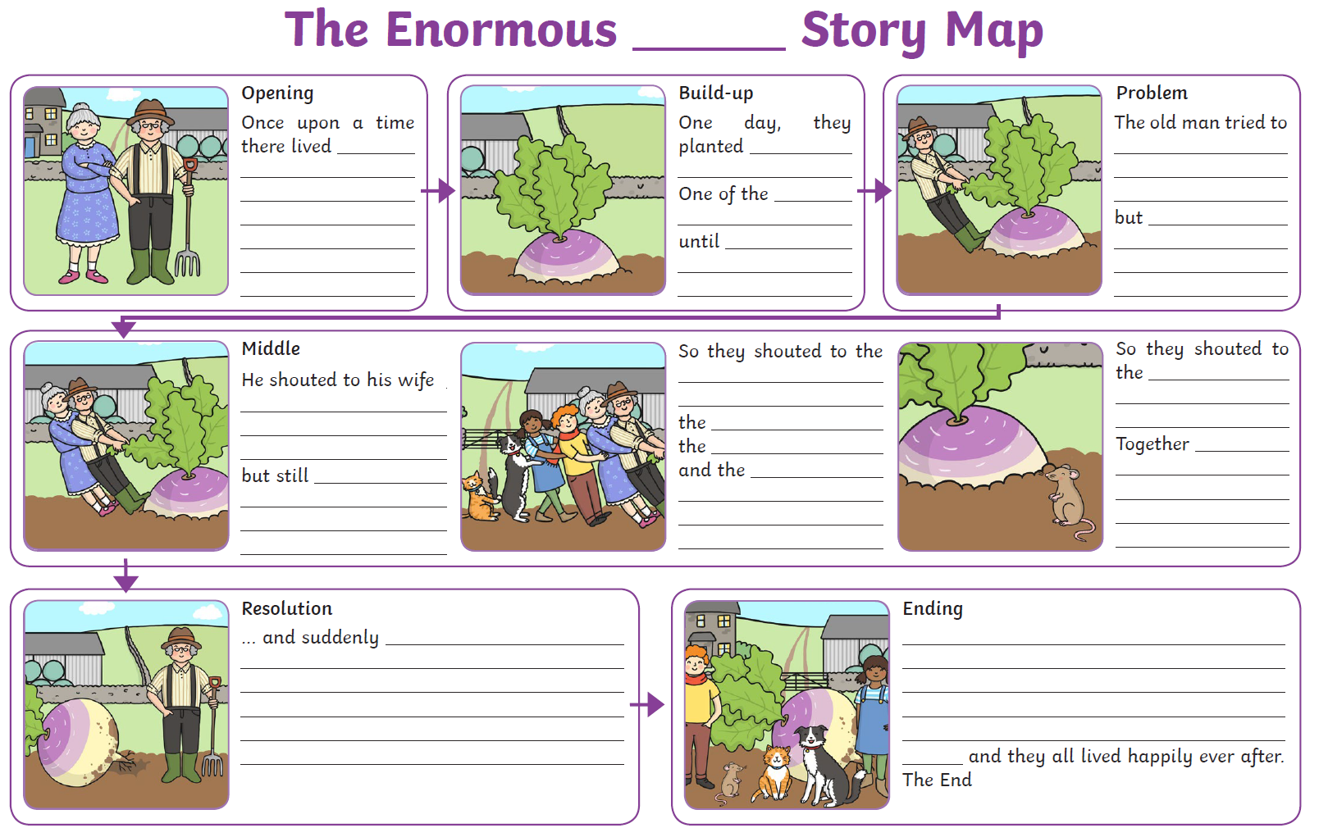

Spelling/Handwriting Home Learning
Monday | Tuesday | Wednesday | Thursday | Friday
Rainbow write the following question words and try to remember the pattern of spelling you can see.  why  who  when  where  what  which | Today create a scribble write for each of the question words from the day before. Can you do this without looking at the spelling at all?  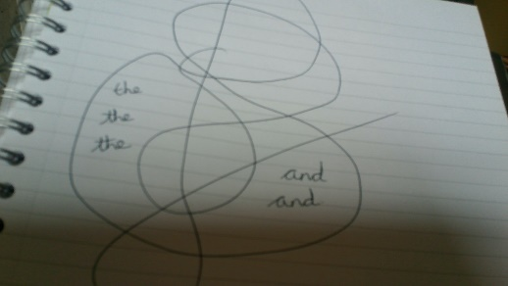 | Handwriting time. Write out each of the words ten times and take your time with making sure your ‘h’ is tall. You do not need to join the w and h. Try to do your handwriting on lined paper. | Another spelling pattern you should be able to do is often connected with a little rhyme to help you remember it.  could  should  would  Oh: O  You: U  Lucky: L  Duck: D  Try spelling these without looking and then have a go at ladder/pyramid write with them. | Choose some of the words from this week and try putting them into sentences. Remember the question words will need a different type of punctuation at the end.
Easier:  Do as many of the above activities as you can. If you are finding some of the activities challenging, try these as they are a little easier:  - 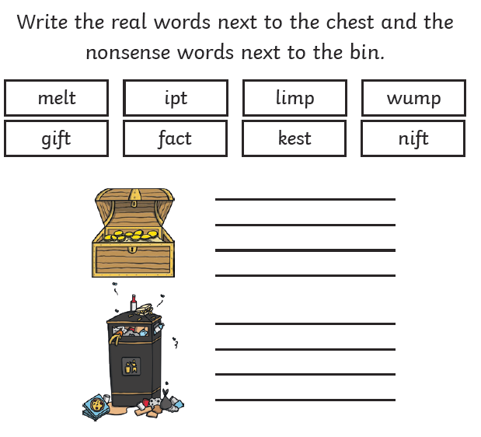  - 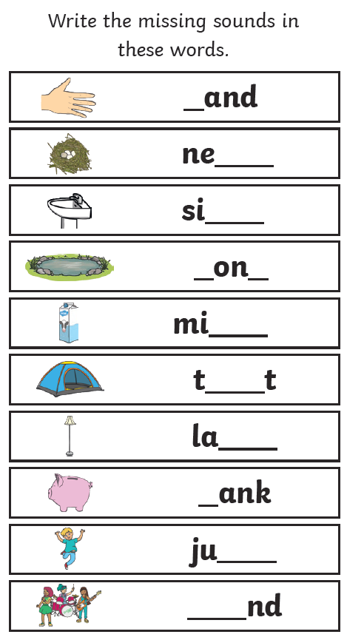 |  | Challenge:  If you feel you need a further challenge, try these:  - Homophones are different ways of spelling words that sound the same. Such as  their  there  they’re  The first one is where something belongs to someone. The next one relates to a place and the last one is a shortened version of they are by using an apostrophe.  First see if you can spell all of them by writing them out 10 times in your best handwriting. Then try creating sentences for each one and make sure you have used it in the right way.  - Have a challenge and ask someone to read out 20 of the common exception words for Year 2 and see if you can spell all of them without looking. How did you do? How many of them can you now do without looking? Challenge yourself to learn another each day.  - 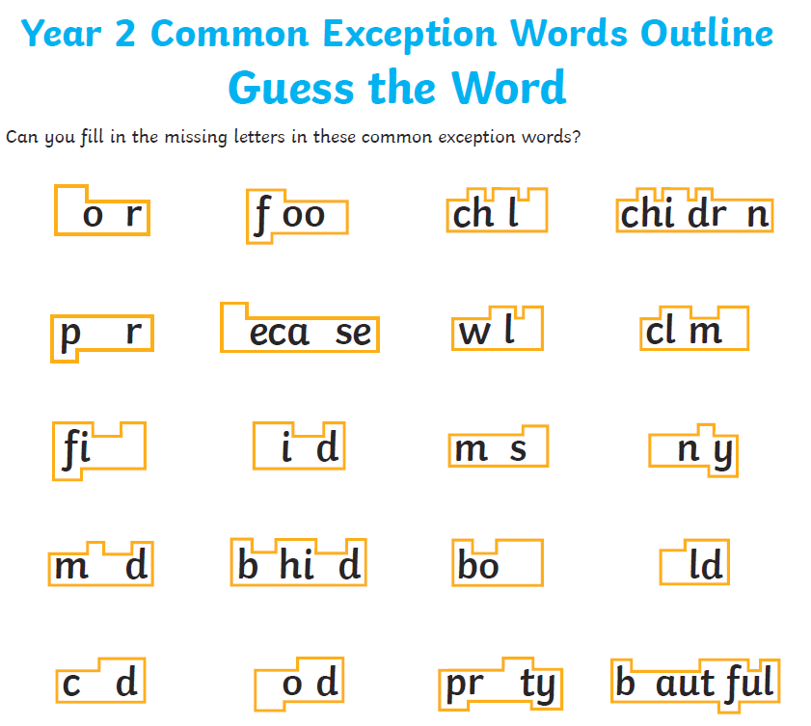

Maths Home Learning
Monday | Tuesday |  | Wednesday
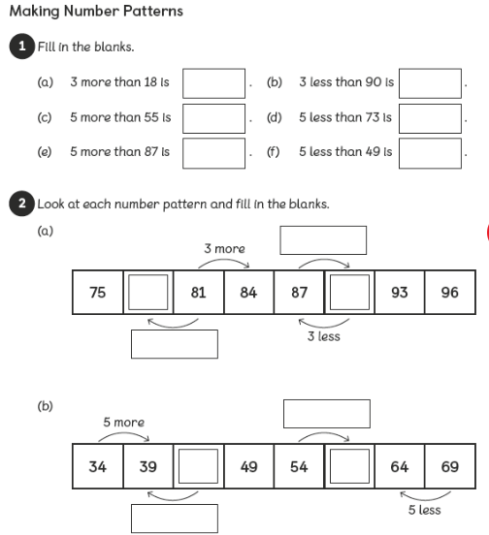 | 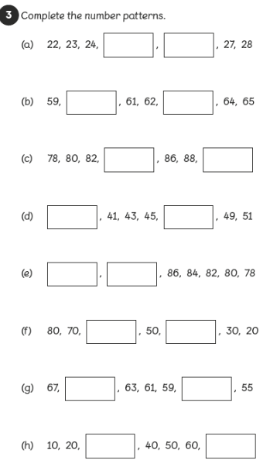 |  | 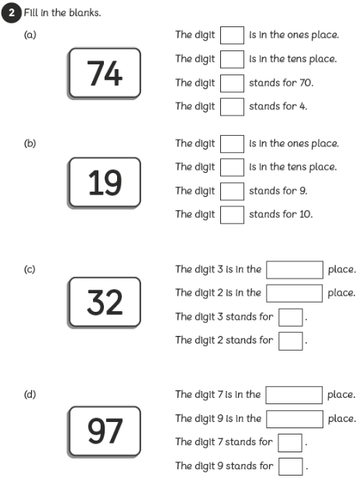
Thursday  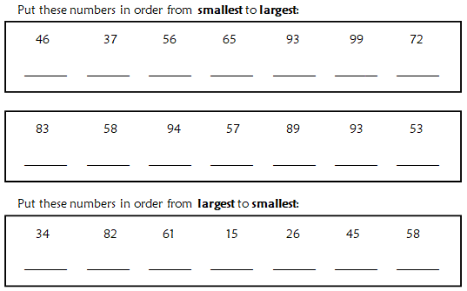 |  | Friday  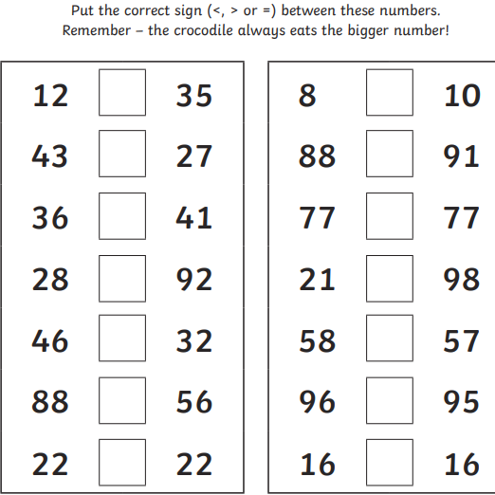

Easier:  Do as many of the above activities as you can. If you are finding some of the activities challenging, try these as they are a little easier:  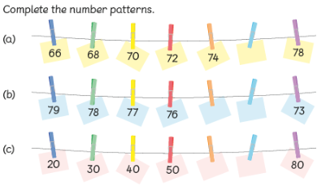  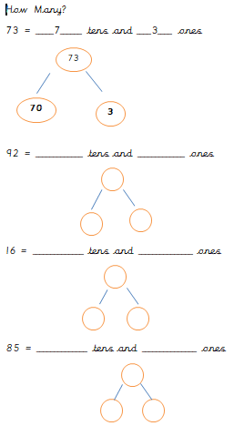 | Challenge:  If you feel you need a further challenge, try these:  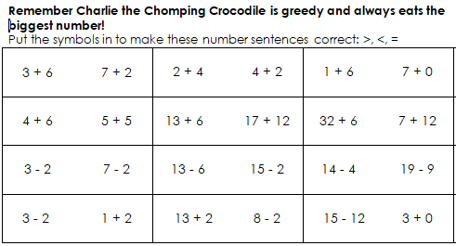  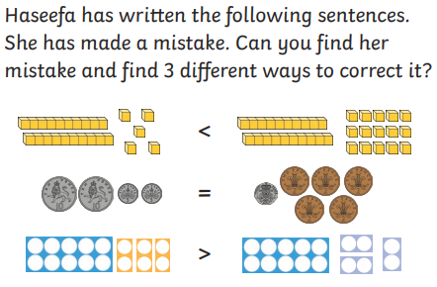
Theme Home Learning
Monday | Tuesday | Wednesday |  | Thursday | Friday
Geography  Coastal erosion occurs when the sea wears away the land. Different parts of the rock face are eroded at high and low tide. If high winds meet a high tide, the erosion will be greater. Different coastal features such as caves, arches and stacks are all formed by erosion.  Match the descriptions with the pictures below. | Geography  The pictures below show the Slatwick Nab coastline.  Describe and explain all the key features of Slatwick Nab such as caves, arches, stacks, beaches, spits, longshore drift. Describe how people use the areas. | Art  Look at the pictures of waves carefully now create your own picture. |  | D&T  Can you create and make the picture below using paint and paper? What techniques do you need to use to make a wave individually?  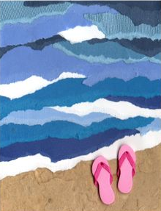 | Science  If you go to a park or garden centre, take this tick sheet with you and tick the plants and flowers you see.
Easier:  Do as many of the above activities as you can. If you are finding some of the activities challenging, try these as they are a little easier:  - Paint a sea picture using different shades of blue. |  |  | Challenge:  If you feel you need a further challenge, try these:  - Draw a diagram of a coastline erosion and describe how does it happen? BBC bitesize videos can help you with this.
Match the description with the pictures:
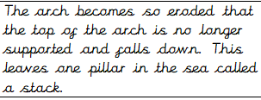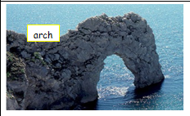
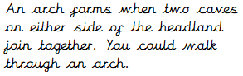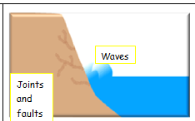
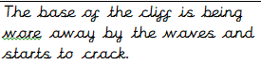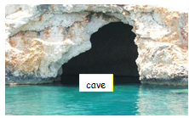
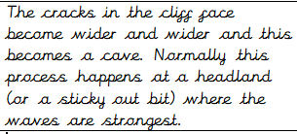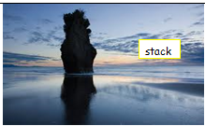

Slatwick Nab
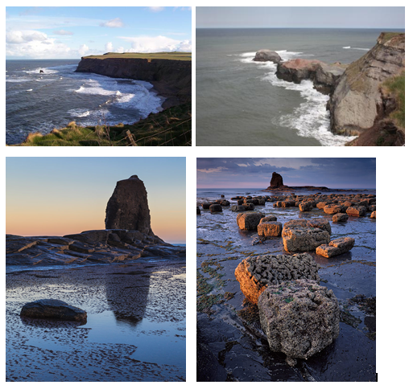

Science
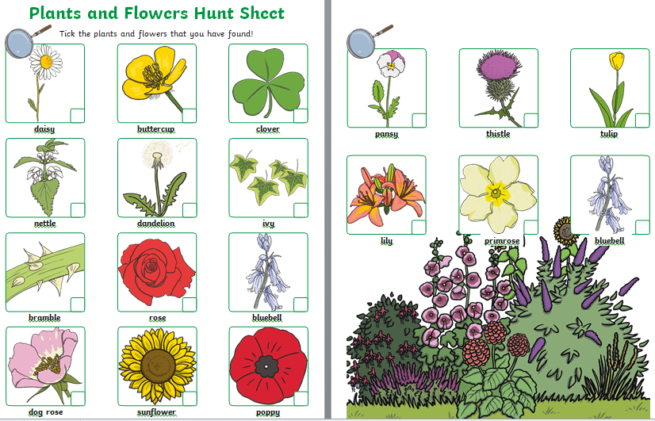
Other Activities
Music  Use some pots and pans from the kitchen to make some music. You could use a wooden spoon as a beater and saucepans as drums. | PSHE  This week it is World Refugee week. Can you find out what a refugee is? Think about how you would feel if you were a refugee. | RE  Which place of worship do you see when you walk around your local area? Draw a picture of it and write down everything you know about what is inside. | Geography  Use the map of the UK to label the countries. Use a map or the internet to label the capital cities of the countries and also Derby. | Science  Plan a healthy meal that your family could make and eat. Ask your adults if you could help to cook it.

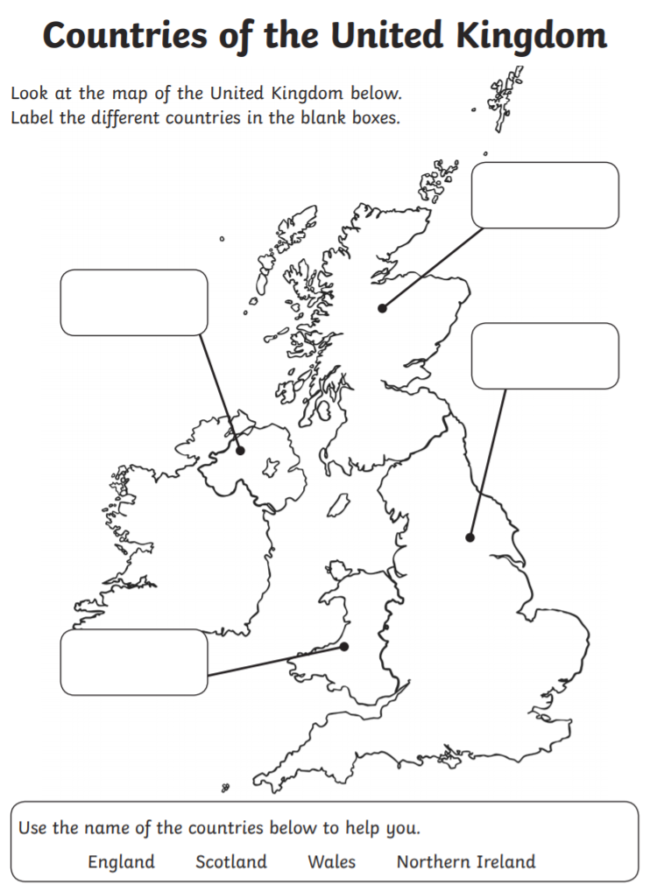
Key skills to continue practising weekly:
- Times Table Rock Stars – I have checked and not many of you are doing this and it is fun to do plus keeps your skills going. If you have forgotten your log on details then just email the school.
- Oxford Owl – lots of books to read
- Telling the time throughout the day to the nearest 5 minutes
- Play shops and work out the change
- Common exception words both reading and spelling

If you are able to access the internet, try these useful websites:
- https://www.bbc.co.uk/bitesize/primary
- https://www.bbc.co.uk/bitesize/clips/z4tmhyc
New lessons are uploaded every day for children to interact with
- https://scratch.mit.edu/
A chance to have a go at computer programming and create your own games, all completely free.
- Plus remember to check the list of other useful websites which are under home learning on a separate sheet.
If you or your child has any further queries regarding their learning projects, please contact admin@hardwick.derby.sch.uk, clearly stating your child’s name and class teacher, and the staff will be in touch to support you and your child.
Thank you and stay safe.

