Year 2 Home Learning
Week Commencing: 4th May 2020
Year 2 teachers: Mrs Nicholson and Mrs Tomordy
Year 2 TAs: Mrs Rowland and Ms Shaista

Message from staff:
Hello to all of you from all of us. We hope you and your families are keeping well. As always we are missing you but thinking about you and planning some exciting tasks for you to complete. As Ramadan begins, it is a special time for many of you but please remember the important advice from the government. If you need a musical reminder, follow the link to the baked potato song and see how many instruments you can recognise!
https://www.youtube.com/watch?v=f0HMHVD8bag

Your Home Learning this Week:
Every day (Monday to Friday), make sure you choose a *reading, *writing, *spelling/handwriting, *maths and *theme learning activity. There are also further activities to choose from should you wish to.

Reading Home Learning
Task 1  Read this text  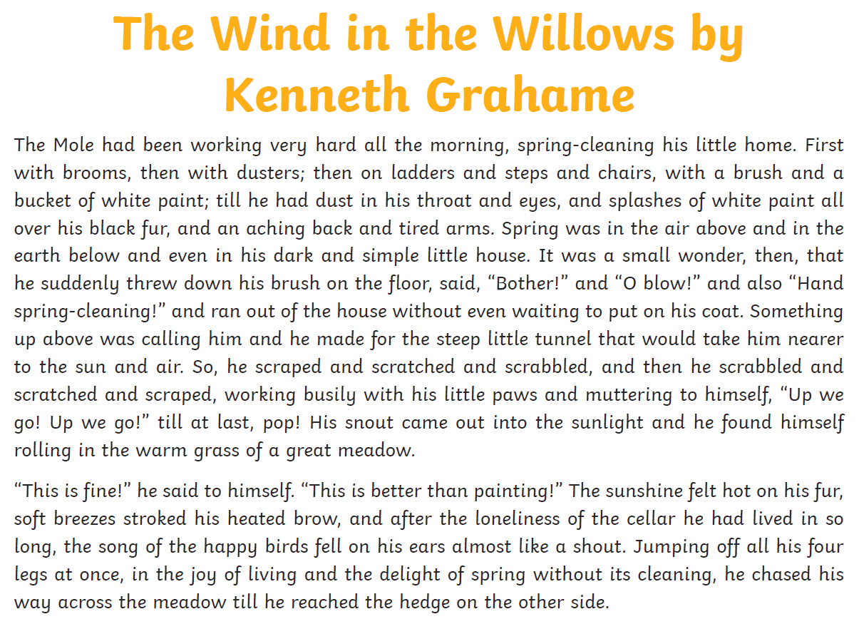  How many prepositions can you find? E.g. in, on, under | Task 2  Answer these questions about the text  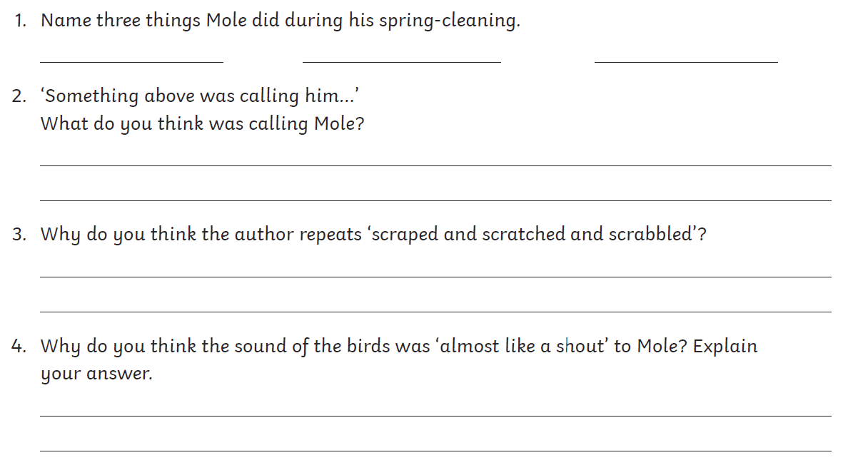 | Task 3  Which words could the author have used instead of -  - little  - ran  - nearer  - fine  - fell  - happy
Task 4  Can you read this text in 60 seconds? Get somebody to time you and keep practising until you can!  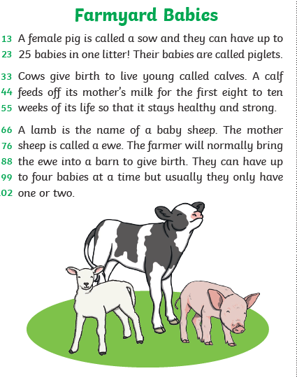 | Task 5  Read this letter to the farmer and correct the mistakes. Watch out for the homophones!  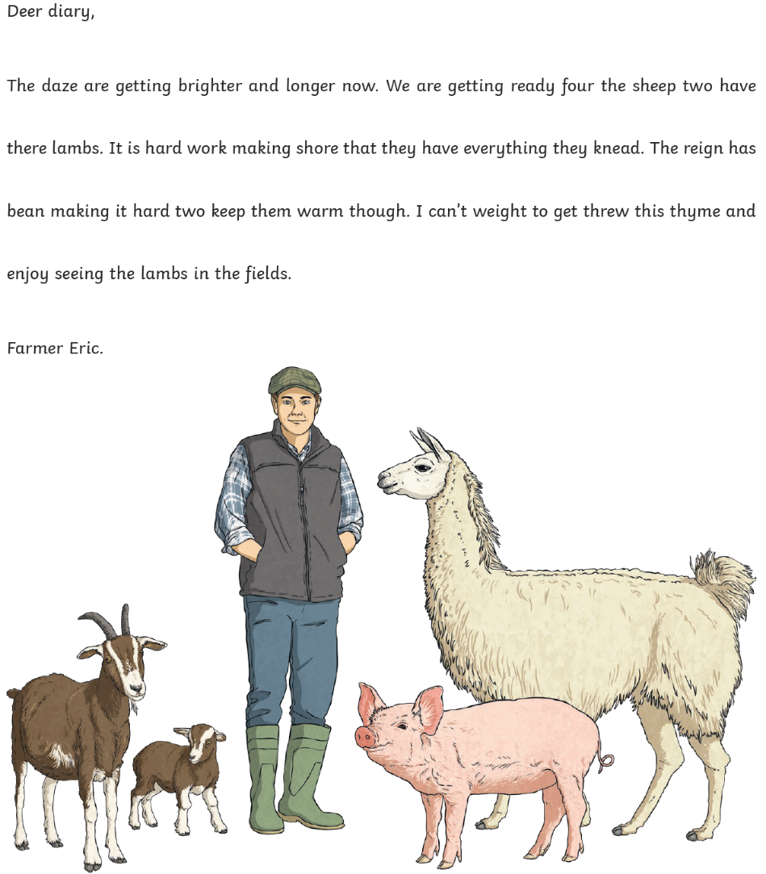

Writing Home Learning
Task 1  Imagine that you have just walked into your kitchen to find this. You can only ask 3 questions to the octopus. What would you ask and why?  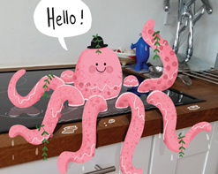 | Task 2  Write the story of how the octopus came to be here, and what happens next. | Task 3  Watch the following short film: https://www.literacyshed.com/butterflies.html  How would you describe the room before he opens the book? How could you describe it afterwards? Think of some different ways to describe the butterflies and how they fly.  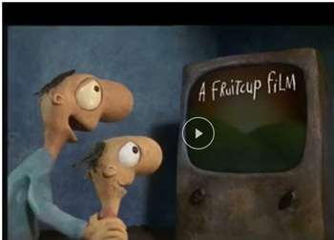 | Task 4  What would happen if lions and tigers came out of the book into the classroom? What would happen if fish came out? | Task 5  Now using all the work from the other tasks, create a story based on the film. Give the man a name and think about where he found the book and what happens next?  Use conjunctions  but, because, although, when  Use words ending in the suffixes er, est and ed.

Spelling/Handwriting Home Learning
Task 1  Practise these spellings and put them into sentences  - decide  - describe  - different  - difficult  - disappear | Task 2  Write these words to practise your joined handwriting. Remember to form the k correctly!  - kind  - break  - lock  - streak  - king | Task 3  Rainbow write these words  - early  - Earth  - eight  - eighth  - enough  - exercise  - experience  - extreme | Task 4  Draw a house and write these spellings 10 times each to fill the house up  - famous  - favourite  - February  - fruit  - forward  - forwards | Task 5  Write these words using joined handwriting. Pay attention to your ascenders and descenders  - grab  - long  - left  - string  - belong

Maths Home Learning
Task 1  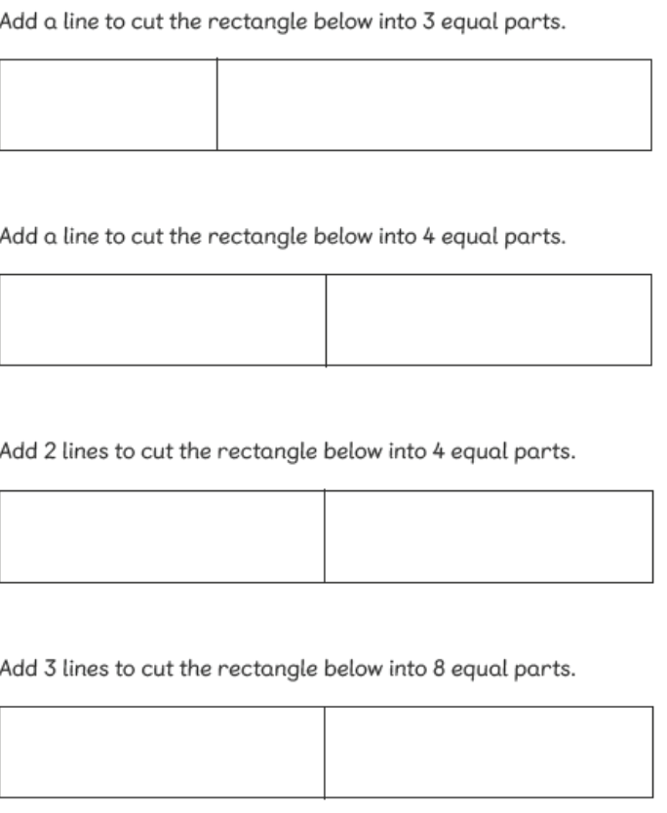 | Task 2  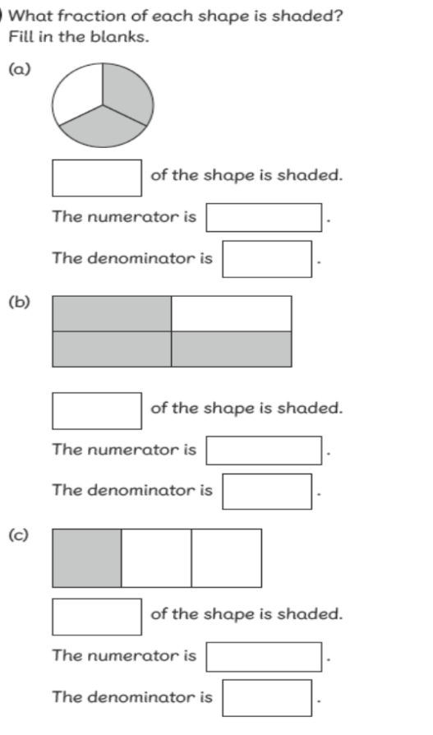 | Task 3  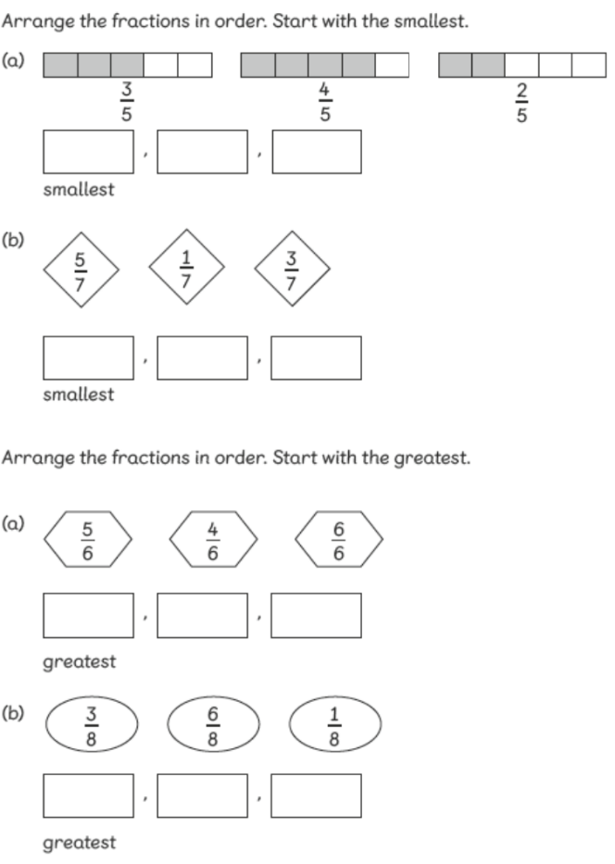
Task 4  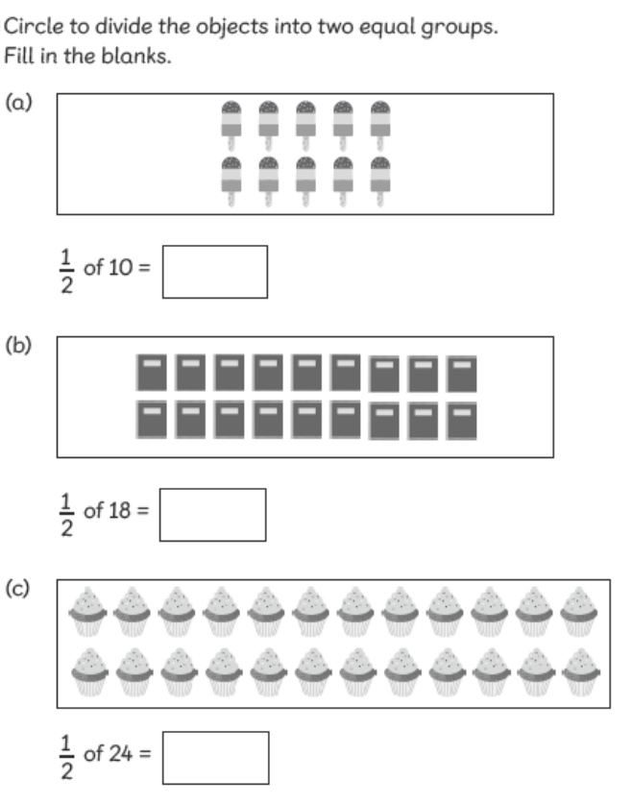 | Task 5  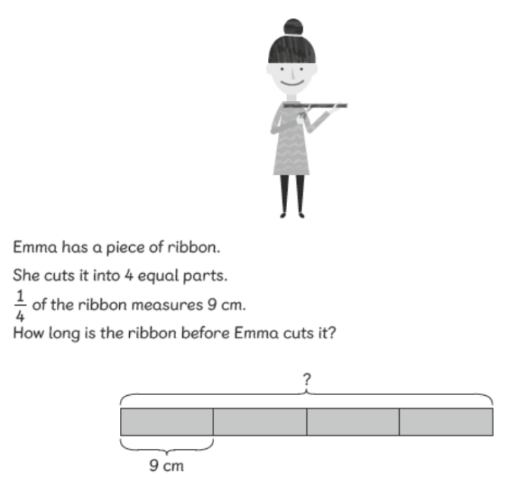

Theme Home Learning
Art  Can you draw a summer scene? What would you expect to see? Can you use your pencils to create different textures? Remember the techniques we learnt in class.  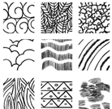 | Computing  Technology is all around us. Write about how the technology that you have in your home or on your street helps us. Think about:  - Cash machines  - Speed cameras  - Washing machines  - Game consoles  - CCTV cameras  - Street lights | Science  We planted some potatoes in school in Spring. Can you research how the potato will grow? Describe what happens at each stage.  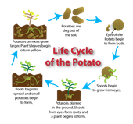 | Geography  Imagine you are walking to school. What can you see along the way? Create a map to show your journey to school. Can you create a key to show symbols instead of drawing pictures? | PSHE  Create a poster to show what is important when being a good friend. What do you think is important in your friends?  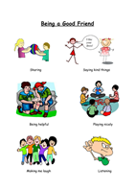

Other Activities
On your daily walk see if you can make a number sentence for the numbers you see.  2 x 6 = 12 | Create a tally chart for the number of cars or people going past your house. Is it more or less on the following day? | Follow an alphabetical treasure hunt in your house and garden. Find something beginning with a, b, c, etc. | Ask your adult if you can help prepare some food. Draw pictures to show the steps and instructions you followed. | Draw a picture of something that makes you feel:  - Anxious  - Excited  - Worried  - Happy  - Surprised

Key skills to continue practicing weekly:
Times Table Rock Stars
Reading with Oxford Owl – you need to register but there are lots of books to read online.
Read, read and read again.
Telling the time to the nearest 5 minutes
Practise reading and spelling your common exception words.
Handwriting out a passage from a book

Useful websites:
https://www.bbc.co.uk/bitesize This is a very useful website. It is run by the BBC and they are running daily lessons for children so why not have a look and see what they have.
On Youtube every morning at 9am, type in Joe Wicks. He is running an exercise session for children and adults to join in with.

If you or your child has any further queries regarding their learning projects, please contact admin@hardwick.derby.sch.uk, clearly stating your child’s name and class teacher, and the staff will be in touch to support you and your child.

Thank you and stay safe.

