Who were the fiercest soldiers?
The soldiers of Sparta were the fiercest army in Ancient Greece. They were brave, ruthless and very well trained. None of the men had ordinary jobs, even in peacetime. They spent their whole lives just training and fighting.
Spartan warriors were famous for their long, flowing hair. Before a battle, they sat down and combed it.
For Spartans, bravery was more important than anything else. To punish cowards, they shaved off half their hair and half their beard. This was a terrible disgrace.
Greek soldiers had to buy their own weapons and armour. A wealthy soldier bought himself a sharp spear and sword with a strong shield as well as expensive body armour. But a poor soldier made do with whatever they could find. Sometimes this meant they fought with an animal skin for protection and a wooden stick.
Greek soldiers fought side by side in tight rows. Each soldier’s shield overlapped his neighbours, making a strong wall of shields that protected them all. 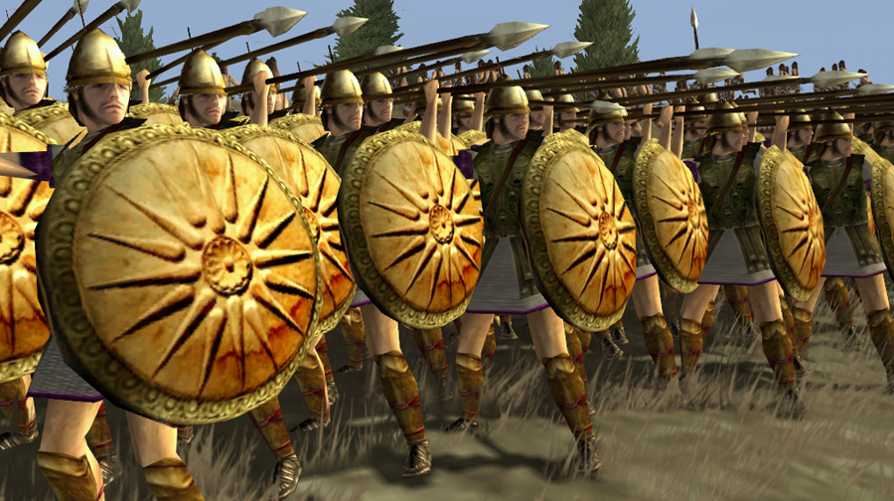
After winning a battle, soldiers sometimes gave their armour to the gods as a thank you present. They laid it inside a temple or hung it from trees.
In Sparta it wasn’t just the men who had to be fit. Women had to do lots of exercises to make sure their babies were strong and healthy!

