Year 2 Home Learning
Week Commencing: 4th May 2020

Year 2 teachers: Mrs J Tomordy, Mrs C Nicholson
Year 2 TAs: Ms Shaista, Mrs C Rowland

Message from staff:

Hello to all of you from all of us. We hope you and your families are keeping well. As always we are missing you but thinking about you and planning some exciting tasks for you to complete. As Ramadan begins, it is a special time for many of you but please remember the important advice from the government. If you need a musical reminder, follow the link to the baked potato song and see how many instruments you can recognise!
https://www.youtube.com/watch?v=f0HMHVD8bag

Your Home Learning this Week:
Every day (Monday to Friday), make sure you choose a *reading, *writing, *spelling/handwriting, *maths and *theme learning activity. There are also further activities to choose from should you wish to.

Reading Home Learning
Jack and the Beanstalk
Once upon a time, there was a boy called Jack. He lived with his mum and they had a cow.
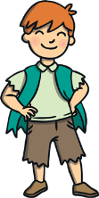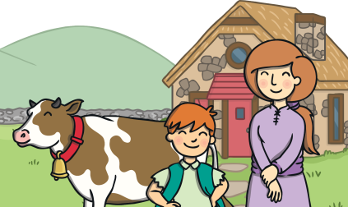
One day, Jack’s mum asked him to sell the cow. Jack met a man, who gave him magic beans for the cow.
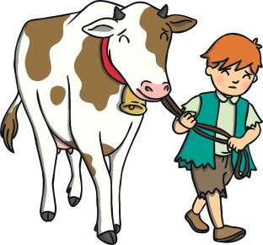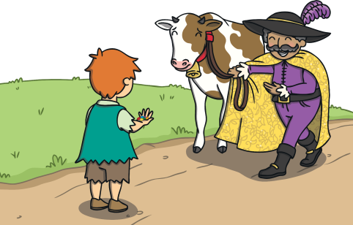
Jack’s mum was cross. She threw the beans out and sent him to bed. The next day, a giant beanstalk had grown! Jack climbed it.
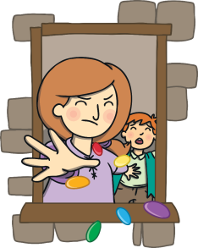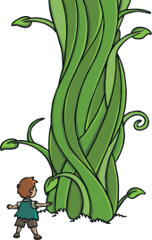
At the top, he saw a castle and went inside. A big giant came into the room with a hen and a harp. The giant fell asleep.
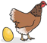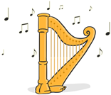
Jack took the hen and the harp. The giant ran after Jack. Jack’s mum cut the beanstalk. The giant fell to the ground.
Jack and his mum lived happily ever after.
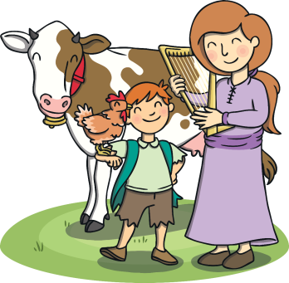
Task 1
Read Jack and the Beanstalk again and then copy and write all the nouns in red. Noun: Noun are the names of people, animals or things.

Task 2
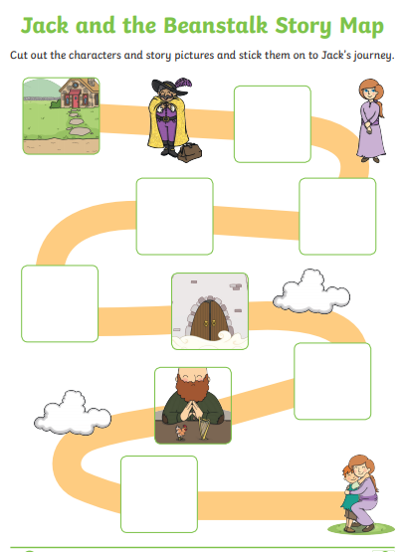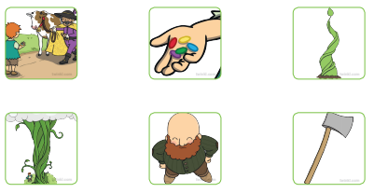
Draw the text map and draw the pictures in the correct place.
Task 3
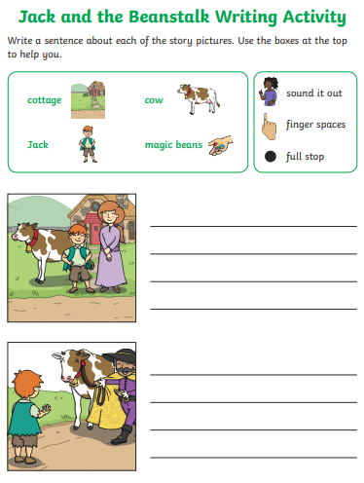
Task 4
List all the key words in the story using your story hand:
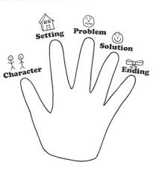
Writing Home Learning
Task 1:
Imagine that you have walked into your kitchen and find this octopus. What questions will you ask? You can start your questions with: what, why, how, when, which, where
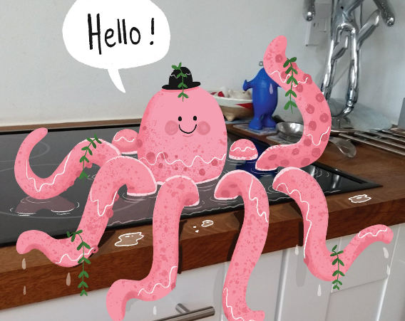

Task 2:
Write a short story about a tiger that comes to your classroom.

Spelling/Handwriting Home Learning
Task 1: Rainbow write these words for example: full
- we
- pull
- into
- the
- on
- no

Tasks:
How many words can you think of these phonemes:  o  f  s  a  t | Write these words 5 times:  today  said  are  do  to  mum | Practice capital letters 10 times on a lined paper.  A  B  C  D  E  F  G  H  I  J

Maths Home Learning
Task 1 2D shapes
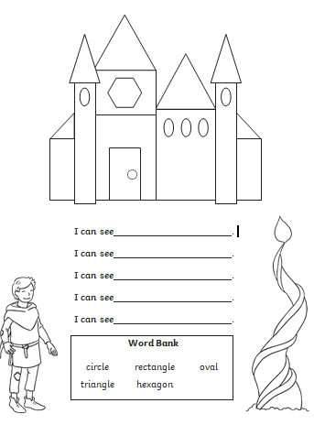

Task 2
2D Shape Properties
Write a description for each shape.

This 2D shape is a ________.
It has ________ sides and _______ corners.
This 2D shape is a ________.
It has ________ sides and _______ corners.
This 2D shape is a ________.
It has ________ sides and _______ corners.
This 2D shape is a ________.
It has ________ sides and _______ corners.
This 2D shape is a ________.
It has ________ sides and _______ corners.

Square Circle Rectangle Triangle Pentagon

Task 3
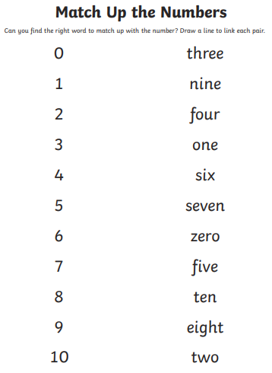

Task 4 for Maths:
Counting in 2s.
Fill in the missing numbers:

2, 4, 6 ___, ___, ___ 6, 8, 10, ___, ___, ___

12, 14, 16, ___, ___, ___ 16, 18, 20, ___, ___, ___

20, 22, 24, ___, ___, ___ 22, 24, 26, ___, ___, ___

Theme Home Learning
Art  Can you draw a summer scene? What would you expect to see? Can you use your pencils to create different textures? Remember the techniques we learnt in class.  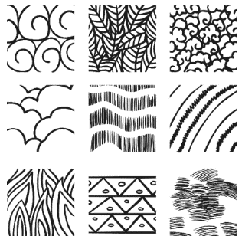 | Computing  Technology is all around us. Write about how the technology that you have in your home or on your street helps us. Think about:  - Cash machines  - Speed cameras  - Washing machines  - Game consoles  - CCTV cameras  - Street lights | Science  We planted some potatoes in school in Spring. Can you research how the potato will grow? Describe what happens at each stage.  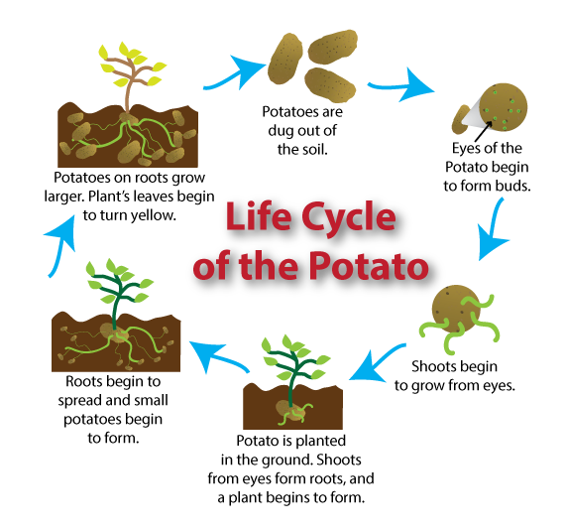 | Geography  Imagine you are walking to school. What can you see along the way? Create a map to show your journey to school. Can you create a key to show symbols instead of drawing pictures? | PSHE  Create a poster to show what is important when being a good friend. What do you think is important in your friends?  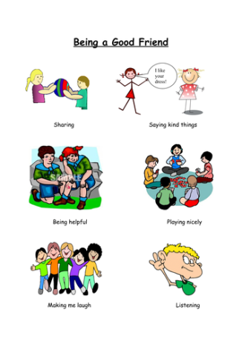

Other Activities
On your daily walk see if you can make a number sentence for the numbers you see.  2 x 6 = 12 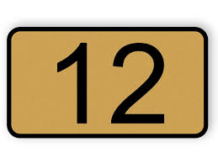 | Create a tally chart for the number of cars or people going past your house. Is it more or less on the following day? | Follow an alphabetical treasure hunt in your house and garden. Find something beginning with a, b, c, etc. | Ask your adult if you can help prepare some food. Draw pictures to show the steps and instructions you followed. | Draw a picture of something that makes you feel:  - sad  - Excited  - Worried  - Happy  - Surprised
Key skills to continue practicing weekly:
Times Table Rock Stars
Reading with Oxford Owl – you need to register but it is free to read lots of books online.
Read, read and read again.
Handwriting out a passage from a book
Useful websites:
https://www.bbc.co.uk/bitesize This is a very useful website. It is run by the BBC and they are running daily lessons for children so why not have a look and see what they have.
On Youtube every morning at 9am, type in Joe Wicks. He is running an exercise session for children and adults to join in with.
If you or your child has any further queries regarding their learning projects, please contact admin@hardwick.derby.sch.uk, clearly stating your child’s name and class teacher, and the staff will be in touch to support you and your child.

Thank you and stay safe.

