Year 2 Home Learning
Week Commencing: 27th April 2020
Year 2 teachers: Mrs J Tomordy, Mrs C Nicholson
Year 2 TAs: Ms Shaista, Mrs C Rowland
Message from staff: Hello to all of you from all of us. I hope you have had chance to enjoy some of the sunshine. We are all keeping busy and trying to ensure that you have tasks to do that will help you keep your brains whirring and your learning continuing in these strange times. Mrs Tomordy has been busy in the Easter holidays sowing some seeds. Have you managed to plant yours yet? She has planted some pea seeds and they are just poking through the soil. She has also been looking at the learning you will be doing when we all get back together again and creating some interesting things for you to do each week.
Mrs Rowland has been looking after Holly and her cat Puss. The weather has been lovely so she has been enjoying the sunshine in the garden while doing her school work. She has also been doing PE with Joe every morning to wake her up. Have you been doing it too? She can’t wait to see you when we get back to school!
Mrs Nicholson has been gardening and finding a path through the jungle in her garden! She has been walking her dog although her dog has had a poorly leg so cannot walk very far.
Mrs Shaista has been busy cooking and trying and experimenting new dishes most of the time successful! The weather has been so beautiful so she has been enjoying the sunshine while walking every morning with her mum. Every day in the evening she is catching up with reading her favourite books. Are you reading as well?

Your Home Learning this Week:
Every day (Monday to Friday), make sure you choose a *reading, *writing, *spelling/handwriting, *maths and *theme learning activity. There are also further activities to choose from should you wish to.

Reading Home Learning
Jack and the Beanstalk
Once upon a time, there was a boy called Jack. He lived with his mother and they had a cow.
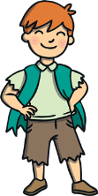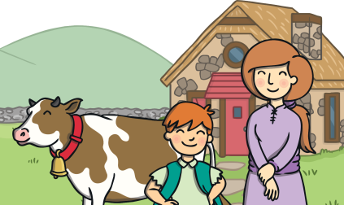
One day, Jack’s mum asked him to sell the cow. Jack met a man, who gave him magic beans for the cow.
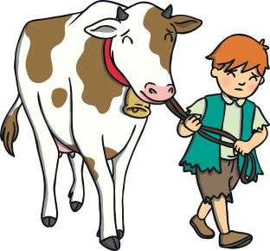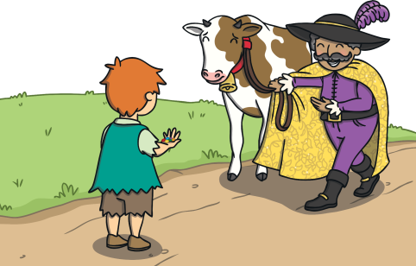
Jack’s mum was cross. She threw the beans out and sent him to bed. The next day, a giant beanstalk had grown! Jack climbed it.
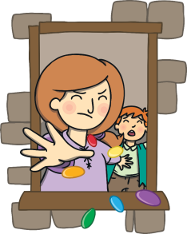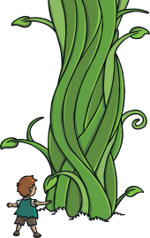
At the top, he saw a castle and went inside. A big giant came into the room with a hen and a harp. The giant fell asleep.
Jack took the hen and the harp. The giant ran after Jack. Jack’s mum cut the beanstalk. The giant fell to the ground.
Jack and his mum lived happily ever after.
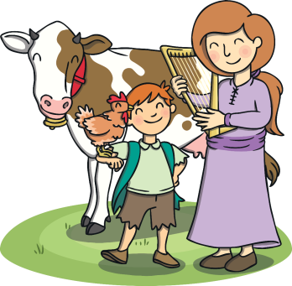
Task 1
Read Jack and the Beanstalk and then make some puppets and retell the story to your mum or friend using the puppets.

Task 2
Answer the questions:
- What was the boy called?

- What animal did Jack and his mum have?

- What did Jack get for the cow?

- How did Jack’s mum feel when Jack came home?

- Who lived in the castle?

8. Where did the giant chase Jack?

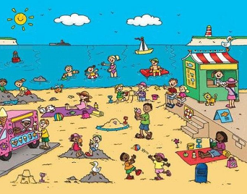

Writing Home Learning
Task 1:
Make a list of things you can see in the seaside picture, For example:
water
seagull

Task 2:
Now write sentences use the words in the list you have done. For example: The seagulls are on the beach and are very noisy.

Spelling/Handwriting Home Learning
Task 1: Practise these spellings and put them into sentences
- Full
- Pull
- Into
- The
- Go
- No

Tasks:
How many words can you think of these phonemes:  g  m  d  c | Rainbow write days of the week:  Sunday  Monday  Tuesday  Wednesday  Thursday  Friday  Saturday | 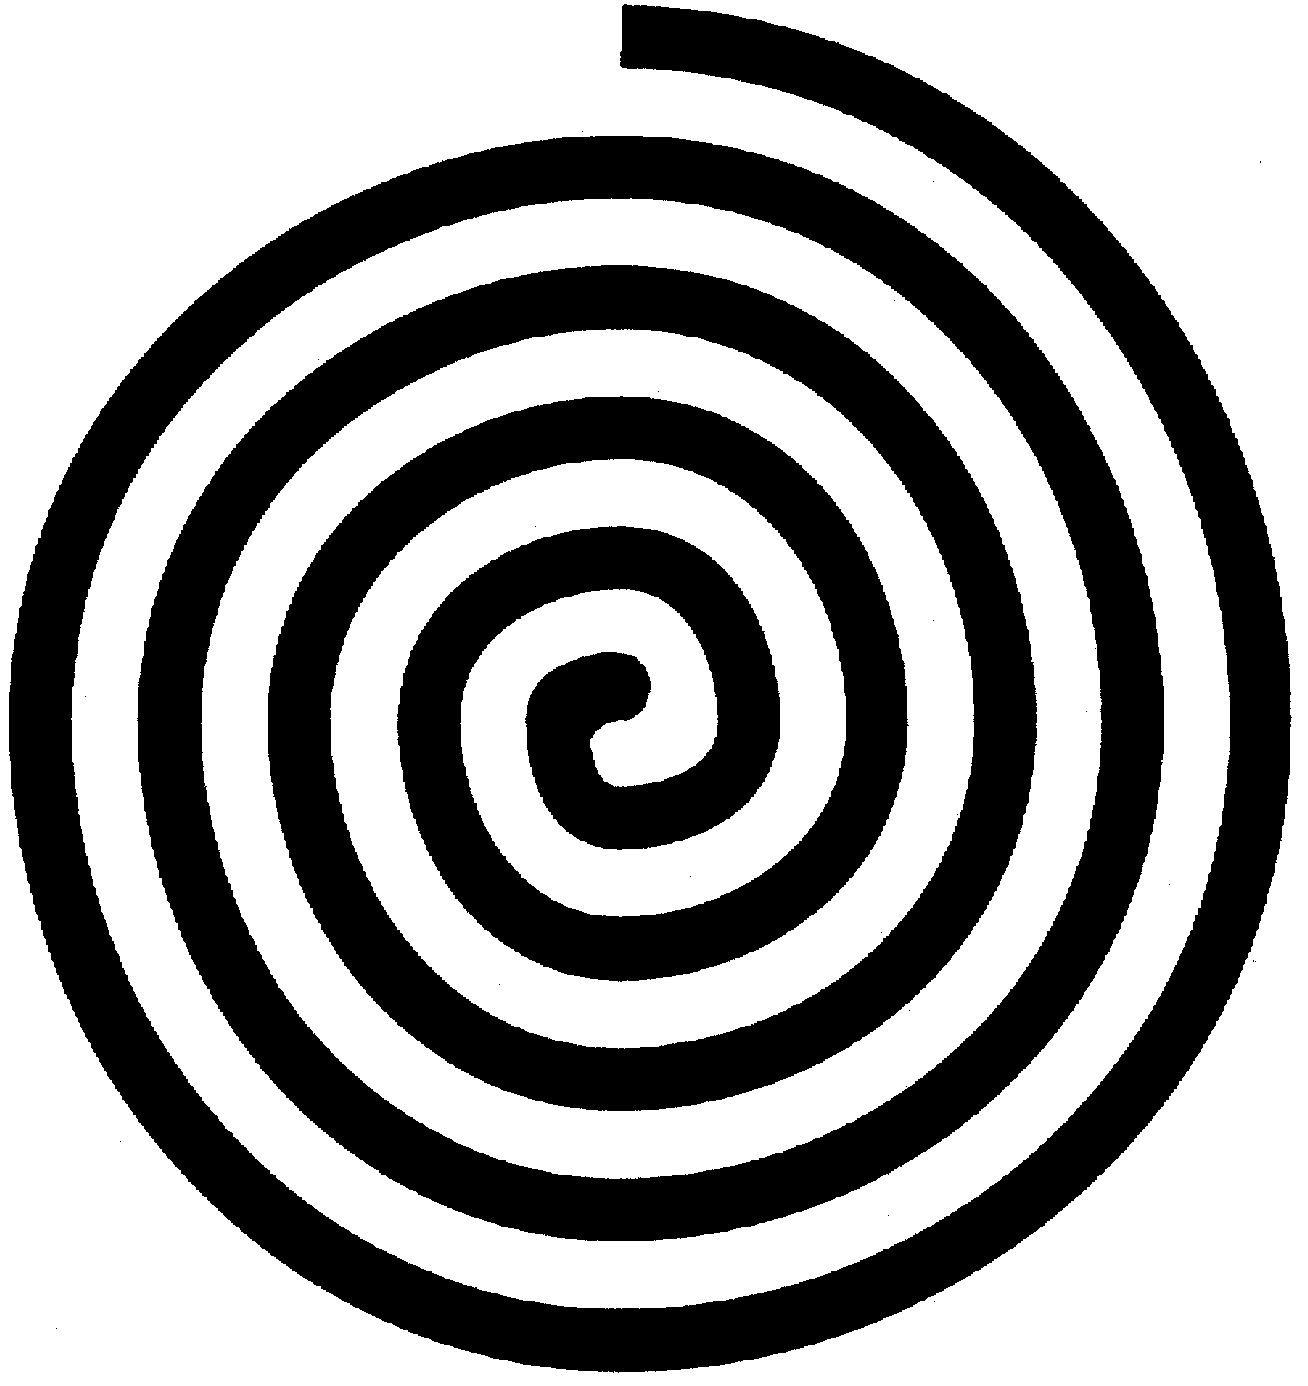  Create a spiral going in a clockwise direction and going inwards then do another going outwards.

Maths Home Learning
Task 1
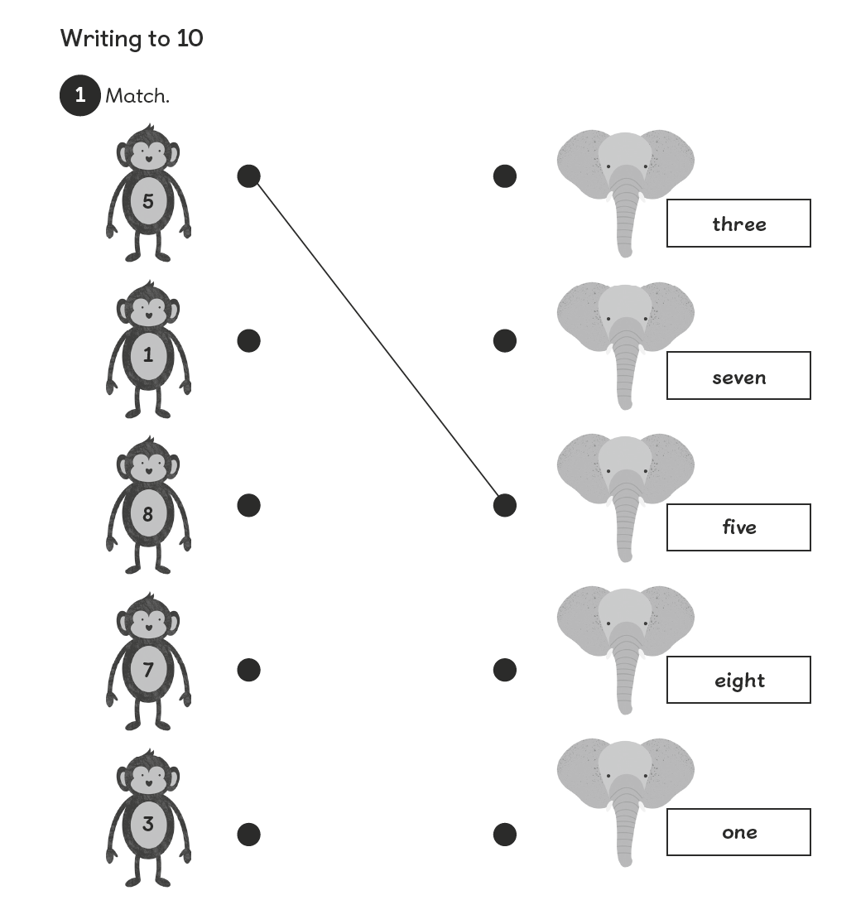
Task 2
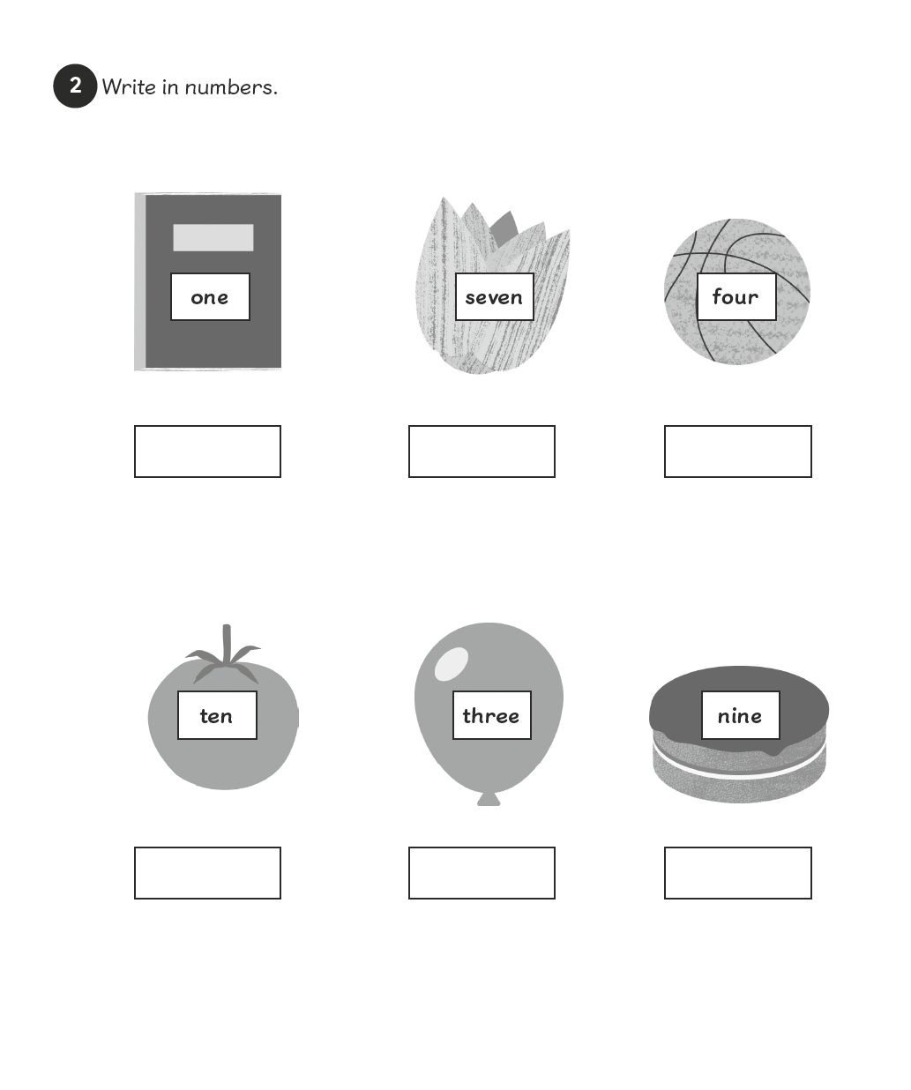

Task 3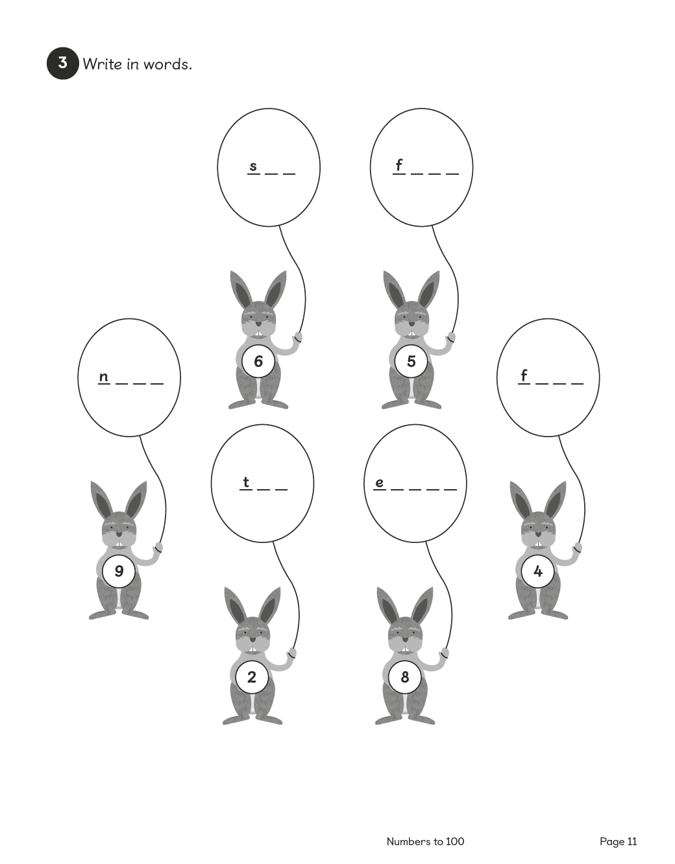

Task 4 for maths:
Count in 2s: 2 4 6 8 10 12……..
Count in 10s: 10 20 30 40 50……

Theme Home Learning
Art  Create a viewfinder with a piece of paper where the middle is cut out and then draw whatever you can see in the middle. Try this with something in your house or a plant in your garden. Try to notice the lines and shapes you can see.  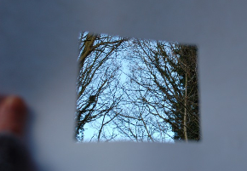 | Computing  Create a poster to tell others how to stay safe online. Remember the most important parts are to tell someone if you are not sure and never share personal information on line, including photographs. | Science  What different things do plants need to survive? Name 4 different things and then explain in a sentence why they need each thing. | Geography  Compare the school playground and your back garden Create a Venn diagram to show what you have found out. Remember the middle is where it is found in both places. | Art/PSHE  Create a poster that you can put up in your window to make people smile. So you could say thank you to someone or just have lots of rainbows, smiles etc.

Other Activities
On your daily walk see if you can add the numbers on the doors in your head. | Write a diary or draw a picture each day of something you have done and how you felt. | Do a rubbing of things around you by placing a thin sheet of paper over something and then carefully rubbing over with a crayon or chalk. How many different patterns can you make? | Create some salt dough and make some models of things. 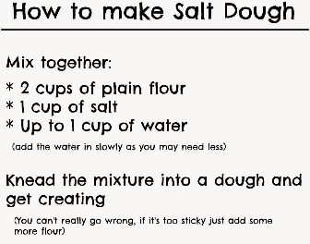 | Create a song or poem about flowers and things that grow. Keep practising it until you can do it in a performance to your family.
Key skills to continue practicing weekly:
Times table rockstars
Reading with Oxford Owl
Read, read and read again.
Practise reading and spelling words.
Handwriting out a passage from a book
Useful websites:
https://www.bbc.co.uk/bitesize This is a very useful website. It is run by the BBC and they are running daily lessons for children so why not have a look and see what they have.
On Youtube every morning at 9am, if you type in Joe Wicks he is running an exercise session for children and adults to join in with.
If you or your child has any further queries regarding their learning projects, please contact admin@hardwick.derby.sch.uk, clearly stating your child’s name and class teacher, and the staff will be in touch to support you and your child.

Thank you and stay safe.

