Year 6 Home Learning
Week Commencing: 6th July 2020
Year 6 teachers: Mrs Haider, Miss Qayoom, Mr Nowak
Year 6 TAs: Mrs Yar-Khan
Message from staff: It is great to know that everybody is doing well. Keep safe and don’t forget to complete an hour of physical activity daily. We will be sharing the days and times for the class picnic next week.

Oracy activity

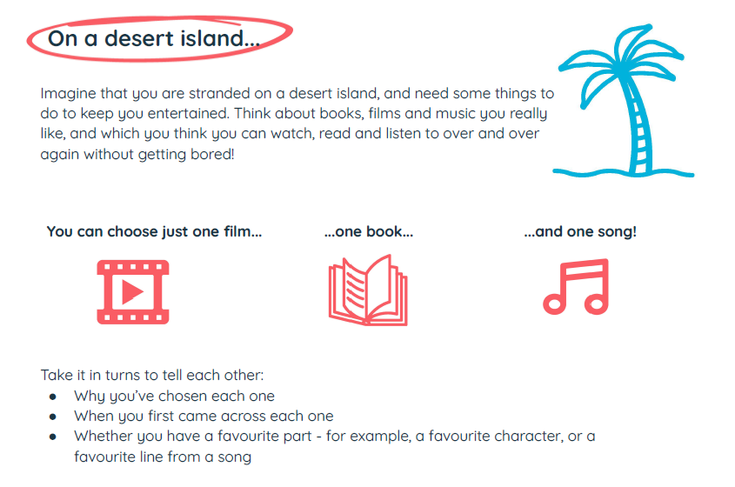
Reading Home Learning
Monday | Tuesday | Wednesday |  | Thursday | Friday
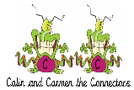  You will be reading a text about rainforests. Make connections with what you already know about rainforests. Are there any interesting facts you know? Have you heard anything about this from your friends/family on the television or elsewhere (e.g. newspapers)? Ask the people you live with if they know anything.  How are rainforests different to other habitats/places? | Read the text ‘Rainforests.’ Use the reading skills to help you understand as you go through it. Highlight any words you do not understand and find the meaning of them.  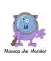 | 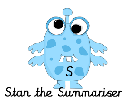  Summarise what you have read in the text. Remember, a summary covers the very important parts of the text (VIP). Which parts in the text do you think are important? |  | Now try answering these questions:  See the differentiated sheets (Easier, year 6 and challenge).  Explain why rainforests are important using your own words. . | 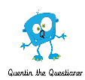  After reading the text, think of any questions you may have. Is there anything you were left wondering that was not answered? Write these questions down. Reread the text again and this time, try to answer the questions you have. Can you answer them? If not, try to research the answers or, save the questions for when we come back to school so you can research at school.
Easier:  Do as many of the above activities as you can. If you are finding some of the activities challenging, try these as they are a little easier:  - Read the text using the reading skills to help you understand as you go through it.  - Highlight any words you do not understand and find the meaning of them.  - What type of text is this and how do you know? What do you notice about how it is set out? Have you seen anything like this before? |  |  | Challenge:  If you feel you need a further challenge, try these:  - Test yourself! Name as many different types of habitats you can think of in one minute.  - What is the purpose of the article?  - Who is the article written for? How did you decide on your answer?  - Why do you think the writer included the ‘Fact File’ section?  Go back to the text. Ask an adult to test you to see if you can explain the meaning of the new words you have learnt.  - Use the new words by writing sentences of your own.
Reading Easier
Reading Year 6

Reading Challenge

Writing Home Learning
Monday | Tuesday | Wednesday |  | Thursday | Friday
Look at the cover in learning activity 1 and write down 5 things you notice. Now make a prediction about what you think might happen in the book.  (Don’t look at the text in learning activity 2) | Learning activity 2: Read the text, is this the same as your thoughts?  Complete learning activity 3 task B. | Read through the learning tips in Learning activity 4, use some of the words in task B to make a range of sentence types. |  | Complete learning activity 5 | Complete learning activity 6
Easier:  Do as many of the above activities as you can. If you are finding some of the activities challenging, try these as they are a little easier:  - Complete learning activity 3 task A.  - Read the words in learning activity 4 task B and write 10 sentences using as many of these words as you can. |  |  | Challenge:  If you feel you need a further challenge, try these:  - What do you think will happen to Shane?  - Complete learning activity 3 task C.  - When completing learning activity 4- challenge yourself to write complex sentences.  - Use this plan to write a story about a stray cat.

Learning activity 1 Learning activity 3
Task A:
What is your response to this ripped page?
How does it make you feel?
What does it make you think of?
What is the effect of the white on the torn edge?
Task B:
Is it the picture or the page of text, which is torn?
What kind of place is this?
How would you describe the setting?
Would you want to be in this place? Explain.
Task C:
Write a three sentence description of the boy?
Look closely at his facial expression and his body language. How has the illustrator conveyed his speed?
Is the time of day significant?
How does it affect the atmosphere and mood created?
Learning activity 2

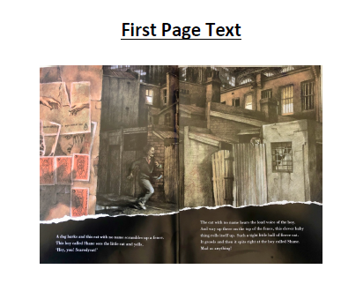
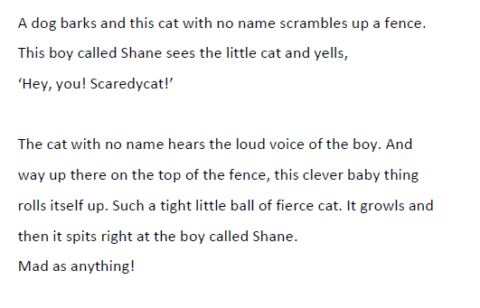

Learning activty 4

Learning tip Task B
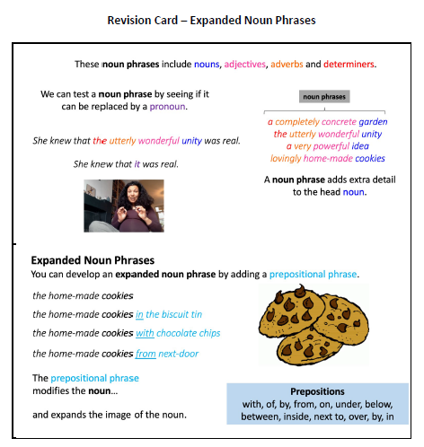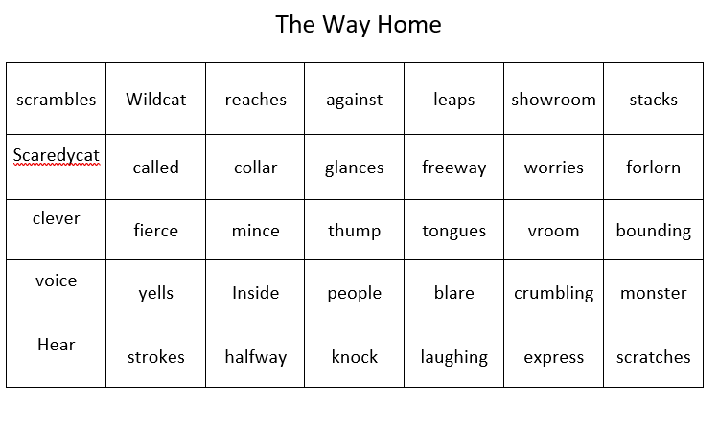

Learning activity 5
Illustrations can change the meaning of the words
Read the words again on their own. In the box below, draw a new illustration that uses the exact same words, but change the setting, colours, layout, design to make a completely different meaning.
A dog barks and the cat with no name scrambles up a fence. The boy called Shane sees the little cat and yells Hey You! Scaredy Cat!

The cat with no name hears the loud voice of the boy. And way up there on the top of the fence, this clever baby thing rolls itself up. Such a tight little ball of fierce cat. It growls and then it spits right at the boy called Shane. Mad as anything.

Learning activity 6
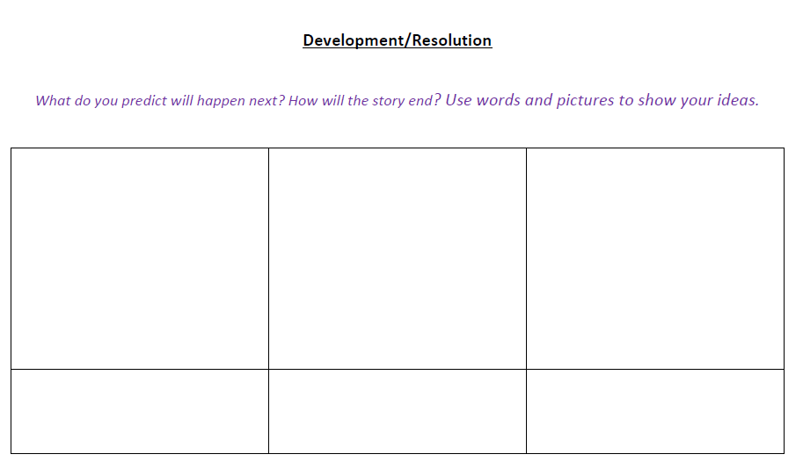

Spelling/Handwriting Home Learning Keep revising the same words this half term.
Monday | Tuesday | Wednesday |  | Thursday | Friday
suspicious  artificial  confidential  commercial  innocence  independent  recommend  significance  appearance  ferocious | Abstract nouns  disappointment  determination  enthusiasm  graciousness  apprehension  consideration  opportunity  speculation  enhancement  disturbance | Hyphens can be used to  join a prefix to a root  word. Words beginning  with the prefix co- can be  written with or without  prefixes.  co-ordinate, re-enter  co-operate, co-own  de-ice, co-author  re-examine, re-educate  re-form, co-pilot |  | Morphology - Provides  opportunity to find links  from previously taught  spelling/structure of  words and parts of words  (Stems, roots, prefixes, suffixes etc.)  Opportunity, parliament  Programme, privilege  Explanation, disastrous  Exaggerate, frequently  Necessary, appreciate | ASSESSMENT  Ask someone in your family to test you. 10 random words.
Easier:  Do as many of the above activities as you can. If you are finding some of the activities challenging, try these as they are a little easier:  - Use a dictionary to make sure you understand each word  - Try the following words:  chef, chalet, machine, brochure, chute, parachute  Moustache, quiche, chauffeur, chandelier |  |  | Challenge:  If you feel you need a further challenge, try these:  - Write a story and try to include as many words from your spelling list as possible.  - Write a poem using some of the words above  - Learn the words with double consonants:  accommodate, accommodation, aggressive,  embarrass, apparatus, success, successfully,  willingness, worthlessness, happiness

Maths Home Learning
Monday | Tuesday | Wednesday |  | Thursday | Friday
Revise over learning tip in Learning activity 1.  Use BIDMAS to complete learning activity 1 task B | Revise over learning tip in activity 2. Complete task B. | Revise over learning tip in activity 3. Complete task B. |  | Choose a challenge from learning activity 4and complete. Work through it with your family. | Choose a challenge from learning activity 4and complete. Work through it with your family.
Easier:  Do as many of the above activities as you can. If you are finding some of the activities challenging, try these as they are a little easier:  - Complete learning activity 1 task A.  - Revise over learning tip in activity 2 and complete task A.  - Use the digit cards to make two different numbers write the number in words and numerals. compare the numbers. Challenge yourself to compare three numbers. |  |  | Challenge:  If you feel you need a further challenge, try these:  - Complete the challenge in Learning activity 1  - Make up your own function machines for learning activity 2.

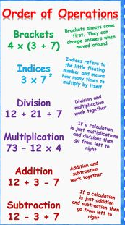
Learning activity 1 Learning tip Task A Task B 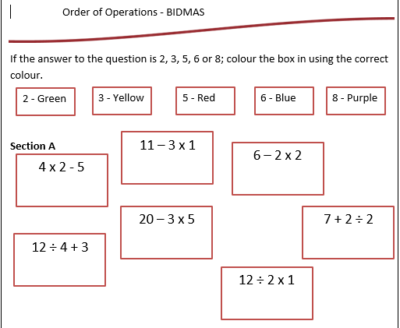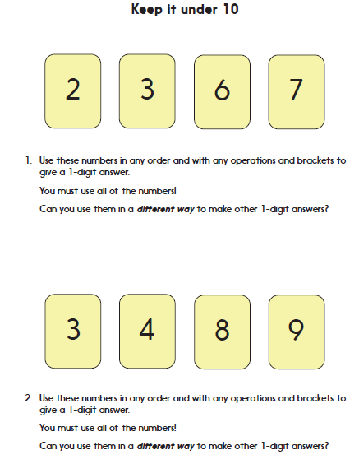
Challeenge
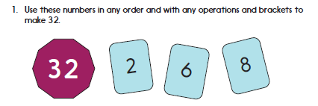
Learning activity 2
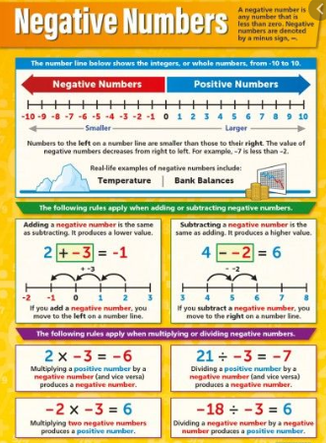
Teaching tip Task A
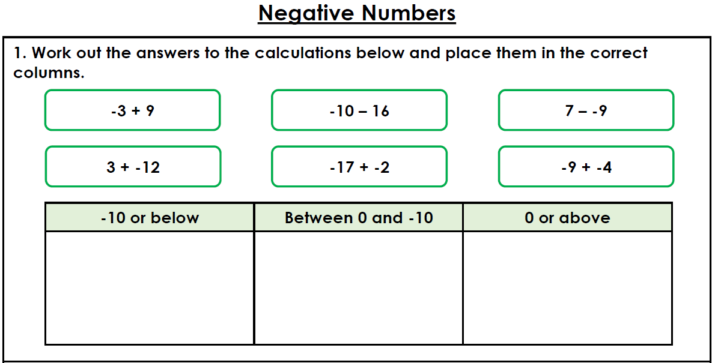
Task B
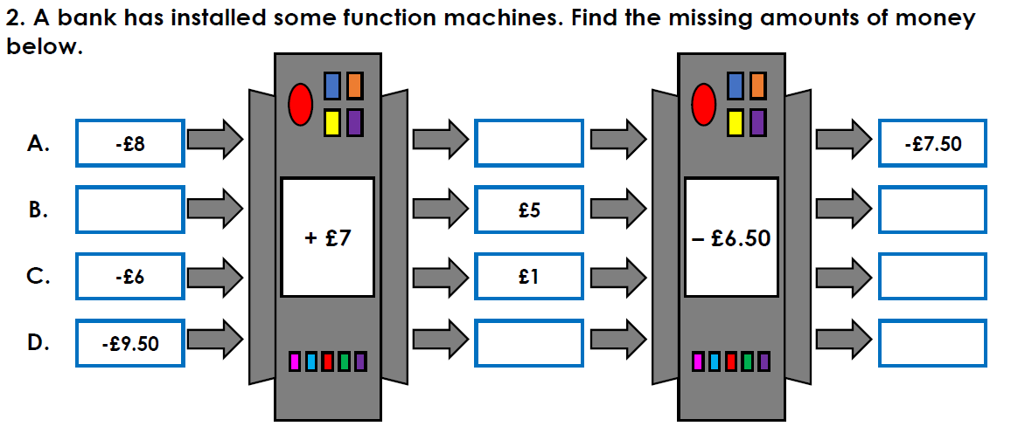
Learning activity 3
Teaching tip Task B
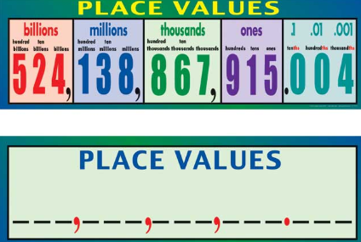
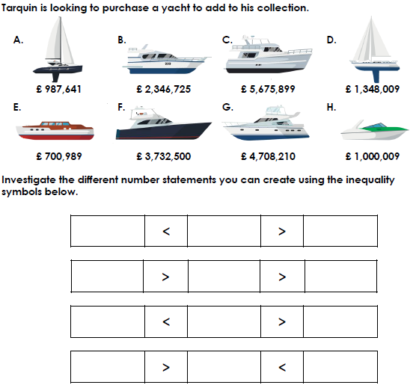
Learning activity 4-
Challenge

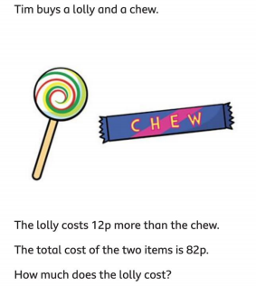
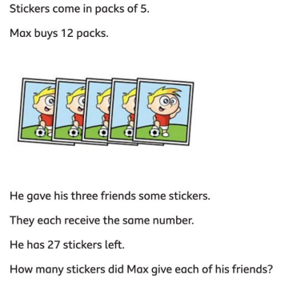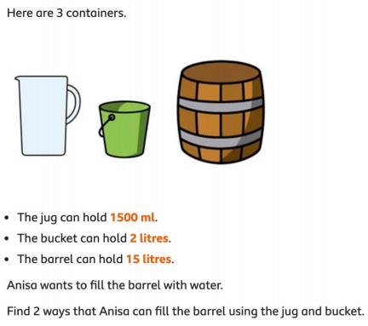

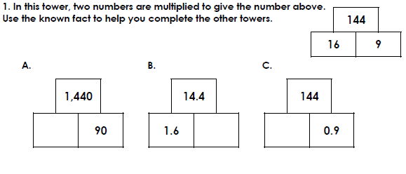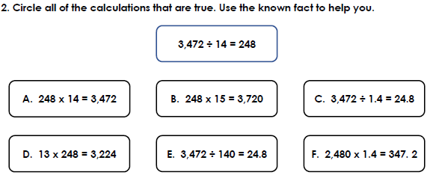

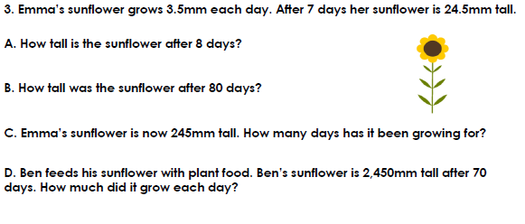

Theme Home Learning
Monday | Tuesday | Wednesday | Thursday | Friday
Science  Look back at the reading comprehension on ‘Rainforests’ and produce a similar text but this time based on Woodlands.  Refer to the information sheet on WOODLANDS to help you.  If you are able to do further research, you could include the information in your text.  Remember to look back at the layout and the type of language used to help you produce a good quality text. | Geography  Complete the differentiated sheets. | PSHCE  Read the story of the enormous turnip.  Reflection:  What they think this story is trying to teach us?  When we meet a huge challenge or are faced with a big task, it’s important to pull together. Everyone’s effort is crucial and, just like the mouse in the story, the smallest help can make ALL the difference. Think about how you can work together with others today.  Think about times when someone has done something that has helped you. Often, these are not enormous things: maybe someone has helped you when you fell over or been kind to them when they were feeling sad. Think about the little things that you can do today which might make a big difference to other people.  Write down what you did and how it made you feel. | PSHCE  - Would you rather?  Complete any 3 activity. Choose any. Write a detailed explanation for each.  Ask an adult to complete the same activity through TALK. Is there anything that surprises you about what they have said? | PE  See PE sheet  Start from Easier (throwing and catching skills).  Complete Year 6 PE section.  Go for a 30 minutes walk with an adult in a safe location if possible.
Easier:  Do as many of the above activities as you can. If you are finding some of the activities challenging, try these as they are a little easier:  - Science look up key words before completing the task so that you understand the text.  - Geography complete the challenge sheets.  - PSHCE Ask an adult to help you think of ideas if you are stuck.  - PE Complete all throwing and catching skills with an adult. |  |  | Challenge:  If you feel you need a further challenge, try these:  - Science Further research if possible.  - Geography Compare the easier activity.  - PSHCE give detailed answers using paragraph and a range of punctuation.  - PE Design your own 10 minutes warm up activities.

Science for all groups
WOODLANDS

Geography
Easier | Year 6

Geography
Challenge

PSHE
- The Story of the Enormous Turnip  Once upon a time, a farmer sowed some turnip seed in his garden. After a few days, some shoots began to show, but one seed grew faster than all the rest. It grew and grew and did not stop growing, until the leaves were like a bush and the most enormous turnip had formed beneath the ground.  The time came when the farmer decided to pull up the enormous turnip to eat. Going to the vegetable patch, he rolled up his sleeves and took a firm grasp of the turnip stem. Then, he pulled (PULL!), and he pulled (PULL!), and he pulled (PULL!), but he couldn’t pull up the enormous turnip.  The farmer called to his partner: ‘Please could you come and help me?’ The farmer’s partner held on to his waist and together they pulled (PULL!), and they pulled (PULL!), and they pulled (PULL!), but they still couldn’t pull up the turnip.  The farmer’s partner called to their son: ‘Please could you come and help us?’ So, the son joined the line and together they pulled (PULL!), and they pulled (PULL!), and they pulled (PULL!), but they still couldn’t pull up the turnip.  Then, the farmer’s son called to his sister: ‘Please could you come and help us?’ So, the farmer’s daughter joined the line and together they pulled (PULL!), and they pulled (PULL!), and they pulled (PULL!), but the enormous turnip still remained in the ground. | A friendly dog stopped at the garden gate. The farmer’s daughter called out: ‘Please could you come and help us?’ So, the dog came and joined the line and together they pulled (PULL!), and they pulled (PULL!), and they pulled (PULL!), but the enormous turnip still would not budge.  By now, everyone was getting very hot and tired. When a cat walked down the path, the dog barked: ‘Please could you come and help us?’ Taking hold of the dog’s tail, the cat joined the line and together they pulled (PULL!), and they pulled (PULL!), and they pulled (PULL!), but they couldn’t pull up the enormous turnip.  Just then, a mouse scuttled out from underneath the hedge. Instead of chasing it, the cat miaowed: ‘Please could you come and help us?’  ‘A mouse?’ exclaimed the others. ‘A mouse? What difference will a mouse make?’  But the mouse cautiously took hold of the cat’s tail and together they pulled (PULL!), and they pulled (PULL!), and they pulled (PULL!), and again with all their might they pulled (PULL!).  Suddenly, the enormous turnip flew out of the ground and they all tumbled in a heap!  The farmer and his partner carried the turnip to their house and used it to cook a vegetable stew. At supper time, there was more than enough to eat for every one of them. Even the dog and the cat and - don’t forget - the mouse!

PSHCE Choose any 3 activities to complete
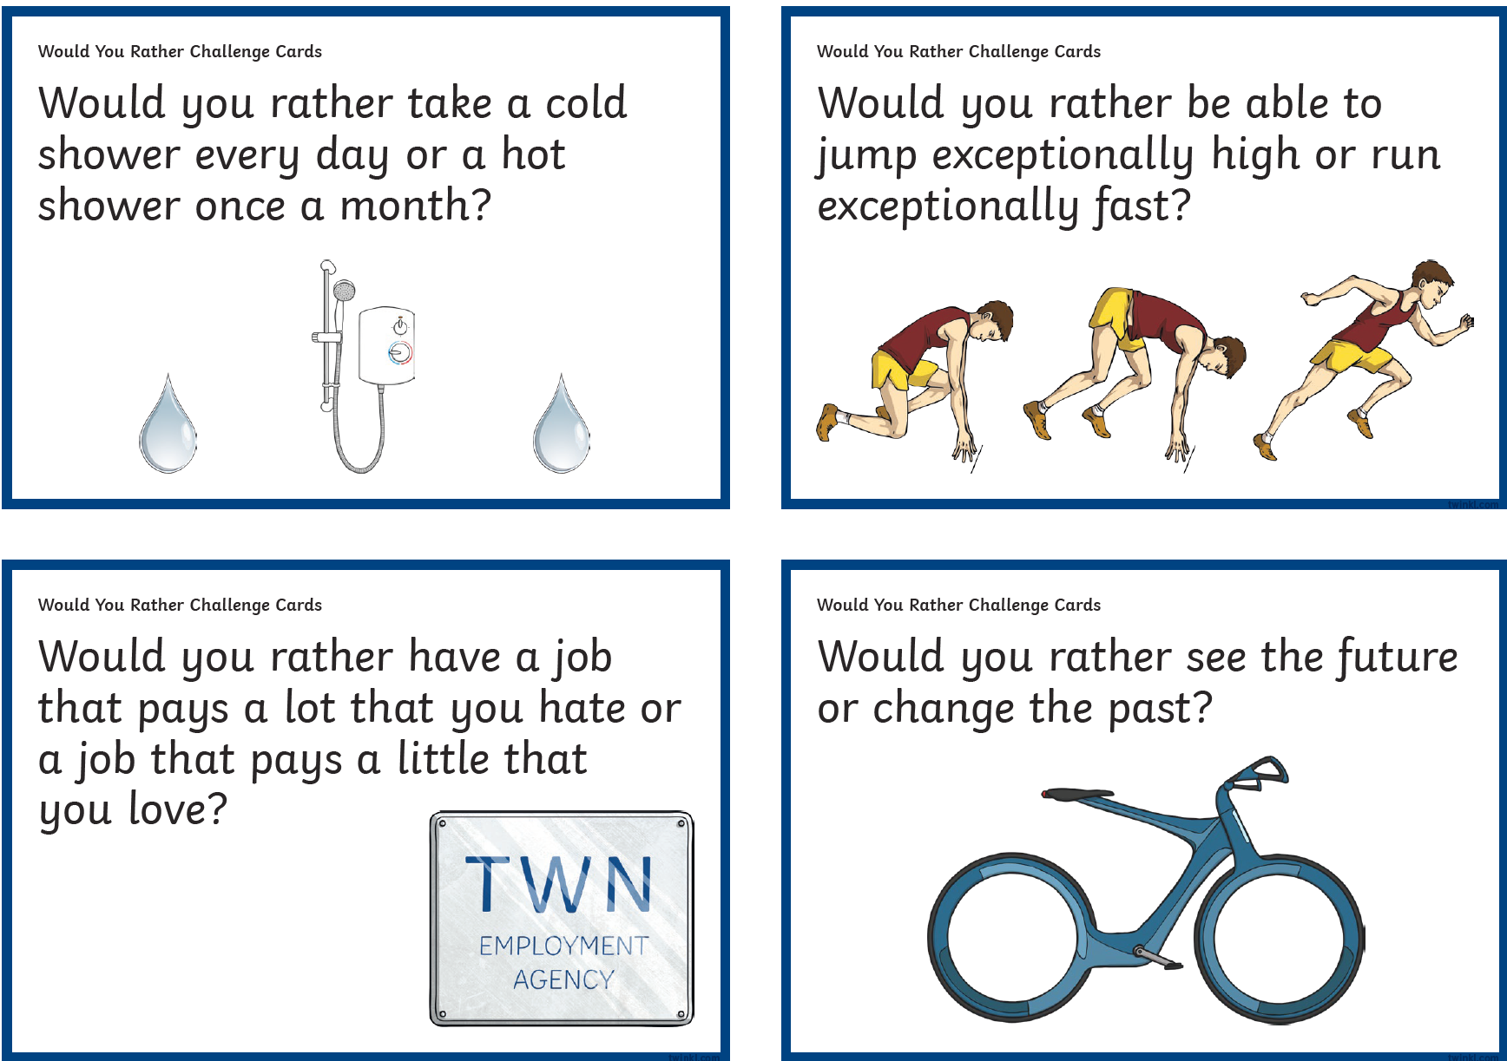
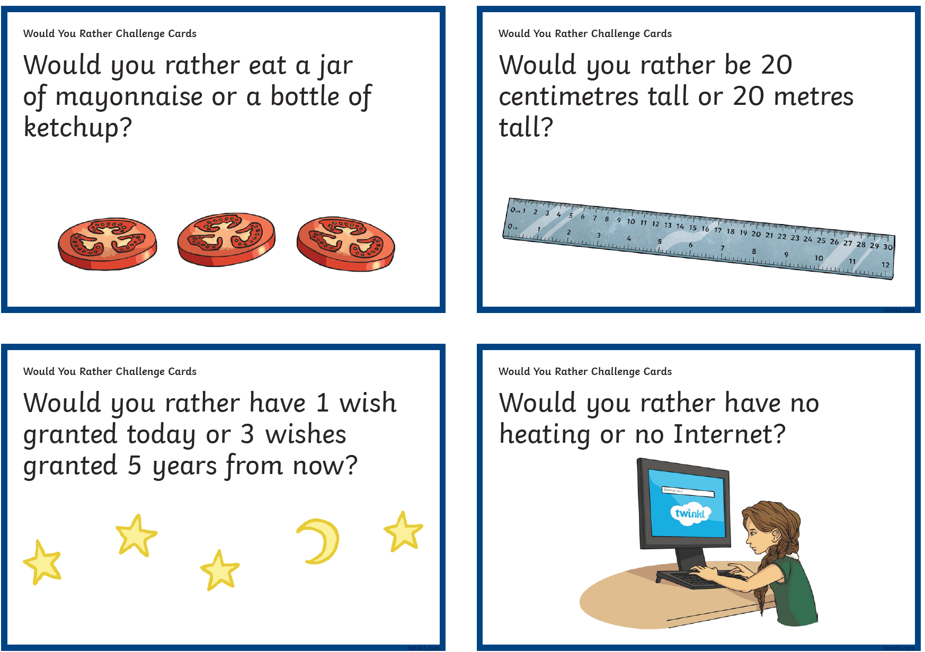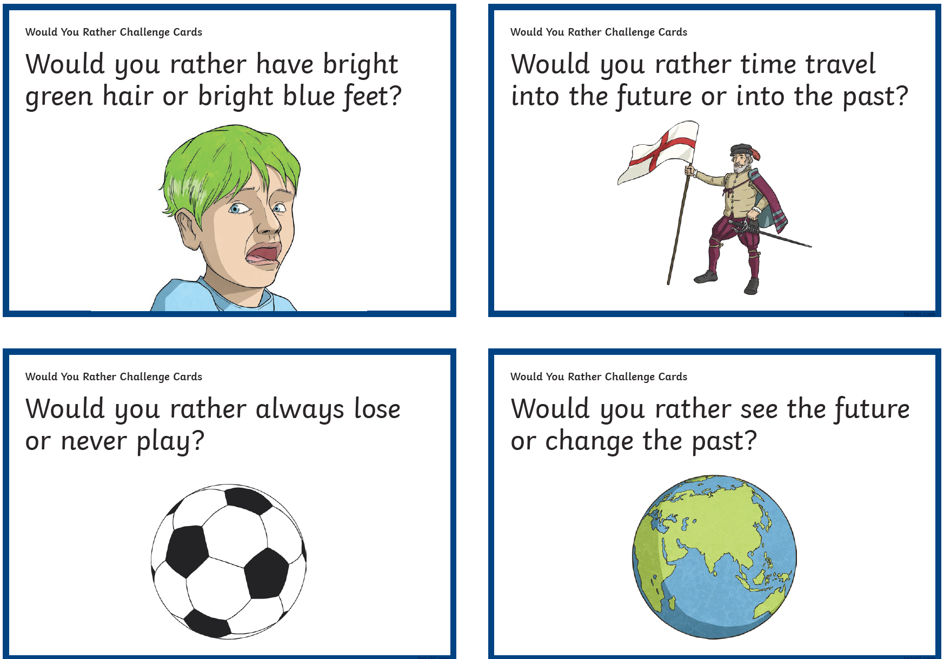
PE Easier
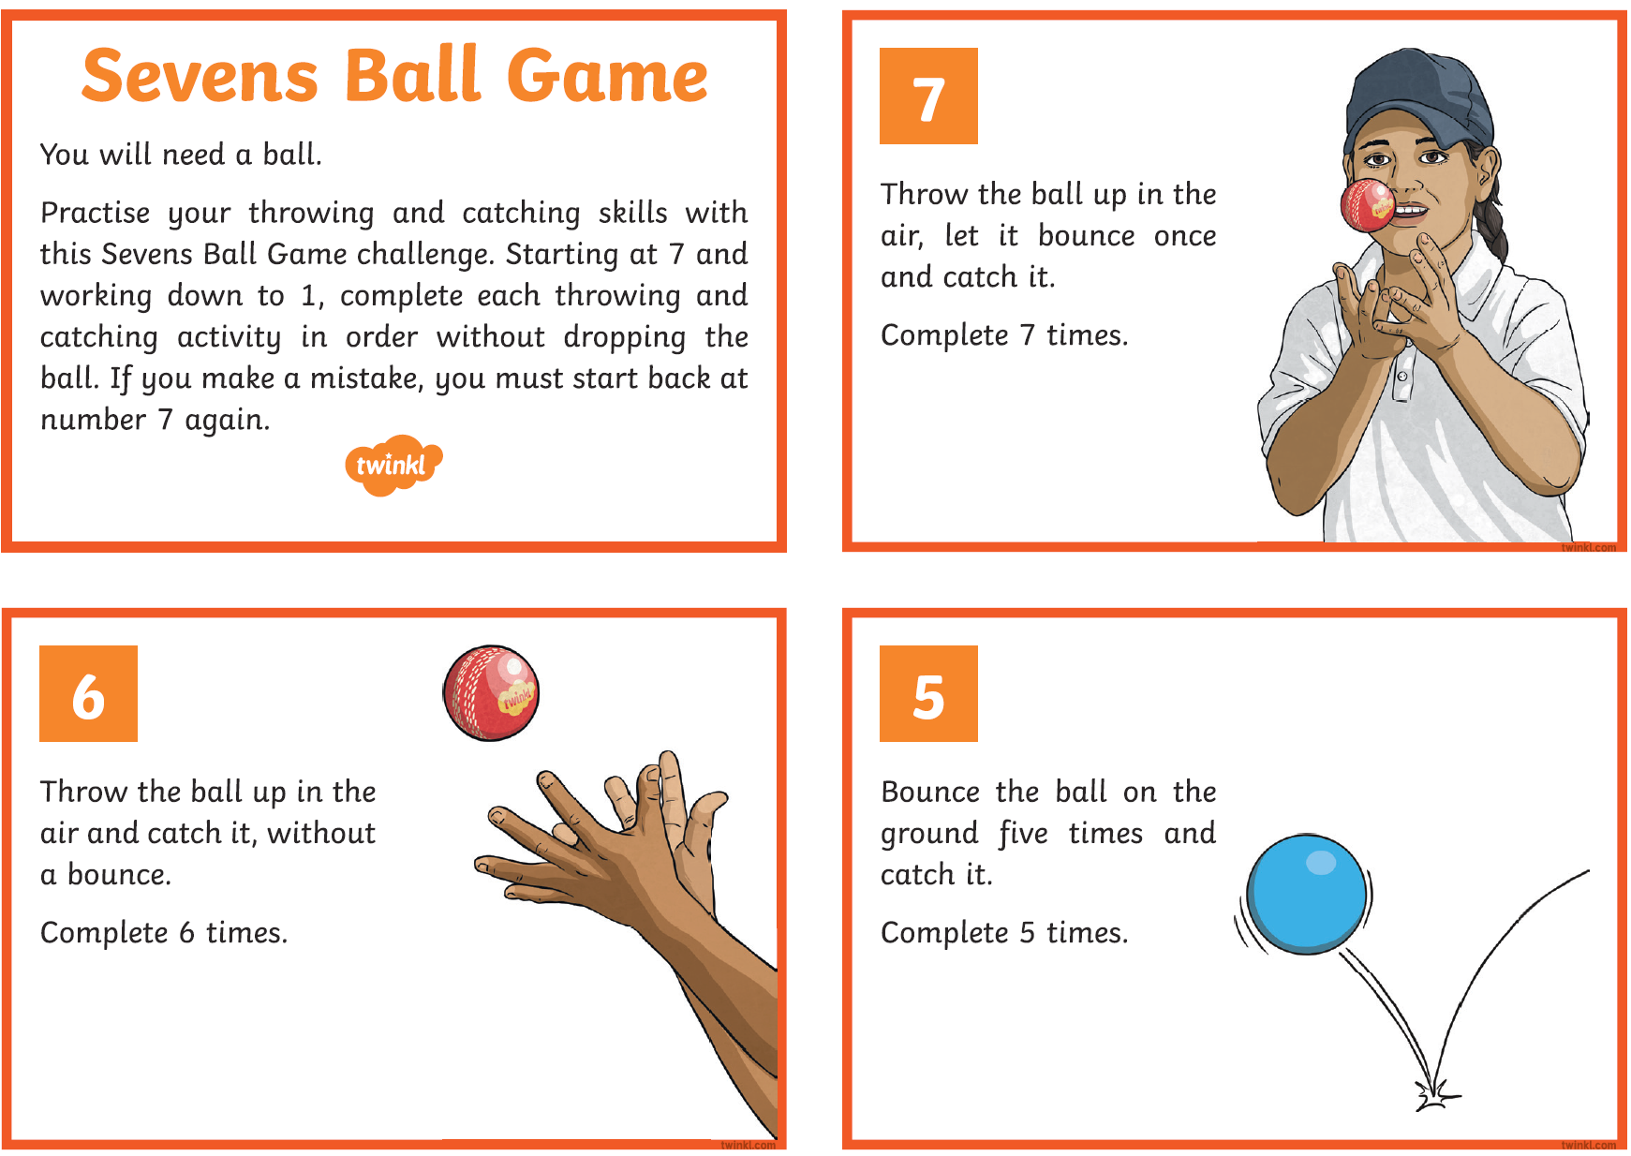
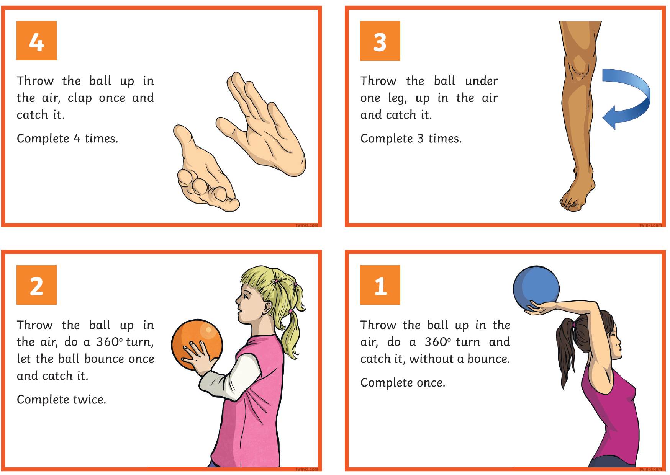

PE Year 6
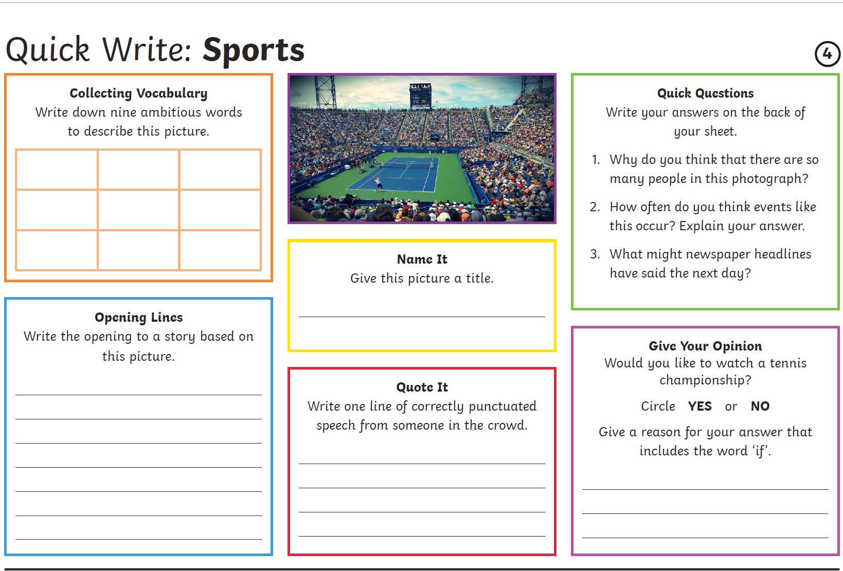
Other Activities
Times tables  Build up speed. Time yourself how long it takes you to answer 0 to 12 x tables in mixed order (work with an adult). | Get active.  With an adult, think of at least two different exercises you can do at home e.g. in the garden. You must exercise for at least half an hour a day. | 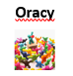  Complete the oracy activity at the start of the booklet.  Reflect on how well you were able to discuss your ideas.  How might you improve next time? | Watch the news and choose any 3 stories to summarise. | Mindfulness  Try out some of the activities attached to help you relax.  How many different mindful techniques can you think of?  Which is your favourite?

Key skills to continue practicing weekly:
-spellings
-grammar (go through revision booklets)
-speed reading
-speed writing (count the number of words you can write in one minute)
-neat and joined up handwriting
-timetables (build up speed)

If you or your child has any further queries regarding their learning projects, please contact admin@hardwick.derby.sch.uk, clearly stating your child’s name and class teacher, and the staff will be in touch to support you and your child.

Thank you and stay safe.

