The Olympic Games were due to be held in Japan this year but did you know they started in Ancient Greece? Find out from the internet which sports were included, which sports girls were allowed to compete in and what the athletes wore. You might be in for a shock.
The answer is 55. What could the question be? Think of + - x and ÷ Make 10 different sums.

How many different four sided shapes can you draw? (square, rectangle, trapezium, parallelogram)

Count the money in your mum’s purse, your dad’s pocket and any money you have. Compare the amounts.
Look for signs of Spring outside. Draw and label them.
Make an acrostic poem for the words: MYTHICAL HEALTHY FABLE URBAN POLLUTION
Here is an example for TOASTER
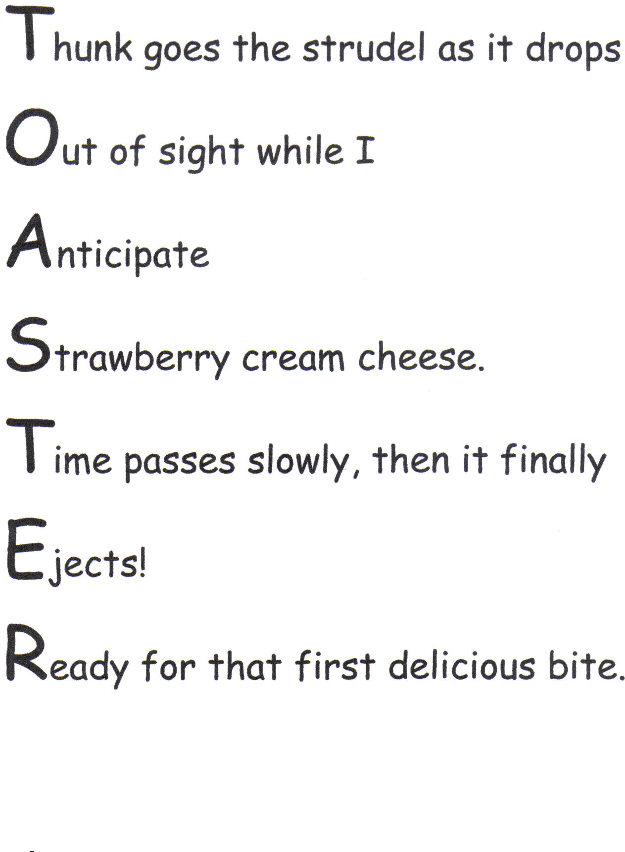
Watch punctuation videos on youtube. Learn about apostrophe for possession and speech marks.
Create some silly rhyming strings….how many words can you thing of that rhyme?
Cat- bat- fat- chat- sat- pat
Happy- snappy- clappy
Find a poem (or write one) and learn it by heart (you could draw your own text map!) and get someone to film you performing it with the actions.
Re-write your favourite story changing the setting and characters as we would at school.
Websites to check out:
BBC Bitesize KS1 and KS2 lots of interesting videos and quizzes.

