Year 2 Home Learning
Year 2 teachers: Mrs Tomordy and Mrs Nicholson
Year 2 TAs: Ms Shaista and Mrs Rowland
Message from staff: Hello to our great Year 2 classes. I know that I enjoyed catching up with some of you last week by phone and it was great to hear you are having a go at these learning tasks. It reminded me how much I miss seeing you all and what a great team we all make together. Mrs Tomordy has been looking after all of her seeds and her tomato plants are doing very well. She is also doing a lot of research and training about how talking helps learning and how to make it fun.
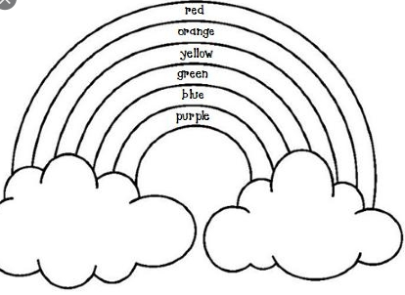
Make sure you are getting your exercise as well and trying to enjoy a bit of time outdoors. Challenge yourself with seeing how many star jumps you can do in a minute and see if you can beat that the following day.

Your Home Learning this Week:
Every day (Monday to Friday), make sure you choose a *reading, *writing, *spelling/handwriting, *maths and *theme learning activity. There are also further activities to choose from should you wish to.

Reading Home Learning
Monday | Tuesday | Wednesday |  | Thursday | Friday
Re read the Jack and the Beanstalk text that you did a text map for and try telling it to someone or a teddy without looking at the actual text.  (Text attached to website and printed packs). | Read the new version of Jack and the Beanstalk in Home Learning and write down any differences between the 2 versions.  (Text attached to website and printed packs). | Use Stan the Summariser to summarise the original Jack and the Beanstalk with only 4 sentences. Remember you need to include key characters and events. |  | Create a picture to show the information you summarised yesterday for each sentence. | There is a new comprehension to do for Jack and the Beanstalk. (Questions attached to website and printed packs).
Easier:  Do as many of the above activities as you can. If you are finding some of the activities challenging, try these as they are a little easier:  - Make a list of the words you can read in Jack and the beanstalk through using your sounds and draw a picture of them.  - How many words can you think of that rhyme with bat?  - Try sounding out these words – path, bath, math |  |  | Challenge:  If you feel you need a further challenge, try these:  - Imagine you get to interview the giant. What would you ask him to find out more about him and his life?  - How would you feel if you were the giant at different parts of the story and why would you feel like that?
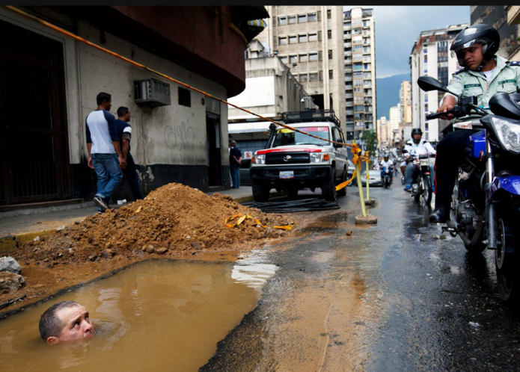
Writing Home Learning
Monday | Tuesday | Wednesday |  | Thursday | Friday
Look at the picture above. Write down 3 different ways you think the man ended up in the water. | Tell me about where the man on the motorbike is going and what he will tell his friends about his journey. | Create a new fairy tale character who might climb the beanstalk. Draw a picture of them and on the inside of the picture say what they are like (e.g. kind, thoughtful) and on the outside describe how they look.(blond hair, knobbly knees) |  | Tell me all about your new character. Where do they live?  Who do they live with?  Where did they get the beanstalk from?  Have they been up it before?  Why do they want to go up the beanstalk?  Do their family agree they should go up? | What did your new character find at the top of the beanstalk? Draw three different ideas and write 3 sentences under each to tell me all about what they found and how it made them feel.
Easier:  Do as many of the above activities as you can. If you are finding some of the activities challenging, try these as they are a little easier:  - How many different things can you see in the picture at the top? Try writing them down using your sounds.  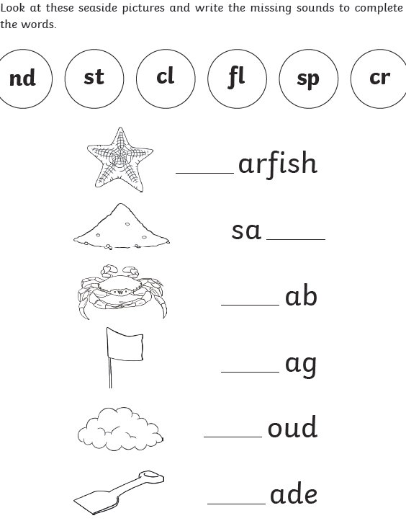 |  |  | Challenge:  If you feel you need a further challenge, try these:  - Task 1  If you were going to write a story about this picture, which characters would be in it? Think of 3 characters. Draw pictures of them and add labels to describe them.  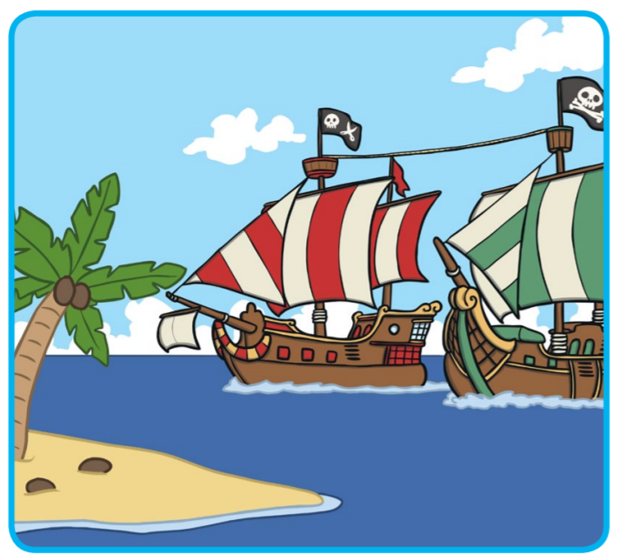  - Task 2  Write a story about your characters and what they do. Make sure you include these words in your story.

Spelling/Handwriting Home Learning
Monday | Tuesday | Wednesday |  | Thursday | Friday
Rainbow write the following words. Can you see the spelling pattern?  picture  cure  vulture  mixture  denture | Create a picture for each of yesterday’s words and practise writing them underneath. If you are not sure what they mean try using a dictionary. | Using lined paper handwrite each of the following words 10 times. Make sure that your letters that go down (descenders) sit on the line but don’t go down too far.  green  yellow  going  purple  queen  giving  yawn |  | Practise writing the following words until you are sure you can write each of them without looking.  could  parents  girl  went  whole  wild  father | Using the words from any of the days see how many different sentences you can create. Remember to take your time and concentrate on your letter formation.
Easier:  Do as many of the above activities as you can. If you are finding some of the activities challenging, try these as they are a little easier:  - Copy the days of the week in rainbow colours and then try scribble writing them.  - Monday, Tuesday, Wednesday, Thursday, Friday, Saturday, Sunday  - Now can you write them in a spiral?  - Keep practising and see if you can eventually do them without looking. |  |  | Challenge:  If you feel you need a further challenge, try these:  Rainbow write these words  - heard  - heart  - height  - history  - knowledge  - learn  - length  - library  - Then practise them in sentences with your neatest handwriting, remembering to make the tall letters tall.

Maths Home Learning
Monday | Tuesday | Wednesday |  | Thursday | Friday
Have a look around your house and see if you can sort things according to how long they are. First try using a finger and seeing what is longer or shorter. Then try measuring against your leg. If you have a ruler or tape measure try measuring things around the house and see which is the shortest. | Can you match the unit to what it measures?  Kg  cm capacity  second  litre time  meter length  day  g  ml weight  Now can you find something in your house you would measure each of these in? | There are 100cm in a meter and 1,000 meters in a kilometre. So now try putting these lengths in order of size starting with the smallest. Then can you change all of them to how many cm they would be?  - 89cm  - 1 and ½ meters  - Half a km  - 2,500 meters  - 30cm |  | 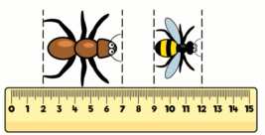  Here is an image. There is no question attached to it. I would like you to think about what you know by looking at the image.  Now make a list of all the facts you can work out from the diagram. I can think of 6. Can you think of more? | Find a recipe for a cake or some biscuits then write down the list of ingredients you need and the amount of each you need. E.g. 150g of flour  Now try making the cake or biscuits and enjoy.
Easier:  Do as many of the above activities as you can. If you are finding some of the activities challenging, try these as they are a little easier:  - Who is the tallest person in your house? Who is the shortest? Can you stand in a line from shortest to tallest and say who is taller?  - Using 1p and 2p coins how many ways can you make 10p?  - How many different types of measurement can you think of?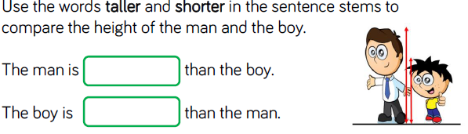 |  |  | Challenge:  If you feel you need a further challenge, try these:  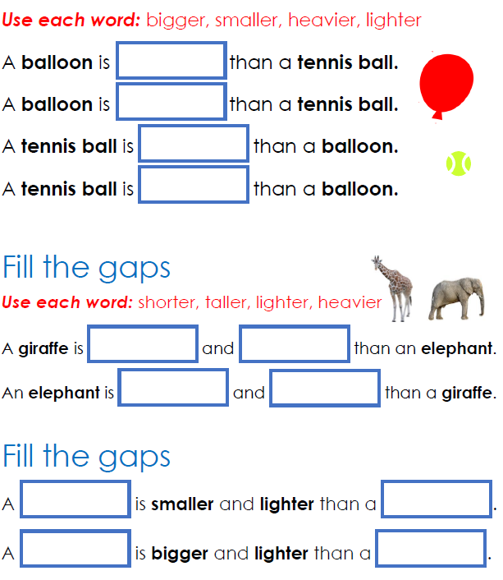

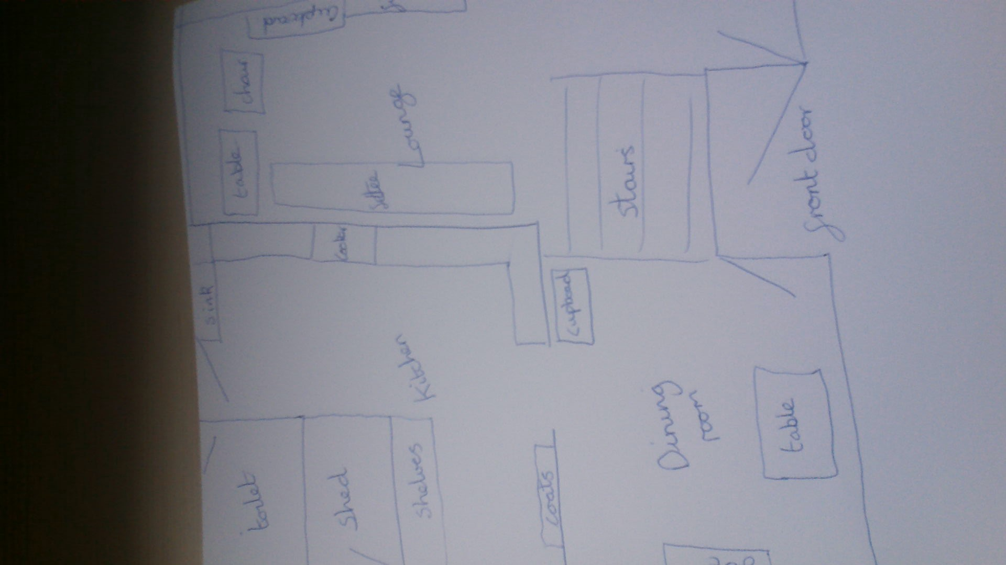
Theme Home Learning
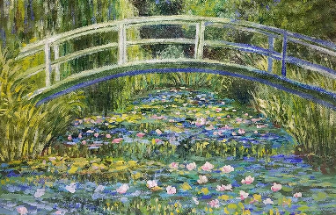

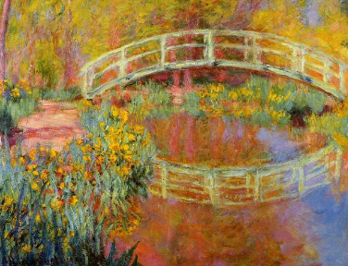

Monday | Tuesday | Wednesday |  | Thursday | Friday
Science  Try sorting the food in the picture below into which would be healthy and which aren’t.  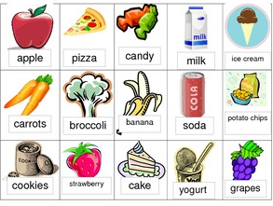 | Science  Design a healthy lunch for you and your family to have at home. Try to include a protein and either fruit or vegetables. | Geography  Using the example on the previous page create a map of the downstairs of your house. |  | PSHE  Create a list of all the good things you have found about staying at home and being with your family. | Art  Looking at the two paintings by Monet on the previous page. Which do you prefer? Why? Try to create your own. What colours would be warm and which would be cold colours?
Easier:  Do as many of the above activities as you can. If you are finding some of the activities challenging, try these as they are a little easier:  - Can you create a map showing the route you would normally take to school?  - How many different fruits or vegetables can you think of? Draw and label them.  - Create your own picture of your garden with red and orange then try it again with just blues and greens. |  |  | Challenge:  If you feel you need a further challenge, try these:  - Can you name the different food groups? Now try to put three foods into each group.  - Can you also create a map of our classroom? Have a think what it looked like and remember to put in the windows and doors.  - Try creating your own warm picture with just red, yellow, orange, try again with cold colours such as blue, and green and see how each make you feel.

Other Activities
Task 1  Music  Create your own musical instrument with a cup or bottle and some rice or pasta to create a shaker and add your own song. | Task 2  Science  Create a paper aeroplane and see how far it will go. Then change the design to see if you can make it go further – maybe shorten or change the shape of the wings. | Task 3  Science  Try the experiment on the next page with a penny. | Task 4  Art  Create a picture of a person or a face using either things from your garden, such as leaves or things around the house, and take a picture. 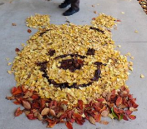 | Task 5  Can you think of a type of food that begins with every letter of the alphabet so:  A = apple  B = bread  C =

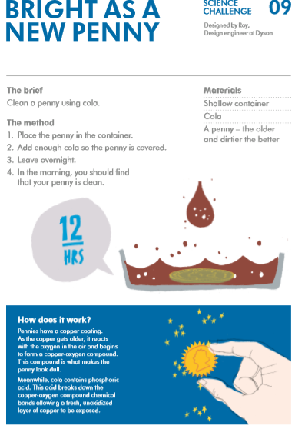

Key skills to continue practising weekly:
- Times Table Rock Stars – I have checked and not many of you are doing this and it is fun to do plus keeps your skills going. If you have forgotten your log on details, then just email the school.
- Oxford Owl – lots of books to read.
- Telling the time throughout the day to the nearest 5 minutes.
- Play shops and work out the change.
- Common exception words both reading and spelling.

If you are able to access the internet, try these useful websites:
https://www.bbc.co.uk/bitesize/primary
New lessons are uploaded every day for children to interact with
https://scratch.mit.edu/
A chance to have a go at computer programming and create your own games, all completely free.
Plus remember to check the list of other useful websites which are under home learning on a separate sheet.

If you or your child has any further queries regarding their learning projects, please contact admin@hardwick.derby.sch.uk, clearly stating your child’s name and class teacher, and the staff will be in touch to support you and your child.
Thank you and stay safe

