Year 4 Home Learning
Week Commencing: 11th May 2020
Year 4 teachers: Mrs Haslam, Mrs Tatla, Mrs Jogela and Miss Annable
Year 4 TAs: Miss Perry and Mrs Smith
Message from staff: Hi Year 4, we hope that you are all well and keeping safe. Even though we are not teaching you, we are thinking about you and working very hard to provide fun activities for you to complete at home. We are also preparing lots of exciting projects for when we return to school. We hope you are taking some time out of the day to get fresh air and spend time with your family.

Your Home Learning this Week:
Every day (Monday to Friday), make sure you choose a *reading, *writing, *spelling/handwriting, *maths and *theme learning activity. There are also further activities to choose from should you wish to.

Reading and writing resource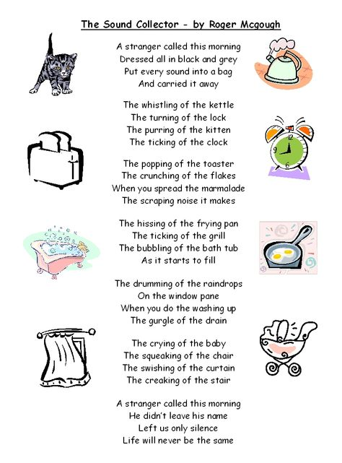
Reading Home Learning
Monday | Tuesday | Wednesday |  | Thursday | Friday
Monica the Monitor  Read ‘The Sound Collector’ by Roger McGough. Using reading skills to help you understand as you go through it. Highlight any words you do not understand and find the meaning of them. | Colin and Carmen the Connectors  Discuss what is similar and different between the noises you could hear in your garden and at meal times and those described in the poem. | Vernon the Visualiser  On reading the poem close your eyes and imagine what the stranger may look like. Draw the image that you have created in your mind. |  | Rhyme is often used in poetry.  Can you identify where it is used in the poem?  Do you know any other poems that use rhyme?  Does rhyme affect the way you read it?  Do you notice any repetition in the structure of the poem? | Oracy – My own  Sound Collector poem  Practise reading your poem aloud to an audience, expressing words clearly and using appropriate intonation.  Add sounds and actions to interest the audience.
Easier:  Do as many of the above activities as you can. If you are finding some of the activities challenging, try these as they are a little easier:  - Listen to an adult read the poem.  - Complete activity 1 Match the words to their meaning.  - Complete activity 2 Match the rhyming words. |  |  | Challenge:  If you feel you need a further challenge, try these:  - Ask yourself the following questions and record your answers.  Who is the stranger?  What words could you use to describe him?  What type of person do you think the stranger is?  Give reasons for your answer.
Reading resource Easier
Writing Home Learning – Poetry - The Sound Collector – Write your own sound poem
Monday | Tuesday | Wednesday |  | Thursday | Friday
Onomatopoeia is a word that imitates the sound it describes.  Examples of this - meow, roar, oops and boom.  Can you identify the onomatopoeia used in the poem? | Today you are going to collect and record sounds to include in your poem. You could go outside and listen to sounds in your garden or listen to sounds made during a family meal (E.g. The chirping of the birds /the chatter of the children/the crunching of the food). | Create your own opening stanza.  Are you going to have a stranger?  What is he/she going to be dressed in?  What is he/she going to put the sounds into? |  | Begin to draft a sound collector poem using The Sound Collector as a template, starting with the first line, ‘A stranger called this morning’ and adding your own verses.  Include your opener from yesterday’s lesson and the sounds you collected from your garden and meal time. | Complete your poem reading aloud as you work to check for fluency and meaning.  Proofread to check for errors in spelling, grammar, vocabulary and punctuation.
Easier:  Do as many of the above activities as you can. If you are finding some of the activities challenging, try these as they are a little easier:  - Discuss the poem with an adult. (Mon)  - Can you hear these sounds at home?  chirp, bark, buzz, howl, knock, rustle, swoosh, bang, chatter, clank, crackle and fizz. (Tues)  - Match the sounds to something that would make that sound. (Wed)  - Use the words above for your poem. (Thurs/Fri) |  |  | Challenge:  If you feel you need a further challenge, try these:  - Choose words that could be heard at an alternative place.  - Create your own onomatopoeia words to use.
Spelling/Handwriting Home Learning
Monday | Tuesday | Wednesday |  | Thursday | Friday
Monday  Choose the next 10 spellings on the list that you struggle with.  Spelling Pyramids. | Tuesday  Race how many times you can write each word in 1 minute with a family member. | Wednesday  Write these words in alphabetical order.  when what why which went where |  | Thursday  Choose a paragraph from your favourite book and write it out using the school handwriting style. Ensure you join letters correctly. | Friday  Spelling quiz!  Ask a family member to test you on your spellings.  You could also test yourself on the Top Marks website:  http://www.ictgames.com/mobilePage/lcwc/index.html
Easier:  Do as many of the above activities as you can. If you are finding some of the activities challenging, try these as they are a little easier:  - Write these words in alphabetical order  when this but said (Wed) |  |  | Challenge:  If you feel you need a further challenge, try these:  - Make a musical dictionary. Check out the meanings of beat, dynamics, harmony, rhythm, round, chord, octave, major key, minor key, crotchet, quaver, semibreve, sharp and flat. (Mon/Tue)  - List the terms in alphabetical order. (Wed)  - Use these as an opportunity to practise your handwriting.

Maths Home Learning
Monday | Tuesday | Wednesday |  | Thursday | Friday
Practise your times tables and division facts. Once you know them test your understanding by getting someone to ask you them and see how many you can answer correctly in 1 minute. Then do the same with the division facts. | Activity 1 (lesson 8 p26-27)  Have a go!  What does the nine stand for in each of these numbers?  0.89 7.98  9.27 98.16  Match. What does the 4 stand for in each number?  27.46 4/100  26.74 40  42.67 4/10 | Activity 2 (Lesson 11 p35-37)  Have a go!  Question 3 and 4 on page 22. |  | Division problems – use the bus stop method to solve.  324 3 =  163 3 =  254 4 =  436 8 =  825 9 = | Multiply three digit numbers by one digit numbers – using the column method  473 x 2 =  268 x 3 =  271 x 8 =  345 x 6 =  577 x 5 =  678 x 9 =
Easier:  Do as many of the above activities as you can. If you are finding some of the activities challenging, try these as they are a little easier:  - Round the two digit numbers to the nearest ten.  23 45 67 82 93 67 88 32 (Tues)  - Order these numbers from the largest to the smallest 69 42 36 21 86  - Create some three-digit number and order from the smallest to the largest.  - Complete 39 3 = 88 4= 64 2= 84 4= |  |  | Challenge:  If you feel you need a further challenge, try these:  - Round the decimal numbers to the nearest tenth.  1.32 2.45 6.21 5.95 7.07 (Wed)  - Create word problems using the questions above and your multiplication and division skills (Thursday/Friday)
Activity 1 Complete p26-27
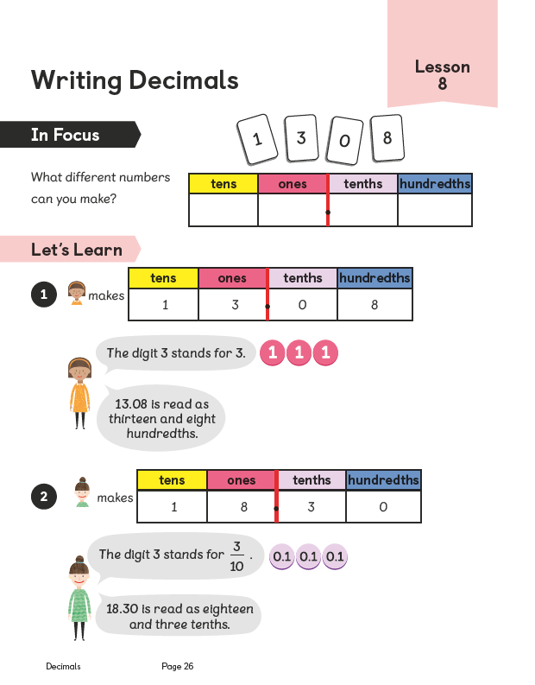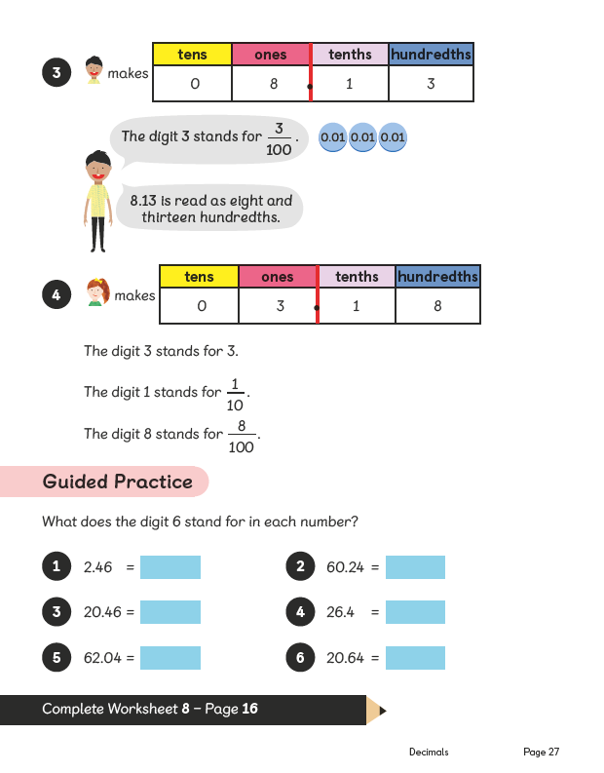

Activity 2 Complete p35-37 and p22

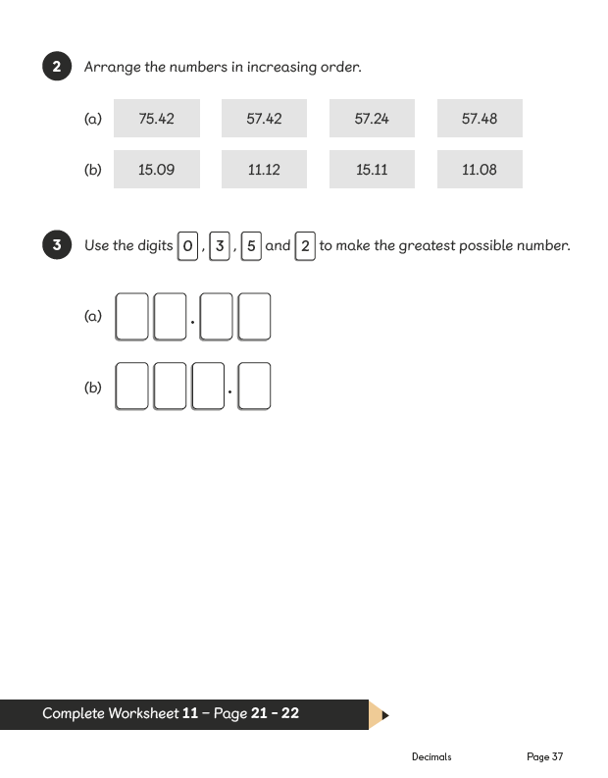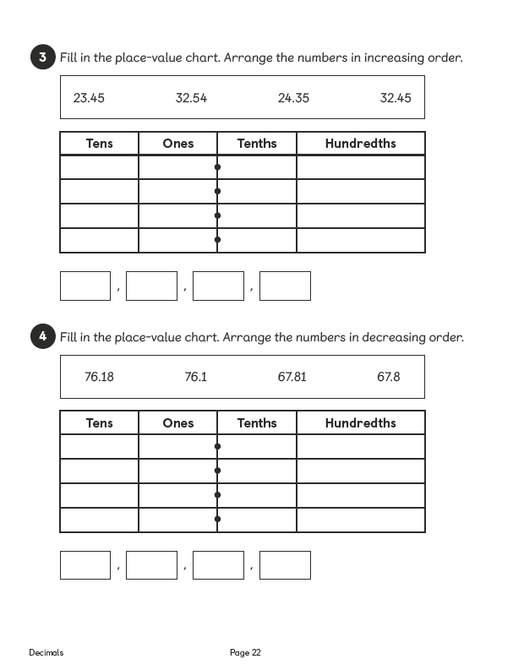
Theme Home Learning – Out theme this term is Playlist
Monday | Tuesday | Wednesday |  | Thursday | Friday
Science  Spend time being silent. Pose the question ‘How does silence make you feel? What sounds would you like the sound collector to take away for ever? Why? | Music  Design and make a musical instrument -  Using any old packaging, boxes, bottles, rubber bands, string – anything you can get your hands on and make an instrument that makes a sound. | Music  Learn your favourite song by heart or play a piece of music on an instrument. Practise and see if you can do it without making any mistakes! |  | PE  Learn a celebratory dance - the Haka.  Watch the video clip and have a go.  (Website listed below)  If you don’t have access to the internet create your own dance to celebrate winning a rugby game | PE  Continue to learn your dance.  Ask someone to film you so that you can watch it and see where you can make improvements.
Easier:  Do as many of the above activities as you can. If you are finding some of the activities challenging, try these as they are a little easier:  - Have a discussion with an adult about possible sounds that you would rather not hear.  - Learn the chorus to one of your favourite songs.  - Create your own celebration dance. |  |  | Challenge:  If you feel you need a further challenge, try these:  - Make a demonstration video to help other children learn how to do the Haka. Add step by step instructions.

Other Activities
Start your day with Joe Wicks’ YouTube workout for kids live every morning at 9.00.  https://www.youtube.com/results?search_query=joe+wicks | You have 3 minutes to make as many words as you can from the letters below?  cmopdlitace  Can you make an eleven letter word? | Use play equipment, such as balls, ropes and hoops, to invent a new competitive game. Devise a set of rules and teach the game to others in your household. Play a game and keep score. Who is the winner? | Word search  This will help you revise the vocabulary used when learning about our teeth.  See attached sheet | BBC Bitesize daily lessons for Year 4  (See timetable of which lessons are taught each day)  https://www.bbc.co.uk/bitesize/dailylessons
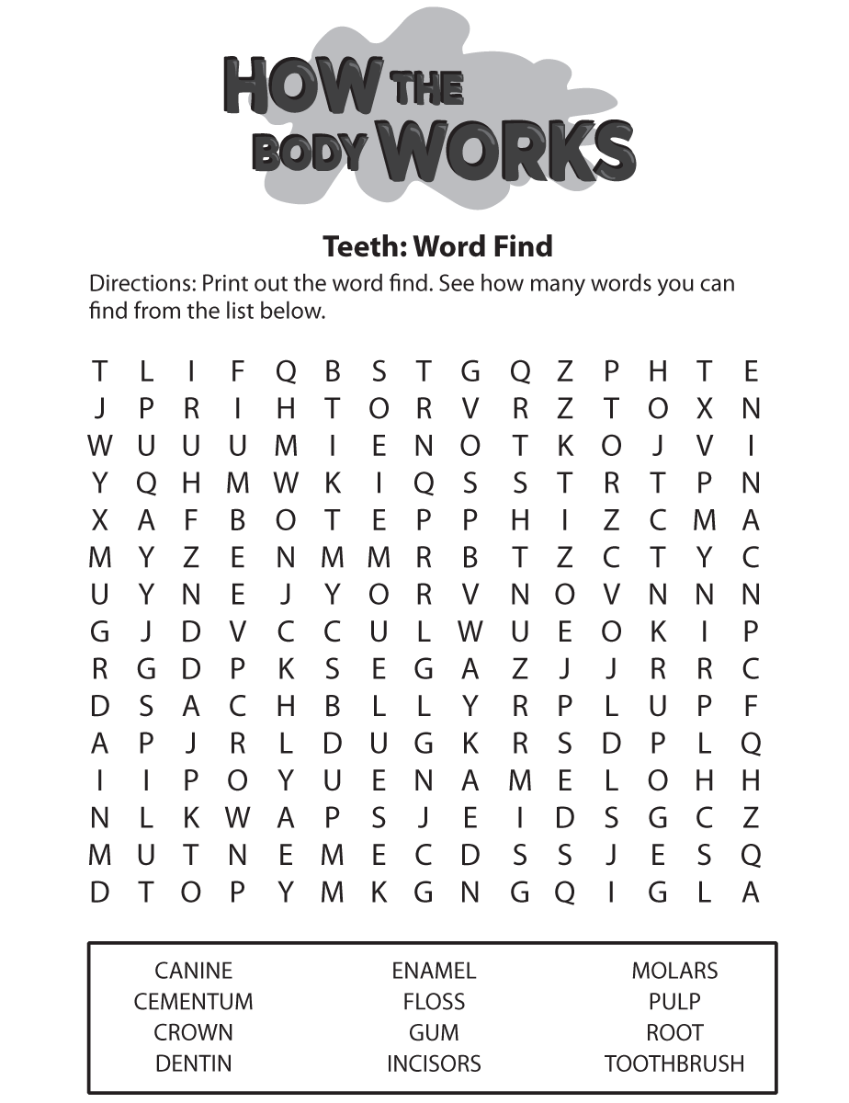
Key skills to continue practising weekly:
- Times tables (including division facts)
- Reading (This can be anything! Reading your favourite book again, reading magazines, sub-titles on the TV etc.)
- Watch Newsround everyday so you are keeping up-to-date with what is going on in the world.

If you are able to access the internet, try these useful websites:
- Reading: There is an online book of short stories written during lockdown by 100 authors, including Michael Morpurgo.
https://issuu.com/bloomsburypublishing/docs/thebookofhopes_interactivepdf/4?ff
- A suitable video clip to support PE – learning the Haka Thursday https://www.youtube.com/watch?v=yiKFYTFJ_kw
- Timestable.co.uk
- Topmarks.co.uk

If you or your child has any further queries regarding their learning projects, please contact admin@hardwick.derby.sch.uk, clearly stating your child’s name and class teacher, and the staff will be in touch to support you and your child.

Thank you and stay safe.

