Year 6 Home Learning
Week Commencing: 1st June 2020
Year 6 teachers: Mrs Haider, Miss Qayoom, Mr Nowak
Year 6 TAs: Mrs Yar-Khan
Message from staff: It was lovely to catch up with you all again and speak to you. It is great to know that everybody is doing well. Keep safe and don’t forget to complete an hour of physical activity daily as well as having a go at mindfulness activities.
You should all now have your Purple Mash logins. Keep exploring the different features and have a go at playing the games.
Remember to collect the booklets from school, if you are having problems going online or simply prefer a printed copy.

Reading Home Learning
Monday | Tuesday | Wednesday |  | Thursday | Friday
Read the title “Should Bullies Always Be Excluded From School?” and predict what the text is going to be about.  Write your explanation then read the text to see if you were right. Underline any words and phrases you are unsure about. | Summarise the main points of the text (VIPs) and write them down using bullet points. | Visualise the text and draw a picture to show the issue of bullying. |  | Answer the first 7 questions and highlight the evidence in the text to support your answers. | Reading for pleasure  Read any book of your choice for 45 minutes.
Easier:  Do as many of the above activities as you can. If you are finding some of the activities challenging, try these as they are a little easier:  - Draw a picture of a bully and give examples  - Find words you don’t understand and look them up in a dictionary  - Summarise the text in one sentence. |  |  | Challenge:  If you feel you need a further challenge, try these:  - Answer Q8, Q9 and Q10 and highlight the evidence in the text.  - Write a balanced argument about bullying.  - Read a book of your choice for 1 hour
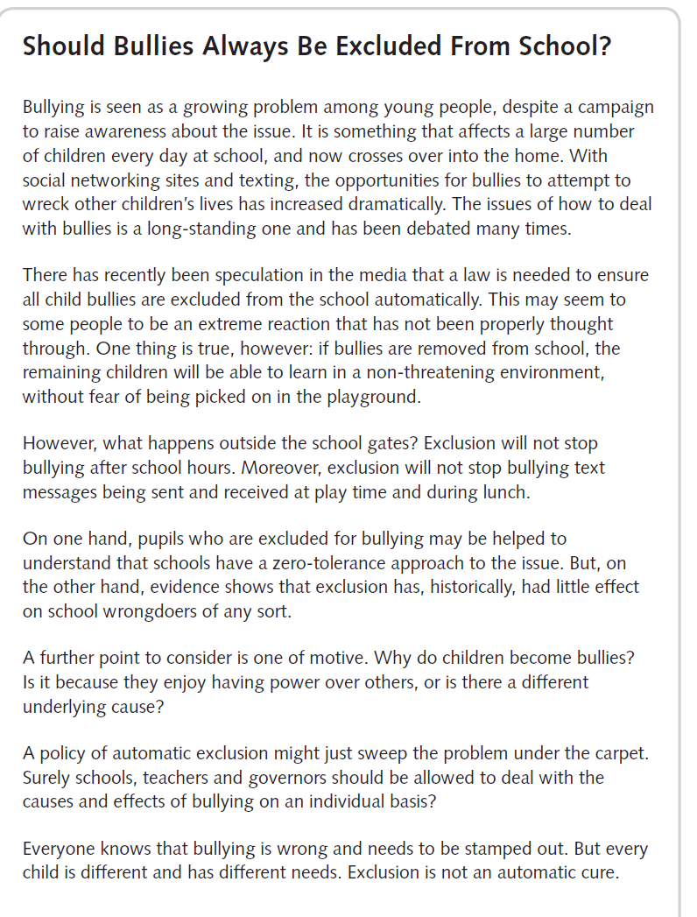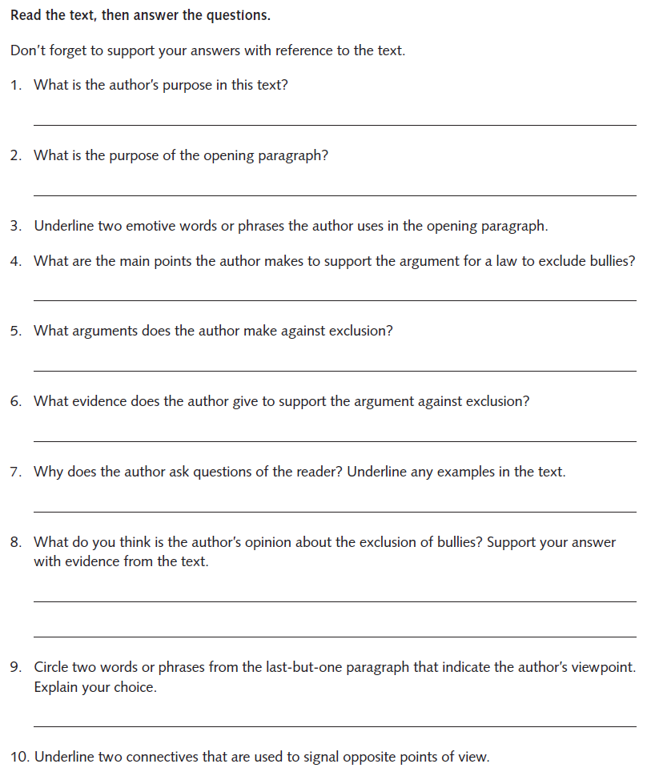
Writing Home Learning
Monday | Tuesday | Wednesday/Thursday |  |  | Friday
Choose one of the images below (Task 1). What kind of person might this be? It’s your job to write a character profile or ‘back story’. | Choose one of the images below (Task 2). What kind of place is this? Your task is to describe the setting in as much detail as possible. Try to make your description as interesting as you can. | Remember the work you did on characters and settings? Now’s your chance to plot their story.  These are just your notes, so you don’t need to write in full sentences. However, if a great sentence, adverb, connective, adjective or clause occurs to you whilst you’re making your notes, jot it down in the space provided – you may want to use it later.  Your story will feature the character you described in Task 1 and the setting you described in Task 2. As you know, all good stories have an opening, a problem, a resolution and an ending(Task 3). |  |  | You’ve worked hard to develop ideas for a character, setting and plot for your story. Now you’re going to write it!  Things to include to really interest your reader:  • varied vocabulary (no ‘said’ or ‘nice’)  • a range of connectives and conjunctions  • dialogue (speech)  • a mixture of simple, compound and complex sentences  • a really catchy title!
Easier:  Do as many of the above activities as you can. If you are finding some of the activities challenging, try these as they are a little easier:  - Use a dictionary to find some interesting adjectives and use them to describe your character  - Write a simpler story and use any characters/setting of your choice.  - Ask an adult to read your story |  |  | Challenge:  If you feel you need a further challenge, try these:  - Include details of what might have happened to this character to make them the way they are  - Try to make your description as interesting as possible  - Select appropriate grammar and vocabulary to enhance meaning.  - Use your revision book and add some complex sentences/expanded noun phrases/adverbials, etc.
Task 1
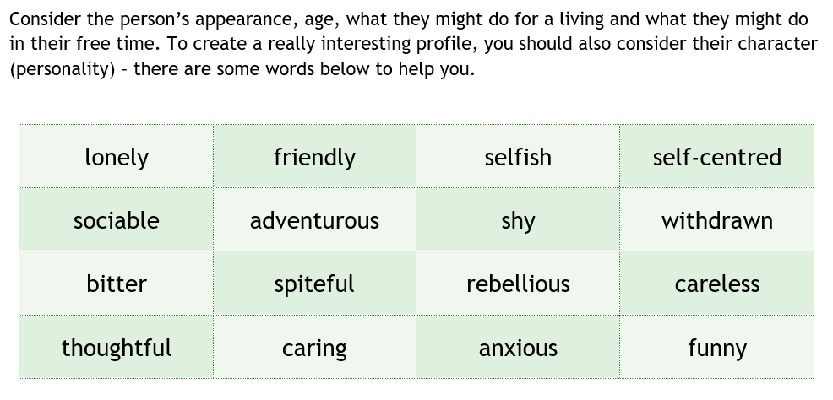
Task 2
Consider how the setting looks, feels (its atmosphere) and even smells. Where might it be in the world? What year might it be? If you find this kind of writing a challenge, here are some words to get you started. If you’re raring to go, challenge yourself to use a thesaurus to come up with some alternative adjectives.
lonely | noisy | eerie | busy | old
desolate | peaceful | vast | crowded | modern

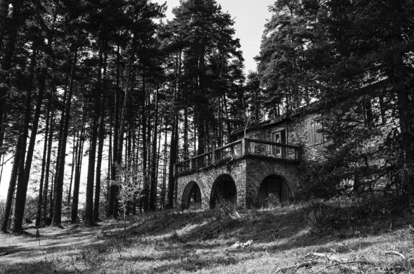

Task 3
Your opening:
Where and when is the story set? What is the atmosphere like? Who is your main character? What are they doing? How are they feeling?

The problem:
This is where you advance the action! What problem does your character encounter? Consider their feelings and any changes in atmosphere.

The resolution:
How does your character overcome the problem? How do they feel as they do so?

The ending:
Now’s the time to describe what happens to your character at the end of the story and tie up any loose ends. Or you might choose to leave your reader hanging …

Spelling/Handwriting Home Learning Keep revising the same words this half term.
Monday | Tuesday | Wednesday |  | Thursday | Friday
Learn the following words. Use the ‘Read, cover, write, check’ method.  SILENT T  fasten  hasten  glisten  moisten  nestle  thistle  whistle  wrestle  bustle  soften | Learn the following words. Use the ‘Read, cover, write, check’ method.  You can use this rule: Use -ent, -ence, -ency after soft c /s/ sound or soft g sound. Remember some words with these endings do not follow this rule.  innocent  innocence  decent  decency  frequent  frequency  confidence  obedience  independent  independence | Learn the following words. Use the ‘Read, cover, write, check’ method.  necessary  collection  channel  substance  tolerance  appearance  frequency  confidence  decent  thistle  independence  innocent |  | Learn the following words. Use the ‘Read, cover, write, check’ method.  nuisance  language  significance  reluctance  importance  communicate  government  annoyance  assistance  resistance  controversy  signature  whistle | ASSESSMENT  Ask someone in your family to test you. 10 random words.
Easier:  Do as many of the above activities as you can. If you are finding some of the activities challenging, try these as they are a little easier:  - Use a dictionary to make sure you understand each word  - Try the following words:  eight  arrive  breath  circle  fruit  guard  height  often  popular  eighth |  |  | Challenge:  If you feel you need a further challenge, try these:  - Write a story and try to include as many words from your spelling list as possible.  - Write a poem using some of the words above

Maths Home Learning
Monday | Tuesday | Wednesday |  | Thursday | Friday
Draw a grid as shown in learning activity 1 and complete this with 10 different numbers ranging from 5 to 7 digit numbers, practise reading and writing these numbers using top tips resource 1a. | Draw a grid as shown in learning activity 2 and complete this with 10 different numbers ranging from 1 to 3 decimal digit numbers, practise reading and writing these numbers using top tips resource 2. | Work with an adult and ask them to say 10 numbers from seven digits to 3 decimal places and you have a go at writing the numbers in numerals.  Example: Can you write 4 million. Thirty-thousand, four and six?  Answer-4,030,406 |  | Look at the numbers you wrote in learning activity 1 and 2. Pair these numbers together. Using the < (less than) and > (more than) symbols compare these numbers.  Example:  3,456,807< 3,560,703 | Choose a task from learning activity 3
Easier:  Do as many of the above activities as you can. If you are finding some of the activities challenging, try these as they are a little easier:  - Focus on reading and writing numbers to 5 digits  - Draw a grid as shown in learning activity 1. Think of 10, 3 to 5 digits numbers, practise reading and writing these numbers using the top tips 1b to . Example: 345 ÷ 10 =  - Ask an adult to say 10 numbers with up to 5 digits and you have a go at writing these in numerals. Example: Can you write five thousand and eight? Answer: 5,008  - Pair the numbers up in the grid and compare them using the symbols; Using the < (less than) and > (more than)  - Complete the place value challenge Learning activity 5 |  |  | Challenge:  If you feel you need a further challenge, try these:  -Learning activity 1.Underline a digit and write the value of that digit. Example: 3,456,807 = 50 thousand or 50,000.  -Learning activity 2. Underline a digit and write the value of that digit. Example:456.87 = seven hundredths or 0.07  - Complete learning activity 4- make up your own riddles

Top tips 1a Top tips 1b
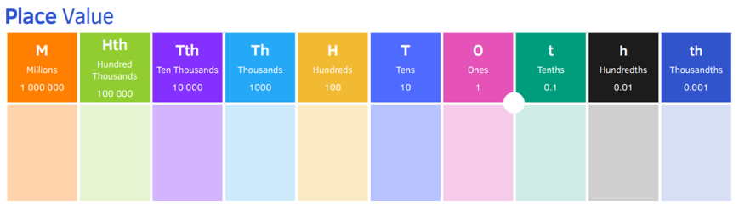
Top tips 2
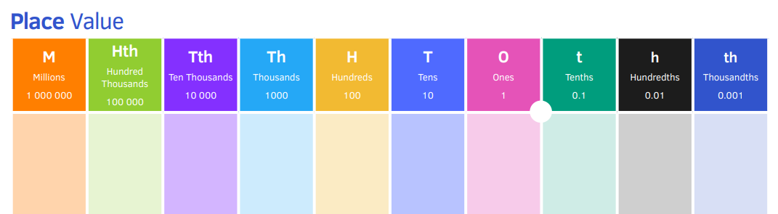

Learning activity 1 Learning activity 2
Numbers in numerals | Number in words
3,456,807 | Three million, four hundred and fifty-six thousand, eight hundred and seven
3,560,703
Numbers in numerals | Number in words
456.87 | four and fifty-six hundred point eight seven

Learning activity 3
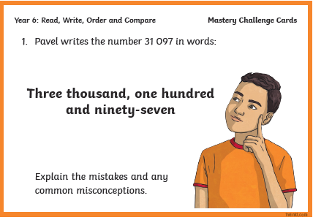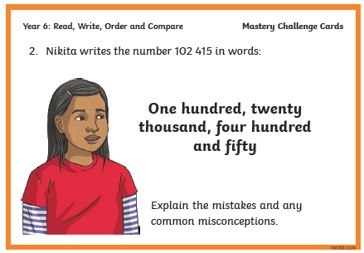
Learning activity 4
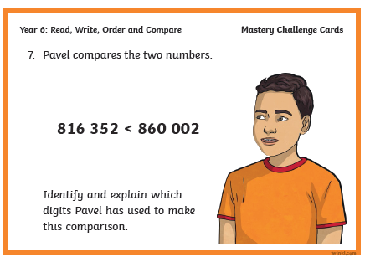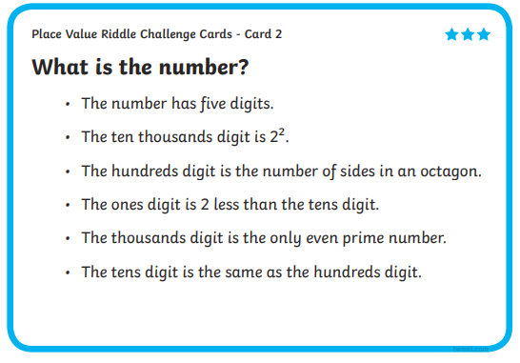
Learning activity 5
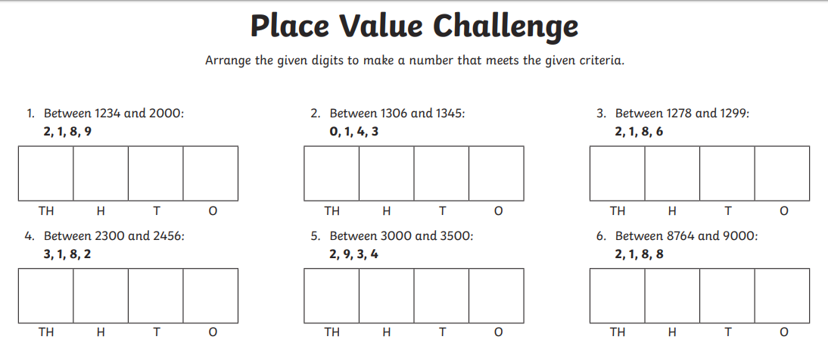
Theme Home Learning
Monday | Tuesday | Wednesday | Thursday |  | Friday
Science  See resource sheet on adaptive traits. Think of 8 animals in different habitats and describe their adaptive trait. Set out you work as shown on the sheets (living thing, habitat and adaptive trait).  Science/DT  Using paper and any resources at home, make a 3D habitat with an animal(s) in it. Explain hot it is adapted to its environment. | Science  Look at the Stem activities in the Science section of this booklet.  With an adult, decide on any 4 activities you wish to complete. Discuss with an adult how you will go about completing the activities. Have fun! | ICT  Create a poster to tell others what to do if they ever faced Cyberbullying.  Talk it through with an adult. | PSHCE  Complete 1 activity. Choose any.  - Complete any 3 activities out of the 4 from the emotion page. |  | PE  See PE sheet  Think of three warm up exercises you could do before playing a sport. Carry out these warm ups.  Complete any 4 activities to complete with a family member.
Easier:  Do as many of the above activities as you can. If you are finding some of the activities challenging, try these as they are a little easier:  - Science choose 4 animals and describe how it is able to survive in its habitat.  - ICT ask an adult to help you.  - RE  - PSHCE ask an adult to help you think of a reason if you are stuck.  - PE Complete any 3 activities to complete with a family member. |  |  |  | Challenge:  If you feel you need a further challenge, try these:  - Science write a detailed paragraph how the animal is adapted to the environment in which it lives.  - Create a poster on the adaptation features of the animal.  - PSHCE complete all activities.  - ICT create a Cyberbullying poster for a year 3 child.  RE  - PE Complete all 5 activities on the sheet with a family member.

Science
Adaptive Traits

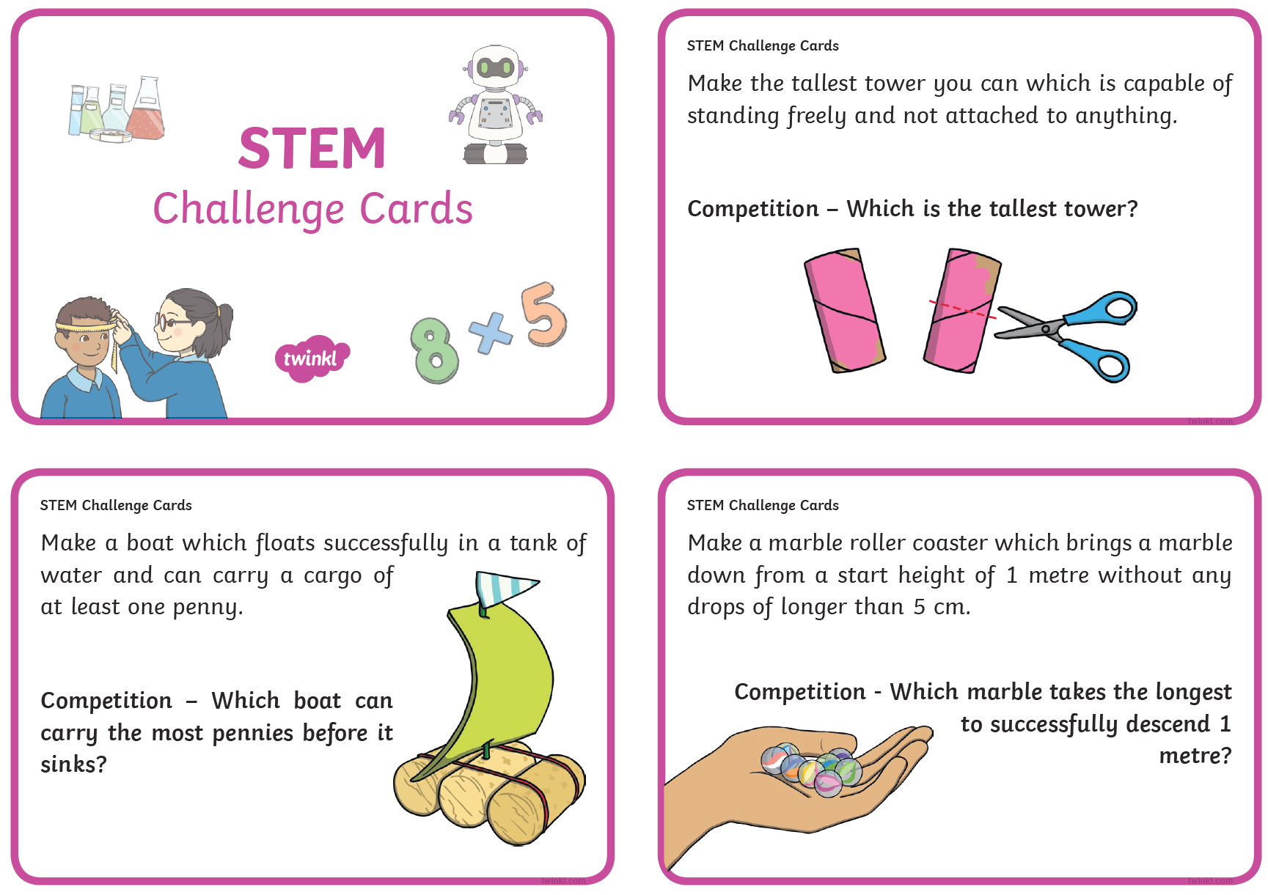
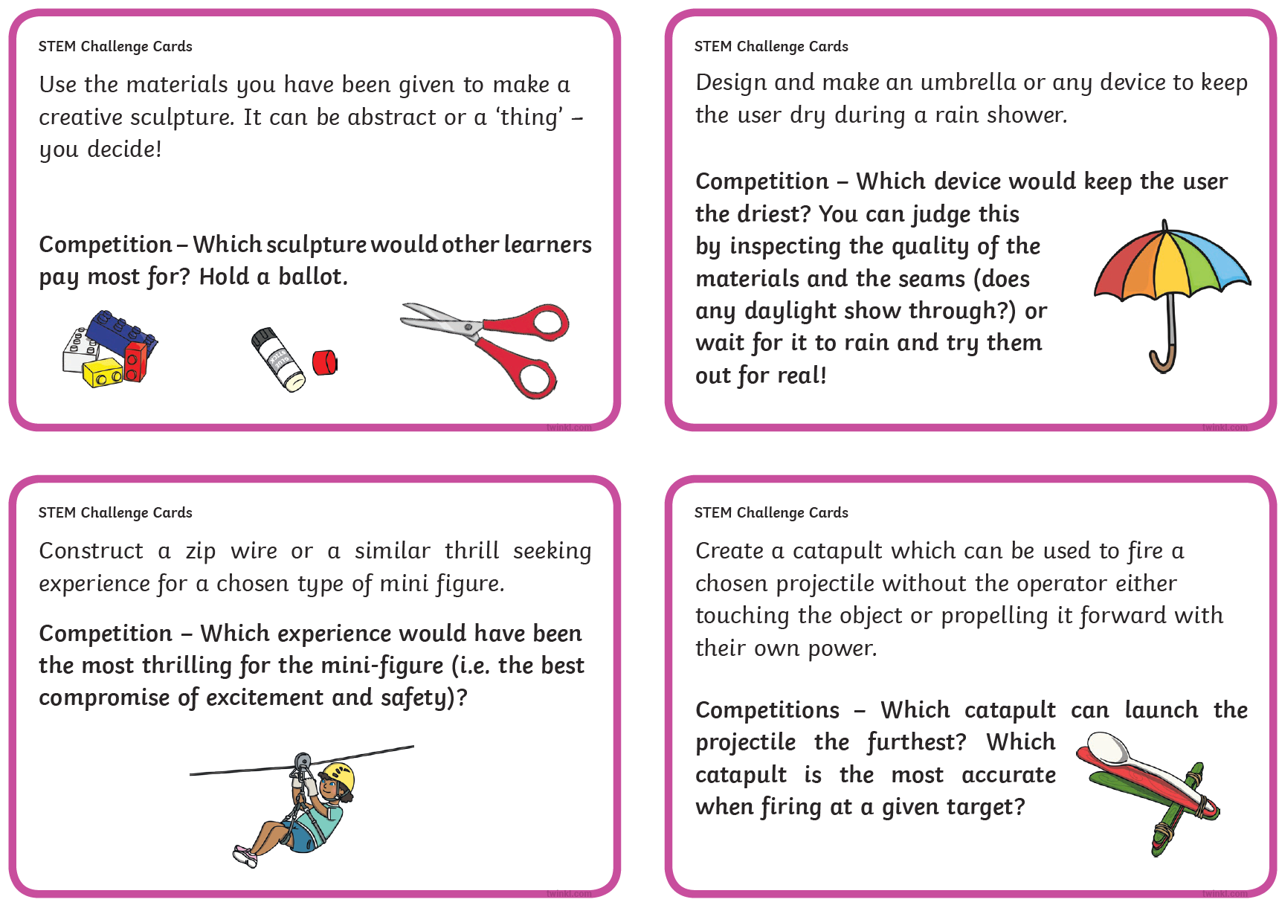

ICT
What is Cyberbullying?
Cyberbullying is bullying that takes place over digital devices like cell phones, computers, and tablets. Cyberbullying can occur through SMS, Text, and apps, or online in social media, forums, or gaming where people can view, participate in, or share content. Cyberbullying includes sending, posting, or sharing negative, harmful, false, or mean content about someone else. It can include sharing personal or private information about someone else causing embarrassment or humiliation. Some cyberbullying crosses the line into unlawful or criminal behavior.
The most common places where cyberbullying occurs are:
- Social Media, such as Facebook, Instagram, Snapchat, and Tik Tok
- Text messaging and messaging apps on mobile or tablet devices
- Instant messaging, direct messaging, and online chatting over the internet
- Online forums, chat rooms, and message boards, such as Reddit
- Email
- Online gaming communities
Task
Create a poster explaining to children what to do if they should face Cyberbullying.

Oracy
Would You Rather…
It is so important to talk and when we are at school, we have plenty of time to do so. However, that doesn’t mean you can’t talk even more when at home! So, to help you and give you an idea, here is an activity you can play with someone at home. For each box, make a choice; which would you rather? Remember, you can only choose one and explain why you would choose that. Don’t forget to have some fun with it!
Write your answer in detail (write one detailed paragraph which explains your reason).

ice – cream  or  chocolate | Bat-man  or  Wonder-woman | snowball fight  or  water balloon fight
fly  or  breathe under water  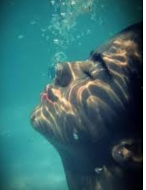 | really cold  or  really hot | play inside  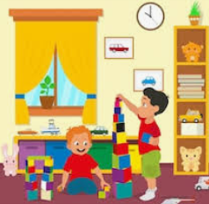  or  play outside
plane  or  ship | dragon  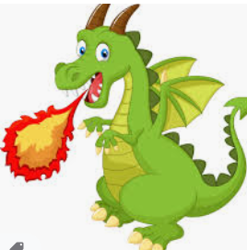  or  dinosaur  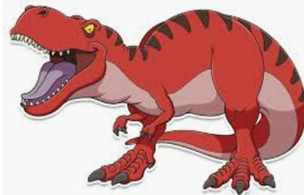 | desert  or  forest  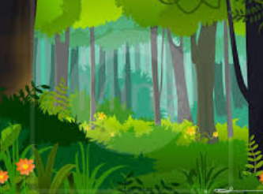

PSHCE Emotions
Complete the sheets below  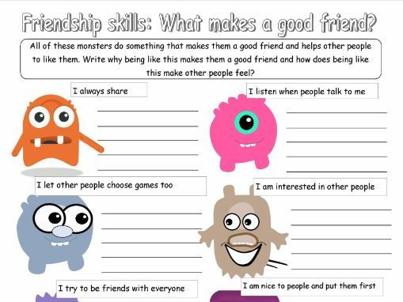 | 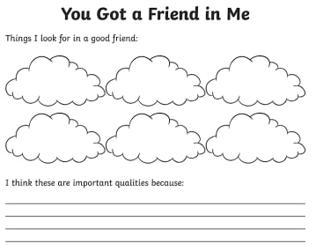
See below for examples how we can help the community.  Draw your own bubble map.  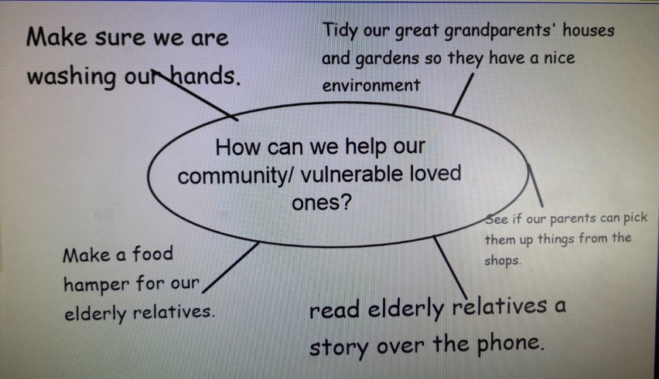 | Emotion wheel  Talk to an adult about how you feel and why.  Use the words in the emotion wheel.

PE

Other Activities
Times tables  Build up speed. Time yourself how long it takes you to answer 0 to 12 x tables in mixed order (work with an adult). | Get active.  With an adult, think of at least two different exercises you can do at home e.g. in the garden. You must exercise for at least half an hour a day. | Use Purple Mash and play online learning games.  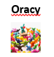  Try the would you rather activities. | Watch the news and choose any 3 stories to summarise. | Mindfulness  Try out some of the activities attached to help you relax.  How many different mindful techniques can you think of?  Which is your favourite?

Key skills to continue practicing weekly:
-spellings
-grammar (go through revision booklets)
-speed reading
-speed writing (count the number of words you can write in one minute)
-neat and joined up handwriting
-timetables (build up speed)

If you or your child has any further queries regarding their learning projects, please contact admin@hardwick.derby.sch.uk, clearly stating your child’s name and class teacher, and the staff will be in touch to support you and your child.

Thank you and stay safe.

