Year 5 Home Learning
Week Commencing: 11th May 2020
Year 5 staff: (Mrs Nisa, Mr Caldwell and Mrs Hollingworth, Miss Gent, Mrs Begum)

Message from staff:
Hello once again from all of the staff in Year 5,
We hope you and your families are all as well as can be and that you are staying safe.
Please remember that we set plenty of work so that the children have something to do. It is important for them to do as much as possible as we are losing a lot of school time at the moment. We do not expect you to complete every single thing on here each week. You can come back to it at a later date if you want to.
We understand it is all very strange and difficult in many ways. It is new to us all and we are trying to adapt as you are also.
Keep doing as much as you can at home. Stay safe. Hopefully we will see you soon.
Speak soon
Year 5 staff

Your Home Learning this Week:
Every day (Monday to Friday), make sure you choose a *reading, *writing, *spelling/handwriting, *maths and *theme learning activity. There are also further activities to choose from should you wish to.

Reading Home Learning
Monday | Tuesday | Wednesday |  | Thursday | Friday
You will be reading a text about VE Day, which is a special event celebrated this weekend. Read the text carefully and highlight or underline any word you do not understand. | Re-read the text and find the meaning of the words you do not understand from yesterday. | Using Stan Summariser, summarise the main information about VE Day – do not forget to use your VIP’s (very important parts).  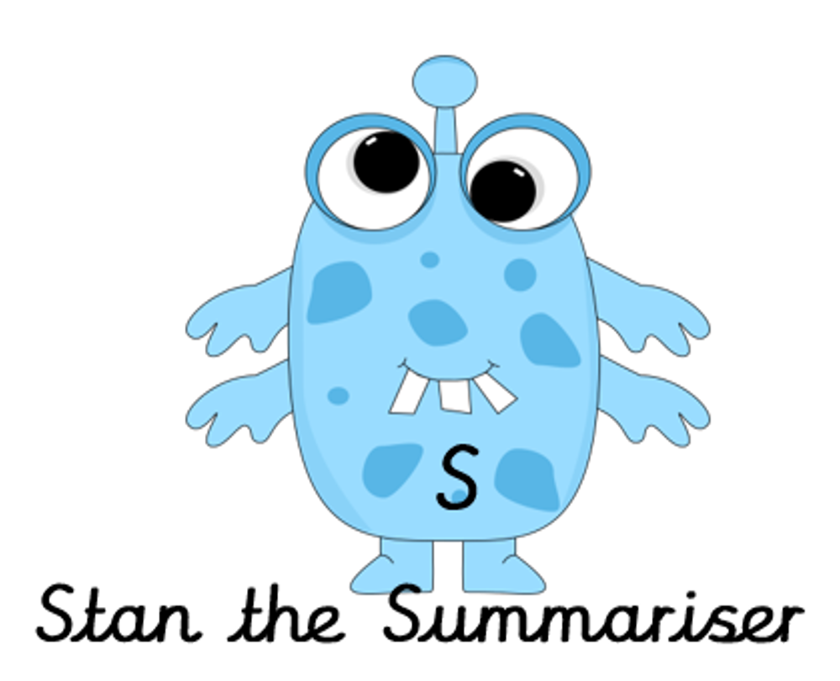 |  | Now try answering these questions:  - In detail, explain why VE Day ended.  - What did General Jodl do?  - What does ‘the bell ringers were on standby’ mean?  - Explain what Stalin did.  - How did people celebrate VE Day? |  | After reading the text on ‘VE Day’, think of any questions you may have. Is there anything you were left wondering that was not answered? Write these questions down. Re-read the text again and this time, try to answer the questions you have. Can you answer them? If not, try to research the answers
Easier:  Do as many of the above activities as you can. If you are finding some of the activities challenging, try these as they are a little easier:  - Read the easier version of the text.  - Highlight any words you do not understand and find out what they mean.  - Try and answer these questions:  - What do we remember on VE Day?  - Name one thing that happened on May 7th 1945.  - Write two ways that people celebrated the end of the war.  - Design a poster with fact you have learnt about VE Day. |  |  | Challenge:  If you feel you need a further challenge, try these:  - Answer the following questions:  - How did Stalin’s actions effect Britain?  - Why do you think two searchlights were lit in the shape of a V?  - Why do you think the author used an exclamation mark when writing about the princesses walking around London?  - Create your own fact sheet about VE Day to demonstrate your understanding.
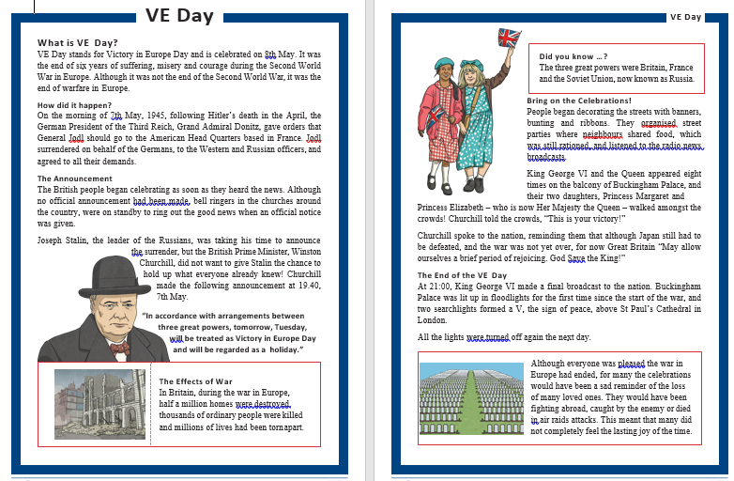
Easier version. Tangram – Maths
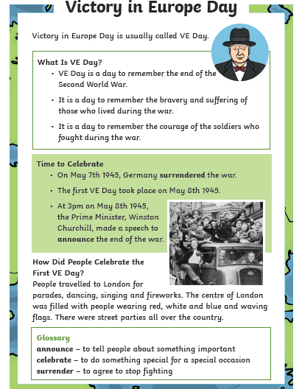 Tuesday-Cut the 7 sections of the tangram
Writing Home Learning
Monday | Tuesday | Wednesday |  | Thursday | Friday
This week you can have a go at writing a story using your own ideas. On the next page is a story organiser that you can use to help you.  Today we want you to use the story organiser to decide on a setting, a main hero and villain and think about what problem the hero has to solve and how they will solve it. | Today we want you to draw a comic strip for you story. This will help you to visualise each of the 5 parts of it, remember to visualise the main parts of the setting, build up, dilemma, resolution and ending. | Today have a go at telling your story to an adult, brother or sister using your comic strip to remind you of the main events. Try to include as much detail as possible to interest your audience. This will help you to organise your ideas in your head ready for writing tomorrow. |  | It is time to have a go! Today, have a go at writing the setting and build up for your story – use your comic strip to help you. Try to include the following:  Fronted adverbial phrases.  A range of different sentence types.  Carefully chosen verbs and adjectives to create the setting. | Re – read your setting and build up from yesterday to remind yourself where you have go too with your story.  Today you need to write the problem, resolution and ending. Remember too add plenty of action and detail to describe the struggle between the hero and villain and include an exciting way to solve the problem.
Easier:  Do as many of the above activities as you can. If you are finding some of the activities challenging, try these as they are a little easier:  - Use the easier story organiser to plan your story.  - Focus on using good adjectives and verbs in your story.  - Re – read each sentence as you write to make sure it makes sense. |  |  | Challenge:  If you feel you need a further challenge, try these:  - Include parenthesis to add further detail to your story, this can be either a dash - or brackets ()  - Think about using conjunctions and fronted adverbial phrases to start each paragraph to link it back to the previous paragraph.  - Try and use a wider range of more adventurous vocabulary.

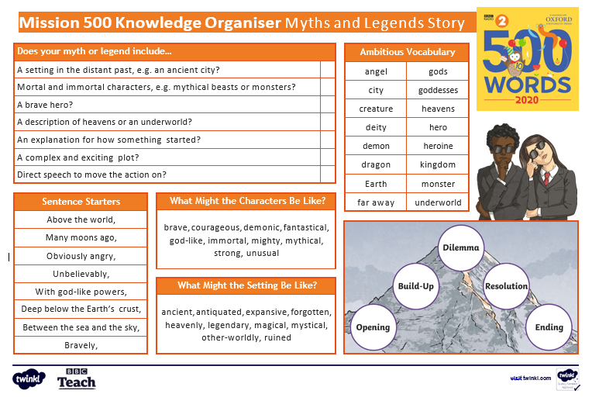

Easier story organiser
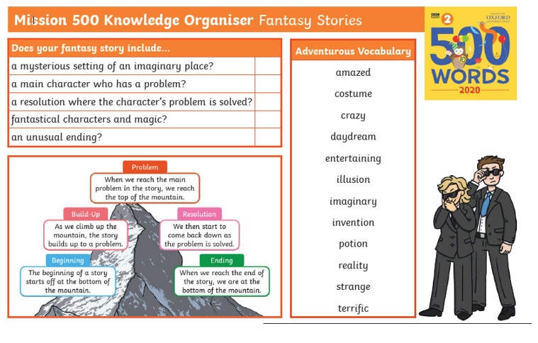

Spelling/Handwriting Home Learning
Monday | Tuesday | Wednesday |  | Thursday | Friday
Pick out some challenging words from a book you are reading or have read. Create your own spelling list to practice this week. | Using the spellings you have chosen on Monday, practice your cursive handwriting. Use this FONT style to help you remember. | Choose someone famous to write a letter to. The Queen, Jeremy Corbyn, Ed Sheeran (your choice) use your neatest handwriting to impress them. |  | Practice your spellings. Use one of the many techniques you have been taught.  -Different colour syllables.  -Say it the way you see it.  -Word pyramid.  -Look cover, write check. | Get your siblings or parents or anyone that can help, to test you on the spellings you have been revising.  Any you get wrong can go on a permanent list to practice another time.
Easier:  Do as many of the above activities as you can. If you are finding some of the activities challenging, try these as they are a little easier:  - Pick out words from any books you have, that are tricky for you and practice them. Get someone to test you at the end of the week.  - Use the same words for handwriting practice. |  |  | Challenge:  If you feel you need a further challenge, try these:  - If you have some of your old spelling lists then get them out and practice the ones you struggled with the most.  - Find year4 and 5 spellings lists online and pick out the ones you are most unsure about.  - Find the definitions of words you do not know.

Maths Home Learning
Monday | Tuesday | Wednesday |  | Thursday | Friday
Perimeter is the measurement of the distance around the outside of a shape.. draw a square, each side being 4cm. add the 4 sides (4+4+4+4= ?  Draw quadrilaterals (4 sided shapes) with a perimeter of 12cm. | Cut out each section of the tangram on page 5. What is the perimeter of each shape?  Write down the  mathematical name  for each of the  pieces. | Draw shapes with straight sides e.g. triangles, rectangles pentagons hexagons etc. calculate the perimeter of each shape by adding the length of each side |  | Chose 5 objects around your house e.g a table, TV screen, microwave etc. measure each side and add together to find the perimeter. | A farmer needs to put a fence around a field.  The length of the field is 24 metres, the width is 10 metres How much wooden fencing does farmer need?  If 1 metre costs £2.000 how much will the fence cost then farmer?
Easier:  Do as many of the above activities as you can. If you are finding some of the activities challenging, try these as they are a little easier:  - Draw squares and rectangles. Add the 4 sides of each shape  - Draw rectangles) with a perimeter of 10cm.  - Find a reading book, one sheet of paper from this pack and a mobile phone. Measure each side and add together to find the perimeter. Draw a diagram to show this. |  |  | Challenge:  If you feel you need a further challenge, try these:  - Use a tape measure and find the perimeter of a door, rug, your bed, a window. Find the perimeter of other objects. Keep a record.  - You are going to put a border around your bedroom walls. Calculate the perimeter of your bedroom. How many metres and centimetres of border will you need?
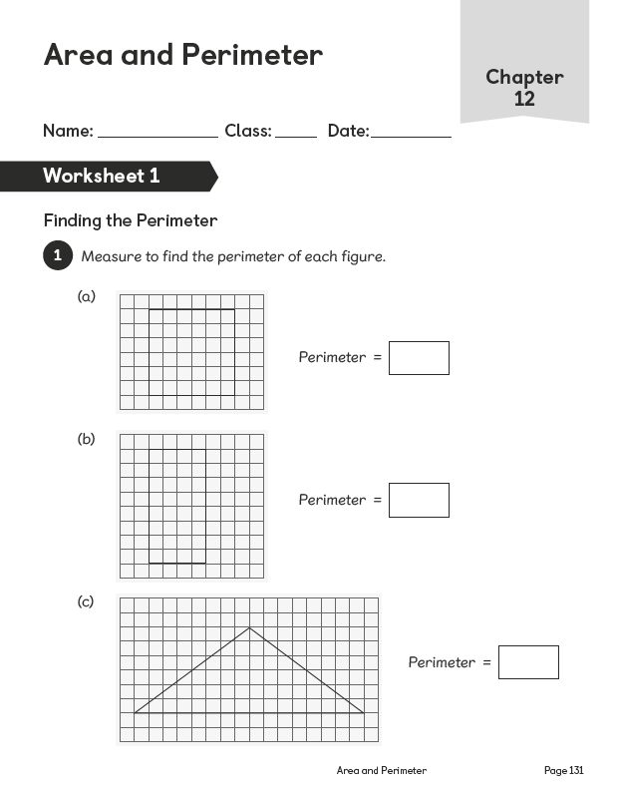
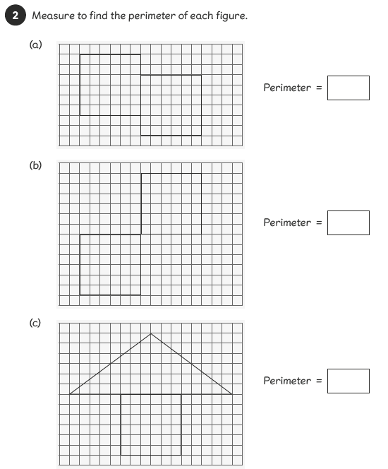
Activity 1
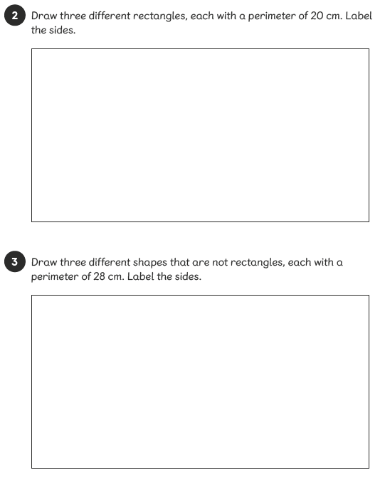
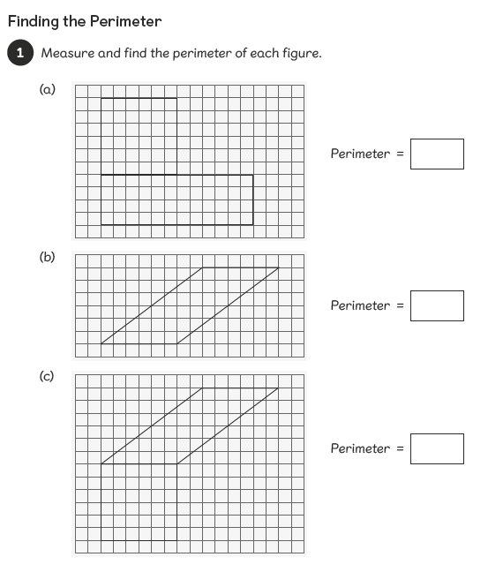
Activity 2
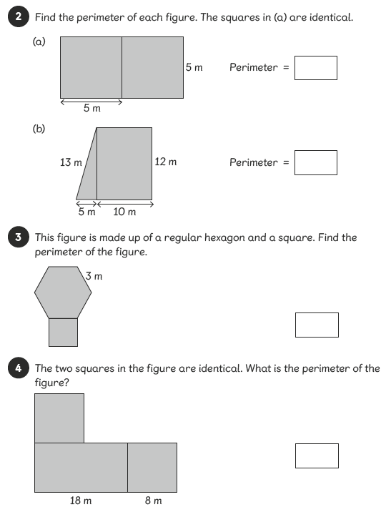
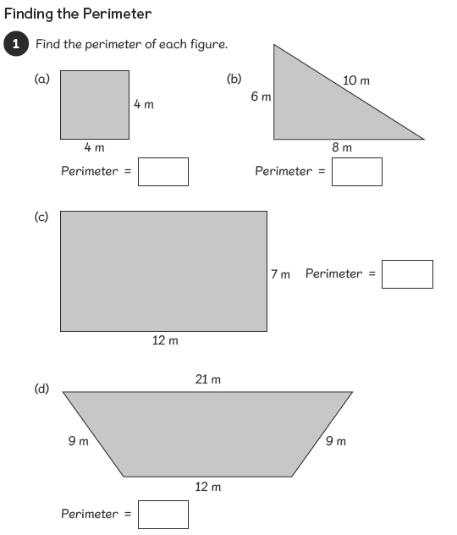
Activity 3
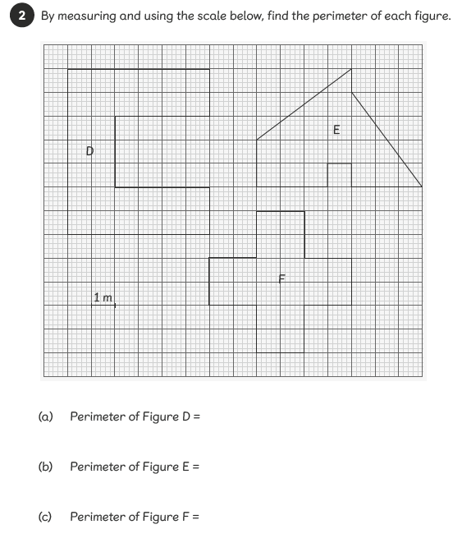
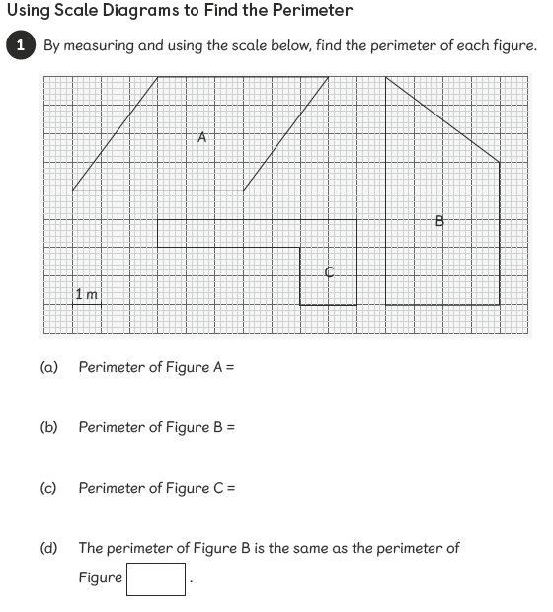
Activity 4
Monday/Tuesday | Wednesday |  | Thursday | Friday
Design your own dream garden. You are going to draw a detailed and labelled plan of your dream garden. It must include:  - A green house and an allotment space for growing your own fruit and veg.  - A few flower beds with your choice of flowers. (ask your family what flowers they would like to see)  - Trees and bushes to create shade?  - Structures: shed, summer house, tree-house etc.  - Extras such as – Jacuzzi, pool, pond, fountain, bird table, bug hotel etc | When doing your daily exercise. Trying going for a stroll on a nearby park and become a nature photographer. If you have a good sized garden, try it there as well. Experiment with close ups of plants bugs etc. |  | RE – During Ramadan write down why it is important and what it means for you.  If you do not celebrate Ramadan, think about some things you may find hard to give up. | Choose a wildlife documentary to watch with your family. These can be accessed via Netflix, Amazon, Sky, Youtube, Virgin, or catch one on normal TV.
Easier:  Do as many of the above activities as you can. If you are finding some of the activities challenging, try these as they are a little easier:  - If you cannot get to the park or do not have a garden try taking photos inside become a photographer. Phone cameras work fine.  - Photograph toys in funny scenarios do a pretend fashion shoot with your siblings. Have fun with it. |  | Challenge:  If you feel you need a further challenge, try these:  - Use your photos of wildlife to do practice the drawing and sketching skills you started last week.  - Photograph toys in funny scenarios do a pretend fashion shoot with your siblings. Have fun with it.  - If you have an ipad/tablet try downloading a free stop-start animation app and create your own stop-start films with your toys.
Theme activities – Home Learning
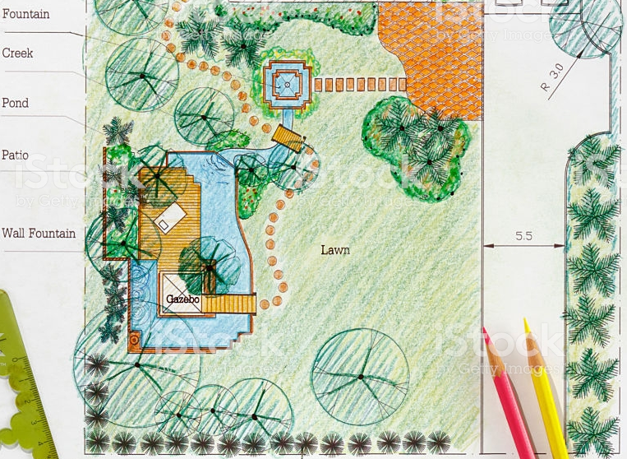
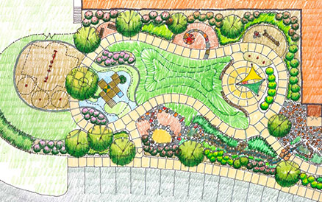
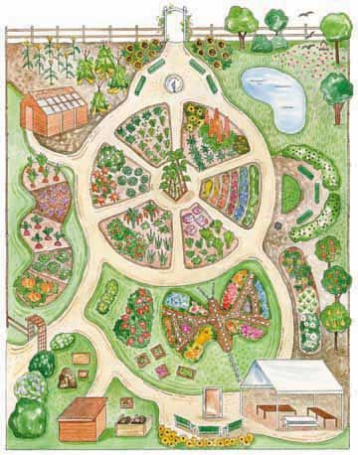
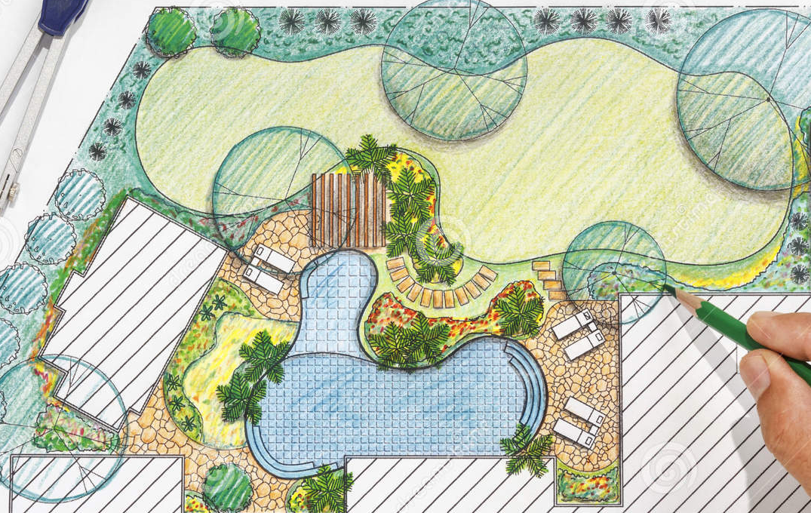
Example gardens to help with Monday/Tuesday theme task
Other Activities
Create, rehearse for a show for your parents. You could do a play, talent show re-enactment of a story/film/show you already know.  - Write a short script if needed.  - Write the performance order if a talent show.  - Think about what you will need to wear and any props. | Create a poster to advertise your show.  Think about how to make your poster catch some ones eye. | Make tickets for your family members that will attend. | Perform your amazing show to your parents/family etc.
Key skills to continue practicing weekly:
- Timetables, Handwriting, Reading of own books, PE/Exercise.
If you or your child has any further queries regarding their learning projects, please contact admin@hardwick.derby.sch.uk, clearly stating your child’s name and class teacher, and the staff will be in touch to support you and your child.

Thank you and stay safe.

