Challenge time home learning week beginning 20th April
Maths
Telling the time to the nearest 5 minutes. The main thing to remember is that as the minute had goes to each number it is another 5 minutes. Between the 12 and 6 it is past the hour and between 6 and 12 it is ‘to’ the next hour.
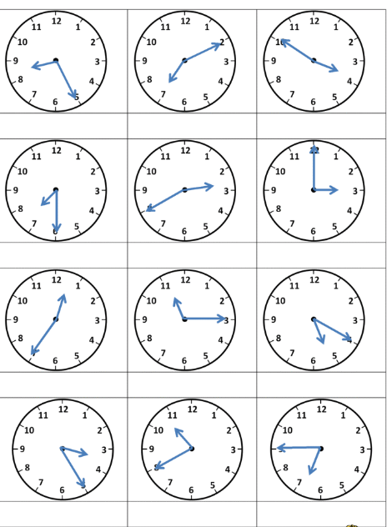

So the first of these would be 25 minutes past 8. Whilst the third one would be ten minutes to 4.

Have a go.

Now it’s time to have a go at some adding but be careful and remember to start with the ones.
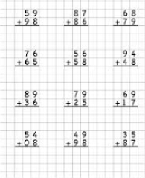

English
First see how many conjunctions you can name in a list. Remember a conjunction is a word that joins two other ideas such as ‘ and’ and because..

Can you complete these sentences so that they make sense.
- I can go into the garden when …….
- I can go into the garden if …………
- My mum will read me a story when …………
- My mum will read me a story if …………
- The chocolate cake will be ready when ……….
- The chocolate cake will be ready if ……………….

Here are some spellings that you could learn over the next week and see if you can use them in a sentence without checking on the spelling. These are Year 3 words so they are hard.
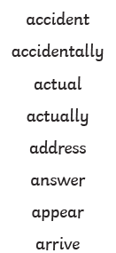

Topic
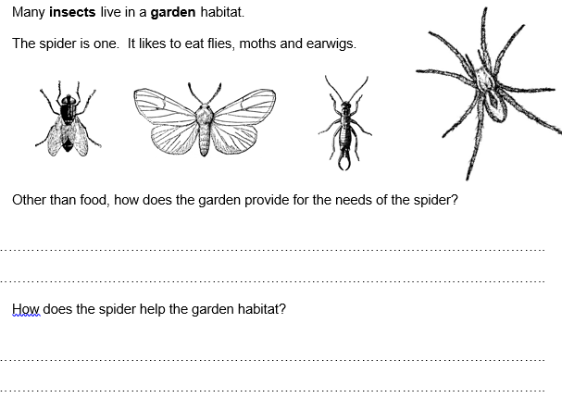

Thank you parents for trying to help with their learning at home. Next week we will attach the answers for this week’s work so you can check it.

The Year 2 team.

