Year 4 Home Learning
Week Commencing: 1st June 2020

Year 4 teachers: Mrs Haslam, Mrs Tatla, Mrs Jogela and Miss Annable
Year 4 TAs: Miss Perry and Mrs Smith

Message from staff: Hi Year 4, we hope that you are all well and keeping safe. Even though we are not teaching you, we are thinking about you and working very hard to provide fun activities for you to complete at home. We are also preparing lots of exciting projects for when we return to school. If you struggle with any of the work, please remember to ask for help when we make our weekly phone call. We hope you are taking some time out of the day to get fresh air and spend time with your family.

Your Home Learning this Week:
Every day (Monday to Friday), make sure you choose a *reading, *writing, *spelling/handwriting, *maths and *theme learning activity. There are also further activities to choose from should you wish to.

Reading Home Learning – Cracking Comprehension!
Monday | Tuesday | Wednesday |  | Thursday | Friday
Vernon the Visualiser  Draw what you picture in your head as you read these sentences.  The food we throw away in our bins each year would fill 8.400 Olympic-sized swimming pools. However, instead of being swimming pools, it ends up in huge holes in the ground called “landfill sites”, which are filled up with our rubbish, including food waste, plastic bags and other waste. You are growing up in a land that is full of holes of decaying food. | Monica the Monitor  Read, ‘Are you wasting good food?’ by Kate Ruttle (next page). Using reading skills to help you understand as you go through it. Highlight any words you do not understand and find the meaning of them. | Colin and Carmen the Connectors  Text-to-self.  As you read the text, what are your thoughts? Do you think you waste too much food?  Make a poster of the different ways you can help reduce food waste. |  | Monica the Monitor: Question Zap!  On your own, answer the questions. | Monica the Monitor: Crack it!  With an adult, go through the questions together, highlight where you found your answers in the text.
Easier:  Do as many of the above activities as you can. If you are finding some of the activities challenging, try these as they are a little easier:  - Listen to an adult read the text.  - Discuss together what the text is about and meaning of new words. |  |  | Challenge:  If you feel you need a further challenge, try these:  - Read the practice text, ‘Would you eat less-than-perfect fruit and vegetables?  - Answer the questions independently
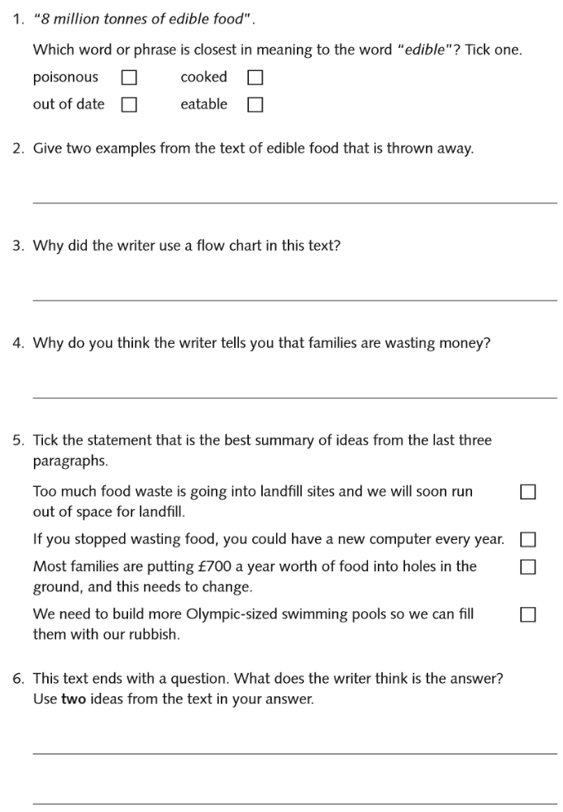
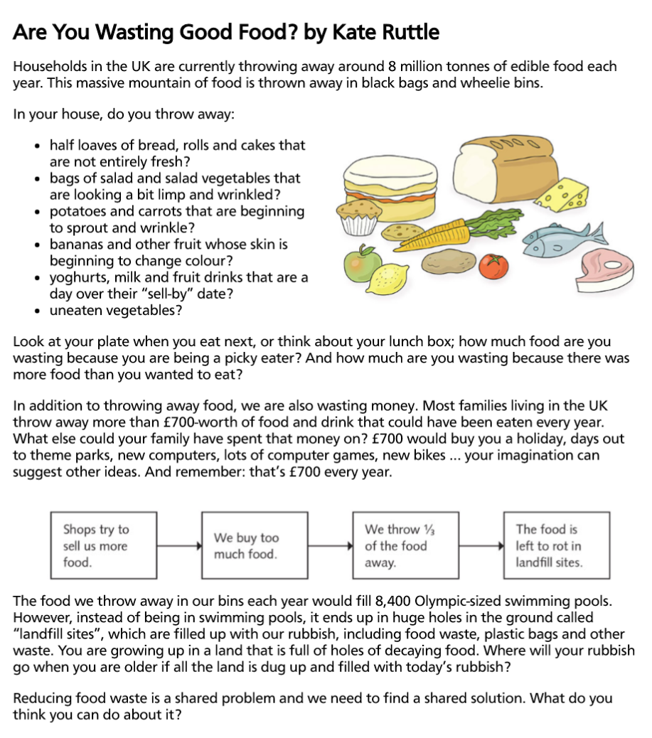

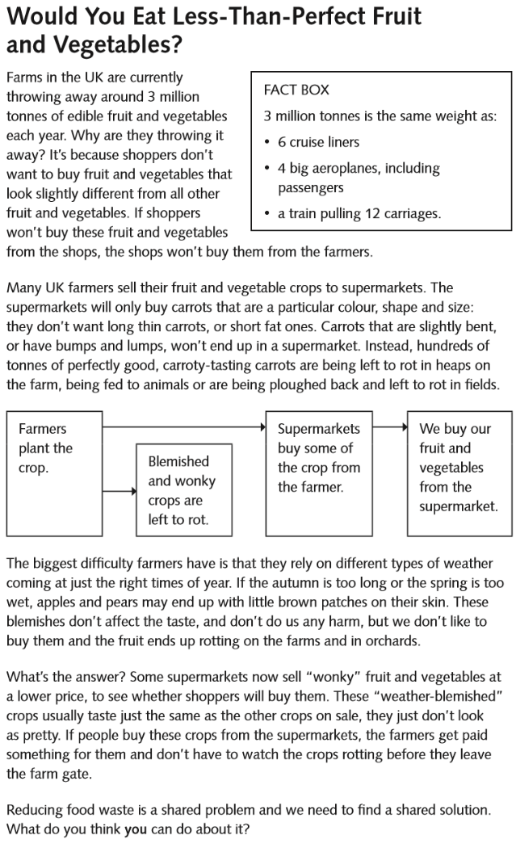
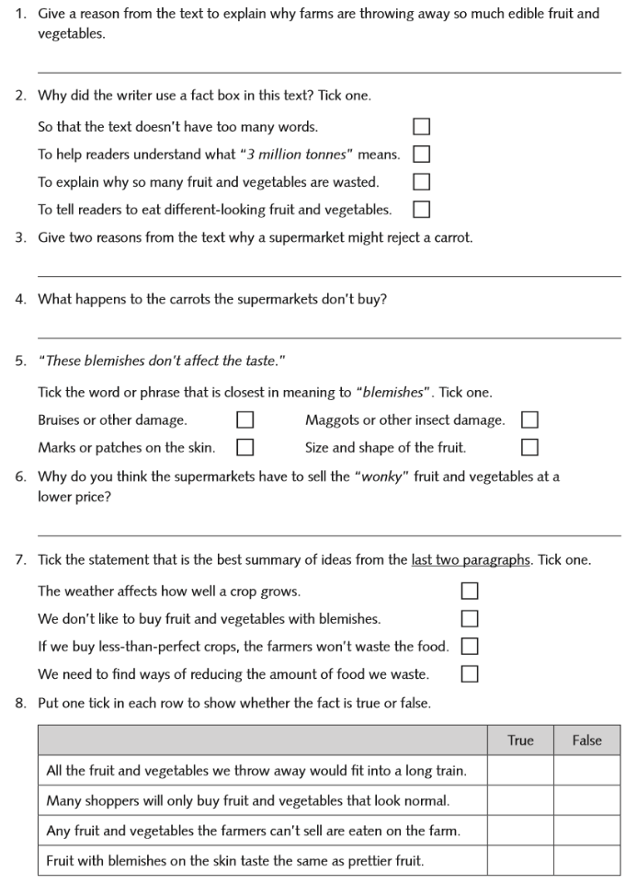
Challenge Reading Activity (Independent)

Writing Home Learning – WOW START!
Monday | Tuesday | Wednesday | Thursday |  | Friday
Question the photo:  Who, What, When, Where, Why, How? | Design your own potion!  Think carefully what kind of story character your potion belongs to. A witch, wizard, fairy, magician, queen, pirate…?  Label your drawing with adjectives of what it looks and smells like. Include how your potion is magical. | Tomorrow you will make your own potion! Make a list of things that you can mix together to make it look and smell a certain way. You could use; flowers, food colouring, paint, shower gel, washing-up liquid, lemons/oranges, herbs etc.  Discuss with an adult which substances that are safe to use. | Make your own potion!  Use any empty container e.g. water bottle, empty container, yoghurt pots, cups…... anything you have available.  Once you have made your potion/perfume, keep away from young children, store in a sensible place or dispose of soon after – DO NOT EAT! |  | Write a set of instructions for your potion.  Introduction: What is your potion called and how is it magical?  Ingredients: Write what you included.  Method: Tell others how they can make the potion/perfume step-by-step.  See example on next page.
Easier:  Do as many of the above activities as you can. If you are finding some of the activities challenging, try these as they are a little easier:  - Discuss with an adult the different things you have available that you could use to make your potion/perfume together. Look on the internet together for extra ideas. |  |  |  | Challenge:  If you feel you need a further challenge, try these:  Decorate your potion/perfume container to make it look ‘real’.
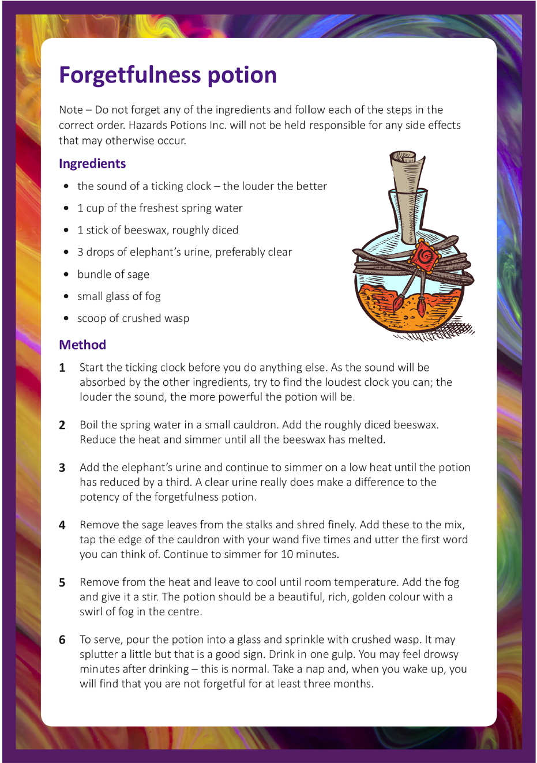
Spelling/Handwriting Home Learning
Monday | Tuesday | Wednesday |  | Thursday | Friday
Monday  Choose the next 10 spellings on your list that you struggle with.  Scribble Write:  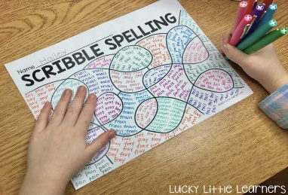 | Tuesday  Write each spelling on a piece of paper and hide them in your house. Race someone in your family to find each of them. The winner is who found the most words. | Wednesday  Find materials in your house to spell out each word like the image below.  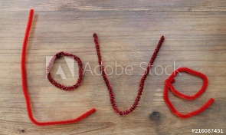 |  | Thursday  Using your finger, ‘write’ the word on a family member’s back and ask them to try and guess the word. | Friday  Spelling quiz!  Ask a family member to test you on your spellings.  You could also test yourself on the Top Marks website:  http://www.ictgames.com/mobilePage/lcwc/index.html
Easier:  Complete the same activities as above but choosing the next 10 spellings on the Year 1 and 2 statutory spelling list that your struggle with.  Must be able to spell correctly by now:  - because  - beautiful  - any/many  - improve/prove  - should/could/would  - hour/our  - clothes  - Christmas |  |  | Challenge:  If you feel you need a further challenge, try these:  - Make a list of as many words as you can think of where there is a short -i sound spelt with a y e.g. myth, pyramid…..  - Make a list of as many words as you can think of where the short u sound is spelt -ou- e.g. touch, young…..  - Make a list of as many homophones as you can and then write each correctly in a sentence.
Maths Home Learning
Monday | Tuesday | Wednesday | Thursday |  | Friday
Practise your times tables and division facts. Once you know them test your understanding by getting someone to ask you them and see how many you can answer correctly in 1 minute. Then do the same with the division facts. | Writing Amounts of Money: Lesson 1  Follow ‘Let’s Learn’ with an adult then complete the two worksheets (pages 43 and 44). | Writing Amounts of Money: Lesson 2  Follow ‘Let’s Learn’ with an adult then complete the two worksheets (pages 45 and 46). | Comparing Amounts of Money: Lesson 3  Follow ‘Let’s Learn’ with an adult then complete the worksheet (page 47). |  | Rounding Amounts of Money: Lesson 4  Follow ‘Let’s Learn’ with an adult then complete the two worksheets (pages 48 and 49).
Easier:  Do as many of the above activities as you can. If you are finding some of the activities challenging, try these as they are a little easier:  - With an adult, count the different coins and notes they have in their wallet/purse and add different amounts together.  - Place lots of coins/notes together and ask your child to find/show you a certain amount of money and write their answer correctly (using symbols e.g. £2.60)  - Play shops together! Label objects in your house of differing prices, someone pretends to be the customer buying objects and someone pretends to be the shopkeeper. The customer either needs to pay with the correct amount of money or the shopkeeper needs to work out how much change to give. Swap roles. |  |  |  | Challenge:  If you feel you need a further challenge, try:  Complete the challenge activities on Page 17 of this booklet.
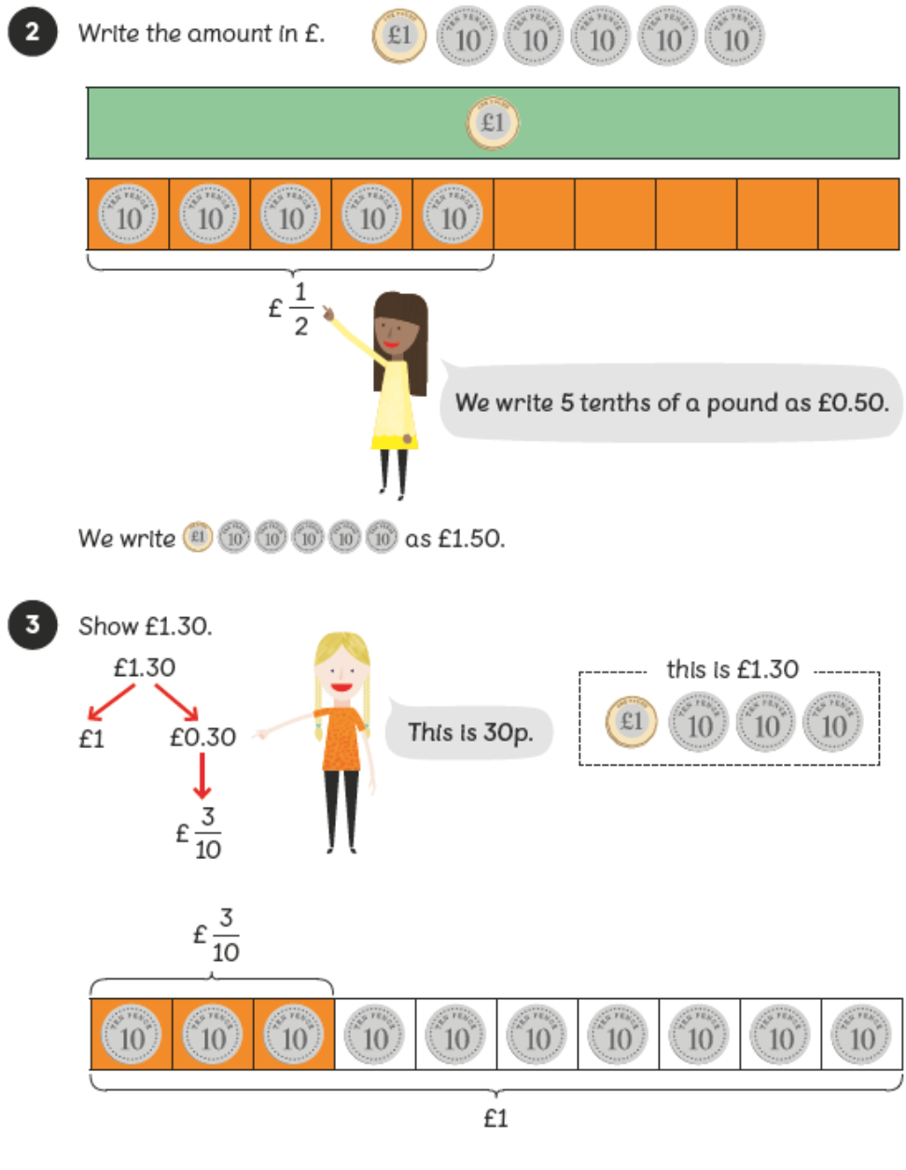
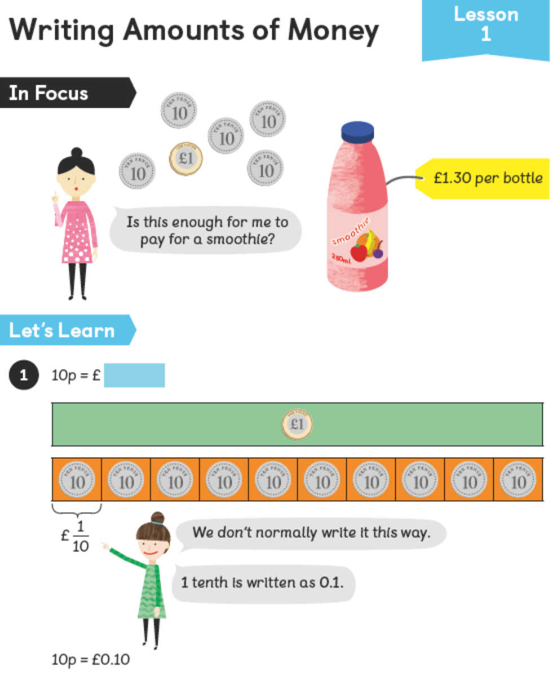

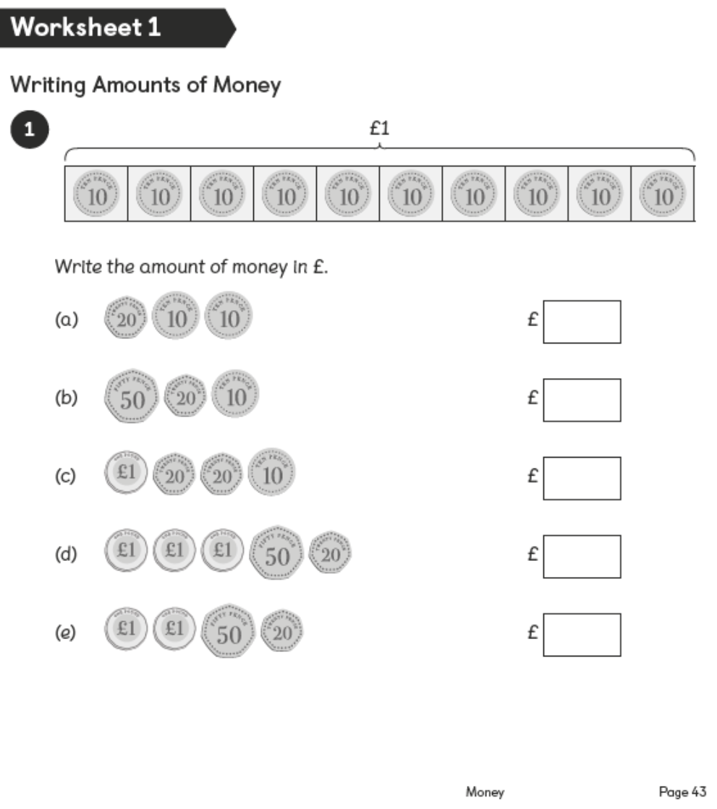
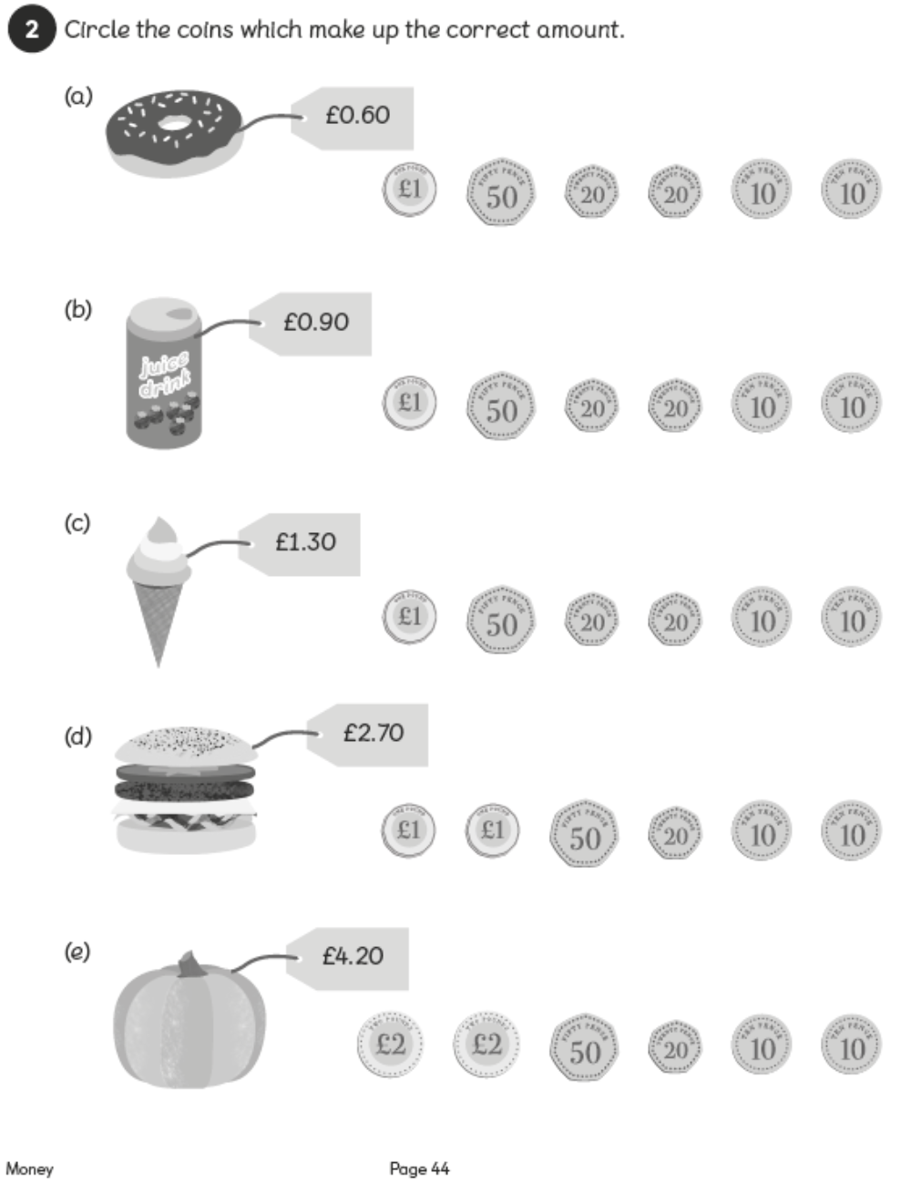

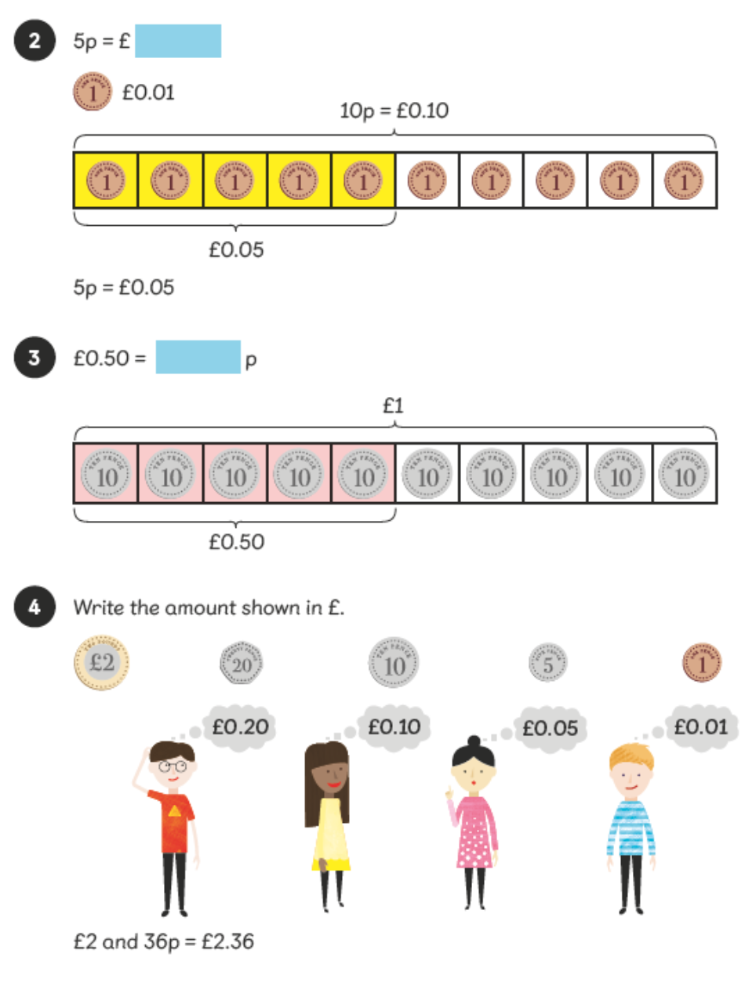
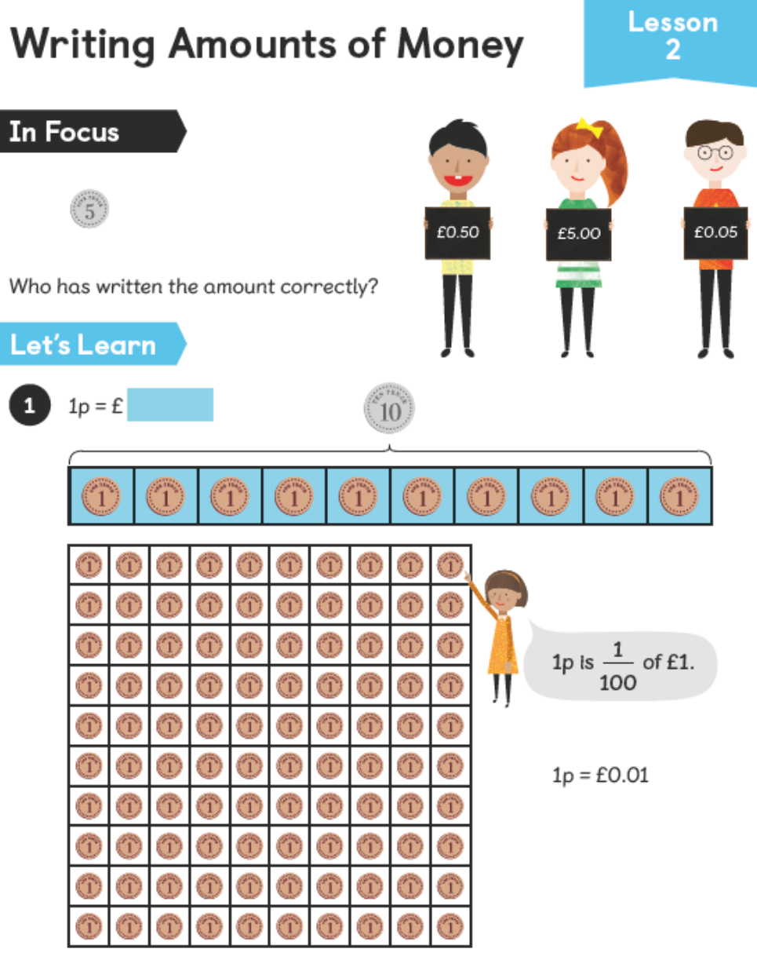

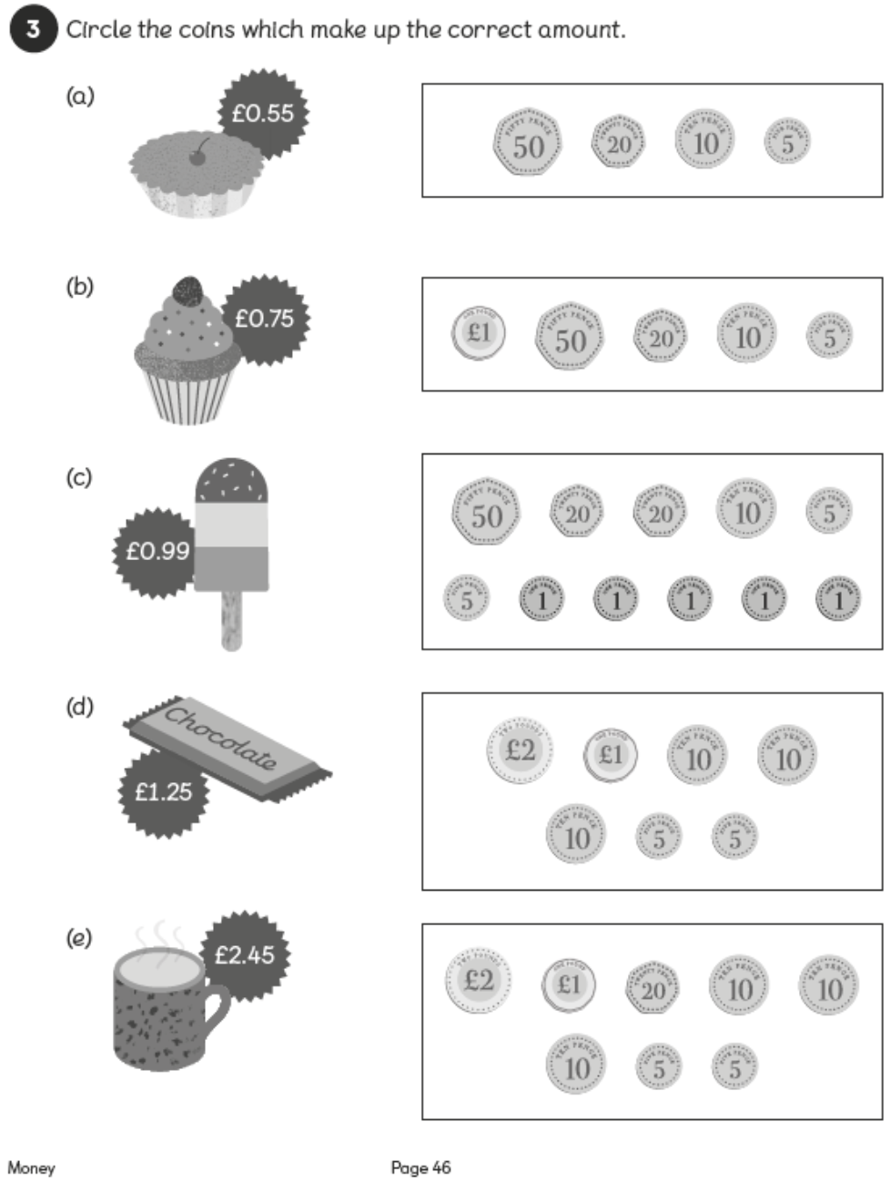
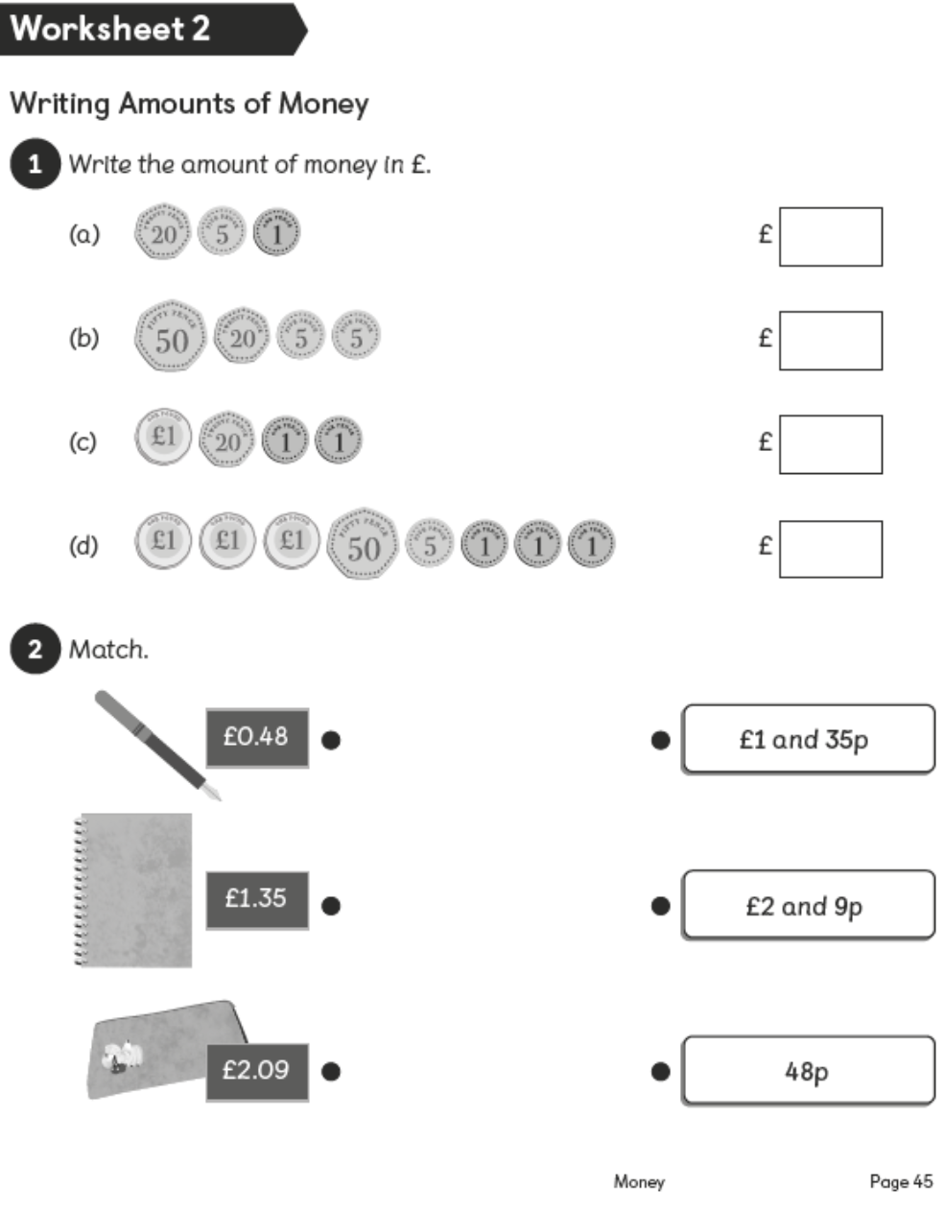

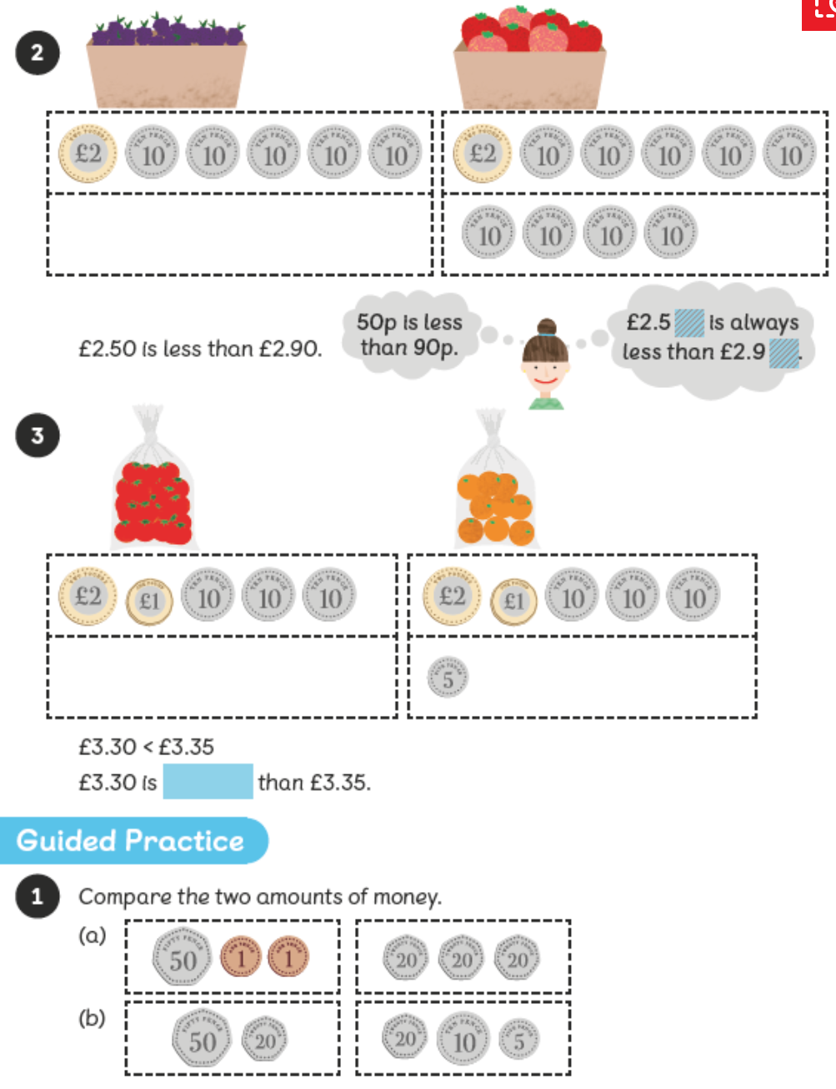
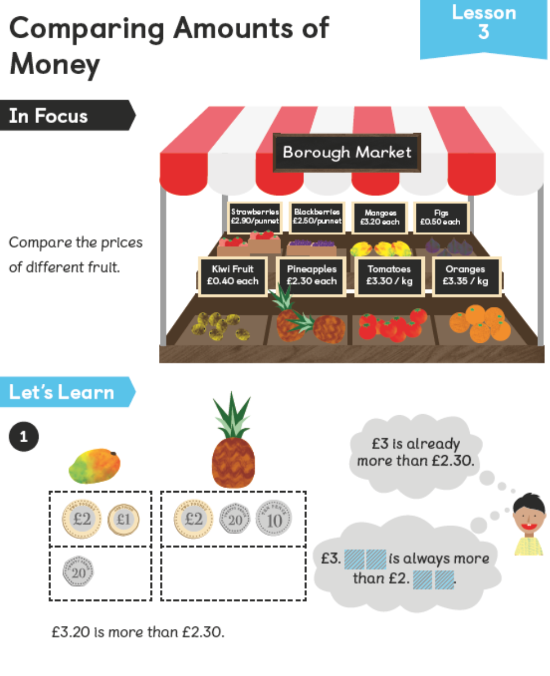

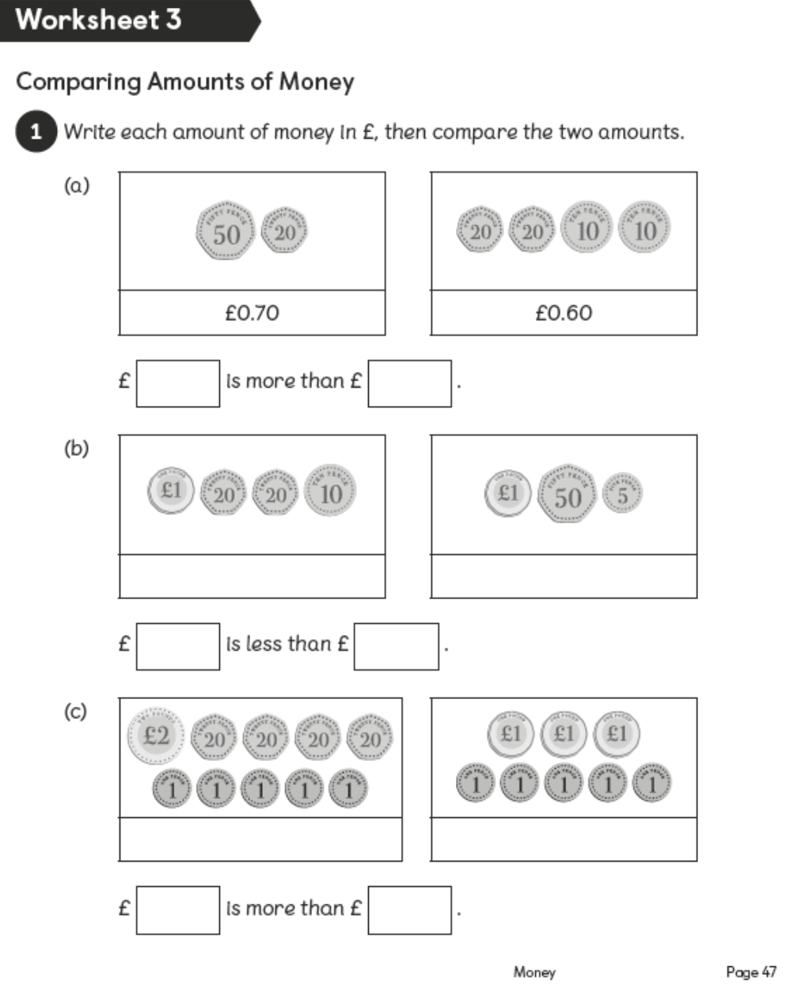

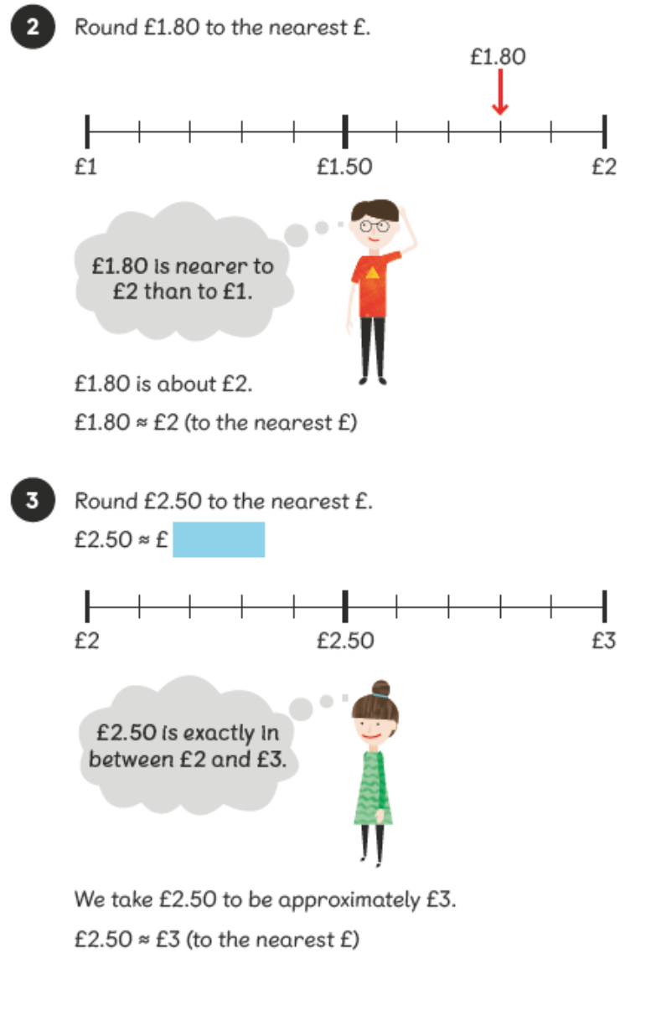
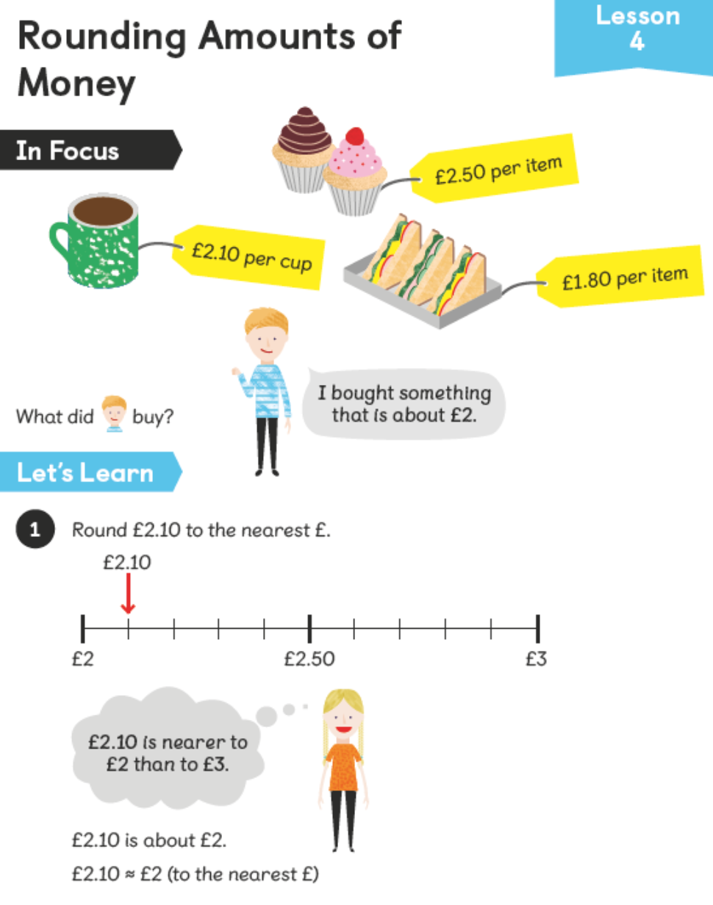

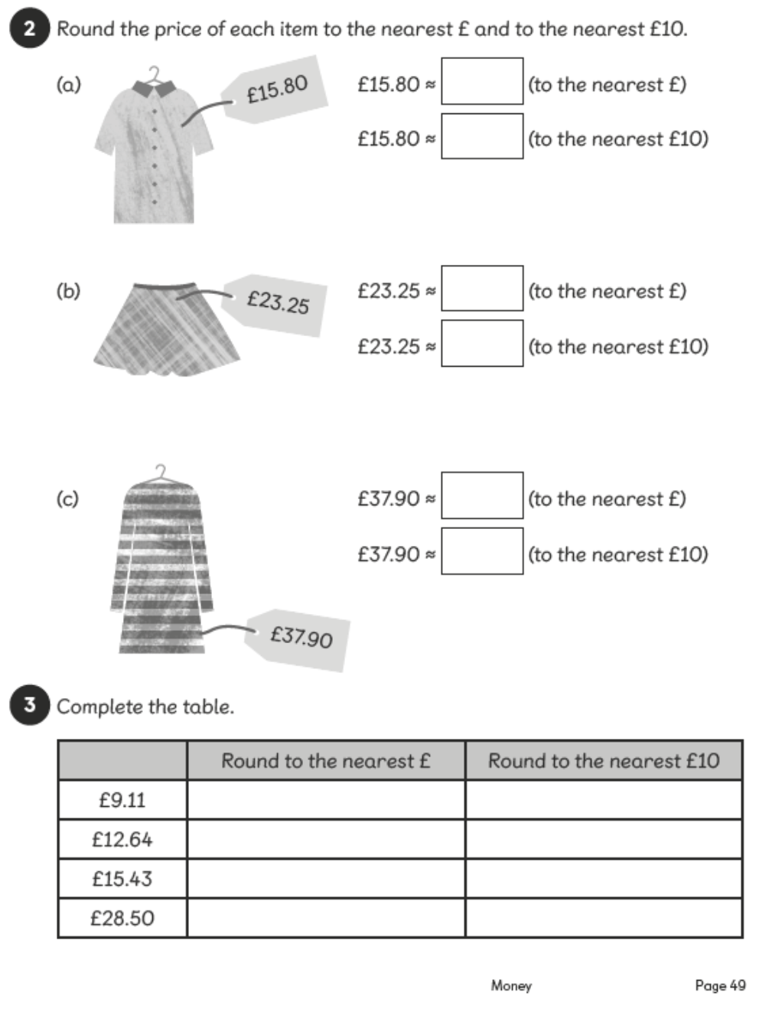
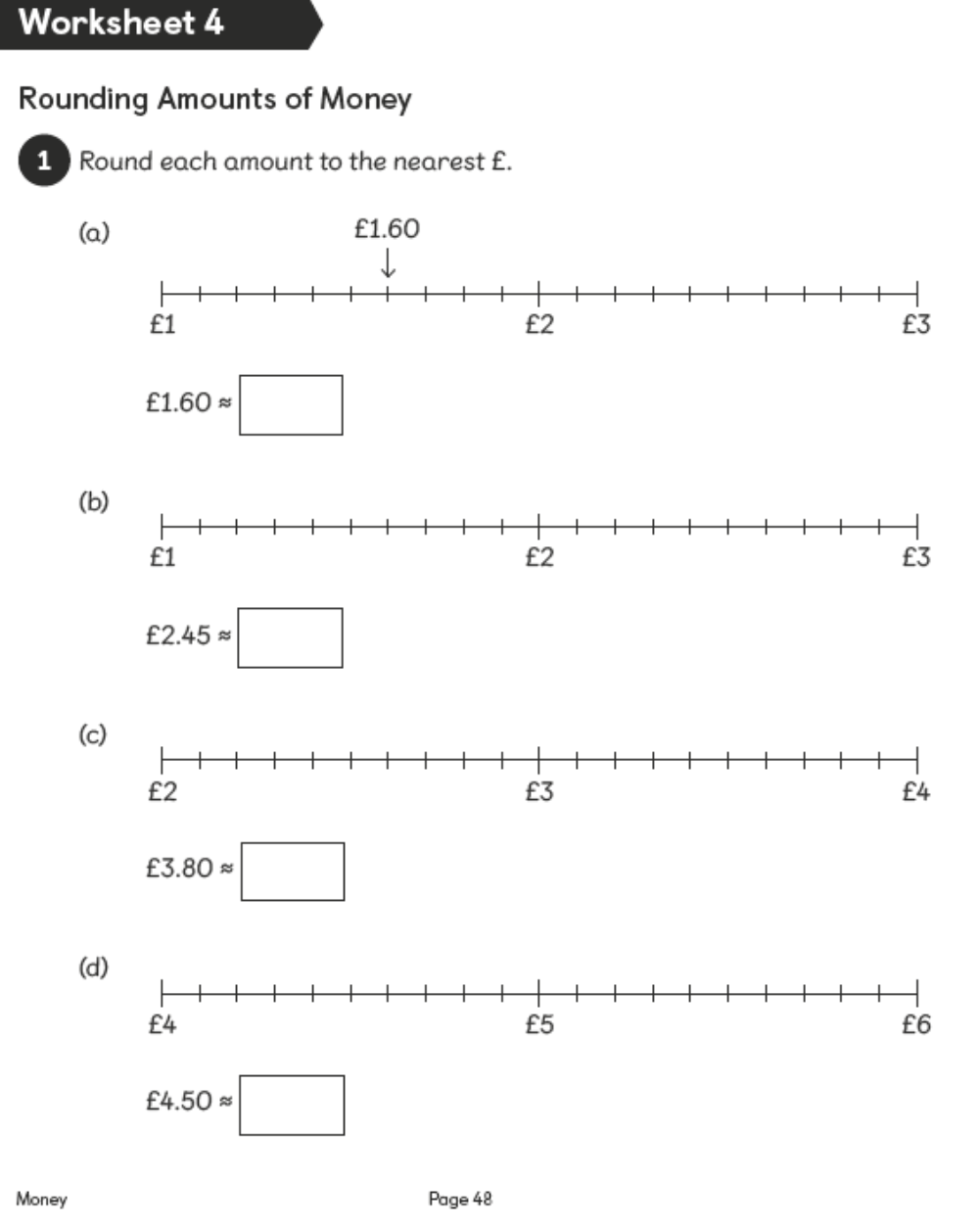

Challenge Maths Activities
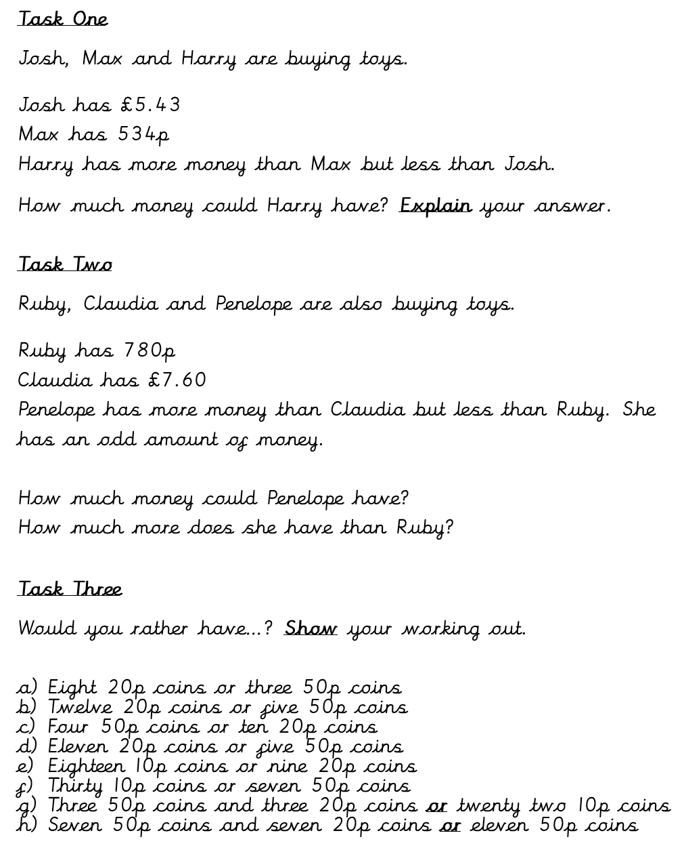

Theme Home Learning – Our theme this half-term is, Potions.
Monday | Tuesday | Wednesday |  | Thursday | Friday
Art  Make a sketch of any interesting bottles you have at home. Remember to add patterns, textures, shading and finer details.  This will help you with your own design tomorrow.  If you do not have any perfume bottles etc. at home, you can look at the perfume bottle examples on the school website or use Google. | Oracy  What is a potion?  Discuss with your family and make a list of as many stories you have read that involves a character using a potion in some way.  Watch the following clip from Alice in Wonderland – how was the potion magical?  https://www.youtube.com/ watch?v=di7dZwidXZU | Science  Test the rates at which liquids flow (viscosity) down a ramp/cup etc. Time how long it takes for five different fluids to reach the bottom. Your selection might include lemonade, oil, double cream, washing up liquid, treacle and ketchup. Decide what to measure and identify the factors that would make it a fair test. |  | History  Click on the following link to recap the Vikings:  https://www.bbc.co.uk/bitesize /topics/ztyr9j6/articles/zjcxwty  Write in your own full sentences:  Who were the Vikings?  Where did they come from?  https://www.natgeokids.com/uk/ discover/history/general-history/10-facts-about-the-vikings/  Write two interesting facts. | History/Geography  Using your findings from yesterday, draw a sketch map of Europe to show where the Vikings came from and where they invaded England.
Easier:  Do as many of the above activities as you can. If you are finding some of the activities challenging, try these as they are a little easier:  - Ask an adult to support you when researching the Vikings and drawing the map of Europe. |  |  | Challenge:  If you feel you need a further challenge, try these:  - Record your findings from the science investigation using a bar chart.  - Discover the importance of the city of York (Vikings).
Other Activities
Start your day with Joe Wicks’ YouTube workout for kids live every morning at 9.00.  https://www.youtube.com /results?search_ query=joe+wicks | Make a Viking longship using recyclable materials. | Unscramble these anagrams to find the names of famous mountains.  1) n w o n d o S  2) n e B v i N s e  3) l s m u O y p  4) t e r e v s E  5) n i a j a m l K i o r | Can you guess the animal from these pictures?  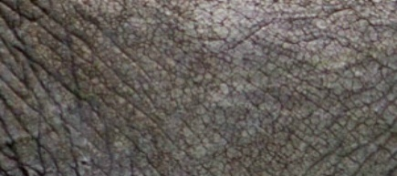  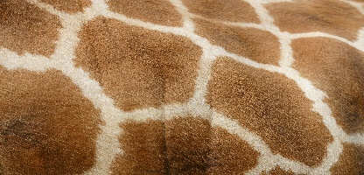  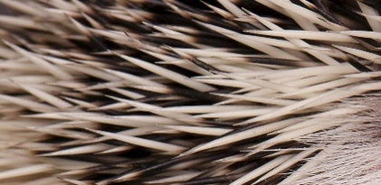  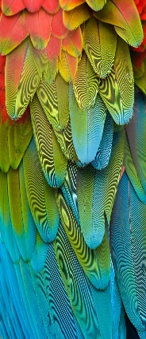  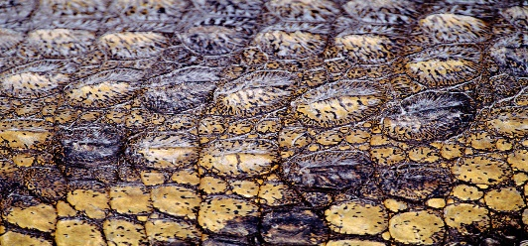 | Year 4 Revision  BBC Bitesize daily lessons for Year 4  https://www.bbc.co.uk/ bitesize/dailylessons

Key skills to continue practising weekly:
- Times tables (including division facts)
- Reading (This can be anything! Reading your favourite book again, reading magazines, sub-titles on the TV etc.)
- Watch Newsround everyday so you are keeping up-to-date with what is going on in the world.

If you are able to access the internet, try these useful websites:
- Reading: There is an online book of short stories written during lockdown by 100 authors, including Michael Morpurgo. https://issuu.com/bloomsburypublishing/docs/thebookofhopes_interactivepdf/4?ff
- Timestable.co.uk
- Topmarks.co.uk

If you or your child has any further queries regarding their learning projects, please contact admin@hardwick.derby.sch.uk, clearly stating your child’s name and class teacher, and the staff will be in touch to support you and your child.

Thank you and stay safe.

