Year 4 Home Learning
Week Commencing: 22nd June 2020
Year 4 teachers: Mrs Haslam, Mrs Tatla, Mrs Jogela and Miss Annable
Year 4 TAs: Miss Perry and Mrs Smith
Message from staff: Hi Year 4, we hope that you are all well and keeping safe. Even though we are not teaching you, we are thinking about you and working very hard to provide fun activities for you to complete at home. We have enjoyed teaching you over the phone. If you struggle with any of the work, please remember to ask for help when we make our weekly phone call. We hope you are taking some time out of the day to get fresh air and spend time with your family.

Your Home Learning this Week:
Every day (Monday to Friday), make sure you choose a *reading, *writing, *spelling/handwriting, *maths and *theme learning activity. There are also further activities to choose from should you wish to.

Reading Home Learning
Monday | Tuesday | Wednesday |  | Thursday | Friday
Monica the Monitor  Read ‘What is a Robot?’ Using reading skills to help you understand as you go through it. Highlight any words you do not understand and find the meaning of them. | Colin and Carmen the Connectors  Text-to-self.  As you read the text, what are your thoughts?  Have you ever seen a robot? Where did you see it? (on TV, a film, book)  What was the robot’s job? | Quentin the questioner  Write 5 of your own questions to ask a family member. Use the text -What is a Robot? to help you. Ask them to read the text then answer your questions.  1)  2)  3)  4)  5) |  | Monica the Monitor: Question Zap!  On your own, answer the questions on page 4. | Monica the Monitor: Crack it!  With an adult, go through the questions together, highlight where you found your answers in the text.
Easier:  Do as many of the above activities as you can. If you are finding some of the activities challenging, try these as they are a little easier:  - Listen to an adult read the text-What is a Robot?  - Discuss the meaning of words that you do not understand. |  |  | Challenge:  If you feel you need a further challenge, try these:  - Find an example of-commas in a list, apostrophe for possession and adjectives. Underline the examples that you find.
Reading Resource- What is a Robot?
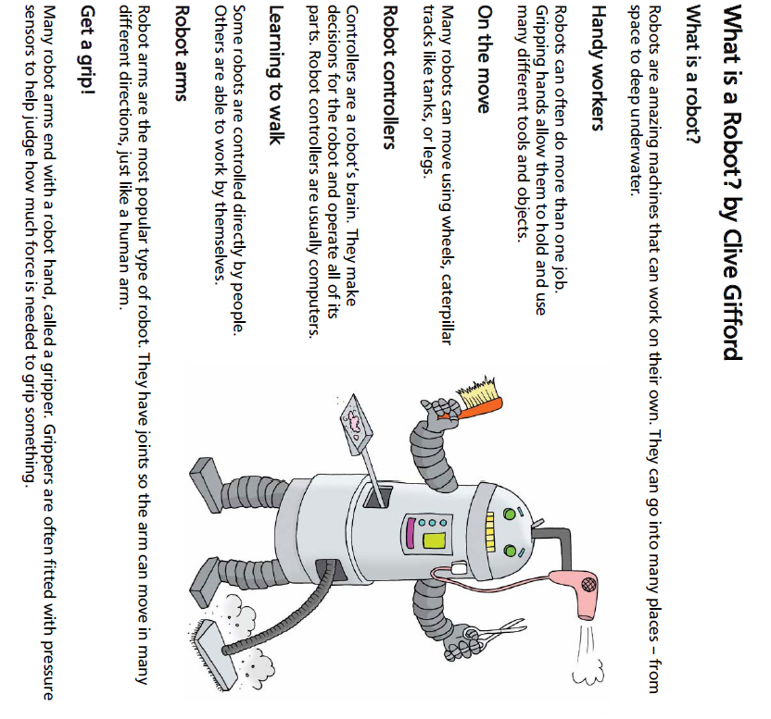
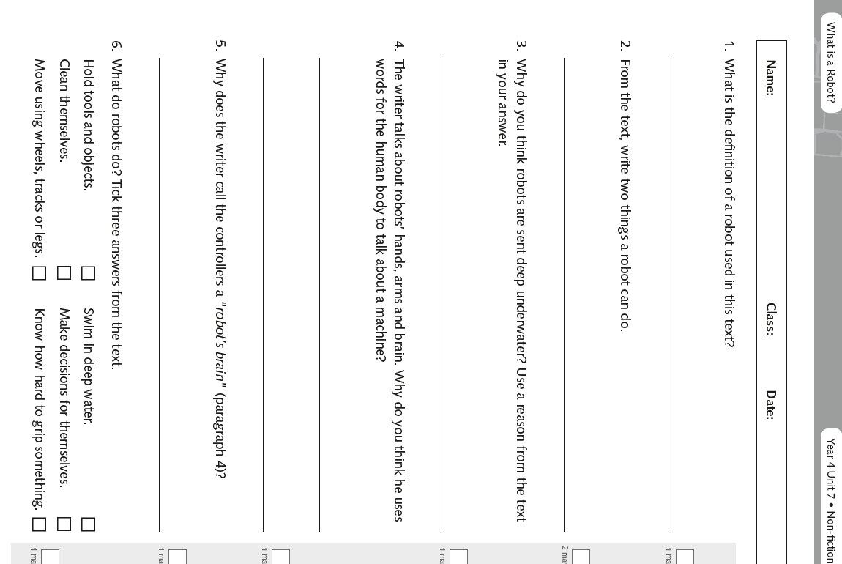

Writing Home Learning – Imaginative Writing
Monday | Tuesday | Wednesday | Thursday  Friday  Now it’s time to write.  Remember to refer to the checklist below to help you.  - Full stops at the end of sentences  - Capital letters for names of people and places  - Variety of conjunctions-and, but, when, because, when, although, even though  - Fronted adverbials-Moments later, In the blink of an eye, All of a sudden, Without thinking,  - Adverbs-slowly, carefully, anxiously  - Correct speech punctuation-  “What’s that shiny object over there?” shouted Zak as he pointed at the trees in the distance.  - Commas in a list
This week you will be writing another short adventure story using the same characters from the story you wrote last week. Try to change different parts of your story so that it is different to the story you wrote last week. Today-discuss your ideas with an adult.  - Two main characters go on an adventure to another world.  - The characters must be aged between 7-11.  - Worlds to choose from-giant world, sweet world, unicorn world etc.  - Think about how the children will be transported to another world-finding a magic key, magic box, a door.. | Use the planner below to help you plan your story. | Practise telling your story to a family member.
Easier:  Do as many of the above activities as you can. If you are finding some of the activities challenging, try these as they are a little easier:  - Use the story planner to help you discuss your story with an adult.  - Have a go at creating a comic strip first before attempting your story. |  |  |  | Challenge:  If you feel you need a further challenge, try these:  Make your story into a book-include a front cover and a blurb for the back.
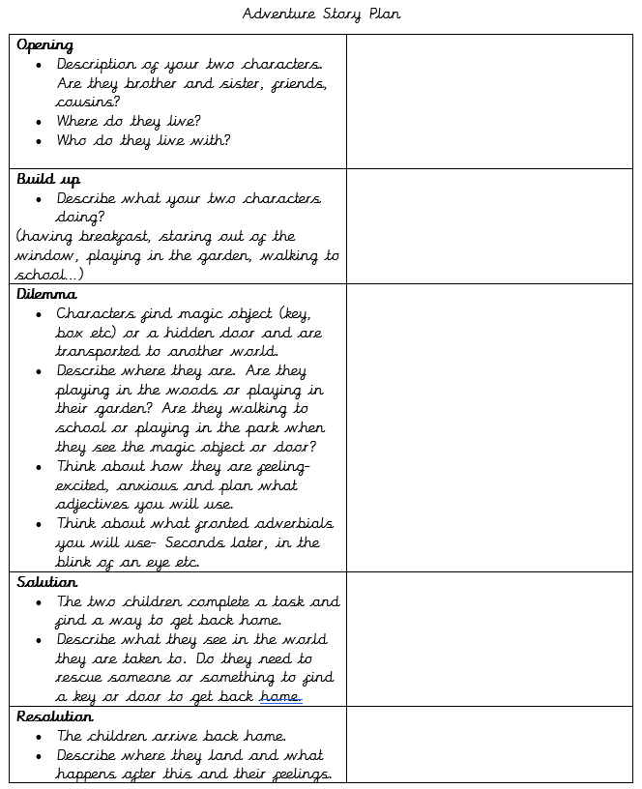Spelling/Handwriting Home Learning
Monday | Tuesday | Wednesday |  | Thursday | Friday
Monday  Choose the next 10 spellings on your list that you struggle with or use the spellings below:  appear early imagine  arrive earth increase  believe eight important  bicycle eighth interest  Spelling Pyramids. | Tuesday  Race how many times you can write each word in 1 minute with a family member. | Wednesday  Write a sentence for each spelling.  Try using different sentence types:  Simple- I was in a car accident.  Compound-I was in a car accident but I wasn’t hurt.  Complex-Although I was in a car accident, I wasn’t hurt. |  | Thursday  Choose a paragraph from your favourite book and write it out using the school handwriting style. Ensure you join letters correctly. | Friday  Spelling quiz!  Ask a family member to test you on your spellings.
Easier: Year 1 and 2 Key Words (Statutory Words)  Do as many of the above activities as you can using the spellings below.  door floor  poor because  find kind  mind behind  climb child  children wild  most only  both |  |  | Challenge:  If you feel you need a further challenge, try these:  - List these words in alphabetical order:  - recommend relevant relevant restaurant rhyme rhythm sacrifice secretary shoulder signature  - Use the words above to practise your handwriting.  - Write a sentence for each of the words above.
Maths Home Learning
Monday | Tuesday | Wednesday | Thursday |  | Friday
Practise your times tables and division facts. Once you know them test your understanding by getting someone to ask you them and see how many you can answer correctly in 1 minute. Then do the same with the division facts. | Area of figures: Lesson 1  Have a go at the guided practice then complete the worksheet. | Area of figures:  Lesson 2  Have a go at the guided practice then complete the worksheet. | Addition:  Write down the following numbers: 0,1,2,3,4,5,6,7,8,9  Cut up your numbers and use them to generate two numbers to add together:  4567+1234=  9876+345=  Aim to complete at least 5 addition questions. |  | Subtraction:  Write down the following numbers: 0,1,2,3,4,5,6,7,8,9  Cut up your numbers and use them to generate two numbers to subtract:  4567-2381=  9876+3452=  Aim to complete at least 5 subtraction questions.
Easier:  Do as many of the above activities as you can. If you are finding some of the activities challenging, try these as they are a little easier:  - Adding:1) 27+35= 2) 26+56= 3)57+24= 4) 28+45=  - Subtracting: 1) 56-49= 2)63-36= 3) 71-49= 4) 100-54=  - Ask an adult to give you some 3 digit addition and subtraction sums, rather than doing the 4 digit ones above. |  |  |  | Challenge:  If you feel you need a further challenge, try these:  - Learn addition and subtraction facts for your 16, 17 and 18 times tables.  - Write down all of the factors for 48  - If a 4 sided shape has a perimeter of 48, what could the length and width measure?  List all the possibilities.

Lesson 1 Work through the In Focus, Let’s Learn and have a go at the guided practice. Then complete worksheet 1.
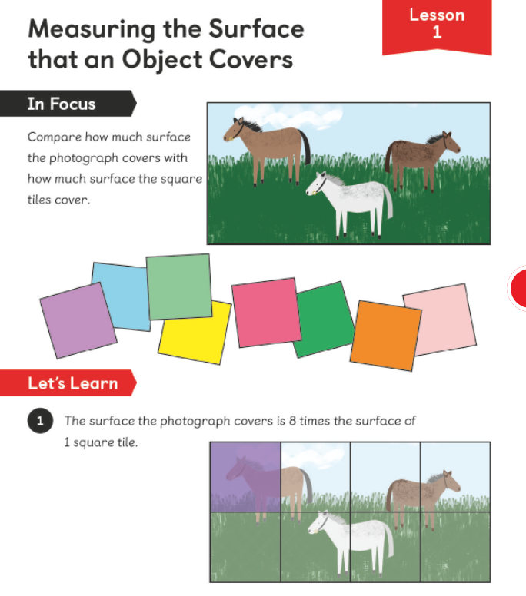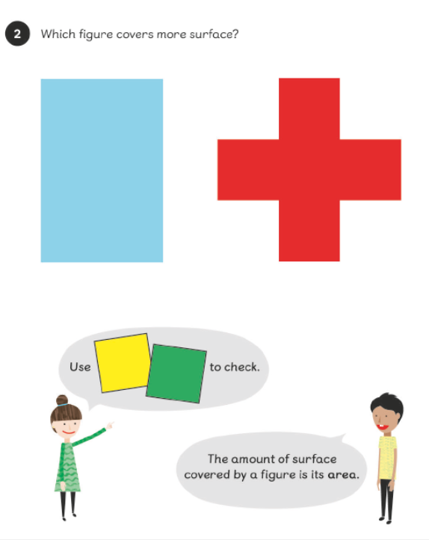
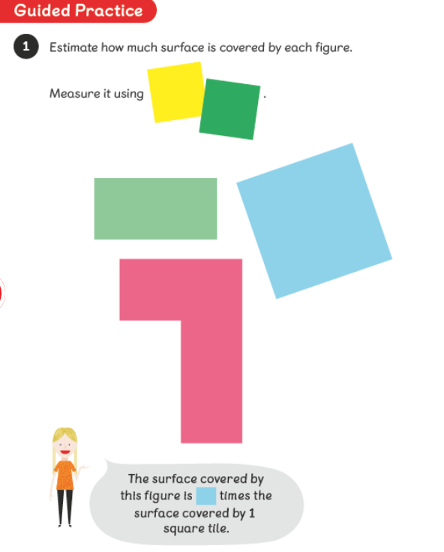

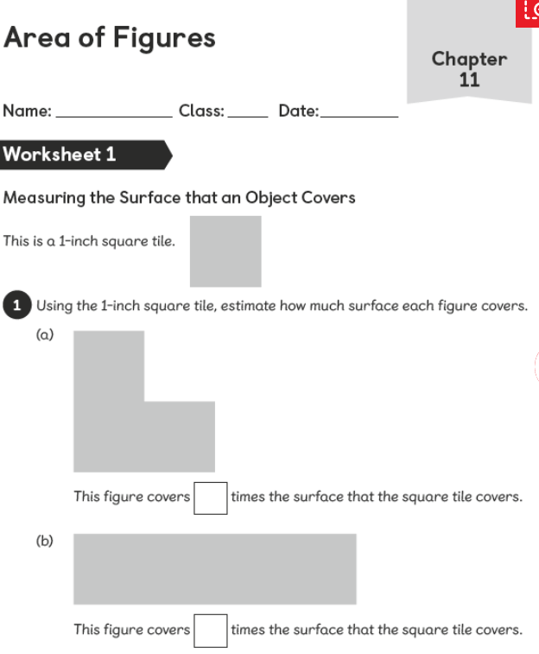
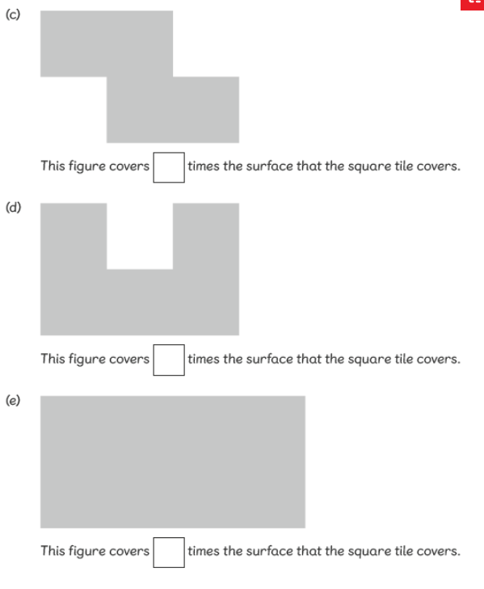
Lesson 2 Work through the In Focus, Let’s Learn and have a go at the guided practice. Then complete worksheet 2.
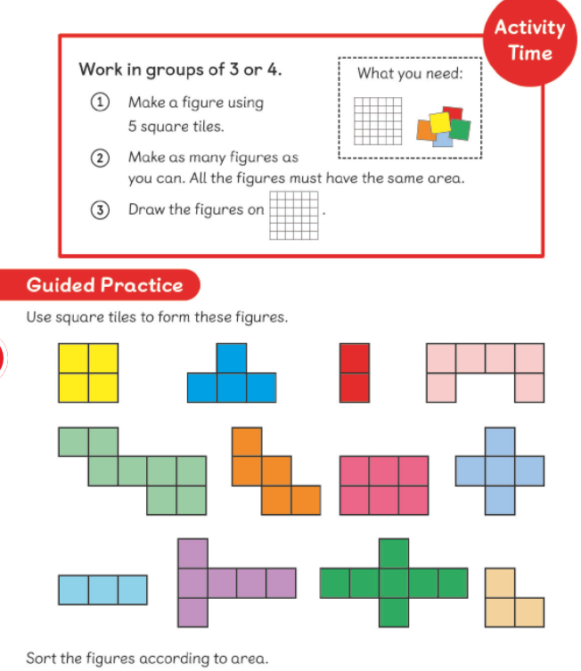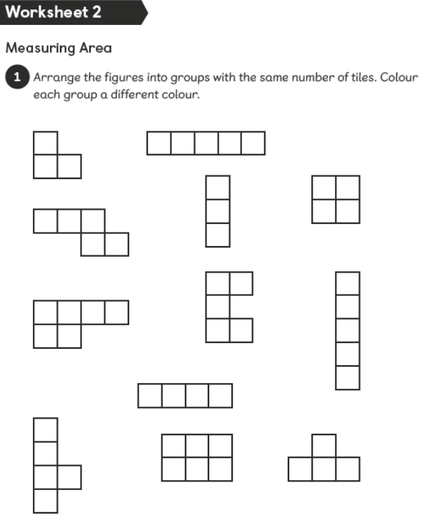

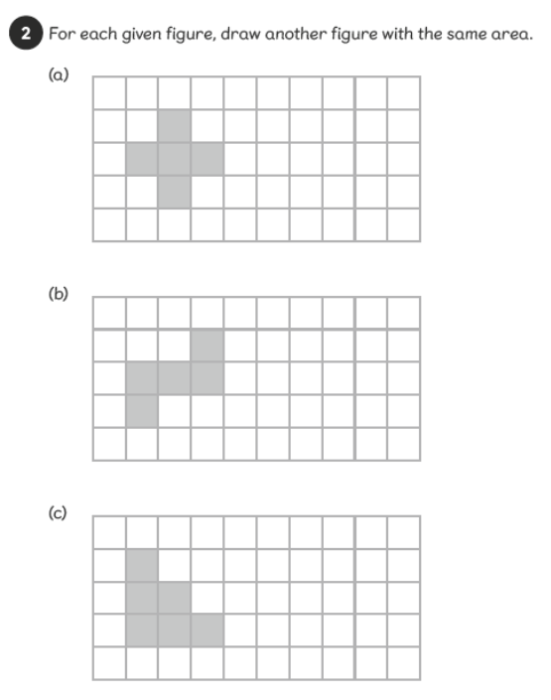

Theme Home Learning
Monday | Tuesday | Wednesday |  | Thursday | Friday
PE-Challenge Yourself  - How many jumping jacks can you do in one minute?  - Is your score increasing each week? | Science-Sound  Challenge:  Use a dictionary or the internet to help you match the following words to their definition.  Amplify, Auditory, Decibels, Echo, Pitch, Sound, Sound waves, Vacuum, Vibrations, Cochlea, Auditory canal, Eardrum, Auditory nerve, Sonar, Soundproof, Volume | History-Vikings  Read the fact sheet about Vikings-fascinating facts. Then design your Viking sword using the worksheet provided. |  | DT- This week, your Reading Text was all about robots.  Now you have the chance to design your own robot.  - Think about what your robot will do? How will it move?  - Will your robot speak?  - Label your robot design and explain how it would work. | PE-Challenge Yourself  Can you beat your time from last week? (Number of jumping jacks in one minute)
Easier:  Do as many of the above activities as you can. If you are finding some of the activities challenging, try these as they are a little easier: |  |  | Challenge:  If you feel you need a further challenge, try these:  PE-How many press ups can you do in one minute?  French  Can you count to 20 in French?  Can you count to 100 in French?
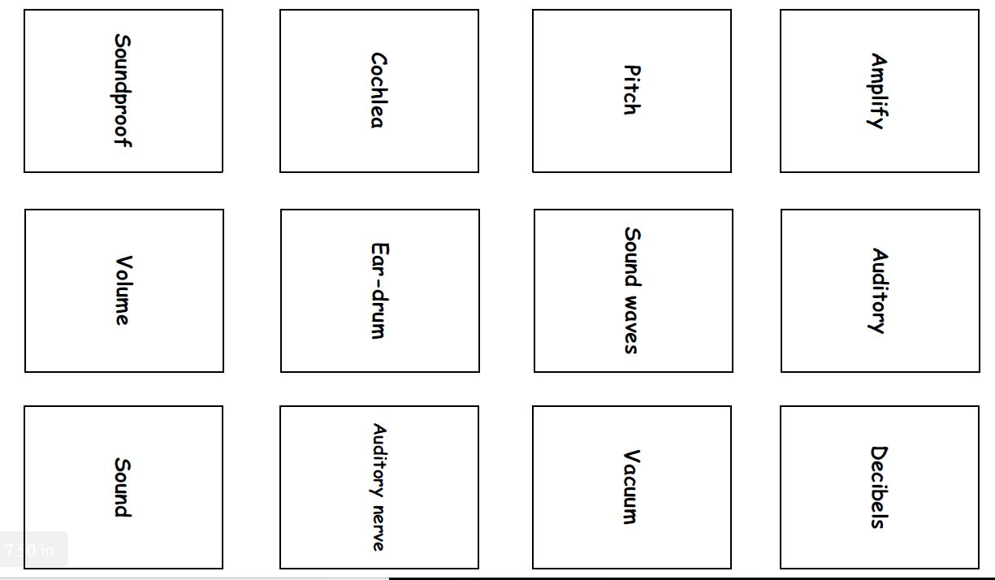
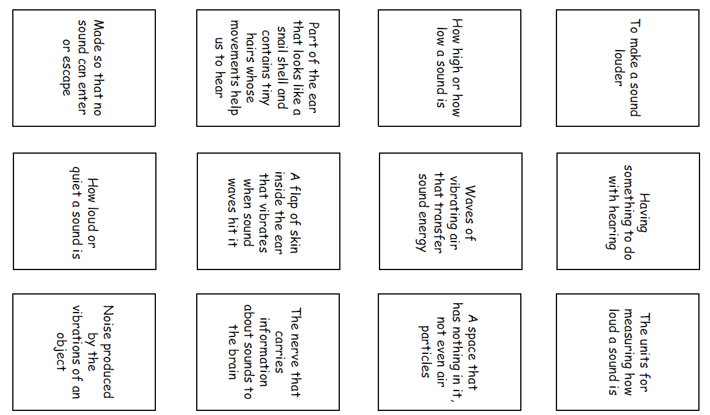

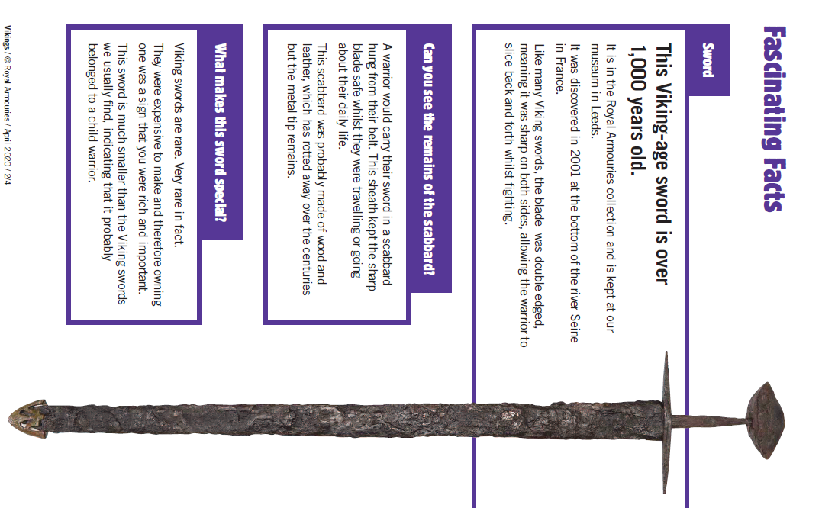

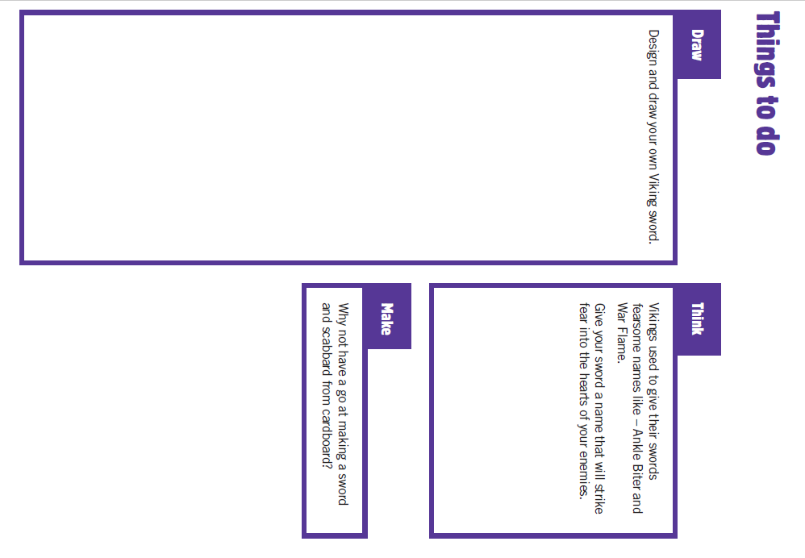
Other Activities
Start your day with Joe Wicks’ YouTube workout for kids live every morning at 9.00.  https://www.youtube.com/results?search_query=joe+wicks | You have 3 minutes to make as many words as you can from the letters below?  e d s t a f I u r w h n I og | Can you design a Maths board game. The questions could be on any of the topics that we have covered so far. | Extra Handwriting Practice  Spend 10 minutes practising your handwriting. | BBC Bitesize daily lessons for Year 4  (See timetable of which lessons are taught each day)  https://www.bbc.co.uk/bitesize/dailylessons
Key skills to continue practising weekly:
- Times tables (including division facts)
- Reading (This can be anything! Reading your favourite book again, reading magazines, sub-titles on the TV etc.)
- Watch Newsround everyday so you are keeping up-to-date with what is going on in the world.
If you are able to access the internet, try these useful websites:
- Reading: There is an online book of short stories written during lockdown by 100 authors, including Michael Morpurgo.
https://issuu.com/bloomsburypublishing/docs/thebookofhopes_interactivepdf/4?ff
- Timestable.co.uk
- Topmarks.co.uk
If you or your child has any further queries regarding their learning projects, please contact admin@hardwick.derby.sch.uk, clearly stating your child’s name and class teacher, and the staff will be in touch to support you and your child.
Thank you and stay safe.

