Theme
Top Group
WALT write a biography for a year 6 child to read.

See a good example of a Biography

Information about Charles Darwin
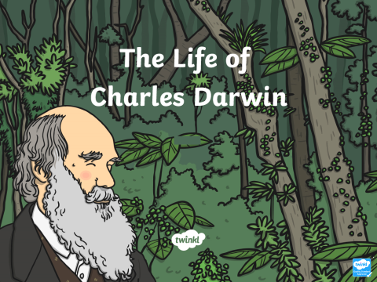
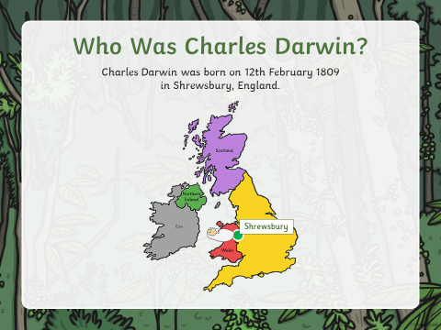
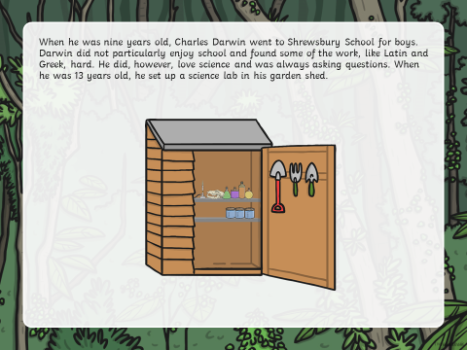

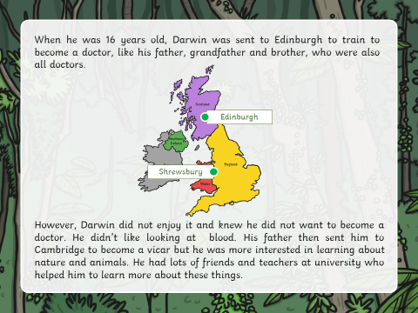
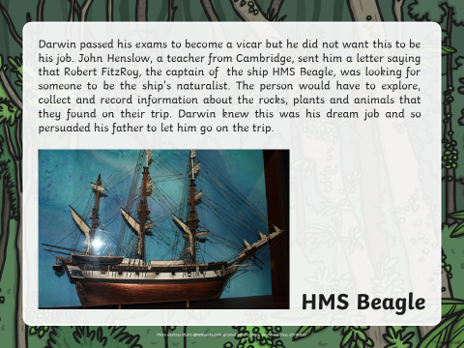
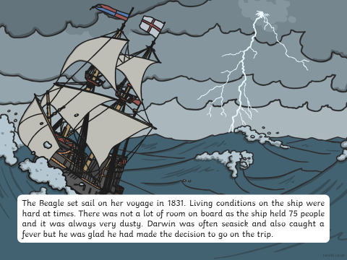

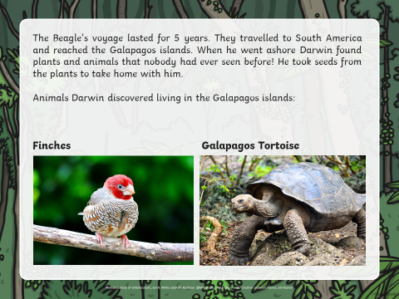
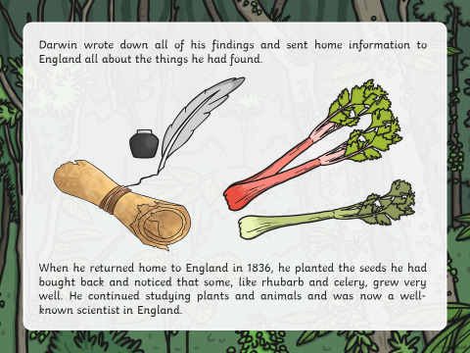
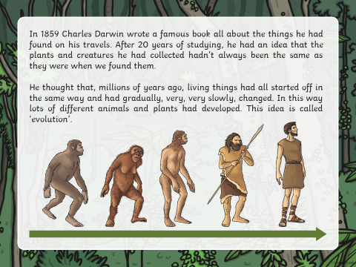

Evolution and Adaptation
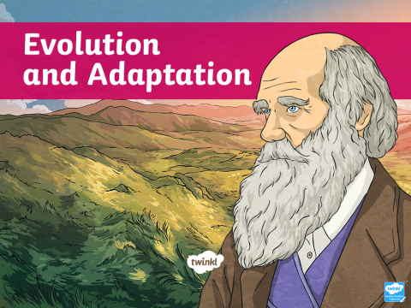 | 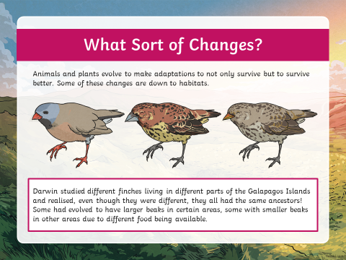
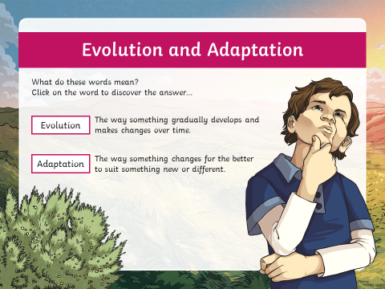 | 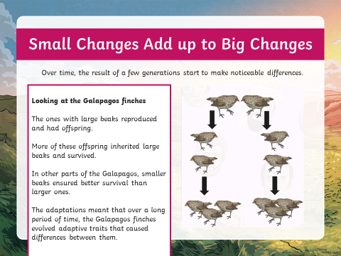
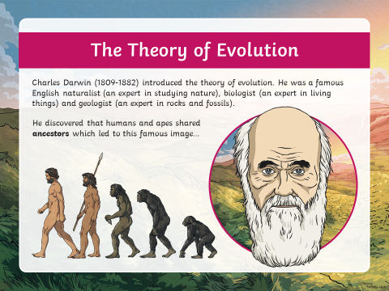 | 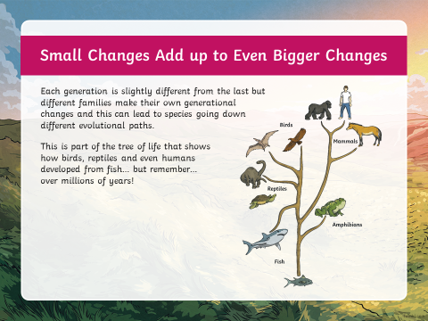
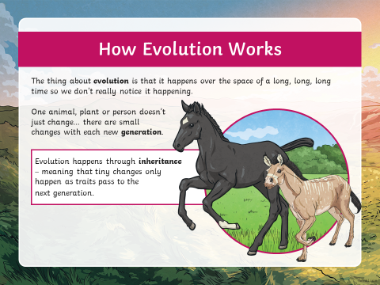

The giant fossil mammals that inspired Charles Darwin's theory of evolution
By Katie Pavid
First published 9 April 2018
In the 1830s, a young Charles Darwin made a series of discoveries in South America: the mysterious remains of extinct mammals.They were to revolutionise his worldview, impacting the naturalist's understanding of extinction, and helping to persuade him of the reality of evolution.
His discoveries included four different species of giant ground sloth (some of the largest land mammals ever to have lived), a gomphothere and the remains of an extinct horse.
Many of Darwin's fossils survive, at the Museum and elsewhere. Interdisciplinary teams at the Museum are now digitising these specimens to allow scientists across the world to study them in greater detail.
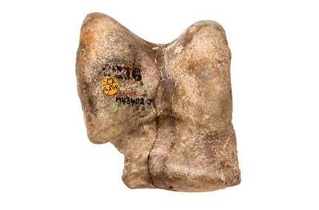
This bone belonged to Macrauchenia, a three-toed South American ungulate that lived during the last ice age

Research Leader Adrian Lister has written about the specimens in his new book, Darwin's Fossils.
He says, 'It is little recognised that fossil-hunting was one of Darwin's main pursuits while on the Beagle voyage.
'The fossil mammals from South America, collected years before he arrived in the Galápagos Islands, were a key factor in his acceptance of evolution. We are fortunate indeed that many of these specimens, of huge importance to the history of science, survive at the Natural History Museum'.

The voyage of the Beagle
Darwin found these fossils during his five-year voyage on HMS Beagle, which sailed around the world between 1831 and 1836.
Captained by Robert Fitzroy, the voyage sailed from England to complete a survey of the coasts of South America.
Darwin was employed as a naturalist, and although most of the expedition was spent at sea, Darwin made many excursions on land, collecting specimens and observing the continent's plants and animals. These collections and records provided the material that helped develop his thinking around geology, extinction and evolution.
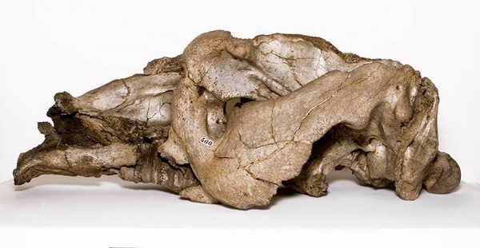
The skull of Toxodon, an extinct South American mammal, discovered by Charles Darwin

The remaining collection of Darwin's South American mammal fossils includes about 100 bones and fragments. They are between 10,000 and 500,000 years old.
One of the strangest is the skull of Toxodon platensis, which belonged to an extinct, giant species of mammal first discovered by Darwin in present-day Uruguay.
The skull was nearly the size of an elephant's. Darwin bought it for a shilling and sixpence, about £7.50 today. Later it was discovered that some giant, rodent-like teeth that had puzzled Darwin belonged to the same creature. He was thrilled at the idea of this 'rhinoceros-sized rodent' and regarded it as one of the most valuable finds of his voyage.
The skull became the type of a new genus and species. We now know that Toxodon platensis is not related to rodents. Instead, it is a member of a group of extinct South American hoofed animals called notoungulates.
Today it ranks among the Museum’s most treasured specimens.
Digitising this collection will mean that more scientists can have access to this material. It also enables us to digitally reconstruct fragments of bone. Digitisation may enable scientists to apply new research techniques, undreamt of by Darwin, to his material.
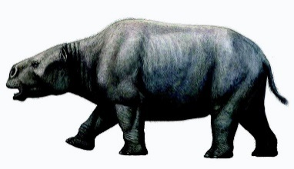
An artist's impression of how Toxodon might have looked. Image by Mauricio Antón.

For instance, carefully managed destructive sampling can now be considered, in order to extract DNA from the fossils. This kind of destructive work could never be considered if a digital surrogate did not exist.
Pip Brewer, Senior Curator of Fossil Mammals, will be leading the digitisation.
She says, 'These specimens are extremely valuable and some are very fragile. There is regular demand to view them by visitors to the collection, due to their incredible historical and scientific significance.
'It is therefore a priority for the Museum to fully document, conserve and produce 3D digital surrogates of these important specimens in order to support their long-term preservation, public engagement and scientific use.'

Learn the definitions below
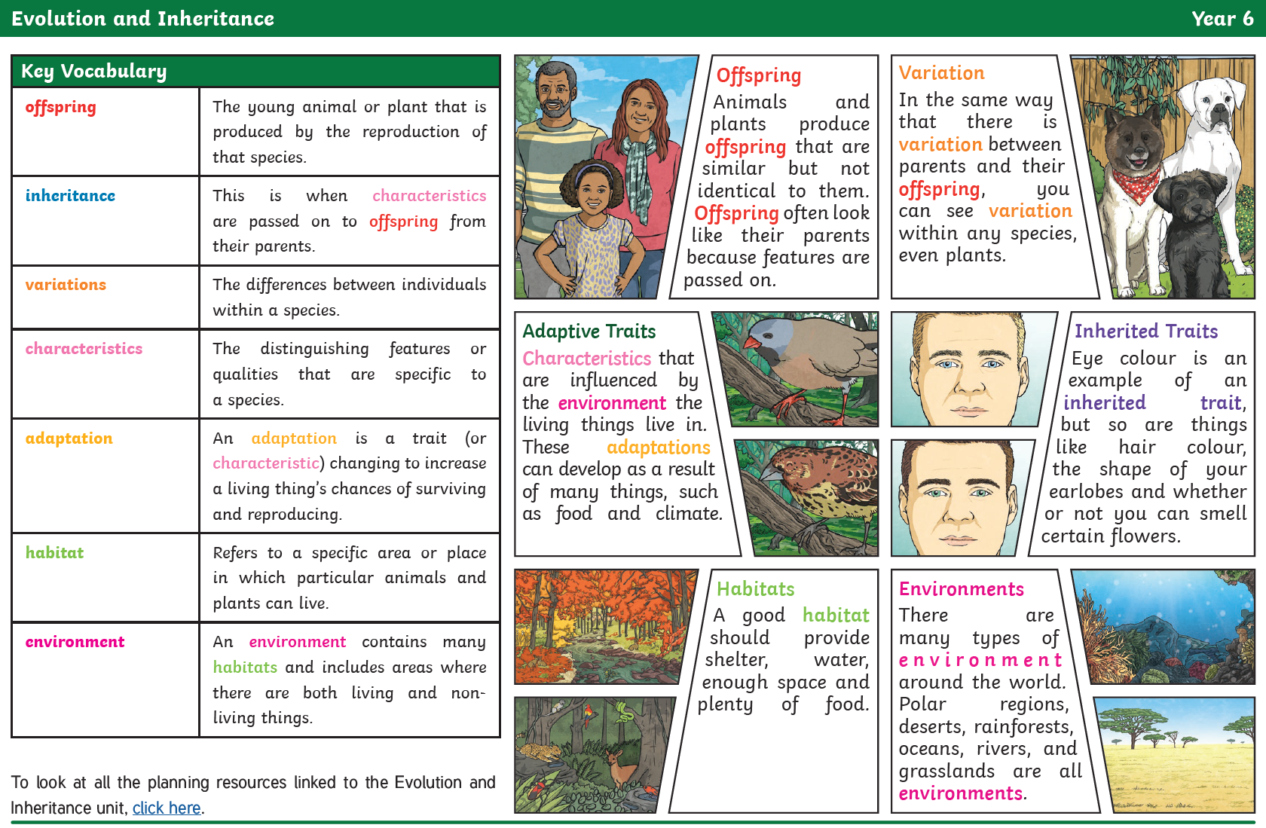
Learn the features of Biography so that you know what to include when you write your own.
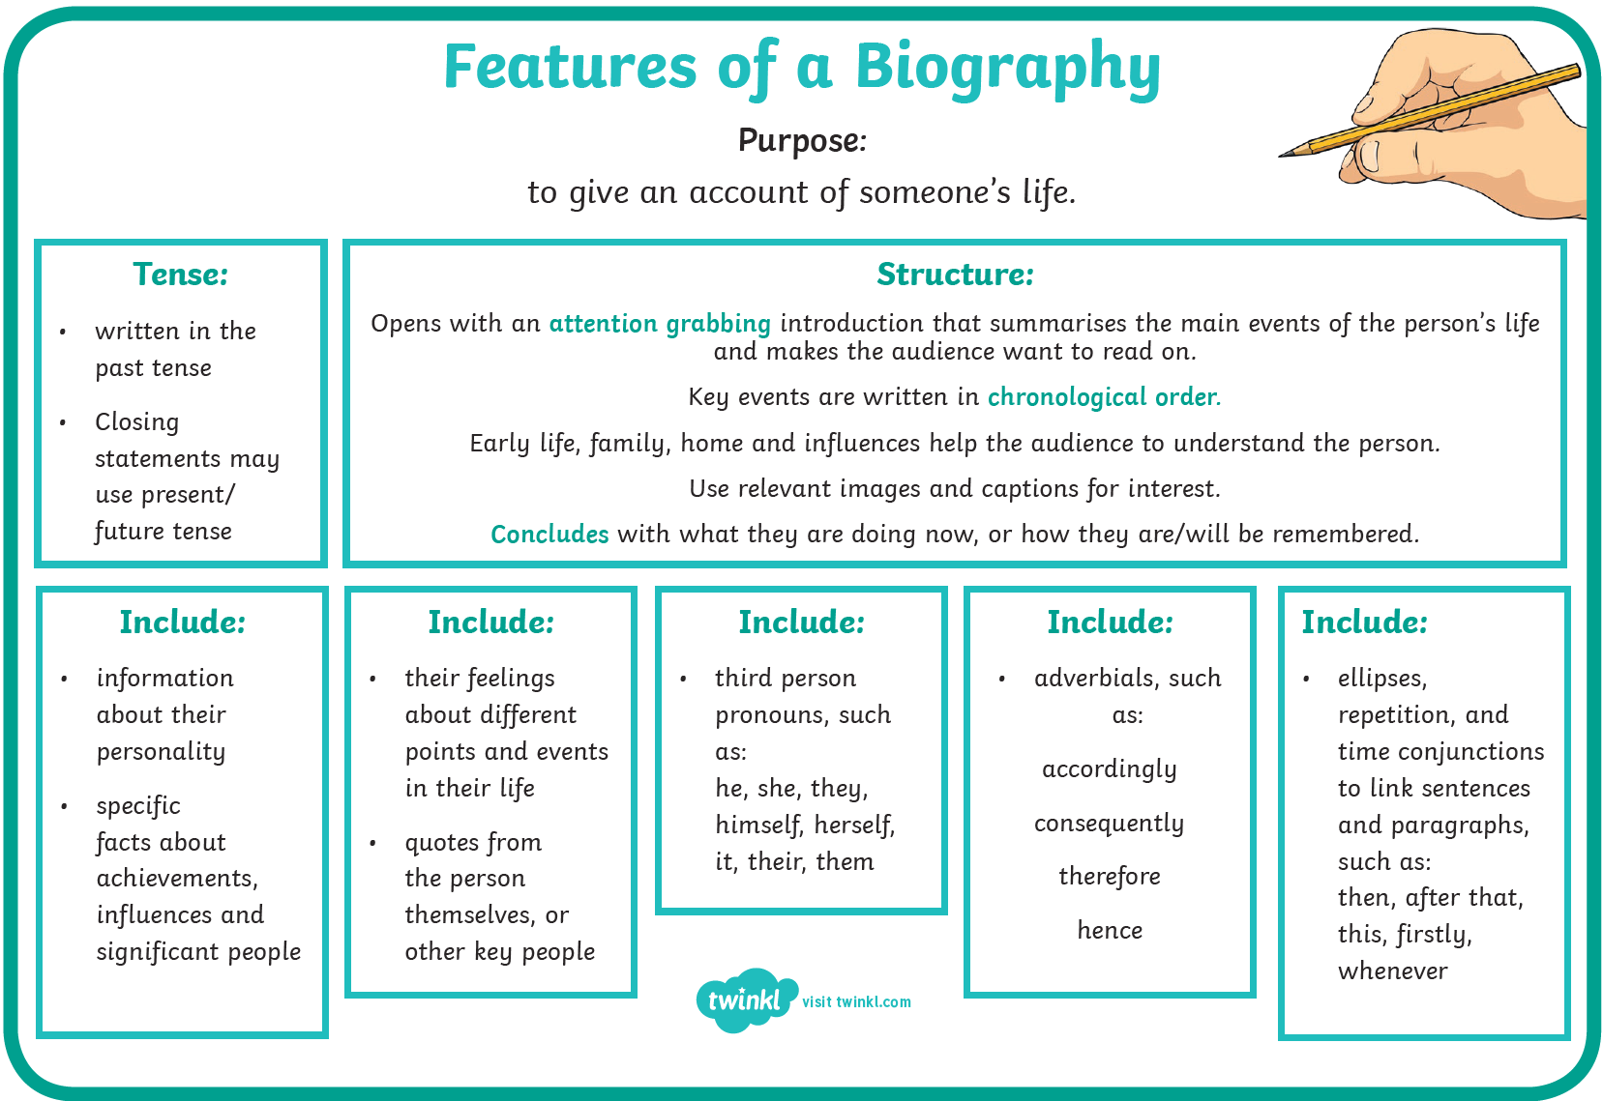

Task
Write an introduction based on who Charles Darwin was. Make sure you include his date of birth.
Write a separate paragraph and include what inspired him with his work which he contributed to Science. Include his family life.
Tips:
-don’t forget to include key dates
-use paragraphs
-record main events
- don’t forget to include pictures which explain the paragraphs you have written.

Then, write further paragraphs which include dates and further work by Charles Darwin.
Edit your biography by using a dictionary/support from an adult at home.
Remember, use the checklist for a biography.

When you write a biography, check you are including the following features listed below in the checklist.

Odd one out
The image below shows models of four mammals:
- Rhinoceros
- Whale
- Elephant
- Hippopotamus
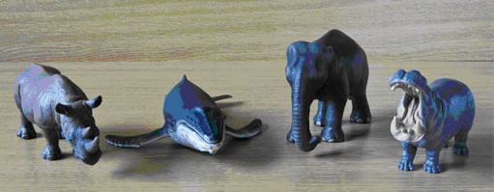
Figure 1
Which of these four do you think is the ‘odd one out’? Why?

Create a fact file booklet on animal adaptation. Base the booklet on the animals of your choice. Choose up to 15 different animals.

Poster
Create a poster based on Charles Darwin discoveries/his contribution to science and the dates.

