Year 2 Home Learning
Week Commencing: 18th May 2020
Year 2 teachers: Mrs Nicholson and Mrs Tomordy
Year 2 TAs: Mrs Rowland and Ms Shaista
Message from staff:
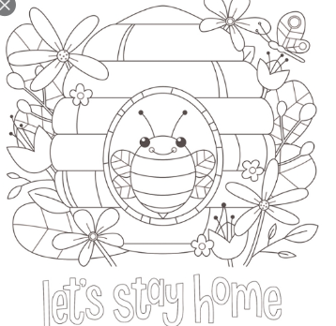
Hello everyone and hope you are all well and enjoying having a go at the learning we are providing for you. We have enjoyed talking to more of you this week and hearing about all the different things, you have been doing at home with your families. Of course, we are all missing you but we are very pleased to know that you are all safe and well. Mrs Tomordy is trying to get out walking every day so that she gets some fresh air but she is disappointed in her runner bean seeds as they still have not decided to pop up to say hello. Maybe this week? Do any of you have your plants growing yet? We are all very busy doing many jobs on our computers and getting things ready for when you can all come back to school. Keep trying hard with these jobs and of course keep reading.

Your Home Learning this Week:
Every day (Monday to Friday), make sure you choose a *reading, *writing, *spelling/handwriting, *maths and *theme learning activity. There are also further activities to choose from should you wish to.
Reading Home Learning
Monday | Tuesday | Wednesday |  | Thursday | Friday
You will be reading a text about the butterfly life cycle. Make connections with what you already know about butterflies. How does a caterpillar become a butterfly? Are there any interesting facts you know? Have you heard anything on the television or in books about butterflies and their life cycle? Ask the people you live with if they know anything.  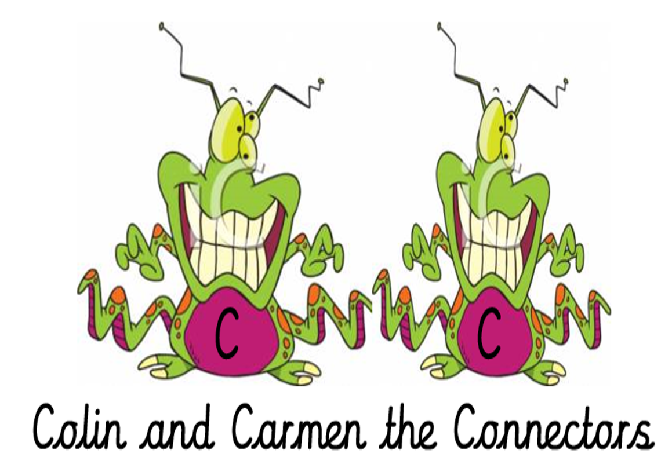 | Read ‘Butterfly Life Cycle’, using reading skills to help you understand as you go through it. Highlight any words you do not understand and find the meaning of them.  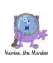 | Summarise what you have read in the text. A summary covers the very important parts of the text (VIP). Which parts in the text do you think are important?  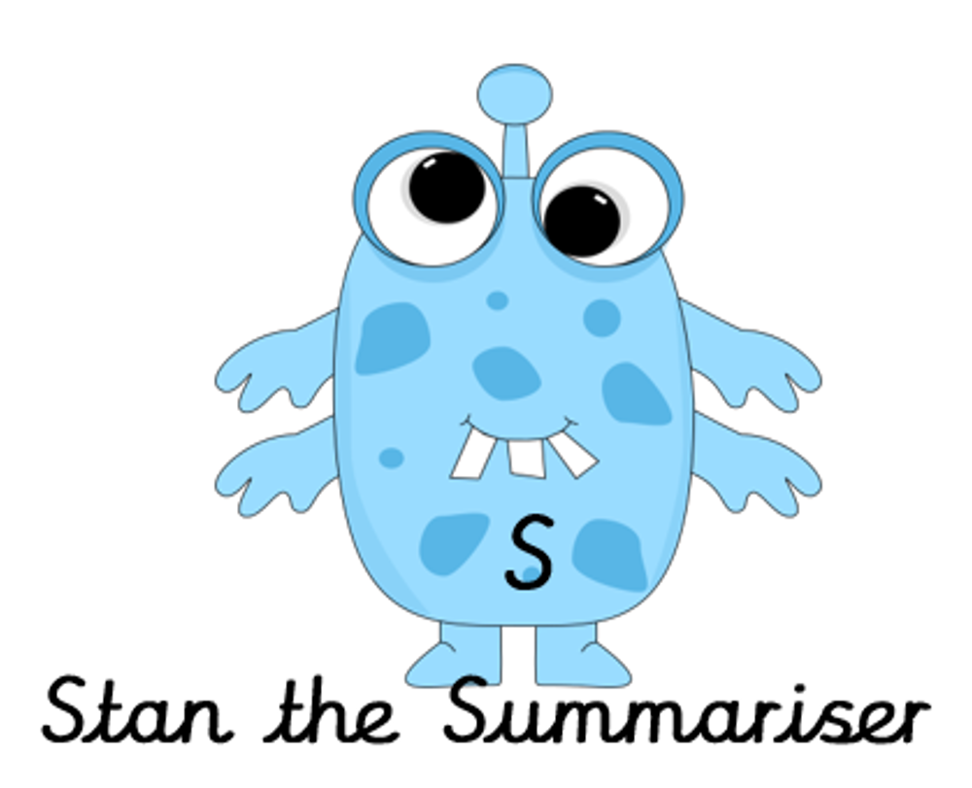 |  | Now try answering these questions:  - How many stages are there in a butterfly’s life cycle?  - What hatches in the second stage?  - What happens to the caterpillar’s skin?  - What colour is the chrysalis (pupa)?  - What does it grow during the pupa stage, before it becomes a butterfly?  - How long does it take the butterfly to learn to fly? | After reading the text on ‘Butterfly Life Cycle’, think of any questions you may have. Is there anything you were left wondering that was not answered? Write these questions down. Reread the text again and this time, try to answer the questions you have. Can you answer them? If not, try to research the answers or, save the questions for when we come back to school so you can research at school.  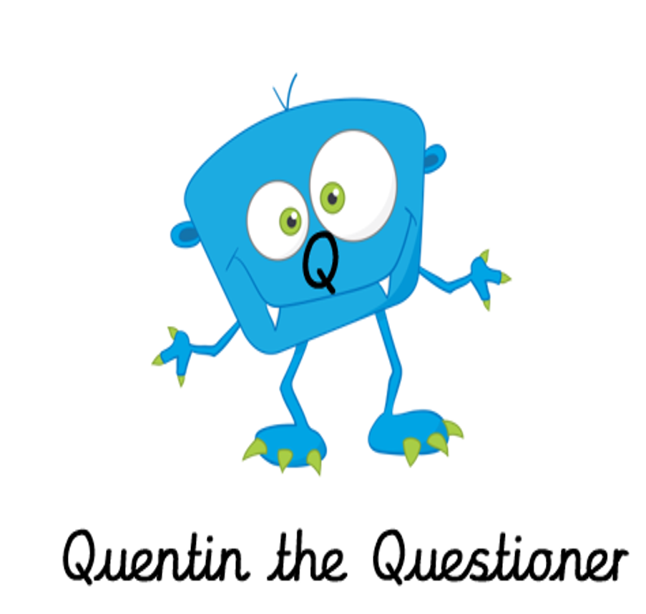
Easier:  Do as many of the above activities as you can. If you are finding some of the activities challenging, try these as they are a little easier:  - Read the text ‘Bats’, using reading skills to help you understand as you go through it. Highlight any words you do not understand and find the meaning of them.  - What type of text is this and how do you know? What do you notice about how it is set out? Have you seen anything like this before?  - Now try to answer these questions:  - How many different types of bats are there in the world?  - What do bats do in the day?  - How old can bats live to?  - Why do bats sleep upside down?  - Where do bats live?  - What do bats in the UK eat? |  |  | Challenge:  If you feel you need a further challenge, try these:  - Test yourself! On a blank piece of paper, write down everything you know about the butterfly life cycle.  - Using ‘Butterfly Life Cycle’ text, create your own information sheet, adding any of your facts you know about it too.  - Predict which section you may find the following information in ‘Butterfly Life Cycle’ text if it were to be written:  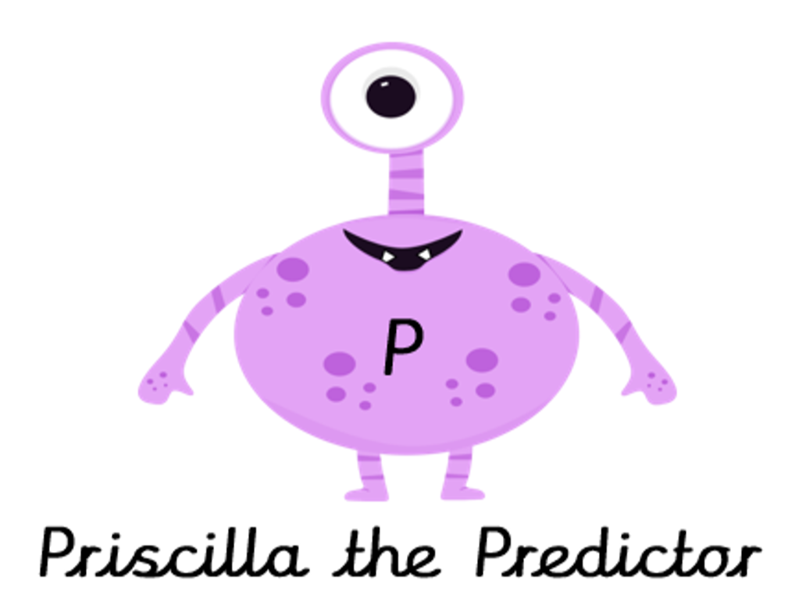  -During the transformation stage, the butterfly wings are formed.  -The adult butterfly migrates and moves to a new habitat.  -The caterpillar might lay eggs on a leaf, stem or other object.

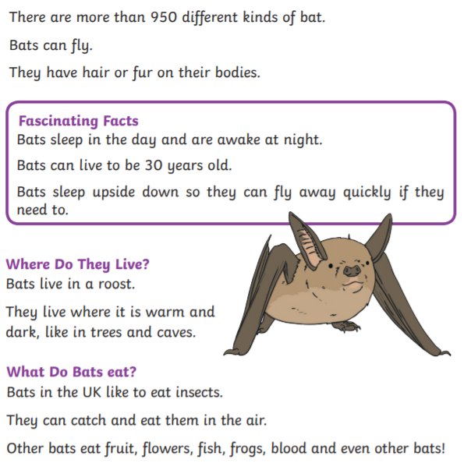
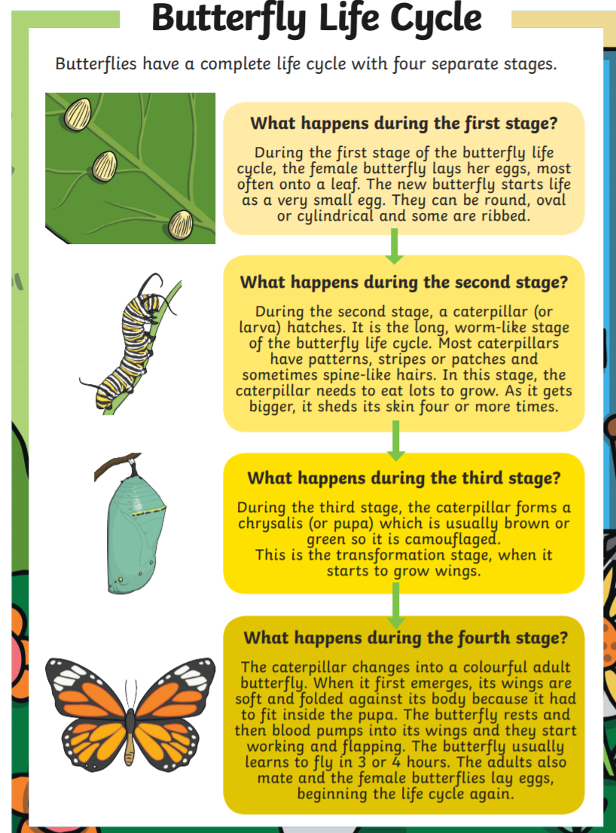
Writing Home Learning
 | Monday |  | Tuesday |  | Wednesday |  |  | Thursday |  | Friday
 | Using the pictures below, tell the story of the Hungry Caterpillar.  Draw a text map to help you. |  | Can you write a description of Cody the caterpillar? What does he look like? What does he do in his garden? Is he kind? Can you describe his home? |  | Cody the caterpillar has lots of friends. Can you describe his friends? What are their names? Where do they live? What does Cody do with his friends? |  |  | Tell a story all about Cody the caterpillar and his friends. Draw a text map to remember your story.  One day, Cody and his friends were sitting on the grass… |  | Write the story that you told yesterday.  Draw an illustration for your story.
 | Easier:  Do as many of the above activities as you can. If you are finding some of the activities challenging, try these as they are a little easier:  - How many different things can you see in the garden? Try writing them down using your sounds.  - Draw a picture for these words, and practise writing them:  egg  leaf  moon  plum  bee  sun  cake |  |  |  |  |  | Challenge:  If you feel you need a further challenge, try these:  Task 1  Add some speech to your story… “Where are you going?” asked Cody.  Task 2  Add some noun phrases to your story:  The sunny garden;  The cool stream;  The Waving grass.
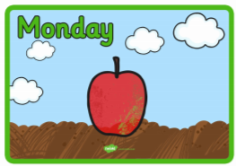 |  | 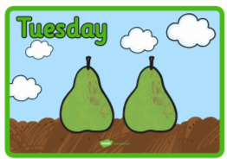 |  | 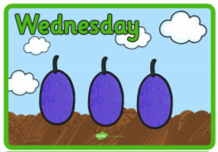 |  | 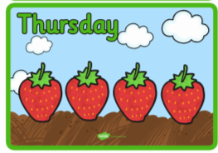 |  |  | 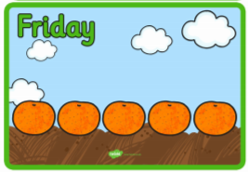 |  | 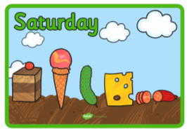

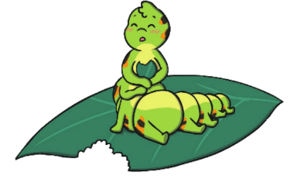
This is Cody the caterpillar This is where Cody lives These are Cody’s friends
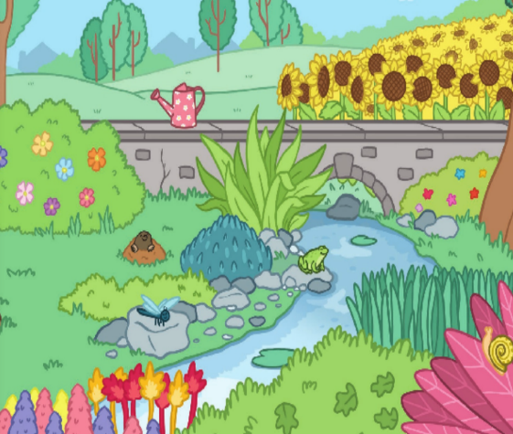
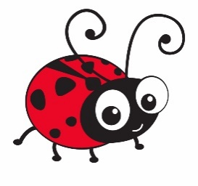

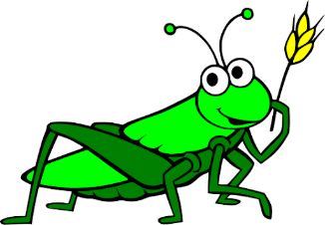
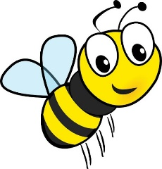

Spelling/Handwriting Home Learning
Monday | Tuesday | Wednesday |  | Thursday | Friday
This week we are going to get confident at writing numbers as words. Let’s start with scribble writing these:  twenty  thirty  forty  fifty  sixty  seventy  eighty  ninety  hundred | Today we are going to practise writing numbers. So write the following as words in rainbow colours and try to do it without looking.  54  89  73  21  47  35 | Now let’s put the numbers from Monday into sentences with the focus being on how we write these out. Make sure the y goes below the line. Try to join all the letters except the r. The ‘we’ is hard but keep trying this join and you will get there. |  | Are you able to spell all of the Year 2 common exception words now? If not try creating a picture with the word. Choose 10 words and try this as a method of remembering the spelling.  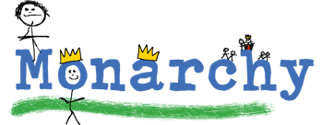 | Have a go at putting boxes around the words you find hard like the example below. If you are not sure which words to try then do could, should, would.  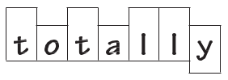
Easier:  Do as many of the above activities as you can. If you are finding some of the activities challenging, try these as they are a little easier:  - Let’s practise ch, sh and th words. Do the following words with rainbow writing – path, bath, shop, ship, shut, chat, chap,  - Now try writing down as many words as you can and put sound buttons on your sounds.  - 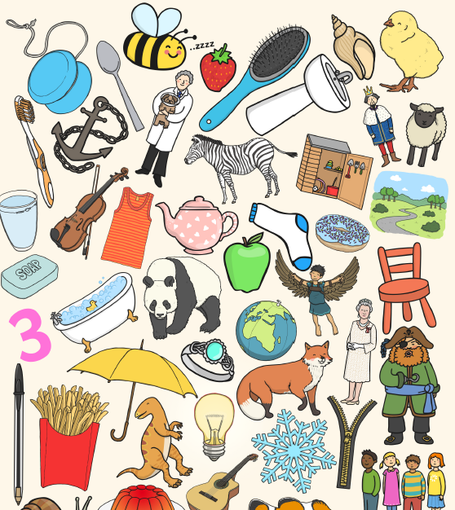 |  |  | Challenge:  If you feel you need a further challenge, try these:  - 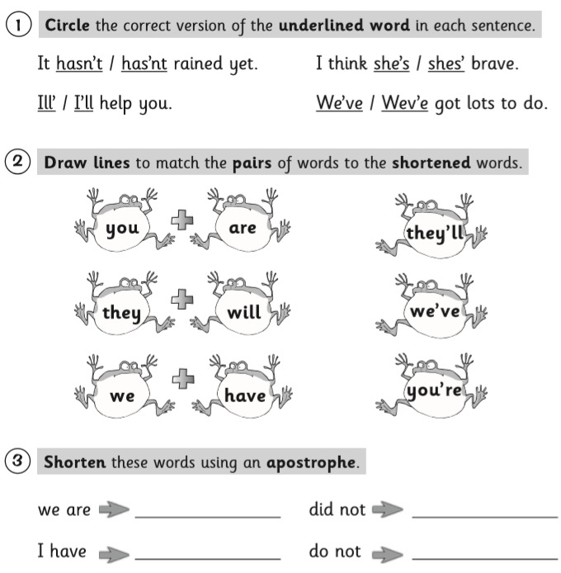
Maths Home Learning
Monday | Tuesday |  | Wednesday
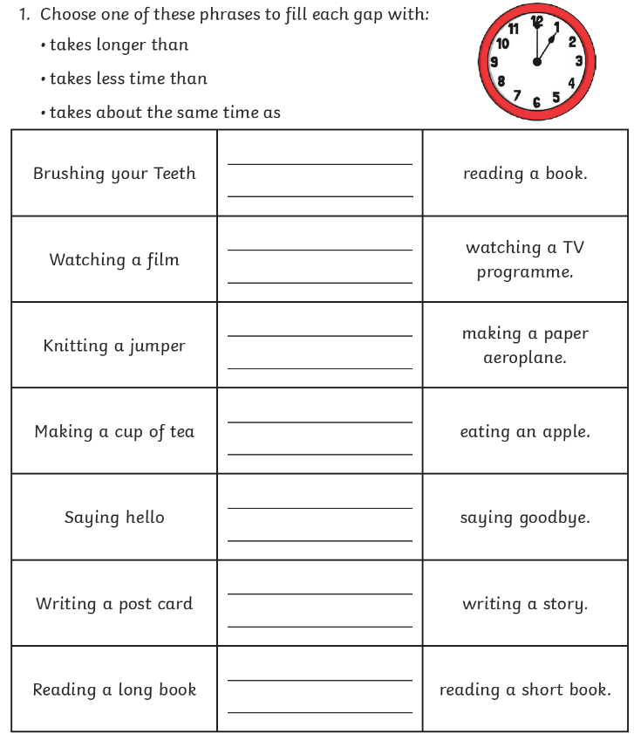 | 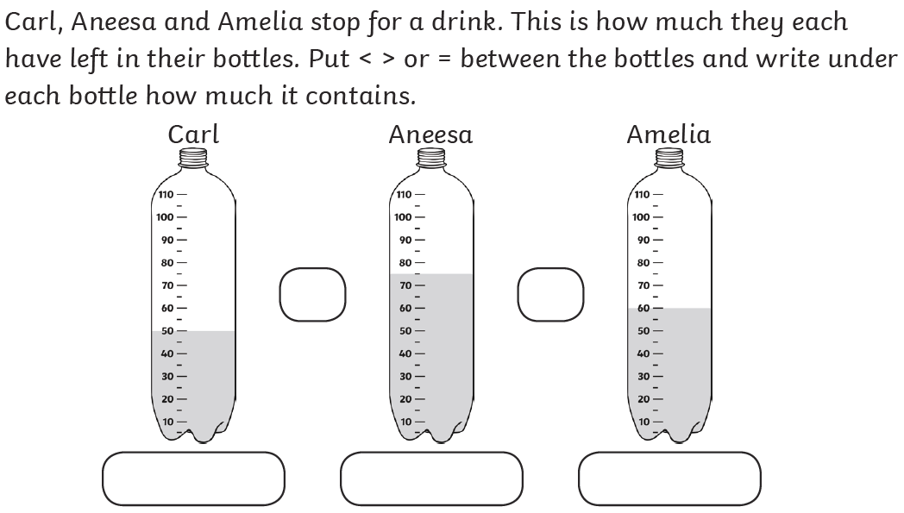 |  | 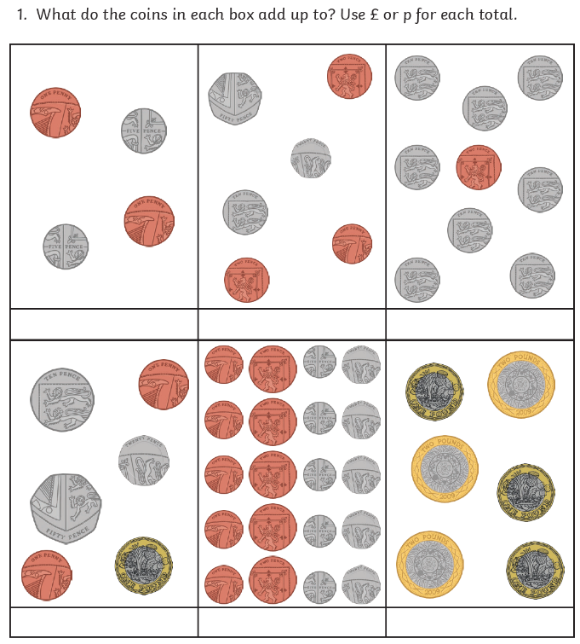
Thursday | Friday
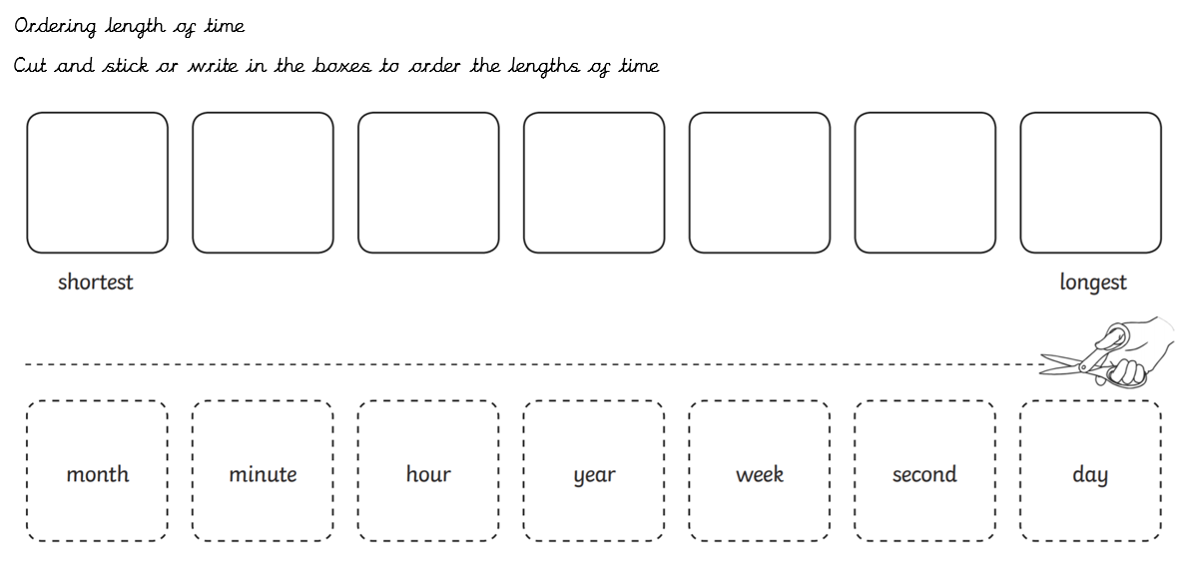 | 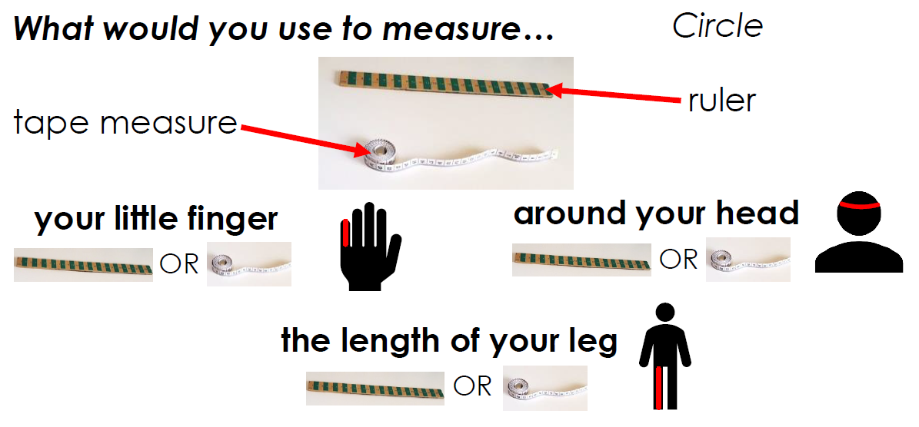
Easier:  Do as many of the above activities as you can. If you are finding some of the activities challenging, try these as they are a little easier:  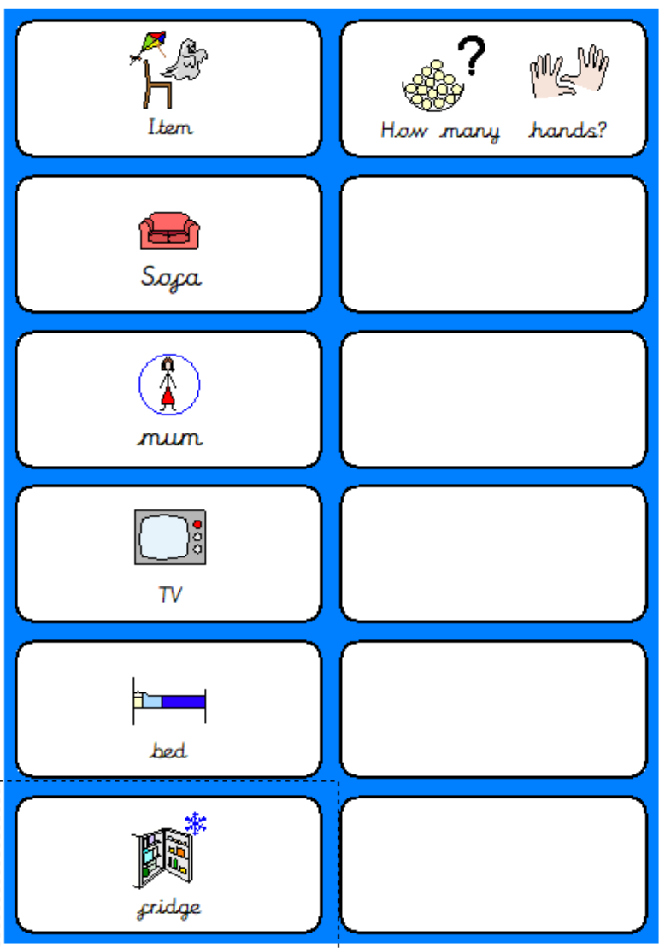  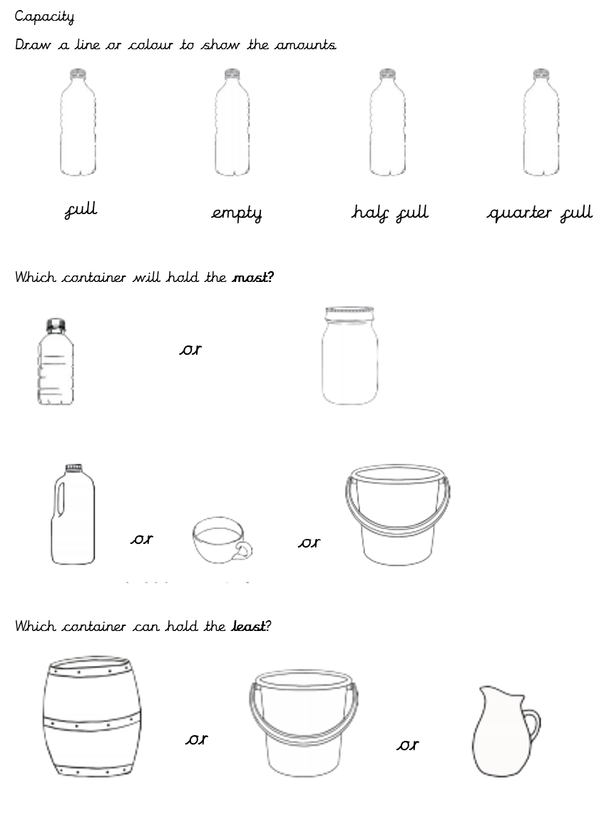 |  | Challenge:  If you feel you need a further challenge, try these:  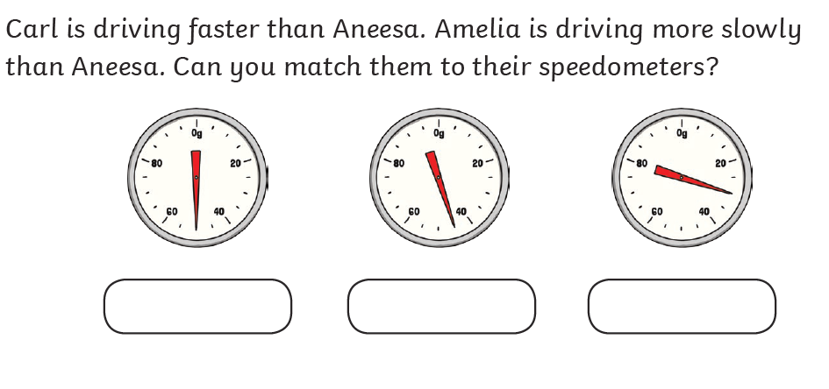  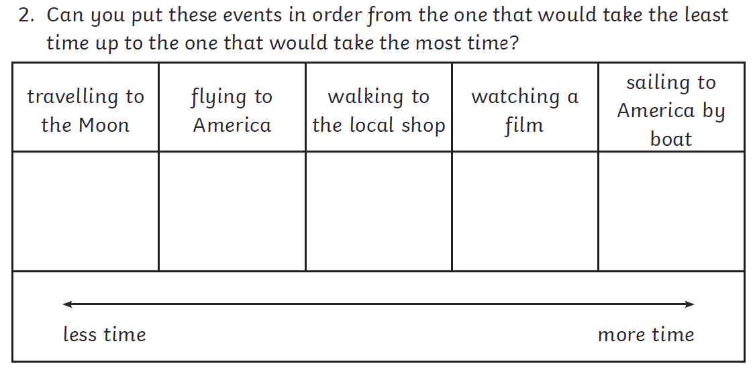  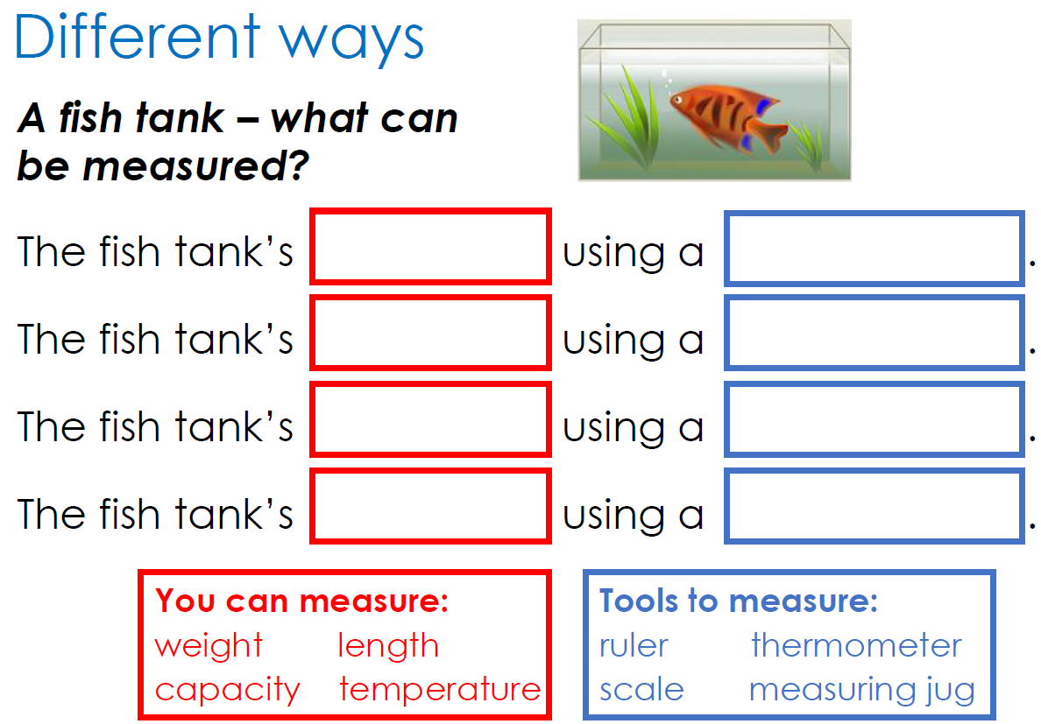

Theme Home Learning
Monday | Tuesday | Wednesday |  | Thursday | Friday
Science  All animals, including humans have offspring (babies). These offspring grow into adults.  Sort out babies to their adults:  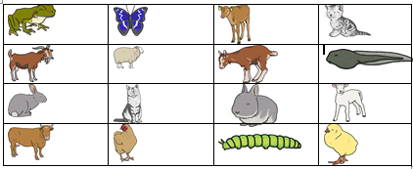 | Science  Write 4 things that animals and humans need to survive.  Draw pictures to show the differences how humans and any other animal meet their needs. | History  In years to come what is happening now will be written in many history books. Create your own account of what has been happening and remember to include what you think people should remember about it all. |  | PSHE  Mindfulness  Lie on your back outside and close your eyes so you can use all your senses except for sight.  Notice the feel of the air, the feel of the ground, the sounds that surround you and any smells that are present. | Art  Design your dream tree house you would like to have in your garden.  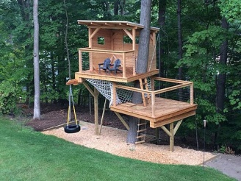
Easier:  Do as many of the above activities as you can. If you are finding some of the activities challenging, try these as they are a little easier:  - Design/decorate a plant pot or a rock for your garden.  - Draw/label a vegetable patch you would like to have in your garden.  - Follow the step by step instructions to draw a rhino  - 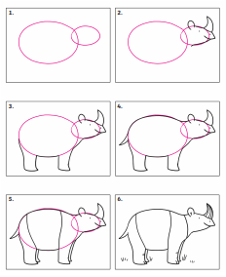 |  |  | Challenge:  If you feel you need a further challenge, try these:  - Design and draw a plan of a landscape garden.  - Draw and label a lifecycle of a frog.  - How many offspring can you think of the jungle animals?

Other Activities
Task 1  Music  Create sea sounds with your voice and body. E.g. Splashing waves, seagulls | Task 2  Science  Create a paper boat. See which paper is best to make one. Which paper boat will stay longer on the water? | Task 3  Science  Try the experiment on the next page with soap. | Task 4  Art  Create a picture of an animal, thing or a person using food such as apples, chips, ketchup, spaghetti on your plate and take a picture.  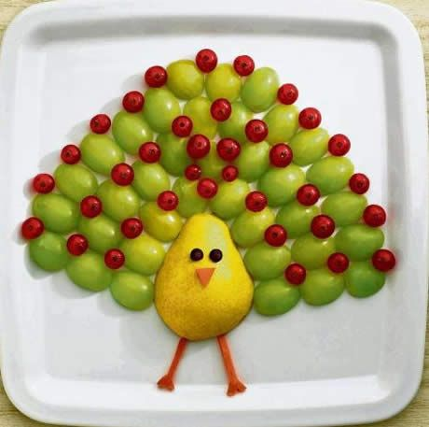  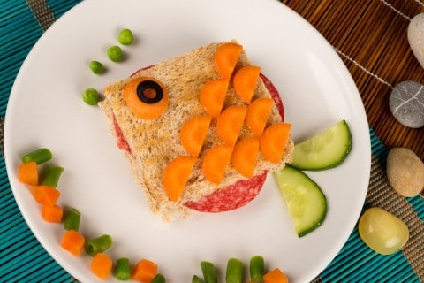 | Task 5  Answer these riddles:  What am I?  - I grow on trees.  I am red.  I am crunchy.  - I have seeds on the outside.  I am eaten in the summer.  I am soft and red.  - I am served in a bun.  I taste good with ketchup and cheese.  I am sometimes served with chips.

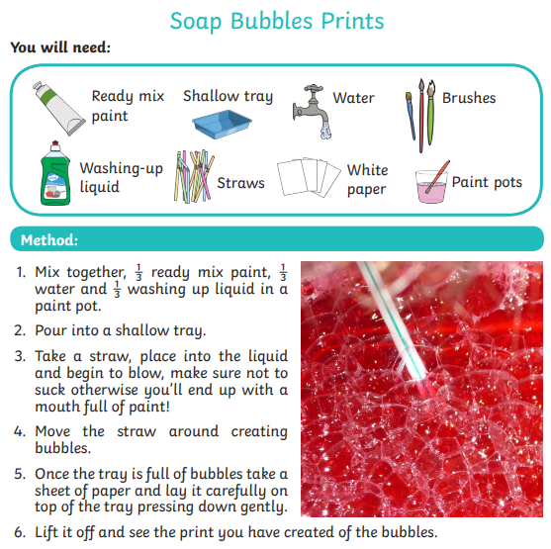

Key skills to continue practicing weekly:
- Times Table Rock Stars – I have checked and not many of you are doing this and it is fun to do plus keeps your skills going. If you have forgotten your log on details, then just email the school.
- Oxford Owl – lots of books to read
- Telling the time throughout the day to the nearest 5 minutes
- Play shops and work out the change
- Common exception words both reading and spelling

If you are able to access the internet, try these useful websites:
- https://www.bbc.co.uk/bitesize/primary
- https://www.bbc.co.uk/bitesize/clips/z4tmhyc
- New lessons are uploaded every day for children to interact with
- https://scratch.mit.edu/
- A chance to have a go at computer programming and create your own games, all completely free.
- Plus remember to check the list of other useful websites which are under home learning on a separate sheet.
- This link will take you to a book all about the coronavirus for children and explains a lot of what is happening in a child friendly way.
- https://nosycrow.com/blog/released-today-free-information-book-explaining-coronavirus-children-illustrated-gruffalo-illustrator-axel-scheffler

If you or your child has any further queries regarding their learning projects, please contact admin@hardwick.derby.sch.uk, clearly stating your child’s name and class teacher, and the staff will be in touch to support you and your child.
This is a short story for you to read or have someone read to you. I hope you like it. 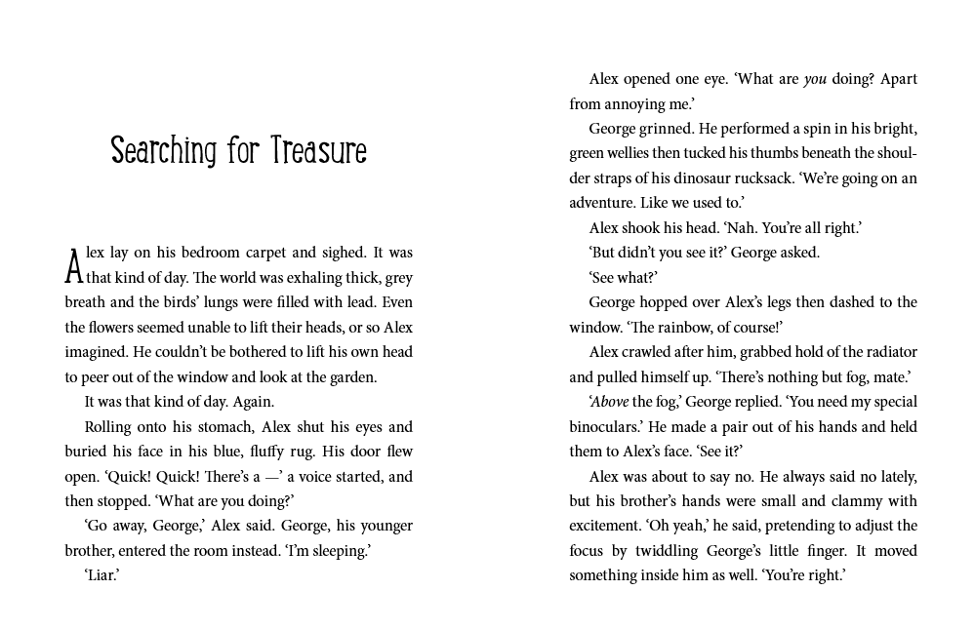
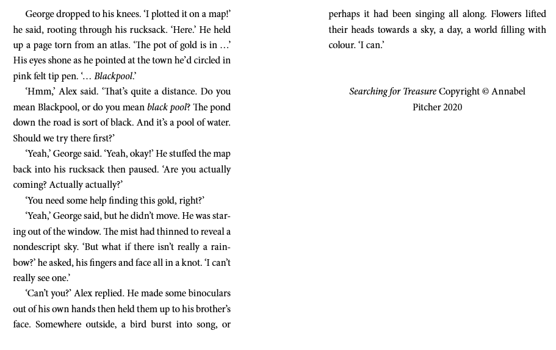 What do you think would happen next? Maybe draw some pictures to tell the story. Thank you and stay safe.

