Year 5 Home Learning
Week Commencing: 29th June 2020
Year 5 staff: (Mrs Nisa, Mr Caldwell and Mrs Hollingworth, Miss Gent, Mrs Begum)

Message from staff:
Hello again Year 5, we hope that you are all well and keeping safe. After the cold, wet weather we have had recently, the sun is shining on us all again. Enjoy going outdoors but make sure you protect yourself by applying sun cream and drink lots of water.
Even though we are not teaching you face to face, we are thinking about you and working very hard to provide fun activities for you to complete at home. We have enjoyed talking to you over the phone. If you struggle with any of the work, please remember to ask for help when we make our weekly phone call.

Your Home Learning this Week:
Every day (Monday to Friday), make sure you choose a *reading, *writing, *spelling/handwriting, *maths and *theme learning activity. There are also further activities to choose from should you wish to.

Reading Home Learning
Monday | Tuesday | Wednesday |  | Thursday | Friday
You will be reading a text about a strange creature called the Scaled Inkdog. Read the text carefully and highlight or underline any word you do not understand. | Re-read the text and find the meaning of the words you do not understand from yesterday. | Using Stan Summariser, summarise the main information about the Scaled Inkdog and do not forget to use your VIP’s (very important parts).  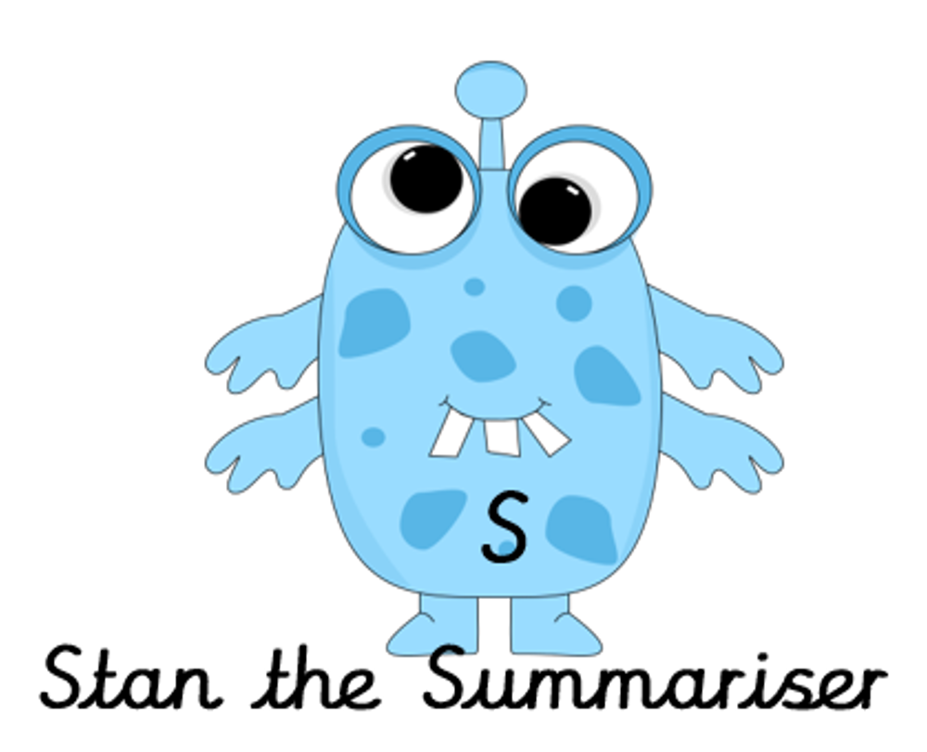 |  | Now try answering these questions:  - Why have humans spent years learning about the Scaled Inkdog?  - What is the purpose of the eyes, paws and skin?  - Why does being nocturnal help the Inkdog?  - Why are they compared to wolves? | After reading the text on British birds think of any questions you may have. Is there anything you were left wondering that was not answered? Write these questions down. Reread the text again and this time, try to answer the questions you have. Can you answer them? If not, try to research the answers
Easier:  Do as many of the above activities as you can. If you are finding some of the activities challenging, try these as they are a little easier:  - Who did Jack live with?  - What animal did Jack and his mother own?  - What did the man offer Jack?  - What word from the story tells us that Jack’s mum was angry?  - Why was she angry? |  |  | Challenge:  If you feel you need a further challenge, try these:  Answer the following questions:  - Write the meaning of the following words:  - devoted  - indicates  - dominated  - elite  - equipping  - What unique qualities do Scaled Inkdogs have that similar species don’t have?  - Record 3 ways the author has organised the information to help the reader.
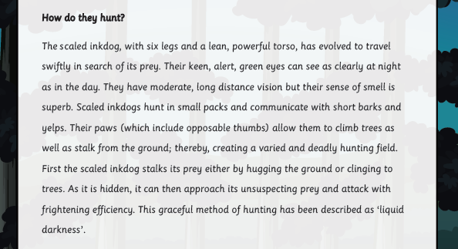
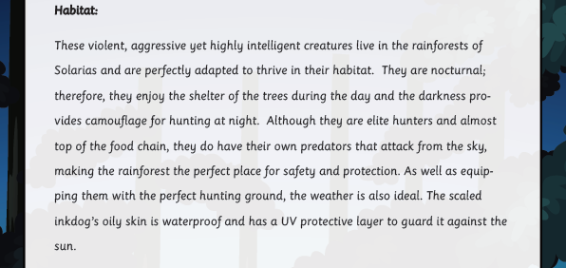
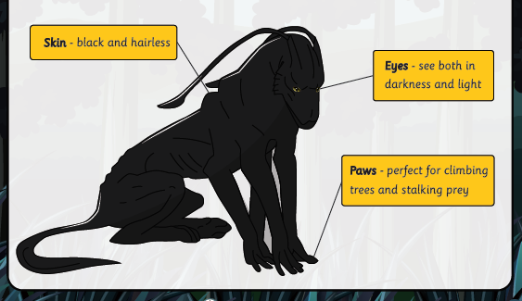
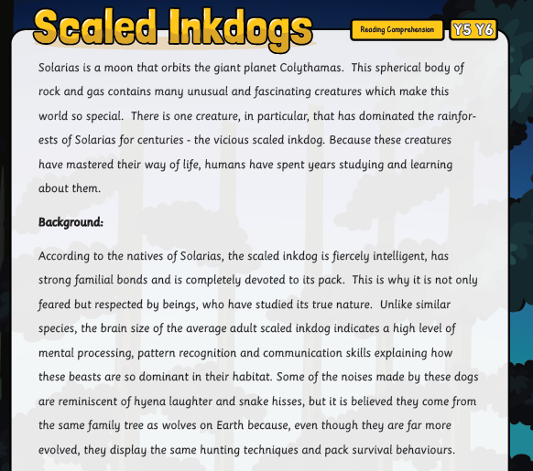

W

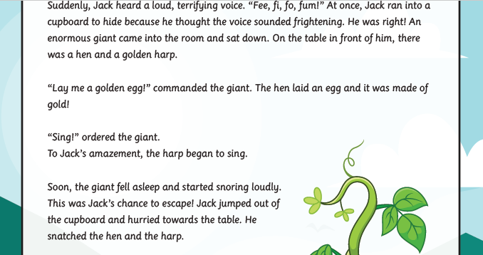
Easier text:
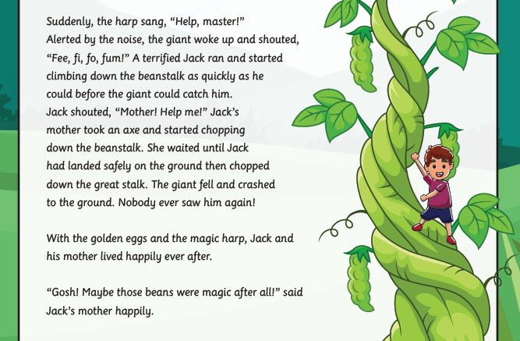
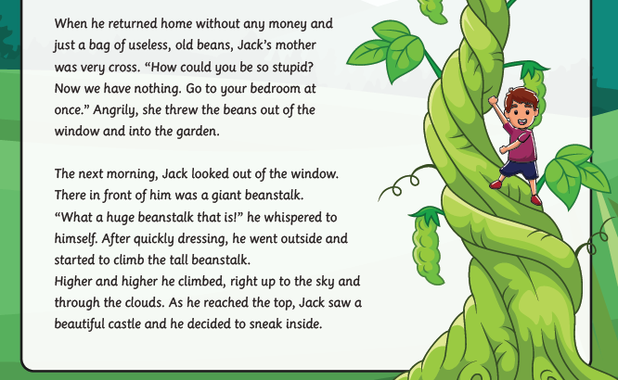

W

Writing Home Learning
Monday | Tuesday | Wednesday | Thursday | Friday
This week Mrs Nisa, Mr Caldwell and Mrs Hollingworth want you to have a go at writing a newspaper report using the prompt sheet below.  The sheet below will help you organise your ideas. Imagine that you are a reporter and you are reporting on a story that children at Hardwick Primary arrived at school to find several Scaled Inkdogs in the playground! Mind map as many possible ideas as you can – what did the Inkdog do to the school and pupils? | Today have a go at writing the orientation paragraph- remember to include the 5W’s to explain when it happened, where it happened, what happened, who was involved and why. | Today have a go at writing the next paragraph of your report. In this paragraph you need to include more information about the Inkdogs, what they look like and what they have done to the school and pupils. | Today have a go at the next paragraph which should include a quote from either a pupil, teacher or the head teacher about what they saw and how they felt. Remember to include your speech punctuation. | Re – read your report so far and write your final paragraph to end your report. This might include a contact address and phone number for anybody with any information about how to deal with an Inkdog.
Easier:Do as many of the above activities as you can. Remember that your report is about the beanstalk and how a local boy in Normanton woke up to find the beanstalk growing in his back garden.  - Use the easier story organiser to plan your story.  - Focus on using good adjectives and verbs in your story.  - Re – read each sentence as you write to make sure it makes sense. |  | Challenge:  If you feel you need a further challenge, try these:  - Include a range of time openers to begin each paragraph to move the report on.  - Try and use a range of more interesting vocabulary to describe people and places and actions.  - Include brackets and dashes for parenthesis to add extra information for the reader.
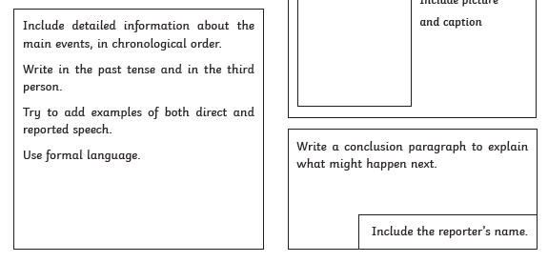
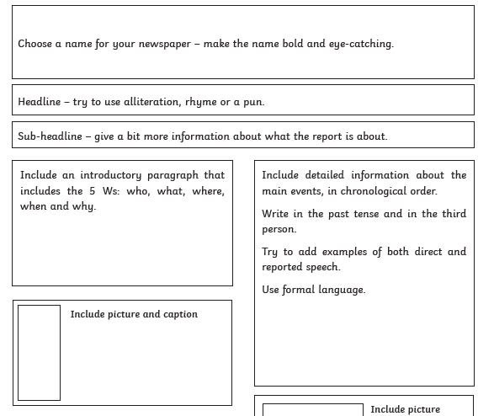
Spelling/Handwriting Home Learning
Monday | Tuesday | Wednesday |  | Thursday | Friday
Pick out some challenging words from the new texts chosen from the reading activities. Create your own spelling list to practice this week.  Even if you only used one of the texts pick out words from both. Expand your vocabulary as much as possible. | Practice your spellings. Use one of the many techniques you have been taught.  -Different colour syllables.  -Say it the way you see it.  -Word pyramid.  -Look cover, write check. | Copy out your reading text in your best joined up writing.  Do it again to see if you can make it even neater.  (remember- Not too small, not too big, letters in proportion to each other, CONSISTENCY.  Practice, practice, practice! |  | Using the spellings you have chosen on Monday, practice your cursive handwriting.  Use different colours to create an image out of the words.  E.g. | Get your siblings or parents or anyone that can help, to test you on the spellings you have been revising.  Any you get wrong can go on a permanent list to practice another time.
Easier:  Do as many of the above activities as you can. If you are finding some of the activities challenging, try these as they are a little easier:  - Pick out words from any books you have, that are tricky for you and practice them. Get someone to test at the end of the week.  - Use the same words for handwriting practice.  - Play hangman with the words you have chosen. |  |  | Challenge:  If you feel you need a further challenge, try these:  - Find the definitions of words you do not know.  - Play games like hangman. Or BIG challenge: INVENT your own game using the words.  - Write sentences correctly using the tricky words you have chosen.
Maths Home Learning – YOU WILL NEED EXTRA PAPER TO DO YOUR WORKING OUT
COLUMN ADDITION – parental support may be required for children that struggle.
Monday | Tuesday | Wednesday |  | Thursday | Friday
Complete Activity 1  Adding 3 digit and 2 digit numbers together.  Easier: take a digit off and try 2 digit + 2digit.  Challenge: Add all of the odd answers together. Then add all of the even answers together. | Complete Activity 2  Adding 4 digit and 3 digit numbers together.  Easier take off some digits if needed.  Challenge: Add all of the answers together. | Complete Activity 3  Adding 5/6 digit numbers to 4/5 numbers.  Easy reduce the numbers before addition practicing |  | Complete Activity 4  Addition in Word problems.  Remember to pick out the relevant information. | Complete Activity 5  Addition in Word Problems(cont.)
Easier:  Do as many of the above activities as you can. If you are finding some of the activities challenging, try these as they are a little easier:  Do as many as you can and if the numbers are too difficult, they can always be made a little bit smaller so you can practice your Written Addition methods.  Parents YOU can help reduce the number slightly. |  |  | Challenge:  If you feel you need a further challenge, try these:  - 45,674,893 + 7,332,887 + 11,893,079  - 56,784,224 + 345,921 + 4,599,403  - 763,933,470,987 + 98,234,802,488  Don’t forget to right them in the correct place value columns.
Activity 1 (MON)
Activity 3 (WEDS)
- 63294 + 8934 =
- 75229 + 3472 =
- 22567 + 6829 =
- 90244 + 7746 =
- 89037 + 2995 =
- 567291 + 34592 =
- 477397 + 51643 =
- 783958 + 19467 =
- 578392 + 940125 =
- 199456 + 65705 =
Challenge:
Add all of the answers together =______________________________________________
Activity 2 (TUES)
- 6324 + 547 =
- 2631 + 558 =
- 7126 + 849 =
- 1834 + 999 =
- 2189 + 686 =
- 5457 + 199 =
- 8115 + 884 =
- 3751 + 989 =
- 7833 + 957 =
- 9786 + 635 =
Challenge:
Add all of the answers together = _______________________
Activity 1 (MON)
- 431 + 57 =
- 516 + 82 =
- 493 + 54 =
- 721 + 96 =
- 377 + 75 =
- 218 + 68 =
- 464 + 28 =
- 908 + 47 =
- 635 + 55 =
- 336 + 89 =
Challenge:
All even answers
= __________________
All odd answers
= __________________
Activity 4 (THURS) – Word problems
- Mr Caldwell walks 429km and Mrs Nisa walks 98km how far did they walk altogether?
- Mrs Hollingworth eats 294 strawberries and Miss Gent eats 567. How many did they eat in total?
- Mrs Begum manage to download 365 songs on Monday and 479 songs on Tuesday. How many songs did she download over the 2 days?
- At a school fair there were 1271 visitors. The following year there were 775 more. How many came to the fair the second year?
- Mr Caldwell has read The Hobbit 4197 times and Mr Nowak has read it 1664 times. How many times have they read The Hobbit in total?
Activity 5 (FRI) – Word Problems continued
- Mrs Begg has taught 57925 lessons and Mr Rogers has taught 9386. How many lessons have they taught altogether?
- If there 32770 schools in the UK and 130,928 in the US. How many are there combined?
- Mr Caldwell has caught 67804 Pokemon. Mrs Hollingworth has caught 65993. What is the total number of Pokemon caught by them?
- When Leicester Won the Premier league in the 2015/16 season, 195045 fans celebrated during the parade and a further 148867 attended the celebrations at Victoria Park. How many people celebrated that day, altogether?
- Derby has a population of 248709, Nottingham has a population of 321564 and Leicester has a population of 329839. What is the combined population of these 3 major cities in the East Midlands?
Theme Home Learning – Bug Hotel – As mentioned last week.
Monday/Tuesday | Wednesday |  | Thursday | Friday
Continuing with the Enterprise week theme we would like you to come up with a BUG HOTEL.  This is basically something that has lots of gaps and holes and spaces for bugs to make there home, to hide from predators and the weather.  Spend these first 2 days collecting scrap and rubbish to construct your BUG HOTEL.  If you read the homework carefully last week we did mention saving some stuff for this week too. Also plan out what your BUG HOTEL will look like and how it is built. | Use today to finalise your plan making any changes you need. Also, plan how you are going to approach the construction.  (drawing diagrams will help if anyone is assisting in the project).  Begin construction. |  | Today will mostly be spent constructing the project. If you finish this part, then begin decorating.  As a BUG HOTEL, decorating with things from the garden or park may be a good idea.  Sticks, leaves, moss etc. | Finish the decorating of you creation and ensure it is structurally sound. Strong enough to take some weather.  Place it in your garden somewhere, or under a bush.  If you don’t have anywhere like this find a safe place in the park with a parent. Place a sign on it so it is not seen as rubbish.
Stuff you can use:  - Old bottles, old boots, toilet and kitchen roll tubes, toothpaste boxes, wrapping paper tubes, straws, small boxes etc  - Sticks, leaves, logs, stones, tree bark, pine cones, bits of brick, old plant pots |  | If you have the internet:  - There are some great picture online of examples. We have put a few below to give an idea.  - Also, Youtube has few videos on bug/insect hotels.  Some will help explain why they are so good/important.
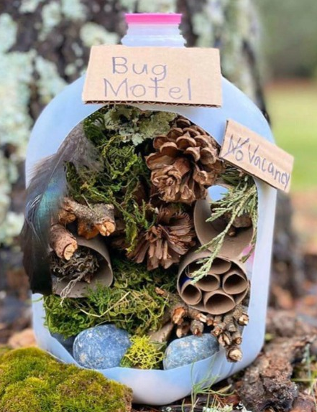
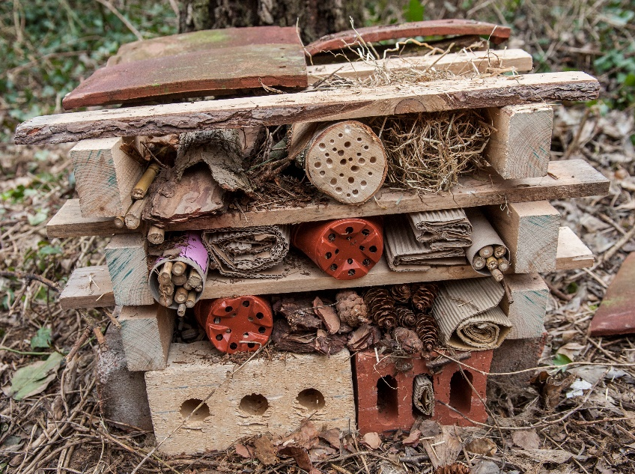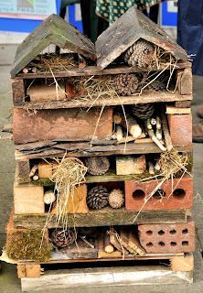
Other Activities
A while ago we set the task of making your own ice lollies.  Have another go at planning your Ice lollies and working out what you need. | Make your ice lollies. A new flavour or the ones you’ve tried before. | Enjoy the Ice lollies as the weather gets hotter. It may be good to make lots and have them ready in the freezer.

Key skills to continue practicing weekly:
- Timetables, Handwriting, Reading of own books, PE/Exercise.
- COLLECT AS MUCH STUFF AS POSSIBLE FOR NEXT WEEKS ENTERPRISE CHALLENGE. Scrap, rubbish craft stuff whatever we normally collect for building and creating things. NEXT WEEK BUILDING A CREATURE!

If you or your child has any further queries regarding their learning projects, please contact admin@hardwick.derby.sch.uk, clearly stating your child’s name and class teacher, and the staff will be in touch to support you and your child.

Thank you and stay safe.
Year 5 Team

