Nursery Home Learning
Week Commencing: 27th April 2020

Nursery Teacher: Mrs Bletcher
Nursery TA: Mrs White

Message from staff: We are both missing you all lots! We hope you are all well, and that you have had a lovely holiday at home with your grown-ups enjoying the sunshine. We are so proud of all of you, and can’t believe so many of you will be starting school in September. You are all so big now! We are SO proud of all of you and can’t wait to see you soon so we can have lots of fun together at Nursery! Whilst you are at home, we’ve put together lots of things you can be doing to have some fun and continue your learning. When you return to school, you can tell us all about it! Big BIG hugs, Mrs Bletcher and Mrs White x

Your Home Learning this Week:
Every day (Monday to Friday), make sure you choose a *physical, *communication, *reading/phonics, *writing and *maths learning activity. There are also further activities to choose from should you wish to.

Physical Home Learning
Develop your fine motor skills by using a knife and fork by yourself to eat your dinner this week!  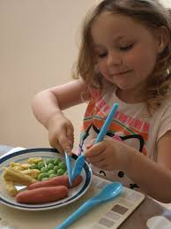 | Develop your fine motor skills by doing up the zip/buttons on your jacket by yourself. | Develop your fine motor skills by peeling your fruit by yourself (Examples: oranges and bananas). | Develop your gross motor skills by exploring slithering like a snake on your tummy. | Develop your gross motor skills by crawling like a tiger on your hands and knees.

Communication Home Learning
Ask your child to retell you the story from our quality text: ‘I am a Tiger’  Follow the link to listen to the story again: https://www.youtube.com/watch?v=QE-ZeusK6bE | Ask your child to tell you about the picture below.  What can you see?  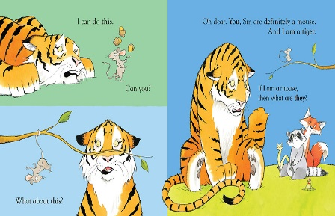 | How do you think the tiger is feeling? Why?  Example: The Tiger is feeling sad because the mouse was mean to him. | Who is your favourite character in ‘I am a Tiger?’ Why?  Example: I like the mouse because he is brave. | Follow the link below to listen to and join in with our Nursery rhyme of the week, ‘The Grand Old Duke of York’.

Reading/Phonics Home Learning
Follow the link to listen to one of our favourite poems in Nursery:  https://www.youtube.com/watch?v=yD-yG2XnxpU  Can you complete the rhyming pairs? (Example: ‘Ning’ and ‘Ping’)  Which sound does ‘Ning, Nang, and Nong’ all start with? | Can you think of a word that rhymes with:  -Cat  -Dog  -Shoe  -Fox  Remember, rhyming words are words that have the same sounding ending! | What object can you see? What sound does it start with? N  Remember, alliteration is when words start with the same sound. | What object can you see? What sound does it start with? N | What object can you see? What sound does it start with? N

Writing Home Learning
Retell the story of ‘I am a Tiger’ by drawing your own story map. Below is an example of a previous story map.  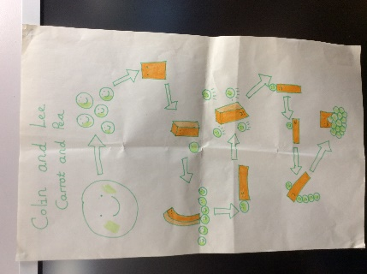 | Practise forming zigzags, crosses, spirals and circles when shown by a familiar adult. | Practise writing the first letter in your name. | Practise writing your whole name by yourself.  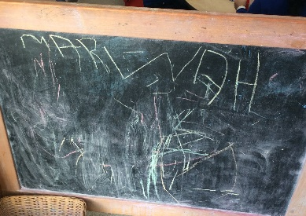 | Draw your favourite character from ‘I am a Tiger’.

Maths Home Learning
Follow the link to join in counting numbers 1-20  https://www.youtube.com/watch?v=0VLxWIHRD4E  Have a go at counting 0-20 by yourself. How far can you get? | Have a go at representing 0-10 on your fingers. | Have a go at writing how old you are.  You will be 3 or 4! | Count how many people live in your house.  Can you recognise the matching numeral?  Can you show it on your fingers? | How many?  Remember to count the holes of Numicon!

Other Activities
Sing one of your favourite Nursery Rhymes every day.  Examples include:  -Wind the Bobbin Up  -Miss Polly had a Dolly  -Two Little Dickey Birds  -5 Little Peas  -Twinkle Twinkle Little Star | Ask your grown-up to put on your favourite songs to dance to. | Draw a picture of what you have done at home every day. | Develop your gross motor skills by helping your grown- up wash the pots after you have eaten. | Think about what your favourite animal in the world is. Why? Draw a picture of your favourite animal.
Key skills to continue practicing weekly:
-Children should be practising being independent with their toileting at home.
-Encourage children to use at least four words in their sentences (Example: ‘I ate toast for breakfast’). This can be supported through modelling.
-Children should be starting to be more independent in dressing/removing clothes themselves. Examples include: Taking their jumper off when hot, putting on shoes on, and starting to do zips and buttons.
-Children should be using knives and forks independently at meal times.

Useful websites: For link to ‘The Grand Old Duke of York’: https://www.youtube.com/watch?v=KGvEQTQaTbQ
For Phonics: https://www.youtube.com/watch?v=Y0ZILFubEdI
https://www.youtube.com/watch?v=VxBEmaaSh1c

If you or your child has any further queries regarding their learning projects, please contact admin@hardwick.derby.sch.uk, clearly stating your child’s name and class teacher, and the staff will be in touch to support you and your child.

Thank you and stay safe.

