Year 5 Home Learning
Week Commencing: 15th June 2020
Year 5 staff: (Mrs Nisa, Mr Caldwell and Mrs Hollingworth, Miss Gent, Mrs Begum)

Message from staff:
Hello Year 5,
We know that it is getting a bit boring now and you all want to come back to school. We feel the same way and miss your faces. Obviously, it is very important that we don’t come back until it is a lot safer. So, in the meantime there is lots to be done.
It is very important that you do as much of the Home learning as you can. We are trying our best to keep it interesting, with elements of fun. However, during this very different time there is more responsibility than normal for you (and your parents - sorry) to make sure you are still learning. The best way to deal with this extended absence from school is to get into a routine. Not as busy as a school day but certainly allotted days or times of the day where specific tasks are to be completed.
Keep it up guys and hopefully we shall see you sooner rather than later.
Ciao for now!
Year 5 Staff

Your Home Learning this Week:
Every day (Monday to Friday), make sure you choose a *reading, *writing, *spelling/handwriting, *maths and *theme learning activity. There are also further activities to choose from should you wish to.

Reading Home Learning
Monday | Tuesday | Wednesday |  | Thursday | Friday
You will be reading a text about wild garden birds in the U.K. Read the text carefully and highlight or underline any word you do not understand.  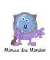 | Re-read the text and find the meaning of the words you do not understand from yesterday. | Using Stan Summariser, summarise the main information about British garden birds and do not forget to use your VIP’s (very important parts).  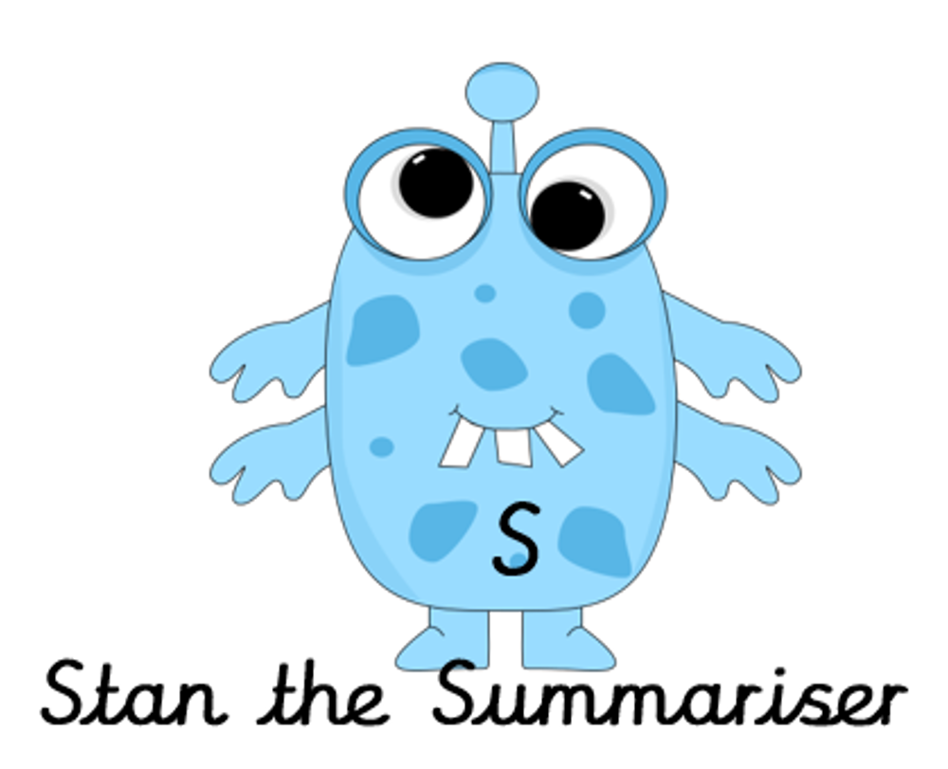 |  | Now try answering these questions:  - How long are blackbirds?  - Name two habitats of the blackbird.  - Summarise the information about Nightingales in no kore than 30 words.  - Why do you think that Nightingales are described as ‘summer visitors’?  - What is the smallest native bird on the U.K? | After reading the text on British birds think of any questions you may have. Is there anything you were left wondering that was not answered? Write these questions down. Reread the text again and this time, try to answer the questions you have. Can you answer them? If not, try to research the answers
Easier: Garden Birds  Do as many of the above activities as you can. If you are finding some of the activities challenging, try these as they are a little easier:  - What is the starlings favourite food?  - Which two types of birds have been seen the most?  - When do swifts and swallows return to the U.K.?  - How do birds help the environment? |  |  | Challenge:  If you feel you need a further challenge, try these:  Answer the following questions:  - Write a description for the appearance of each bird’s eggs.  - Find a phrase from the text that shows that Nightingales do not live permanently on the U.K.  - Why do you think that Robins can become so tame that they can feed out of people’s hands?  - Give two reason why Robins are thought to be Britain’s favourite bird.
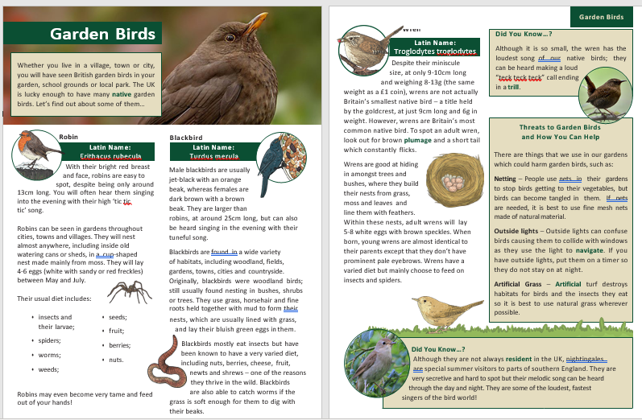
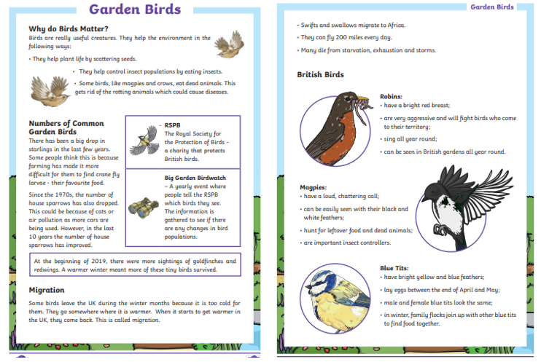
Writing Home Learning
Monday | Tuesday | Wednesday |  | Thursday | Friday
This week Mrs Nisa, Mr Caldwell and Mrs Hollingworth want you to have a go at writing a story using the prompt sheet below. Your story will begin with – Today was the day it all went wrong, it began when…  The sheet below will help you with ideas. Mind map as many possible ideas as you can. Your ideas can be serious, funny or silly, e.g., It all began when I arrived at school to find my teacher had grown two heads! | Today we want you to draw a comic strip for you story. This will help you to visualise each of the 5 parts of it, remember to visualise the main parts of the setting, build up, dilemma, resolution and ending. | Today have a go at telling your story to an adult, brother or sister using your comic strip to remind you of the main events. Try to include as much detail as possible to interest your audience. This will help you to organise your ideas in your head ready for writing tomorrow. |  | It is time to have a go! Today, have a go at writing the setting and build up for your story – use your comic strip to help you. Try to include the following:  Fronted adverbial phrases.  A range of different sentence types.  Carefully chosen verbs and adjectives to create the setting. | Re – read your setting and build up from yesterday to remind yourself where you have got to with your story.  Today you need to write the problem, resolution and ending. Remember to add plenty of action and detail and include an exciting way to solve the problem.
Easier: Do as many of the above activities as you can. If you are finding some of the activities challenging, try these as they are a little easier:  -Use the easier story organiser to plan your story.  -Focus on using good adjectives and verbs in your story.  -Re – read each sentence as you write to make sure it makes sense. |  |  | Challenge:If you feel you need a further challenge, try these: -Include a range of time openers to begin each paragraph to move the story on.  -Try and use a range of more interesting vocabulary to describe people and places and actions.  -Use ‘show not tell’ strategies to infer how a character is feeling rather than telling the reader.  -Include brackets and dashes for parenthesis to add extra information for the reader.
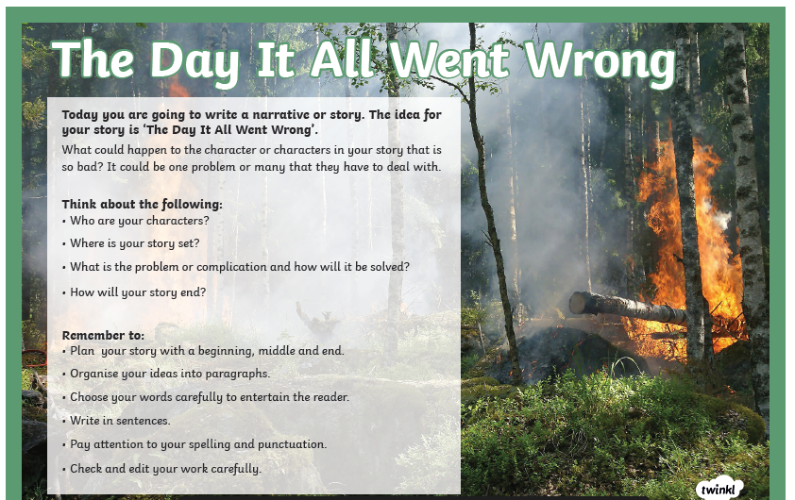
Easier Writing

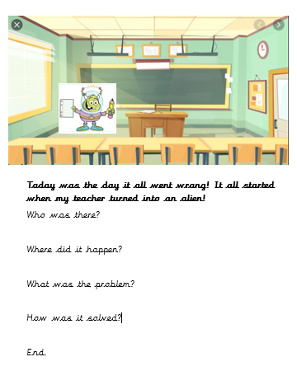

Spelling/Handwriting Home Learning
Monday | Tuesday | Wednesday |  | Thursday | Friday
Pick out some challenging words from a book you are reading or the new text chosen from the reading activities. Create your own spelling list to practice this week. | Practice your spellings. Use one of the many techniques you have been taught.  -Different colour syllables.  -Say it the way you see it.  -Word pyramid.  -Look cover, write check. | Copy out your reading text in your best joined up writing.  Do it again to see if you can make it even neater.  (remember- Not too small, not too big, letters in proportion to each other, CONSISTENCY. |  | Using the spellings you have chosen on Monday, practice your cursive handwriting.  Get plenty of colours. Write each spelling as many times as possible in different shapes, Follow the lines and curves of the shape to fit as many words in as possible. | Get your siblings or parents or anyone that can help, to test you on the spellings you have been revising.  Any you get wrong can go on a permanent list to practice another time.
Easier:  Do as many of the above activities as you can. If you are finding some of the activities challenging, try these as they are a little easier:  - Pick out words from any books you have, that are tricky for you and practice them. Get someone to test at the end of the week.  - Use the same words for handwriting practice.  - Play hangman with the words you have chosen. |  |  | Challenge:  If you feel you need a further challenge, try these:  - Continue with some of your old spelling lists (if you found them last week) practice the ones you struggled with the most.  - Find year 4 and 5 spellings lists online and pick out the ones you are most unsure about.  - Find the definitions of words you do not know.  - Play games like hangman. Or BIG challenge: INVENT your own game using the words.

Maths Home Learning
Monday | Tuesday | Wednesday |  | Thursday | Friday
Volume is the amount of space a 3D shape takes up. A cubic cm block takes up 1 cubic cm. the volume can be worked out by counting cubic centimetres.  Activity 1 and 2 | 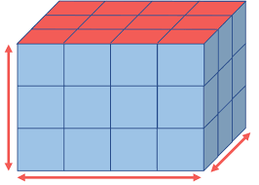  Count the cubes to find the volume of the shape | This is written as 1 cm³. You can work out the volume of a shape by multiplying height × width × depth. If the shape is made of cubic cm blocks, you can count the cubes to find the shape's volume. |  | 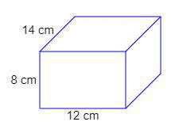  Name this shape.Calculate its volume. | 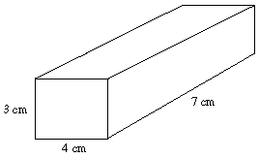  Name this shape.Calculate its volume.
Easier:  Do as many of the above activities as you can. If you are finding some of the activities challenging, try these as they are a little easier:  - Count the cubes. Work out how many there are in each layer |  |  | Challenge:  If you feel you need a further challenge, try these:  - Draw 5 different sized cubes, write the height, width and depth. Calculate the capacity of each one  - Draw 5 cuboids, write the height, width and depth. Calculate the capacity of each one

Activity 1
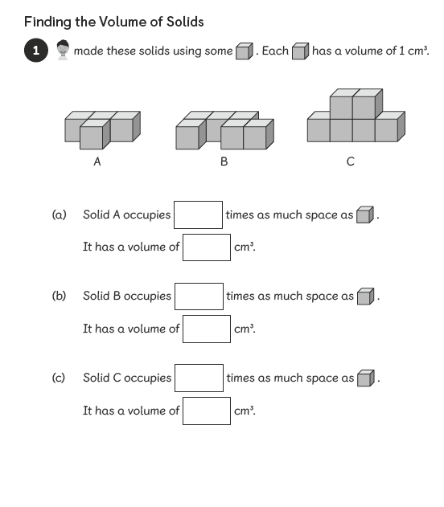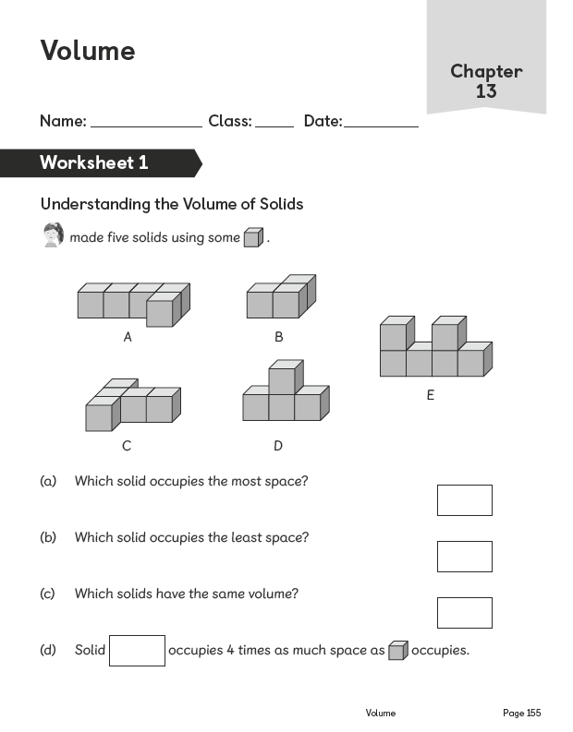
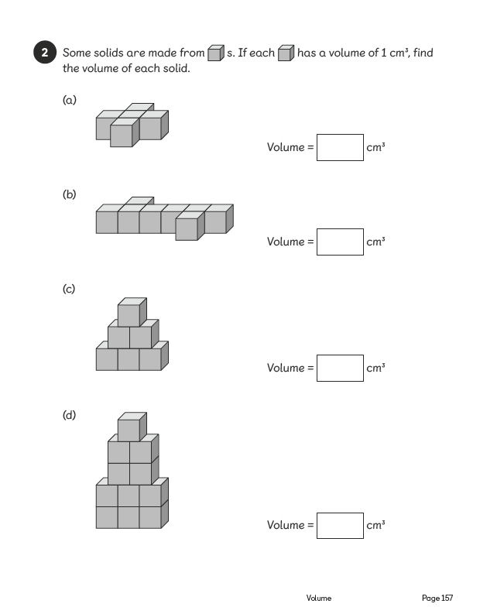
ACTIVITY 2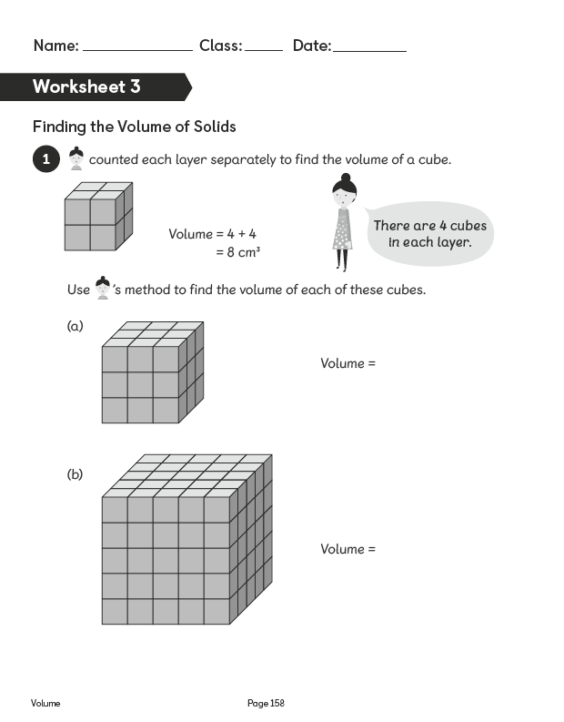
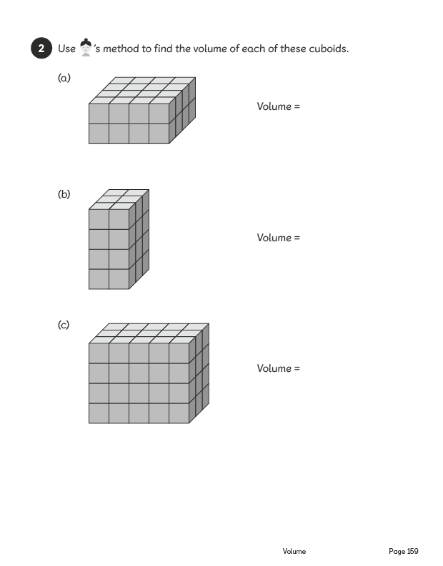
Activity 3
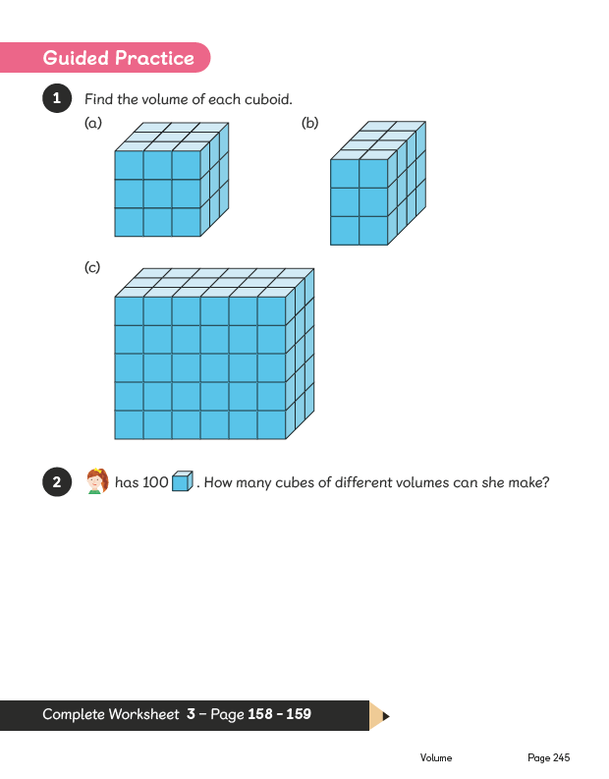
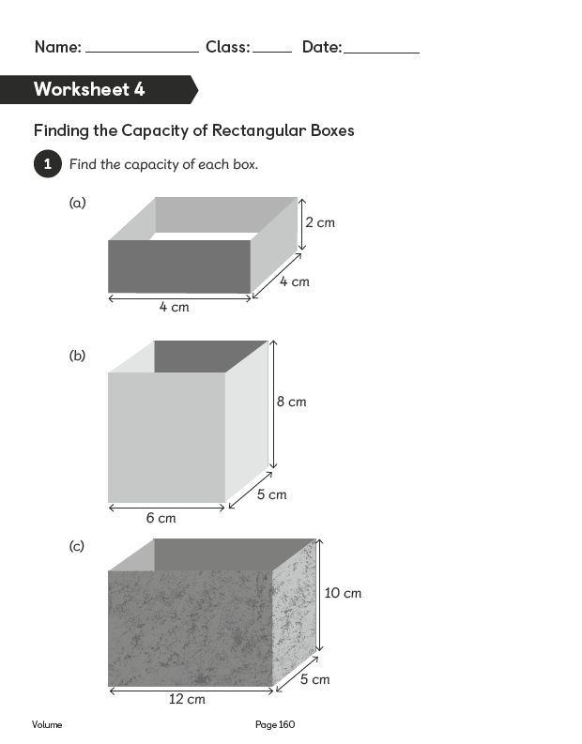
Activity 4 To find the capacity, multiply the length by the width and height. E.g.No.1a 2x4x4. 2x4=8,8x4= 32
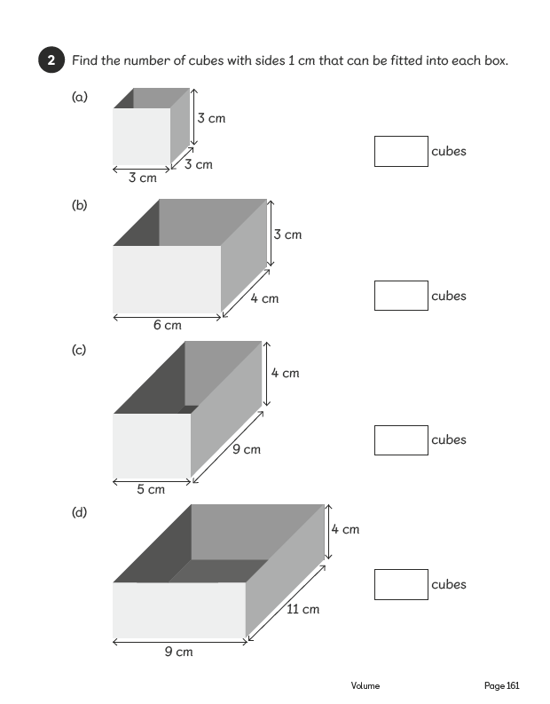
Activity 5 multiply the length by the width and height.
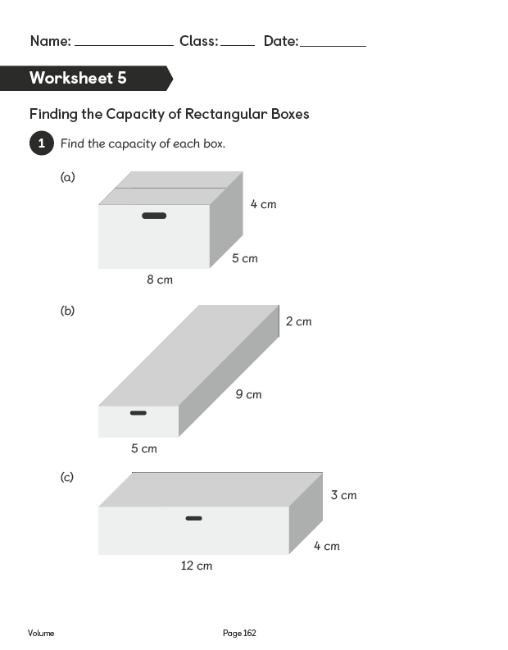
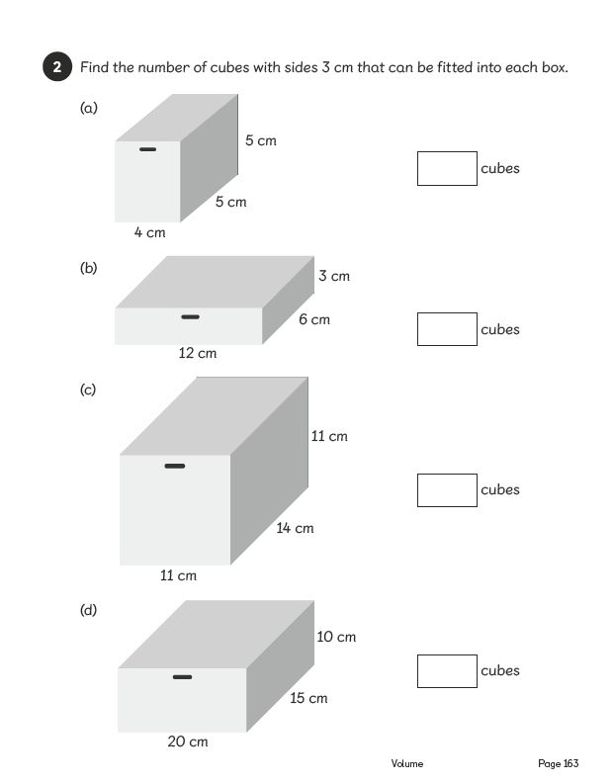
Theme Home Learning
Monday/Tuesday | Wednesday/Thursday/Friday
The last few weeks have focussed on staying active and exercising, as well as eating a healthy balance of food. This week we are looking at personal and other things you need to do to stay healthy and safe.  Poster 1  Create a poster reminding your fellow students and family members how to stay safe online.  Think about what we have learnt at school and ask your parents for their opinions. | Poster 2  We all know that to stay healthy you must eat a balanced diet and exercise frequently. However, what other things do we require to remain healthy.  This week you will be creating a poster about personal hygiene/health. What must people do to stay hygienic? This should include:  -dental routine  -sleeping routine  -eating routine  -washing routine (nails, face, body, hair etc)  -keeping your clothes clean  Now you may need to ask your parents about some of these.
Easier: Do as many of the above activities as you can. If you are finding some of the activities challenging, try these as they are a little easier:  - Combine all the things you know about  -Healthy eating  -Exercise  -Keeping clean (teeth, washing, sleeping)  And create a poster for children that may not know as much as they should.  Create a poster about how to stay safe online and in public places. |  | Challenge: 2 WEEK HEALTHY LIVING CHALLENGE  If you feel you need a further challenge, try these:  - To see a comparison, we would like (WITH PARENTAL PERMISSION) children to have no limit to their ‘screen-time’ and slightly later bed-time than normal for week.  The following week we would like to see a strict screen-time routine followed and strict bedtime routine. The plan is to compare how they feel.
Other Activities
Have a drawing session with your siblings/family members. Mum or Dad can write down a bunch of things (animals, items, scenes, people -real or not, buildings etc) then take it in turns pulling one out of the pot and everyone has to draw it. | Set up a treasure hunt.  Parental help setting up needed.  Create a list of things children need to find around the house/in the garden  For example:  -something beginning with Y  -something purple  -something you twist  Anywhere between 10-20 items? | BUG HUNT  Using a see-through tub from the kitchen.  Hunt for bugs and collect them in your tub. Look at them, draw them, compare them, discuss with your siblings/family.  Be careful they are living things.  At the end put them back in the garden and wash your tub.  You could also draw a diagram of your garden and plot where you found the creatures. | The Alphabet Game  You will need a pencil/pen and some paper.  5ED and 5JS have done this before.  You pick a subject and write one thing for each letter of the alphabet. E.g.  -Fruit and veg?  -Animals?  -Girls or Boys names?  -Cities/countries?

Key skills to continue practicing weekly:
- Times tables
- Reading
- Handwriting

If you are able to access the internet, try these useful websites: We focussed our search on READING this week.
This website has put together some shortcuts to some pretty good websites for reading.

https://www.online-tech-tips.com/cool-websites/7-websites-with-free-online-books-for-kids/
I have investigated in depth and the following are the best:

Oxford Owl – Home access has lots stuff for parents to look through, there is also a free eBook section. Requires a sign in but certainly worth it. Can read the books themselves or listen to it as an audio book.

Storyline Online – videos of stories read by celebrities (younger audience). Fun to watch together.
Open Library - requires signing up, definitely worth it! Great selection of books and turn the pages

like a real book. Monitor which books they are accessing.

The ones below are not as good, more like book shopping sites:
International Children’s Digital Library – Very difficult to navigate, too much to sift through.
Amazon’s Free Kids Ebooks – difficult to navigate, require massive downloads
Barnes & Noble Free Nook Books for Kids – more like a shopping site
Mrs. P’s Magic Library – Mixed site with some learning and some story videos.
If you or your child has any further queries regarding their learning projects, please contact admin@hardwick.derby.sch.uk, clearly stating your child’s name and class teacher, and the staff will be in touch to support you and your child.
Thank you and stay safe.

