FS2 Home Learning
Week Commencing: 6th July 2020
FS2 teachers: Mrs Connelly-Haywood and Miss Ralph
FS2 TAs: Miss Hayat
Message from staff:

Hello everyone! It has been another busy week for us in school. We have been reading the story Jack and the beanstalk and have completed some lovely activities based on the book. We even planted our own beans in pots. We imagined all the possible things we could find at the end of a beanstalk as we explored in the creative area. Every day we talk about all of our friends at home and we really hope that you are all still enjoying your home learning. We cannot wait to speak to you soon. Take care everyone!

Your Home Learning this Week:
Every day (Monday to Friday), make sure you choose a *physical, *communication, *reading/phonics, *writing and *maths learning activity. There are also further activities to choose from should you wish to.
Physical Home Learning
Monday | Tuesday | Wednesday |  | Thursday | Friday
Develop your fine motor skills by building a house for a mouse out of Lego/Duplo/blocks.  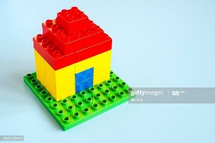 | Develop your gross motor skills by crawling on the floor quietly and then pretending to climb the curtains on the spot like Mouse.  Can you change your speed?  Can you change direction? | Develop your fine motor skills by writing your name in a small amount of flour in a bowl.  Explore making patterns with other small utensils, like a small brush or a fork. |  | Develop your fine motor skills by scrubbing your favourite toy clean with a brush and a bowl of water.  What happens when you scrub your toy faster? | Develop your fine motor skills by using a knife to carefully slice citrus fruits. What shapes can you make?  Remember, you will need a grown up to help you if you are using a knife!  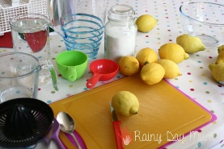
Easier:  Do as many of the above activities as you can. If you are finding some of the activities challenging, try these as they are a little easier:  - Practise holding a pencil and make lines and circles. – Try to write your name.  - Practise peeling a piece of fruit by yourself.  - Explore making marks modelled by an adult in flour. Example include: Spirals, zigzags, and crosses.  - Explore writing the first letter in your name in flour. |  |  | Challenge:  If you feel you need a further challenge, try these:  - Develop your fine motor skills by adding stairs to Mouse’s Lego house. Can you build another floor? Can you make furniture to put inside it? For example: A bed or a bath.  - Explore making patterns in flour using a cotton bud. Is it easier or harder to use than your finger? Why?
Communication Home Learning
Monday | Tuesday | Wednesday |  | Thursday | Friday
See attached the story ‘Mouse’s Adventure’. Can you listen to the whole story carefully when your grown up reads it out to you?  On Monday, where does Rafa find Mouse? | Retell the story of ‘Mouse’s Adventure’ to someone in your house. Can you remember it all?  On Tuesday, where does Rafa find Mouse? | How does Rafa feel when he can’t find Mouse? Why do you think this?  Example: Rafa feels sad when he can’t find Mouse because he has lost his friend.  On Wednesday, where does Rafa find Mouse? |  | Why do you think Mouse goes on his adventures at night time?  Example: I think Mouse goes on his adventures at night time because he knows he won’t get caught!  On Thursday, where does Rafa find Mouse? | On Friday, where does Rafa find Mouse?  Why do you think Mouse does not go on an adventure on Friday?  Example: I think Mouse does not go on an adventure on Friday because he is tired.
Easier:  Do as many of the above activities as you can. If you are finding some of the activities challenging, try these as they are a little easier:  - Who does Rafa live with? Example: Rafa lives with Grandma.  - Using your words, talk to your grown up about your favourite toy. |  |  | Challenge:  If you feel you need a further challenge, try these:  - How do you think the evil robot trapped Mouse?  - Do you think any of your toys go on secret adventures at night time? How do they creep out without anybody seeing them? Tell your grown up where you think they might go.

Reading/Phonics Home Learning
Monday | Tuesday | Wednesday |  | Thursday | Friday
Focus on ‘oo’  Read and write words.  Too, koo, boot, foo, zoom, food, moon, woo, book, wool  Which words are real? Can you sort the words by writing a list of real and pretend words? | Focus on ‘ar’  Read and write words.  Bar, car, card, cart, hard, jar, park, market  Can you think of and write down your own words? | Focus on ‘or’  Read and write words. Play a game to see if you can write the words as quickly as you can.  For,fork, cord, cork, sort, born, worn, fort, torn, cornet  Can you think of your own words? |  | Focus on ‘ur’  Read and write words.  Fur, burn, urn, burp, curl, hurt, surf, turn, turnip, curds  Can you think of your own words? | Focus on recapping the key words  Was, my, you, her, they, all, are  Can you read them by sight?  Practice writing the key words.
Easier:  Do as many of the above activities as you can. If you are finding some of the activities challenging, try these as they are a little easier:  - Have a go at recapping the sounds below. Can you make any CVC words with the sounds s, a, t, p, i, n? Examples include: Sat, sit, tap, pin. If you have magnetic letters at home these will help you make the words!  - Find a toy in your house that begins with the sounds s, a, t, p, i, n  - s, a, t, p, i, n, m, d, g, o, c, k, ck, e, u, r, h, b, f, ff, l, ll, ss, j, v, w, x, y, z, qu, sh, ch, th, ng |  |  | Challenge:  If you feel you need a further challenge, try these:  - Recap the key words we have covered so far. Can you write them in a sentence?
Writing Home Learning
Monday | Tuesday | Wednesday |  | Thursday | Friday
Create a diary for the week by drawing a picture of what you have done at home every day.  Further your learning by writing a sentence using the days of the week:  Monday Tuesday  Wednesday Thursday  Friday Saturday  Sunday | Retell the story of Mouse’s Adventure by writing the story down. Have a go at using the tricky words ‘the, to, I, no, go’ in your story. | Draw or paint a picture of the evil Robot that traps Mouse in the story. Can you write a sentence about it using the tricky words ‘the’, ‘to’, and ‘I’?  Example: I do not want to be friends with the evil robot. |  | Draw or paint a picture of your favourite toy at home. Can you write a sentence about them using the tricky words ‘the, to, and ‘I’?  Example: I went to the shops to buy my doll. | Write a list of your favourite toys at home. Have a go at sounding out words by yourself!  Examples include: doll, car, mouse, house, dog, lego
Easier:  Do as many of the above activities as you can. If you are finding some of the activities challenging, try these as they are a little easier:  - Draw a picture of Mouse and Rafa. Label the picture with the first sounds you can hear in Mouse and Rafa. Can you sound out R-a-f-a by yourself to help you write it down?  - What are the initial sounds for these words: Grandma, Lego, robot, shower. Have a go at writing them down by yourself! |  |  | Challenge:  If you feel you need a further challenge, try these:  - Can you write your own story about your favourite toy at home, using tricky words the, to, I, no, go, he, she, we, me, be, was, my, you, her, they, all, are.  - Can you read your story back to your family when you have finished?

Maths Home Learning
Monday | Tuesday | Wednesday |  | Thursday | Friday
With a sibling or grown up at home explore making a toy shop with toys to sell. You could ask a grown up in your house if you could borrow some change to play with.  Explore using the language:  Money  Penny  Pounds  Change  How much?  Bill  Receipt  Amount  Cost  Coin | Go on a money hunt in your home! Can you find any of these coins in your home? Which one is worth the most? How do you know?  Remember to look for the numbers on coins to work out the correct amount!  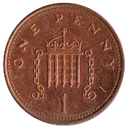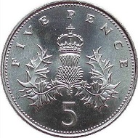 | How much do you have all together? Remember to look for the numbers on coins to work out the correct amount! Can you write it down correctly?  Write a number sentence down to help you.  Example: 2p + 5p= 7p |  | How much do you have all together? Remember to look for the numbers on coins to work out the correct amount! Can you write it down correctly?  Write a number sentence down to help you. Can you find a coin that equals the same amount?  Example: 5p + 5p=10p | How much do you have all together? Remember to look for the numbers on coins to work out the correct amount! Can you write it down correctly?  Write a number sentence down to help you. Can you find a coin that equals the same amount? Example:2p + 2p +1p + 5p=10p
Easier:  Do as many of the above activities as you can. If you are finding some of the activities challenging, try these as they are a little easier:  - Can you find five pennies in your home? Have a go at counting how many you have and writing the number down! |  |  | Challenge:  If you feel you need a further challenge, try these:  How much do you have all together? Write a number sentence down to help you. Remember to look for the numbers on coins to work out the correct amount!

Other Activities
Explore freezing water by making ice cubes. What happens to the water when you leave it in the freezer overnight? | Make lemonade by adding sliced lemons to water and sugar. Mix all ingredients in a jug together!  Use your words to describe how it tastes! | Take photos of your favourite toy having their own adventure! What will they get up to? | Help a grown up at home make dinner by listening carefully to their instructions. | If you have a younger brother or sister at home, help them get dressed in the morning!

Key skills to continue practising weekly:
- Write your name.
- Practise handwriting – try to form the letters on the line correctly.
- Form numbers correctly.
- Getting changed on your own.
- Zip your coat up on your own.
- Match the capital letters with the lowercase letters e.g. A a B b
- Number bonds to 10.
If you are able to access the internet, try these useful websites:

- Change for life indoor activities: https://www.nhs.uk/change4life/activities/indoor-activities
- Cosmic Kids - https://www.youtube.com/watch?v=tWSgNEs4IPg
- Playdough - https://www.bbcgoodfood.com/howto/guide/playdough-recipe
- Number Blocks – doubling: https://www.youtube.com/watch?v=Bot83VxMLqM
- Paper fan instructions - https://www.wikihow.com/Make-Paper-Fans
- https://www.talk4writing.com/wp-content/uploads/2020/06/R-Maxs-Jungle.pdf
If you or your child has any further queries regarding their learning projects, please contact admin@hardwick.derby.sch.uk, clearly stating your child’s name and class teacher, and the staff will be in touch to support you and your child.

Thank you and stay safe.
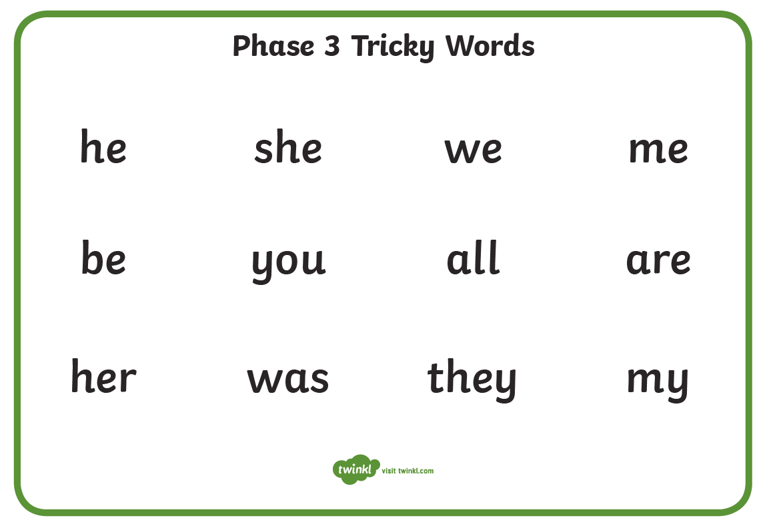

Mouse’s Adventures
Once upon a time, there was a boy called Rafa who lived with his Grandma in a big city. Every day, Rafa played football and built Lego but, most of all, he played with Mouse.

Rafa’s Grandma gave Mouse to him on the day that he was born and Rafa loved him. Whenever anyone asked Rafa why his friend was just called Mouse, Rafa would smile and say, “Well, he’s just so … mousey!”

On Monday, Rafa woke up, turned over in bed and reached for Mouse, but Mouse wasn’t there. “Oh bother!” said Rafa. “He’s been on an adventure again.” So, Rafa looked here, he looked there, he looked everywhere and, finally, he found him on his bedroom shelf in amongst the Lego models. “What have you been up to?” asked Rafa, picking Mouse up and snuggling his soft ears. “We-e-e-ll,” said Mouse, “I was having a lovely time playing in the Lego until I got trapped by an evil robot!”

On Tuesday, Rafa woke up, turned over in bed and reached for Mouse, but Mouse wasn’t there. “Oh bother!” said Rafa. “He’s been on an adventure again.” So, Rafa looked here, he looked there, he looked everywhere and, finally, he found him in the lounge, hanging from the curtain rail. “What have you been up to?” asked Rafa, picking Mouse up and stroking his fluffy tail. “We-e-e-ll,” said Mouse, “I was having a lovely time climbing the curtains until I slipped! Lucky I’ve got a super strong tail!”

On Wednesday, Rafa woke up, turned over in bed and reached for Mouse, but Mouse wasn’t there. “Oh bother!” said Rafa. “He’s been on an adventure again.” So, Rafa looked here, he looked there, he looked everywhere and, finally, he found him in the kitchen cupboard, covered in flour. “What have you been up to?” asked Rafa, picking Mouse up and dusting him down. “We-e-e-ll,” said Mouse, “I was having a lovely time looking for treats until a big, white cloud landed on me!”

On Thursday, Rafa woke up, turned over in bed and reached for Mouse, but Mouse wasn’t there. “Oh bother!” said Rafa. “He’s been on an adventure again.” So, Rafa looked here, he looked there, he looked everywhere and, finally, he found him sitting in the bath. “What have you been up to?” asked Rafa, picking Mouse up and wrapping him in a warm towel. “We-e-e-ll,” said Mouse, “I was having a lovely time sliding in the bath until the shower rained on me!”

On Friday, Rafa woke up with something warm and fluffy and orange cuddled up under his chin. “Good Morning,” said Rafa. “no adventures last night?” “We-e-e-ll,” said Mouse, “I was having a lovely time diving in the duvet waves until … I fell fast asleep!”

