A LO - To know how to use decimal notation when recording measures

Can you now write mass in three ways and convert between them?

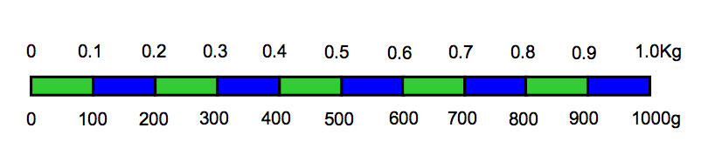

Kg | Kg and g | g
 | 1kg 250g
 |  | 1700g
2.30Kg
 | 2Kg 400g
 |  | 2800g
2.75Kg
 | 3Kg 175g
 |  | 850g
 | 1kg 90g
2.05Kg
 |  | 4020g

