Year 2 Home Learning
Week Commencing: 29th June 2020
Year 2 teachers: Mrs Nicholson and Mrs Tomordy
Year 2 TAs: Mrs Rowland and Ms Shaista
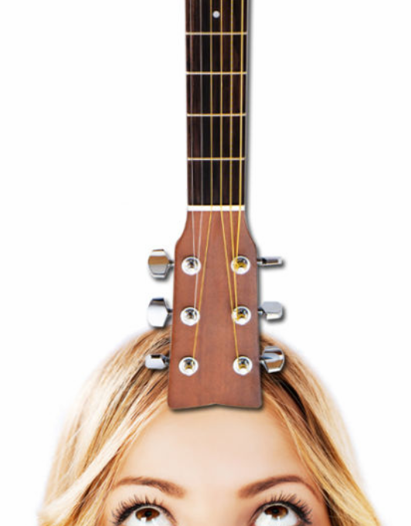
Message from staff: Hello everyone. The reading this week is all about someone who set a world record. People try to set new world records for lots of different things. Can you guess which of the following facts is not true? I will tell you the answer next week!!
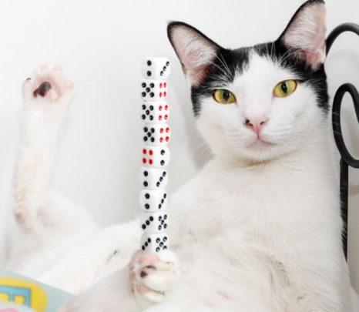

The record for the height of cheese and onion crisps stacked up on each other is 1.4 metres.
The record for the length of time someone could balance a guitar on their forehead is 7 minutes!
The record for the number of dice stacked on a cat’s paw is 10!

Your Home Learning this Week:
Every day (Monday to Friday), make sure you choose a *reading, *writing, *spelling/handwriting, *maths and *theme learning activity. There are also further activities to choose from should you wish to.
Reading Home Learning
You will be reading a text about travelling around the world. Make connections with what you already know about travelling. How do people travel to different countries? Are there any interesting facts you know? Have you heard anything on the television or in books about travelling around the world? Ask the people you live with if they know anything.  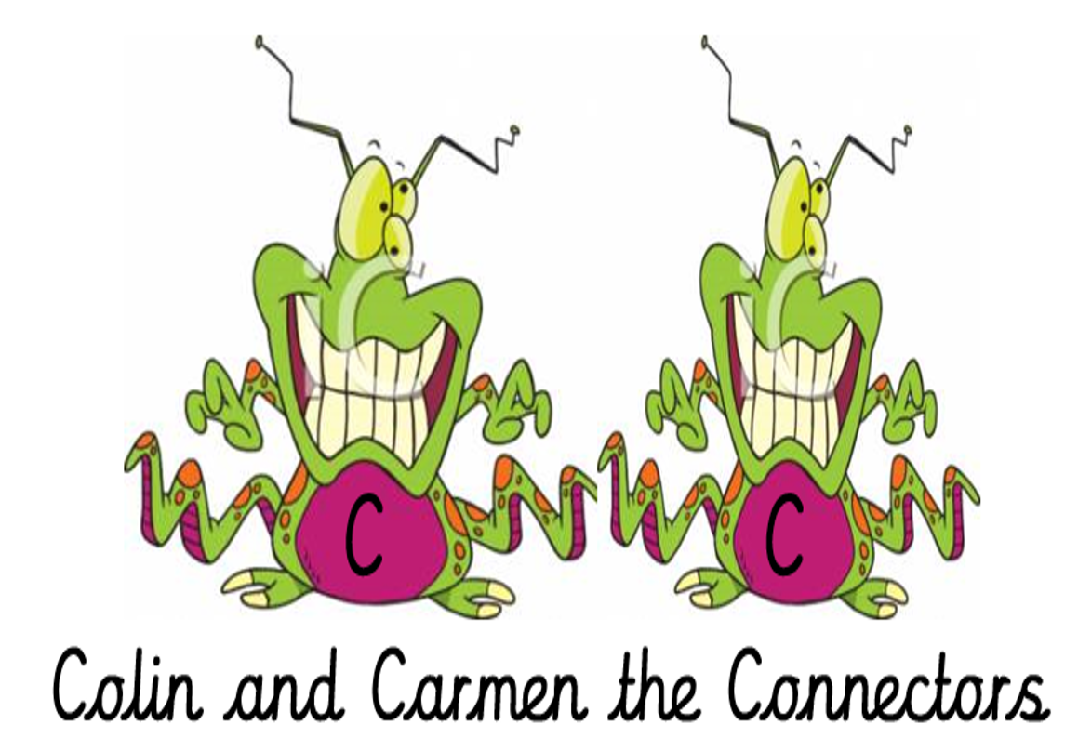 | Read ‘Around the world in 80 days’, using reading skills to help you understand as you go through it. Highlight any words you do not understand and find the meaning of them.  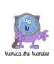 | Summarise what you have read in the text. A summary covers the very important parts of the text (VIP). Which parts in the text do you think are important?  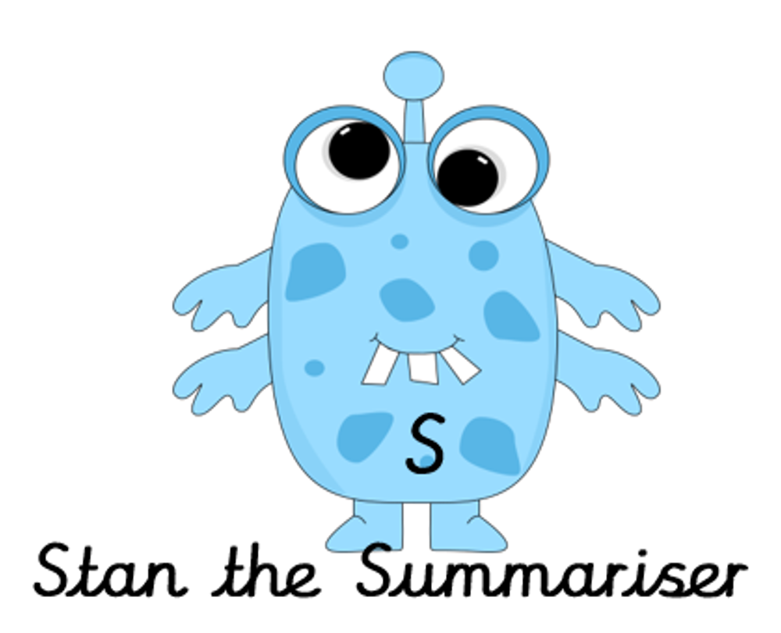 |  | Now try answering these questions:  - Who wrote ‘Around the world in 80 days’?  - How long did Mark ride for each day?  - Which continents did he visit?  - How far did Mark travel around the British coast?  - What does equipment mean?  - What does ‘broke the world record’ mean? | After reading the text on ‘Around the world in 80 days’, think of any questions you may have. Is there anything you were left wondering that was not answered? Write these questions down. Reread the text again and this time, try to answer the questions you have. Can you answer them? If not, try to research the answers or, save the questions for when we come back to school so you can research at school.  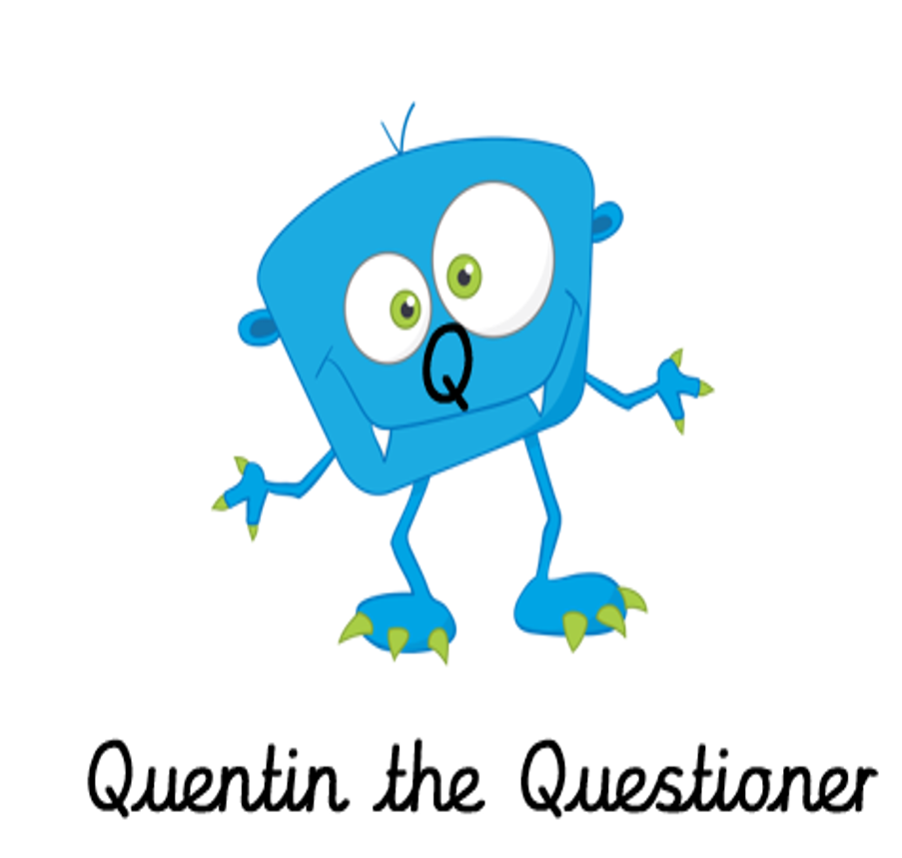
Easier:  Do as many of the above activities as you can. If you are finding some of the activities challenging, try these as they are a little easier:  Read the text ‘Lion’s lunch’ and answer the questions:  Who went to get some lunch for Lion? ___________________________________  What did Fox see outside Lion’s cave? ____________________________________________________________________________________________  What did he not see? ____________________________________________________________________________________________  Why did Fox run away? ____________________________________________________________________________________________  Match what each animal said:  Why are there footprints going into the cave, but no footprints coming out?  Zebra  I will go and see him.  Deer  He might like a visitor, then.  Fox |  |  | Challenge:  If you feel you need a further challenge, try these:  - Why do you think Mark decided to take on this challenge? Why do people set world records?  - If you could set Mark’s next challenge, what would it be?
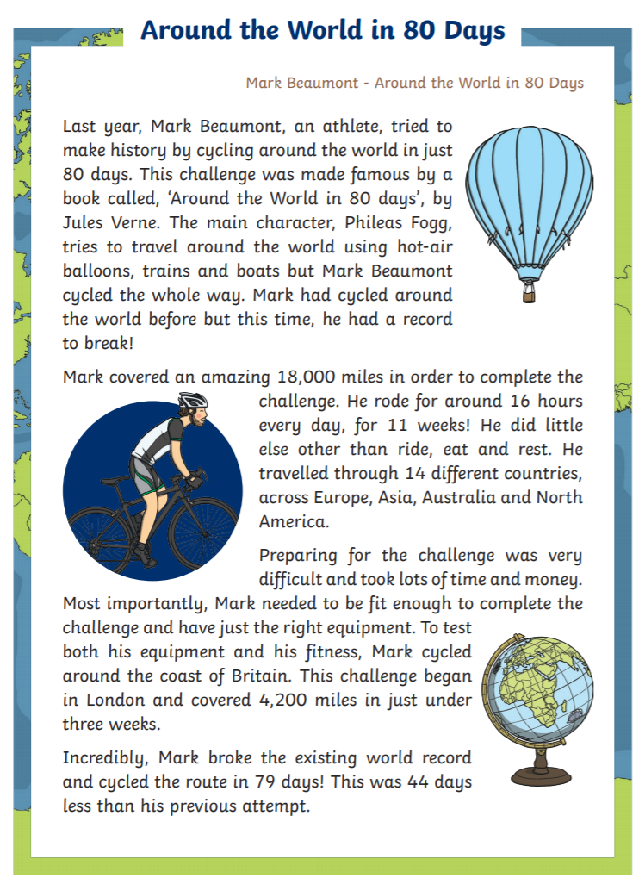 |  |  | Lion’s lunch  Lion wanted some lunch. So, Lioness said, “I will go and get some lunch for you, Lion.” She went out.  Lioness saw Zebra. “Poor lion is in his cave. He is not feeling very well,” said Lioness.  “I will go and see him,” said Zebra.  Then Lioness saw Deer. “Poor Lion is feeling sick,” said Lioness.  “He might like a visitor, then,” said Deer. He went to Lion’s cave.  Fox came along. “Will you go and visit Lion?” asked Lioness. “He needs his friends to visit him.”  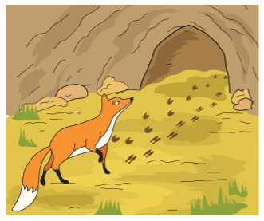  Fox looked at Lion’s cave and he asked, “Why are there footprints going into the cave, but no footprints coming out?”
Writing Home Learning
Task 1  Talking – getting ready to write!  Talk about the picture ready to write a story about it. Jot down ideas you have to the following questions so you can create a story.  What’s happening in the picture?  Give the creatures names.  Why does the purple creature have a peg on its nose? Why are its cheeks bulging? | Task 2  Talking – getting ready to write!  Is the large character an ogre? A troll? Something else?  Why does he have his foot in a bowl?  How is he feeling? Why? Why are there flies around him? | Task 3  Talking – getting ready to write!  Use all your ideas from Monday and Tuesday to create a story. Think about your story hand.  Tell someone your story. Now tell someone else so that you remember it – jot down words for the beginning, middle and end.  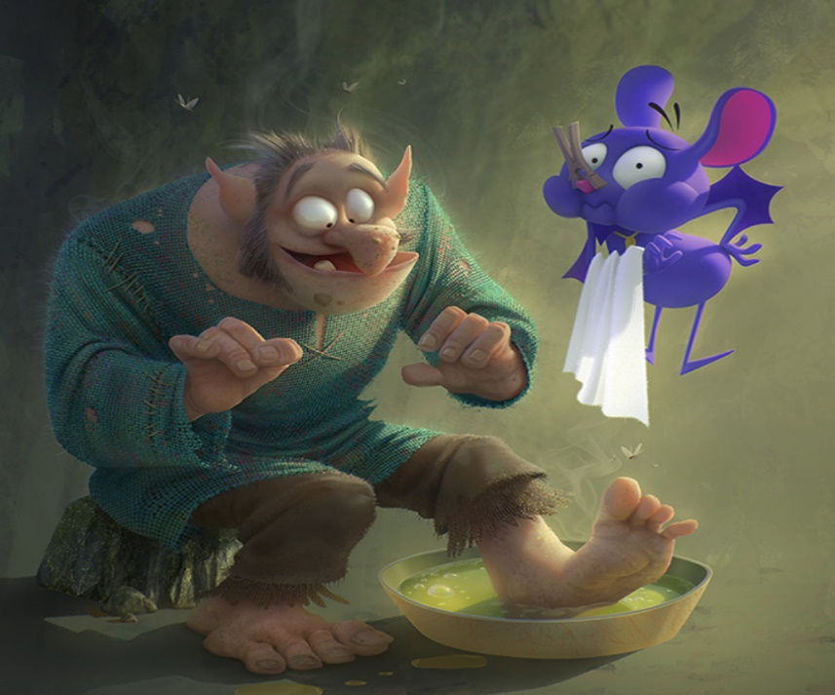 |  | Task 4  Now write your story.  Remember to think about the following:  Use capital letters Use full stops Leave finger spaces  Write on the line Sound out words Make good word choices  Read your sentences back Join-up some of your letters  abc | Task 5  Finish your story. Check the spelling and punctuation. Does it make sense? Are there any words you would change? Did you include good descriptions? Was there a problem and solution? Who do you think would enjoy your story? Can you read it to them?
Easier:  Do as many of the above activities as you can. If you are finding some of the activities challenging, try these as they are a little easier:  - Use the word bank below to help you create and write a story about the picture above.  - Read and check your story.  - Read your story to someone else.  - Draw a picture for your story.  giant fairy ugly  flying feet pointed  ears butterflies huge  kind tripped smelly |  |  | Challenge:  If you feel you need a further challenge, try these:  Task 1  Add some speech to your story… “What did you do to your foot?” asked the purple creature.  Task 2  Add some noun phrases to your story:  torn, ragged trousers;  cool, refreshing water;  odorous feet.
Spelling/Handwriting Home Learning
Monday | Tuesday | Wednesday | Thursday | Friday
Can you match the following homophones to their picture below? Remember a homophone is a word that sounds the same but is spelt differently.  whole, bee, sea, flower, bear, bare, hole, be, see, flour, blew and blue | Can you colour in the correct spelling of these words? Both are phonetically correct.  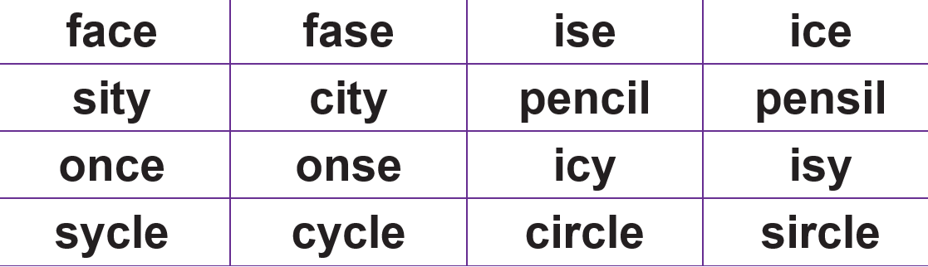 | Today we are going to have a practise at our handwriting. Using the homophones from Monday write each of these 10 times on a line. Ensure that the ascenders (l, h, b and d are tall). | To show you know what each of the homophones mean put each one into a sentence. Try to include and adjective and a conjunction in each sentence and practise them until your handwriting is beautiful. | Please do the word search below with the common exception words.
Easier:  Do as many of the above activities as you can. If you are finding some of the activities challenging, try these as they are a little easier:  Please see the activities below.  If you have time, try writing numbers to 10 in your best handwriting.  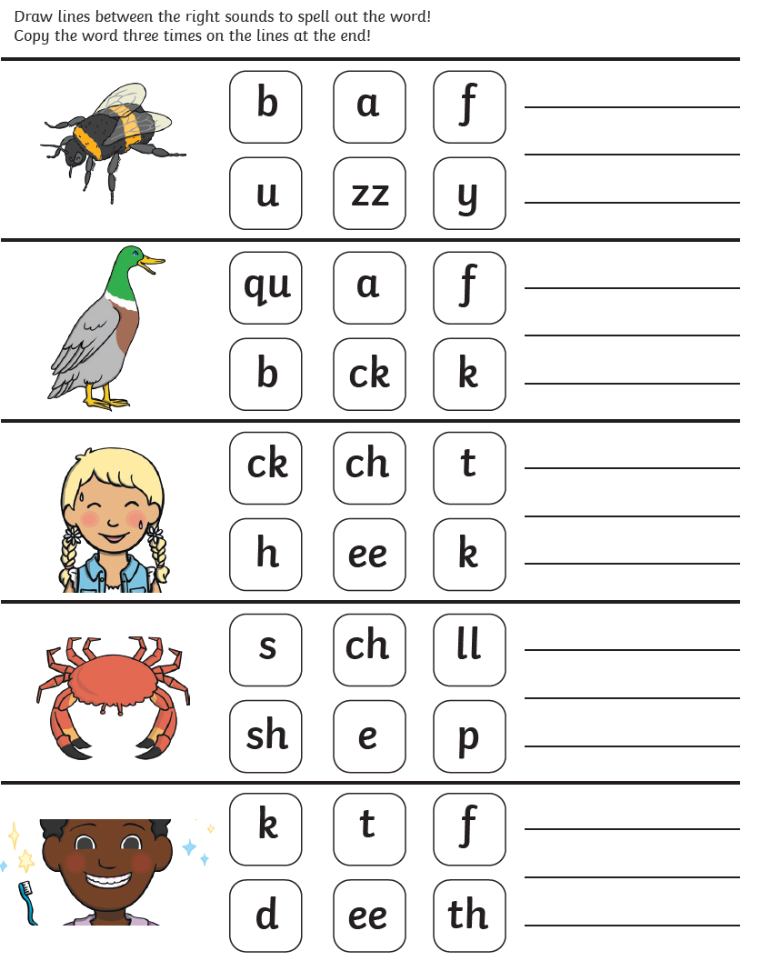  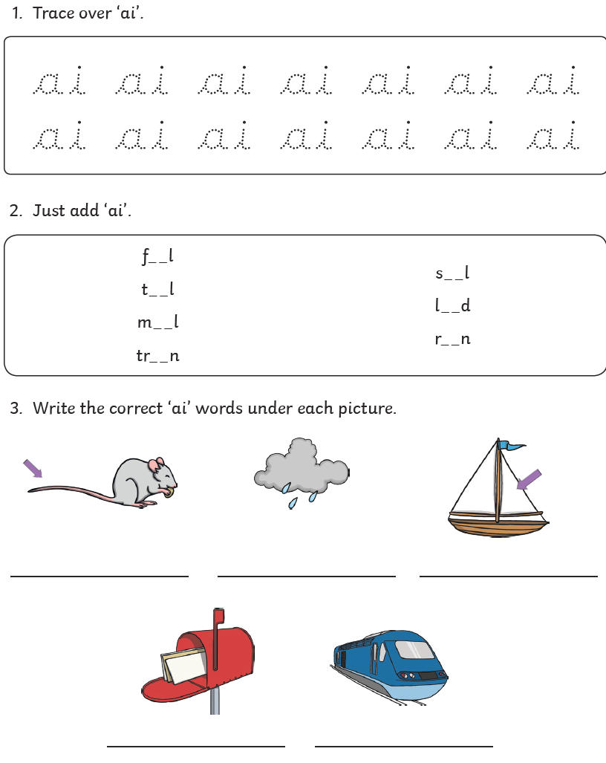 |  | Challenge:  If you feel you need a further challenge, try these:  Task 1  We are going to look at the homophone which can be spelt 3 different ways. to, two and too. Try saying each of these in a sentence to show you know what they mean.  Task 2  Now write each of them into a sentence and remember to be careful with your handwriting.  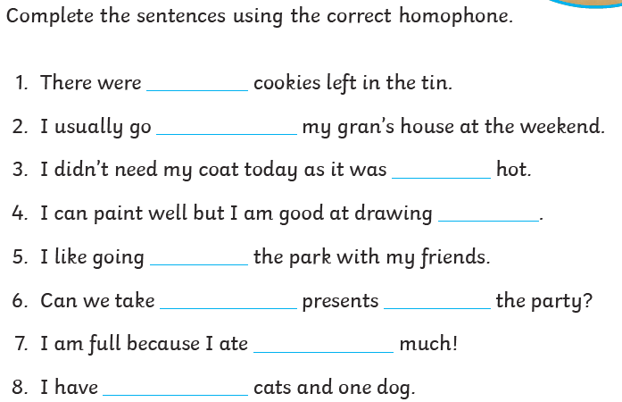  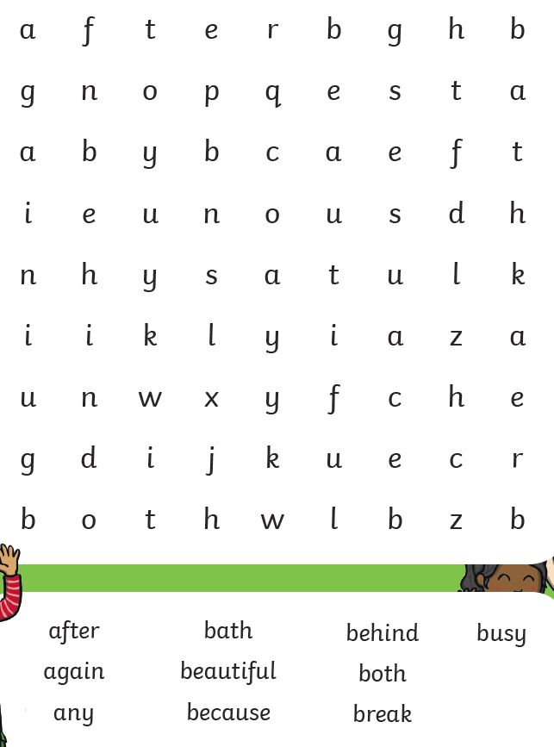  Task 3
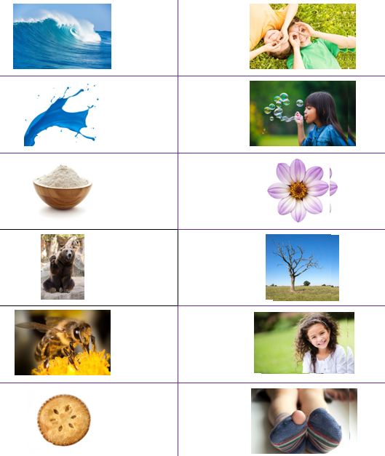

Maths Home Learning
Monday | Tuesday |  | Wednesday
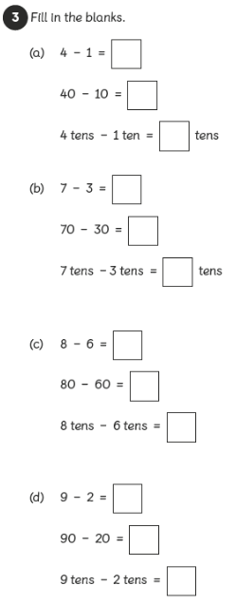 | 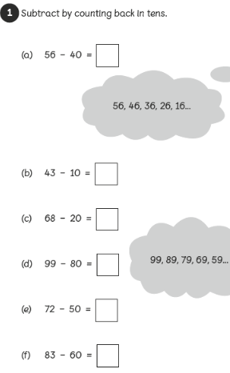 |  | Solve these word problems:  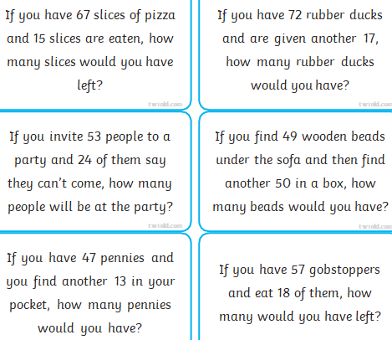
Thursday |  | Friday
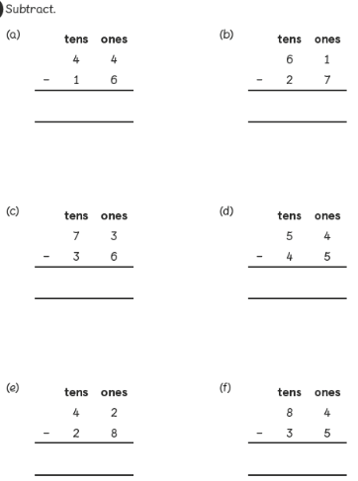 |  | 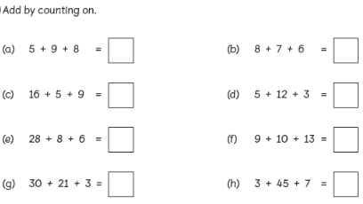

Easier:  Do as many of the above activities as you can. If you are finding some of the activities challenging, try these as they are a little easier:  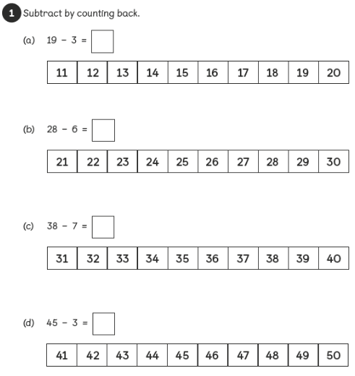  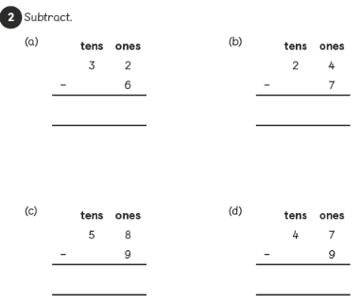 | Challenge:  If you feel you need a further challenge, try these:  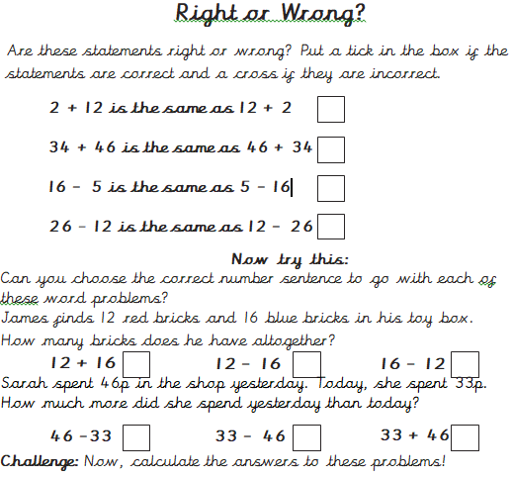

Theme Home Learning
Monday | Tuesday | Wednesday |  | Thursday | Friday
Science  Complete the ‘Habitat’ information in the boxes below: | Science  Complete the quiz below about the importance for people to do exercise: | Art  Use your art skills and imagination to create an under the sea scene image. |  | Music  Match the musical instruments words and pictures below. | Science  Draw some pictures in the bubbles below to show when it is important to wash your hands.
Easier:  Do as many of the above activities as you can. If you are finding some of the activities challenging, try these as they are a little easier:  Word Search |  |  | Challenge:  If you feel you need a further challenge, try these:  Describe and explain:  - 5 benefits of exercises  - 4 different types of exercises  - 3 tips for people who struggle to exercise

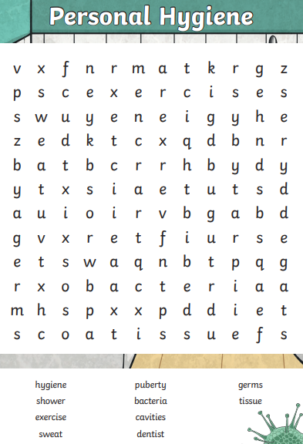

Science-
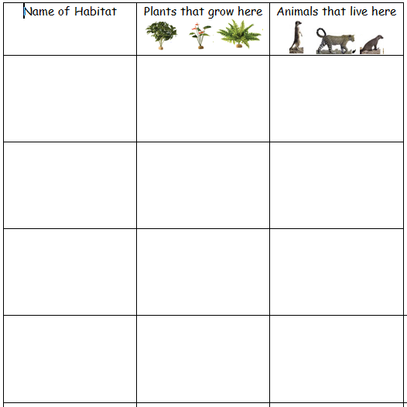
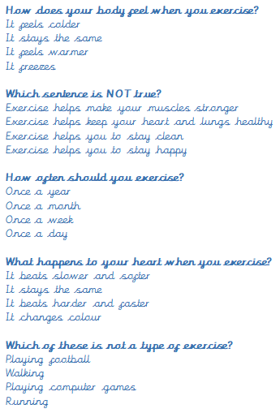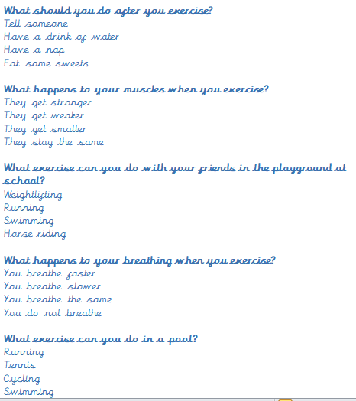
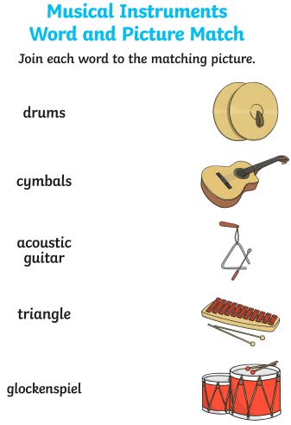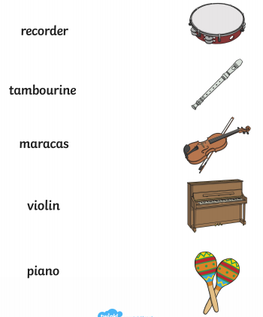
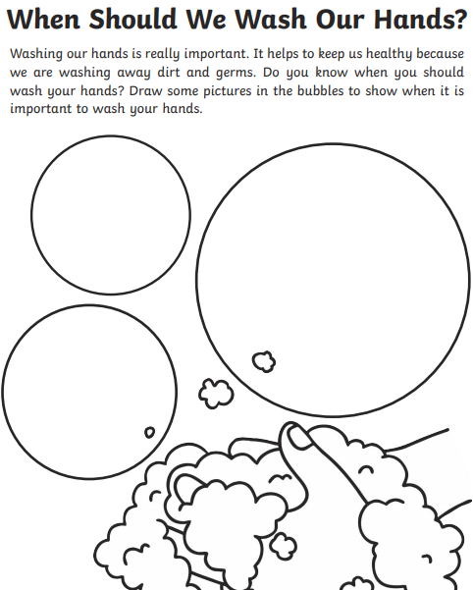
Other Activities
Art  Andy Goldsworthy was an artist who used natural materials. Use some natural materials to create a piece of art.  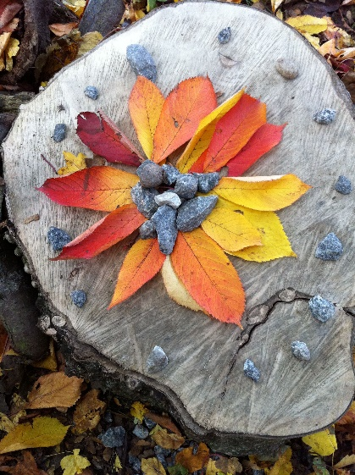 | PSHE  Draw a picture of all the people in your lockdown bubble. What’s the nicest thing about them? What are they good at? What have you enjoyed doing together? What will you do together in the future? | History  What do you remember about the Great Fire of London? When did the fire start? Where did it start? How did it start? What did the people do to stop the fire? Who wrote a diary? What did write about? 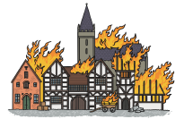 | Geography  Draw a tree in summer, autumn, winter and spring. Use some weather symbols to show the weather in each season.  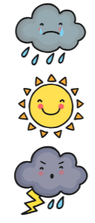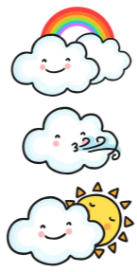

Science
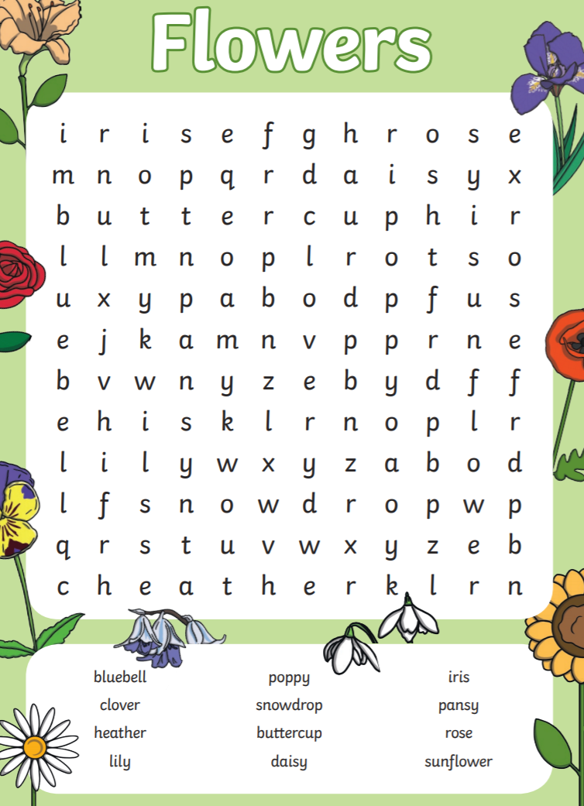

Key skills to continue practicing weekly:
- Times Table Rock Stars – I have checked and not many of you are doing this and it is fun to do plus keeps your skills going. If you have forgotten your log on details, then just email the school.
- Oxford Owl – lots of books to read
- Telling the time throughout the day to the nearest 5 minutes
- Play shops and work out the change
- Common exception words both reading and spelling

If you are able to access the internet, try these useful websites:
- https://www.bbc.co.uk/bitesize/primary
- https://www.bbc.co.uk/bitesize/clips/z4tmhyc
- New lessons are uploaded every day for children to interact with
- https://scratch.mit.edu/
- A chance to have a go at computer programming and create your own games, all completely free.
- Plus remember to check the list of other useful websites which are under home learning on a separate sheet.

If you or your child has any further queries regarding their learning projects, please contact admin@hardwick.derby.sch.uk, clearly stating your child’s name and class teacher, and the staff will be in touch to support you and your child.
Thank you and stay safe.

