Year 4 Home Learning
Week Commencing: 6th July 2020
Year 4 teachers: Mrs Haslam, Mrs Tatla, Mrs Jogela and Miss Annable
Year 4 TAs: Miss Perry and Mrs Smith
Message from staff: Hi Year 4, we hope that you are all well and keeping safe. Even though we are not teaching you, we are thinking about you and working very hard to provide fun activities for you to complete at home. We have enjoyed teaching you over the phone. If you struggle with any of the work, please remember to ask for help when we make our weekly phone call. We hope you are taking some time out of the day to get fresh air and spend time with your family.

Your Home Learning this Week:
Every day (Monday to Friday), make sure you choose a *reading, *writing, *spelling/handwriting, *maths and *theme learning activity. There are also further activities to choose from should you wish to.

Reading Home Learning
Monday | Tuesday | Wednesday |  | Thursday | Friday
Monica the Monitor  Read Childhood Tracks Using reading skills to help you understand as you go through it. Highlight any words you do not understand and find the meaning of them. | Colin and Carmen the Connectors  Text-to-self.  As you read the text, what are your thoughts?  Does this text remind you of anything? What does it remind you of? | Quentin the questioner  Write 5 of your own questions to ask a family member. Use the text – Childhood tracks to help you. Ask them to read the text then answer your questions.  1)  2)  3)  4) |  | Monica the Monitor: Question Zap!  On your own, answer the questions on page 4. | Monica the Monitor: Crack it!  With an adult, go through the questions together, highlight where you found your answers in the text.
Easier:  Do as many of the above activities as you can. If you are finding some of the activities challenging, try these as they are a little easier:  - Listen to an adult read the text- Childhood Tracks  - Discuss the meaning of words that you do not understand. |  |  | Challenge:  If you feel you need a further challenge, try these:  - Can you write a similar poem?

Reading Resource- Childhood Tracks Text
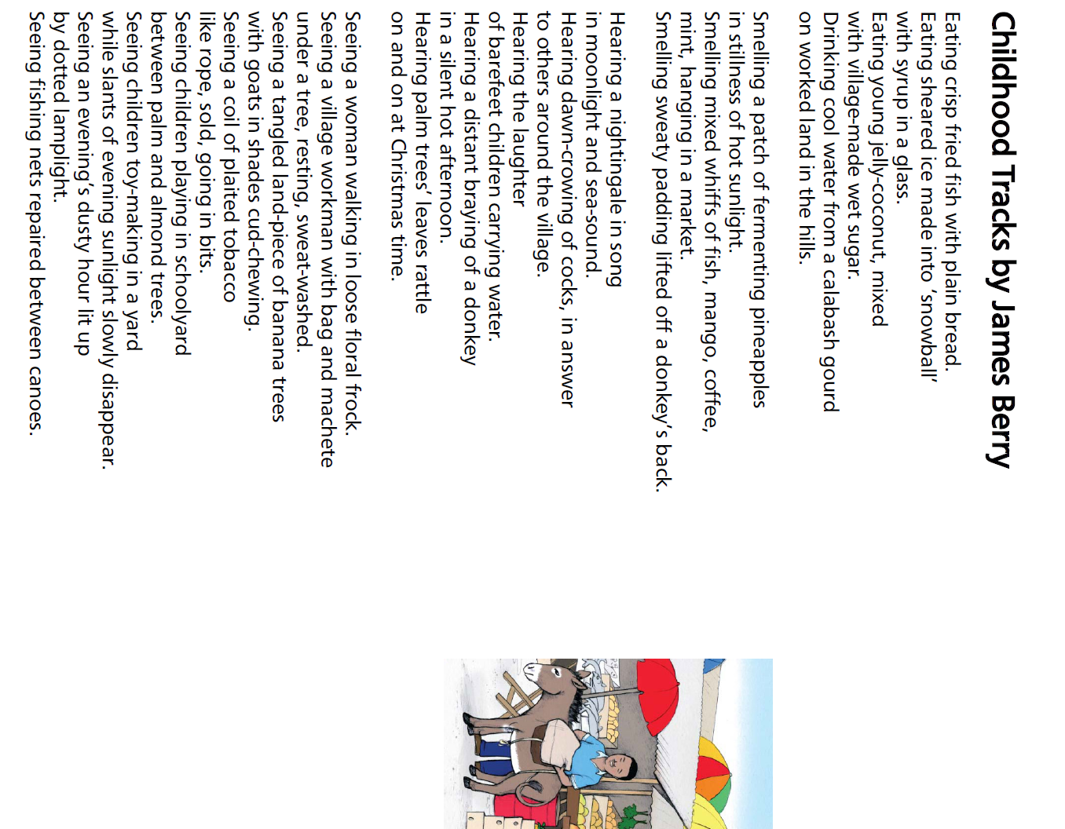
Reading Resource- Childhood Tracks Questions
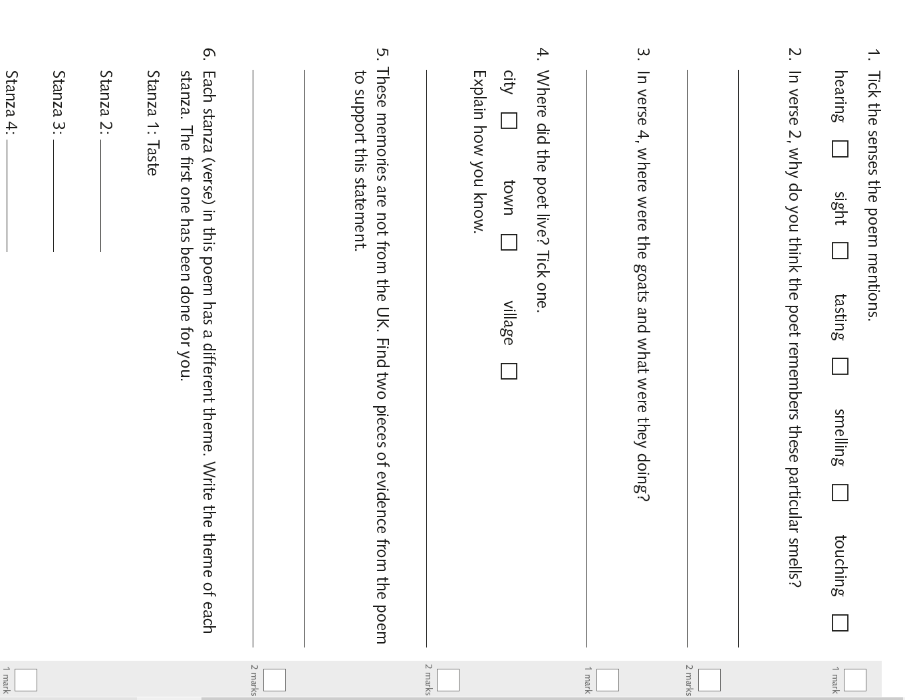
Writing Home Learning – Non Chronological Reports
Monday | Tuesday | Wednesday |  | Thursday | Friday
This week, you will be planning and writing your own non-chronological report on an animal of your choice.  Task- Choose an animal and ask a adult who you live with to help you research facts about the animal. Use the planning sheet on the next page to record your notes.. If you don’t have access to the internet, choose between the two animal fact sheets in this booklet. |  | Now it’s time to write your Non-chronological report.  Let’s start by writing the first paragraph.  Use the teacher example for paragraph 1 and 2 to help you. |  | Use the teacher example for paragraph 3 and 4 to help you. | Use the teacher example for paragraph 5 to help you.  Read through your work and use the checklist to check that you have included the correct features.
Easier:  Do as many of the above activities as you can. If you are finding some of the activities challenging, try these as they are a little easier:  - Ask an adult to help you research an animal of your choice. Or ask an adult to help you read the example text about killer whales in the pack.  - Try making notes on the planning sheet on the next page. Then write a sentence for each subheading- definition, appearance, habitat and feeding habits. |  |  | Challenge:  If you feel you need a further challenge, try these:  Research a second animal and create a fact file.

Planning sheet for your report
What is the animal?  What is it known for? | Third person (they)  Present tense (are, has, is)  Expanded noun phrase | Definition
What do they look like?  What shape is its body?  Does it have fins? A tail?  What is their skin like? What colour is the animal? | Third person (they)  Present tense (are, has, is)  Key facts (measurements)  Technical vocabulary  Punctuation- ? , .  Commas in a list  Conjunction openers  expanded noun phrases | Appearance
Where do they live? Why Are they found here?  Why do they move from place to place? | Third person (they)  Present tense (are, has, is)  Punctuation- ? , .  Conjunction openers  Fronted adverbials  -Verbs, Adverbs, When? Where?  Technical vocabulary | Habitat
What do they feed on?  (meat or plants)  How do they feed?  Do they hunt?  When do they eat? | Third person (they)  Present tense (are, has, is)  Punctuation- ? , . ABC  Commas in a list  Conjunction openers-while, when  Fronted adverbials  - Adverbs, When? Where?  Technical vocabulary | Feeding habits
Has the animal ever been hunted to the brink of extinction?  How has this affected the populations?  How is the animal affected by pollution? | Third person (they)  Present tense and past tense (are, has, is, was hunted)  Punctuation- ? , . ABC  Commas in a list  Conjunction openers  -When, If, After, While  Fronted adverbials  -Adverbs,  Technical vocabulary | Conclusion

Teacher example (paragraph 1 and 2) Teacher example (paragraph 3 and 4)
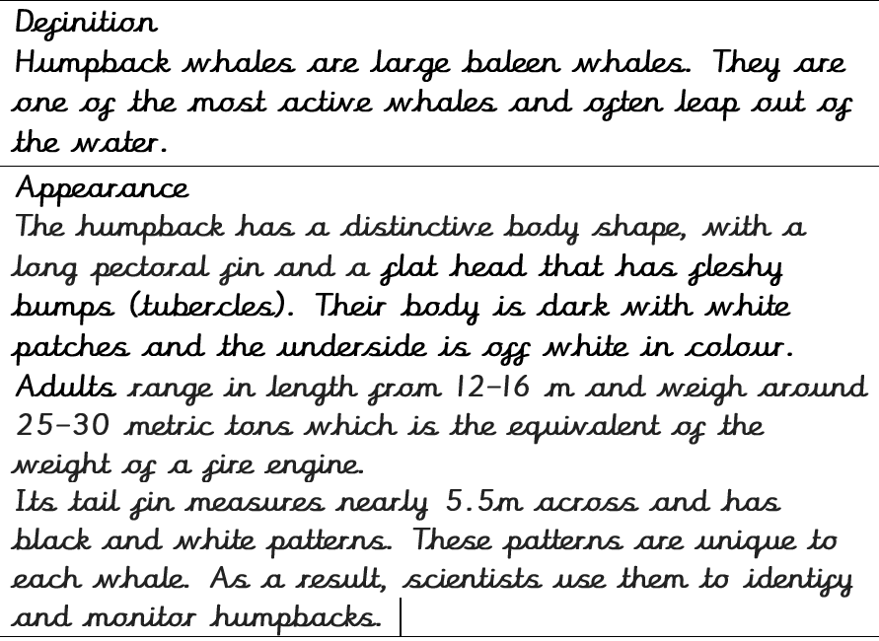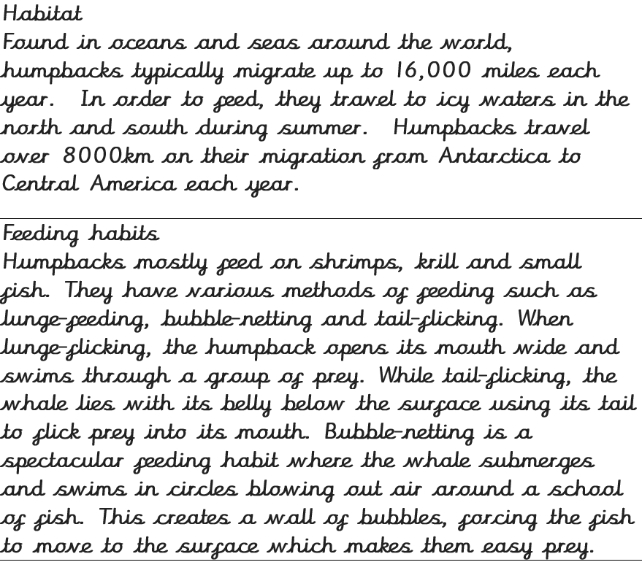

Teacher example (paragraph 5)
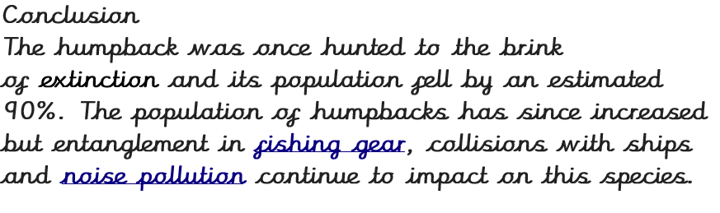

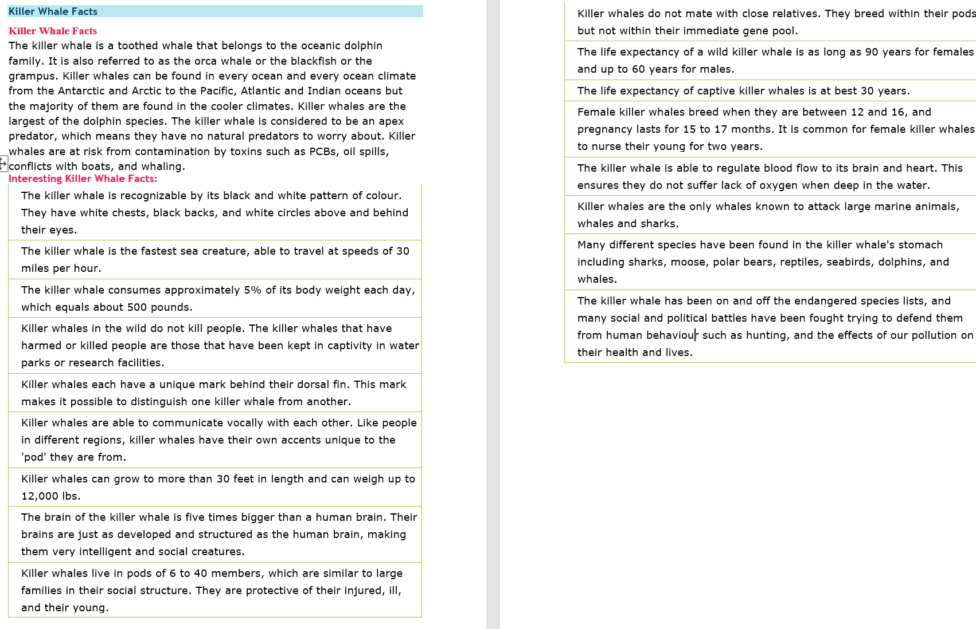
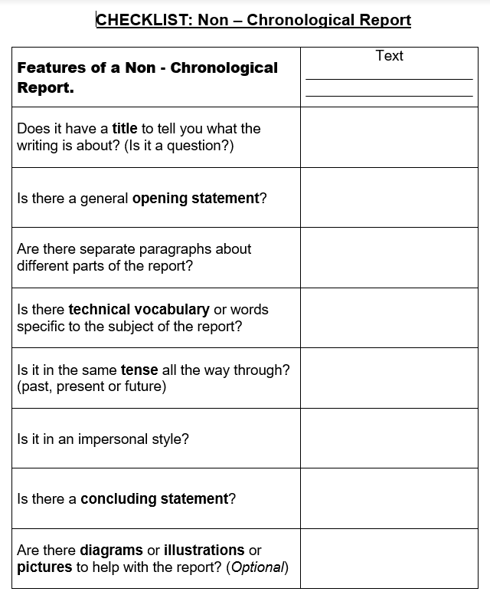
Spelling/Handwriting Home Learning
Monday | Tuesday | Wednesday |  | Thursday | Friday
Monday  Choose the next 10 spellings on your list that you struggle with or use the spellings below:  breath enough island  build exercise knowledge  busy experience learn  business extreme length  Spelling Pyramids. | Tuesday  Race how many times you can write each word in 1 minute with a family member. | Wednesday  Write a sentence for each spelling.  Try using different sentence types:  Simple- I was in a car accident.  Compound-I was in a car accident but I wasn’t hurt.  Complex-Although I was in a car accident, I wasn’t hurt. |  | Thursday  Choose a paragraph from your favourite book and write it out using the school handwriting style. Ensure you join letters correctly. | Friday  Spelling quiz!  Ask a family member to test you on your spellings.
Easier: Year 1 and 2 Key Words (Statutory Words)  Do as many of the above activities as you can using the spellings below.  eye  people water who  whole  again  half money  parents  Mr Mrs  Christmas |  |  | Challenge:  If you feel you need a further challenge, try these:  - List these words in alphabetical order:  variety communicate especially leisure queue vegetable vehicle yacht variety  communicate especially leisure queue vegetable  vehicle yacht  - Use the words above to practise your handwriting.  - Write a sentence for each of the words above.
Maths Home Learning
Monday | Tuesday | Wednesday | Thursday |  | Friday
Practise your times tables and division facts. Once you know them test your understanding by getting someone to ask you them and see how many you can answer correctly in 1 minute. Then do the same with the division facts. | Complete Worksheet 1  Addition  Choose easier or harder worksheet. | Complete Worksheet 2  Subtraction  Choose easier or harder worksheet. | Complete Worksheet 3  Multiplication  Have a go at Worksheet 3. |  | Complete Worksheet 4  Division  Have a go at Worksheet 4.
Easier:  Do as many of the above activities as you can. If you are finding some of the activities challenging, try these as they are a little easier:  - Practise counting on in 2s, 5s and 10s  - Learn the following times tables: 2s, 5s, and 3s.  - Ask a family member to test you on your tables. |  |  |  | Challenge:  If you feel you need a further challenge, try these:  - Learn addition and subtraction facts for your 16, 17 and 18 times tables.  - Write down all of the factors for 54  - If a 4 sided shape has a perimeter of 54, what could the length and width measure?  List all the possibilities.

Worksheet 1 Addition
Easier Harder
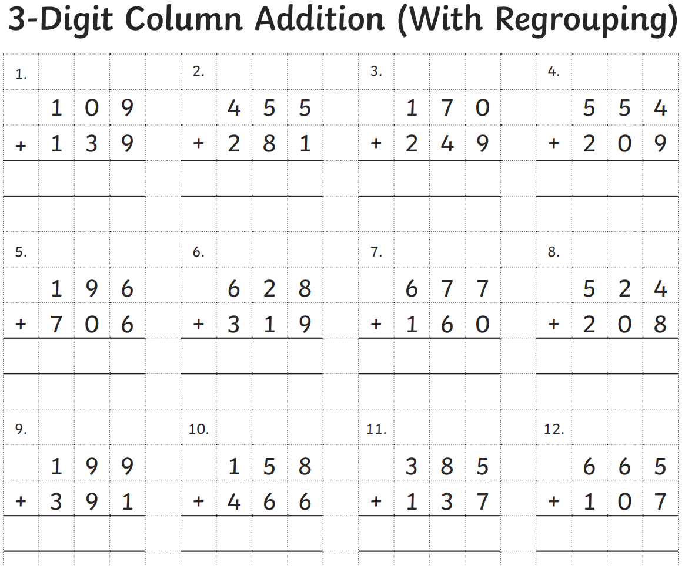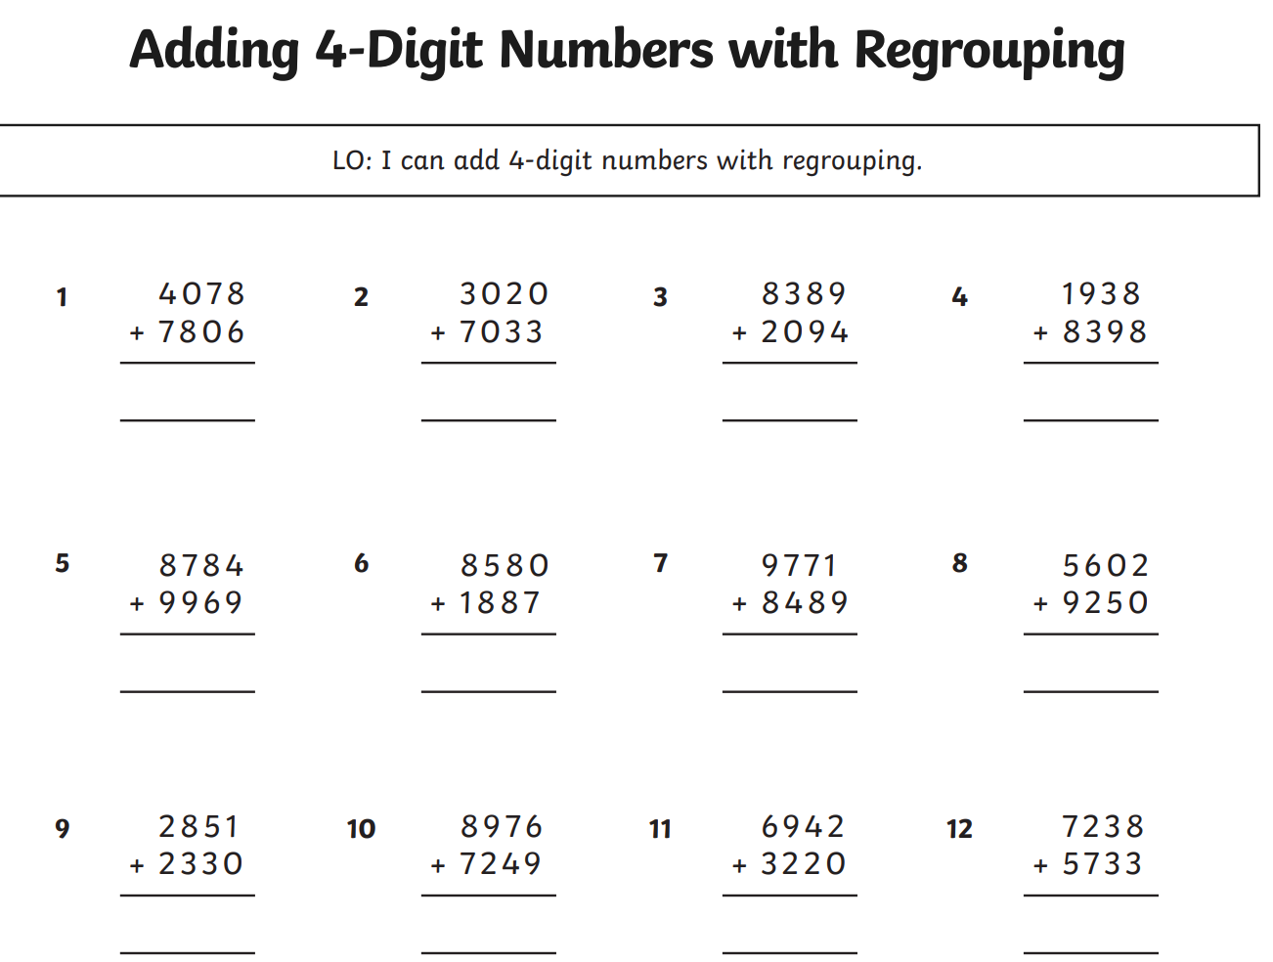

Worksheet 2- Subtraction Here is a quick reminder of a method that you can use.
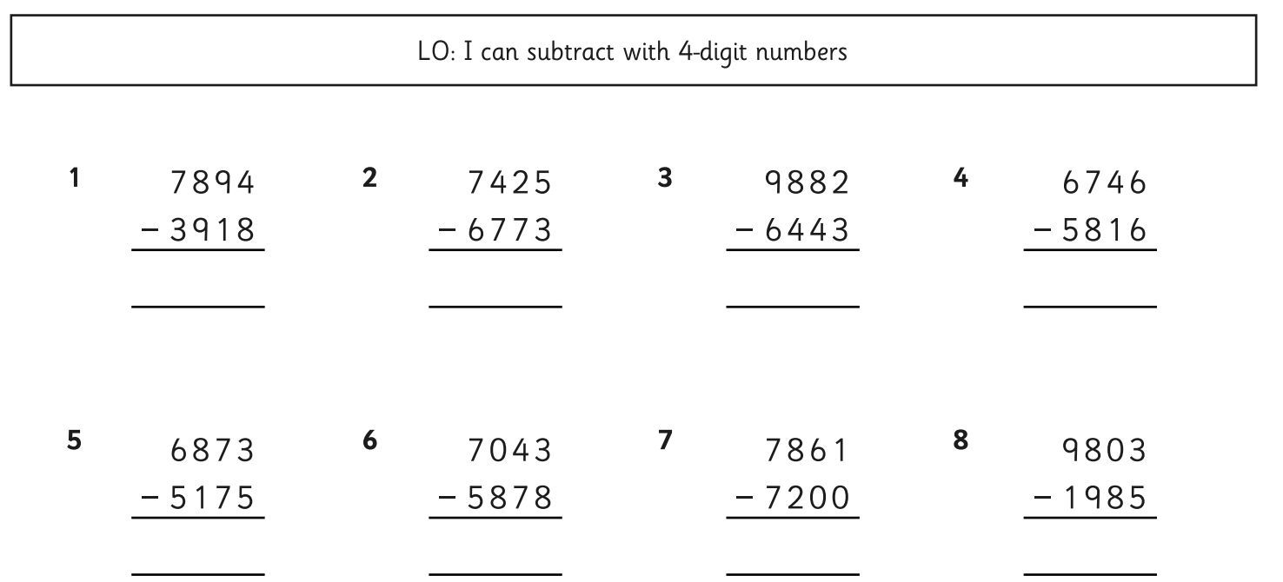

Easier
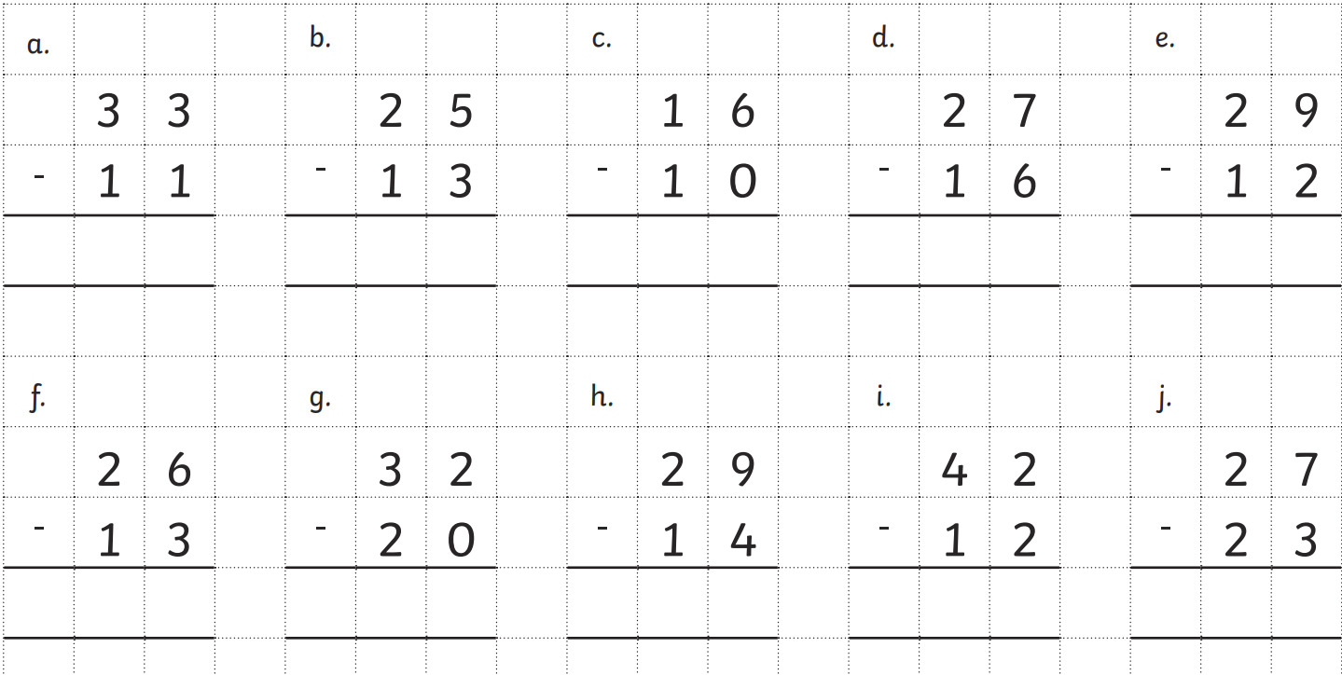
Worksheet 3 -Multiplication
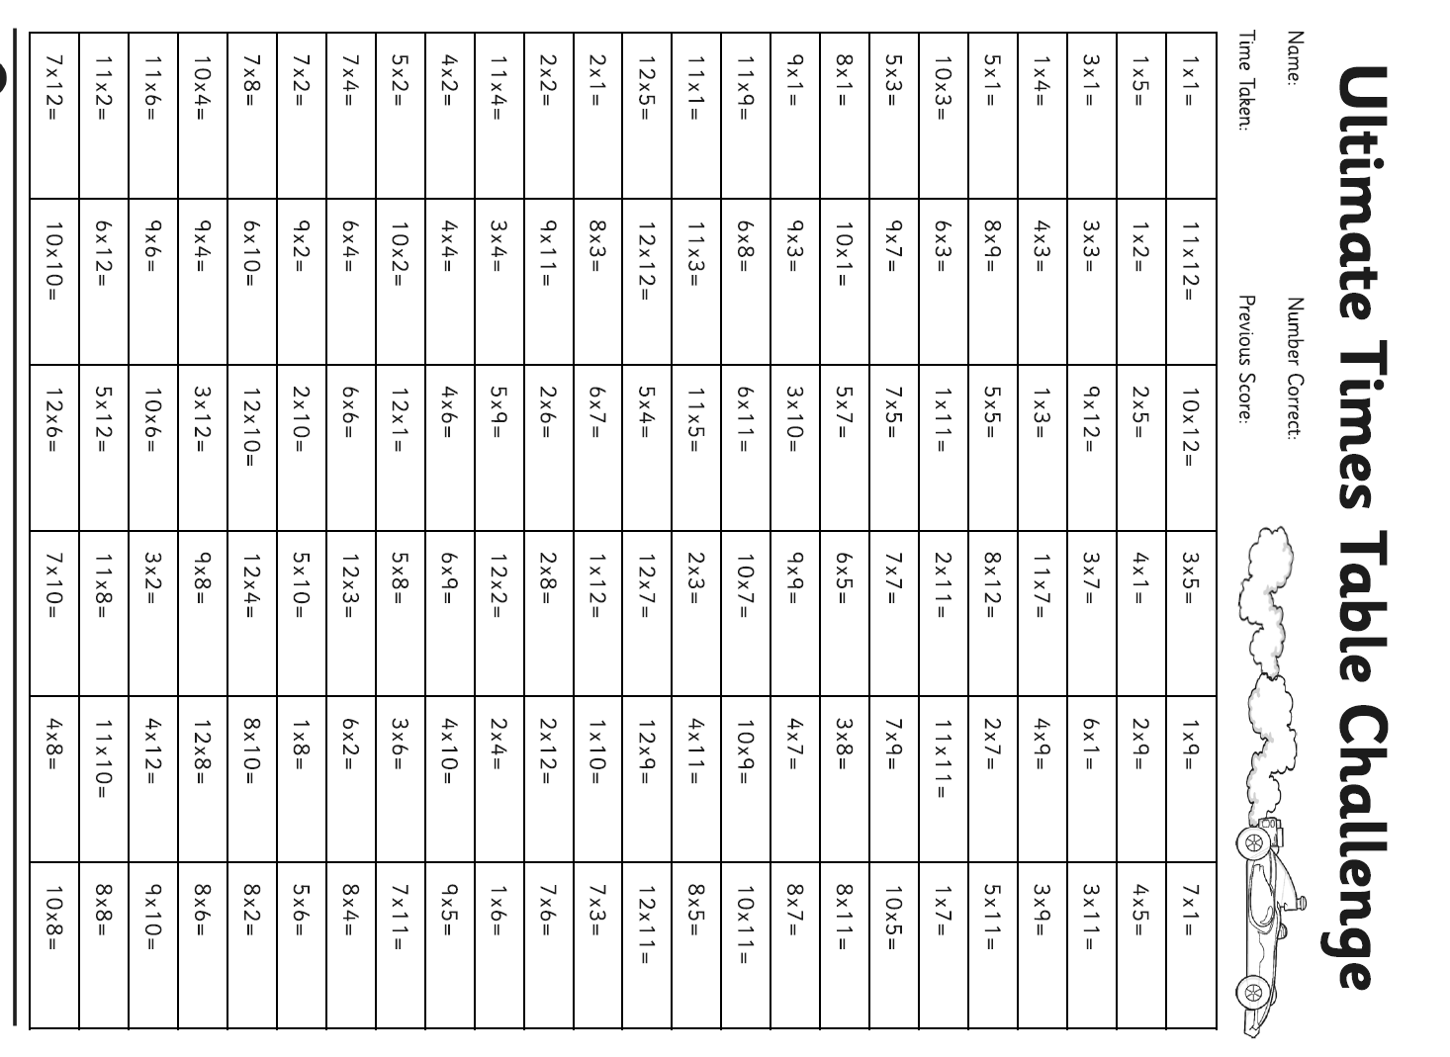
Worksheet 4-Division
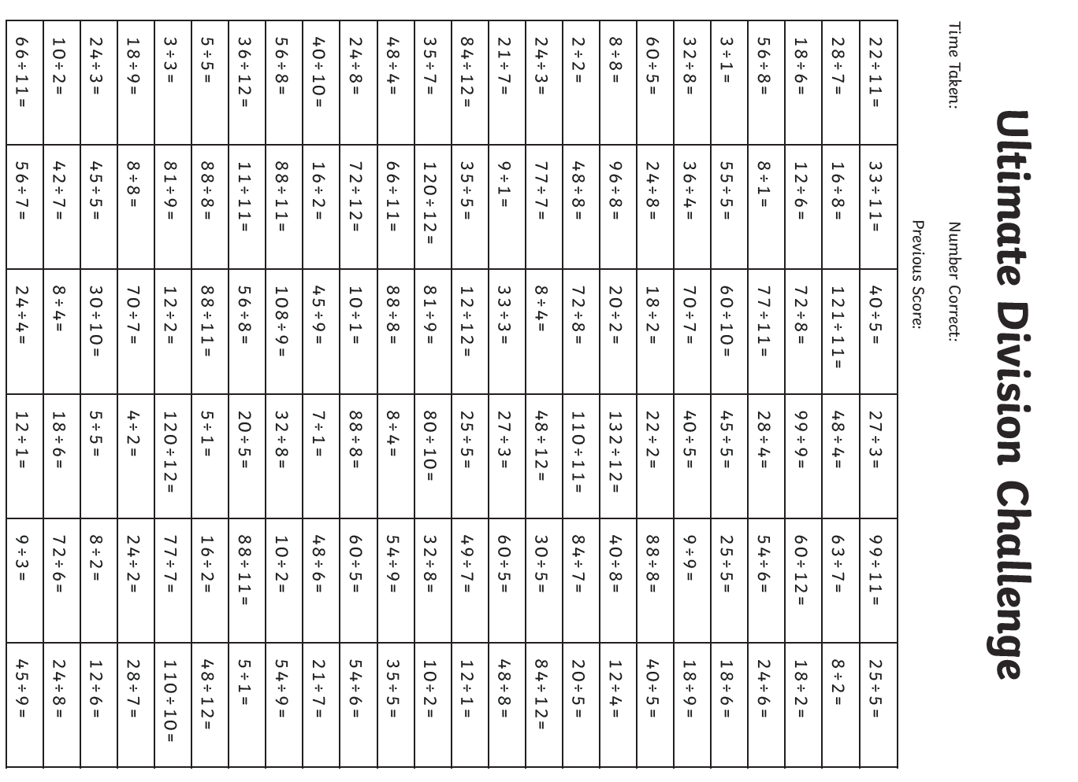

Theme Home Learning
Monday | Tuesday | Wednesday |  | Thursday | Friday
PE-Challenge Yourself  - How many jumping jacks can you do in one minute?  - Is your score increasing each week? | Science Investigation  This week you will  carrying out an experiment to see how sounds are produced by vibrations.  Ask an adult to help you carry out the investigation using the science sheet in this home learning pack.  (You may be able to use a pot and pan to make your sound if you don’t have an instrument.) | History  Use the Viking Rune Writer to write like the Vikings and create a special message using runes. |  | History  Use the worksheet in this pack to design a Viking shield. | PE-Challenge Yourself  Can you beat your time from last week? (Number of jumping jacks in one minute)
Easier:  Do as many of the above activities as you can. If you are finding some of the activities challenging, try these as they are a little easier: |  |  | Challenge:  If you feel you need a further challenge, try these:  PE-How many press ups can you do in one minute?  French  Can you count to 20 in French?  Can you count to 100 in French?

Sound Investigation
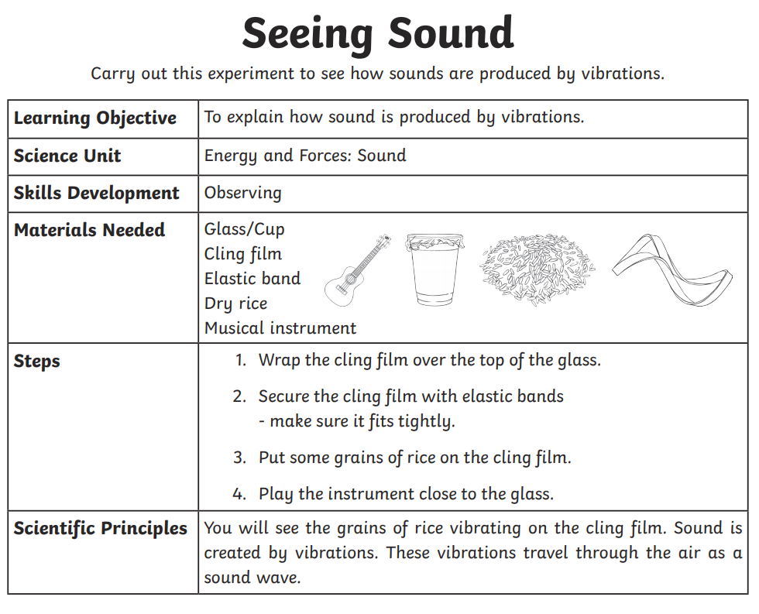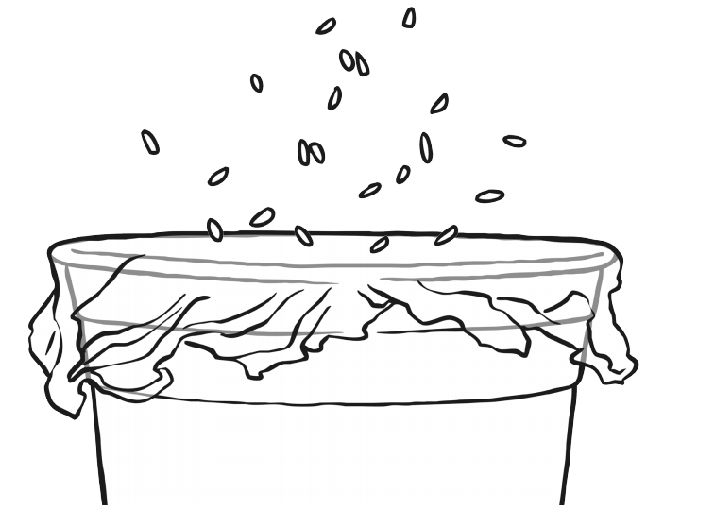

History-Vikings Rune Writing
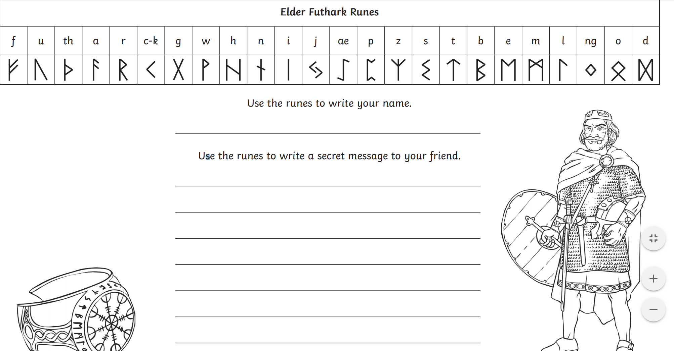

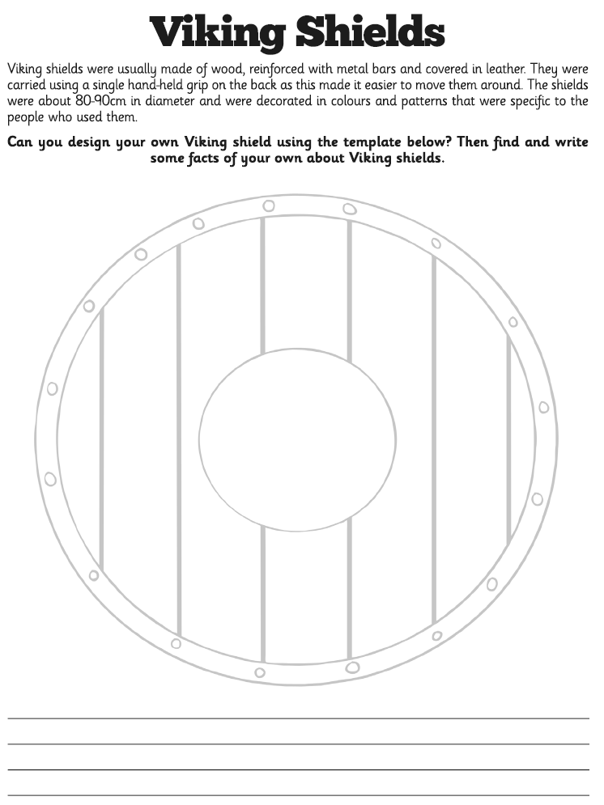
Other Activities
Start your day with Joe Wicks’ YouTube workout for kids live every morning at 9.00.  https://www.youtube.com/results?search_query=joe+wicks | You have 3 minutes to make as many words as you can from the letters below?  e d s t a f I u r w h n I og | Can you design a Maths board game. The questions could be on any of the topics that we have covered so far. | Extra Handwriting Practice  Spend 10 minutes practising your handwriting. | BBC Bitesize daily lessons for Year 4  (See timetable of which lessons are taught each day)  https://www.bbc.co.uk/bitesize/dailylessons
Key skills to continue practising weekly:
- Times tables (including division facts)
- Reading (This can be anything! Reading your favourite book again, reading magazines, sub-titles on the TV etc.)
- Watch Newsround everyday so you are keeping up-to-date with what is going on in the world.
If you are able to access the internet, try these useful websites:
- Reading: There is an online book of short stories written during lockdown by 100 authors, including Michael Morpurgo.
https://issuu.com/bloomsburypublishing/docs/thebookofhopes_interactivepdf/4?ff
- Timestable.co.uk
- Topmarks.co.uk
If you or your child has any further queries regarding their learning projects, please contact admin@hardwick.derby.sch.uk, clearly stating your child’s name and class teacher, and the staff will be in touch to support you and your child.
Thank you and stay safe.

