Year 6 Home Learning
Week Commencing: 18th May 2020
Year 6 teachers: Mrs Haider, Miss Qayoom, Mr Nowak
Year 6 TAs: Mrs Yar-Khan
Message from staff: It was lovely to catch up with you all again and speak to you. It is great to know that everybody is doing well. Keep safe and don’t forget to complete an hour of physical activity daily.
You should all now have your Purple Mash logins. Keep exploring the different features. We will begin to set work on this soon.
You should have received information about collecting booklets from school. If you are still experiencing difficulties, please get in touch.

Your Home Learning this Week:
Every day (Monday to Friday), make sure you choose a *reading, *writing, *spelling/handwriting, *maths and *theme learning activity. There are also further activities to choose from should you wish to.

Reading Home Learning
Monday | Tuesday | Wednesday |  | Thursday | Friday
Read the title “Ancient Oak Flattens School” and predict what the text is going to be about.  Write your explanation then read the text to see if you were right. | Summarise the main points of the text (VIPs) and write them down using bullet points. | Visualise the text and draw a picture to show what’s happening at Broad Oak Primary School. |  | Answer the first 5 questions and highlight the evidence in the text to support your answers. | Reading for pleasure  Read any book of your choice for 45 minutes.
Easier:  Do as many of the above activities as you can. If you are finding some of the activities challenging, try these as they are a little easier:  - Draw a picture of a school with a tree that fell on the top of the roof  - Find words you don’t understand and look them up in a dictionary  - Summarise the text in one sentence. |  |  | Challenge:  If you feel you need a further challenge, try these:  - Answer Q6 and Q7 and highlight the evidence in the text.  - Write your own article. Imagine something like that happened at Hardwick!  - Read a book of your choice for 1 hour
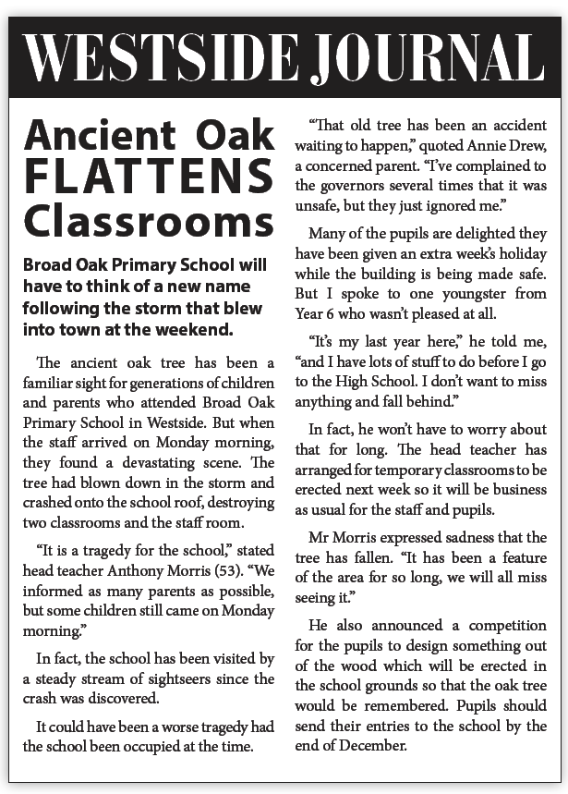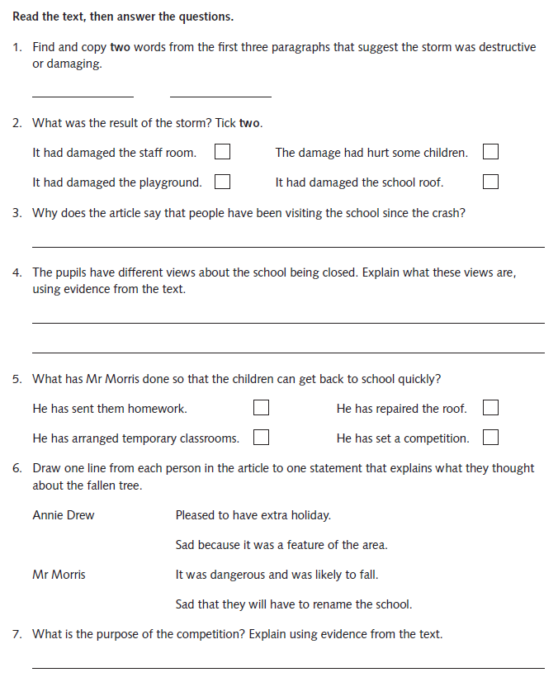
Writing Home Learning
Monday | Tuesday | Wednesday |  | Thursday | Friday
Read the extract 2 carefully and underline or highlight all the errors. | Read the story. What feedback would you give the writer of this story? Consider the questions below the text to help you. | Write a paragraph giving two (or more) things you liked about the story and suggesting four (or more) things they could do to improve it, with examples. |  | Look outside of your window and make a list of everything you can see. Then listen carefully and make a list of everything you can hear. Did you notice anything strange? | Write a short story about what it is like to be stuck at home during coronavirus.
Easier:  Do as many of the above activities as you can. If you are finding some of the activities challenging, try these as they are a little easier:  - If you’re a little anxious about your proofreading skills, try the first extract.  - Use a dictionary, if necessary  - Instead of writing a whole paragraph, you could write just a few sentences explaining what you liked about the story |  |  | Challenge:  If you feel you need a further challenge, try these:  - Rewrite one of the extracts with all your corrections.  - Rewrite the story (with your improvements)  - Use similes, metaphors, adverbial phrases and

Extract 1:
Wood you spend ours watching some-one playing video games
If you has a young person in your house its unlikely that your unaware of the latest gaming phenomenon – Fortnite.
published by Epic Games and with over 125 million players, Fortnite will be a single or multi-player survivle game set on modern-day earth Thanks to a sudden worldwide storm, most of the worlds population has been wipe out and those people remaining face attack from zombie-like creatures. Players worked together on mishuns to collect resources and build fortifications weapons and traps to defending themselves against the uprising

Extract 2:
Wood you spend ours watching some-one playing video games
If you has a young person in your house its unlikely that your unaware of the latest gaming phenomenon – Fortnite.
published by Epic Games and with over 125 million players, Fortnite will be a single or multi-player survival game set on modern-day earth. Thanks to a sudden worldwide storm most of the worlds population has been wiped out and those people remaining face attack from zombie-like creatures. Players worked together on missions to collect resorces and build fortificacions weapons and traps to defending themselves against the uprising
Whilst the popularness of such a game may not be surprising, what could be considered surprising is the popularity of watching gamers in action via online streaming platforms such as Twitch. emmett shear co-founder of Twitch compares watching gamers to watching sports stars or chefs on TV: ‘You're enjoying watching someone whose really great at it with some entertainment at the same time.
Twitch is a free service, but many chooses to subscribe to other platforms to watch the top gamers like Ninja, who makes millions streaming his live Fortnite action. ‘The people who makes the most money surprisingly aren't necessarily the best gamers, their often the ones who are most entertaining,’ explains Shear. ‘Ninja is a prime example….very high energy, very entertaining to watch.’
Weather you’re keen to watch or, like me, it sounds about as interesting to you as watching paint dry, it looks as though Fortnite and it’s live streamers are here to stay. At least until the next gaming phenomenon sweeps the world.
My story
One day, Jack was playing on his Xbox when he got sucked into the game. He didn’t know what to do. He looked around and saw a tunnel. A demon began chasing him as he ran towards the tunnel. Luckily, he was fast and got into the tunnel before he was caught. He ran down the tunnel and it brought him back home. The end.
1. Was the main character well-developed?
2. Did the writer set the scene well?
3. Was there a good plot?
4. Was the problem interesting or exciting?
5. Was the resolution imaginative?
6. Did the ending explain everything?
7. Was the vocabulary interesting and varied?
8. Did the story have a clear structure?

Spelling/Handwriting Home Learning
Monday | Tuesday | Wednesday |  | Thursday | Friday
Learn the following words. Use the ‘Read, cover, write, check’ method.  SILENT T  fasten  hasten  glisten  moisten  nestle  thistle  whistle  wrestle  bustle  soften | Learn the following words. Use the ‘Read, cover, write, check’ method.  You can use this rule: Use -ent, -ence, -ency after soft c /s/ sound or soft g sound. Remember some words with these endings do not follow this rule.  innocent  innocence  decent  decency  frequent  frequency  confidence  obedience  independent  independence | Learn the following words. Use the ‘Read, cover, write, check’ method.  necessary  collection  channel  substance  tolerance  appearance  frequency  confidence  decent  thistle  independence  innocent |  | Learn the following words. Use the ‘Read, cover, write, check’ method.  nuisance  language  significance  reluctance  importance  communicate  government  annoyance  assistance  resistance  controversy  signature  whistle | ASSESSMENT  Ask someone in your family to test you. 10 random words.
Easier:  Do as many of the above activities as you can. If you are finding some of the activities challenging, try these as they are a little easier:  - Use a dictionary to make sure you understand each word  - Try the following words:  eight  arrive  breath  circle  fruit  guard  height  often  popular  eighth |  |  | Challenge:  If you feel you need a further challenge, try these:  - Write a story and try to include as many words from your spelling list as possible.  - Write a poem using some of the words above

Maths Home Learning
Monday | Tuesday | Wednesday |  | Thursday | Friday
Remind yourself about how to work out a percentage amount. (÷ by 100 and multiply by the % amount- see example below).  Find a catalogue and find the prices for 5 items. Round to the nearest whole pound.  Now, imagine everything has been reduced by 30%. Find the new price of the items. | Ask a parent to show you a receipt of the weekly shopping. Use the items to make up % word problems.  A pack of PG tips cost £3.65. Find the new price if it is reduced by 25% and 35%. | Complete learning activity 1. |  | Complete learning activity 2 | Complete learning activity 4
Easier:  Do as many of the above activities as you can. If you are finding some of the activities challenging, try these as they are a little easier:  -Find a catalogue and find the prices for 5 items. Round to the nearest whole pound.  Now, imagine everything has been reduced by 50%. Find the new price of the items.  - Choose a challenge and complete learning activity 5  - Choose a challenge and complete learning activity 6 |  |  | Challenge:  If you feel you need a further challenge, try these:  -Find a catalogue and find the prices for 5 items. Round to the nearest whole pound.  Now, imagine everything has been reduced by 35%. Find the new price of the items.  - After completing learning activity 2. Make up your own word problems similar to these.  - Complete learning activity 3  - After completing learning activity 4. Make up your word problems similar to these.
Example of how to work out % amounts. Learning activity 1
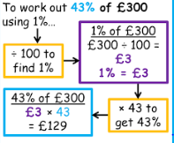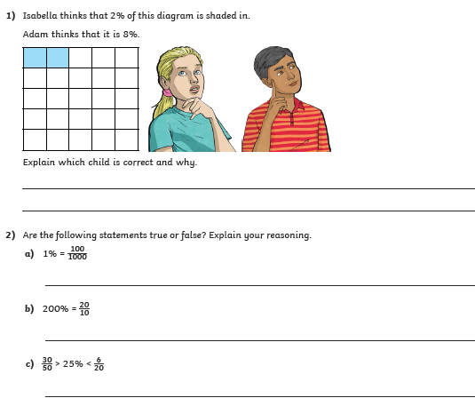
Learning activity 2
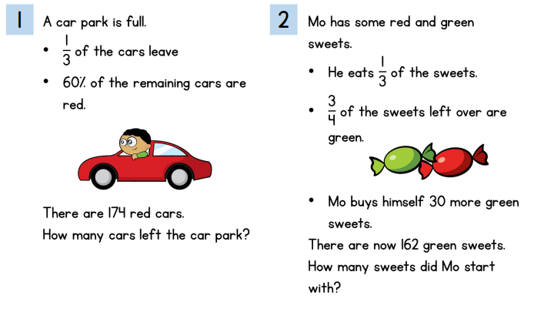

Learning acvtivity 3
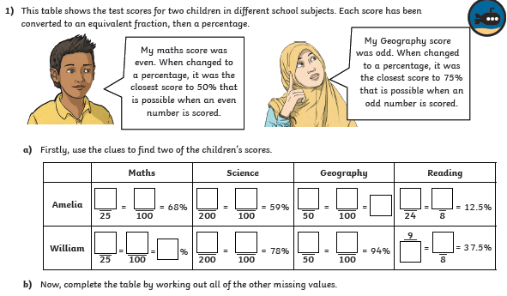
Learning activity 4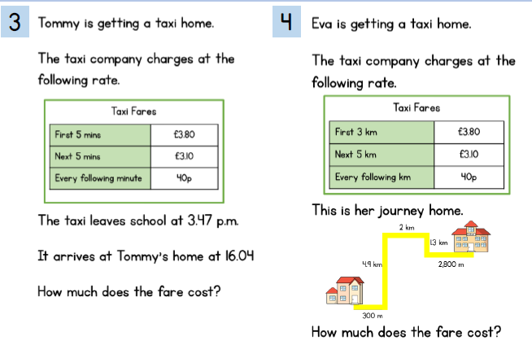

Answers for learning activity 3
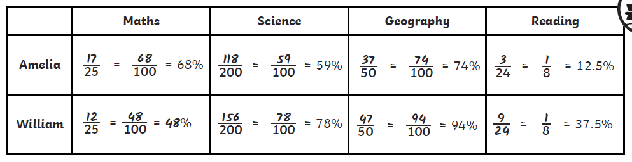

Learning activity 5 and 6
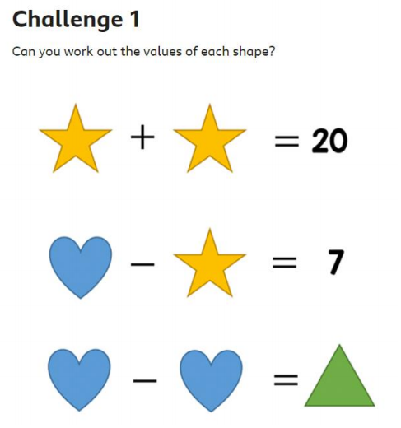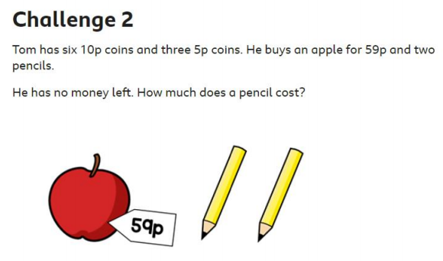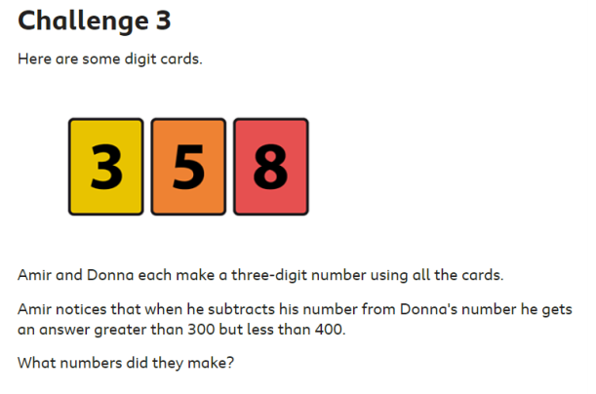
Theme Home Learning
Monday | Tuesday | Wednesday | Thursday |  | Friday
PSHCE/ICT  Online safety laws  Read the article on safety laws. Read the text carefully and answer the questions.  (See the differentiated activity sheets: easier, Year 6 and Challenge). | Science  Use the information to understand what food chains and food webs are. Look carefully at the direction the arrows are placed.  Complete the differentiated sheets on food chains. | Science  Use a range of materials e.g. tissue paper, card, pipe cleaners etc and create a food web. Choose an ecosystem of your own choice. | RE  Complete the Venn diagram by comparing your own beliefs to that of Buddhism. |  | PE  Dance  See PE (sheet given last week for homework. Use the same sheet).  Complete any 5 activities to complete with a family member
Easier:  Do as many of the above activities as you can. If you are finding some of the activities challenging, try these as they are a little easier:  - Science complete easier worksheets.  - Ask an adult to support you make a food web. Look at the examples given to help you decide on the ecosystem you wish to choose.  - Make your own food chains and food webs (choose your own ecosystem).  - ICT Online safety laws. Explain what you learnt about internet safety by reading the article.  - RE Ask an adult or an older sibling to help you complete the Venn diagram and for any ideas.  Draw a Venn diagram and compare Buddhists beliefs with your own religious beliefs.  - PE Complete any 4 activities to complete with a family member. |  |  |  | Challenge:  If you feel you need a further challenge, try these:  - Science complete all science sheets starting from easier to challenge  - Make a 3D model of a food web in an ecosystem of your own choice. You can use any materials you wish.  - ICT Summarise the article by writing a paragraph  RE Can you think of at least 8 things for each part of the Venn diagram?  - PE Dance  - Complete all 6 activities on the sheet with a family member.

Easier/Year6/Challenge
PSHCE/ICT Internet safety
Read the text below and answer the questions on the next page.
Easier
What did you learn by reading the article?

Year 6
Challenge

Science

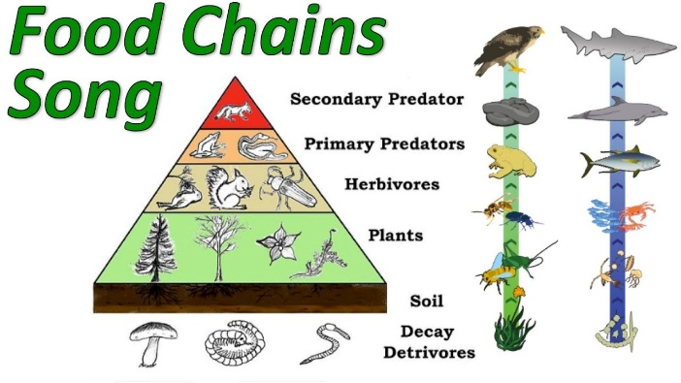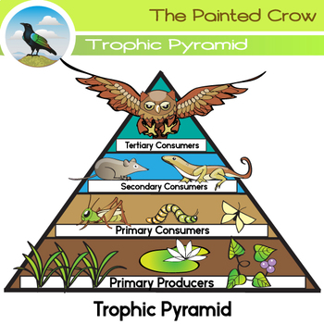

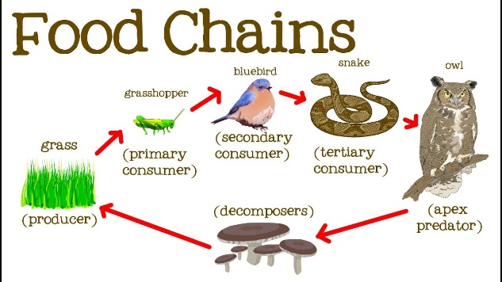

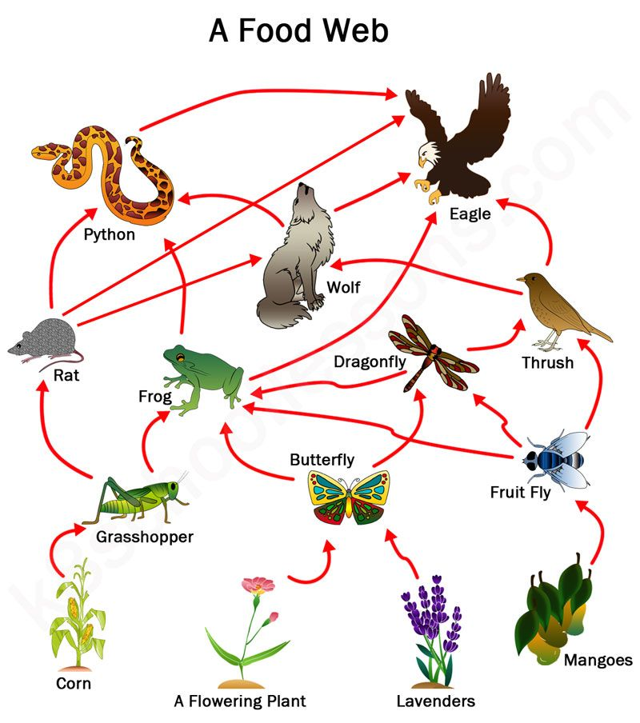

Easy | Easy

Year 6 | Year 6

Challenge
 |  | 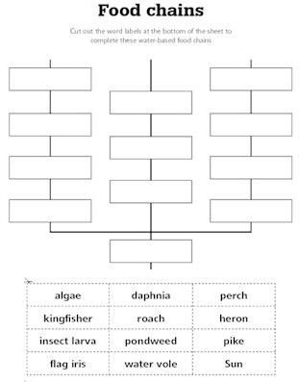
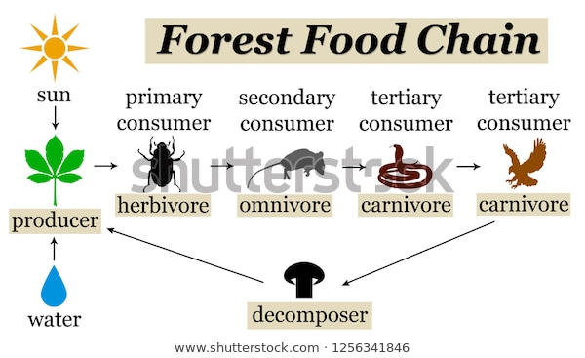 | 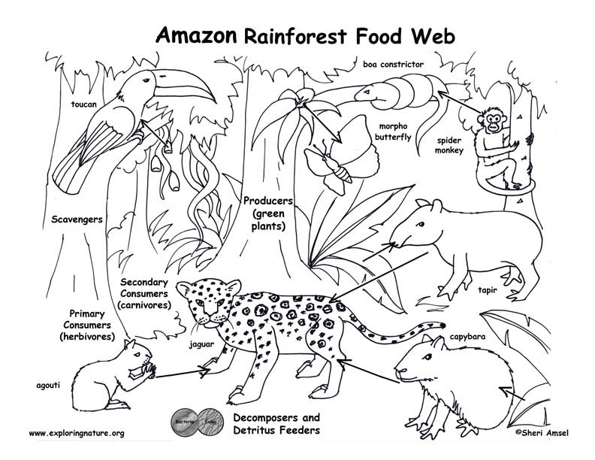
Choose a different ecosystem and create a food web.  See the definition of an ecosystem below.  An ecosystem is a large community of living organisms (plants, animals and microbes) in a particular area. The living and physical components are linked together through nutrient cycles and energy flows. Ecosystems are of any size, but usually they are in particular places. | Choose a different ecosystem (see above picture as an example) and make a 3D picture. Add in a food web. You can cut out the animals and stick them on. Be as creative as you wish.

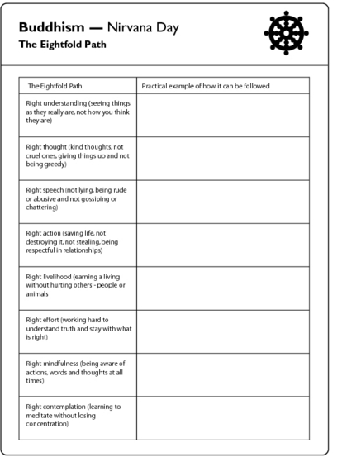
RE
Venn Diagram
Compare Buddhists beliefs to your own
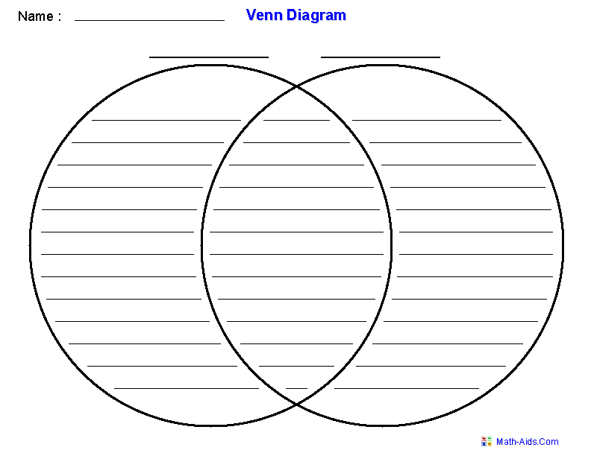

Other Activities
Times tables  Build up speed. Time yourself how long it takes you to answer 0 to 12 x tables in mixed order (work with an adult). | Get active.  With an adult, think of at least two different exercises you can do at home e.g. in the garden. You must exercise for at least half an hour a day. | Use Purple Mash and play online learning games.  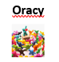  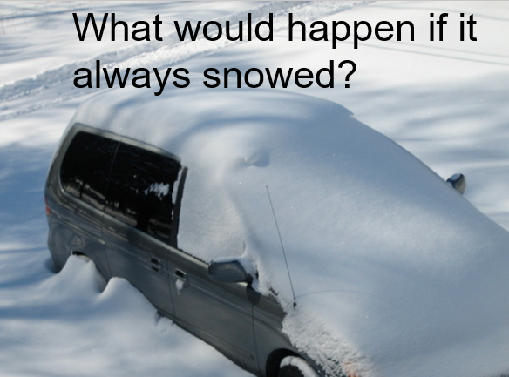 | Watch the news and choose any 3 stories to summarise. | Mindfulness  Try out some of the activities attached to help you relax.  How many different mindful techniques can you think of?  Which is your favourite?

Key skills to continue practicing weekly:
-spellings
-grammar (go through revision booklets)
-speed reading
-speed writing (count the number of words you can write in one minute)
-neat and joined up handwriting
-timetables (build up speed)

If you or your child has any further queries regarding their learning projects, please contact admin@hardwick.derby.sch.uk, clearly stating your child’s name and class teacher, and the staff will be in touch to support you and your child.

Thank you and stay safe!

Would You Rather…
It is so important to talk and when we are at school, we have plenty of time to do so. However, that doesn’t mean you can’t talk even more when at home! So, to help you and give you an idea, here is an activity you can play with someone at home. For each box, make a choice; which would you rather? Remember, you can only choose one and explain why you would choose that. Don’t forget to have some fun with it!
ice – cream  or  chocolate | Bat-man  or  Wonder-woman | snowball fight  or  water balloon fight | plane  or  ship
fly  or  breathe under water  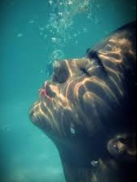 | really cold  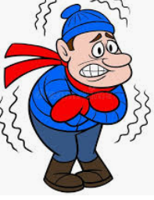  or  really hot  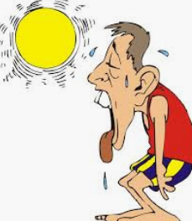 | play inside  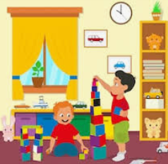  or  play outside | or  dinosaur  