Year 2 Home Learning Projects
Week 1 Summer Term
Hope you are all well and taking this time to do lots of reading and having fun. A few projects to keep you busy learning for the next week. There are extra challenges and some alternative tasks if you are finding them a bit hard.
English
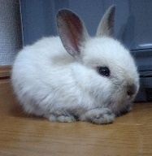
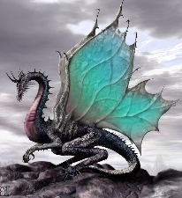
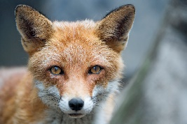
Write a story that involves these characters. Remember to use ‘but’, ‘if’ and ‘when’ in your sentences as well as lots of amazing adjectives.
Create stick puppets for the story you created above and tell it to your family. Try to use expression to make it interesting to watch
Correct the spelling mistakes in this passage and write it out again correctly.
ew have sports day next week and I’m sor it’ll eb so much fun! Evrybodi hsa to join in, evn if you don’t like playing sports. I didn’t want to join in last year because I’m not grate at any sport but ym teacher says it’s not about being the best, it’s about trying to inpruve each year. I want to prouve to myself that I can run faste and make rM Gill proud.

Complete the comprehension about ‘Super Seeds’ and ‘Crazy Cacti’ at the end of this document.

Which would you rather be and why?

Maths
Keep up with your Times Table Rock Stars and see if you can create some word problems that use your knowledge of times tables.

For example: Mrs Tomordy had 5 cups of tea every day. How many cups of tea did she have in a week?
53 – 27 = 62 – 39 = 42 - 18 =
45 + 17 = 78 + 13 = 39 + 11 =
95 – 37 = 56 – 49 = 78 – 9 =
43 + 22 = 45 + 23 = 64 + 22 =
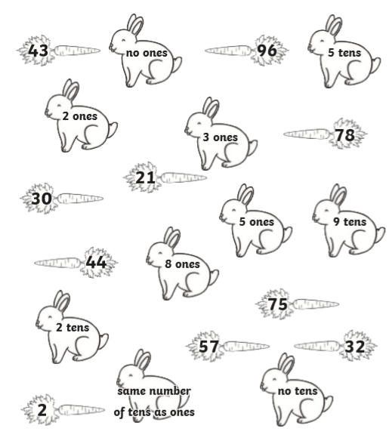
Match the rabbit to the correct carrot.

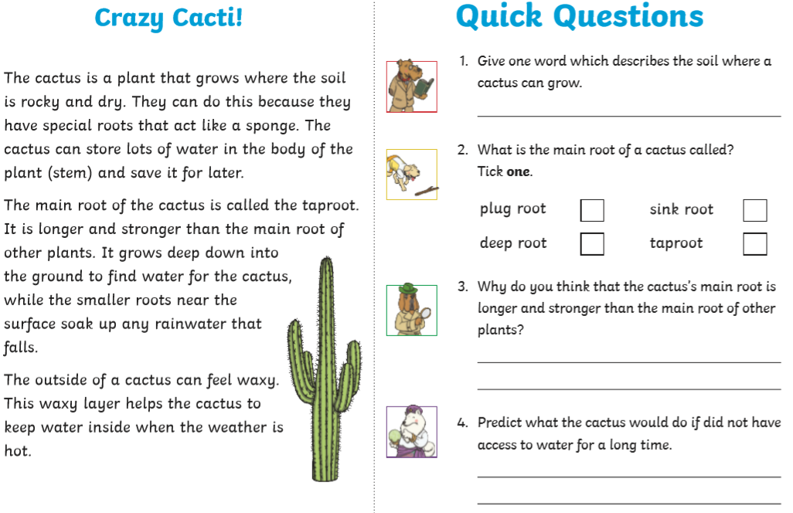
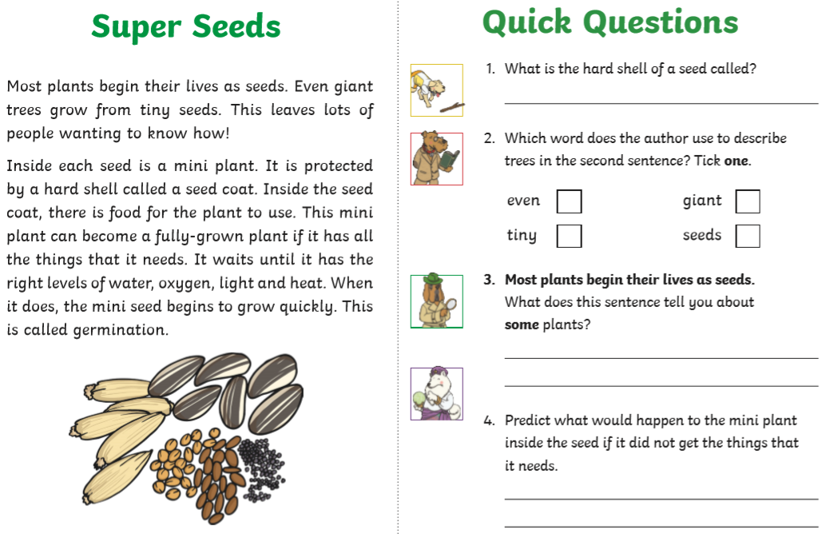

More Home Learning to follow later in the week.

