Year 2 Home Learning
Week Commencing: 27th April 2020
Year 2 teachers: Mrs J Tomordy, Mrs C Nicholson
Year 2 TAs: Ms Shaista, Mrs C Rowland
Message from staff: Hello to all of you from all of us. I hope you have had chance to enjoy some of the sunshine. We are all keeping busy and trying to ensure that you have tasks to do that will help you keep your brains whirring and your learning continuing in these strange times. Mrs Tomordy has been busy in the Easter holidays sowing some seeds. Have you managed to plant yours yet? She has planted some pea seeds and they are just poking through the soil. She has also been looking at the learning you will be doing when we all get back together again and creating some interesting things for you to do each week.
Mrs Rowland has been looking after Holly and her cat Puss. The weather has been lovely so she has been enjoying the sunshine in the garden while doing her school work. She has also been doing PE with Joe every morning to wake her up. Have you been doing it too? She can’t wait to see you when we get back to school!
Mrs Nicholson has been gardening and finding a path through the jungle in her garden! She has been walking her dog although her dog has had a poorly leg so cannot walk very far.
Mrs Shaista has been busy cooking and trying and experimenting new dishes - most of the time successful! The weather has been so beautiful so she has been enjoying the sunshine while walking every morning with her mum. Every day in the evening she is catching up with reading her favourite books. Are you reading as well?

Your Home Learning this Week:
Every day (Monday to Friday), make sure you choose a *reading, *writing, *spelling/handwriting, *maths and *theme learning activity. There are also further activities to choose from should you wish to.
Reading Home Learning
Task 1  I have put a copy of Jack and the Beanstalk on the web page and we would like you to read it and then summarise what happens in 5 pictures. Don’t forget to include characters and where they are (the settings). | Task 2  Re-read the Jack and the Beanstalk text and then create some puppets. Retell the story to someone else using the puppets. | Task 3  Answer the comprehension questions for the text labelled Jack and the Beanstalk. | Task 4  Complete the Seaside Safety comprehension. | Task 5  Complete the Under the Sea 60 second reading comprehension.  Remember you should be able to read the whole text in 60 seconds (and understand it) but you can re-read it to help you answer the questions.

Writing Home Learning
Task 1  Looking at the picture of the deckchairs try to answer the following questions:  - Who was sitting on the deckchairs?  - Where have they gone?  - Are the seagulls a nuisance?  - Do the seagulls have more right to be at the seaside than us? | Task 2  Create a list of things you can see in the seaside picture and use an adjective with each.  For example:  Freezing water  Noisy seagull | Task 3  Now create some amazing sentences using the adjectives and nouns from yesterday | Task 4  Add some conjunctions to the sentences you created to make them more interesting and see if you can make them start in different ways.  Conjunctions:  and, but, because, if, when, | Task 5  Now using all the work from the other tasks, create a postcard to me about what you did at the seaside and how you were feeling.
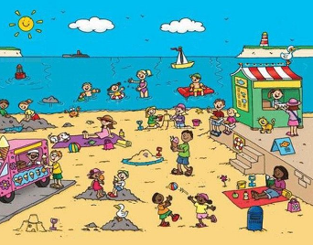

Spelling/Handwriting Home Learning
Rainbow write the months of the year. Try to do this without looking.  January  February  March  April  May  June  July  October  November  December | Ladder write numbers to 20  o  on  one  t  tw  two | Using lined paper if possible write these words 10 times each. Check that your tall letters are tall.  elbow  hotel  double  branch  table | Check you know how to spell each of these without looking:  could  should  would  there  their  they’re  sea  see | Create a spiral going in a clockwise direction going inwards then do another going outwards.

Maths Home Learning
Task 1  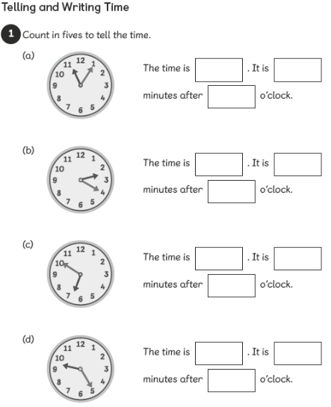  Telling the time to the five minutes. So the first one would be11.05 | Task 2  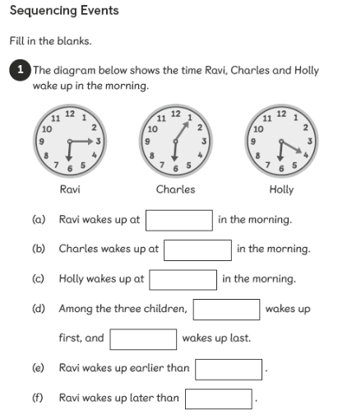  Sequencing time.
Task 3  Please draw on the other hand and check whether it is the longer minute hand or the shorter hour hand. 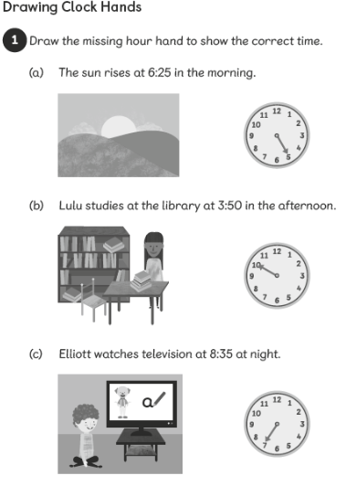 | Task 4  Remember 30 minutes on the clock is half way further around or a jump of 6 numbers.  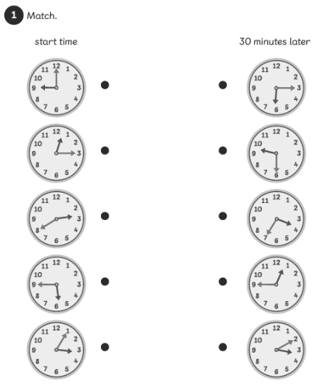
Task 5 for maths is to keep telling the time to someone else and remember the minute hand moves around 1 number for every 5 minutes. This will get easier the more you do it.
Theme Home Learning
Art  Create a viewfinder with a piece of paper where the middle is cut out and then draw whatever you can see in the middle. Try this with something in your house or a plant in your garden. Try to notice the lines and shapes you can see.  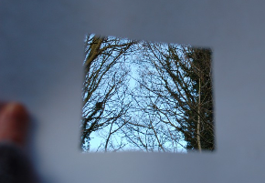 | Computing  Create a poster to tell others how to stay safe on line. Remember the most important parts are to tell someone if you are not sure and never share personal information on line, including photographs. | Science  What different things do plants need to survive? Name 4 different things and then explain in a sentence why they need each thing. | Geography  Compare the school playground and your back garden Create a Venn diagram to show what you have found out. Remember the middle is where it is found in both places. | Art/PSHE  Create a poster that you can put up in your window to make people smile. So you could say thank you to someone or just have lots of rainbows, smiles etc.

Other Activities
On your daily walk see if you can add the numbers on the doors in your head. | Write a diary or draw a picture each day of something you have done and how you felt. | Do a rubbing of things around you by placing a thin sheet of paper over something and then carefully rubbing over with a crayon or chalk. How many different patterns can you make? | Create some salt dough and make some models of things. 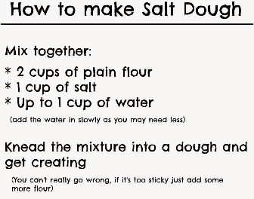 | Create a song or poem about flowers and things that grow. Keep practising it until you can do it in a performance to your family.

Key skills to continue practicing weekly:
Times table rock stars
Reading with Oxford Owl
Read, read and read again.
Telling the time to the 5 minutes
Practise reading and spelling your common exception words.
Handwriting out a passage from a book

Useful websites:
https://www.bbc.co.uk/bitesize This is a very useful website. It is run by the BBC and they are running daily lessons for children so why not have a look and see what they have.
On Youtube every morning at 9am, if you type in Joe Wicks, he is running an exercise session for children and adults to join in with.

If you or your child has any further queries regarding their learning projects, please contact admin@hardwick.derby.sch.uk, clearly stating your child’s name and class teacher, and the staff will be in touch to support you and your child.

Thank you and stay safe.

