The Snow Leopard

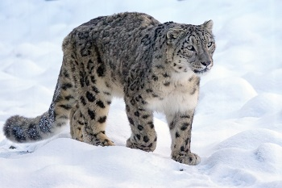
The snow leopard, an endangered animal, lives in the Ala Tau and Himalayan Mountains of Central Asia. In the summer, the leopards live high up in the mountains and in the winter they stay in warmer valleys. Except for a mother and her cubs, snow leopards live alone in their own territories. Snow leopards are usually active in early morning and late afternoon. They are powerful animals and can leap over large ravines when they are hunting. They hunt for ibex, sheep, rabbits, and even birds like geese.
A full-grown snow leopard can be up to six feet long. Its tail is three feet long and is covered with the same thick, grey fur as the rest of the body. When the leopard sleeps, it covers its nose with its tail as protection from cold winds. Because its ears are small, less body heat comes out through them. The snow leopards’ fur can be up to three inches thick! This thickness helps them survive in the cold Asian mountain weather. The fur is grey with brown spots, and it allows the leopard to hide beneath snow drifts and stalk prey.
Unfortunately, snow leopards are endangered because they are killed for their thick fur. One of the main reasons that snow leopards are endangered is because of poaching. Poachers illegally kill snow leopards, even though they are endangered, and sell the animals for money. Humans are a second reason that snow leopards are endangered. Farmers have pushed their livestock in the snow leopard’s habitat. Therefore, overgrazing of the animals damages the fragile mountain grasslands, leaving less food for the wild sheep and goats that are the snow leopard’s main prey. With less food for wild sheep and goats, there are fewer animals for the snow leopard. This leaves the snow leopard with little choice but to prey on the domestic livestock for their own survival. An unhappy farmer, arriving at his goat pen one morning to find that all of his goats have been killed by a snow leopard, might retaliate by killing the snow leopard if he can find it.
The Snow Leopard Conservancy is just one of many organisations that are trying to help troubled animals in the world. Hopefully, organisations like these will be able to stop poaching and overgrazing. However, if it continues, sadly snow leopards may become extinct in the future.

