FS2 Home Learning
Week Commencing: 22nd June 2020
FS2 teachers: Mrs Connelly-Haywood and Miss Ralph
FS2 TAs: Miss Hayat
Message from staff:

Mrs Connelly-Haywood and Miss Ralph have been busy in school this week. They have really enjoyed seeing some of you again. The children in school have had lots of fun as they have been doing lots of lovely activities. We have been making rainbows to brighten up our classroom. Miss Hayat has been busy making phone calls and is enjoying speaking to lots of you. We can’t wait until we see you all again.

Your Home Learning this Week:
Every day (Monday to Friday), make sure you choose a *physical, *communication, *reading/phonics, *writing and *maths learning activity. There are also further activities to choose from should you wish to.

Physical Home Learning
Monday | Tuesday | Wednesday |  | Thursday | Friday
Look at the yoga poses sheet and complete 10 minutes of yoga, holding each pose. When in each position, close your eyes, breathe in through your nose and out through your mouth. Try to slow down and focus on keeping calm. | Using a piece of paper, fold it so that you make a paper aeroplane.  Instructions at the end. | Colour in the ice-cream. |  | Play Helping Heihei.  Follow the instructions below. | Freeze a plastic toy in a block of ice. Can you break into it? How can you get the toy out?
Easier:  Do as many of the above activities as you can. If you are finding some of the activities challenging, try these as they are a little easier:  - Practise holding a pencil and make lines and circles. – Try to write your name.  - Can you practise doing up buttons on a shirt?  - Can you kick a ball to another person?  - Play with your play dough at home. See if you can do these with the dough: roll, squish, pull, pinch, stretch, pat |  |  | Challenge:  If you feel you need a further challenge, try these:  - Can you have a go at threading? Pierce holes in a piece of cardboard and use a shoelace to thread through the holes.

Communication Home Learning
Monday | Tuesday | Wednesday |  | Thursday | Friday
Talk about pirates. What can you see in the picture? What do pirates do? Can you describe the things in the picture? | Make your own pirate hat and eye patch. Give yourself a pirate name and pretend to be a pirate. | Pirates like to find treasure. What is treasure to you? What precious items would you put in a treasure chest and why? |  | If you met a pirate, what questions would you ask them?  Who…?  What…?  Where…?  When….?  Why…? | If you had your own pirate ship, where would you go?
Easier:  Do as many of the above activities as you can. If you are finding some of the activities challenging, try these as they are a little easier:  - What does a pirate wear?  - How do pirates travel?  - Can you talk about a pirate and pretend to be one? |  |  | Challenge:  If you feel you need a further challenge, try these:  - Do you know a story about a pirate? Can you retell what happened in the story?  - Can you think of your own story about a pirate? Use your imagination. What happens at the start of the story? What happens in the middles of the story? What happens in the end of the story?

Reading/Phonics Home Learning
Monday | Tuesday | Wednesday |  | Thursday | Friday
Focus on ‘sh’  Read and draw pictures to match the words.  ship, shop, shell, fish, cash  Can you think of your own words? | Focus on ‘ch’  Read and draw pictures to match the words.  chip, rich, chill, chin  Can you think of your own words? | Focus on ‘th’  Read and draw pictures to match the words.  thin, thick, bath, think  Can you think of your own words? |  | Focus on ‘ng’  Read and draw pictures to match the words.  Ring, sing, strong, long  Can you think of your own words? | Practice writing the key words on the sheet provided.
Easier:  Do as many of the above activities as you can. If you are finding some of the activities challenging, try these as they are a little easier:  - Ask a grown up to say the sounds below. Can you write the letters to match the sounds?  - Can you sort the words into the correct category? qu sh ch th ng  quiz, quit, quick, liquid, quack, ship shop shell fish cash bash hush rush ship shop shell fish cash bash hush rush, chip rich chill much  them, then, that, this, with, thin, thick, Ring, sing, ping, pong, strong, long  s, a, t, p, i, n, m, d, g, o, c, k, ck, e, u, r, h, b, f, ff, l, ll, ss, j, v, w, x, y, z, qu, sh, ch, th, ng |  |  | Challenge:  If you feel you need a further challenge, try these:  Can you write sentences using the key words on the sheet provided?  Revise all of the sounds from Phase 3. Read and write some words using these sounds:  - s, a, t, p, i, n, m, d, g, o, c, k, ck, e, u, r, h, b, f, ff, l, ll, ss, j, v, w, x, y, z, qu, sh, ch, th, ng, ai, ee, igh, oa, oo, ar, or, ur, ow, oi, ear, air, ure, er

Writing Home Learning
Monday | Tuesday | Wednesday |  | Thursday | Friday
Talk about what you might see at the beach on a sunny day. Have you ever been to the beach? What is it like? Draw a picture of the beach/seaside with 5 objects you might find. Label the picture. | Write a list of 5 things that you would see at the seaside on a summer day. E.g. sea, hat, picnic. Choose 1 of your objects and finish the sentence on the senses poem provided.  I can see a boy swimming in the sea. | Write a list of 3 things that you would hear at the seaside on a summer day. E.g. birds, waves. Choose 1 of your objects and finish the sentence on the senses poem provided.  I can hear the waves crashing. |  | Write a list of 3 things that you would smell at the seaside on a summer day. E.g. salt water, fish and chips. Choose 1 of your objects and finish the sentence on the senses poem provided.  I can smell yummy fish and chips | Write a list of 3 things that you would taste and feel at the seaside on a summer day. E.g. picnic, sand Choose 1 of your objects and finish the sentence on the senses poem provided.  I can feel the sand on my feet.
Easier:  Do as many of the above activities as you can. If you are finding some of the activities challenging, try these as they are a little easier:  - Draw a picture of the beach and write single words for what you can see, hear, smell, feel and taste. Finish the poem with one/two words for each sentence. Try and make each sentence different.  - I can see sand. |  |  | Challenge:  If you feel you need a further challenge, try these:  - When completing your senses poem try to use an adjective to describe each object. E.g. I can see golden sand. I can feel ice cold water.  - Write a short story (5 sentences) about a day at the seaside and an imaginary adventure that you went on.  At the seaside…

Maths Home Learning
Monday | Tuesday | Wednesday |  | Thursday | Friday
This week we are looking at time and sequencing. Use the daily routine sheet to discuss what you do at different times in the day. Cut and stick the pictures in an order that you think these activities could be done in one day. | Use the clock face template to make your very own clock. Cut and stick the numbers and try to make the hands moveable so you can change the time on your clock (use a split pin if you have one). | Read ‘The Bad Tempered Ladybird’ on youtube (link below) and use your clock to make the times as the ladybird does different activities during the day.  or  Use a cuddly toy you have at home and create/role play a funny time story about what the toy does.  At 7 o’clock I got out of bed.  At 9 o’clock I had breakfast with my friend. |  | Use the sheet to draw a picture to show what you do at 9 o’clock, 11 o’clock, 1 o’clock, 4 o’clock and 7 o’clock during the day. | Play a game of guess the time using the clock you made with an adult. Say a time and find it on your clock as quick as you can. Remember the short hand points to the hour and the long hand points to the minutes (12).
Easier:  Do as many of the above activities as you can. If you are finding some of the activities challenging, try these as they are a little easier:  - Count to 10 in different ways. Jump, hop, star jump or clap as you count each number.  - Count back from 10 in different ways. Point to the numbers on the number line to help.  - Do you know the days of the week? Can you sing a days of the week song to help you remember? |  |  | Challenge:  If you feel you need a further challenge, try these:  - Write a sentence to describe what you did at the different times in the day.  - Have a look and see if you can make these times on your clock:  Half past 1  Half past 10  Half past 3

Other Activities
Role play an ice cream shop at the beach with an adult. You can use real coins and money to pretend to buy and make different flavours. | Read your favourite book to an adult. | Can you make a boat from any empty containers you have at home and make it float on water in the bath/sink or outside? | 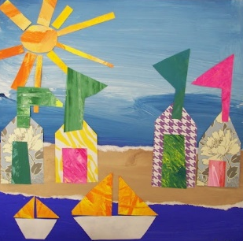  Make a beach themed collage picture using different coloured paper cut up into small pieces. You can add lots of different types of material to your artwork.

Key skills to continue practising weekly:
- Write your name.
- Practise handwriting – try to form the letters on the line correctly.
- Form numbers correctly.
- Getting changed on your own.
- Zip your coat up on your own.
- Match the capital letters with the lowercase letters e.g. A a B b
- Number bonds to 10.

If you are able to access the internet, try these useful websites:
- Change for life indoor activities: https://www.nhs.uk/change4life/activities/indoor-activities
- Cosmic Kids - https://www.youtube.com/watch?v=96R059yOPVI
- Playdough - https://www.bbcgoodfood.com/howto/guide/playdough-recipe
- Come outside – Bulbs: https://www.youtube.com/watch?v=op86kAE0Nsw
- The Bad Tempered Ladybird - https://www.youtube.com/watch?v=bH6UIYCRmAE

If you or your child has any further queries regarding their learning projects, please contact admin@hardwick.derby.sch.uk, clearly stating your child’s name and class teacher, and the staff will be in touch to support you and your child.

Thank you and stay safe.

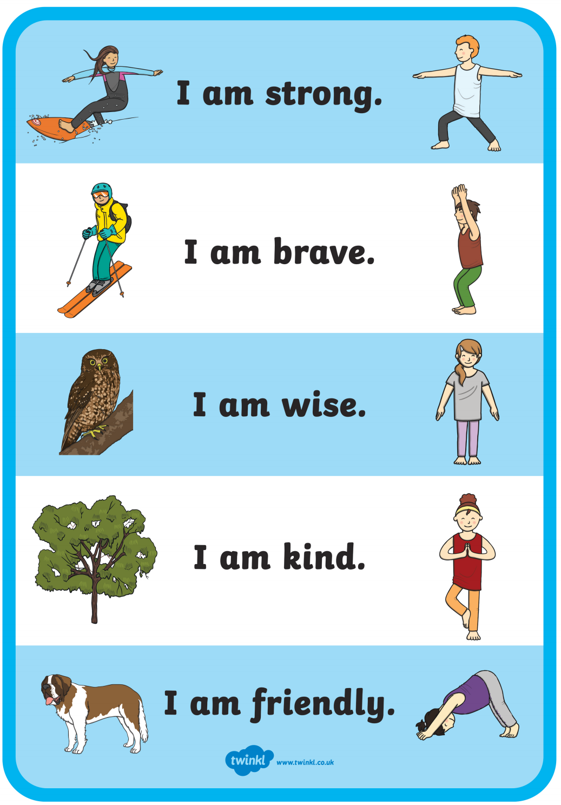

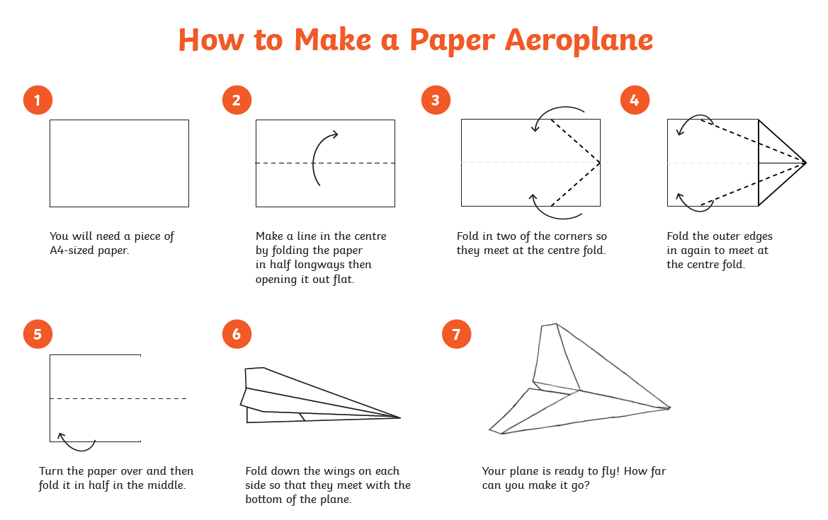
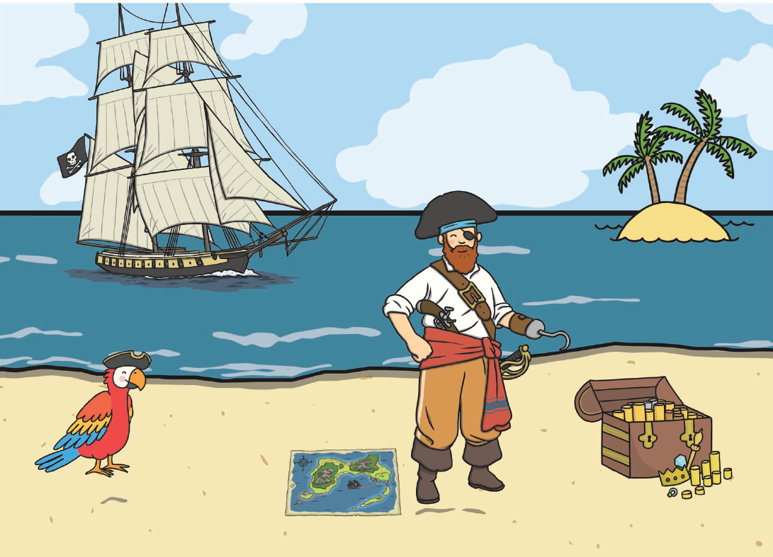
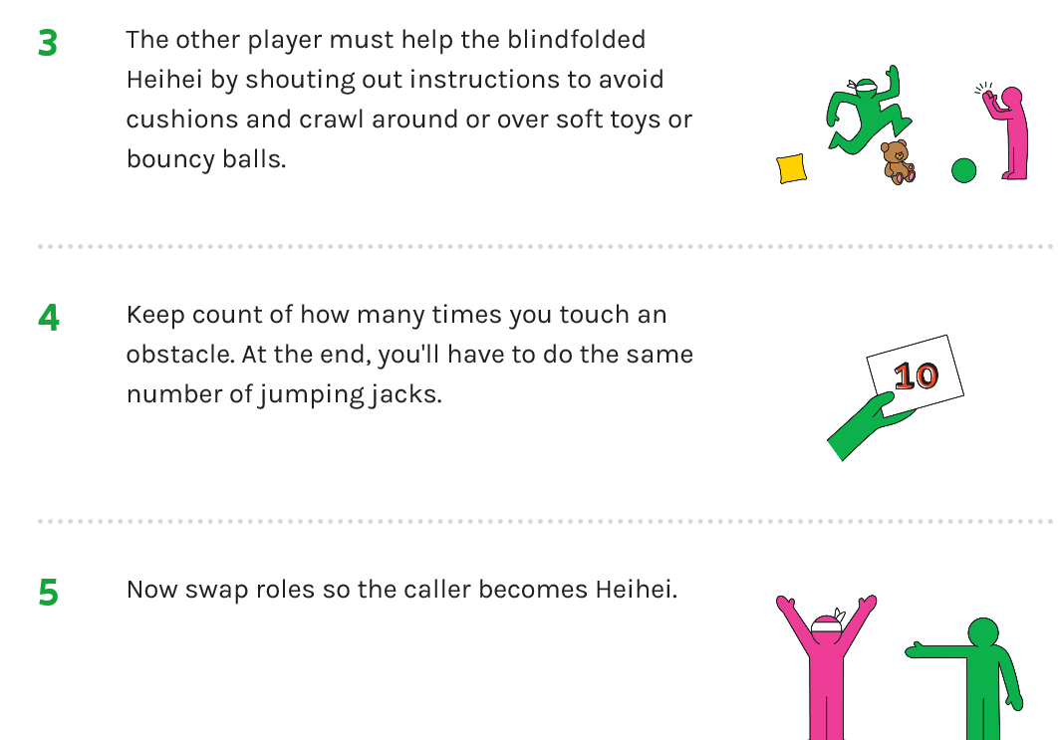
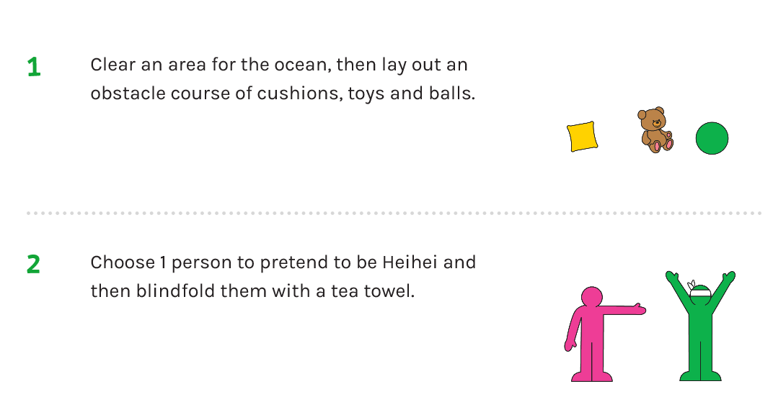

What do you do during the day?
9 o’clock | 11 o’clock | 1 o’clock | 4 o’clock | 7 o’clock

