Year 6 Home Learning
Week Commencing: 15th June 2020
Year 6 teachers: Mrs Haider, Miss Qayoom, Mr Nowak
Year 6 TAs: Mrs Yar-Khan
Message from staff: We are all missing you and it is great catching up with you all. Hope you are all well and continuing to work independently as well as with your family to explore the learning activities.
You should also continue to explore the different features of Purple Mash.
You should have received information about collecting booklets from school, if you are still experiencing difficulties please get in touch.

Reading Home Learning
Monday | Tuesday | Wednesday |  | Thursday | Friday
Read the title “The Milky Way” and predict what the text is going to be about.  Write your explanation then read the text to see if you were right. Underline any words and phrases you are unsure about. | Summarise the main points of the text (VIPs) and write them down using bullet points. | Visualise the text and draw the Milky Way. |  | Answer the first 5 questions and highlight the evidence in the text to support your answers. | Reading for pleasure  Read any book of your choice for 45 minutes.
Easier:  Do as many of the above activities as you can. If you are finding some of the activities challenging, try these as they are a little easier:  - Draw a picture of the space. Include as many planets as you can.  - Find words you don’t understand and look them up in a dictionary  - Summarise the text in one sentence. |  |  | Challenge:  If you feel you need a further challenge, try these:  - Answer Q6 and Q7 and highlight the evidence in the text.  - Write everything you know about astronomy.  - Read a book of your choice for 1 hour
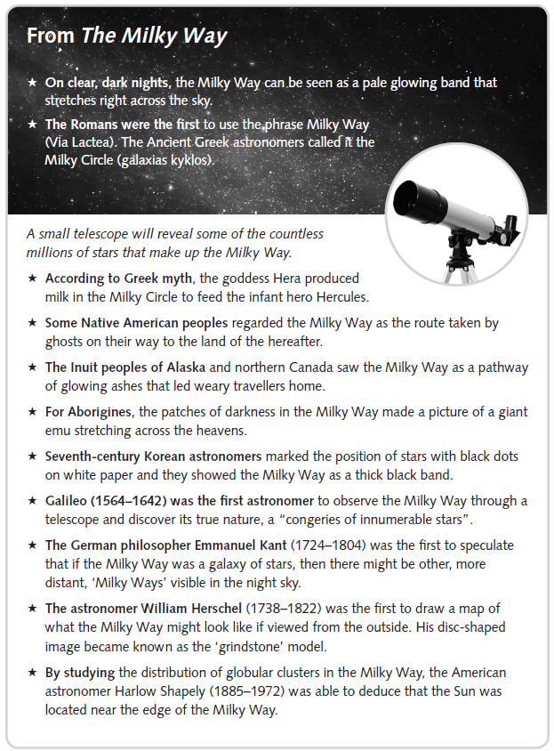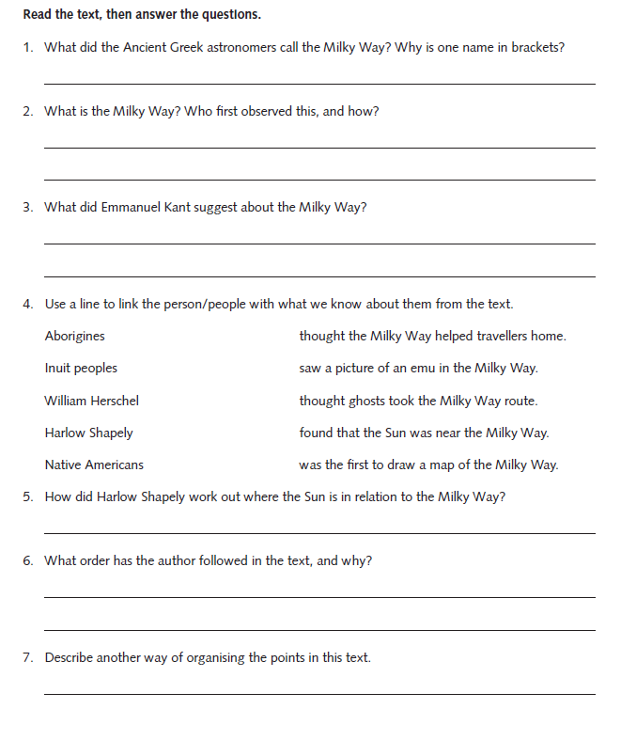
Writing Home Learning
Monday | Tuesday | Wednesday |  | Thursday | Friday
Task 1  Your task is to write a letter to Ewan giving your point of view. | Have a look at the messages (Task 2) and consider their audience (who they are written to) and purpose (why they have been written). Then write each one in a more appropriate style. | Summarise the passage (Task 3) into a few sentences to make it easier and quicker to read.  Remember, the best summaries include devices such as headings and bullet points. Challenge yourself to use at least one of these and to summarise the text in no more than five sentences. |  | Now you’re nearing the end of year 6, you may want to reflect on your year and give some advice to the children in year 5 for their move into year 6.  Think about what you would have liked to know at that point. Do you have any warnings? Words of support? Tips to make things easier? Your task is to write either a letter, a leaflet or a list for year 5. It can be serious or light-hearted or a mixture of both, but it must be helpful! | It’s the end of a busy and important year and time for your school report – but this time, you’re going to put yourself in your teacher’s place and write your own!  Consider your attitude, your behaviour, your work, your friendships and your contribution to the class or school. There is also a section for you to write about your English work. Be honest!  Write your report in the third person, as your teacher would write about you.(At least 250 words)
Easier:  Do as many of the above activities as you can. If you are finding some of the activities challenging, try these as they are a little easier:  - Use a dictionary to find some interesting persuasive verbs when writing a letter to McGregor  - Write a simpler letter to McGregor  - Ask an adult to read your letter |  |  | Challenge:  If you feel you need a further challenge, try these:  - Choose your audience and purpose and write a message in an inappropriate form. You might choose to write a message asking for funding for a good cause, fan mail to your sporting or music hero or a thank you letter to Grandma. The choice is yours!

Task 1
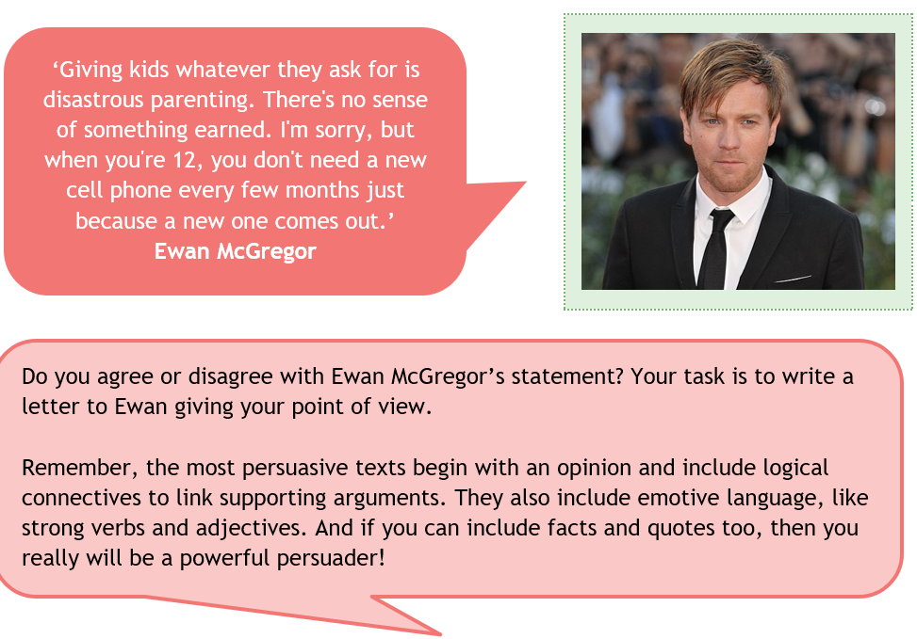

Task 2
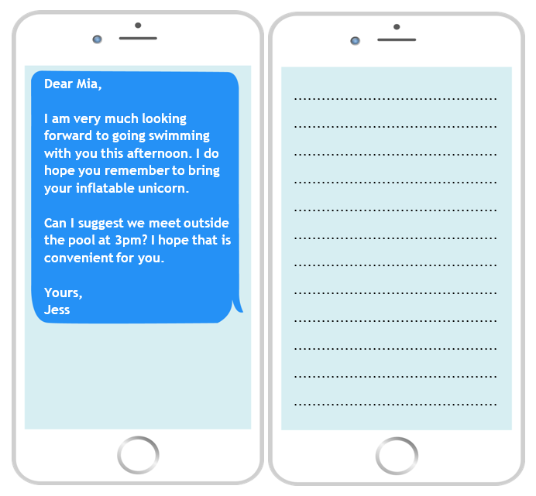
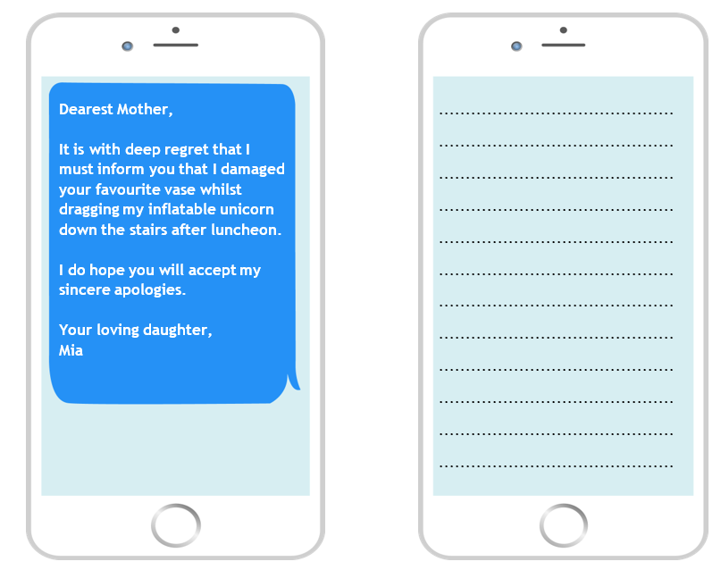
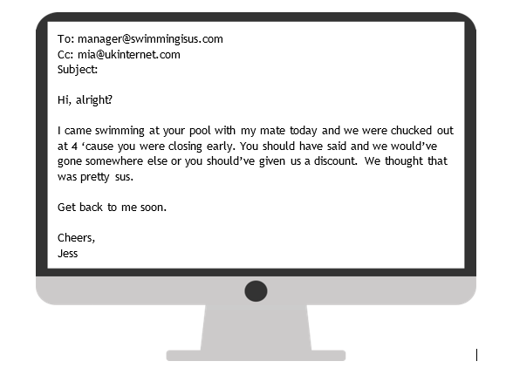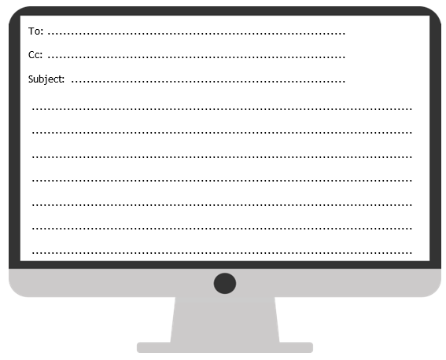

Task 3
Spelling/Handwriting Home Learning Keep revising the same words this half term.
Monday | Tuesday | Wednesday |  | Thursday | Friday
suspicious  artificial  confidential  commercial  innocence  independent  recommend  significance  appearance  ferocious | Abstract nouns  disappointment  determination  enthusiasm  graciousness  apprehension  consideration  opportunity  speculation  enhancement  disturbance | Hyphens can be used to  join a prefix to a root  word. Words beginning  with the prefix co- can be  written with or without  prefixes.  co-ordinate  re-enter  co-operate  co-own  de-ice  co-author  re-examine  re-educate  re-form  co-pilot |  | Morphology - Provides  opportunity to find links  from previously taught  spelling/structure of  words and parts of words  (Stems, roots, prefixes, suffixes etc.)  opportunity  parliament  programme  privilege  explanation  disastrous  exaggerate  frequently  necessary  appreciate | ASSESSMENT  Ask someone in your family to test you. 10 random words.
Easier:  Do as many of the above activities as you can. If you are finding some of the activities challenging, try these as they are a little easier:  - Use a dictionary to make sure you understand each word  - Try the following words:  chef  chalet  machine  brochure  chute  parachute  moustache  quiche  chauffeur  chandelier |  |  | Challenge:  If you feel you need a further challenge, try these:  - Write a story and try to include as many words from your spelling list as possible.  - Write a poem using some of the words above  - Learn the words with double consonants:  accommodate  accommodation  aggressive  embarrass  apparatus  success  successfully  willingness  worthlessness  happiness

Maths Home Learning
Monday | Tuesday | Wednesday |  | Thursday | Friday
Complete learning activity 1 on addition and subtraction. | Complete learning activity 4 on x | Revise your times tables, use TT Rockstar to help you.  Complete learning activity 7 |  | Choose a challenge from the learning activity 9 and have a go. Share with your family. | Choose a challenge from the learning activity 9 and have a go. Share with your family.
Easier:  Do as many of the above activities as you can. If you are finding some of the activities challenging, try these as they are a little easier:  - Complete learning activity 2, focusing on addition  - Complete learning activity 3, focusing on x  - Complete learning activity 6,focusing on x7 timetable |  |  | Challenge:  If you feel you need a further challenge, try these:  - Complete learning activity 5  - Complete learning activity 8
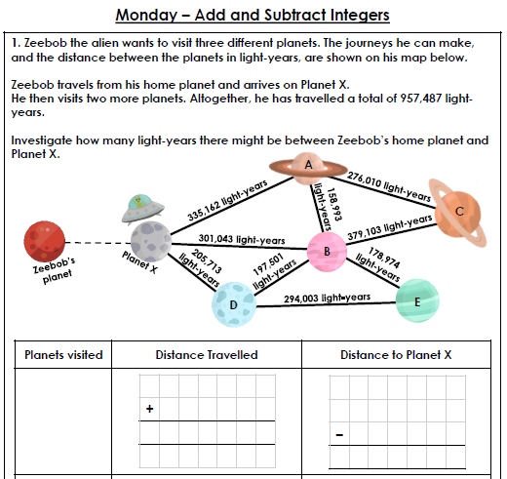
Learning activity 1 Learning activity 2
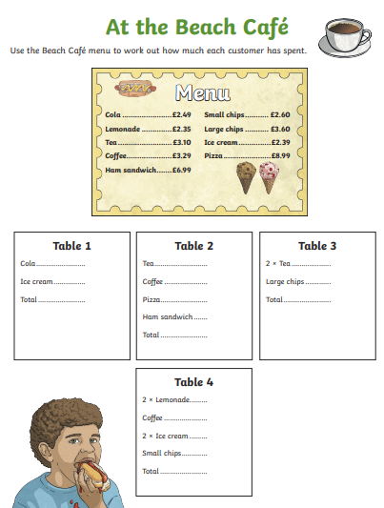
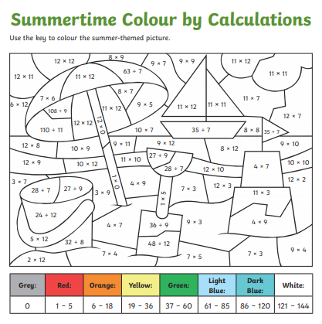
Learning activity 3 Learning activity 4
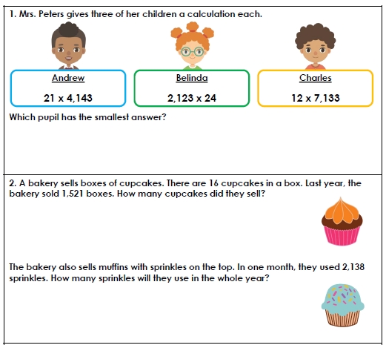
Learning activty 5
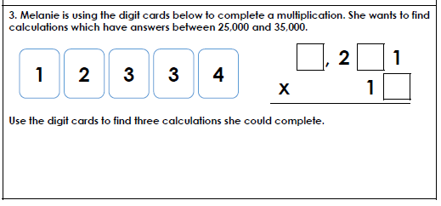
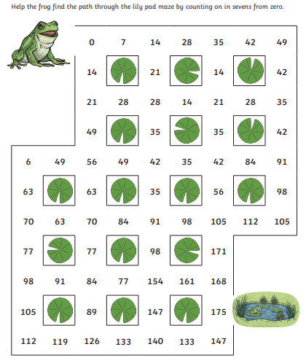
Learning activity 6 Learning activity 7
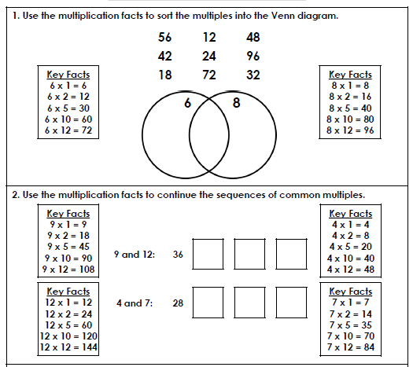
Learning activity 8
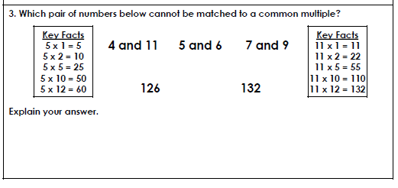
Learning activity 9- challenges
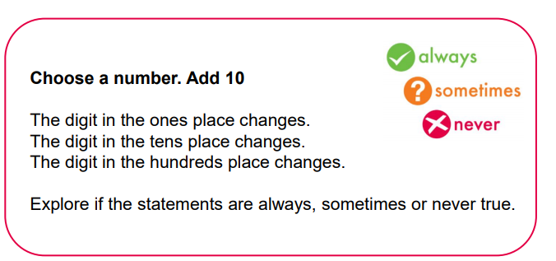
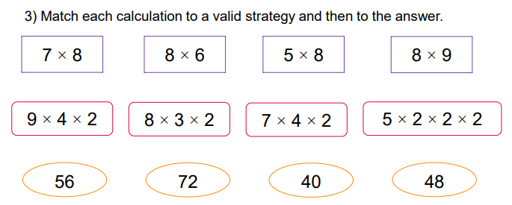

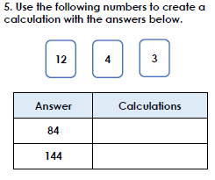
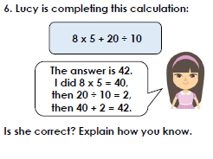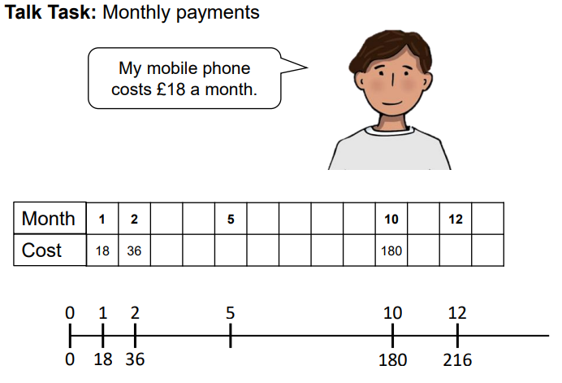
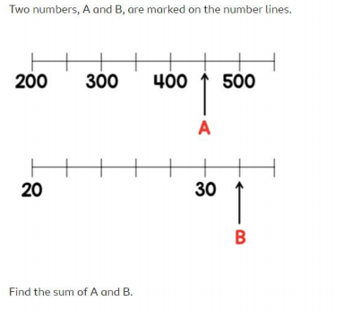
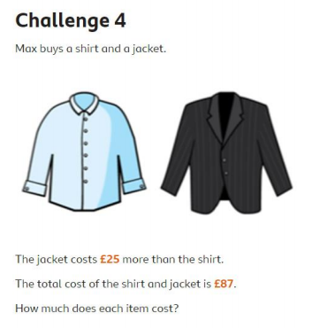

Theme Home Learning
Monday | Tuesday | Wednesday | Thursday |  | Friday
Science  Read through the science experiment you will carry out (Why soap works experiment).  Make sure that you complete task one and task two before you start the experiment.  Once you have completed the experiment, you can complete the ‘What actually happened’ sections and the second sheet. | Science  Buy some sunflower seeds.  Plant the seeds and record what happens daily. Record how tall the plant grows in cm.  Plant some tomato seeds and record the daily growth.  Don’t got to water the plants. | RE  Label the places of worship. Explain what the objects are and how the objects are used.  Explain how the places of worship are different and similar from each other. (Write a detailed paragraph). | PSHCE  - Would you rather?  Complete any 3 activity. Choose any. Write a detailed explanation for each. |  | PE  See PE sheet  Start from Easier (throwing and catching skills).  Complete Year 6 PE section.
Easier:  Do as many of the above activities as you can. If you are finding some of the activities challenging, try these as they are a little easier:  - Science talk your work through with an adult.  - RE label the places of worship. Explain what the objects are and how they are used with an adult.  - PSHCE choose any two activities, Ask an adult to help you think of a reason if you are stuck.  - PE Complete all throwing and catching skills |  |  |  | Challenge:  If you feel you need a further challenge, try these:  - Science Carry out the experiment at least 3 times. Explain why this was necessary.(Clue: fair testing).  RE compare places of worship using a Venn diagram.  PSHCE give detailed answers using paragraph and a range of punctuation.  PE Complete PE challenge sheet.

Science
After you have carried out the experiment, write the experiment in full. See the next sheet.

Science Write up

Plant sunflower seeds
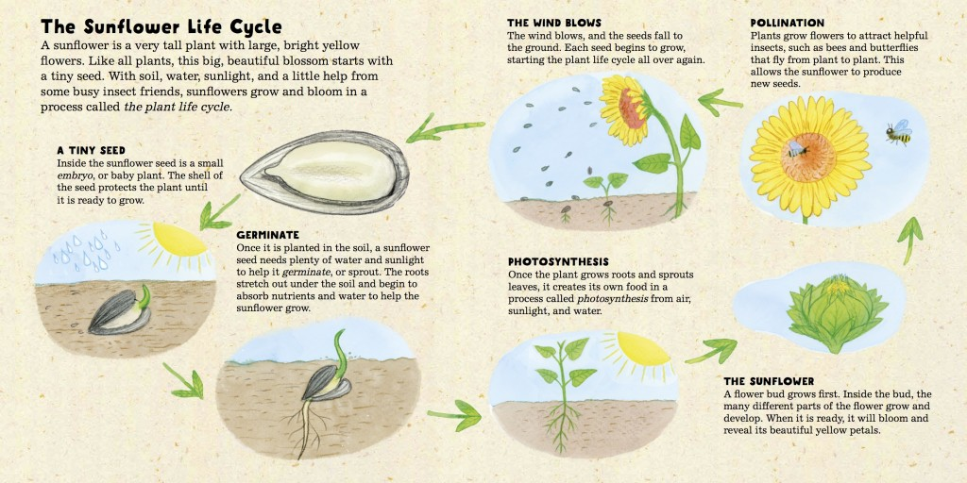

Plant tomato seeds
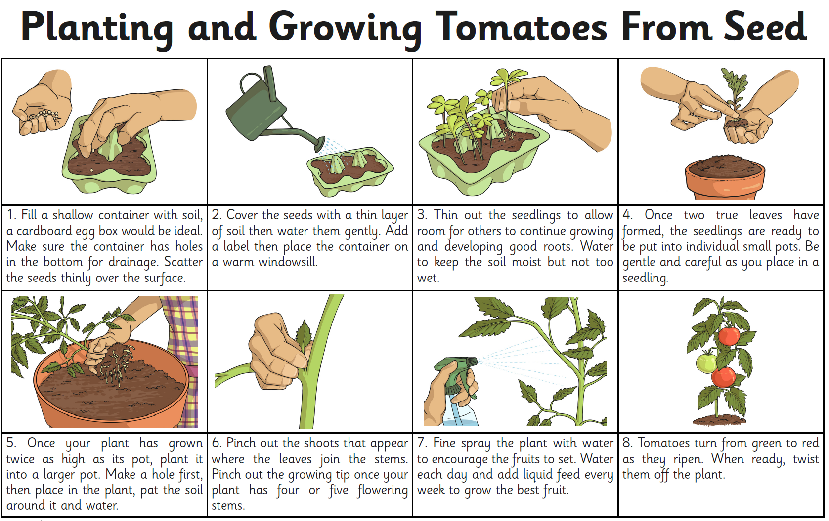
RE
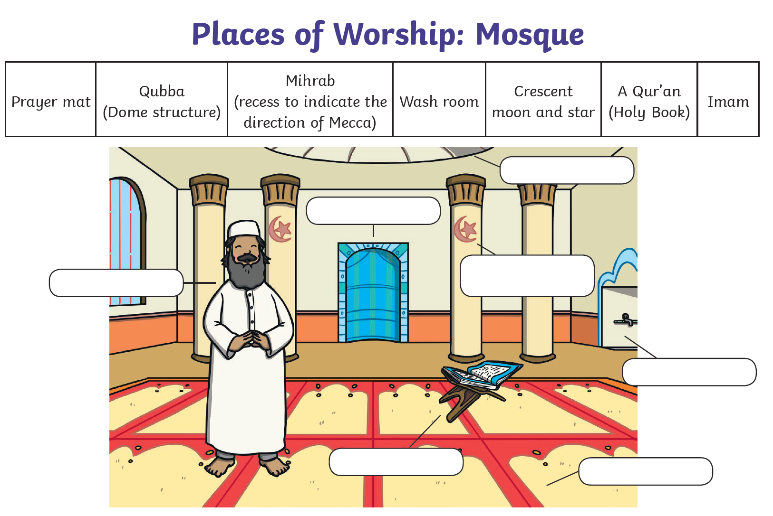

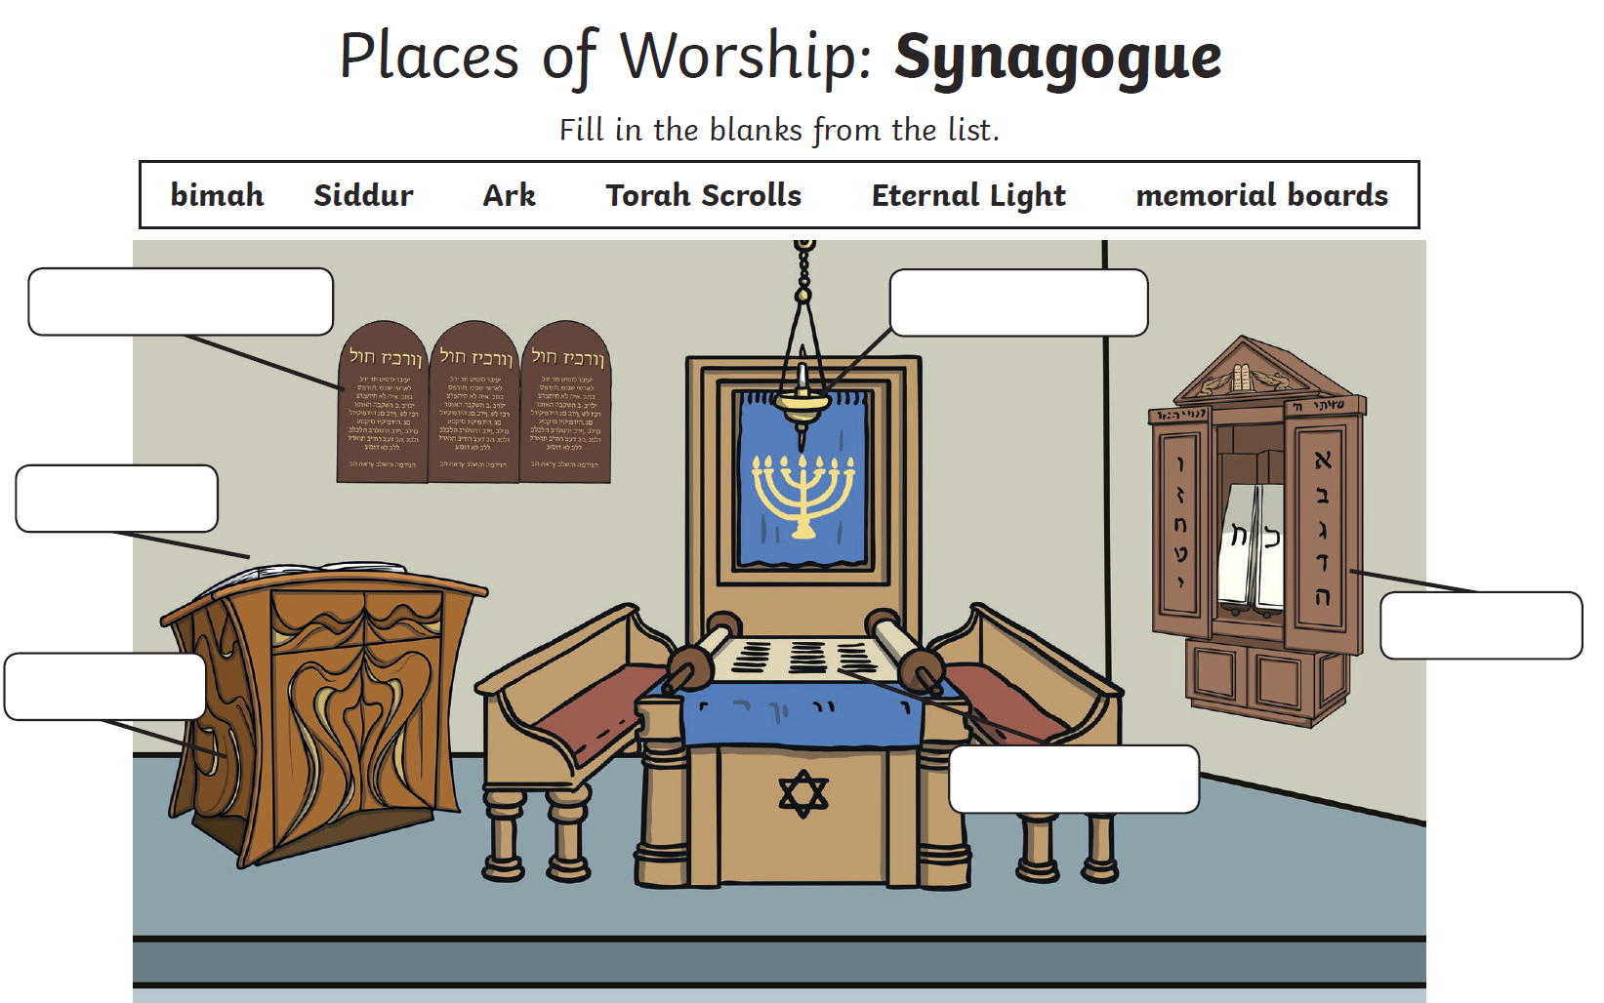

PSHCE Choose any 3 activities to complete
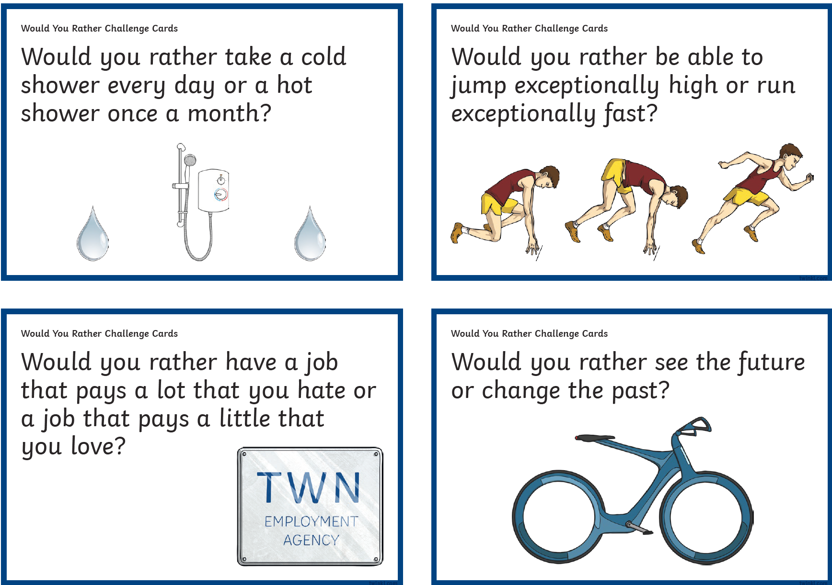
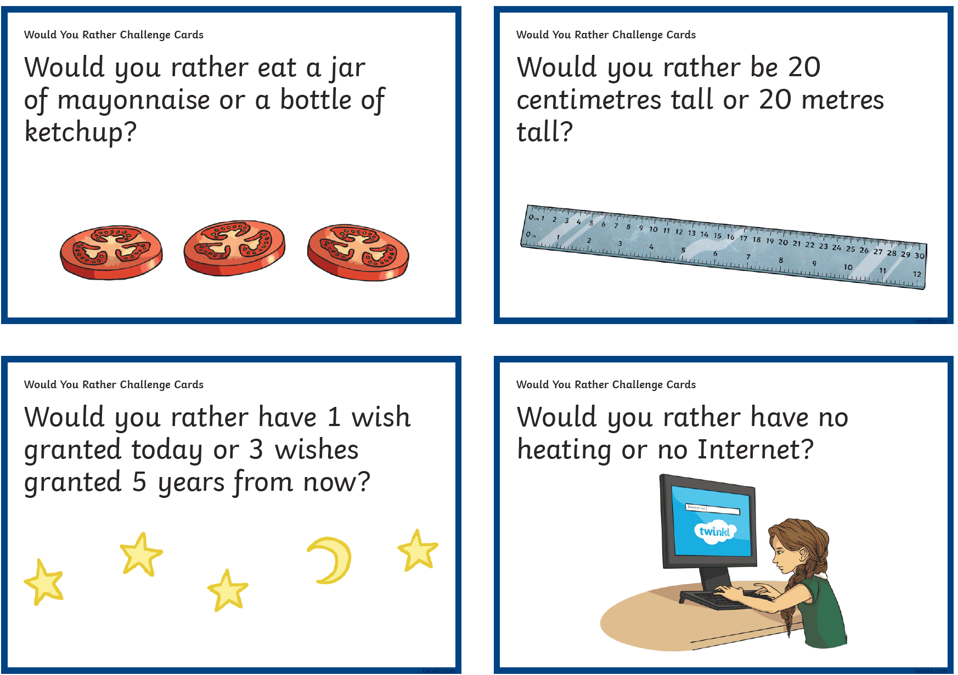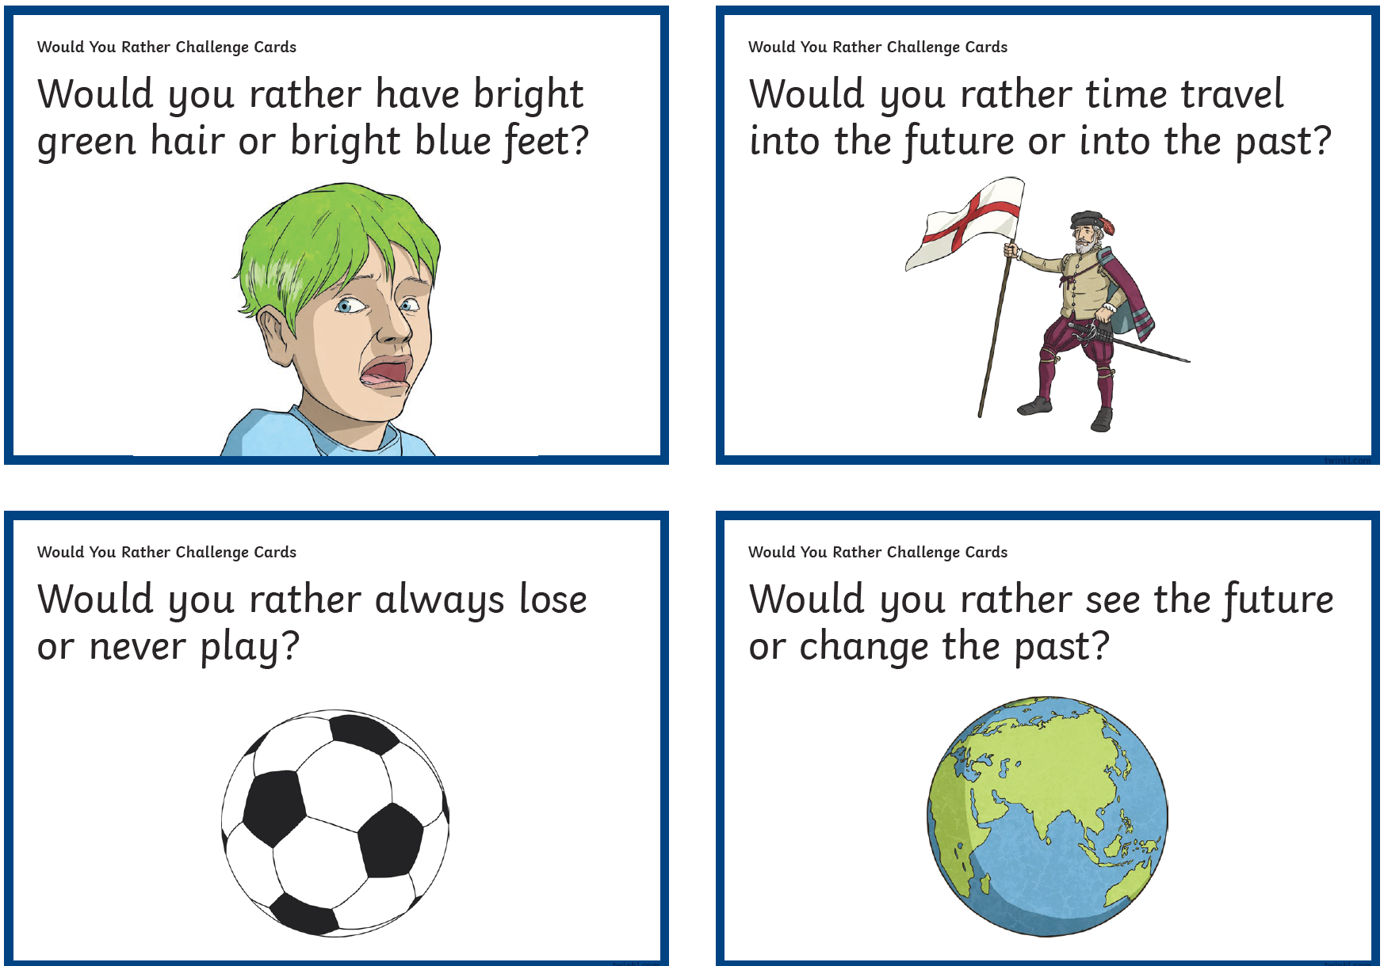
PE Easier
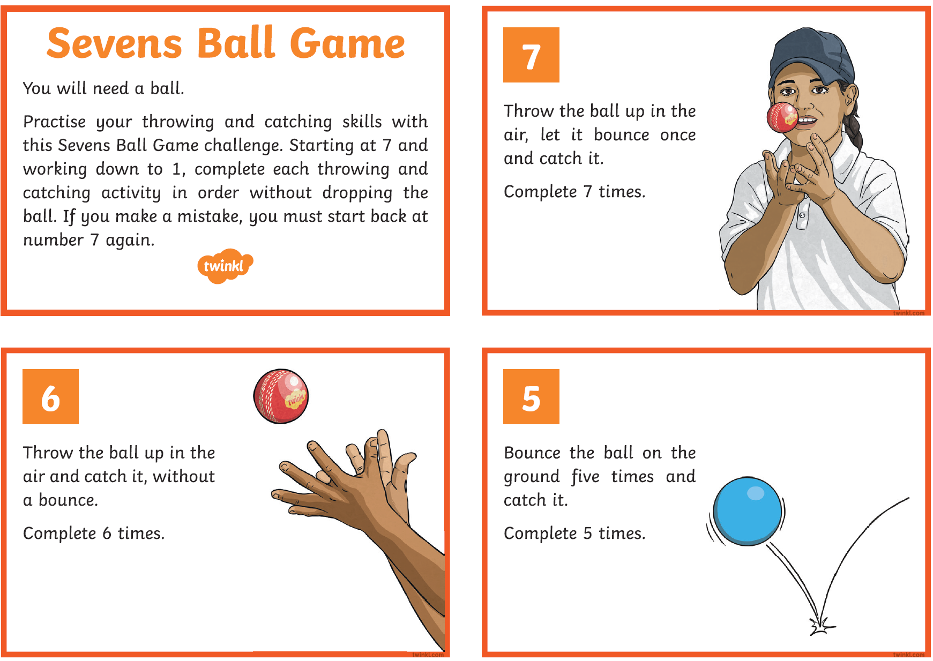
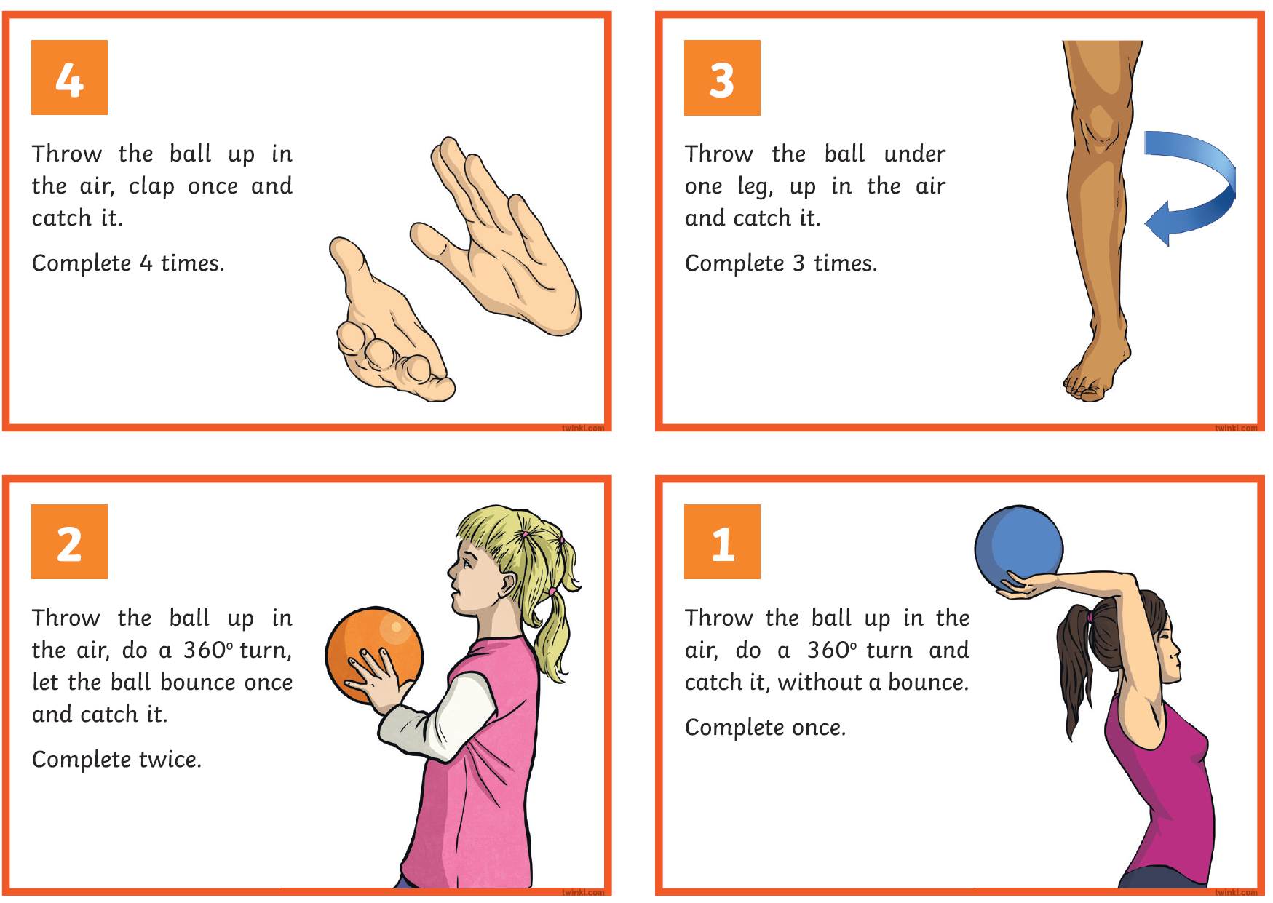

PE Year 6
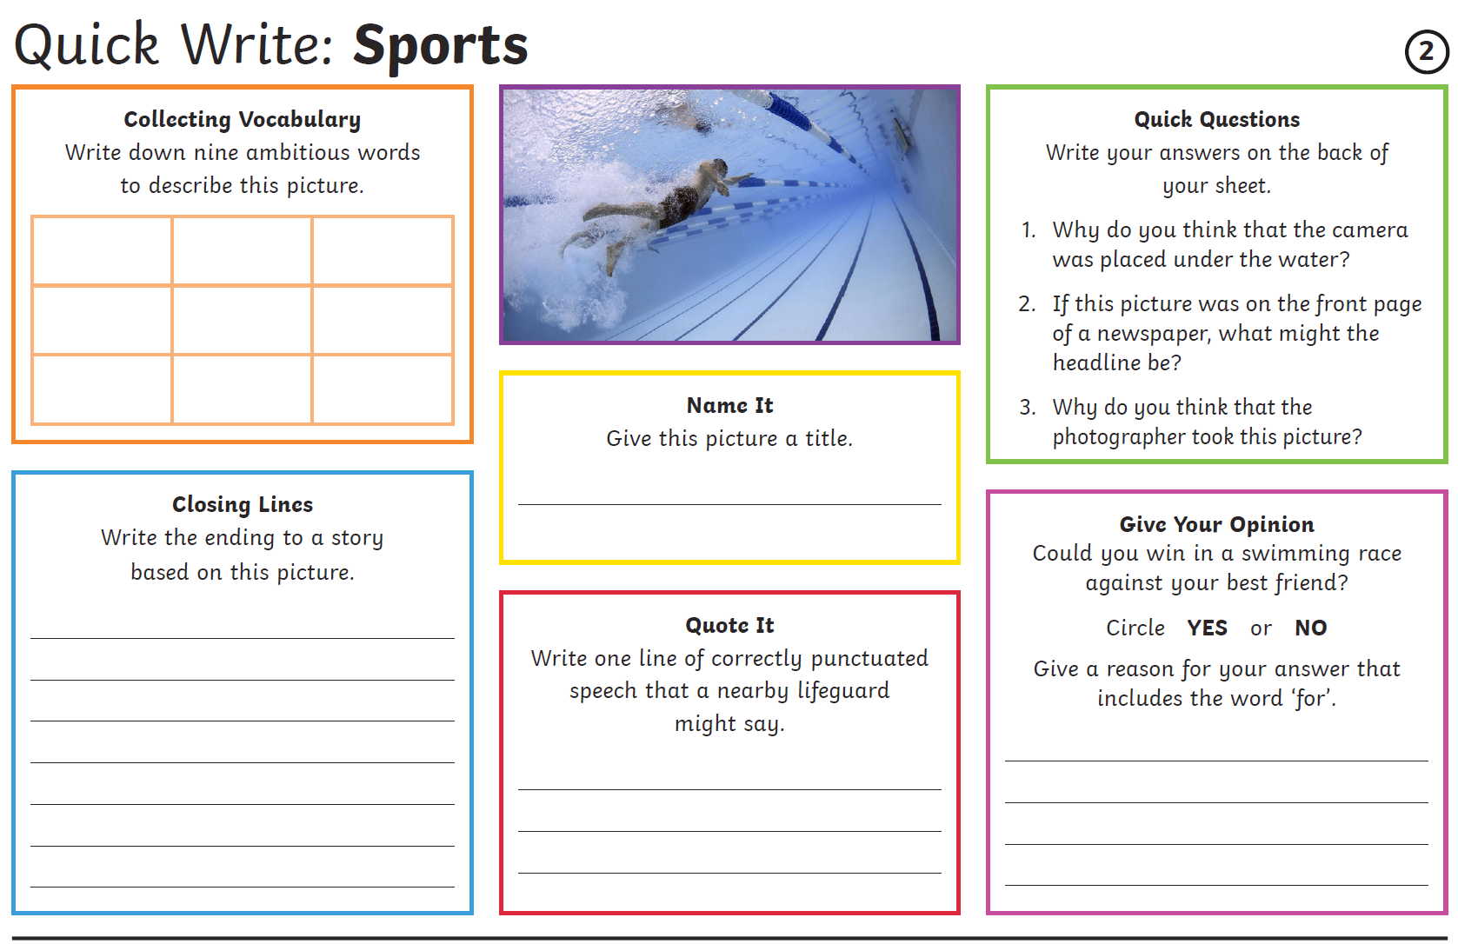
PE Challenge
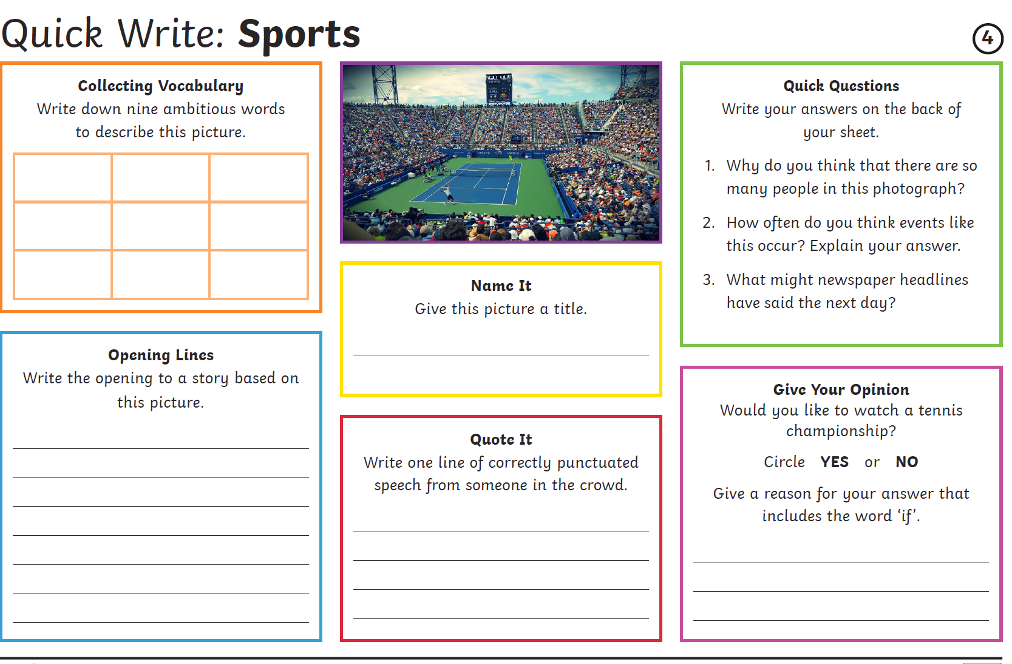

Other Activities
Times tables  Build up speed. Time yourself how long it takes you to answer 0 to 12 x tables in mixed order (work with an adult). | Get active.  With an adult, think of at least two different exercises you can do at home e.g. in the garden. You must exercise for at least half an hour a day. | 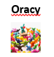  Complete the- Guess the hobby | Watch the news and choose any 3 stories to summarise. | Mindfulness  Try out some of the activities attached to help you relax.  How many different mindful techniques can you think of?  Which is your favourite?
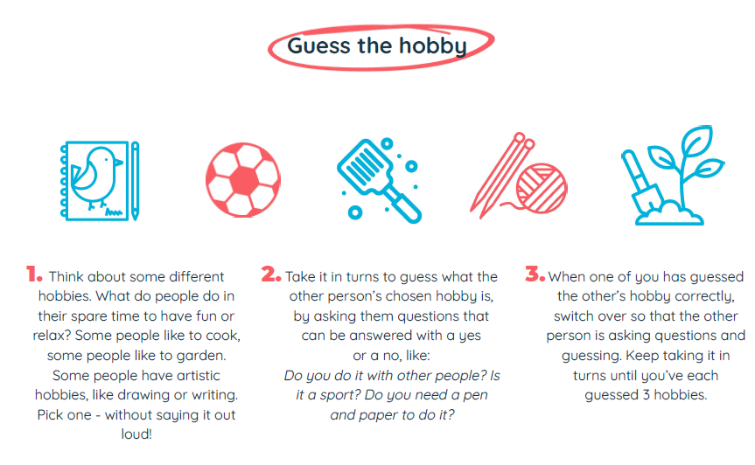
Key skills to continue practicing weekly:
-spellings
-grammar (go through revision booklets)
-speed reading
-speed writing (count the number of words you can write in one minute)
-neat and joined up handwriting
-timetables (build up speed)

If you or your child has any further queries regarding their learning projects, please contact admin@hardwick.derby.sch.uk, clearly stating your child’s name and class teacher, and the staff will be in touch to support you and your child.

Thank you and stay safe.

