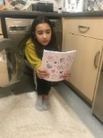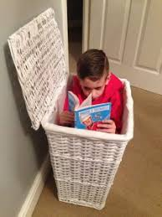

56 – 14 = 42 but 14 – 56 does not equal 42.Create a poster to explain why this is. true.

Take some photos of you reading in odd ‘extreme reading’ places. Can you get your family to read in interesting places too?

Woodlands website – lots of maths ideas <http://www.primaryhomeworkhelp.co.uk/maths/index.html>

Use the internet to find out about Greek mythical creatures. Explain what they did. Draw and label these creatures.

This is a special time.

Write how you have been feeling through this time. What have you been doing? Have you learnt any new skills? Write a day in the life recount about living through this time.

Write some messages of Hope.

Use one of these creatures to write a story. Imagine you are a Greek hero or heroine and you have to fight it. Remember to describe the beast. Who were you trying to protect? Do you win or lose? What weapons did you have?

Create a profile about Greece.

Find out:

Population

Location

Climate

Continent it is in.

Industries

Famous landmarks

When it hosted the Olympics?

Famous people

How far it is from the UK?

How can you get to Greece?

Create shapes which have 12 sides. What is this shape called? How many ways can you make this shape?

Find out about the roman numerals. What do they look like? Write down the roman numerals you find out?

Can you write the date using these numerals?

Write a letter or email to someone in your family who you cannot go to see. Send it…I’m sure that they’ll send one back.