Year 5 Home Learning
Week Commencing: 18th May 2020
Year 5 staff: (Mrs Nisa, Mr Caldwell and Mrs Hollingworth, Miss Gent, Mrs Begum)

Message from staff:
Hello Year 5 once again,
Hopefully you are getting as much of this done as possible. Parents and pupils please remember there is no pressure to finish everything. Do as much as possible without everyone getting too stressed about it. Please remember to have fun with it all and to have time to look after yourselves mentally.
It is a strange time and we are all experiencing it, so it is therefore just as important to relax and enjoy this time together.
We all miss the children very much and can’t wait to get back to school. However, that will have to wait until it is safe to do so. Thank you all for your patience and co-operation.
Keep working hard, keep yourselves busy and stay safe.

Your Home Learning this Week:
Every day (Monday to Friday), make sure you choose a *reading, *writing, *spelling/handwriting, *maths and *theme learning activity. There are also further activities to choose from should you wish to.
Reading Home Learning:
Monday | Tuesday | Wednesday |  | Thursday | Friday
Choose the Easier or Challenge text. Read through and Highlight any words/parts you don’t understand. Find out what they mean by researching or discussing with an adult.  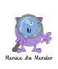 | Summarise, in a short paragraph, what the text is about. Remember to read through a few times and include the VIPs (Very Important Parts)  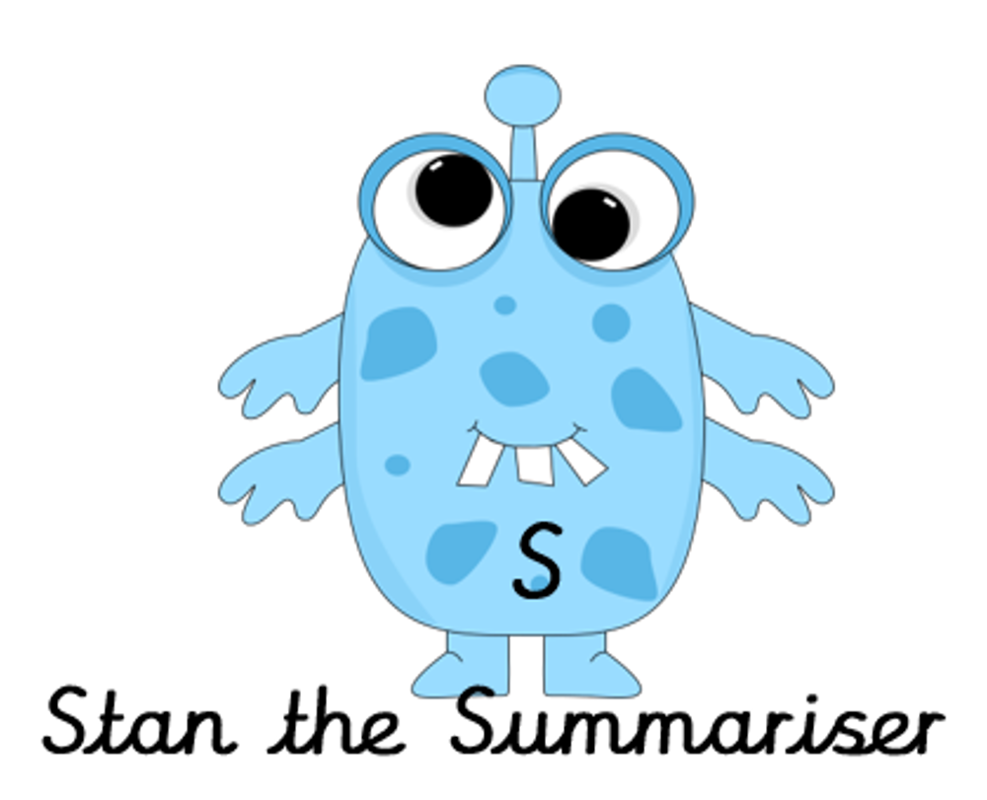 | Question the text. Write down 5-10 questions about the text/information. Re-read the text and try to answer your own questions. Discuss it with a parent.  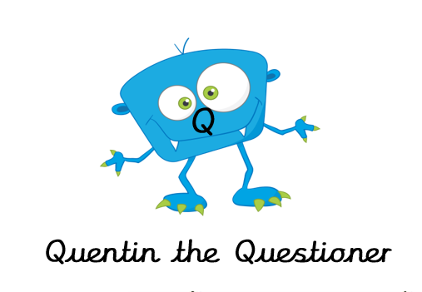 |  | Now we are to draw what the text makes us visualise. It may be different to each reader depending on what part of the text creates an image in your mind.  Close your eyes and visualise every possible detail. |  | Now have a go at the questions provided with each text. Remember reading questions are easy because the you can look at the text while you answer.  The answers are in there, you just have to understand and find them.
Easier: PLANTING BULBS  Do as many of the above activities as you can. If you are finding some of the activities challenging, try these as they are a little easier:  - Tuesday – look back at the text to remind yourself  - Thursday – Try visualising the different stages of a flower growing. Draw 5 stages showing how it may change each time. |  |  | Challenge: THE FIRST HOMINIDS  If you feel you need a further challenge, try these:  - Tuesday - Challenge yourself by referring back to the text as little as possible.  - Thursday – Visualise Homo-erectus discovering fire, the beginning of socialising round the fire, Homo-habilis sheltering under cliffs, homo-habilis or homo-erectus hunting in groups.

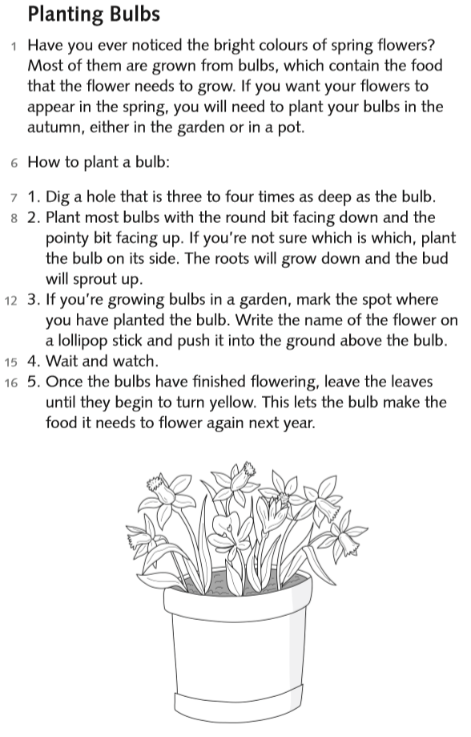
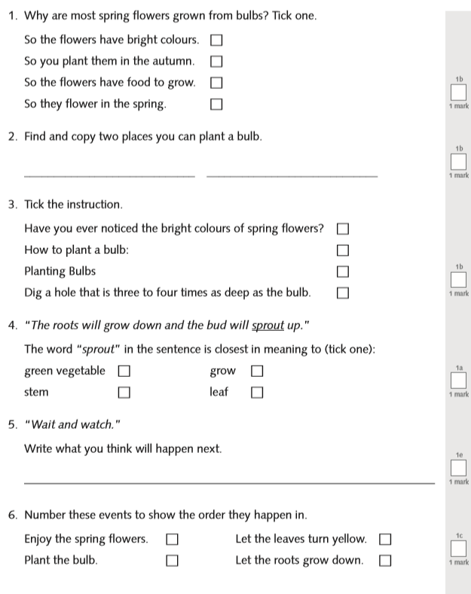
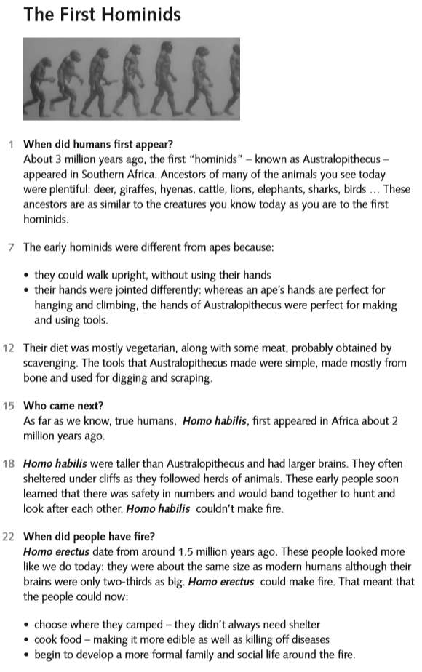
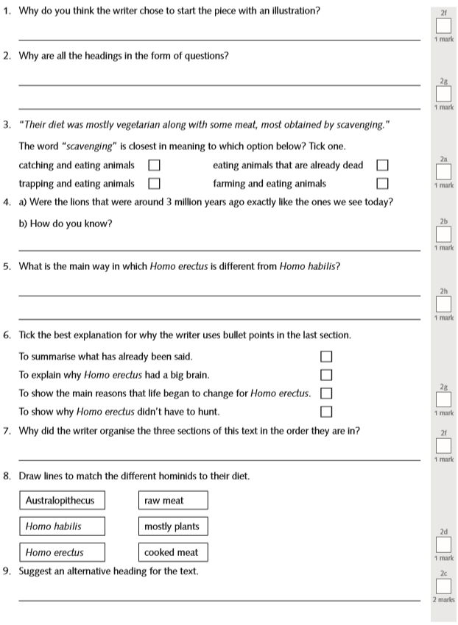

Writing Home Learning
Monday | Tuesday | Wednesday |  | Thursday | Friday
Write a sentence for the following words:  (don’t forget to use a variety of sentences–compound, complex, fronted adverbials, relative clauses)  Diet, vegetarian, hunt, tools, disease scavengers, digging scraping, ancestors, and scavenger. | Using the sentences you wrote yesterday, edit and improve them. Make sure they are the best they can be.  -Punctuation?  -Handwriting?  -Spellings?  -Makes sense?  -Capitals?  -Quality openers?  -WOW words? | With your family discuss and choose a dish you can help to make.  Make a list of ingredients and notes on how to make it.  write a sentence for these imperative verbs you may need slice, spread, mix, stir, add, whisk, blend, beat, pour, spread, place, grill, boil, and grate. |  | Make the dish with adult supervision. Make brief notes about what you are doing in the correct order time how long it takes. | Research some recipes and look at the features. Write a set of instructions for your friend to make the dish.  Remember to start with a list of ingredients, use chronological order. Draw a picture of your finished dish. Share and discuss your instructions with an adult.
Easier:  Do as many of the above activities as you can. If you are finding some of the activities challenging, try these as they are a little easier:  - Write a sentence for each of these words: cut, slice, spread, mix, add, and pour  - Make your favourite food with your family  - Write instructions in the order you do things |  |  | Challenge:  If you feel you need a further challenge, try these:  - research any other imperative verbs used in recipes
Spelling/Handwriting Home Learning
Monday | Tuesday | Wednesday |  | Thursday | Friday
Pick out some challenging words from a book you are reading or the new text chosen from the reading activities. Create your own spelling list to practice this week. | Practice your spellings. Use one of the many techniques you have been taught.  -Different colour syllables.  -Say it the way you see it.  -Word pyramid.  -Look cover, write check. | Copy out your reading text in your best joined up writing.  Do it again to see if you can make it even neater.  (remember not too small, not too big, letters in proportion to each other, CONSISTENCY. |  | Using the spellings you have chosen on Monday, practice your cursive handwriting.  This time do some SPEED WRITING. Challenge your family members.  How many of one word can you write in ONE minute? | Get your siblings, parents or anyone that can help, to test you on the spellings you have been revising.  Any you get wrong can go on a permanent list to practice another time.
Easier:  Do as many of the above activities as you can. If you are finding some of the activities challenging, try these as they are a little easier:  - Pick out words from any books you have, that are tricky for you and practice them. Get someone to test at the end of the week.  - Use the same words for handwriting practice.  - Play hangman with the words you have chosen. |  |  | Challenge:  If you feel you need a further challenge, try these:  - Continue with some of your old spelling lists (if you found them last week) practice the ones you struggled with the most.  - Find year 4 and 5 spellings lists online and pick out the ones you are most unsure about.  - Find the definitions of words you do not know.  - Play games like hangman. Or BIG challenge: INVENT your own game using the words.
Maths Home Learning
Monday | Tuesday | Wednesday |  | Thursday | Friday
Area is the measure of how much space there is inside a shape. Area is measured in square cm- cm2, square meters -m2 or square kilometres –Km2  How many of these sheets of paper would you need to cover a table in your house? | Write an example of when you might use each of these units cm2 squared centimetres  m2 squared metres km2 squared kilometres | Using the squared paper draw 5 shapes which have four sides. Write the length and width of the shape and the area inside the shape |  | Draw shapes with 5 or more sides. on the squared paper. Write the area inside each shape. | Select some suitable surfaces to measure the area of. Make sketches and diagrams of the space you are measuring Use the words length, width and breadth to describe dimensions.
Easier:  Do as many of the above activities as you can. If you are finding some of the activities challenging, try these as they are a little easier:  Measure the length and width of a table  - Estimate how many sheets of paper you would need to cover the table  - Use the A4 sheet and find out how many you would need. Draw a diagram to show this. |  |  | Challenge:  If you feel you need a further challenge, try these:  Decide if the following involve thinking about length or area. Write in the missing word:  1.Distance I travel to school, ______________ 2.Turf for a football pitch ______________ 3.Paint needed to cover a wall ______________ 4.Fence needed to go around a park ______________ 5.Length of a pencil ______________ 6.Tiles to cover a bathroom floor ______________
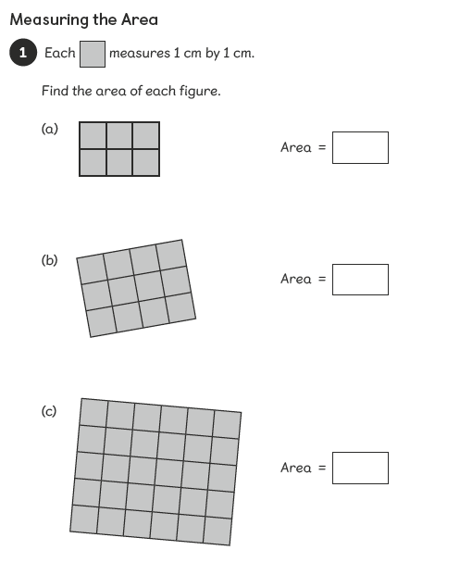
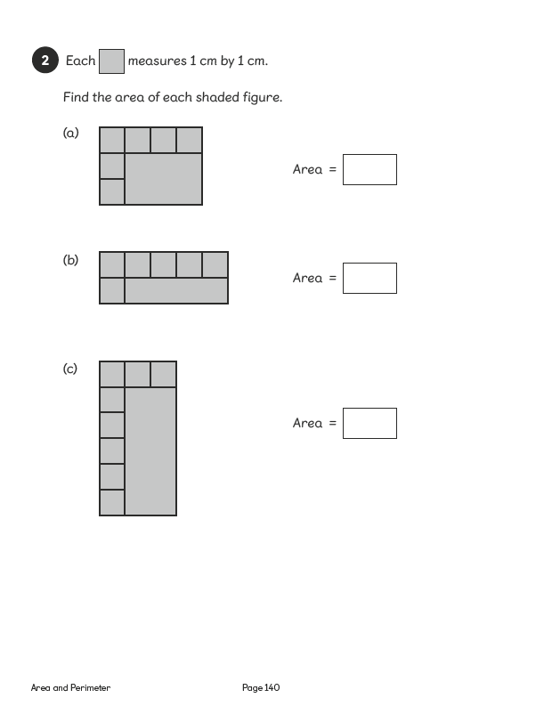
Activity 1

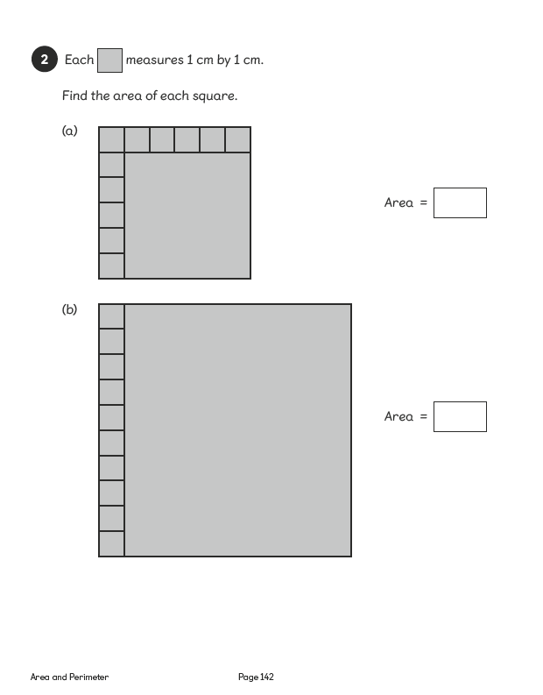
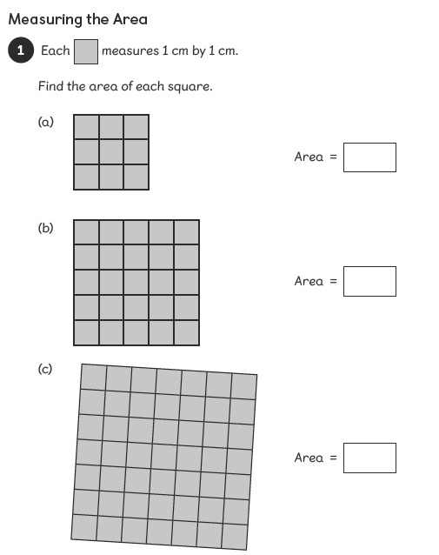
Activity 2
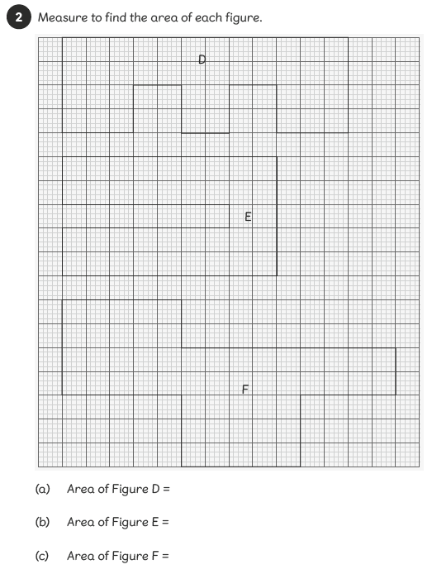
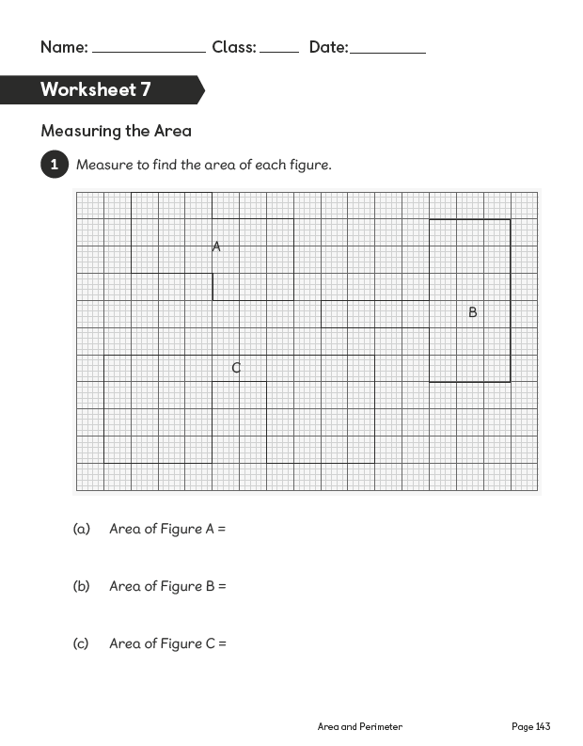
Activity 3
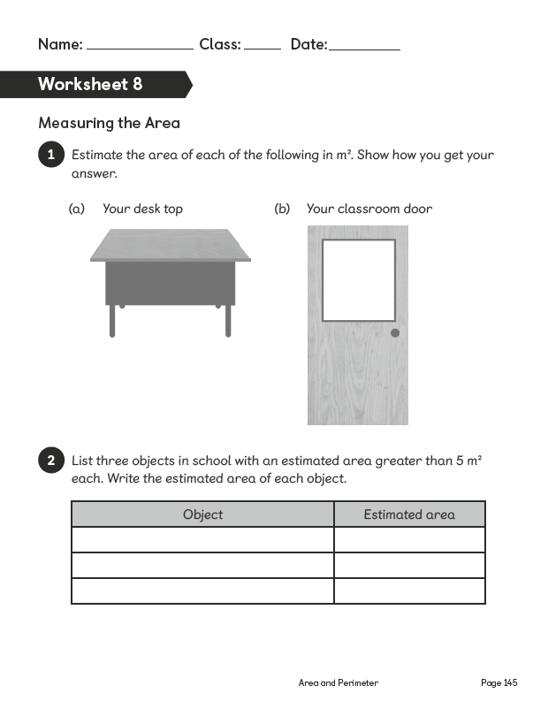
Activity 4

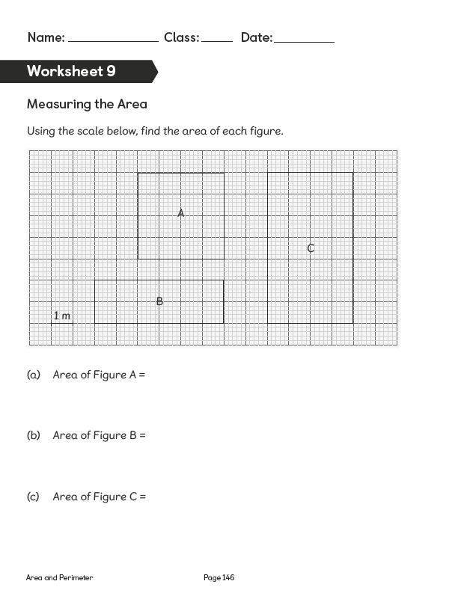
Activity 5

Theme Activities – Home Learning
Monday/Tuesday | Wednesday |  | Thursday | Friday
Design your own ice-lollies ready for when the weather gets better again.  Think about what flavours your family like. Ask them. Collect some simple yoghurt pots to create them in and use teaspoons as the sticks.  Possible ingredients:  Yoghurt, squash, fruit juice, mashed berries etc Maybe a couple of these mixed.  Eg. Juice and mashed fruit. Or Yoghurt and mashed fruit. | Design and create an Ice-lolly advertisement.  Make sure its bright and eye-catching. Can you think about your target customers and give it a name and theme. |  | Using the collected pots, make your ice- lolly mixtures and fill the pots. Remember liquids expand when you freeze them so do not fill them to the top.  Place a teaspoon the pot and put in the freezer over-night. | Nice and easy the task today.  - Take your ice lolly out of the freezer.  - Eat it and enjoy!!
Easier:  Do as many of the above activities as you can. If you are finding some of the activities challenging, try these as they are a little easier:  - Get some yoghurts on the next family shopping trip.  - Take the lid off and mix with a small spoon.  - Leave the spoon in and place in the freezer.  - The next day, Eat and enjoy!! |  | Challenge:  If you feel you need a further challenge, try these:  - If you have access to the internet, look up kitchen or gardening hacks. Have a go at creating something that can help store things in the kitchen or garden.
If you have an ice-lolly mould then obviously use that, however yoghurt pots are a simple alternative or find something similar.

Other Activities
When it is sunny again, take some paper, some toys and a pencil and have a go at drawing round the shadows of your toys. | Following on from yesterday’s activity, create a shadow scene using some of your toys. | Don’t forget that what is happening at the moment is History in the making.  Take photos to remind you of this time.  -Photograph the things that have changed.  -Photograph your creations and achievements. (food, homeworks etc)  -The things you have done as a family.  -Your wild hairstyles because you all need a haircut!  -Changes in your house.
Key skills to continue practicing weekly:
- Timestables, Handwriting, Reading of own books, PE/Exercise.

If you are able to access the internet, try these useful websites:
- BBCbitesize/daily lessons
- https://www.bbc.co.uk/bitesize/subjects/z39d7ty - keep up with your French buy learning new words and phrase

If you or your child has any further queries regarding their learning projects, please contact admin@hardwick.derby.sch.uk, clearly stating your child’s name and class teacher, and the staff will be in touch to support you and your child.
Thank you and stay safe.

