Year 3 Home Learning
Week Commencing: 8.6.20
Year 3 teachers: Mrs Begg, Mrs Lumsden, Mrs Priestland, Mr Rogers
Year 3 TAs: Miss Batool, Mrs Stringer
Message from staff:
Hello everyone. We hope you are keeping well and staying safe. I know it is a strange time and we are all hoping that we will see each other soon and enjoy learning together again. Mrs Lumsden has put some amazing activities this week about mindfulness. It is lovely to speak to you over the phone and hearing about what you have been up too.
Remember you do not have to do the easier and the harder. Do the activities to the best of your abilities.
Please take care of yourself and your family and see you soon.

Your Home Learning this Week:
Every day (Monday to Friday), make sure you choose a *reading, *writing, *spelling/handwriting, *maths and *theme learning activity. There are also further activities to choose from should you wish to.

Reading Home Learning
Monday | Tuesday | Wednesday |  | Thursday | Friday
Read the story of the Lion and the Mouse.  Underline any words you do not understand. Is your word in the list? Read the story again. Then tell the story to your mum in your own words.  Stan the summariser | Read the story-  Draw four pictures to tell the story.  Write a sentence to go with each picture.  Remember to pick the VIPs - very important parts. | Think about the way the lion was feeling during the story. Explain his feelings and why?  Eg The lion was grateful when the little mouse set him free.  Write three different sentences. |  | Underline the words the lion and the mouse said. Speech marks go around the actual words a character says. Look for speech marks in your own reading book. Who was speaking? What did they say? | The moral of the story is a kindness is never wasted.  Can you explain the moral of this story in your own words.
Easier:  Do as many of the above activities as you can. If you are finding some of the activities challenging, try these as they are a little easier:  Ask mum or dad to read the story to you  - Where was the lion?  - How did the mouse wake him up?  - Why was the Lion angry?  - Why did the lion laugh at the little mouse  - Who trapped the lion?  - How did the mouse know the Lion needed help?  - How did he help him? |  |  | Challenge:  If you feel you need a further challenge, try these:  - Could there be a different moral to this story?  - Think about the mouse. How did he feel in the different parts of the story?  - Try to use the new words in your own sentences.  - Draw a picture to try to help you remember the meaning of these new words.
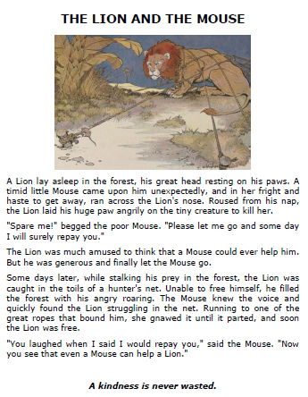
New words
timid – shy, nervous
haste – speed, in a hurry
roused – woken up
begged - asked
spare me – let me go, let me off
repay – pay you back
amused – found it funny
generous – kind, good hearted
stalking – looking for hunting
toils – ropes
bound – tied
gnawed – nibbled, bit
parted – broke into two

Writing Home Learning
Monday | Tuesday | Wednesday |  | Thursday | Friday
Mice and Lions are very different animals. Write four sentences explaining how different they are. Eg.  A mouse is tiny but a lion is huge. | Write four sentences explaining how mice and lions are the same. Eg  A mouse has fur and a lion has fur. | Imagine you were the mouse telling his friend about what had happened. Write the story from the mouse’s point of view. Use I  Eg One morning I was scampering through the forest…. |  | Imagine the lion and the mouse carried on talking. What did they say to each other? Write their speech using speech marks. | Commas in a list. Write a list of foods different animals eat.  Eg Lions eat zebras, antelope, mice and birds.  Think of 5 different animals.
Easier:  Do as many of the above activities as you can. If you are finding some of the activities challenging, try these as they are a little easier:  - Draw the mouse and the lion. Draw and write a speech bubble for each of the characters.  - Describe a lion in sentences.  - Describe the mouse in sentences.  - Don’t forget to use full stops, finger spaces and capital letters. |  |  | Challenge:  If you feel you need a further challenge, try these:  - If you came across a lion in a net. What would you do to set it free?  - Could you rewrite this story changing the setting and the animals - showing how a little creature helped a large creature.  - Imagine you are interviewing the mouse for a TV show. What questions would you ask him?  - Practise writing sentences with speech marks.

Spelling/Handwriting Home Learning
Monday | Tuesday | Wednesday |  | Thursday | Friday
young, double, trouble, country, rough, touch  ou is making the /u/ phoneme.  Practise spelling these words. Use a doodle spell. | Put the words from yesterday into sentences. | Unjumble the words. They all have the /u/ sound, spelt in different ways.  nnruy beluod othuc orbhtre  gonuy dolob  lepuoc lemtub |  | Here are three homophones –  heel heal he’ll  grown groan  plain plane  Put the words into sentences. | Look at the sentences below and write them out with the correct spelling.
Easier:  Do as many of the above activities as you can. If you are finding some of the activities challenging, try these as they are a little easier:  - to, to, two  - hair hare  - pear pair  - be bee  - see sea  - Draw a picture for each of the words and then write them in sentences. |  |  | Apostrophes for contractions  do not – don’t  He is –  I am –  We have –  We are –  is not –  have not –  are not -  I’m he’s we’re isn’t we’ve  aren’t haven’t
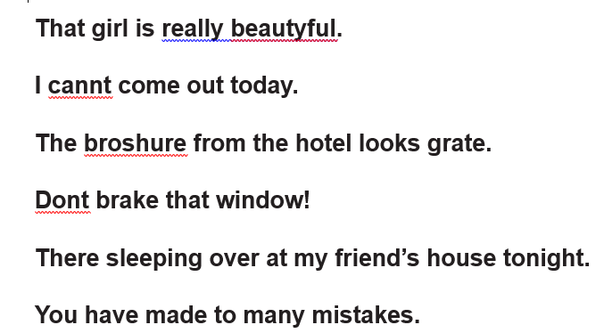
Look at these sentences. Can you correct the spelling?

Maths Home Learning
Monday | Tuesday | Wednesday |  | Thursday | Friday
Practise adding 3 digit numbers.  456 + 376=  708+ 145=  533 + 283=  702 + 297 =  509 + 285 = | This is an everyday maths problem.  Oakwood School has 465 pupils and Redwood School has 378 pupils. How many pupils are there altogether? Find the answer and then write everyday problems for yesterday’s maths. | Practise subtracting three digit numbers  468 – 246 =  670 – 345 =  621 – 453 =  956 – 672 =  300 – 156 = |  | This is an everyday maths problem.  Ali had £468 in the bank. He spent £246 on a bike. How much did he have left? Find the answer and write everyday problems for yesterday’s subtractions | If I know  46 + 23 = 69  Then 32 + 46 = 69  And 69 – 32 = 46  And 69 – 46 = 32  Find the 2 addition and 2 subtraction facts for these numbers.  63 + 28 = 91  ---------------------  536 + 213 =
Easier:  Do as many of the above activities as you can. If you are finding some of the activities challenging, try these as they are a little easier:  Count forwards and backwards to find the answer  - 46 + 7 = 57 + 5 = 78 + 4 = 69 + 7 =  - 63 – 7 = 52 – 6 = 84 – 6 = 42 – 7=  - Write some of your own  - 56 + _____ =61 47 + _____ = 52 77 + _____ = 81  - 72 - ______ = 69 73 - _____ = 67 32 - ______ = 27 |  |  | Challenge:  If you feel you need a further challenge, try these:  - Fill in the missing numbers:  - 426 + ___________ = 837  - 572 - ____________ = 241  - 632 + __________ = 943  - ________ - 453 = 213
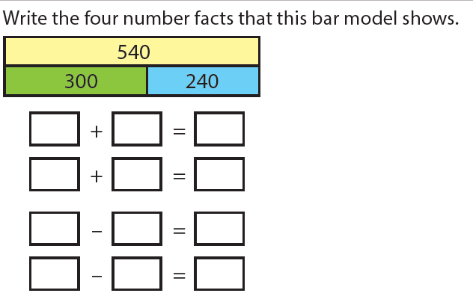
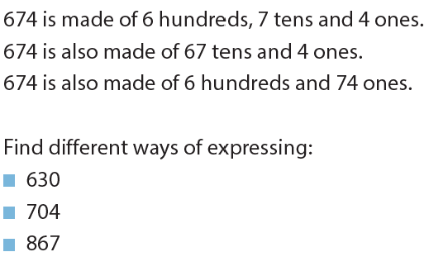
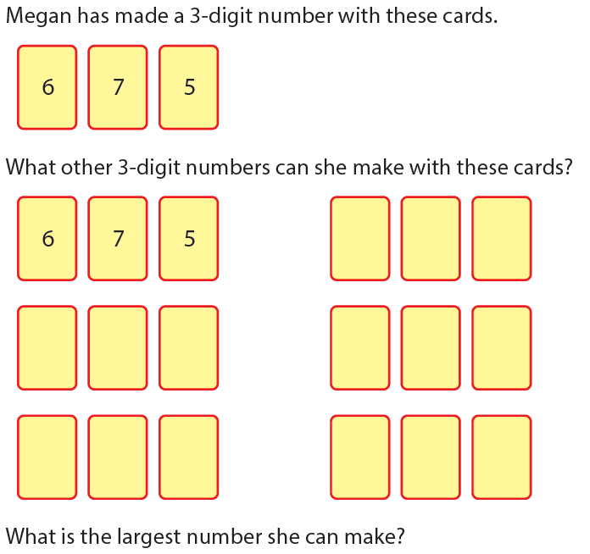

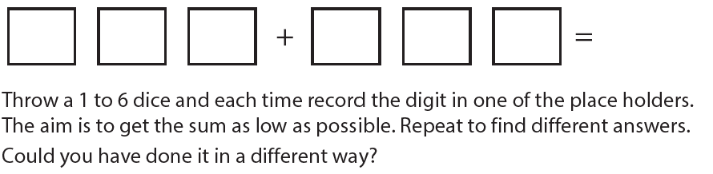

Theme Home Learning – Staying fit and healthy
Monday | Tuesday | Wednesday | Thursday | Friday
Exercise is good for your body and for your mind. Think of a sport or activity beginning with each letter of the alphabet  Eg A – archery  B - basketball | Go outside and run around your garden ten times. Stop and notice your body.  What is happening to your breath, heart, face, skin, legs are you hot or cold? Which parts of your body were you exercising? Write about the changes to your body. | What will happen to your body if you eat too much and don’t exercise enough.  Make a poster to explain.  Make sure you exercise every day. | It is OK to eat a few treats from time to time. If we eat things with too much fat or sugar we can become overweight and unhealthy.  Write a list of 20 treat foods – foods you should not eat too much of. Label the foods. | Many people find walking in the countryside helps them to feel relaxed and happy. Draw a picture of a place that makes you feel happy and safe. It is important to have the time and a place to chill.

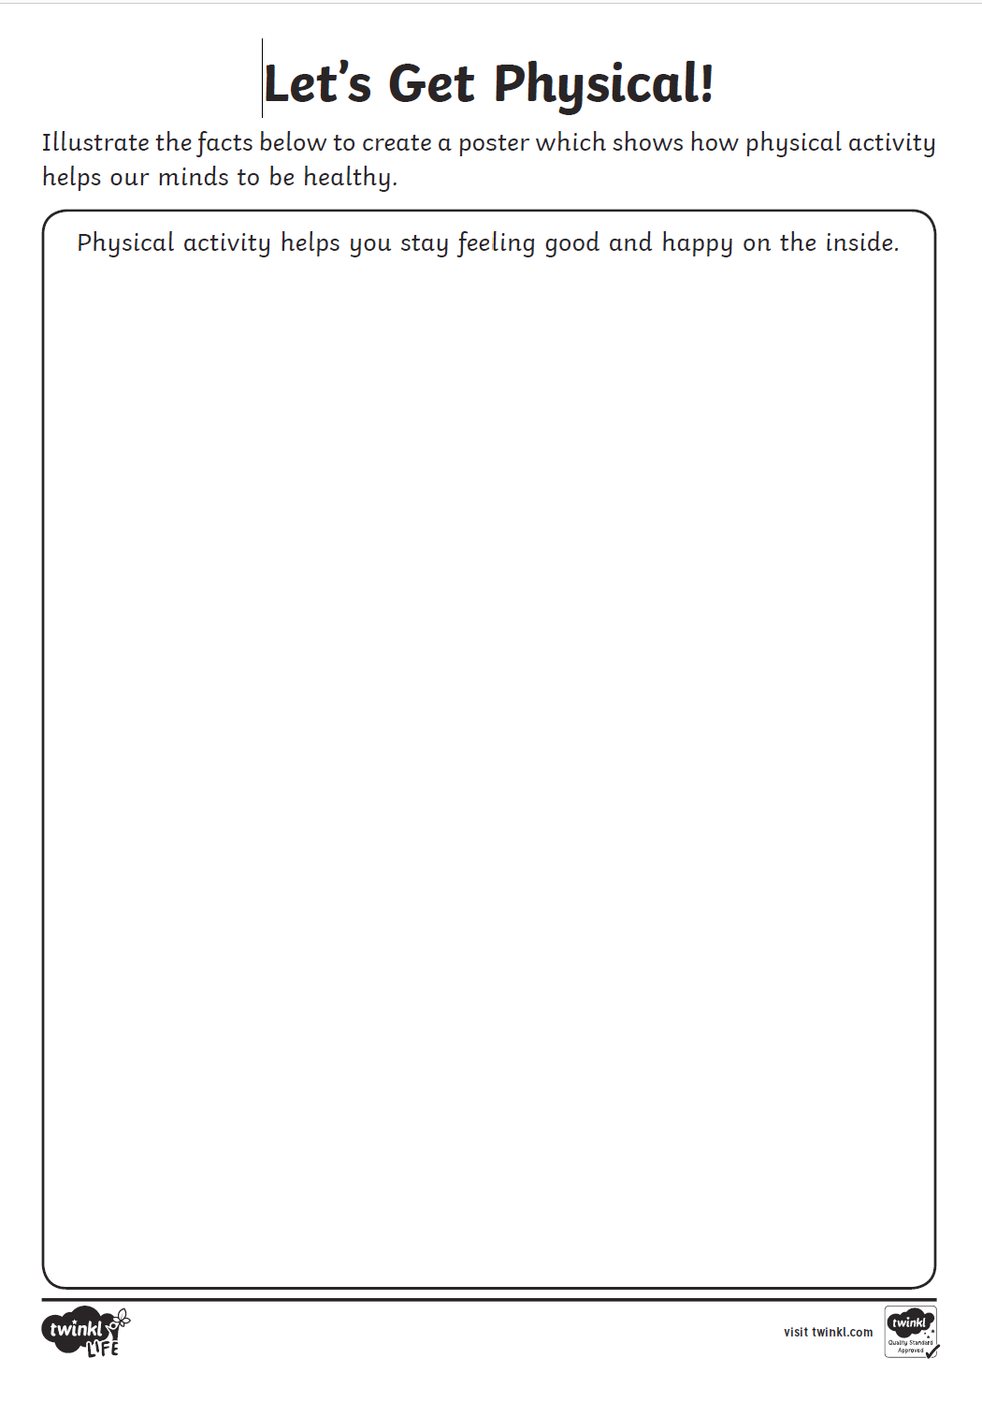

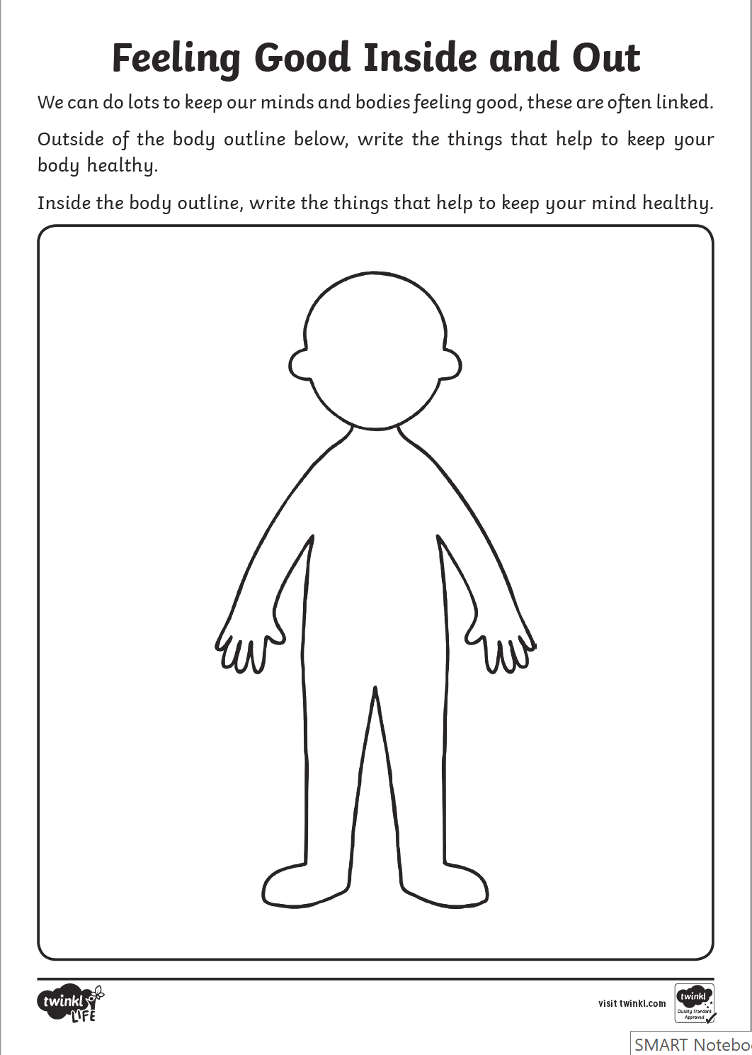

Other Activities This week we will investigate two more types of automatic negative thoughts you might have.
Complete the sheet that teaches you all about 2 more types of automatic negative thoughts, how many examples can you think of?  Remember to do some mindful breathing at home. | Learn what is wrong with all-or-nothing thinking and what can be learnt from the Yin Yang symbol.  Complete the chart to think of both negative and positive outcomes for a situation. | Use the star breathing sheet to practise your mindful breathing at home.  Once you are calm and focused from your mindful breathing, think about what these quotes mean to you and your life. | You CAN help your brain to think more positively. Read through the large sheet of positive affirmations and choose your favourite 5 that you will say to yourself to build stronger positive pathways. | Try writing a gratitude diary for the next 7 days.  Can you find at least 1 thing you are thankful or grateful for every day?

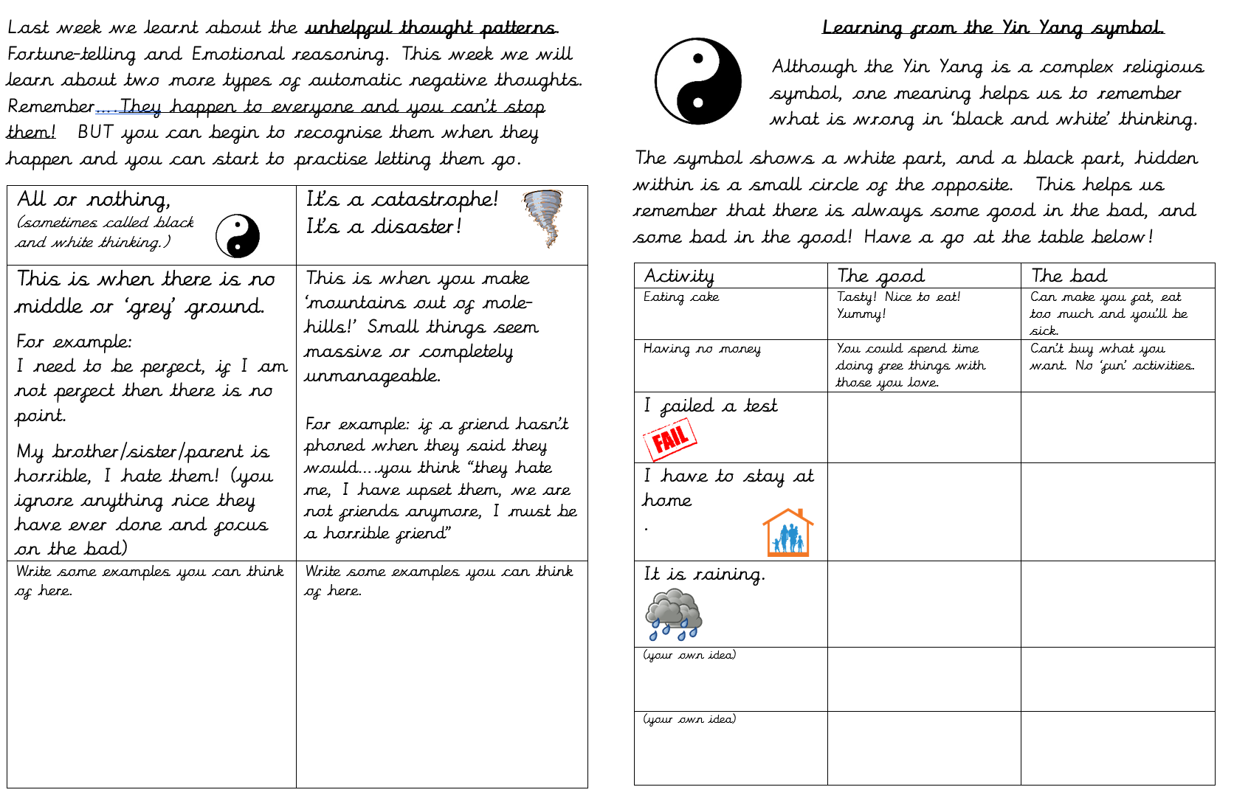

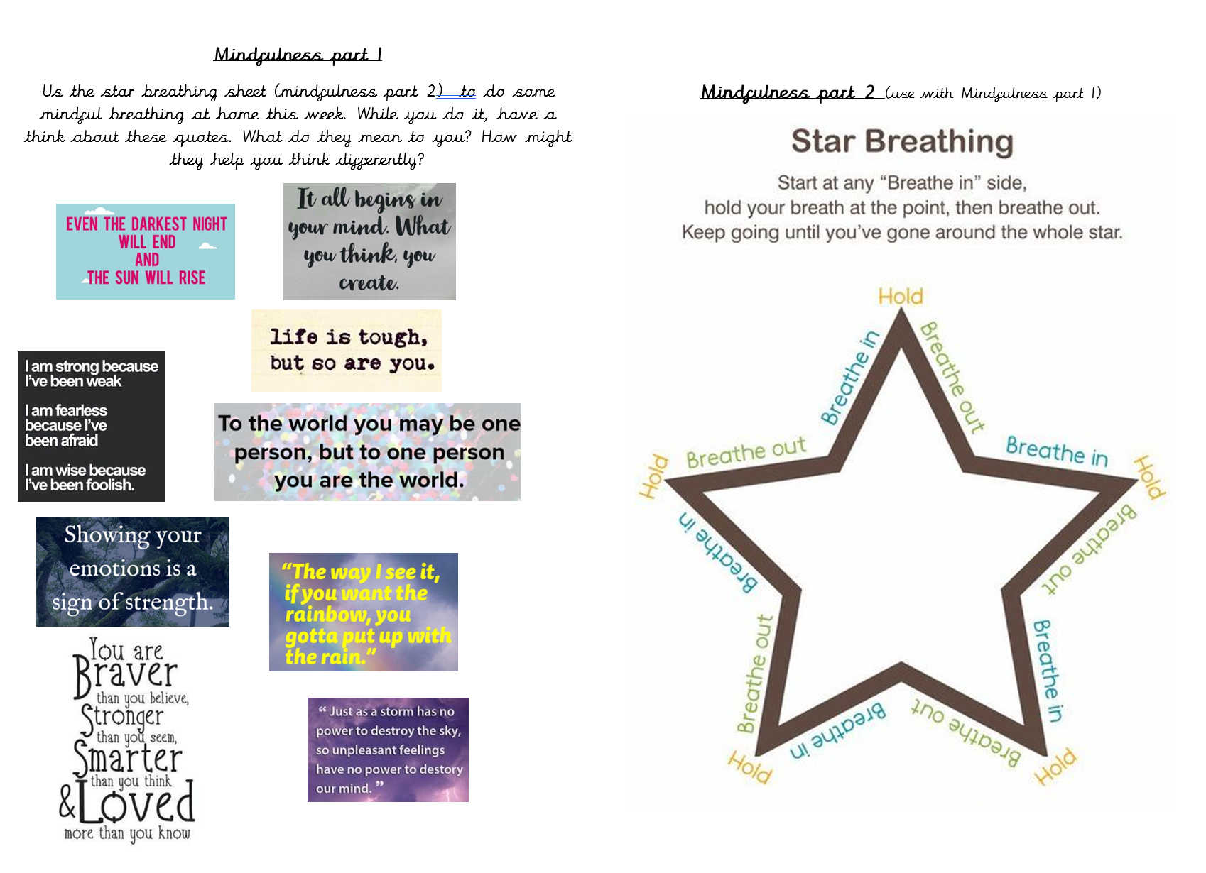

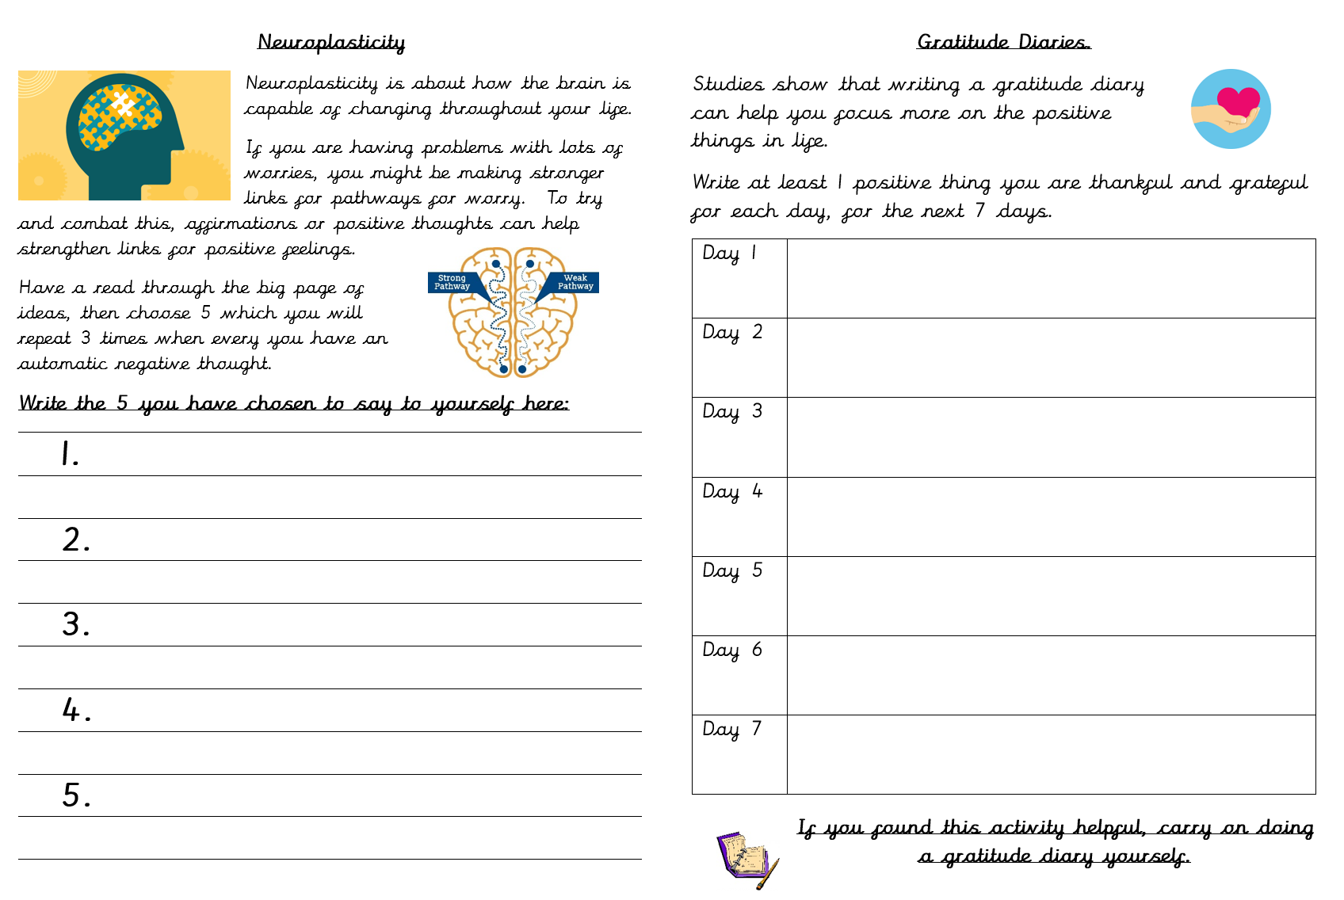

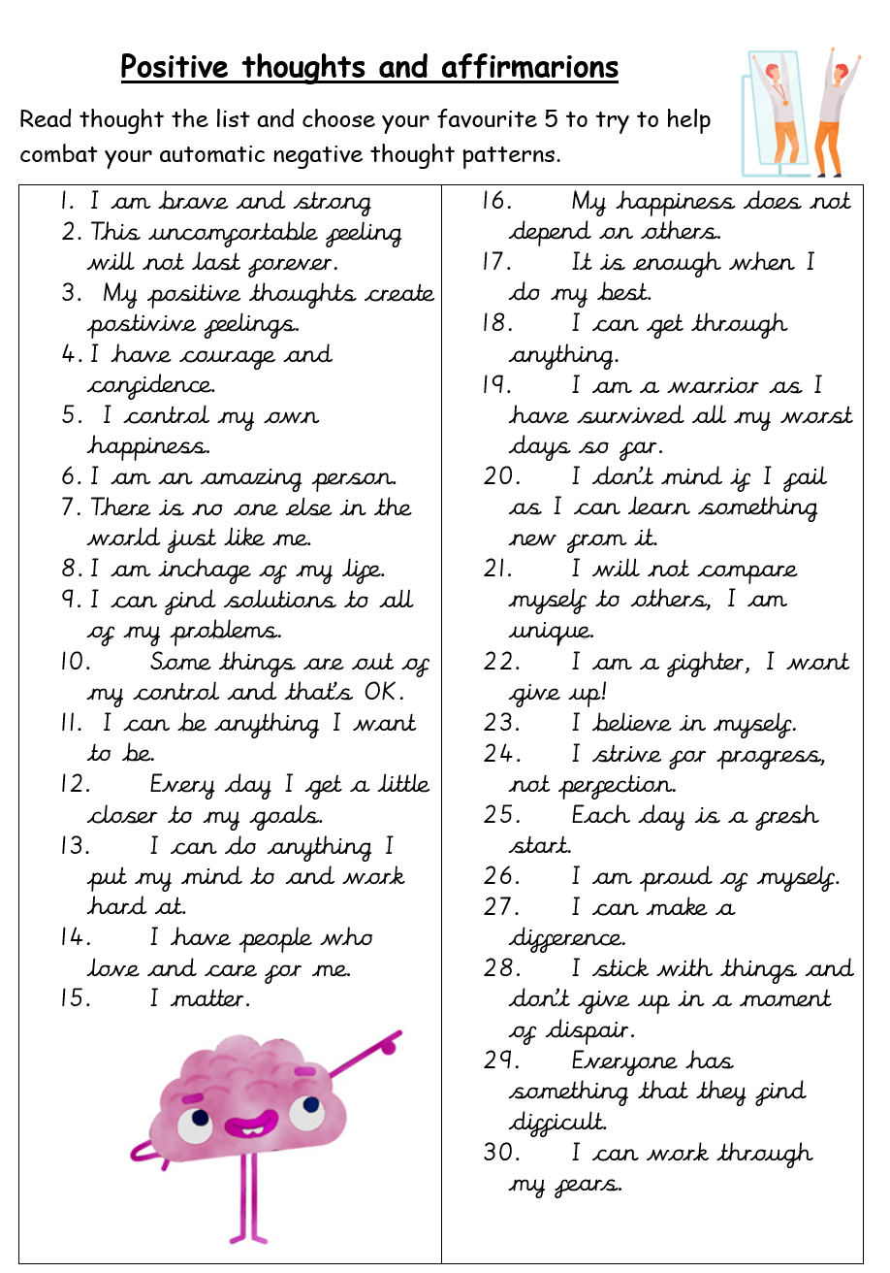

Key skills to continue practising weekly:
- 2, 3, 4, 5, 8, 10 times tables
- Quick addition and number facts 9+7 11 - 5
- Year One, two and three spelling sheets
- Reading any books, newspapers, cereal packets, websites you can find

If you are able to access the internet, try these useful websites:
- BBCbitesize/daily lessons
- https://www.youtube.com/user/CosmicKidsYoga- Cosmic Yoga is amazing. There are lots of yoga stories, mindfulness activities and active exercises for you to do.
- https://scratch.mit.edu/- we would be doing this if we were at school. Have an explore of Scratch and learn how to code. Make the cat move, speak and even dance. Create new characters, change the background and have some fun.

If you or your child has any further queries regarding their learning projects, please contact admin@hardwick.derby.sch.uk, clearly stating your child’s name and class teacher, and the staff will be in touch to support you and your child.

Thank you and stay safe.

