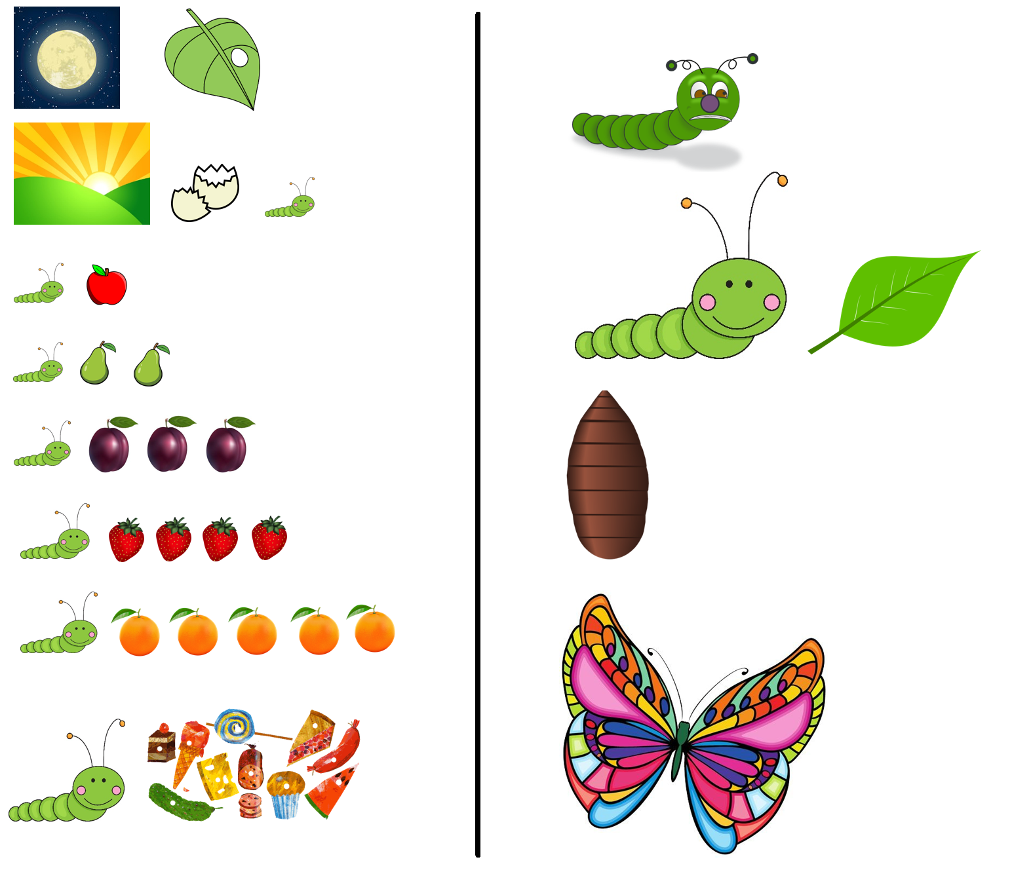
The Very Hungry Caterpillar
By Eric Carle

