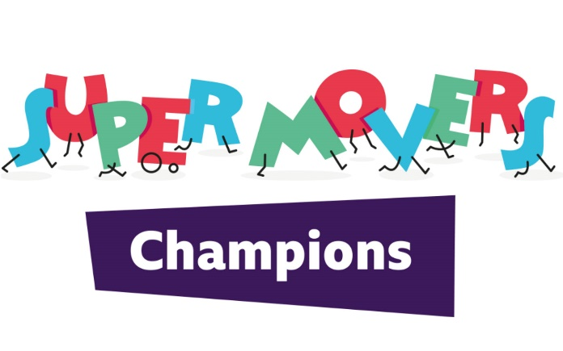
HARDWICK PRIMARY SCHOOL

Learning Outcome
I will learn about different ways that I or my family can get active both Indoors and outdoors.
Activities
What’s your super statue?
Step 1: Move to the music.
Step 2: When the music stops, freeze in a super statue shape that represents a physical activity or sport you like doing.
Step 3: Move again and each time the music stops try a different super statue.
See if you can identify your family’s statues.
Balloon Bonkers
Tap a balloon back and forth in pairs. When you hear ‘stop’ whoever is receiving the balloon must catch it and talk to their partner about the question posed. Then repeat.
Family Fitness Fun
Step 1: In small groups, come up with four moderate to vigorous super moves you think your family might enjoy taking part in.
Step 2: Test the movements out by trying to perform each for 30 seconds each.
An idea of a little circuit you could do at home - https://www.derbycountycommunitytrust.com/wp-content/uploads/2020/04/Family-Fitness-Circuit-1.pdf
Make it work for everyone
Think about what changes you might look to make to play your game at home.
• Do you need to adapt the game to make it safe in the space available at home?
• Do you need to make the task easier for anyone at home to be able to join in?
• Would adding equipment from around the house, such as a teddy or a chair, make it more fun?
• Who could you get involved? Is there 10 minutes in the day where more people could join in?
What physical activities could you encourage your family to get involved with?
Outdoor activities
What physical activities could you encourage your family to get involved in outdoors?
• Take the dog for a walk
• Play a game or sport together
• Jump on the trampoline
• Go for a bike ride
• Others?
Indoor activities
What physical activities could you encourage your family to get involved in indoors?
• Clean the house to music
• Do physical challenges during TV adverts, e.g. star jumps
• Play an active game, e.g. Musical Statues, Simon Says etc.
• Others?
Follow these links
KS2 Active Maths - https://www.bbc.co.uk/teach/supermovers/ks2-maths-collection/z7frpg8
KS2 Active English - https://www.bbc.co.uk/teach/supermovers/ks2-english-collection/zmv4scw
Derby County Community Trust activities - https://www.derbycountycommunitytrust.com/programmes/resource-documents/

